
Student Name: | Nofiza Sajid
Student ID Number: | 2407944
Programme: | Certificate of Higher Education Skills for the Workplace (Health & Social Care)
Module Title: | Introduction to Health and Social Care
Module Code: | LCHS4003
Lecturer:

Table of Contents
Introduction ......................................................................................... 3
Importance of Effective Communication ........................................... 3
Importance of Good Administrative Skills ......................................... 5
Importance of Inter-professional Collaboration …………..…………. 6
Table ...................................................................................................... 7
Conclusion ............................................................................................ 7
References ............................................................................................ 9

Introduction
Effective care for individuals recovering from stroke hinges on three core professional competencies: communication, administration, and collaboration. Mr Ahmed, a 68-year-old stroke survivor with limited English proficiency and post-hospital care needs, highlights the complexity of providing equitable, person-centred care within multidisciplinary health and social care settings. Communication barriers can significantly impair participation in treatment planning, shared decision-making, and daily care routines and have been linked with poorer rehabilitation outcomes in stroke populations (Zingelman et al., 2024). These challenges are magnified when language differences necessitate interpretation or thoughtful accommodation strategies. Legislation such as the Equality Act 2010 obliges healthcare providers to mitigate discriminatory barriers and deliver services that respect individual needs, while data governance frameworks like the Data Protection Act 2018 ensure ethical handling of sensitive patient information. This report critically examines how professional practice in communication, administrative skills, and inter-professional teamwork applies to the context of Mr Ahmed’s post-stroke care.

Effective Communication
Effective communication is a critical determinant of high-quality health and social care, particularly for service users who face language and cognitive challenges such as Mr Ahmed. Patients with limited proficiency in the dominant language often experience poorer healthcare outcomes, including decreased satisfaction and increased risk of misunderstanding clinical information (Ahrens and Elias, 2023). In the context of post-stroke rehabilitation, ensuring that instructions about medication, daily routines, and therapy are understood accurately is essential to safe and effective care.
The Berlo SMCR (Source–Message–Channel–Receiver) model offers a structured framework that supports clinicians in analysing and improving communication processes. In this model, the Source refers to the healthcare provider their communication skills, clarity of expression, and cultural competence affect how the message is encoded. The Message must be tailored to Mr Ahmed’s understanding level: using plain language, simplified explanations, translated written materials, and visual aids increases the likelihood of accurate decoding by the receiver. The Channel comprises the method of delivery face-to-face interaction, written care plans, pictorial medication schedules, or electronic prompts chosen according to the receiver’s needs. The Receiver, in this case Mr Ahmed (and often his wife acting as interpreter), must decode the message correctly, and techniques such as “teach-back” confirm understanding (Ahrens and Elias, 2023).
Training healthcare professionals in intercultural communication enhances their ability to encode and deliver messages effectively. Research on intercultural communication training suggests that self-awareness, adaptability, and cultural humility are essential competencies for healthcare providers working with linguistically diverse patients (Schouten et al., 2023). By incorporating these competencies, clinicians can reduce misunderstandings, build trust, and promote engagement in care planning.
Applying this structured approach aligns with the Equality Act 2010, which mandates reasonable adjustments to ensure that patients with communication needs are not disadvantaged or discriminated against. This includes providing professional interpretation or translation where required, and ensuring that communication methods meet the needs of individuals with limited English proficiency (Equality Act 2010). Family involvement such as engaging Mr Ahmed’s wife to support interpretation should be approached ethically, ensuring accuracy without over-burdening the family member.
Using the Berlo SMCR model helps healthcare professionals systematically address barriers in communication by focusing on clear message design, appropriate delivery channels, and confirmation of understanding. Coupled with cultural competence and legislative compliance, this approach enhances patient safety, autonomy, and overall care quality for individuals like Mr Ahmed.

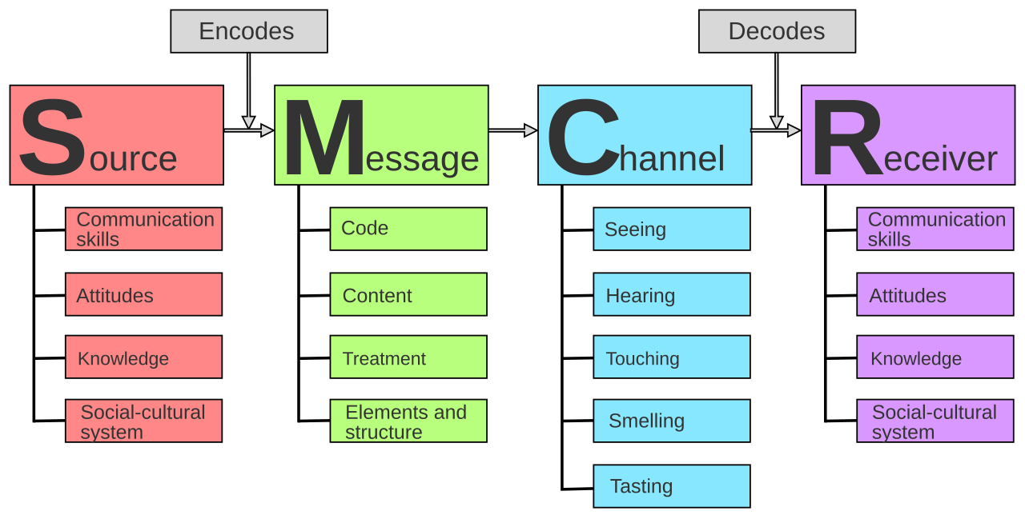

(Berlo, 1960)

Importance of Good Administrative Skills
Effective administrative skills are fundamental to professional practice in health and social care, directly influencing patient safety, quality of care, and legal compliance. For patients like Mr Ahmed, who require complex post-stroke care across multiple services, accurate record keeping ensures continuity, reduces errors, and facilitates communication among the multidisciplinary team (Demsash et al., 2023). Missed home visits, delayed medications, and inconsistencies in therapy can all be prevented or promptly addressed when records are thorough, clear, and updated in real time.
Record keeping is not only a professional obligation but a legal requirement. Documentation must be accurate, timely, relevant, and complete, covering details such as patient observations, medication administration, care interventions, and any incidents (Wahyuni et al., 2024). In Mr Ahmed’s situation, recording each domiciliary care visit, monitoring blood pressure, and noting communication challenges is crucial to identify trends, detect early complications, and support clinical decisions. Clear records also protect healthcare professionals legally in case of disputes or audits.
The introduction of electronic health records (EHRs) enhances accuracy, legibility, and accessibility of information. Studies show that structured electronic documentation improves communication between care teams, provides real-time data for clinical decision-making, and creates audit trails to track accountability (Wahyuni et al., 2024). For Mr Ahmed, EHRs enable the GP, district nurse, domiciliary carers, and speech and language therapist to access the same care plan, ensuring interventions are consistent and coordinated.
Legislation such as the Data Protection Act 2018 (DPA 2018) and UK GDPR governs the handling of personal health information. These regulations require that records are stored securely, processed lawfully, and maintained accurately. Patients have the right to access their records, request corrections, and be informed about how their data is used (GMC, 2023). In practice, this means implementing password-protected systems, controlling access to sensitive data, and following organizational policies for data retention.
Policy frameworks like the Records Management Code of Practice for Health and Social Care outline responsibilities for secure storage, retention, and lawful destruction of records (Scotland.gov, 2024). Compliance with these standards safeguards sensitive patient information, supports accountability, and fosters trust between service users and professionals.
Strong administrative skills, including precise record keeping, proper electronic documentation, and adherence to DPA 2018 principles, are essential for safe, person-centered care. For Mr Ahmed, these practices ensure continuity across his multidisciplinary care team, prevent errors, and maintain legal and ethical standards. Efficient administration supports high-quality care delivery, professional accountability, and ultimately, improved patient outcomes.

Importance of Inter-professional Collaboration
Inter-professional collaboration is essential in managing complex care needs, such as those of Mr Ahmed, a 68-year-old stroke survivor. Effective collaboration ensures coordinated, safe, and person-centered care by combining the expertise of multiple professionals, including the GP, district nurse, domiciliary care workers, and speech and language therapist (Reeves et al., 2021). Poor teamwork or communication failures between professionals can lead to fragmented care, missed interventions, and adverse outcomes, as exemplified by Mr Ahmed’s recent missed domiciliary visit.
To foster collaboration, structured approaches such as regular multidisciplinary team (MDT) meetings, shared care plans, and electronic communication platforms are effective (D’Amour et al., 2020). In Mr Ahmed’s context, weekly MDT meetings allow the GP, district nurse, and therapists to review his progress, update medication schedules, and address rehabilitation goals. Digital care records enable all team members to access real-time information, ensuring consistency and avoiding duplication of interventions.
Overcoming common challenges in multi-agency working requires clarity of roles, open communication, and mutual respect. Misunderstandings can arise due to differing professional perspectives or hierarchical barriers (Reeves et al., 2021). Strategies such as joint care protocols, clear documentation, and conflict-resolution mechanisms support effective collaboration. Engaging the family, particularly Mr Ahmed’s wife, further bridges communication gaps and reinforces adherence to care plans.
Inter-professional collaboration enhances patient safety, promotes continuity of care, and improves outcomes for complex cases like Mr Ahmed. Structured communication, shared documentation, and role clarity are key strategies to overcome barriers and deliver coordinated, high-quality care (D’Amour et al., 2020).

Table: Summary of Key Strategies in Mr Ahmed’s Care
Aspect | Application | Expected Outcome | Reference
Communication (Berlo SMCR Model) | Source: Culturally sensitive, trained staff Message: Simplified language, visual aids, written care plans in Bengali Channel: Face-to-face, pictorial prompts, digital reminders Receiver: Patient and wife; confirm understanding via “teach-back” | Improved understanding, reduced errors, enhanced adherence to care plans | Ahrens & Elias, 2023; Schouten et al., 2023
Administrative Skills | Accurate record keeping of visits, medications, therapy; timely documentation Electronic health records (EHR) for multidisciplinary access Data protection: secure storage, lawful processing under DPA 2018 | Continuity of care, prevention of missed interventions, legal compliance, patient safety | Demsash et al., 2023 ; Wahyuni et al., 2024 ; GMC, 2023
Inter-professional Collaboration | Weekly multidisciplinary team meetings (GP, district nurse, carers, therapist)Shared documentation across teamrole clarity and family engagement | Coordinated care, reduced errors, improved decision-making, patient-centered outcomes | Reeves et al., 2021 ; D’Amour et al., 2020

Conclusion
In conclusion, providing high-quality care for patients like Mr Ahmed requires a combination of effective communication, robust administrative skills, and inter-professional collaboration. Using the Berlo SMCR communication model ensures that messages are clearly encoded, delivered through appropriate channels, and accurately received, reducing misunderstandings and promoting patient-centered care (Ahrens and Elias, 2023). Accurate record keeping and compliance with the Data Protection Act 2018 underpin legal and ethical practice, supporting continuity of care and safeguarding sensitive information (Demsash et al., 2023). Finally, structured inter-professional collaboration through multidisciplinary team meetings, shared documentation, and role clarity enhances care coordination and patient safety (Reeves et al., 2021). Integrating these approaches ensures comprehensive, safe, and person-centered care, improving outcomes and quality of life for individuals with complex needs like Mr Ahmed.

REFERENCES
Ahrens, E. and Elias, M. (2023) Effective communication with linguistically diverse patients: a concept analysis. Patient Educ Couns, 115, p.107868. doi:10.1016/j.pec.2023.107868. PMID: 37480794. https://pubmed.ncbi.nlm.nih.gov/37480794/
D’Amour, D., Ferrada-Videla, M., San Martin Rodriguez, L. and Beaulieu, M.D. (2020) The conceptual basis for interprofessional collaboration: Core concepts and theoretical framework. J Interprof Care, 34(4), pp.472–480. https://pubmed.ncbi.nlm.nih.gov/32150784/
Demsash, A.W., et al. (2023) Health professionals’ routine practice documentation and its impact on care continuity and safety. PubMed Central. https://www.ncbi.nlm.nih.gov/pmc/articles/PMC9936289/
Equality Act 2010 (UK legislation) – ensures reasonable adjustments for disabled and language-impaired patients. https://www.legislation.gov.uk/ukpga/2010/15/contents
General Medical Council (GMC) (2023) Managing and protecting personal information. https://www.gmc-uk.org/professional-standards/the-professional-standards/confidentiality/managing-and-protecting-personal-information
Healthwatch England (2025) One in four patients in England find errors in medical records. https://www.theguardian.com/society/2025/may/01/one-in-four-patients-in-england-find-errors-in-medical-records-watchdog-says
Reeves, S., Pelone, F., Harrison, R., Goldman, J. and Zwarenstein, M. (2021) Interprofessional collaboration to improve professional practice and healthcare outcomes. Cochrane Database Syst Rev, 3:CD000072. https://pubmed.ncbi.nlm.nih.gov/34087031/
Schouten, B.C., Manthey, L. and Scarvaglieri, C. (2023) Teaching intercultural communication skills in healthcare to improve care for culturally and linguistically diverse patients. Patient Educ Couns, 115, p.107890. doi:10.1016/j.pec.2023.107890. PMID: 37437511. https://pubmed.ncbi.nlm.nih.gov/37437511/
Scotland.gov (2024) Records Management Code of Practice for Health and Social Care. https://www.gov.scot/publications/records-management-code-practice-health-social-care-v4-0/
Wahyuni, E.D., et al. (2024) Electronic nursing documentation for patient safety and care quality: systematic review. Journal of Pakistan Medical Association. PMID: 39279074. https://pubmed.ncbi.nlm.nih.gov/39279074/

