1/7/2021
Student name: Andreea Esanu (1713835)
Lecturer name: Rexon Nting

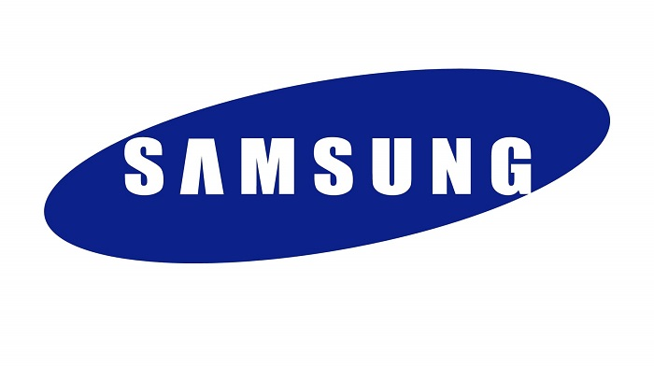
Workplace culture and impact on Organizational Efficiency- BMSW5105
Workplace culture at Samsung Company

Table of Contents
Introduction 2
SAMSUNG Background 2
Samsung vision 9
Samsung Sustainability Management System 10
Samsung’s Organizational Culture 11
Edgar Schein`s Culture Framework 12
Factors Affecting Organization Culture 12
External environmental factors that affect Samsung 13
PESTLE Analysis of Samsung 13
Samsung SWOT Analysis 17
Conclusion 18
References 20

Introduction

Everywhere in the world there are people with different needs and priorities. Technology is one of the most important things because has created amazing tools and resources which it helps you in every step you make, even if you are talking about personal life or business life. We all know that technology influences everyday life and has a strong influence on culture being incorporated in all its aspects such as travel, art, food, government. Due the pandemic period started at the beginning of this year (COVID-19), technology has become the most important tool for an effective business. Samsung, like other companies, has arranged numerous measures to provide a safe environment for everyone, and to ensure the continuous safety and wellbeing of their customers, employees and business partners all over UK, also Ireland, trying not to affect the business culture. Culture it is a shared set of beliefs, values, attitudes, purposes and behaviours. A company’s culture is important because is basically the foundation of every organisation, in order to improve levels of employee engagement, performance and productivity. A strong culture is the company’s way to acknowledge that people are the most important asset a company holds, leading to a successful business.
The report is based on facilities that Samsung provided to its employees during this harsh time that world is been through and how this external factor (COVID-19) affected the Samsung Company culture and its performance, because there are few factors that can affect the company culture and the principle is the individuals working with the organization, which contribute in their own way to the culture of the workplace with their attitudes, mentalities, interests, the way they thinks, and even the thought process of the employees affect the organization culture.

SAMSUNG Background
Samsung is a South Korean company being one of the world’s largest producers of electronic devices, also the company specializes in the production of numerous variety of consumer and industry electronics, including appliances, digital media devices, semiconductors, memory chips, and integrated systems. It has become one of the most-recognizable names in technology and produces about a fifth of South Korea’s total exports (Bondarenko, 2015).
Founded by Lee Byung-Chull on March 1, 1938, Samsung has started as a grocery trading store, trading noodles and other goods, exporting them to China and its provinces. In the end of the Korean War, the business was expanded into textile and Lee opened the largest woollen mill in Korea. In 1970 the company expanded its textile-manufacturing and new subsidiaries were established, such as: Samsung Heavy Industries, Samsung Shipbuilding, and Samsung Precision Company (Samsung Techwin). Also, during the same year the company started to invest in the heavy, chemical, and petrochemical industries, leading the company to a promising way to grow and develop.
First enter to the electronic industry for Samsung was in 1969 and their first products were black and white televisions. In early 80s Samsung had a rapidly expansion in technologies business (the late 1970s the company already began to export home electronics products overseas) and in 1978 an aerospace division was created. In 1985 a Samsung Data System was created in order to help business to growing need for systems development, which leaded the company to become a leader in information technology services. In 1990 Samsung had a continuous expansion into the global electronics markets. Even if with some scandals that impacted the company, Samsung continued to grow by creating product quality fronts such as semiconductors to computer-monitor and LCD screens, climbing the company into top-five positions in global market share. In 2000 Samsung created the Samsung Galaxy smartphones series which become the company’s most sold product being in the top annual lists of the most best-selling smartphones in the world. In this way, Samsung become in 2006 the top-selling global manufacturer of televisions and in 2010 they introduced in galaxy series the tablet computers therefore introducing the Galaxy Tab.
Being a successful company worldwide, in 2005 Chelsea is delighted to announce that Samsung Electronics Co. Ltd as its official sponsor of the English Premier League football club for the next five years (see image 1 below). In the image below as from left to right we can see Jose Mourinho, Chelsea Manager and First Team Coach, In-Soo Kim, President and Chief Executive Officer of Samsung Europe and Peter Kenyon, Chelsea Chief Executive (DIOMEDIA, n.d).
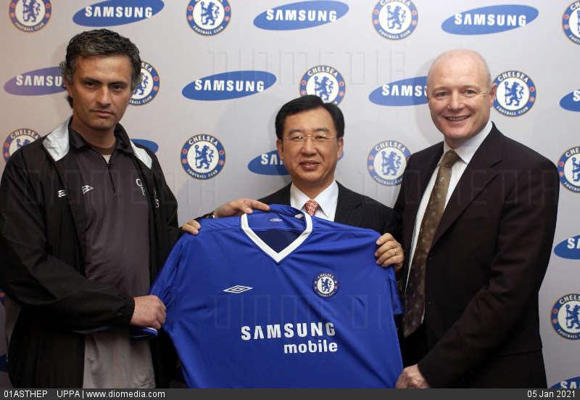
Image 1
Source: https://www.diomedia.com/stock-photo-samsung-new-sponsors-of-chelsea-fc-image17440199.html
In 2006, Samsung starting their sponsorship with the Paralympic Winter Games Torino and supporting six consecutive Paralympic Games becoming a Worldwide Partner of the International Paralympic Committee (IPC) through the innovative wireless communication technologies (see image 2 and 3 below). Also, in 2006, Samsung developed the world`s first 40 nanometer 32Gb NAND flash memory and 50 nanometer 1GB DRAM memory. In 2007 the company became an official Olympic technology sponsor and they established the Tv manufacturing in Russia in 2008, climbing the company`s brand value in the 19 places in the world by Interbrand`s 2010 Best Global Brands. In the 2010 Samsung launched the Galaxy smartphone series with the Android OS and merged with Samsung Digital Imaging.
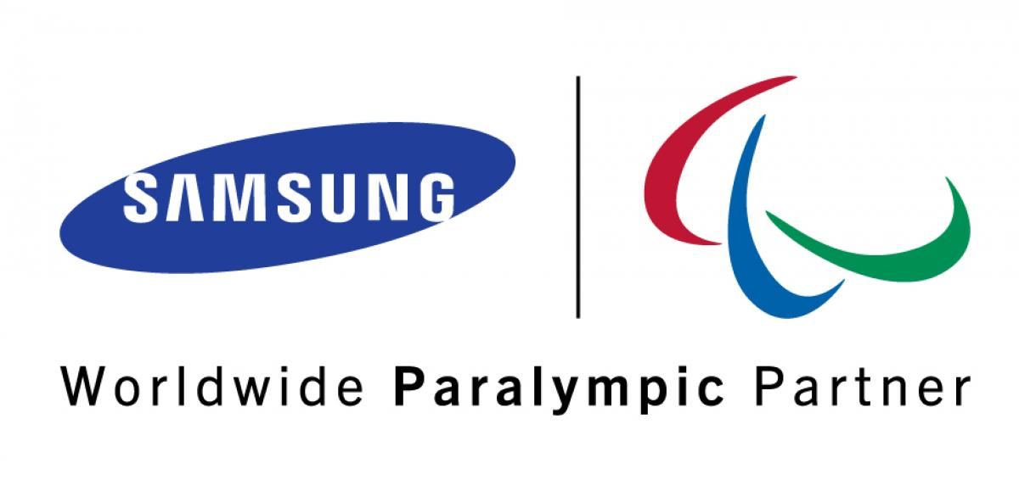
Image 2
Source: https://www.paralympic.org/news/awards-given-samsung-paralympic-bloggers-project

Image 3
Source: https://news.samsung.com/global/samsung-electronics-extends-worldwide-paralympic-partnership-through-2020

Also in 2010, Samsung acquired the medical equipment company, Medison (see image 4) which has commercialized the Live 3D technology in 2001 and since being part of Samsung Electronics in 2011 it is integrating IT, image processing, semiconductor and communication technologies into ultrasound systems for efficient and confident diagnosis (Samsung Medison, n.d).
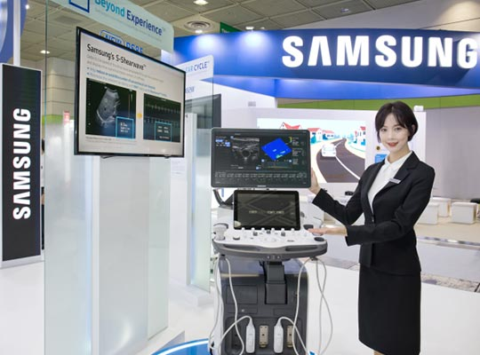
Image 4
Source: https://pulsenews.co.kr/view.php?year=2018&no=179618
In the next few years Samsung developed and launched many products that place the company in 2012 in the 9th place among global top 100 brands with a brand value of USD 32.9 billion. Also, in 2013 the company launched Samsung Galaxy S4, leading the organisation to a big success. Therefore in 2014, Samsung took the 7th place as the most valuable brand in the world, as the Interbrand`s “Best 100 Global Brands 2014” says in their report. Also in 2014, they created the first smartphone with a curved edge screen, unique at that time in the world, together with the first wearable featuring 3G connectivity device called Gear S; also they celebrated the opening of a new semiconductor factory in China and released the world`s first 105” curved UHD TV with $120.000 price tag (see image 5 below).
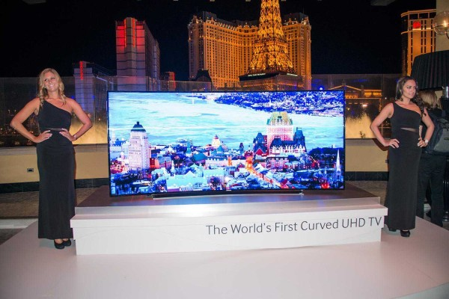
Image 5
Source: https://www.luxuo.com/lifestyle/gadgets/samsung-un105s9w-curved-uhdtv.html
In 2015 Samsung increased their success maintaining the first position in the global TV market for ten consecutive year. During this year they unveiled a personal sleep monitoring device which helps people to improve the quality of their sleep, called “ SleepSense”; also, has been launched the mobile payment service, called Samsung Pay; they launched the Gear S2 (a stylish smartwatch) and the Galaxy S6 and Galaxy S6 Edge with the first curved display on both sides in the world. They brought in 2016 to the global market the Galaxy S7 and Galaxy S7 Edge; they introduced the world`s first Universal Flash Storage (UFS) which is a removable memory card, that is offering up to 256 Gigabyte capacity.
In 2017 the company advanced with one position in Interbrand`s Best Global Brands, becoming no.6. During this year it has been unveiled Galaxy S8, S8+(together with the Samsung intelligence assistant first introduced on the Galaxy S8 and S8+) and Note8; debuted the first Cinema LED Screen in the world; and Bixby activities and her capabilities of voice were already available in over 200 locations worldwide (see image 6).
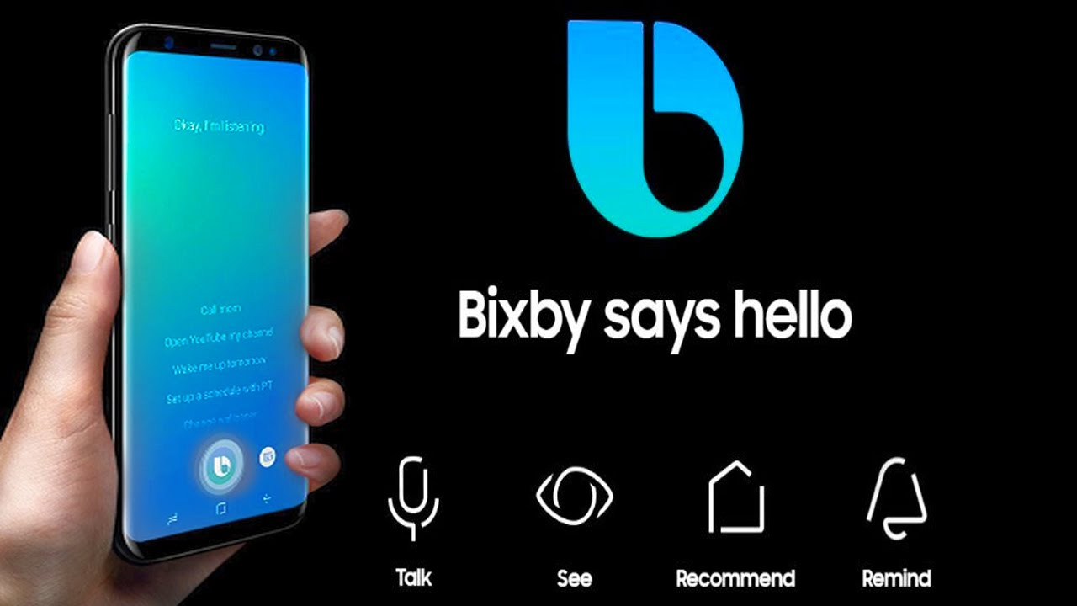
Image 6
Source: https://mspoweruser.com/samsungs-bixby-voice-assistant-now-supports-5-new-languages/
During 2018, Samsung launched in U.S and Korea the world`s first 5G network commercial equipment, also they launched the Galaxy S9, S9+ and Galaxy Note9 and introduced the world`s 3D Cinema LED for movie theatre. In the end of the year they announced mid and long-term expansion plans of renewable energy.
On the celebration of its 50th anniversary (2019) Samsung announced a new CSR vision named `Together for Tomorrow! Enabling People`; also, they put on the market 5G Smartphone `Galaxy S10 5G` and the `Galaxy Fold` with this they created a whole new mobile category. Also, Samsung announced that they have plans for a big investment in logic chip business by 2030.
On March 2020 Samsung released three models of new flagship phones: Galaxy S20, Galaxy S20+ and Galaxy S20 Ultra with 5G support and high-quality displays and sharp cameras with zoom. We can see in the images below the evolution of Samsung phones and Samsung TV. Samsung has become a powerhouse in several different industries, with more than 300 thousand employees, 215 regional offices, over 50 distribution offices located in over 70 countries worldwide (Fast Facts, n.d).
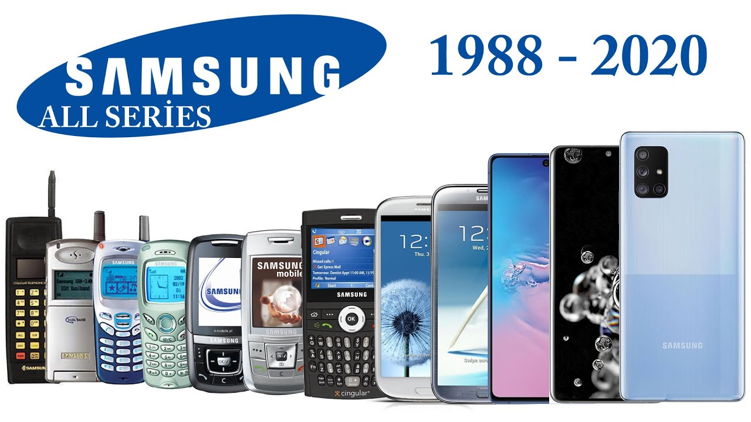
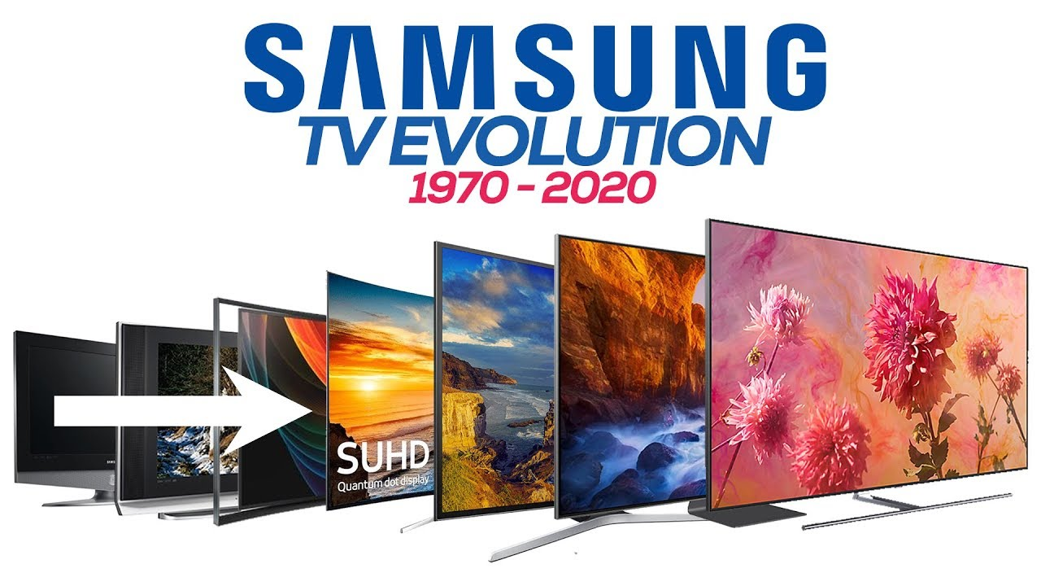

Samsung vision
In order to create the most high quality products and services that contribute to a better global society, Samsung sets a high value on its people and technologies to achieve its goals. The company has set three big goals in order to be successful, such as:
- Key Elements of Management
-based on Human Resources & Technologies
- Company Objectives (Inside goals)
-Create the best products on the market and offer the best services
- Company Objectives
-And Contribute to Society

Samsung Sustainability Management System
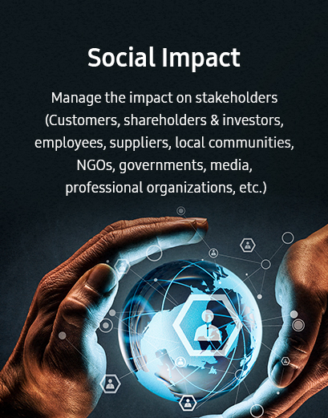
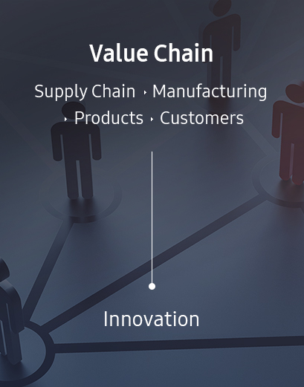
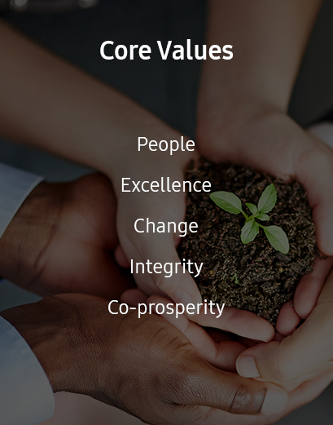

As we can see in the images above, there is a sustainability system that Samsung follow in order to create integrated values, which is their principle aim. They maximize profits and shareholders values to create economic values, also in order to create social values, Samsung is taking on a stronger responsibility as a global citizen. The core value that Samsung is pursuing is based on the delivering innovative products and services along the value chain, generating values in the fields of economy, society, and environment.

Samsung’s Organizational Culture
Culture-definition
The term “culture” should be reserved for the deeper level of basic assumptions and beliefs that are shared by members of an organisation, that operate unconsciously, and that define in a basic “taken for granted” fashion an organisation`s view of itself and its environment (Haneberg, 2008). Culture can also be defined as shared patterns of behaviours and interactions, cognitive constructs and understanding that are learned by socialization, that provide important social and economic benefits, enhancing the quality of life and increasing the well being for both individuals and communities. Culture can benefits individuals in many different ways, such as intrinsic benefits. These benefits are those who can provide emotionally and intellectually moving experiences, pushing the individual to encourage celebration or contemplation. These intrinsic benefits are coming from the things that attract us and reasons why we participate. Another benefit that culture brings is that we can improve learning and valuable skills for the future, such as develop thinking skills, builds self-esteem, and improves resilience, all of which enhance education outcomes. Also, participation in culture can improve the well-being and healthy populations, developing creativity and engagement. There are also economic benefits of culture helping the organisation in the form of productivity advancements, regional development, community branding, and increased local tourism (Ontario, 2019).
In the article “Coming to a New Awareness of Organizational Culture”, Edgar Schein (1984) defined organizational culture as “the pattern of basic assumptions that a given group has invented, discovered, or developed in learning to cope with its problems of external adaptation and internal integration, and that have worked well enough to be considered valid, and, therefore, to be taught to new members as the correct way to perceive, think, and feel in relation to those problems”. For a better understanding, in the next chapter of the report it will be discussed the Schein`s Culture Framework.

Edgar Schein`s Culture Framework
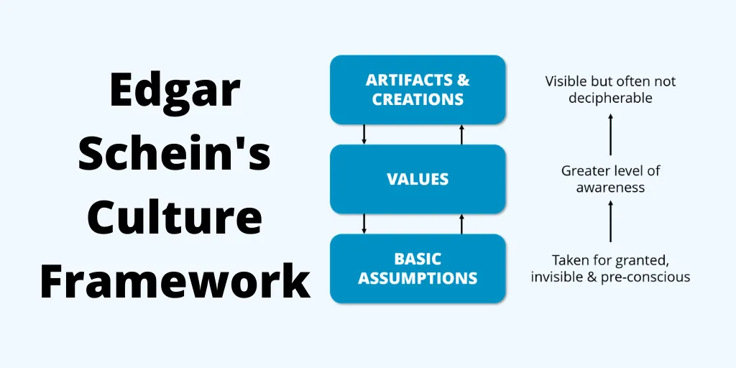
Source: https://think-boundless.com/edgar-scheins-anxiety-assumptions-powerful-ideas-on-culture/
As we can see in the image above, Schein model is presented as three different layers:
- Artifacts and Creations- these are the main symbols of the culture, meaning those things that you notice when you go to a country for the first time: the language, volume of speech, the clothing style, the food, the architecture, the houses and so on.
- Values- these are the national characteristics of a culture often founded on company websites, giving great level of awareness
- Basic assumptions- usually these are used as beliefs by people that are making daily decisions within an organization, as it is written in the diagram above: taken for granted, invisible and pre-conscious.

Factors Affecting Organization Culture
Organization culture gives the employees a sense of direction, also controls the way they behave with each other bringing them on a common platform in order to uniting them at the workplace. The main factor that can affect the organization`s culture is the individual working with the organisation, because every employee in their own way contribute to the workplace culture with their mentalities, attitudes, interests and perceptions. There are other factors that can affect the organization culture: the sex of the employee, the nature of the business, the clients and the external parties, also the culture of the organization can be affected by its goals and objectives, and by the management and its manner of handling the employees.
This crossover points to the importance of corporate culture traits in order to achieve long-term business success in technology company's various endeavours. For example, the success of Samsung's corporate social responsibility strategy depends on human resource support, which is influenced by corporate culture. In terms of relationships, corporate cultural characteristics affect the company's ability to compete with Apple, Dell, LG, Google, Sony, Intel, Acer and Lenovo. Samsung's strategic leadership and management efforts include considerations on how to use corporate culture to improve the company's competitive edge (Evans, 2018).

External environmental factors that affect Samsung
There are many factors that can influence the growth in the technology market, including evolving customer preferences, technologic advancement and the biggest factor that has had a huge impact not only on Samsung but on all business is COVID-19. During this challenging time, Samsung support the customers and their global workforce by providing resources and updates on the latest guidelines from health authorities. Also, they close some stores in order to support social distancing efforts. Being a global conglomerate that operates in the market for consumer appliances and gadgets, Samsung, during the global pandemic time, continued to use their technology and resources to direct the urgent needs of those working in frontline in order to control and fight the threat and impact of COVID-19.
Therefore, there are other factors that can affect organisational culture and its performance such as: political, economic, socio-culture, technological, legal and environmental factors (see image A below), means a PESTLE Analysis, an important tool which provides visibility into the impact, performance and control of business.

PESTLE Analysis of Samsung
Political factors- being a technology corporation, Samsung has to follow the pre-existing regulatory legislation, meaning that in some certain situation, the company has to stop selling their products from foreign markets. This can have a huge impact to business, affecting its financial success. During the manipulation of political instability, Samsung has gained and has lost a lot being involved with numerous scandals supporting the first female president of South Korea and faced terrible consequences. After many other implications with important people from South Korea Government that stopped the Samsung`s electronic sales mobile in few areas, nothing considerable changed in the other countries influences.
Economic factors- this is an important factor that helps the organisations to extend globally. The same situation happened with Samsung which opened a several markets in the world, helping the company to expand its global footprint.

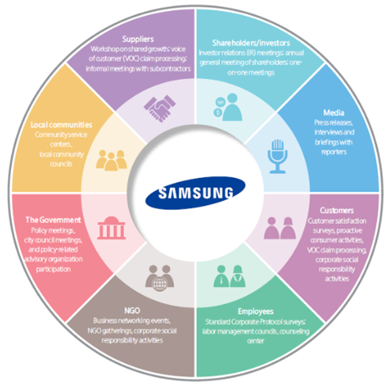
Image A
Source: https://medium.com/@silzemar/pestle-analysis-of-samsung-2020-2c282fe4b019
The volatility and instability are causing the company to adjust its strategies and continuously in the macroeconomic environment in which Samsung works globally. As their logo says, “Inspire the World, Create the Future”, Samsung is opened to new changes by improving the global community through its constant pursuit of ground-breaking innovations and value creation, hoping that they will cover for missed revenue in the developed world. During this global pandemic situation that caused the current economic crisis, Samsung needs to adapt and develop new strategies to mitigate the negative impact on the company and spreading into new and growing markets.
Socio-cultural factors- Samsung is primarily a South Korean Chaebol or a family owned multinational, means that despite its global footprint it still operates from the core as a Korean company (Management Study Guide, n.d.). in order to extend its global operations, the company has to adapt first to the local conditions, to act locally and adopt a local strategy because in each country the social-cultural factor are different and the company has to reorient its self in each market that is strongly influenced by the lifestyle preferences of consumers.
Technological factors- at this point the company is at an advantage because the technology is the main characteristic of the company. The Samsung mission is to develop and upgrades the current items. But in 2016, the company faced a critical production project error from Samsung Galaxy Note 7, launched in August. Being marked as a large screen top-end device and positioned as a rival to Apple's iPhone, a few months after launch, Samsung had to had to recall about 2.5 million phones after complaints of overheating and exploding batteries (BBC News, 2017)- see image B and C below.
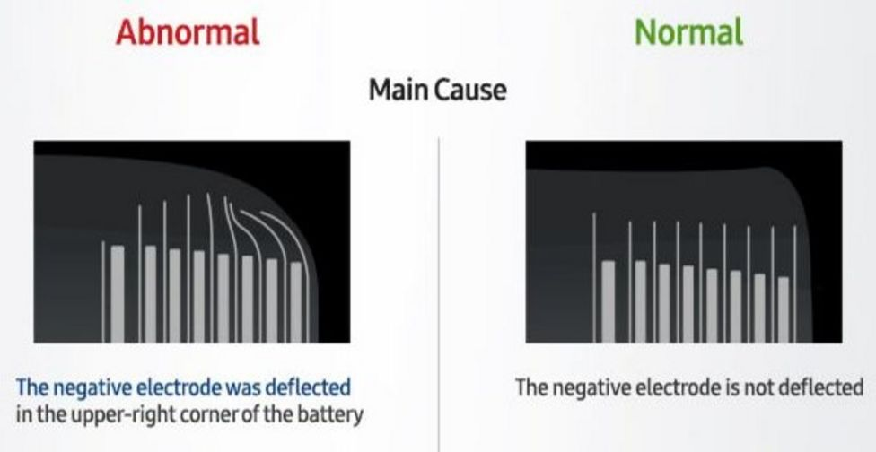
Image B- Some batteries were affected by a design error
Source: https://www.bbc.com/news/business-38714461
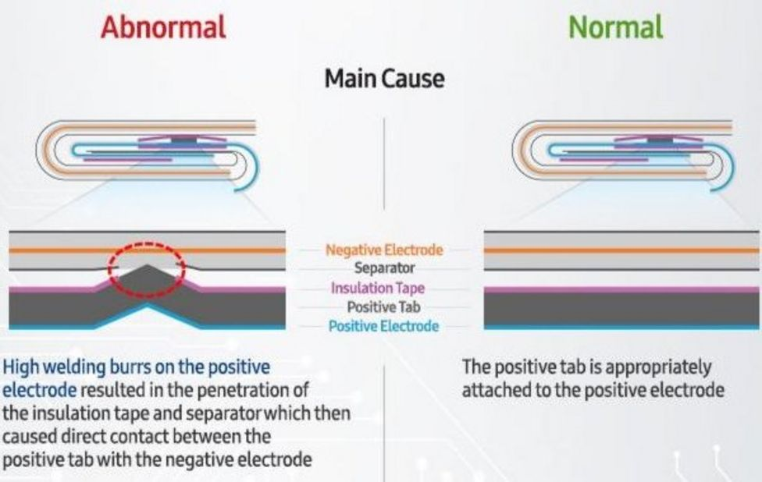
Image C- while others suffered from insulation problems
Source: https://www.bbc.com/news/business-38714461
The company said there would be no repeat of the fires in future devices such as the upcoming S8, giving a lesson here for other technology understanding and taking notes from Samsung’s experiences.
Legal factors- at this point, Samsung had to struggle with heavy penalties because there were some accusations saying that they copied Apple’s iPad and iPhone, facing lawsuit and losing a lot of money, trying to wriggle out of the legal traps.
Environmental factors- in order to make its products in a socially and environmentally responsible manner, Samsung has to make sure that the consumer knows that all products pleasure the modern customer politically correct and to ensure that they don’t compromise the working hours or conditions for those who are in charge to deliver the final products.
To conclude this section, it is important to mention that the PESTLE Analysis from above indicates that Samsung has wide experience facing critic external problems, even though there was a sales projection increase in the smartphone industry in 2020, this expectation will not be reached, and it will decrease drastically more due to the current coronavirus crisis (Silzemar, 2020).

Samsung SWOT Analysis
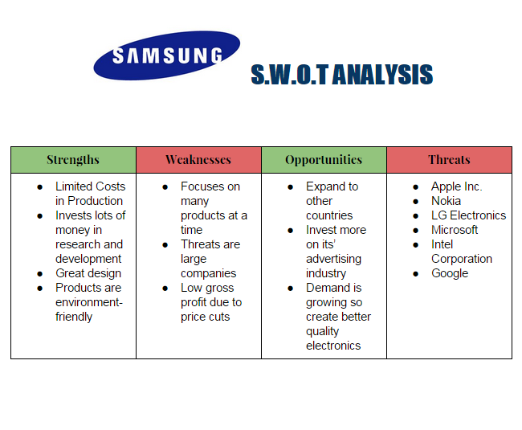
Source: https://kevinl2561.wordpress.com/2015/06/11/samsung-s-w-o-t-analysis/
As we can see in the image above there is a complete analysis of every point of a SWOT component.
Strengths- as a global company, Samsung being a large producer of mobile phones and tablets, their brand is now a common household name and has a wide product portfolio. Also, the company invest lots of money in research and development, they have strong brand name and brand loyalty, great design and the products are environment-friendly thing that pleasure modern customer politically.
Weaknesses- Competition is one of the weaknesses because other brands are overtaking in the smart phone market, for example, Huawei had 19% market share in Q1 of 2019 and Xiaomi has 8%. Also, other brands such as Apple has their brand strategy more effective than Samsung, having a stronger brand loyalty then Samsung, meaning that Samsung must spending more time and money on promotion in order to attract new customers and take away those one from Apple.
Opportunities- Samsung has the opportunity to diversify into new areas such as electric cars, because the demand is growing and can create better quality electronics, Samsung can take advantage and develop its markets in Africa and India.
Threats- the biggest threat for Samsung is Apple, which is still the top player within the market, but also other technology brands such as Nokia, Intel Corporation, Google. Also, the corona virus can be a threat for Samsung because a small percentage of their products (especially the phones) are made in China. The consumer doesn’t feel the need to upgrade the product because the technology has reached a stage where they can have everything into single device.
With a complete SWOT Analysis, Samsung can be up to date with their general situation, helping the company to face the challenging time from its competitors and market that is in a continuous changing. There is important that every organization to know their threats and how to take advantage of every opportunity that its shown in their way to accomplish their goals.
A company’s ethical standards, values, beliefs can help the organisation achieve its corporate objectives and social responsibilities and all are connecting with organisational culture, setting expectations for how people behave at workplace and how they work together as a team. It is important to know the company`s mission, objectives, expectations, and value in order to guide them to its employees. After the global pandemic situations which had and still having a big impact on our personal and work life, we all learnt how to appreciate the life and to respect others culture by supporting each other and find a way to build business models and resilient culture, with a positive attitude for customers, employees and investors.

Conclusion
In conclusion, every single organisation must be prepared for such a situation like COVID 19, because there already many factors that can affect organisational culture and its performance, and no one can risk to lose their business and must know how to face the challenges and risks. Being in a high technology area with high quality product, we can say that Samsung faced in a positive manner de current situation and they kept a low profile in workplace environment changes. As any other business, Samsung see hope in their resilience by accepting these challenges, looking after their employees, trying to offer support to their customers, and aid their communities, and dedicating resources to help those in need and help them, as a society, arise much stronger on the other side. With an innovation-centred organizational culture, that emphasizes employees’ knowledge, skills, and abilities for innovating the company’s technology products, such as smartphones and laptops, which supports the company’s mission and vision statement. Samsung`s organisational culture helps the company to develop a work environment where all employees’ career development goals are taken in consideration in an reasonable manner.
A great organizational culture is the key point in order to develop a business success and give to the company the chance to improve its major strength that brings results for a long period of time, collecting values, expectations, practices consistent and authentic behaviours, that lead to improve performance weather there are difficult times and changes, making the business`s environment to come out stronger in order to experience incredible growth.

References
About Us About Samsung Medison. (n.d.). Retrieved January 05, 2021, from Samsung Medison: https://www.samsungmedison.com/company_inf
About us- Fast Facts. (n.d.). Retrieved January 6, 2021, from Samsung Newsroom: https://news.samsung.com/global/fast-facts
About Us Samsung. (n.d.). Retrieved January 7, 2021, from Vision 2020: https://www.samsung.com/levant/aboutsamsung.html/aboutsamsung/
AFPRelaxnews. (2014, July 25). LUXUO Lifestyle. Retrieved January 5, 2021, from Samsung introduces a 105″ curved UHDTV for $120,000: https://www.luxuo.com/lifestyle/gadgets/samsung-un105s9w-curved-uhdtv.html
BBC News. (2017, January 23). Retrieved January 7, 2021, from Samsung confirms battery faults as cause of Note 7 fires: https://www.bbc.com/news/business-38714461
Bondarenko, P. (2015, September 2015). Samsung South Korean Company: Britannica. Retrieved January 04, 2021, from Britannica: https://www.britannica.com/topic/Samsung-Electronics
Evans, L. (2018, March 18). Panmore Institute. Retrieved January 6, 2021, from Samsung’s Organizational Culture & Its Characteristics (An Analysis): http://panmore.com/samsung-organizational-culture-corporate-cultural-characteristics-analysis
Haneberg, L. (2008). ASTD Handbook for Workplace Learning Professionals. Alexandria, United States: Association for Talent Development. Retrieved January 7, 2021, from https://search-proquest-com.ezproxy.uwtsd.ac.uk/books/section-vii-organizational-level-applications/docview/896136439/se-2?accountid=130472
Ontario. (2019, October 21). Retrieved January 7, 2021, from The importance of culture: https://www.ontario.ca/document/environmental-scan-culture-sector-ontario-culture-strategy-background-document/importance-culture#foot-24
SAMSUNG NEW SPONSORS OF CHELSEA F.C: DIOMEDIA. (n.d.). Retrieved January 05, 2021, from DIOMEDIA: https://www.diomedia.com/stock-photo-samsung-new-sponsors-of-chelsea-fc-image17440199.html
Schein, E. (1984, January 15). Coming to a New Awareness of Organizational Culture. MITSloan Management Review. Retrieved January 7, 2021, from https://sloanreview.mit.edu/article/coming-to-a-new-awareness-of-organizational-culture/?use_credit=fecf2c550171d3195c879d115440ae45
Silzemar, D. F. (2020, May 19). PESTLE ANALYSIS OF SAMSUNG 2020. Retrieved January 7, 2021, from Medium: https://medium.com/@silzemar/pestle-analysis-of-samsung-2020-2c282fe4b019
Surur. (2018, December 12). Samsung’s Bixby voice assistant now supports 5 new languages. Retrieved January 5, 2021, from MSPoweruser: https://mspoweruser.com/samsungs-bixby-voice-assistant-now-supports-5-new-languages/

