BA (HONS) LEADERSHIP AND MANAGEMENT SKILLS FOR THE WORKPLACE
MODULE: DEVELOPING RELATIONSHIPS AND WORKPLACE ACHIEVEMENTS
NAME: MIRABELA DAFINA LUNGU

STUDENT ID: 2111136

LECTURER NAME: APARNA VENKATESAN

Table of Contents
Introduction 2
Critical evaluation of the development vehicles 2
Types of Performance appraisal methods and their effectiveness 3
360-degree Feedback 3
Effectiveness of 360-degree Feedback 3
Management by Objective 4
Effectiveness of Management by Objective 4
Behaviourally Anchored Rating Scale (BARS) 5
Effectiveness of Behaviourally Anchored Rating Scale (BARS) 6
Human resource management theories 6
Strategic Contingency Theory 6
Scientific Management Theory 7
Professional Development Plan of Integrated Service Solutions Ltd (ISS Linton) 7
Conclusion 11
References 13

Introduction
The following report will shed light on the various development vehicles which are a combination of performance appraisal tools and techniques which motivates the employees working for the Integrated Service Solutions (ISS LINTON). Developing healthy relationships and setting certain workplace achievement goals in an organisation is the building block of a successful company. ISS LINTON provides an end-to-end service starting from the port to the customer depot via the modern pack house and through the different logistics partners. ISS LINTON packs and carries various organic and inorganic produce while specialising in those sectors which require more attention to detail. The company guarantees full satisfaction of the customers and that they will get great products which are handled expertly each and every time. The following report will also give a brief description on the types of performance appraisal methods like the 360-degree feedback, management by objective and behaviourally Anchored Rating Scale. Proceeding to the next level, the report will highlight the two types of human resource management theories which are Strategic Contingency Theory and the Scientific Management Theory and will also tell how they are inherited by ISS LINTON.

Critical evaluation of the development vehicles
As per the opinion of (Tang, 2019), an organisation is not just run by employees but also the development values which are inbuilt inside them. There are certain types of development vehicles that drive the best out of the employees and they are able to contribute towards a successful and health organisation (OKPIMAH et al., 2022). Some of the employee development vehicles are training, coaching, mentoring, stimulation, conferences, on the job training, self-study and career planning. These developmental vehicles are undertaken by ISS LINTON in order to train the employees with these skills so that they can update themselves according to the technological advances that are happening in the business environment and can accordingly serve to cater the needs of the customers (Paris, 2019).

Types of Performance appraisal methods and their effectiveness

360-degree Feedback
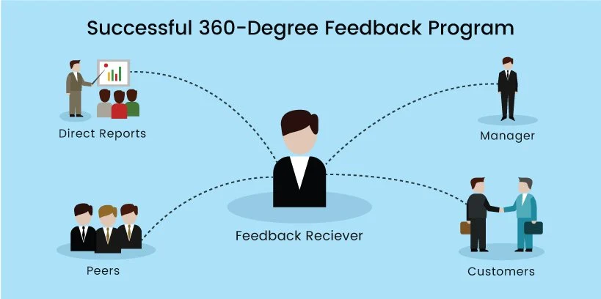
Figure 1: 360-degree feedback
(Source: Fleenor, Taylor and Chappelow, 2020)
The 360-degree feedback is a type of multidimensional appraisal feedback which assesses an employee based on the feedback that is mainly collected from the employee’s range of influence which includes his/her manager, peers, direct reports and customers (Fleenor, Taylor and Chappelow, 2020). It is one of the most important types of performance appraisal in any organisation. The different reviews given by different individuals are self-appraisals where it allows the employees to look thoroughly at their past performance and identify their strengths and weaknesses, managerial reviews where the manager is given the responsibility for the performance appraisal of the employee which is also a kind of basic traditional form of appraisal and also the customer reviews because they are the ones who are considered the most important element of a business. The reviews given by the customers or clients are considered to be most authentic because they are able to evaluate the output of the employees better than any other individual of the organisation.

Effectiveness of 360-degree Feedback
The 360-degree feedback is very much effective for an organisation that is trying to climb up the business ladder of success. It increases the employee’s awareness and makes them understand the amount of impact they create on other stakeholders. This type of feedback is being inherited by the ISS LINTON to help the employees to self-introspect their strengths and weaknesses by encouraging them to invest in different self-development areas. ISS LINTON inherits the 360-degree feedback wherein it keeps a maintained review of its employees to ascertain what values they are adding to the company. The company also tries to integrate the performance feedback along with the work culture to ensure sustainability and promote social culture in the organisation.

Management by Objective
Management by Objective is a kind of appraisal method where the managers and employees work together in an organisation and identify, plan and execute their target of achieving a specific goal. They also communicate different objectives which need to get a focus during the specific period of appraisal. There must be a set of goals, not a single goal specified in the papers. Once the goals are set, then the subordinates and the managers try to communicate between different periods regarding the progress being made in their work and they also debate upon the feasibility of attaining those set of objectives. This kind of performance method appraisal is mainly followed to achieve an overreaching target which requires a lot of planning, evaluating and executing the target. The employees also try to validate their objectives by using the SMART method to ensure that the set of objectives are Specific, Measurable, Achievable, Realistic and Time sensitive.
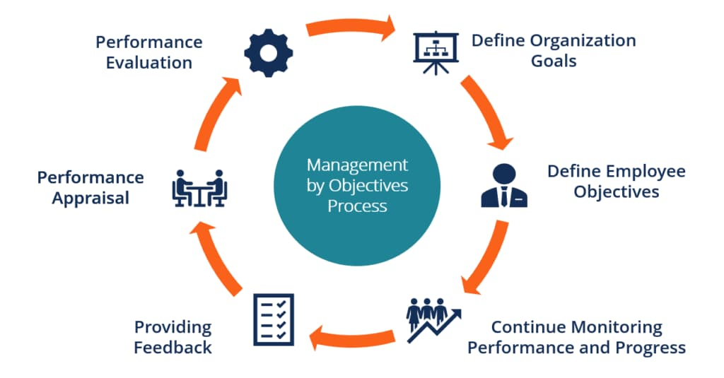
Figure 2: Management by objective
(Source: Petchrompo, Wannakrairot and Parlikad, 2022)

Effectiveness of Management by Objective
ISS LINTON successfully inherits the management by objective form of appraisal in its organisation whenever it has a target to achieve some overarching goal. These overarching goals can be the consignment of the shipping of huge bulk organic or inorganic produce to a distant place. In order to achieve the targets, ISS LINTON ’s managerial body discusses it with some of the senior employees and arranges the required resources in order to achieve the target. The company regularly engages with the customers to keep a track of the activities that are taking place in order to achieve the targets. Since the targets are set high, it becomes quite tedious for the employees to achieve all of it but if they turn out to be successful, they are judged by their results. A good result especially turns into a promotional opportunity for the employees who had to work hard to earn the same.

Behaviourally Anchored Rating Scale (BARS)
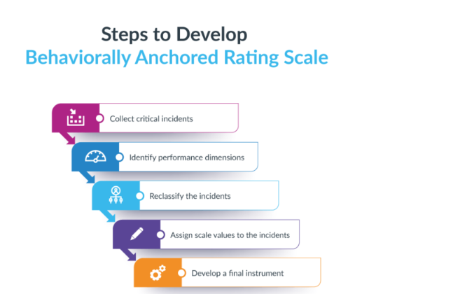
Figure 3: Behaviourally Anchored Rating Scale (BARS)
(Source: Nugraha, Aisha and Suwarsono, 2020)

As stated by Nugraha, Aisha and Suwarsono, (2020), the Behaviourally Anchored Rating Scale (BARS) is a performance-based appraisal that ascertains both the qualitative and quantitative determinants in the appraisal process. BARS always constructs a set of behavioural examples and compares the employee’s performance based on it. They are provided with different numerical ratings based on their performance (Mo et al., 2023) There is a bar scale under this appraisal method where each and every performance level of the employees is anchored by different bar scales which describes the employee’s behaviour which they routinely exhibit. The bar scales act as different yardsticks to measure an employee’s individual performance against some predetermined standards. The first and foremost step in BARS creation is the establishment of certain critical incidents which depict the behavioural workplace (Petchrompo, Wannakrairot and Parlikad, 2022). The next step is the editing of the critical incidents and bringing them in a common format and thereby reducing the redundancy. The critical incidents that are left, they are used in order to create BARS and evaluate the employee’s performance.

Effectiveness of Behaviourally Anchored Rating Scale (BARS)
ISS LINTON successfully implements the Behaviourally Anchored Rating Scale (BARS) under its umbrella. The company maintains the BARS scales and gives different ratings based on the qualitative and quantitative aspects of work of the employees (Baik, Kim and Patel, 2019). By doing so, the company is able to decrease the chance of any type of bias thereby ensuring a fair amount of judgement through the process of appraisal. The company is also able to enjoy the clear standards, consistent evaluation and improved feedback analysis. It also helps the company to eliminate the construct which is irrelevant in the performance appraisal in order to put emphasis more on the concrete, observable and specific behaviours (Holland et al., 2022).

Human resource management theories
Human resource management theories are different kinds of strategies, objectives and theories which are used by the managers and the business owners to administer the policies and procedures which are related to the employees. The theories explain how the management’s structures and practices can influence the behaviour of the employees.

Strategic Contingency Theory
The Strategic Contingency Theory is one of the most important types of Human resource management theories which is mainly based upon two theories which are strategy and contingency respectively (Kurniawati, Musnadi and Kesuma, 2022). This theory was coined by DJ Hickson in the year 1971. According to the Strategic Contingency Theory, a leader is considered as the central part of the organisation upon which the different tasks of the subunits create an effect. The contingency in this theory becomes strategic when the other subunits start controlling the various contingencies and thus becomes powerful in the organisation (Fernández-Robin et al., 2019). Some factors like power and politics play an important role in this kind of theory. Some of the assumptions in the Strategic Contingency Theory are that the power of different subunits depends usually on few contingencies (Sjahruddin et al., 2022).
The Strategic Contingency Theory de-emphasises the personality trait and straight focuses on the problem-solving management of an employee. ISS LINTON successfully installed this kind of theory thereby objectifying certain leadership techniques rather than relying on certain personality traits (Hadi, Iskandar and Fitriadi, 2021). The company aims to define the dependencies of different subunits by control of their contingencies. The central positioning of the leader acts as a source of power and it can also be categorised as immediacy and the pervasiveness. Pervasiveness can be defined as the positioning of the subunit in ISS LINTON whereas immediacy is concerned with the power of the subunit in the overall performance (Asana, Sudipa and Putra, 2021).

Scientific Management Theory
Scientific Management Theory is a certain kind of procedure that aims to improve the efficiency of a workplace (Reed 2020). Scientific Management Theory as the name suggests, uses certain scientific methods in order to access the work processes. This theory was coined by Frederick Taylor (John-Eke and Eke, 2020). The scientific management theory undertaken by ISS LINTON is based on certain principles which mainly include assigning the workers with the task in which they excel or the ones which are their natural skillset, dividing the workload equally among the employees and the managers, and choosing the methods which are mainly based on science. This theory helps in the better establishment of the organisation in a more structured way by following the principles based on which the theory is established (Haveman and Wetts, 2019).

Professional Development Plan of Integrated Service Solutions Ltd (ISS Linton)

Development Objectives | Priority | Activities to be undertaken | Resources | Target Start date | Target End date | Evaluation
To make the company- ISS LINTON adapt to the changing environment. | This kind of development objective in a company is of high priority and it should be achieved by the organisation as soon as possible. If the organisation does not change according to the technology that keeps on changing everyday then it would be difficult for the customers to rely on the organisation for their products and they will start looking for food alternatives. | In order to keep the ISS LINTON updated according to the changing environment, there should be a strategic team who will be responsible for keeping a track on the new changes of the environment. | The strategic team will be in need of proper informative resources like newspapers, access to digital media news, E-news, journals and many more. | 20/03/2023 | 30/04/2023 | Once the strategic teams come into action then it will start notifying the changes happening in the technological world and subsequently it can freeport these changes to the executing team who will do the needful changes which are necessary for the success of ISS LINTON.
To improve ISS LINTON’S performance in terms of profitability and market share. | It is one of the most important high priorities of an organisation. The level of competition in the business world is increasing on a dynamic scale. If the companies do not increase their profit share, then it would not be considered competent enough in the business market. | In order to improve ISS LINTON’S performance in terms of profitability it should increase its sale by curtailing certain extra costs over its products or induce some discounts on various organic products which they generally deal with during their shipping. | The company will be in need of more products and a variety of new products through which it can offer a wide variety of products to the customers and also the various stakeholders in order to increase the market share of the company. | 25/03/2023 | 15/05/2023 | Once there is an availability of the new and varied products then it will reach a wider section of the public thereby increasing its sale which in turn will improve ISS LINTON’S profitability and also market share.
Focussing on ISS LINTON as a team. | ISS LINTON should start focussing on working as a team rather than different managerial teams or subunits. | In order to achieve this objective, it should start work on the interpersonal and personal behaviours of the employees within the organisation. | The biggest resources that are required under this objective are the employees because until and unless they will know each other, they cannot work together as a team. | 01/04/2023 | 10/05/2023 | Team work always enables an organisation to prosper in the business world. Once this objective is executed, the company can be successful not only in monitory manner but also in the goodwill of the company
Improving the capability of ISS LINTON. | ISS LINTON should start focussing on the capability of the employees and provide them with different chances to prove their capability in the organisation. | It should start giving different challenges to the employees and test their individual capabilities as they tackle those challenges. | Different situational based case studies can be provided to the employees. Therefore, theoretical managerial books will be much needed by ISS LINTON. | 10/04/2023 | 20/05/2023 | The fulfilment of this objective will ensure self-independent employees who will be self-sufficient enough to handle the problems in case of any kind of crisis.
To encourage the employees to solve different problems. | ISS LINTON should always encourage its employees to actively participate in the problems and provide a solution accordingly. | It should provide different practical case studies to the employees. | The resources which will be needed in order to fulfil this objective will be different practical handouts relating to various case studies. | 17/04/2023 | 15/06/2023 | This objective will always ensure the efficiency of the employees of the organisation.

Conclusion
From the above report, it has been concluded that development vehicles and setting different workplace achievements is equally essential for a company to be successful in the business world. The following report evaluated certain development vehicles critically and mentioned their uses and their implementation. The report further stated different types of performance appraisal methods like the 360-degree feedback, management by objective and Behaviourally Anchored Rating Scale (BARS) and also stated their effectiveness in ISS LINTON. There was also a brief discussion on Strategic Contingency Theory and Scientific Management Theory followed by a Professional Development Plan of Integrated Service Solutions Ltd (ISS Linton). All the following appraisal methods and human resource management helped to understand the company in an organised manner.

References
Asana, I.M.D.P., Sudipa, I.G.I. and Putra, K.A.P., 2021. A Decision Support System on Employee Assessment Using Analytical Network Process (ANP) and BARS Methods. Jurnal Teknik Informatika CIT Medicom, 13(1), pp.1-12.
Baik, K., Kim, K.Y. and Patel, P.C., 2019. The internal ecosystem of high performance work system and employee service-providing capability: A contingency approach for servitizing firms. Journal of Business Research, 104, pp.402-410.
Fernández-Robin, C., Celemín-Pedroche, M.S ., Santander-Astorga, P. and Alonso-Almeida, M.D.M., 2019. Green practices in hospitality: A contingency approach. Sustainability, 11(13), p.3737.
Fleenor, J.W., Taylor, S. and Chappelow, C., 2020. Leveraging the impact of 360-degree feedback. Berrett-Koehler Publishers.
Hadi, K., Iskandar, I. and Fitriadi, M.A., Employee Performance Assessment with Behaviorally Anchor Rating Scale (BARS) Approach: A Case Study.
Haveman, H.A. and Wetts, R., 2019. Organizational theory: From classical sociology to the 1970s. Sociology Compass, 13(3), p.e12627.
Holland, J.R., Arnold, D.H., Hanson, H.R., Solomon, B.J., Jones, N.E., Anderson, T.W., Gong, W., Lindsell, C.J., Crook, T.W. and Ciener, D.A., 2022. Reliability of the Behaviorally Anchored Rating Scale (BARS) for assessing non-technical skills of medical students in simulated scenarios. Medical Education Online, 27(1), p.2070940.
John-Eke, E.C. and Eke, J.K., 2020. Strategic planning and crisis management styles in organizations: A review of related literature. Journal of Strategic Management, 5(1), pp.36-46.
Kurniawati, E., Musnadi, S. and Kesuma, T.M., 2022. Analysis of Position Based on Behaviorally Anchored Rating Scales (Bars) and Personnel Capacity on Career Development and Its Implications on the Aceh Selatan Regional Secretariat Employee Performance.
Mo, R., Wang, Y., Dong, S., Ma, J. and Mo, Y., 2023. Ecosystem Service Evaluation and Multi-Objective Management of Pinus massoniana Lamb. Plantations in Guangxi, China. Forests, 14(2), p.213.
Nugraha, F.N., Aisha, A.N. and Suwarsono, L.W., 2020. 360-Degree Feedback Practices: Pure Blood or Wanna Be?-A Review. no, 1, pp.519-525.
OKPIMAH, S.A.E.O., Emoefe, S.A., OPATAYO, K. and Titilayo, K., 2022. THE EFFECT OF STRATEGIC HUMAN RESOURCE MANAGEMENT ON EMPLOYEE JOB SATISFACTION: THE STUDY OF SELECTED OIL AND GAS COMPANIES IN NIGERIA. WEST AFRICA DYNAMIC JOURNAL OF HUMANITIES, SOCIAL AND MANAGEMENT SCIENCES AND EDUCATION: CAPE COAST, GHANA.
Paris, I., 2019. Between efficiency and comfort: The organization of domestic work and space from home economics to scientific management, 1841–1913. History and Technology, 35(1), pp.81-104.
Petchrompo, S., Wannakrairot, A. and Parlikad, A.K., 2022. Pruning Pareto optimal solutions for multi-objective portfolio asset management. European Journal of Operational Research, 297(1), pp.203-220.
Reed, S.J., 2020. Measuring learning and engagement during debriefing: A new instrument. Clinical Simulation in Nursing, 46, pp.15-21.
Sjahruddin, H., Hidayat, P., Moridu, I. and Sutaguna, I.N.T., 2022. Determination of The Best Employee Using The Behavioral Anchor Rating Scale. Jurnal Mantik, 6(3), pp.2753-2758.
Tang, Z., 2019. Rural revitalization and scientific management in the Pearl River Delta—scientific decision based on scientific rationality and public understanding. Global Transitions, 1, pp.241-250.

