UWTSD
The impact of Covid-19 lockdown on sustainable logistics and transportation.
Cameron Rees
1900641
8th November 2020
Sustainable Logistics Operations (M5X01284)

Contents Page

- Introduction
- What have different types of transportation logistics done differently due to Covid-19 lockdown in order to be sustainable.
- Air Transportation
- Cost structure
- Effect on passenger traffic
- Effect on revenues
- Adaption to Covid-19
- Water Transportation
- Port Closures
- Less demand for cargo
- What actions have been made in order to maintain sustainability for water transportation.
- Road Transportation
- How road freight transportation has been impacted by Covid-19 globally
- Impacts on European road passenger transport
- Triple Bottom Line
- Conclusion
- References

Introduction
In this report I will be addressing and conducting an assignment based on the key factors on how sustainable logistics and transportation has been affected by the COVID-19 lockdown. Sustainable logistics can be defined as producing and distributing goods or products in a sustainable way taking account of environmental, financial, and social factors. From this I will be talking about how different types of logistic transportation have responded and also be looking at an organisations perspective when considering the environmental, financial and social factors in order to determine if the covid-19 lockdown has made an impact on sustainable logistics and transportation. In this report I will also talk about how organisations have adapted in order to minimise loss due to COVID-19 19 and has this resulted in permanent change in companies or do they have a sustainable plan of action for the future?. Finally, I will explain and discuss what the triple bottom line is and how does this effect supply chain sustainability. The triple bottom line is a measure of sustainability that involves environmental (Planet), financial (Profit) and social (People) measures that helps provide that there is a long-term supply of people, natural resources, and profit.
What have different types of transportation logistics done differently due to Covid-19 lockdown in order to be sustainable.
Air Transportation
Air transportation is crucial to the economic progression of cities countries and continents. They supply to economies by providing services to airlines, transporting passengers, and also transporting cargo. Governments, Consumers, and companies also profit from the movement of goods and people this is why air transportation is key in order to maintain a strong economy. As a consequence of Covid-19 airports have suffered greatly as airlines have urgently cut flight capacity which has led to the decrease in air travel. The extensive impact of COVID-19 on the global economy is colossal and this has played a huge part on why airports are essential in the economic development in cities countries and continents.
Cost structure
When facing a decline in demand airport owners and operators have limited scope to curtail costs. Due to safety and security services, infrastructure associated with the provision and maintenance have extremely high fixed costs. “Operating expenses comprise about 65 percent of total costs and include staff costs (30–40 percent), contracted services (20–25 percent), utilities (about 7 percent), and rent or concession fees (about 7 percent). Capital costs (on average, 35 percent) mainly comprise depreciation (about 65 percent) and interest payments (about 32 percent).”
(Twinn, 2020)
Effect on passenger traffic
Air transport globally has seen a decreased number of passengers due to the Covid-19 pandemic. Due to the widespread deadly virus, governments suggested to avert travel and airport closures as containment measures were taken place in response to the very fast-moving virus that began in Asia. According to ACI (Advance Cargo Information) global air traffic has seen a dramatic decrease due to the containment measures that were taken place. In February 2020 global air traffic decreased by 22.9 percent and in March it had dropped to 53.1 percent. These figures represent a massive reduction in passengers equivalent to 620 million in the first quarter of 2020. Globally by April 90 percent of passenger traffic volumes had decreased.
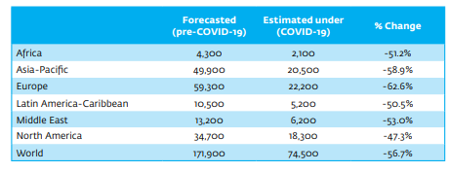
Effect on revenues

The table above shows the results from forecasted (Pre-Covid-19) vs Approximated under (Covid-19) the figures under the forecasted and estimated are shown as million usd. From the table above it shows a colossal drop from each region by roughly 50 percent or more. This percentage loss is made from aeronautical and non-aeronautical activities.
Both aeronautical and non-aeronautical have almost been unactive due to the sudden drop in air traffic. Due to people not flying, revenue from non-aeronautical bases such as duty free, restaurants and parking facilities collapse. Same goes for aeronautical revenues due to the cut capacity of passengers less flights are taking off which means there is a fall in landing charges for the aircraft and security charges.
Even through Covid-19 various airports have remained open for cargo purposes, which should provide some comfort to airports. Cargo is normally transported in the belly of a passenger aircraft however cargo operations have been affected due to the airlines’ decrease in capacity. Due to this decrease in capacity airlines were charging with much higher rates even though both demand and capacity for air cargo decreased in February 2020 due to Covid-19. The reason for the higher rates charged by the airlines is due to the fact that less than 10 percent of the total airport revenues is provided by cargo revenues. With no passenger flights airlines need to make some sort of income in order to survive hence the reason to increase the rates of air cargo.
Adaption to Covid-19
In response to the Covid-19 the support of the government is crucial to ensure the survival of aviation. As well as the governments help, airports are reducing costs to save revenue. Firstly, airports are calling for the governments help in order to protect airport revenues, to start they are asking to easy up on airport slot usage requirements for cargo needs and also provide relief from airport taxes. $3 billion out $58 billion in grants for airport contractors such as caterers have been awarded by the US government to help passenger airlines. Secondly, costs are being reduced by airports in order to adapt and survive this devastating virus. Actions such as closing portions of infrastructure (e.g. runways), furloughing staff or reducing wages and also cancelling Capex. For example, in early April staff at Heathrow airport were asked to take reduced salaries of 10-15 percent for the next 9 months in order for companies and airports to be able to adapt during the global pandemic.

Water Transportation
Water transportation such as Bulk carriers, general cargo ships, container ships, tankers and barges are the oldest but cheapest form of transport. Except from canals, construction and maintenance do not need big capital investment due to the fact that water transportation operates on a natural track e.g. Seas and oceans. Due to water transportation taking routes that are natural the cost of operating the transportation is much lower than other modes of transport. Water transportation is one of if not the best form of transport as it can transport bulky goods and products over long distances and also it has the biggest carrying capacity. Due to water transportation providing all these great advantages it has contributed a key role in joining the world closer and is now indispensable to foreign trade. (Agarwal, no date)
Port Closures
Some vessels due to COVID-19 19 have been left on the water even though they do not have a destination port to travel to. This is due to the ban of marine vessels into certain countries as those countries are trying to lower the number of coronavirus cases, ensure the safety and well-being of workers and also the closure of ports due to quarantine periods. There has been carnage within marine transportation facilities worldwide as the entry of vessels by certain countries has been limited or banned.
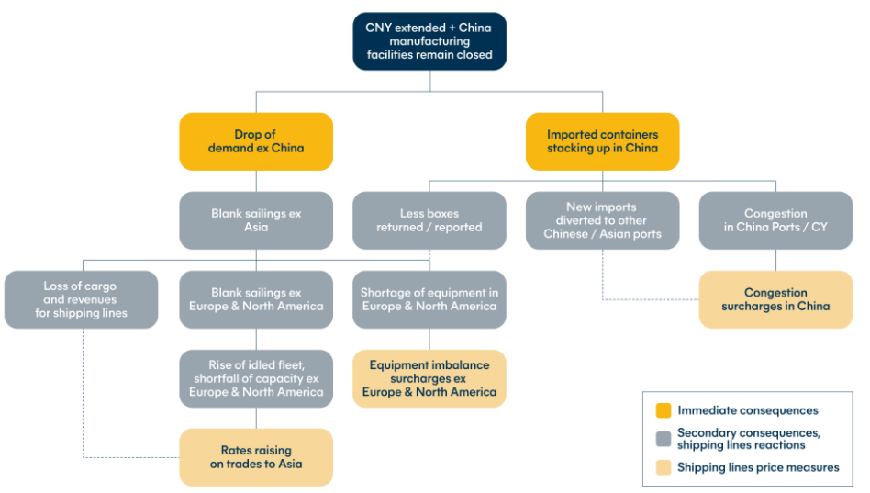

(Covid-19 impact on shipping industry, no date)

Less demand for cargo
Products and goods between various countries and regions has decreased in terms of how much is being imported and exported, as health authorities from every county are not taking any risks of spreading Covid-19. The demand for cargos now has been limited due to goods and products that have been once transported conveniently on a ship or any other type of water-based transport have now to abide to new rules and procedures. Moreover, another reason for the increased decline of demand for cargos is due to the complexity of quarantine periods that have led to delays and postponements in transportation. Finally, adequate authorities in each country have to prescribe a waiting time for goods or products to be transported. Perishable goods cannot be transported however because firstly, either there is a waiting period of 14 days or the waiting time has not been prescribed by adequate authorities in every country.
What actions have been made in order to maintain sustainability for water transportation.
In the shipping and maritime industry due to the outbreak of Covid-19 mandatory precaution measurements have been issued by the FTA (The Federal Transport Authority) who are based in the UAE (United Arab Emirates). These measures and methods that have been instructed for allowing the entry of vessels and containers through waterways are meant to be executed globally by each country. The safety of the staff and users who are involved within the transportation process is top priority in order to maintain a negative effect of this contagious virus. The first measure or method that has been put in place is the cutting of staff interacting with transportation to ensure the virus does not spread. Secondly, the staff who have not been cut they have to maintain a two-metre distancing policy when dealing with customers or the public. Next, adequate authorities have said that disinfection the form of transport and facilities needs to be taken place regularly. Moreover, if somebody onboard catches the virus the transportation must have back up human resources in order for operations to be maintained on the ship. Another measurement that has taken place is, if a ship is entering a new country, the ship must contact that country and get a brief of what that countries procedures are if somebody onboard catches Covid-19. They do this to be more organised and get a better understanding so that if a member of staff catches the virus while in this country they will already know how to facilitate the reporting and how to keep this person as safe as possible (STA Law Firm, 2020)
Road Transportation
Covid-19 has affected all modes of transportation however road transportation has suffered the most due to this global pandemic. This is due to procedures and restrictions of transport and movement that have been put in place by countries all around the world which had resulted in interruptions to mobility networks and supply chains and also the overall economic slowdown. Due to these restrictions, transport operator finances have been greatly affected, including cash flow and revenue which is moving various companies closer to bankruptcy. Road transport in terms of logistics point of view is a key component of economic and social activity, the restoration from Covid-19 in countries globally is at great risk.
How road freight transportation has been impacted by Covid-19 globally
Movement restrictions, health screening and border closures and controls have caused the world an expected decrease in annual turnover by -18 percent which is equivalent to a loss of $551 billion based on 78 major economises globally.
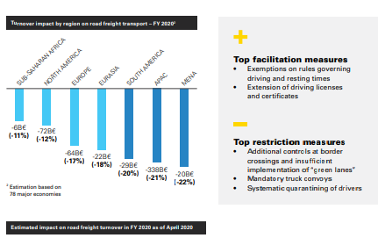

Impacts on European road passenger transport
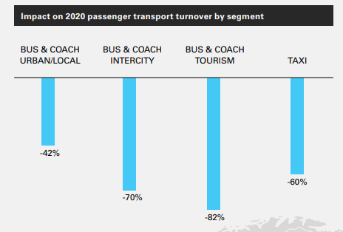
The average annual turnover in Europe for passenger road transport has been estimated to be at a decline of -57 percent which is equivalent to around a loss of $81 billion. This is due to the banning of public transport and international movements along Europe, with the biggest impact on the tourism sector. The most affected countries in Europe include Bulgaria, Spain, the UK and also Sweden as shown from the diagrams below.
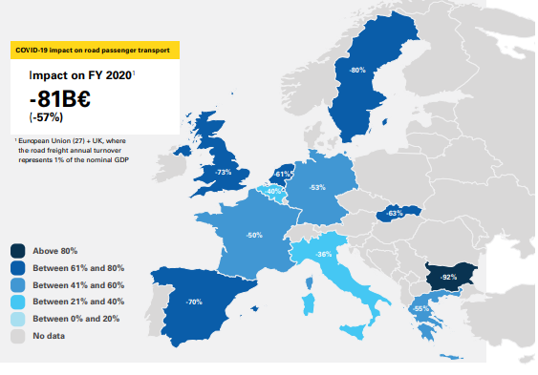

(IRU, 2020)
Triple Bottom Line
As mentioned from my introduction the triple bottom line is a measure of sustainability that involves environmental (Planet), financial (Profit) and social (People) measures that helps provide that there is a long-term supply of people, natural resources, and profit.
Covid-19 has impacted the triple bottom line massively in all 3 aspects of the triple bottom line (People, Planet and Profit). Firstly, one example which covers every aspect of the triple bottom line is the involvement of airlines. The first aspect out of the 3 I would like to talk about is the social aspect and how Covid-19 is making people redundant and out of a job. Due to Covid-19 hundreds of thousands of jobs are at a huge risk as Virgin Atlantic have cut 3500 jobs out of the 10000 people working for them at the start of the year. That is 35 percent of the company and they felt it was necessary in order to cut costs in order to survive. Another example of this is shown in America where American airlines will cut 19000 jobs in October when the government wage support scheme comes to an end. Moreover, Germany’s Lufthansa is at a risk of losing 22000 jobs also. This all contributes to the social (people) aspect of the triple bottom line as hundreds of thousands of vulnerable people are now without a job and a source of income and have been left to go find more jobs when there are none available due to this devasting pandemic. (BBC, 2020a) (BBC, 2020c)
Secondly the financial (Profit) aspect for airlines is devasting as airlines are on course for the worst year in terms of money on record. The fall in travel due to Covid-19 will increase airline losses by more than $84bn this year. Earnings would decrease significantly to $419bn which is a 50% drop from 2019 according to the international air transport association. Due to the reduction of nearly half the number of passengers since 2019 the association have said that airlines are expected to lose $230 million on average each day in 2020. Airlines would see losses in economy again next year however damage would decrease significantly as revenues start to build and passenger numbers rise again, "Provided there is not a second and more damaging wave of Covid-19, the worst of the collapse in traffic is likely behind us," Mr de Juniac said. (BBC, 2020b) Finally, in the UK and all over Europe due to Covid-19 lockdown there has been 11,000 fewer deaths from pollution as air quality has increased. According to the centre for research on energy and clean air there has been a decrease in industrial emission sand road traffic. Due to this 1.3 million people have had fewer days of work absence, 1,900 avoided emergency room visits in hospitals and finally 6000 fewer children developing asthma. (Watts, 2020)

Conclusion
In Conclusion, from writing this report I believe the impact of Covid-19 lockdown on sustainable logistics and transportation has affected companies and people all around the world. I believe this is the case as all forms of transportation such as air, water and road have all been heavily affected in terms of financially and socially. From the triple bottom effect, I can see that the financial and social side have suffered due to companies going bust and people losing their jobs. However, from an environmental aspect it is positive as the world now have cleaner air, bluer skies, and less pollution.

References

Agarwal, R. (no date) Water Transport: Kinds, Advantages and Disadvantages of Water Transport. Available at: https://www.yourarticlelibrary.com/geography/transportation/water-transport-kinds-advantages-and-disadvantages-of-water-transport/42133 (Accessed: 6 November 2020).
BBC (2020a) ‘American Airlines cuts 19,000 jobs amid travel slump’, BBC News, 25 August. Available at: https://www.bbc.co.uk/news/business-53910936 (Accessed: 8 November 2020).
BBC (2020b) ‘Coronavirus: Airlines set for “worst” year on record’, BBC News, 9 June. Available at: https://www.bbc.co.uk/news/business-52983756 (Accessed: 8 November 2020).
BBC (2020c) ‘Coronavirus: Hundreds of thousands of airline jobs at risk, warns industry body’, BBC News, 29 September. Available at: https://www.bbc.co.uk/news/business-54334558 (Accessed: 8 November 2020).
Covid-19 impact on shipping industry (no date) Hillebrand. Available at: https://www.hillebrand.com/media/publication/covid-19-impact-shipping-industry (Accessed: 6 November 2020).
IRU (2020) COVID-19 Impacts on the Road Transport Industry - Executive summary. Available at: https://www.iru.org/resources/iru-library/covid-19-impacts-road-transport-industry-executive-summary (Accessed: 8 November 2020).
STA Law Firm (2020) Impact Of COVID-19 On The Shipping And Maritime Industry - Transport - United Arab Emirates. Available at: https://www.mondaq.com/marine-shipping/958770/impact-of-covid-19-on-the-shipping-and-maritime-industry (Accessed: 6 November 2020).
Twinn, I. (2020) The Impact of COVID-19 on Airports: An Analysis. Available at: https://www.ifc.org/wps/wcm/connect/Industry_EXT_Content/IFC_External_Corporate_Site/Infrastructure/Resources/The+Impact+of+COVID-19+on+Airports (Accessed: 3 November 2020).
Watts, J. (2020) ‘Clean air in Europe during lockdown “leads to 11,000 fewer deaths”’, The Guardian, 30 April. Available at: https://www.theguardian.com/environment/2020/apr/30/clean-air-in-europe-during-lockdown-leads-to-11000-fewer-deaths (Accessed: 8 November 2020).

