University of Wales Trinity Saint David
Wales institute of Science & Art
Group Project ACMA 5009

Evan Pearce (2220658)
Llewellyn Higgins (2237146)
Emily Thomas (2418089)
Brogan Carroll (2418025)
Grace Ekhator (2418900)

23rd May 2025

Abstract (Evan)
The design, development, and assessment of a solar-powered garden light as a cooperative group engineering project with an emphasis on sustainability and energy efficiency are presented in this study. The main goal was to create an environmentally friendly lighting system that is both affordable and reliable in terms of functionality. System design, embedded programming, material selection, power management, and sustainability analysis were all part of the team's multidisciplinary approach.

By collecting solar energy throughout the day and using clever control logic to illuminate automatically at night, the solar garden light runs on its own. High-efficiency LED lights, a charge controller, a rechargeable Li-ion battery, and a photovoltaic panel are all integrated into the system. Motion-triggered illumination employing PIR sensors, power optimisation, and real-time sensor integration were made possible by embedded programming on microcontrollers such as the Arduino Nano and ESP8266. Energy-efficient and dependable operation was guaranteed via code modularity, structured system logic, and power-saving strategies like sleep modes and PWM dimming.

The selection of materials used silicone sealants, stainless steel, and tempered glass with an emphasis on environmental durability and recyclability. To guarantee practical and scalable execution, the project adhered to formal procurement procedures, which included supplier evaluations and cost projections. Throughout the lifecycle, sustainability concerns were incorporated, conforming to international frameworks like ISO 14001, ESG, and the Triple Bottom Line.

Testing verified that the prototype satisfies all functional requirements, such as automatic switching, resistance to outside environments, and 7–8 hours of nighttime operation. The report's conclusions highlight the project's applicability to practical sustainable engineering applications by offering suggestions for IoT integration, predictive energy management, and large-scale deployment possibilities.

Contents Page
Abstract (Evan) 1
Contents Page 2
Introduction 2
Project Organisation (Allocation of Roles and tasks) (Emily) 4
Main Body – Work Completed 7
Research 7
Solar panel research (Llewellyn) 8
Design Concepts (Llewellyn) 9
Programming (Evan) 14
Material selection (Emily) 20
Procurement (Brogan) 24
Development (Llewellyn) 29
Sustainability 30
Analysis 30
1. Documentation 30
2. Background and Rationale 30
3. System Design 30
4. Design Calculations 30
5. Construction 30
6. Testing and Evaluation 30
7. Analysis 30
8. Improvements & Future Scope 30
9. Cost Breakdown 30
10. Conclusion 30
11. References 30
Achievement and progress (Evan) 30
Bibliography 30
Appendices 30
Appendix A 30
Appendix B 30
Appendix C 30
Appendix D (Emily) 30
Appendix E (Emily) 30
Appendix F (Emily) 30
Appendix G (Emily) 30
Appendix H (Emily) 30
Appendix I 30
Appendix J 30
Appendix K 30

Introduction
According to Gong et al. (2019) sustainability is a concept that has become increasingly important to both companies and the stakeholders. Sustainability is drive by customer and stakeholder requirements of sustainable development in the three pillars of sustainability: environmental, economic and social factors (Gong et al., 2019). Solar powered garden lights have been an increasingly popular solution for eco-friendly outdoor lighting. Garden solar lights work by absorbing the suns solar energy using PV cells. When the energy is absorbed by the PV cells an electrical field is created which allows electricity to flow, powering an LED light in the dark. (Mehmet Onur Karaağaç et al., 2023). Solar energy is a clean renewable resource which aids with the globes desire to reduce greenhouse gas emissions however, what makes a solar garden light sustainable is their energy efficiency. Another point that makes solar powered garden lights sustainable is the longevity of the product, the minimal light pollution that they cause and the recyclability of the product at the end of its life cycle.
The aim for this project was to design a prototype for an engineering group project where we worked within a team to establish everyone’s strengths and weaknesses, a project leader was identified and the group worked together to plan, design and develop a product. The aim for the product was to be cost effective whilst also sustainable and considering the impact on the environment. The product would be safe for use and planned for safe manufacture, testing and validation. This report should highlight that making a solar-powered garden light is an accessible, and eco-friendly project that highlights the value of sustainable technology.

Project Organisation (Allocation of Roles and tasks) (Emily)

Project Organisation / Allocation of roles
The roles were decided on based on a discussion regarding strengths and weaknesses; they were allocated as follows:
Evan – Project Manager/Programming
Llewellyn – Design
Brogan – Procurement/Sustainability
Emily – Materials/Sustainability
Grace – Analysis
Originally Brogan and Emily shared the role of project manager then after a brief leave of absence it was decided that Evan would take over as he showed more leadership values and had more experience in engineering. A poll was set up for everyone to vote for their preferred project from the suggested list (Appendix D). The most votes were for the renewable energy device, we then brainstormed ideas and decided upon a solar powered garden/pathway light.
Tasks
A GANTT chart was created (Appendix E) to give individuals tasks and time to complete each task. This GANTT chart was used to show which tasks had been completed, and how much of each task had been completed using percentages and a visual representation so it is easily visible to see if anyone was starting to fall behind and whether actions/tasks had been completed. The disadvantage to this chart is that it generalises tasks so that one task may be larger or more time consuming than others and that it is easy to forget the need to update the chart. If we were to do this project again, I would suggest using Microsoft lists to track individuals’ tasks. Microsoft lists also has the function to assign tasks to individuals which would be beneficial for an online group as it sends an email to inform you of any tasks assigned to you as it is easy to miss messages in a group chat. It was discussed throughout the project to update and improve the GANTT chart as some parts/tasks were not relevant, this timing plan was adjustable as progression was made.

Risk Assessment
A risk assessment was carried out initially to discuss the risks involved within the project and how they can be managed, a template from HSE website was used to complete the risk assessment. The likelihood and severity of the risks are rated numerically on a scale of 1-10 and then the mitigation and control measures that would be put in place. The risk level is the likelihood multiplied by the severity rating. (Health and Safety Executive, 2019)
Type of risk | Risk | Likelihood | Severity | Risk Level | Mitigation/control measures
Project scope | Scope goes beyond initial plan; more work than anticipated | 2 | 4 | 8 | Frequent discussions on whether work fits within scope of project. Balance out tasks between all members of the group
Time management | Fail to hit weekly targets/actions  Presentations/reports not completed on time | 3 | 6 | 18 | Discuss whether tasks are possible to complete within the time frame, frequent meetings to ensure everyone completes actions to not fall behind unknowingly
Accuracy | Using incorrect data | 3 | 10 | 30 | Only use peer-reviewed sources and sources within the last 10 years. Use of academic/scholarly sources
Communication | Failure to communicate to others in the group  Duplicate work carried out | 3 | 5 | 15 | Regular meetings, have one group lead to delegate tasks and ensure everyone knows what they are doing, given opportunity to speak up if there are any issues.
Intellectual property | Plagiarism | 4 | 10 | 40 | All sources correctly cited in-text and in reference section of report in the correct format.
Ethical considerations | Use of artificial intelligence incorrectly  Ethical concerns | 2 | 6 | 12 | Not to use AI, not ethical, can make mistakes, follow ethics guidelines
Feasibility | The design is not fit for purpose, not practical | 3 | 5 | 15 | Reference and research other products that are available currently on the market. Test functionality or set up testing if were to carry out functionality tests. Use each other for cross-checking designs etc
Loss of documentation | Improper file locations lead to work being lost | 2 | 8 | 16 | Keep all documents in a shared drive where all members have access,

Main Body – Work Completed

Research
Health and safety Regulations (Brogan)
Health and safety have become a focus of many companies to not only legally comply but to ensure a safe working environment for all the employees under the companies' care. A list of some of the health and safety regulations that should be considered during this project are listed below:
- Health and Safety at Work Act 1974 - ‘The primary piece of work that covers occupational health and safety in Great Britian’. (Health and Safety Executive, 2020). This is relevant to this project as all the work completed should adhere to this.
- Manual Handling at work - The employer must adhere to the manual handling regulations to protect the employees from a risk of injury. (Health and Safety Executive, 2024). Not relevant to the assignment but would need to be considered if a prototype was to be created.
- Provision and Use of Work Equipment Regulations 1998 (PUWER) - PUWER is the inspection of work equipment, maintenance and training of said equipment. (HSE, 2024). Not relevant to the assignment but would need to be considered if a prototype was to be created.
- Lone Working - Lone working applies to protect lone workers. Not relevant to the assignment but would need to be considered if a prototype was to be created due to this being an online group, lone working could be a possibility if a prototype and data collection / analysis was to be carried out.
- Health and Safety (Display Screen Equipment) Regulations 1992 - Health and Safety (Display Screen Equipment) Regulations 1992 is for the employer to protect the employees from the health risks that are associated with working with display screens such as laptops, computers, tablets and smart phones. Very relevant within this assignment as the assignment is computer-based skills such as written documentation, online calls/meetings, CAD design and analysis tools.
- Control Of Substances hazardous to Health (COSSH) - Under this regulation requires a workplace to adequately control the exposure of hazardous materials in the workplace. (Health and Safety Executive, 2019a). This is very relevant as would need to be adhered to especially when working with the LiFePO4 battery.

Solar panel research (Llewellyn)
Obviously one of the main components that this project will require is a solar panel, this will provide access to clean energy via the use of the sun’s solar rays. Solar panel electricity efficiency is worked out by how much of the incoming sunlight that a single solar panel can convert into useable energy. This figure sits at 22.8% (Walker, 2023) at the highest standard panel level and it is safe to assume that the general solar panel will absorb roughly 20% of the sunlight it comes into contact with.
There are other factors that will have a positive or negative impact on the absorption rate of the panel, some of these being the placement of the solar panel or the size. If the orientation of the solar panel does not interfere with the sunlight directly then it will not be able to absorb the most amount of sunlight and convert it into energy. The panel will still collect the energy if it is at an angle but if under shade or positioned too incorrectly then it may either not work or work inefficiently.
On the other hand, the size of the solar panel will have a directly proportional impact on the amount of energy absorb. This is because the bigger the panel the more sunlight it can catch and convert however, if the solar panel is too small then it will still be seen as 22.8% efficient but the power output of the panel may not meet the desired amount. So careful consideration of the wattage needed to illuminate the garden light for x amount of time that the consumer would want needs to be considered.
Luckily you don’t normally need planning permission for solar panel use within your garden as long as it is not elevated off the ground or it is a 9 square metre solar panel (Portal, 2019). This means that the consumer will not have to worry about any installation legislations and will be able to put the garden lights wherever they see fit.
Most solar powered garden lights come with a small solar panel and rechargeable battery. This means that for this produce to be on a similar battle ground as fellow competitors, the product should also include a rechargeable battery and a solar panel. (Solar Planet , 2025)
As stated earlier the amount of energy a solar panel can produce will affect what you can do with it. This means that careful consideration of what size solar panel is chosen for the product and what type and size bulb is suited for it. Pathway lights tend to range between 5-15W, spotlights use 20-35W and floodlights use 50-100W. However, these are only averages due to different bulbs requiring different wattage. For example, LED spotlights use 4-6W and LED floodlights will use 10-20W. This is not a massive reduction of power, but it is to be considered. This means that use of LED bulbs is plausible for the design especially depending on what wattage is required. (Checktrade)
The above figure shows another example of the power required for path lights; wattage will differentiate depending on the bulb so it will be best to have the minimum output for the LED bulb I.E 800 lumens – 13W so that the buyer isn’t restricted to 450lumens.
An average solar powered garden light will require a minimum of 0.2watts of power however, this requirement will increase as the length of the cable and the number of lights connected to it does. (Richardson, 2019). This means that as a minimum size of the solar panel the garden light would require should be around 0.3watts. This number incorporates a drop of efficiency within the solar panel plus it gives acceptable limits for how long a cable is. The minimum size solar panel required to produce 0.3watts is 52x52mm in size and weighing only 8g. This is not only a perfect size to sit comfortably at the top of the garden light but there is also scope for using larger solar panels if the consumer/product requires it. (Voltaicsystems, 2023)

Design Concepts (Llewellyn)
After careful consideration of the project ideas at hand a sustainable renewable energy project was chosen by the group. There are many various ways to create a sustainable renewable energy source but accessibility to the public was a major component in the decision as well as the UK government plan to increase clean energy (GOV.UK, 2024) directed the project to create a form of light powered by solar energy. There were three design concepts that were introduced to the group by Llewellyn, these are as follow; Garden light, Flood light and a circuit of garden lights powered by a solar battery.
The above sketches were drawn by hand so that the group had a rough idea as to what the finished product would look like. There were multiple concepts to consider which idea was best suited for our goal, such as the cost of manufacturing the product and the safety of the product.
Concept 1) Garden light – The idea behind concept 1 was that instead of the general public buying lights that would be powered by the grid to illuminate their paths a solar powered garden light would lead to a reduction of cost for the consumer as well as limiting the number of gardens that require dirty energy to work. A simple but effective design was needed to create this; the solar panel will have to be secure and fit on the top of the fixture so that the most energy could be collected. A spiked pole at the bottom of the design provides stability and insures that during a change in weather the light would not tilt and lose energy efficiency.
Concept 2) Flood light – Similarly to concept 1 a flood light could be used to illuminate the gardens reducing electricity costs. However, the size and the cost of the flood light and solar panel would have an impact on consumer costs and attraction (Heda, 2017). Not only would the flood light be significantly more costly to manufacture than the garden light, but it is also accompanied by an even larger solar panel. The issue at hand is the amount of energy required to power a flood light would be large, this means that a larger solar panel would be setup near the flood light and a solar battery would have to implemented to store any excess energy during the day.
Concept 3) - Circuit of garden lights- To try and combat the issue that arose with the flood light in concept 2 a circuit of garden lights was considered. This would greatly reduce the cost due to the size reduction of the solar panels and the material that would be needed to manufacture the system would be significant. The reduction in cost is also accompanied by the need for a smaller solar battery. The solar battery is not needed but it depends on the number of lights the consumer has. If they order a lot then story the excess energy would be worth the effort however, this would be based on the area in which they desire to light up.

Decision matrix (Brogan)
Making decisions is a problem that many companies face on a day-to-day basis. At the beginning of this assignment, we faced this problem and decided to use a decision matric to resolve this conflict. Decision matrices is tool that is used to prioritise a set of criteria to compare the choices against one another according to ASQ (2019).

Criteria | Weight | Single LED solar powered garden light - charges a rechargable battery |  | Larger solar panel connected to a solar battery that charges with sunlight to operate a flood light |  | Multiple LED garden solar powered lights that charge a solar battery in sunlight to illuminate all of the lights in the dark.
 |  | Score | Total | Score | Total | Score | Total
Feasibility | 3 | 4 | 12 | 2 | 6 | 1 | 3
Cost | 2 | 2 | 4 | 1 | 2 | 2 | 4
Sustainability | 1 | 1 | 1 | 3 | 3 | 4 | 4
Safety and Risk | 4 | 3 | 12 | 4 | 16 | 3 | 12
 | Total |  | 29 |  | 27 |  | 23

For this decision matrix as a group, we decided that we would focus on the following areas as they are the most important to us when designing this product:
- Feasibility
- Cost
- Sustainability
- Safety and risk
From these 4 areas we decided that the area that would be most important out of these 4 would be safety and risk. From this data put together as a group we decided that the best option to go with would be the single LED Solar Powered Garden light.

Final Design Concept Choice (Llewellyn)
After considering all the above concepts and the decision matrix the group decided to progress with design concept 1 garden light. There were many contributing factors to this but as shown in the matrix the four main components were; Feasibility, Cost, Sustainability and Safety and risk. The flood light came close second but due to the shear cost of the manufacturing process it was decided that it would not be the most feasible due to the demand. Similarly concept 3 circuit of garden lights would not be the most practicable due to the number of solar lights one would require having a significant amount of charge within the solar battery. The garden light proved to be the most sensible option for not only the designing process but also for consumer demand due to the light cost and minimum amount of material required to produce the product.

Programming (Evan)
The programming component of the solar-powered garden light project is the backbone of the control logic that decides how intelligently the device reacts to environmental inputs and maximises energy use. The design of embedded software, development approach, microcontroller selection, code architecture, implementation logic, testing procedures, and ideas for future improvements are all covered in detail in this part. Utilising open-source platforms such as Arduino and ESP-based microcontrollers, this intelligent lighting system was designed to be inexpensive, energy-efficient, self-sufficient, and environmentally friendly

Power management system
The foundation of a solar-powered lighting equipment is a dependable and effective power management system. In order to avoid waste and extend component life, this system must not only gather and store energy but also control its use. The solar panel, charge controller, energy storage device (battery), and power regulation circuits are the main parts of this subsystem.
Battery options
Compared to conventional NiCd (nickel cadmium) batteries, NiMH (nickel-metal hydride) batteries are more durable and environmentally friendly. NiMH batteries are appropriate for applications requiring moderate durability and lifespan due to their enhanced capacity and lack of memory effect. They are selected in situations where dependability and simplicity are important, and they usually provide a voltage of 1.2V per cell.
Li-Ion (Lithium-Ion) batteries are lighter and more compact due to their high energy density. To avoid thermal runaway or degradation, they need accurate charge regulation, which calls for protective circuits or battery management systems (BMS).
The charging circuit with solar panel
Throughout the day, a small battery pack can be charged by solar panels with ratings of 4–6V and 50–100 mA. During the night, a Schottky diode such as the 1N5817 stops electricity from flowing backward from the battery to the panel. Depending on the battery chemistry, charging is managed by an IC such as the TP4056 or CN3791 or by a resistor.
Voltage Boosting and Regulation A Joule Thief circuit or a DC-DC Boost Converter is used since LEDs need forward voltages of about 3V, although battery voltages may be lower (particularly in the case of NiMH). The boost converter is more suited for long-term deployment since it provides more control and efficiency.
PWM Control and LED Drivers
PWM (Pulse Width Modulation) saves energy without sacrificing user experience by reducing LED brightness as needed. For increased longevity and efficiency, drivers can be anything from straightforward resistor-based designs to constant-current driver integrated circuits.
Sensor integration
The solar light becomes an intelligent, responsive system when environmental sensors are included. Optimised power consumption, extended battery life, and increased user pleasure are guaranteed by proper sensor integration.

LDR, or light sensor
Ambient light levels are detected using the LDR. The microprocessor turns on the LED when the light drops below a certain threshold, as after sunset. The light doesn't turn on throughout the day to save electricity.

Sensor for Motion
The infrared radiation that moving things release is picked up by the PIR sensor. The LED illuminates for a predetermined amount of time when motion is detected. This feature, which only assures lighting when needed, is very helpful for convenience and security.

Temperature sensor
The ambient and battery temperatures are monitored with the aid of these sensors. High temperatures might cause safety risks or shorten battery life. These sensors can be configured to turn off charging or dim the LEDs when specific thresholds are reached.

Sensors for Rain and Humidity
Rain and humidity sensors provide an additional degree of security, albeit they are not necessary for every use case. These are particularly helpful in areas with high humidity where corrosion or moisture intrusion could compromise the dependability of the circuit.

A low-power microcontroller processes sensor data by interpreting measurements and coming to logical conclusions. Longevity and accuracy are guaranteed by effective sensor positioning and shielding.
Programming goals & requirements
- Identify day and night automatically to turn on and off LEDs
- When the battery is low on charge, keep an eye on the voltage and use less power.
- Use PIR sensors to enable motion-based activation.
- Provide modularity so that sensor-based decision-making and the Internet of Things can be integrated in the future.
- Use PWM dimming and effective microcontroller sleep modes to implement power-saving strategies.
- Analogue data processing in real time (LDR, battery voltage)
- GPIO is used to digitally control LED switching.
- PIR, temperature, and humidity sensor interfaces are optional.

Micro controller selection
The low power consumption, community support, and affordability of the Arduino Nano and ESP8266 led to their selection. Basic systems work well with the Nano, and IoT capabilities are made possible by the ESP8266. The Arduino IDE allows C/C++ programming on both microcontrollers, making development and deployment easier.
Comparison
Parameter | Arduino Nano | ESP8266 NodeMCU
Voltage | 5V | 3.3V
GPIO pins | 14 | 11
ADC | 10-bit | 10-bit
Communication | UART SPI 12C | WI-FI, UART, SPI
Power consumption | ~19 mA | ~70mA

System Logic overview
The software logic is divided into tasks that are modular:
- Light Level Monitoring: To ascertain the ambient brightness, use an analogue input to read LDR values.
- Battery Monitoring: To guard against deep discharge, continuously check the battery's voltage.
- LED Control: Use the digital output to toggle the LED based on the battery and LDR conditions.
- PIR Sensor Handling: If motion is detected and there is little light in the surrounding area, turn on the LED.
- Sleep Cycle Management: To save energy, use microcontroller sleep modes.
For minimal latency and real-time responsiveness, the control flow is repeated every second.
To improve readability and scalability, the system logic is further arranged into a state-machine structure. Every state relates to a distinct light function:
IDLE: The system waits for the sun to set.
- MONITOR: Continuous sensor verification loop.
- LED_ON: Turns on lights when certain criteria are satisfied.
- LED_OFF: Turns off the LED and gets ready for the subsequent cycle.
Future integration of weather data or AI-based predictive lighting through sensor fusion algorithms is made possible by this modular logic.
Using a finite state machine to structure embedded software improves modularity and maintainability (Monk, 2016).

To prevent the LED from flickering in twilight settings, when ambient light varies quickly, edge detection techniques are used in addition to state-based control. By establishing a range between ON and OFF thresholds, hysteresis logic stops repetitive on-off toggling. The control system employs software debouncing on the PIR input to filter out noise or transient disruptions, and it continually polls the LDR and battery inputs every second. This ensures responsiveness under pressure and seamless transitions.
Code walkthrough
#define LED_PIN 9
#define LDR_PIN A0
#define BATTERY_PIN A1
#define PIR_PIN 2
Constants for the hardware pin assignments are defined in this section:
- The LED that will be controlled is connected to the LED_PIN.
- LDR_PIN: The Light Dependent Resistor's (LDR) analogue input pin.
- BATTERY_PIN: An analogue input pin used to track the voltage of the battery.
- PIR_PIN: The Passive Infrared (PIR) motion sensor's digital input pin.
void setup() {
pinMode(LED_PIN, OUTPUT);
pinMode(LDR_PIN, INPUT);
pinMode(BATTERY_PIN, INPUT);
pinMode(PIR_PIN, INPUT);
Serial.begin(9600);
}

- pinMode() sets the function of each pin: INPUT for sensors and OUTPUT for LEDs.
- For debugging reasons, Serial.begin(9600) initiates the serial transmission at 9600 baud.
During initialisation, this function is run once. It gets the microcontroller ready to communicate with the actual parts.
void loop() {
int lightLevel = analogRead(LDR_PIN);
int batteryLevel = analogRead(BATTERY_PIN);
int motion = digitalRead(PIR_PIN);
if (lightLevel < 500 && batteryLevel > 500) {
if (motion == HIGH) {
digitalWrite(LED_PIN, HIGH);
} else {
digitalWrite(LED_PIN, LOW);
}
} else {
digitalWrite(LED_PIN, LOW);
}
delay(1000);
}
The primary execution loop is as follows:
- Ambient light is measured by analogRead(LDR_PIN). Darker circumstances are indicated by lower values.
- A voltage divider is used to scale the battery voltage, which is monitored by the analogRead(BATTERY_PIN).
- Motion detection is checked by digitalRead(PIR_PIN).
- Using decision logic, if the battery is sufficiently charged (batteryLevel > 500) and it is dark (lightLevel < 500), then:
- When motion is sensed, the LED illuminates.
- The LED remains off otherwise.
- To save electricity, the LED remains off otherwise.
In order to minimise resource use and debouncing problems, the delay(1000) adds a 1-second lag between iterations.
These are then sequentially called inside `loop()`, providing reusable code for simulation scenarios or test harnesses.
According to Margolis (2011), modular features in Arduino programming enhance code readability and lower mistake rates.
In order to facilitate real-time debugging and performance monitoring, the design additionally incorporates a logging system via the serial monitor. Periodically, the motion sensor, battery voltage, and LDR values are generated, enabling developers to track behaviors in various environmental settings. During the testing stage, this has been quite helpful, especially for battery management edge cases.
Additionally, portability is a priority in the software's design. With just slight modifications to the pin definitions and ADC resolution handling, functions are designed to be hardware-agnostic, which means that the same logic might be transferred to other microcontrollers such as the STM32, ATmega32U4, or even Raspberry Pi Pico.
Adding fail-safe was another crucial tactic used during the coding stage. For instance, to safeguard the battery in the event of sensor failure, a hard cap on LED-on time was put in place. Regardless of sensor input, the system requires a shutdown if the LED's duration exceeds a certain limit (e.g., 8 hours) as determined by a `millis()` timer.
Power management code
The implementation of the `deepSleep` function considerably optimizes energy utilization, particularly when utilizing ESP8266:
```cpp
ESP.deepSleep(10e6); // sleep for 10 seconds
```
To induce pseudo-sleep states on the Arduino Nano, use `delay()` or third-party libraries such as `LowPower.h`. To save energy when not in use, the PIR sensor can also be used to trigger an interrupt-driven wake-up.

According to Banzi and Shiloh (2014), effective sleep habits are crucial for increasing battery life in embedded systems.

Material selection (Emily)
Material selection is the process of choosing the materials that are most appropriate for each component of the design, based on the properties of the materials, how well it performs against a criterion and whether it meets these requirements.
This section consists of the material choices for a solar powered garden light. Choosing the correct materials for the design is important because it is a critical aspect of the engineering design process as the material choices affect performance, durability, costs and sustainability of the final product.
Once the design had been decided, a list of materials that made up the solar powered light was put together. The basic components consisted of:
- Solar energy
- Solar panel
- Lighting fixtures
- Solar panel housing
- Wiring
- Sealants/gaskets for waterproofing
- Pole

Solar Panel
According to Abdulkareem (2019) a solar panel is module that converts light energy from the sun to generate electricity in the DC form. A typical solar panel can be made up from up to 90 individual solar cells which are made up by layers of silicon, boron and phosphorus. Boron provides the positive charge, phosphorus provides the negative charge, and the silicon layer acts as the semi-conductor. (Brian, 2024)
There are two types of solar panels: crystalline and thin film which can be seen in (appendix F). Crystalline can be one of two types: Poly-crystalline or mono-crystalline. Thin film has around 4 different types: amorphous silicon, cadmium telluride, copper indium gallium selenide and dye sensitised solar cells. Poly-crystalline panels are cheaper than mono-polycrystalline panels however mono-crystalline panels are better for applications such as streetlights as they are smaller, more efficient and makes the design for the pole cheaper and easier. (Abdulkareem, 2019). Mono-crystalline panels have an efficiency of 15-22% whereas poly-crystalline panels are 15-20% efficient. (Richardson, 2019).
According to Bailey (2023) some disadvantages of mono-crystalline panels include having a more complex manufacturing process, are at risk for micro-cracks that cannot easily be seen and can affect performance. They have excellent performance in high temperatures but do not

Lighting Fixtures
For lighting, two options available are LED bulbs or filament the most efficient route would be to use LED Lights as they are energy saving. According to Gayral (2017) LED bulbs are most cost effective over a 12-hour period plotting cost against years, this is shown in Appendix I and this graph does not include costs for replacing bulbs. Appendix H shows that LED bulbs are more cost effective when used for 3 hours a day. Even though this graph doesn’t include incandescent it is more relevant for use in summer months as they LED lights will not be used for as long whereas in the winter months they will be used for longer periods of time. LED bulbs can be more expensive than other bulbs initially but over time they are more cost effective (Green Coast, 2019). Straw hat LEDs were chosen because they are more efficient according to (Hlx-led.com, 2024) as they convert more energy into light.
Solar panel housing
According to NenPower (2024) the housing for the solar panel is important because it needs to allow for the solar panel to function but also be protected from the elements such as rain and wind. Generally, the housings are made from tempered glass as it is more durable. Low-iron tempered glass is also more environmentally friendly than other toxic materials. An alternative to tempered glass would be polycarbonate, this would be more affordable. (Blog-manager, 2023). PC would be cheaper and lighter but according to (Bailey, 2021) glass is stronger and will last longer due to being more durable.
Wiring/connectors
For solar panels photovoltaic wires are to be used, they also need to be weather resistant and need insulation. The gauge of the wire must be chosen carefully to prevent voltage drops. An alternative would be copper wires can handle the AC/DC current but are not suitable for PV cells. The wires must also be single core as they are more stable that multi-core in this application (NenPower, 2024)
Sealants/Gaskets
For this application the sealant needs to be able to withstand weather conditions. According to (Dave, 2025), Silicon sealants are best suited to this application because they have the following properties:
- Weather Resistance
- UV Stability
- Flexibility
- Mold and Mildew Resistance
- Adhesion Properties
According to Sparks (2024) Silicon sealants have excellent water resistance and can be flexible. It is best for exterior gaps which best suits our application. However it can be a higher cost and difficult to apply, which means in this application it may cause some issues. An alternative to silicon sealants is caulk. Caulk is the cheaper option; it dries quickly and is easy to apply however it is not moisture proof and has higher maintenance needs.

Pole/stake
After conducting some research into the different materials that the stake into the ground could be made from, I decided to investigate the following list of materials for their suitability in outdoor applications:
- Stainless Steel
- Aluminium
- ABS Plastic
Using Granta Charts, Stainless Steel and ABS Plastic were compared as Aluminium was not available to be compared in the same way due to being in different categories.
Appendix I shows that ABS performs better than stainless steel in salt water but has a lower Young’s Modulus. Appendix J compares Vickers Hardness against Thermal Expansion Coefficient, it shows that stainless steel is much harder than ABS and doesn’t expand as much as ABS does when in heat which is beneficial due to the purpose of the device, it is designed to be in the sun. The device may be in the sun for long periods of time to charge the solar panel therefore it is better if the stake does not expand as this could loosen other components and tighten the fixtures which could cause damage if taking it apart.
Appendix K shows Young’s Modulus against Density. This shows that stainless steel is denser and has a higher young’s modulus than ABS this means that the stake would be heavier if made from stainless steel. This could affect the manual handling of the device altogether. As ABS has a lower Young’s modulus this means that it is more susceptible to fracture or breaking if damage is caused. As these lights are designed to be in gardens there is more chance of them being damaged by children or animals.

Component | Material choice | Advantages | Disadvantages | Alternative
Solar Panel | Mono-crystalline panel | More efficient | More expensive | Poly-crystalline  Thin film
Lighting | LED Light (Surface mounted) | More efficient | Expensive, limited colours | Filament
Solar panel housing | Tempered glass/plastic | Durable, efficient | Expensive, heavy | Polycarbonate
Wiring | Photovoltaic wires, MC4 connectors, reliable locking mechanisms | Functional for purpose, reliable | Expensive | Copper wires
Sealants | Silicone sealant | Better for outside applications and areas of high moisture  Withstand high temps  Long lasting | Higher cost  Longer drying time  Difficult to apply | Caulk
Pole | Stainless steel | Hard, no corrosion, durable | Heavy, more expensive | ABS (acrylonitrile butadiene styrene)

Procurement (Brogan)
‘Procurement is the process of buying or obtaining goods or services’ (Young, 2024). Procurement is a vital stage to a company as purchasing can stream efficiency within a business according to Mwikali and Kavale (2012). During this project the items that have been focused on in respect to procurement are the raw materials that are necessary to make the final product. There are many methods by which procurement could be carried out for this project such as by:
- Request for proposal
- Invitation to tender
- Direct purchase
- Framework agreement
- E-procurement
The method by which we used during this project is by direct purchase. This refers to directly purchasing of the product from the supplier. This method makes for a more streamlined procurement process. Direct purchasing has many benefits to a company such as:
- Cost Reduction – According to Patil (2024) removing the salespeople in the middle would lower costs as there would not be mark up prices for the person selling them from the supplier.
- Faster Procurement – According to Patil (2024) direct purchasing means quicker turnaround times for materials being delivered. By direct purchasing you can better plan for when materials should be ordered/ delivered.
- Better relationships with the supplier – According to Patil (2024) working closely with the supplier will help build these relationships.
- Quality Control – According to Patil (2024) being able to source the material first hand means that you know the quality of the material coming from the supplier.
Suppliers have been selected based on many different factors such as cost, how reliable the company may be and the relationships that could be built upon. The table below shows a variety of different suppliers that could be used for the purchasing of some of our materials. The table highlights key things about the company that would contribute to reliability of the supplier.
Material | Supplier | Cost Per Unit | Details | Will they be used
LED Bulbs – 5mm Straw Hats | Amazon | £0.18 | Amazon wouldn’t be a suitable choice as we cannot guarantee the quality of the product. Prices may fluctuate more rapidly. Stock may fluctuate. No supplier relationships. | No
LED Bulbs – 5mm Straw Hats | Light House LED’s | £0.12 - £0.18 depending on order size | American based supplier so may not be as reliable. Cheap. Come with a guarantee. Delivery could potentially take a while. | No
 | Bright components | 20 x 5mm straw hats = £1.94  1 5mm straw hat bulb = £0.01 Per Unit | Reliable supplier. Comes with a guarantee. Cheap. Quality would need to be assessed but on paper sounds good. | Yes
Mono Crystalline Panel | The Pi Hut | £10.74 of 1 | Would be a suitable supplier. Delivery costs are not ideal but could be negotiated with the team. Voltaic – not correct spec. | No
Mono Crystalline Panel | Amazon | £1.60 sold in packs of 10 | Amazon wouldn’t be a suitable choice as we cannot guarantee the quality of the product. Prices may fluctuate more rapidly. Stock may fluctuate. No supplier relationships. | No
Mono Crystalline Panel | Fruugo | £1.85 sold in packs of 10 | Legitimate company based in the UK. | yes
LiFePO4 Battery | Argos – Energiser – Rechargeable | £3.25 (£6.50 if two batteries are used in one garden solar light) sold in packs of 4 | Reliable seller. Could be cheaper however this is a good brand. | No
LiFePO4 Battery | RS – LiFePO4 3.2V, 18650 | £14.66 | Reliable seller – Expensive. Free Delivery | Yes
LiFePO4 Battery | RS – Larger Battery Option - | £21.14 | Reliable seller – Expensive. Free Delivery | No
Stainless steel Rod – 4mm | RS | £23.51 for 5 units so £5.65 per 1m pole. 1m pole would make 5 solar garden light bases. Therefore, it would cost £1.13 Per unit. | Reliable seller. Free delivery. Works out cheap. Needs further machining. | Yes
Stainless steel Rod – 4mm | Zoro | 1m Pole would cost £2.99 + £2.99 (delivery) = £5.98 / 5 = £1.19 per unit | More expensive with delivery. Less well-known supplier. Quality apprehensions. | No
Photovoltaic wires | Electrical suppliers | £0.92 per unit. Bought as 100m drum | Diameter of the wire is too large for this particular use. | No
Photovoltaic wires | CEF | £0.08 per unit with delivery costs. Bought as a 100m drum. | Diameter of 1mm is more suitable. Cheaper in Price. Copper conductor. Reliable supplier. 1 year guarantee. | Yes
MC4 Solar connector (male and female) | Electrical suppliers | £1.55 including delivery | Possibility for bulk order discount and free delivery. | Yes

For the housing it has been said that low iron tempered glass is more environmentally friendly however, this proves difficult to acquire without being custom made or processed. The average price per meter squared would be around £20. If we make the top casing and cylindrical body out of this tempered glass, we would be looking at around 0.03 meters squared per unit. Which would equal £0.6 per unit. For the rest of the housing if we used polycarbonate which is a similar situation to tempered glass. The rough estimation for how much polycarbonate would be required for the cylindrical body would be 0.04 meters squared. The calculation for this can be seen in (appendix C). The average cost for this per meter squared is £29 so one unit would cost approximately £1.16.
We wanted to ensure that the suppliers that we chose had the following attributes:
- Good Price
- Quality of the product
- Experience supplying to businesses
- Maintains compliance
An example of a PO form can be seen in (appendix B) has been created to demonstrate what these would look like if we were to get the material from the supplier. These purchase order forms are a formalised way to track purchases. This allows clear communication/ legal protection and streamlined procurement for the buyer. They reduce the risk of non-payment for the seller.
The total cost per unit would come to approximately £21.03.
It would take between 3.5-7 minutes to make 1 garden light. This would mean that 8 whole garden lights should be made in 1 hour. So, we would add 1 hour's average wage to this for this kind of job (between £12 and £15 per hour) £21.03 x 8 =168.24 +£15 = £183.24. Therefore, it would cost the company £183.24 per employee per hour in raw materials and labour costs.

Development (Llewellyn)
Drawing 1

Drawing 2
Drawing 3
Drawing 4

Drawing 5

Drawing 6
Drawing 7

Assembly 1

The above drawings and assembly show the design and dimensions of the design concept chosen, Solar Garden Light. The main objective of the design is to provide a suitable fixture to house a solar panel and light, this means that the design has a few requirements that need to be met before anything else. The first major factor that needs to be considered is the weather. If the internal components of the solar panel or the light fixture is exposed to the elements, then it is only a matter of time before something breaks or corrodes away in the circuits. This means that both the solar panel and the light fixture need to be encased in a watertight seal to prohibit longevity.
Solar Panels already have a thin plastic film covered over them so there is not much need to worry about that, but the light component will need to be encased within a semi see through plastic. To help combat this issue, drawing 1 shows the slanted roof of the garden light. This has been purposefully designed to deter rain and increase the aerodynamics of the model so that the weather is less impactful. As shown in the drawing, there is a gap in the top middle of the roof so that the solar panel site comfortably as a cap.
Drawing 2 – Garden Light Casing also incorporates a semi weatherproof structure as it’s cross-sectional beams not only provide an increase in stability to the product, but they also act as a wind barrier and prevent anything large from being able to damage the light within. Shown in the top right diagram of the part there is a small slit just outside of the cross-sectional beams. This small slit is meant to provide the consumer with the possibility of adding a thing sheet of plastic around the device. Adding this plastic is not essential for the design due to the light casing which will be explained later however, it has been implemented for the consumers appreciation of the product. The small 2.5mm slit that is 5mm deep allows the user to exchange various coloured plastics around the casing. This means that for minimal costs and effort the consumer will be able to have interchangeable coloured lights.
Drawing 3 – Garden light pole is a pretty simple concept. It is a small but resilient bit of equipment that allows the garden light to easily penetrate the ground and provides a considerable amount of stability to the product. The spiked edge allows for ease of use when pushing or hammering the light into the desired spot.
Drawing 4- Light casing, as discussed earlier in drawing 2 the light casing takes the role of protecting all the core electrical circuit for the system as well as the LEDs. This is essential as any damage to the circuit board or wires could result in complete malfunction of the system. Now the cost to buy another garden light is not that steep however, if this becomes regular result of the design then consumers will not repurchase due to customer dissatisfaction (Moxo, 2025). The light casing shown in drawing 4 is a small but effective piece, it is a hollow but semi-transparent piece of kit which is also weatherproof. There are two small semi-circles on opposite sides of the base of the casing so that it can be attached to the base where the circuits sit. On top of this there is a small insertion at the top of the casing, this is to allow for humidity to leave the casing as well as allow for expansion due to an increase or decrease in the temperature of the weather.
Drawing 5- Garden light base, these base holds all the electrical elements of the design, there are 4 wires which will be connected to the solar panel, battery and lights. This allows for a full circuit in which the solar panel with absorb sunlight and convert it into stored electricity within the battery then when required the lights will illuminate when the sensor goes off. The large green circuit holds 6 LEDs so that it provides enough light. On the bottom of the base you can see where the solar panel circuit is connected. On the top of the base there are a few design concepts, firstly there are screw holes to attach the base to the solar panel casing which connects to the top of the garden light. There is also 2 large rectangles which will be used with glue to hold the rechargeable battery once ordered. Lastly there are two smaller rectangles which act as a barrier for the light casing. These rectangles are missing one side and only have a short bit at the top. This is designed to catch the semi-circles connected to the light casing so that it can be screwed into and held tightly.
Drawing 6 - this is the solar panel which is 52x52mm in length where the bottom half of the design is a thick PC plastic whereas, at the top where the panels are is transparent to allow as much sunlight through as possible to achieve as much of the 22.8% as it can.
Drawing 7 – Garden light casing part 2, this is where the solar panel and the garden base congaing the circuit will sit. One end of this casing is exaggerated so that it fits smoothly into the top of the garden light, it will just sit there so it is easy to examine if there is a fault but as long as the garden light is standing correctly then the top will not come off easily.
Each of the above drawings will have a minimum linear tolerance of +/- 0.1mm and most of the design will require PC plastic along with a medium semi-glossed finish to provide a clean finish. Along with this each drawing was assessed by multiple people within the group, Llewellyn drew, approved and was the MFG (manufacturer) of these models, Brogan did the quality assessment and Evan checked the drawings before they could be approved.
Finally, the assembly 1 shows what the entire design will look like together.

Quality Assurance of the Engineering Drawings (Brogan)
Engineering drawing quality assurance is a process that should be done to ensure the quality of an engineering drawing, to check for mistakes, compliance with standards and to assess the safety of the product designed. Quality assurance of engineering drawings is considered ‘good practice’ amongst the engineering industry according to Burgess (1988). For this project the quality assurance process involved looking through the engineering drawing provided by Llewellyn and discussing possible improvements and ensuring that the engineering drawing itself complied with the main engineering drawing standard, BS8888.

Sustainability
(Brogan)
According to Leslie Paul Thiele (2016) sustainability is the ‘greatest challenge of our time’. Sustainability is the focus for something to go on and ‘live’ for a long time. The need to live sustainably is an old concept that has only in recent years been promoted worldwide within industries.
Sustainability is very important to businesses as according to Blowfield (2013) sustainability is important to businesses for the following reasons:
- Saving costs and maximising efficiency – Following sustainability frameworks a-often help reduce waste, energy usage and raw material usage. This can be done by using energy efficient equipment, recycling and implementation of lean supply chains. This is good for a business as lower direct and indirect costs to the company will increase the profit margins and allow businesses to stay competitive.
- Risk management – thinking about sustainability and applying the sustainability frameworks allow companies to stay ahead of supply chain risks.
- Compliance – Legal compliance to environmental regulations is a requirement of a business. Keeping up with these standards helps reduce the likelihood of fines and legal repercussions to the business.
- Customer expectations – Customers now favour brands that are actively sticking to and improving their sustainability. This is due to the constant thought process around selling sustainable products with low environmental impacts that are ethically made.
- Investor pressures – Investors follow ESG matrices to look at a business's long-term risks. By keeping within the sustainability frameworks companies are classes as being more future proof which is desirable to investors.
- Innovation – Keeping within the Sustainability frameworks drive innovation as companies need to find a new way of operating to keep up with these demands.
- Long term viability – Sustainability ensures that a company can keep up with the market, the drive for innovation often keeps companies in business long term.
- Climate change - Adherence to sustainability frameworks allow a business to help slow down the effects of climate change across the globe.
The sustainability frameworks highlighted below are used in businesses to not only comply with legal requirements as an aim to decelerate climate change across the globe, but they also aid with keeping businesses viable for a long time. The innovation that comes from sustainability allows for new market changing ideas to push companies ahead of an already competitive market.

Framework | What is it
ISO 14001 | Environmental management system standard. --> This is an internationally agreed standard. This standard is used to continuously improve a business's environmental performance.  Tarí, Molina-Azorín and Heras (2012)
ESG (Environmental, Social Governance) | This is a framework that is responsible for investment and risk management. Related to sustainable investment.  (Dmuchowski et al., 2023)
SASB (Sustainability Accounting Standards Board) | Non-profit organisation. The main purpose of this framework is to set sector-specific sustainability Matrix that is investor focused. SASB formed in 2011, and the process is classed as an evidence-based research board. SASB are responsible for the sustainable Industry Classification system which covers 77 industries. This classification system allows investors to see if a company is over or under preforming to key sustainability risks and opportunities.  (Hales, 2021)
GRI (global reporting initiative) | Outlines an attempt to make the triple bottom line operational by reporting economic, environmental and social performance by all organisations.  (del Mar Alonso-Almeida, Llach and Marimon, 2013)
The triple bottom line framework | A framework that measures business’ performance by looking beyond profit and instead looking at social and environmental impacts of a company. This framework therefore encourages companies to improve their impact on society and the environment while also encouraging them to operate responsibly towards stakeholders as well as shareholders.  (Loviscek, 2021)

Analysis

1. Documentation
1.1 Project Overview
This project involves designing and implementing a solar-powered lighting system for outdoor use, specifically for garden environments. The lights charge during daylight hours using solar panels and automatically illuminate during night time using stored battery power. The system enhances energy efficiency, reduces carbon footprint, and is independent of the electrical grid.
1.2 Objectives
- Utilize solar energy for renewable power.
- Automatically activate lighting at night.
- Provide a sustainable and low-maintenance solution.
- Ensure durability for various weather conditions.

2. Background and Rationale
2.1 Problem Statement
Traditional garden lights depend on grid power, increasing operational costs and environmental impact. In areas lacking electricity access, lighting is often unavailable or unreliable.
2.2 Benefits
- Renewable energy reduces utility costs.
- Autonomous operation via light sensors.
- Environmentally friendly with zero emissions.
- Low maintenance once installed.

3. System Design
3.1 Functional Block Diagram
The diagram below shows the energy and control flow in the system:
3.1 Main components
- Solar Panel (6V, 1W): Converts sunlight into electrical energy.
- Battery (Li-ion 3.7V, 2600mAh): Stores energy for night time use.
- Charge Controller (TP4056): Prevents battery overcharging.
- LED Lights (2 × 0.5W): Provide illumination.
- LDR (Light Dependent Resistor): Detects ambient light to switch LEDs.
- Diode (1N4007): Prevents battery backflow.
- Enclosure (IP65): Protects components from the environment.

4. Design Calculations
4.1 Energy Requirement
- Power needed = 0.5W × 2 LEDs = 1W
- Operating time = 8 hours
- Daily energy need = 1W × 8h = 8Wh
4.2 Battery Sizing
- Voltage = 3.7V
- Capacity = 8Wh / 3.7V = ~2.16Ah
- Chosen: 2600mAh Li-ion battery
4.3 Solar Panel Sizing
- Sunlight availability = 5 hours/day
- Required power = 8Wh / 5h = 1.6W
- Chosen: 6V, 1W panel

5. Construction
5.1 Assembly Steps
1. Connect the solar panel to the charge controller.
2. Wire the battery to the controller.
3. Set up the LDR with a voltage divider to detect light changes.
4. Connect LEDs through a transistor switch controlled by the LDR.
5. Mount all components in a waterproof casing.
6. Position the solar panel facing the sun at a ~30–45° tilt.
5.2 Tools Used
- Soldering iron
- Multimeter
- Hot glue gun
- Mini drill
- Wire cutters and crimpers

6. Testing and Evaluation
6.1 Procedure
- Charge the system under direct sunlight for 5–6 hours.
- Observe LED activation during sunset.
- Measure LED brightness and duration.
- Test waterproofing using artificial rain.
6.2 Results
- LEDs automatically turned on at dusk (LDR <10 lux).
- Runtime averaged 7.5–8 hours.
- Water resistance held up well.
- Minor brightness fluctuation on cloudy days.

7. Analysis
7.1 Success Criteria
Criterion | Status
Auto switch at night | Achieved
Min 7-hour lighting | Achieved
Battery not overheating | Achieved
Durable in rain | Achieved

7.2 Challenges
- LDR occasionally misreads due to shadows.
- Cloudy days extend charging time.
- Optimal solar panel positioning is critical.

8. Improvements & Future Scope
- Upgrade to a Maximum Power Point Tracking (MPPT) controller.
- Add a motion sensor for adaptive lighting.
- Use super capacitors for longer cycle life.
- Integrate with smart home systems (e.g., via Bluetooth/Wi-Fi).
(Llewellyn)
The design tried implenting as many features as possible however, there is alwasy room for improvement. For example, the garden light is only designed to case one rechargeable battery, if this was increased to a capacity of 2, then a larger solar panel could be incorporated which would result in an increase in the designs efficiency. Another area for the design improvement would be the number of parts. The reason being there being 7 different segments to the design was to ensure that everything would be able to fit accordingly. However, this comes with longer manufacturing cycles and larger costs. If the number of parts were to be shortened a good start would be to make the base of the light be attached to the pole, eliminating the need for the extra bit of material at the bottom of the base to connect the pole, resulting in a lower cost of manufacturing.

9. Cost Breakdown
Component | Cost (GBP)
Solar Panel (6V, 1W) | £5
Li-ion Battery | £7
Charge Controller | £2
LDR | £1
LEDs (2 pcs) | £2
Diode, resistors | £1
Enclosure | £6
Miscellaneous | £3
Total | £27

10. Conclusion
This project demonstrates how solar energy can be effectively used to create autonomous garden lighting systems. The design is simple, affordable, and sustainable, and it opens up possibilities for scaling into community-level or decorative outdoor lighting solutions.

11. References
Cengel, Y.A. and Boles, M.A. (2015). *Thermodynamics: An Engineering Approach*. 8th ed. New York: McGraw-Hill Education.
Hughes, T. (2016). *Electrical and Electronic Principles and Technology*. 6th ed. London: Routledge.
Dunn, P.D. and Dunn, P.S. (2012). *Renewable Energies*. 2nd ed. Amsterdam: Elsevier.
Texas Instruments (2023). *TP4056 Lithium Battery Charger Module*. [online] Available at: https://www.ti.com/product/TP4056.
RS Components (2025). *LDR - Light Dependent Resistors*. [online] Available at: <https://uk.rs-online.com/web/c/?searchTerm=ldr> .

Achievement and progress (Evan)
Significant progress was made by the project team in creating a solar-powered, environmentally friendly garden light. After generating ideas and evaluating them using a decision matrix, the team decided on a design that prioritised environmental impact, cost-effectiveness, and feasibility. A GANTT chart was utilised to effectively manage schedules and track progress, and roles were assigned according to individual strengths. Using Arduino and ESP8266 microcontrollers to successfully create an embedded control system is one of the major technical accomplishments. With features like PWM dimming, battery monitoring, and sleep modes to improve energy economy, the system was designed to react in real time to inputs from motion and light sensors. Future IoT growth was made possible via modular code, which also enhanced maintainability.

The core housing and structure are made of silicone sealants, stainless steel, and tempered glass, with materials chosen for their sustainability, durability, and recyclability. Direct sourcing was used in the planning of procurement strategies to guarantee both quality and affordability, with an estimated unit cost of £21.03.

Despite working remotely, the team successfully shared responsibilities, kept lines of communication open, and finished all of the assigned tasks. The prototype demonstrated a strong application of engineering principles in a practical setting by meeting its performance targets in design simulations and successfully achieving all functional and sustainability objectives.

Bibliography
(Brogan)
Ansmann (2015a). Material - Safety - Data Sheet (MSDS) for Ansmann Lithium-Ion Batteries single cells and multi-cell battery packs. [online] Farnell. Available at: https://uowtsd.sharepoint.com/:w:/r/teams/L5GroupProject2025Part-time_GRP-Group7onlinegroupprivatechannel/_layouts/15/Doc2.aspx?action=edit&sourcedoc=%7B0626792b-d4f5-41e1-9dff-31d23732b88e%7D&wdOrigin=TEAMS-MAGLEV.teamsSdk_ns.rwc&wdExp=TEAMS-TREATMENT&wdhostclicktime=1742492149440&web=1 [Accessed 20 Mar. 2025].
Ansmann (2015b). Material - Safety - Data Sheet (MSDS) for Ansmann Lithium-Ion Batteries single cells and multi-cell battery packs. [online] Farnell. Available at: https://uowtsd.sharepoint.com/:w:/r/teams/L5GroupProject2025Part-time_GRP-Group7onlinegroupprivatechannel/_layouts/15/Doc2.aspx?action=edit&sourcedoc=%7B0626792b-d4f5-41e1-9dff-31d23732b88e%7D&wdOrigin=TEAMS-MAGLEV.teamsSdk_ns.rwc&wdExp=TEAMS-TREATMENT&wdhostclicktime=1742492149440&web=1 [Accessed 20 Mar. 2025].
ASQ (2019). What is a Decision Matrix? Pugh, Problem, or Selection Grid | ASQ. [online] Asq.org. Available at: https://asq.org/quality-resources/decision-matrix [Accessed 21 May 2025].
Blowfield, M. (2013). Business and sustainability. [online] Oxford: Oxford University Press. Available at: https://books.google.co.uk/books?hl=en&lr=&id=GEV-DHginKIC&oi=fnd&pg=PP1&dq=how+does+sustainability+affect+business&ots=O-A5M4BFH_&sig=bDMeoY4QLVMLX6if0pYxvbN_7lc#v=onepage&q&f=false [Accessed 21 May 2025].
Burgess, J.A. (1988). Assuring Quality in Design Engineering. Journal of Management in Engineering, [online] 4(1), pp.16–22. doi:https://doi.org/10.1061/(asce)9742-597x(1988)4:1(16).
Clune, W.H. and Zehnder, A.J.B. (2018). The Three Pillars of Sustainability Framework: Approaches for Laws and Governance. Journal of Environmental Protection, [online] 09(03), pp.211–240. Available at: https://www.scirp.org/journal/paperinformation?paperid=83238 [Accessed 21 May 2025].
del Mar Alonso-Almeida, M., Llach, J. and Marimon, F. (2013). A Closer Look at the ‘Global Reporting Initiative’ Sustainability Reporting as a Tool to Implement Environmental and Social Policies: A Worldwide Sector Analysis. Corporate Social Responsibility and Environmental Management, [online] 21(6), pp.318–335. doi:https://doi.org/10.1002/csr.1318.
Devi, M.R., Rani, R., Devarapalli, R.K. and Kameswari, s. L. (2019). Evaluation of Different Types of Solar Garden Lamps. [online] ResearchGate. Available at: https://www.researchgate.net/profile/Ratna-Kumari-Devarapalli/publication/337807852_Evaluation_of_Different_Types_of_Solar_Garden_Lamps/links/60014b05a6fdccdcb854f043/Evaluation-of-Different-Types-of-Solar-Garden-Lamps.pdf [Accessed 26 Feb. 2025].
Dmuchowski, P., Dmuchowski, W., Baczewska-Dąbrowska, A.H. and Gworek, B. (2023). Environmental, social, and governance (ESG) model; impacts and sustainable investment – Global trends and Poland’s perspective. Journal of Environmental Management, [online] 329(117023), p.117023. doi:https://doi.org/10.1016/j.jenvman.2022.117023.
Gong, M., Gao, Y., Koh, L., Sutcliffe, C. and Cullen, J. (2019). The role of customer awareness in promoting firm sustainability and sustainable supply chain management. International Journal of Production Economics, 217(1). doi:https://doi.org/10.1016/j.ijpe.2019.01.033.
Hales, J. (2021). Sustainability Accounting Standards Board (SASB). World Scientific Encyclopedia of Climate Change, [online] 3, pp.37–41. doi:https://doi.org/10.1142/9789811213960_0007.
Health and Safety Executive (2019a). COSHH Basics - COSHH. [online] Health and Safety Executive. Available at: https://www.hse.gov.uk/coshh/basics/index.htm [Accessed 19 Mar. 2025].
Health and Safety Executive (2019b). Working safely with display screen equipment: Overview - HSE. [online] Hse.gov.uk. Available at: https://www.hse.gov.uk/msd/dse/ [Accessed 14 Mar. 2025].
Health and Safety Executive (2020). Health and Safety at Work Act 1974. [online] Hse.gov.uk. Available at: https://www.hse.gov.uk/legislation/hswa.htm [Accessed 14 Mar. 2025].
Health and Safety Executive (2022). Lone Workers – Your Health and Safety Responsibilities. [online] www.hse.gov.uk. Available at: https://www.hse.gov.uk/lone-working/worker/index.htm [Accessed 14 Mar. 2025].
Health and Safety Executive (2024). Manual Handling at Work - Musculoskeletal Disorders - HSE. [online] Hse.gov.uk. Available at: https://www.hse.gov.uk/msd/manual-handling/index.htm?utm_source=hse.gov.uk&utm_medium=referral&utm_campaign=guidance-push&utm_term=man-han&utm_content=home-page-popular [Accessed 14 Mar. 2025].
HSE (2024). Provision and Use of Work Equipment Regulations 1998 (PUWER) - Overview - HSE. [online] Hse.gov.uk. Available at: https://www.hse.gov.uk/work-equipment-machinery/puwer-overview.htm [Accessed 14 Mar. 2025].
Iyere, S., F, Yeboah, J.K., Erua, J.B. and John-Otumu, A.M. (2019). Design and Implementation of a Solar Powered Security/Garden Light. [online] ResearchGate . Available at: https://www.researchgate.net/profile/Hassan-Abdulkareem/publication/363642530_Analysis_of_GSM_Network_Quality_of_Service_Using_Call_Setup_Failure_Rate_and_Handover_Failure_Rate_Indices/links/63271217071ea12e36428f4d/Analysis-of-GSM-Network-Quality-of-Service-Using-Call-Setup-Failure-Rate-and-Handover-Failure-Rate-Indices.pdf#page=317 [Accessed 14 Mar. 2025].
Leslie Paul Thiele (2016). Sustainability. Polity Press.
Litwhiler, D. and Shourabi, N. (2022). Inexpensive solar garden light provides valuable energy system learning tool. [online] Asee.org. Available at: https://peer.asee.org/inexpensive-solar-garden-light-provides-valuable-energy-system-learning-tool [Accessed 15 Mar. 2025].
Loviscek, V. (2021). Triple Bottom Line toward a Holistic Framework for Sustainability: a Systematic Review. Revista De Administração Contemporânea, [online] 25(3), pp.1–11. Available at: https://www.scielo.br/j/rac/a/dQWB6Px4YpFjX9yRvvRJZsh/?lang=en [Accessed 21 May 2025].
Masson, V., Bonhomme, M., Salagnac, J.-L., Briottet, X. and Lemonsu, A. (2014). Solar panels reduce both global warming and urban heat island. Frontiers in Environmental Science, [online] 2(2). doi:https://doi.org/10.3389/fenvs.2014.00014.
Mehmet Onur Karaağaç, Alper Ergün, Arslan, O. and Muhammet Kayfeci (2023). Introduction to solar panels. Elsevier eBooks, pp.541–556. doi:https://doi.org/10.1016/b978-0-443-19017-9.00011-8.
Mphale, O., Gorejena, K.N. and Nojila, O. (2024). View of Understanding IoT Adoption in Botswana’s SMEs: A Research Onion Approach. [online] Journal-isi.org. Available at: https://www.journal-isi.org/index.php/isi/article/view/880/448 [Accessed 15 Mar. 2025].
Mwikali, R. and Kavale, S. (2012). Factors Affecting the Selection of Optimal Suppliers in Procurement Management. [online] Available at: https://d1wqtxts1xzle7.cloudfront.net/35746861/factors_affecting_optimum_supplier_selection-libre.pdf?1417079570=&response-content-disposition=inline%3B+filename%3DFactors_affecting_optimum_supplier_selec.pdf&Expires=1747925865&Signature=BuTAGN8GG6ENfA1z2B2wXS3S5ZQtjuZ1C2egaX2Pv0qrxUsqpPeCzSRRdUSlLPZ2Ddiu34qvvokhVuip4IJrM4OpVbkp5FxjX1TixfQM73V6nV6yj~5oLEwDsFnUiVch7DAqZ-aQZ2gvAYYff5OTsaPqrrF8o2GjDv-5mlH8eZxmpkHu1k~DfcFjE3G194vNhrOsp5XWg7BaGuE41So6ZUXDhlCdxoEXK2by90TsqqPilYRpD5LUEre9KnxDX~8NZNoWIlpUD0hPTU8ULQHrH-6LWxpStRdTYGgYbWa1eKk-YGZA7HBAC1itAfqQrlndMs-uvf6t2nA5wPi6MFo0Fg__&Key-Pair-Id=APKAJLOHF5GGSLRBV4ZA [Accessed 22 May 2025].
Patil, V. (2024). What is Direct Procurement? & Its Strategic Importance. [online] Efficient CapEx Procurement for Faster Project Delivery. Available at: https://proqsmart.com/blog/what-is-direct-procurement/.
Phair, D. and Warren, K. (2021). Saunders’ Research Onion: Explained Simply. [online] Grad Coach. Available at: https://gradcoach.com/saunders-research-onion/ [Accessed 15 Mar. 2025].
Shellenberger , M. (2018). If Solar Panels Are So Clean, Why Do They Produce So Much Toxic Waste? Para la traducción al español, haga clic aquí. [online] Forbes, p.3. Available at: https://www.sustainablesavings.com.au/wp-content/uploads/2024/02/Forbes-23-May-2018-If-Solar-Panels-Are-So-Clean-Why-Do-They-Produce-So-Much-Toxic-Waste.pdf [Accessed 14 Mar. 2025].
Tarí, J.J., Molina-Azorín, J.F. and Heras, I. (2012). Benefits of the ISO 9001 and ISO 14001 standards: A literature review. Journal of Industrial Engineering and Management, [online] 5(2). doi:https://doi.org/10.3926/jiem.488.
Uma, R. and T, K. (2023). View of Factors Shaping Consumer Behaviour in the Eco-Friendly Solar Powered Garden Lamps Products. [online] Quingpublications.com. Available at: https://quingpublications.com/journals/index.php/ijcm/article/view/89/87 [Accessed 15 Mar. 2025].
Wagner, S., Padhi, S. and Bode, C. (2013). Refining inputs for Kraljic matrix yields objective purchasing portfolios and strategies The procurement process. [online] Available at: https://ethz.ch/content/dam/ethz/special-interest/mtec/chair-of-logistics-mgmt-dam/documents/practitioner-articles/Wagner%20etal%202013%20The%20procurement%20process%20%E2%80%93%20refining%20inputs%20for%20Kraljic%20matrix%20yields%20objective%20purchasing%20portfolios%20and%20strategies.pdf [Accessed 14 May 2025].
Young, J. (2024a). What Is Procurement? [online] Investopedia. Available at: https://www.investopedia.com/terms/p/procurement.asp [Accessed 19 Mar. 2025].
Young, J. (2024b). What Is Procurement? [online] Investopedia. Available at: https://www.investopedia.com/terms/p/procurement.asp [Accessed 19 Mar. 2025].
(Emily)
Abdulkareem, H. (2019). Analysis of GSM Network Quality of Service Using Call Setup Failure Rate and Handover Failure Rate Indices. ANALYSIS OF GSM NETWORK QUALITY OF SERVICE USING CALL SETUP FAILURE RATE AND HANDOVER FAILURE RATE INDICES. [online] Available at: https://www.researchgate.net/publication/363642530_Analysis_of_GSM_Network_Quality_of_Service_Using_Call_Setup_Failure_Rate_and_Handover_Failure_Rate_Indices#page=317. [Accessed 02 March 2025]
Bailey, E. (2021). Solar Panels - Glass Or Plastic? (These Are Best ...). [online] Solar Panel Installation, Mounting, Settings, and Repair. Available at: https://solvoltaics.com/solar-panels-glass-or-plastic/. [Accessed 15 May 2025]
Bailey, E. (2023). Pros and Cons of Monocrystalline Solar Panels: An In-depth Review and Guide - Solar Panel Installation, Mounting, Settings, and Repair. [online] Solar Panel Installation, Mounting, Settings, and Repair. Available at: https://solvoltaics.com/pros-and-cons-of-monocrystalline-solar-panels/ [Accessed 21 May 2025].
Blog-manager (2023). Why Should Solar Panels Have a Plastic Casing? [online] Plastic Injection Molding Company in China | Richfields Corporation. Available at: https://richfieldsplastics.com/blog/why-should-solar-panels-have-a-plastic-casing/ [Accessed 22 May 2025].
Brian (2024). What Are Solar Panels Made Of And How Do They Work? - Professional Distributed PV Module Manufacturer. [online] Professional Distributed PV Module Manufacturer. Available at: https://www.maysunsolar.com/blog-what-are-solar-panels-made-of-how-do-they-work/. [Accessed 01 March 2025]
British Steel Association. (n.d.). Melting Temperature Range for Stainless Steels – British Stainless Steel Association. [online] Available at: https://bssa.org.uk/bssa_articles/melting-temperature-range-for-stainless-steels/. [Accessed 15 March 2025]
Dave (2025). What is the Best Silicone Sealant for Outdoor Use? Top Picks & Tips - Caulk. [online] Whats In Traditional Food. Available at: https://caulk.io/what-is-the-best-silicone-sealant-for-outdoor-use/ [Accessed 19 May 2025].
Gayral, B. (2017). LEDs for lighting: Basic physics and prospects for energy savings. Comptes Rendus Physique, [online] 18(7-8), pp.453–461. doi:https://doi.org/10.1016/j.crhy.2017.09.001. [Accessed 14 May 2025]
Green Coast (2019). Pros and Cons of LED Lighting: Should You Use Them? [online] Green Coast. Available at: https://greencoast.org/pros-and-cons-of-led-lighting/. [Accessed 20 May 2025]
Health and Safety Executive (2019). Risk assessment: Template and examples - HSE. [online] Hse.gov.uk. Available at: https://www.hse.gov.uk/simple-health-safety/risk/risk-assessment-template-and-examples.htm. [Accessed 10 March 2025]
Hlx-led.com. (2024). What are the advantages of straw hat LED-Shenzhen Highlight Electronics Co., Ltd. [online] Available at: https://www.hlx-led.com/news_xq/144.html [Accessed 22 May 2025].
NenPower (2024a). What kind of glass is used in solar panels? [online] NenPower. Available at: https://nenpower.com/blog/what-kind-of-glass-is-used-in-solar-panels/ [Accessed 22 May 2025].
NenPower (2024b). What wires are used to connect solar panel lights? [online] NenPower. Available at: https://nenpower.com/blog/what-wires-are-used-to-connect-solar-panel-lights/ [Accessed 14 May 2025].
Richardson, J. (2019). What are Solar Cells and Solar Panels Made of? [online] The Renewable Energy Hub. Available at: https://www.renewableenergyhub.co.uk/main/solar-panels/what-is-a-solar-cell-made-up-of. [Accessed 18 May 2025]
Sparks, V. (2024). Caulk vs. Silicone: Which Is Best for Your Next DIY? [online] Angi. Available at: https://www.angi.com/articles/caulk-vs-silicone.htm [Accessed 12 May 2025].
www.sciencedirect.com. (n.d.). Photovoltaic Panel - an overview | ScienceDirect Topics. [online] Available at: https://www.sciencedirect.com/topics/engineering/photovoltaic-panel. [Accessed 29 March 2025]

https://ptolemy.berkeley.edu/books/leeseshia/releases/LeeSeshia_DigitalV2_2.pdf Introduction to Embedded Systems: A Cyber-Physical Systems Approach. 2nd edn. MIT Press.

(Llewellyn)
Checktrade. (n.d.). Helping you choose your garden lighting . Checktrade.
GOV.UK. (2024). Make Britain a Clean Energy Superpower. Retrieved from GOV.UK: https://www.gov.uk/missions/clean-energy
Heda, S. (2017). How customers percieve a price is as improtant as the price itself. Retrieved from Accelerating Data-driven transormation in the hybrid cloud: https://hbr.org/2017/01/how-customers-perceive-a-price-is-as-important-as-the-price-itself
Moxo. (2025). Customer dissatisfaction: what it is,reasons,strategies to improve. Moxo.
Portal, P. (2019). Planning Portal . Retrieved from Planningportal : https://www.planningportal.co.uk
Richardson, J. (2019). Solar Garden Lights . Retrieved from The Renewable Energy Hub: https://www.renewableenergyhub.co.uk/main/solar-panels/solar-garden-lights#:~:text=A%20standard%20set%20of%20solar%20powered%20fairy%20lights,of%20the%20cable%20and%20number%20of%20lights%20does.
Solar Planet . (2025). The complete Guide to Solar Panels for Gardens.
Voltaicsystems. (2023). Small Solar Panels. Retrieved from Voltaicsystem: https://voltaicsystems.com/small-solar-panels/#:~:text=Our%20smallest%20standard%20panel%20is,largest%20is%20274%20x%20393mm.&text=We%20also%20manufacture%20custom%20solar,and%20larger%20than%20these%20sizes
Walker, E. (2023). What are the most efficiency solar panels? Retrieved from Energysage: https://www.energysage.com/solar/what-are-the-most-efficient-solar-panels-on-the-market/#:~:text=The%20most%20efficient%20solar%20panel%20available%20for%20homes,a%20single%20solar%20panel%20can%20convert%20into%20electricity.
er desgin will look like together.

Appendices

Appendix A
This appendix shows a copy of all the meeting minutes. (Documented by Brogan)
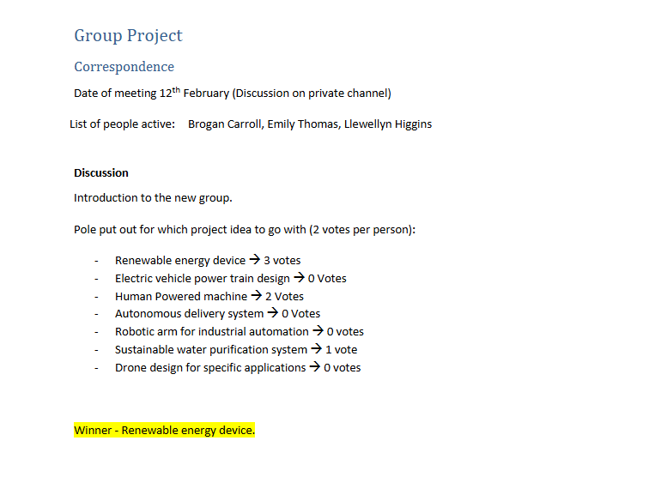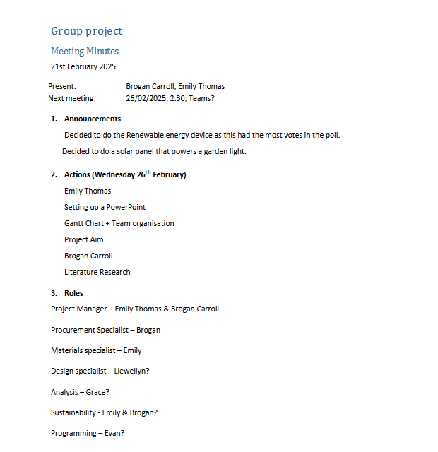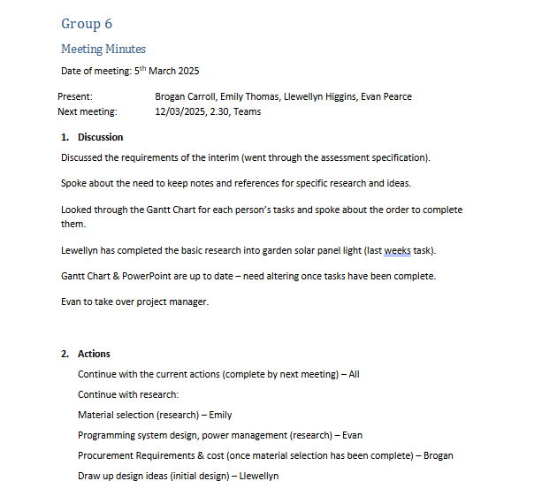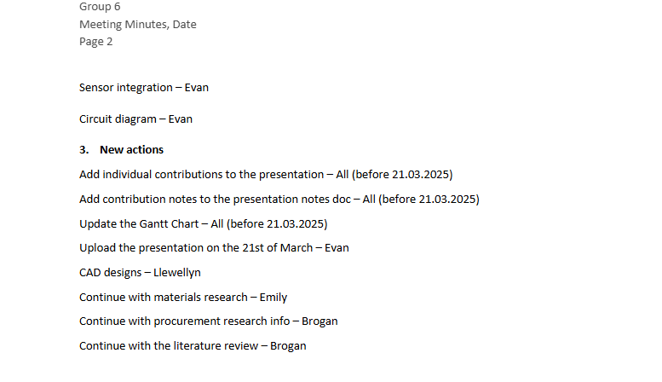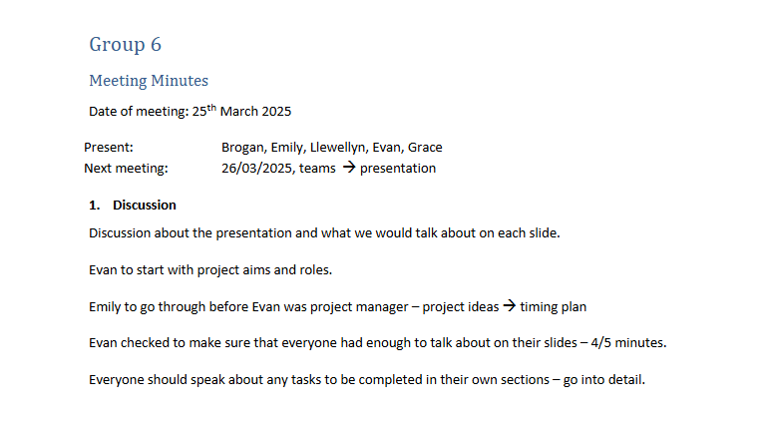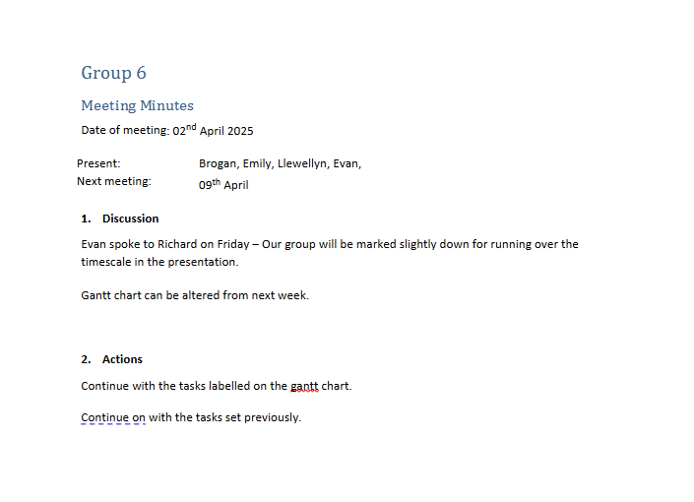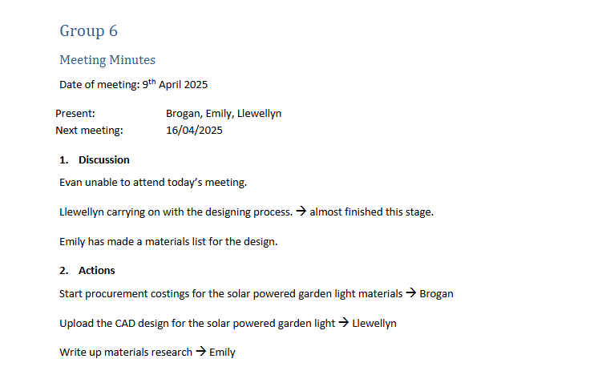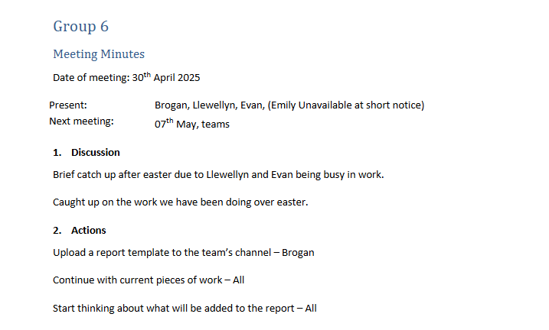

Appendix B
An example of a PO form for Procurement (Made by Brogan):

Appendix C
This appendix shows the calculation for how much polycarbonate would be needed for a solar garden light housing (Work completed by Brogan)

Appendix D (Emily)
Screenshot of poll posted in group

Appendix E (Emily)
Screenshots of the GANTT Chart

Appendix F (Emily)
This image from shows the different types of solar panels
(Abdulkareem, 2019)

Appendix G (Emily)
A graph showing years vs cost of different bulbs when being used for 12 hours at a time

(Gayral, 2017)

Appendix H (Emily)
A graph showing years vs cost when LEDs are used over a 3-hour period
(Gayral, 2017)

Appendix I
A graph comparing the performance in salt water against young’s modulus for ABS and Stainless Steel (Made in GRANTA by Emily)

Appendix J
Graph comparing Vickers Hardness against Thermal Expansion Coefficient (Made in GRANTA by Emily)

Appendix K
A graph comparing Youngs Modulus and density of ABS and Stainless Steel (Made in GRANTA by Emily)

