
Student Name:Xiaotong Feng

Student Id:2224462

Lecturer name:Gwyneth Jones

Assignment Title
Report
BMBM6016 Strategic Marketing

In the dynamic market environment, how the McDonald's fast food chain brand to achieve sustainable development

TABLE OF CONTENT
1.0 INTRODUCTION 3
2.0 MAIN BODY 4
2.1 PESTEL Analysis 4
2.1.1 Political Factor 4
2.1.2 Economical Factor 4
2.1.3 Social Factor 4
2.1.4 Technological Factor 5
2.1.5 Environmental Factor 6
2.1.6 Legal Factor 6
2.2 SWOT Analysis 6
2.3 Ansoff Model 7
2.3.1 Market Penetration 8
2.3.2 Product Development 8
2.3.3 Market Development 9
2.3.4 Diversification 9
2.4 Porter’s Five Forces Model 9
3.0 RECOMMENDATIONS 10
4.0 CONCLUSIONS 10
5.0 REFERENCES 12

1.0 INTRODUCTION
McDonald's Corporation's brands include McDonald's, Afternoon Espresso, Boston Market and The Big Mexican Taco Express. McDonald's is a major global multinational restaurant chain brand founded by Ray Kroc in 1955 in Chicago, USA and it has a history of over 80 years. It is present in 121 countries across six continents, accompanied by 32,000 outlets. By 2022, McDonald's generated a total revenue of US$23.18 billion (Jones, 2022). It has a global market share in the fast-food industry that is surprisingly three times larger than that of Starbucks.
The logic of McDonald's business revolves around creating opportunities for industrialization and chaotization. Industrialization means driving down the marginal cost of individual products through economies of scale (Kotler, 2019). Chaotization means improving management efficiency by adopting a replicable single restaurant management model to drive brand building and increase credibility and awareness in the market.
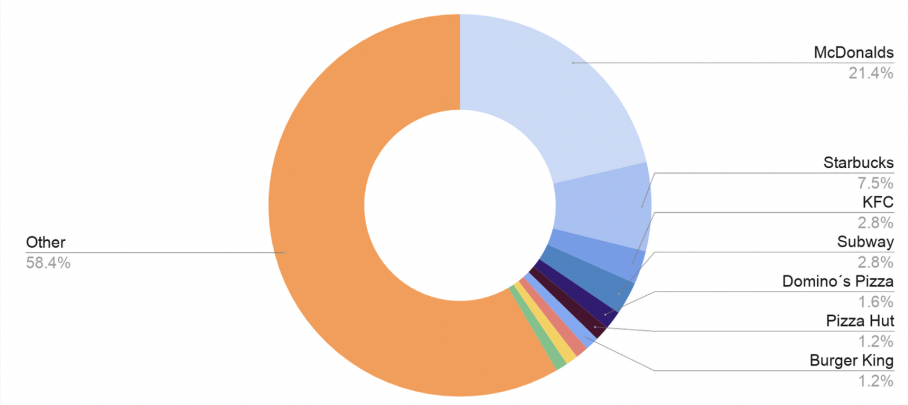
Figure 1: Global Fast Food Market Revenue by Brand (Jones, 2022)
However, McDonald's, the world's largest restaurant chain, has been in a sustained downturn in the turbulent economic climate. There was a time when McDonald's overall worldwide sales declined, which had a serious impact on McDonald's market position. The Financial Times pointed out that the essential reason for this was McDonald's failure to respond to the fundamental changes that have taken place in the restaurant industry in recent years, where consumer demand for greener, healthier food has increased dramatically (Lock, 2021).
The risks for McDonald's under COVID-19 are even more evident. Global supply chain disruptions and forced shop closures have resulted in the risk of cash flow constraints for a restaurant industry like McDonald's (McDonald, 2021). McDonald's has already gained public recognition and brand awareness through online promotions and social responsibility by providing free supplies to workers fighting the epidemic, which is not only a challenge but has made McDonald's re-examine its operating model and business philosophy and product types. In the long run, to achieve sustainability, McDonald's has to respond to consumer trends and be socially responsible in order to gain a better reputation and brand equity.
In view of some of the challenges mentioned above, the author will use PESTEL and SWOT models to help McDonald's put forward strategic planning for corporate improvement or transformation in the turbulent market environment. In this process, Ansoff model and Porter's Five Forces model will also be applied to make the critical analysis more specific and sufficient.

2.0 MAIN BODY

2.1 PESTEL Analysis
The PESTEL analysis model, also known as broad environmental analysis, is an effective tool for analyzing the macro environment. It not only identifies the external environment, but also all the forces that have an impact on the organization (Barness, 2022). This essay will refer to this model to provide a reasonable view on the marketing strategy of McDonald's Group in terms of political, economic, socio-cultural, technological, environmental, and legal factors.

2.1.1 Political Factor
Food safety and health have become a topic of concern for many countries. The World Health Organization is also committed to appealing to countries to take food health seriously. Many governments are also concerned about fast food chains for the protection of people, which means that fast food restaurants are at risk of being forced to close if they do not take food safety policies into account. In addition, international relations are also a key factor affecting McDonald's operations in global markets (Ghemawat, 2017). For example, the stalemate in political relations between Iran and the United States led to the suspension of McDonald's operations in Iran. Moreover, McDonald's operations in Russia were forced to suspend after the start of the war between Russia and Ukraine.
The political stability of a country undoubtedly has a positive impact on the sound development of a business. It is also obvious from previous cases that major political changes and turbulent environment have caused McDonald's business in some countries to receive serious impact. What's more, McDonald's has a large chain of businesses around the world, so the risk of its business being affected by politics has also increased accordingly.

2.1.2 Economical Factor
The factors that determine the success of McDonald's depend on the multiple countries it serves globally. In addition to the recession of 2008, its global turnover fell by 22% during Covid-19, which caused it to reduce its workforce in order to fight this financial crisis (Barness, 2022). Besides this, tariffs and trading conditions have been major factors in increasing the cost of international business. McDonald's profit margins have also become volatile with these two factors.

2.1.3 Social Factor
The prevailing culture of society influences the purchasing habits of consumers to a large extent. For a fast-food brand such as McDonald's, it has indeed experienced a significant socio-cultural impact in recent years. Specifically, the general public is progressively more health conscious and taste are not the only criterion in choosing food. Instead, foods that are green, low in sugar, low in calories and high in protein are becoming more and more popular among consumers. McDonald's has been producing high-calorie burgers, fries and fried chicken (Lock, 2021). Its standardization has always been towards high-calorie products. It is still a challenge for McDonald's to scale up the production of green food with McDonald's characteristics in the global market.
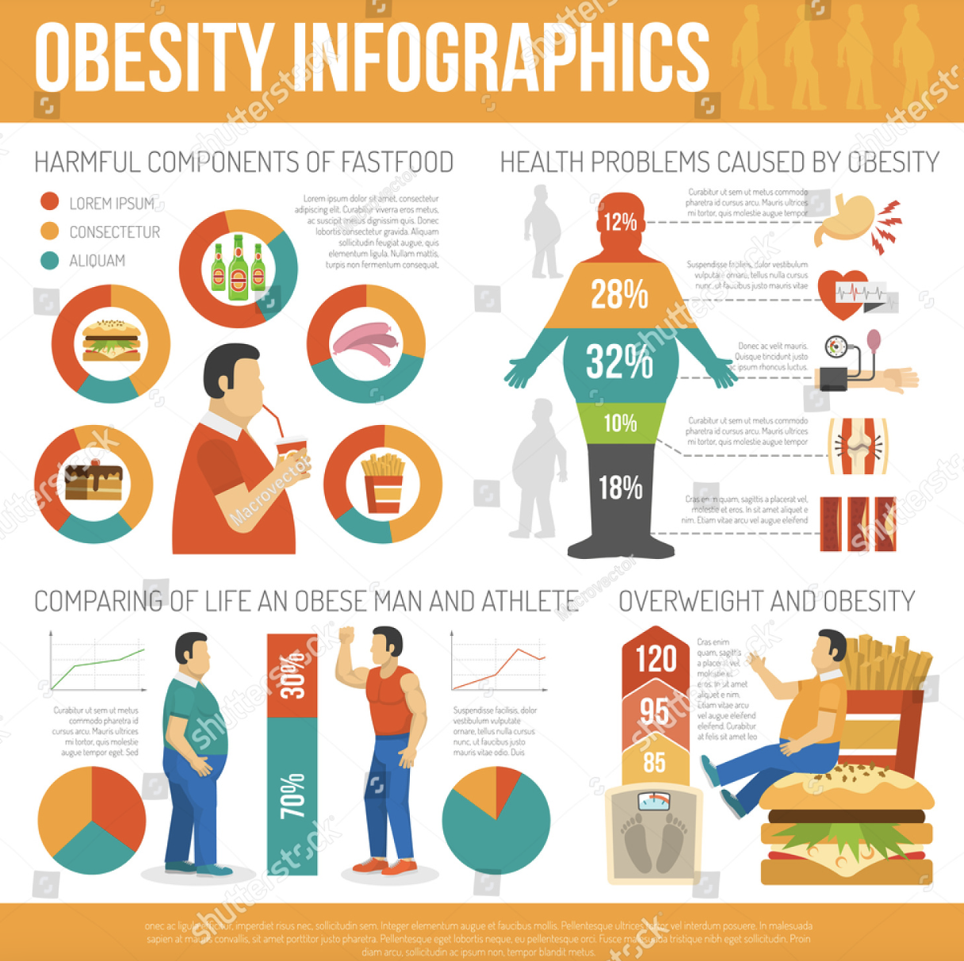
Figure 2: Harmful of Fast-food (Lock, 2021)

2.1.4 Technological Factor
The progress of information technology will enhance the management efficiency of McDonald chain operation, so that it headquarters can quickly grasp the management status of all branches in the world in a short time and give effective guidance.
The internet as a platform has gathered a huge number of users which enables companies to attract more customers and potential customers. McDonald's also makes use of online platforms such as social media to attract the attention of customers, such as Facebook, Wechat, Sina Microblog, Instagram (Levitt, 2020). Social media uses big data to analyze users' preferences and help companies target their advertising to attract consumers' attention, which gives them an edge over their competitors. McDonald's can use advanced technology to increase the efficiency of its campaigns and reduce the waste of resources. In addition, the efficient use of online ordering platforms and artificial intelligence technology has also contributed to improving the user experience and thus increasing their loyalty.
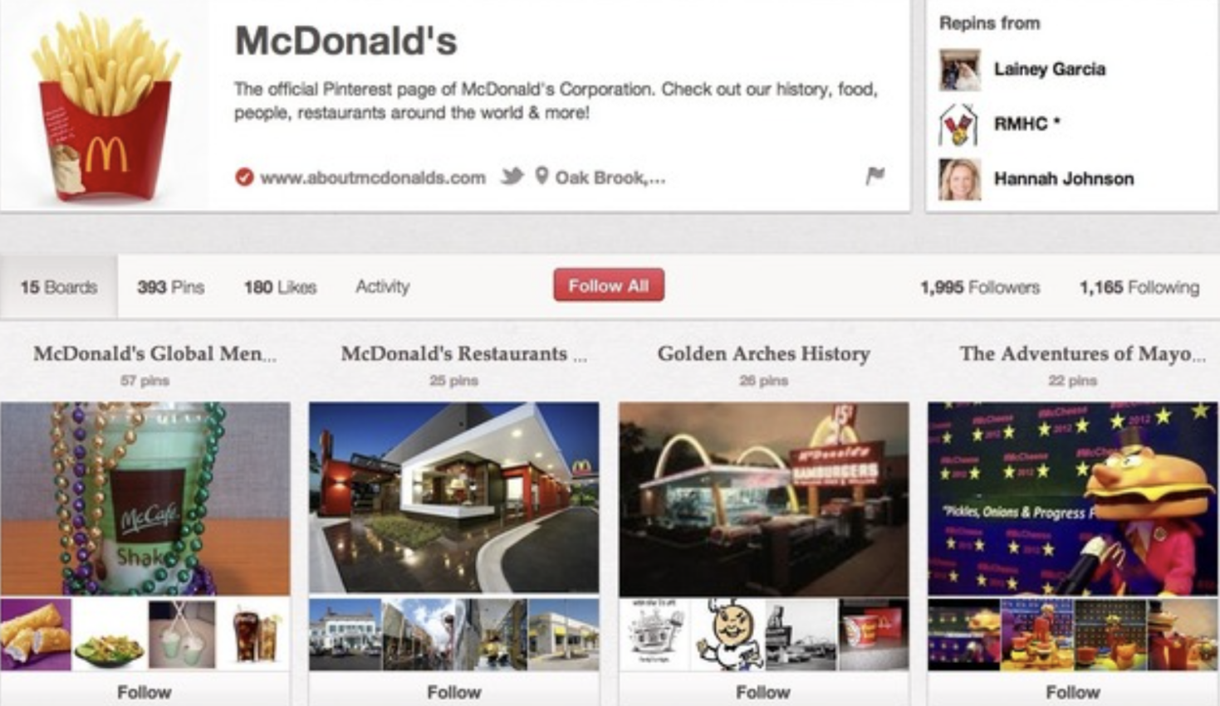
Figure 3: How McDonald’s uses Facebook, Twitter, Pinterest and Google+ (McDonald, 2021)

2.1.5 Environmental Factor
The large amount of fast-food waste increases white pollution and wastes a lot of resources. To demonstrate corporate social responsibility and thus enhance the credibility and brand image, McDonald's must lead the way by creating sustainable change as a key focus of their marketing strategy. In fast food, they can replace disposable materials such as plastic with recyclable materials. In addition, they can consider partnering with technologically advanced new material companies to produce food packaging from renewable energy sources to reduce waste. Environmental considerations are a key factor that McDonald's must consider as it has a large customer base. If McDonald's neglected to protect the environment, the pollution it would cause to the world in the course of its business would be particularly huge.

2.1.6 Legal Factor
McDonald's must comply with each country's food safety laws when it operates. In addition, since multinational operations involve taxes and tariffs, they must be strictly complied with in order to ensure the legal and normal operation of McDonald's worldwide. Some countries also regulate working hours and minimum wages for employees, which has a corresponding effect on brands' profit margins.

2.2 SWOT Analysis
Strengths:  - High brand awareness and brand influence  - Huge customer base  - Multiple product mix  - McDonald's production, stable production  - Clear brand concept  - Impressive brand image  - Relatively loyal customer group  - The Rise in Health-Consciousness  (Crook, 2019) | Opportunities:  - Provide green food to cater to consumer tastes  - Use big data and artificial intelligence technology to enrich customer service  - Catering to rapidly growing consumer demand continues to expand its global reach  - Global Expansion  - Rebuilding the Brand Image  - Mobile order and McDelivery  (Bernstein, 2020)
Weaknesses:  - High-calorie products  - The worrying overprocessing of food  - Consumers' distrust of the health of their products  - The Franchise business model  - Negative Publicity  (Taplin, 2018) | Threats:  - The number of competitors has grown  - Higher raw material costs limited profits  - Foreign liquidity risks continue to rise  - Currency changes and political turmoil  - Cultural Threat While operating in Various Countries  - McDonald's social ads are affecting the health of young people around the world  (Barker and Kaynak, 2019)
According to SWOT analysis, McDonald's, as the world's largest fast-food chain, has extremely high popularity and brand influence. However, its business operations are also threatened by the volatile political and economic environment and the changing buying tendencies of consumers. McDonald's should improve its innovation ability to develop greener, healthier, and lower calorie products. At the same time, it should also seize the opportunity brought by the Internet and new media to give full play to its brand value and further expand the consumer group. For the instability brought by the global market, McDonald's can predict the trend in advance through risk analysis and adjust the market strategy in time to avoid risks and achieve sustainable business development.
Although the company has been inheriting, it needs to adjust its marketing strategy by examining areas that could cause trouble. In the SWOT analysis of the company, the author has highlighted the strengths, weaknesses, opportunities, and threats McDonald's faces in the market.

2.3 Ansoff Model
Ansoff model can help enterprises or managers to analyze the competitive environment. It is considered a strategic tool for managing volatile environments. This model limits the enterprise strategy to the category of product and market.
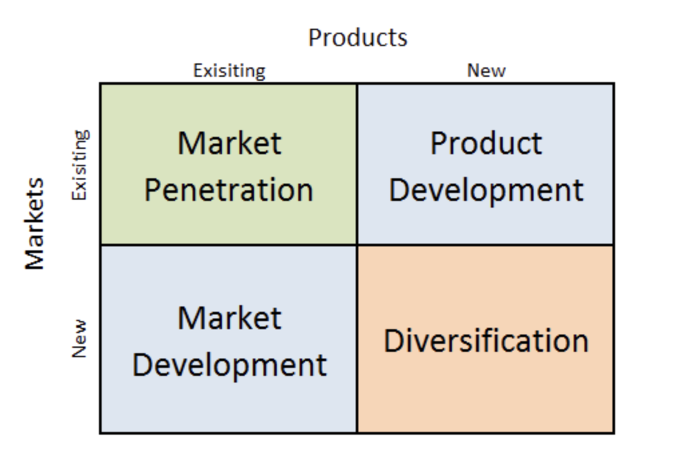
Figure 5: McDonald’s Ansoff Growth Matrix (Chen and Hicks, 2021)

2.3.1 Market Penetration
Market penetration as seen in the matrix is when a company offers an existing product or service to an existing market. McDonald's Group has a large product line that offers fries, beverages, desserts, burgers, and other products to its customer base. The standardization of its production process maintains the quality control of McDonald's Group, which maintains the satisfaction of its customer base (Sull, 2018). In addition, McDonald's often offers coupons or discount packages to attract more customers to its stores. For the China market, McDonald's is also good at using social media, celebrity benefits, live streaming, and other powerful marketing tools to increase its sales. In terms of full-year financial performance, McDonald's achieved revenues of approximately $23.183 billion in 2022, up approximately 6% year-over-year, excluding currency effects. According to the latest statistics, McDonald's also expects to open 900 new stores in China in 2023.

2.3.2 Product Development
Product development strategy refers to providing the new generation of products or related products to the existing consumer groups and expanding the depth and breadth of the existing products. McDonald's often adds new items to its menu. In addition to continuous research and development of meals suitable for consumers' tastes, McDonald's uses brand extension to launch the MC Cafe coffee brand and dessert station to expand the afternoon tea market (Timmer, 2019). At present, the functions of fast-food restaurants are becoming more and more diversified. In addition to the core products for all meals, McDonald's also launched the MC Cafe coffee brand and dessert station to meet the needs of business negotiations, friends' parties and other needs, which can also increase the turnover of the restaurant in non-meal time.

2.3.3 Market Development
McDonald's has grown from a native American brand to one of the world's best-known fast-food brands thanks to its development of new markets to sell its existing products. With standardized procedures and efficient operations, it contributed $1.1 billion in total global market revenue by 2021. In McDonald's history, its development strategy has not always been smooth. Specifically, it closed its operations in Iceland in 2009 (Reinach, 2015). In a turbulent environment, the financial crisis in 2008 led to a rise in marginal costs and a corresponding decline in profits, which also hindered McDonald's market plans to continue to expand in the global market. In addition, the further expansion of McDonald's market has been severely affected by the policy of banning the McDonald's brand in some countries, such as Bermuda, Yemen, and North Korea.

2.3.4 Diversification
Diversification refers to the development of new products into its new markets. McDonald's tried and failed to open a Golden Arches hotel in 2001 (Kotler, 2020). Nevertheless, to avoid the instability brought by McDonald's in the international market, it should also focus on diversification to diversify risks and find new growth points. Therefore, when it comes to the topic of sustainable development, the diversification strategy should be the key consideration of McDonald's Group, despite its previous failures.

2.4 Porter’s Five Forces Model
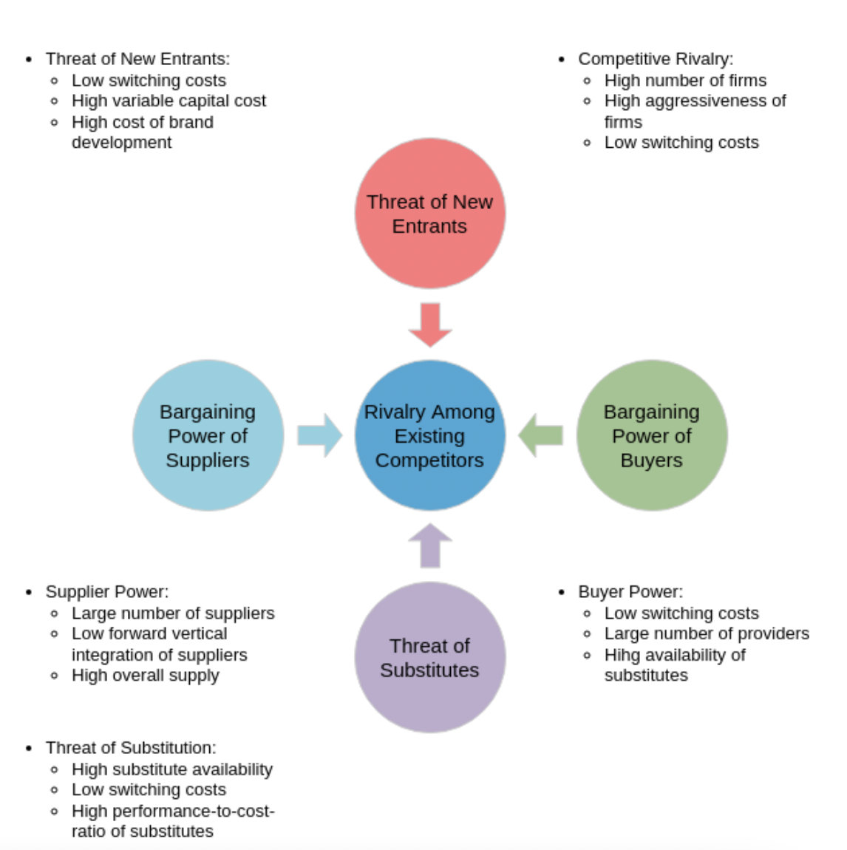
Figure 6: McDonald's Porter's five Forces model (Michel, 2022)
According to Porter's five forces analysis of McDonald's, McDonald’s is in a competitive industry where competition is stimulating, McDonald's has strong bargaining power, its suppliers have weak bargaining power, McDonald's has high substitutability, and McDonald's is moderately threatened by new entrants (Joan, 2021). These findings suggest that McDonald's should prioritize strategic issues related to competition, consumers, and substitutes because they all have a significant impact on its external environment. Despite the low bargaining power of suppliers and the low threat from new entrants, McDonald's can improve its core competencies by referring to its strengths based on the previous SWOT analysis. To better satisfy its customers, based on Porter's five forces analysis, McDonald's can implement higher quality standards to address the forces of competition and substitution.

3.0 RECOMMENDATIONS
With the promotion of sustainable development and health concept in the world, as a famous large chain fast food brand, McDonald's original operation from food to packaging should be upgraded in an all-round way. In addition to launching healthy products, they should also be keen to show support for the environment (Johnson, 2011). McDonald's should not only pay attention to the guests' dining convenience, but also consider the health of the food and the combination of nutrition. For example, adding more healthy food options by introducing organic juices and healthy salads. More importantly, McDonald's should ensure that all its products are packaged in environmentally friendly and certified materials. It should also use its brand awareness to popularize the concept of health so as to positively influence more people.
The turbulent political and economic environment will undoubtedly make McDonald's international market development relatively difficult. Covid-19 is a good example, which has led to a serious threat to McDonald's offline business. In addition, the pace of people's lives is accelerating, so the catering industry should focus on offline (Lopez, 2019). Instead, they should also enter the development era of e-commerce making full use of technology. The combination of online and offline operation mode can bring more market opportunities for McDonald's while avoiding risks (Marangoni, 2016). McDonald's can take advantage of the huge customer base of the Internet and the big data to better find target customers and drainage. The traditional promotion mode is relatively low in influence and efficiency, while online operation can help enterprises gain more cash flow and disperse the risks caused by external turmoil.
McDonald's should strengthen the construction of internal control system. In the long run, McDonald's should conduct strict supervision from the aspects of operating procedures and management rules (Bradley, 2015). Specifically, McDonald's should strengthen internal audit control to reasonably avoid and prevent the occurrence of financial risks. In addition, McDonald's to ensure that financial decisions are correct. It is difficult to deal with unknown changes based on experience alone, so that managers should make more use of big data and less of empiricism.

4.0 CONCLUSIONS
This essay has utilized four models, PESTEL, SWOT, Ansoff model and Porter's Five Forces model to help McDonald's analyze the external market and sort out its internal strengths and weaknesses so as to make McDonald's understand its current business situation more clearly and develop a more appropriate strategy to resist external uncertainties.
In conclusion, McDonald's, as one of the world's most famous fast-food brands, has strong brand advantages and a large customer base. With the changing consumption concept of the consumer group, McDonald's should transform to green food instead of focusing on the existing high-calorie products. In addition, as McDonald's business scope involves the global market, how to diversify the risk and do a good job of relevant management to avoid the risk brought by political and legal factors is also a key issue that McDonald's should consider.

5.0 REFERENCES
Barker, A. T. and Kaynak, E. (2019). An Empirical Investigation of the Differences Between Initiating and Continuing Exporters. European Journal of Marketers, 26(3), pp.123-131.
Barnes, D., (2022). Operations Management: An International Perspective. UK Cengage Learning EMEA.
Bernstein, W. (2020). A Splendid Exchange: How Trade Shaped the World. Atlantic Monthly Press.
Bradley, F. (2015). International Marketing Strategy (5th edition). Prentice Hall.
Chen, A. and Hicks, M. (2021). Going Glob Avoid Culture Clashes. PC Week.
Cooper. R.G., Edgett. S.J. (2021). Product Innovation and Technology Strategy. USA: State – Gate International.
Crook, T. R. (2019). Does human capital matter? A meta-analysis of the relationship between human capital and firm performance. Journal of Applied Psychoology, 96(3), pp.443-56.
Ghemawat, P. (2017). Redefining Global Strategy: Crossing Borders in a World Where Differences Still Matter. Harvard Business School Press.
Joan, V. G (2021): Five forces analysis of fast-food industry. United States Census Bureau.
John F. (2020). McDonald’s: Behind the arches. UK: Transworld Publishers Ltd.
Johnson, M. (2011) “Inditex breaks new ground for seasons in the south” Financial Times, 22(4), pp.209-211.
Jones, M. (2022) 9 countries that have banned McDonald’s, available at: https://www.businessinsider.com/countries-that-have-banned-mcdonalds-2018-1?r=US&IR=T (accessed 08 March 2023)
Kotler, P. (2020). Global Standardizaion—Courting Danger. Journal of Consumer Marketing, (3)2, pp.13–15.
Levitt, T. (2019). The Globalization of Markets. Graduate School of Business Administration, Harvard University.
Lock, S. (2021) Revenue of McDonald’s Corporation worldwide in 2019, by region, available at: https://www.statista.com/statistics/219453/revenue-of-the-mcdonalds-corporation-by-geographic-region/ (accessed 06 March 2023)
Lopez, C. (2019) “Internationalisation of the Spanish fast-food brand”, Journal of Marketing and Management, 13(2), pp.102-119.
Marangoni, G. (2016), “Flexible Specialisation 20 Years On: How the 'Good' Industrial Districts in Italy Have Lost Their Momentum”, Competition and Change Vol 10(1):73-87.
McDonald (2021) Where we operate, available at: https://corporate.mcdonalds.com/corpmcd/our-company/where-we-operate.html (accessed 05 March 2021)
Michel, S. (2022) The upside of falling flat, available at: https://hbr.org/2007/04/the-upside-of-falling-flat (accessed 10 February 2023)
Perry, A. C. (2017). International versus Domestic Marketing: Four Conceptual Perspectives. European Journal of Marketing, 24(6), pp.41–54.
Porter, M. E. (2020). Competitive Advantage. Creating and Sustaining Superior Performance. Free Press.
Reinach, S. (2015), “China and Italy: Fast Food versus Prêt à Porter. ” Competition and Change, 9(1), pp.908-912.
Sull, D. (2018), “Fast Food Industry Lessons” Business Strategy Review, 20(3), pp.1346-1439.
Taplin, I. M. (2016). “Restructuring and reconfiguration” European Business Review, 18(3), pp. 172–86.
Timmer, M. P. (2019). Functional specialisation in trade. Journal of Economic Geography, 19(1), pp.1–30.
Tokatli, N. (2020), “Global sourcing: insights from the fast-food industry—the case of McDonald, a fast-food retailer” Journal of Economic Geography, 8(2), pp.38-45.

