Learning EnvironmEnts

Inside and Out
LISA THOMAS
EAEE5010C

Student No: 1002474

Date: October 1st, 2018
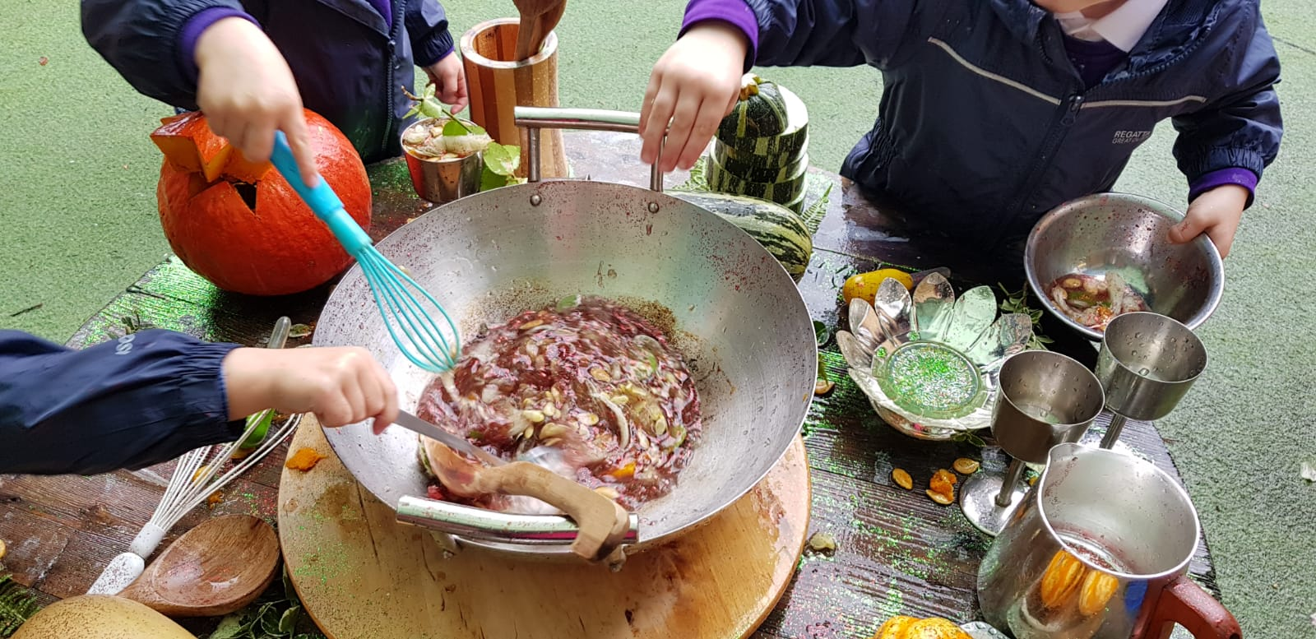
Table of Contents

Component 1 - Activity Plan for Outdoor Experience……………………….. Page 2 - 6
Component 2 - Risk assessment and environmental audit…………..…….. Page 7- 14
Component 3 - Activity Evaluation and Photographs………………..………. Page
Component 4 - Academic Overview…………………………………….…... Page

Experience Plan – component 1

Area of Provision: | Outdoor garden with indoor access | Timescale: | 2.5 hours
Number of children: | 6 children | Age of children: | 2 – 4 years
Adult to child ratio: | 1:2 (3 adults) | ALN support worker: | 1

Role of the adult:
The natural world is an open-ended learning opportunity where children can flourish and connect with their living environment. Children are innate explorers who love to experience sights, textures sound and scents that provide a sensory experience that stimulates their senses.
Playing outdoors which many children do not have regular access too can provide endless opportunities for discovery, creativity, problem-solving and supports STEM learning principles being science, technology, engineering and mathematics
The opportunity for them to explore independently from hands on experiences with plants, insects, foods and loose parts is an essential part of learning and development and will also support children’s emotional and physical health and wellbeing.
Books in all areas of play will support children to make choices for themselves and encourage them act on the stories observed in an aim to develop their creative use of speech, language and communication.

Experience Overview:
- Be committed in exploring the outdoors to support children’s learning across the Foundation Phase Curriculum.
- Ensure the area has been risk assessed and regular handwashing is promoted.
- Explain to the children what the experience is about and any safety aspects such as the use of tools and how to use, care and store them
- Ensuring children are valued and respected as active participants in their own learning ensuring any adult led experience is explained in simple steps offering differentiation for stages of development.
- Support children in developing their confidence in exploring the outdoor area independently, learning to assess risks for themselves as much as they can manage safely.
- Provide time and space for them to explore and experiment with the variety of resources available and opportunities for children to revisit, practise or enjoy a sense of mastery
- Observe play and record achievements or difficulties.
- Join in when invited and watch and listen before intervening, whilst offering challenges to extend their learning and development
- Promote new language opportunities where children can express themselves freely
- Ensure the environment is inclusive and easily adapted to support individual needs and opportunities for differentiation is offered.
.
Learning Outcomes: | Differentiation
- To explore the experience in a natural environment  - To work collaboratively with peers, sharing ideas.  - To observe skills across the curriculum  - To utilise the resources available to develop fine and gross motor skills  - To learn about seasonal foods and their functions  - To use tools and equipment with confidence  - To make decisions for themselves, being imaginative and taking pride in their own achievements that support their holistic development. | - Some children will struggle to use some of the tools and equipment  Ensure ALN support worker follows child’s need and adapts activities accordingly.  Offer simple steps and direction.  - Some children might have little or no language and may become frustrated  Use PECS board available and flashcards  Reinforce strategies ‘Show me’  - Children who are more able  Offer challenges that reflect their skill level and development needs  - Welsh speaking families  Ensure keyworker communicates in the language choice of the child
Open Ended Questions | Key Vocalbalary
- What is happening?  - What do you want to do?  - What do you think will happen next?  - How does this feel, smell, taste?  - How we can find out?  - What is this for?  - What can you see? | - Hard, soft, slippery, squelchy, spiky, smooth, hot, cold, whisky, stir, por, carry, move, scrape, fill, taste, hold, smell, squeeze, pick, shake, tap, noisy, quiet, wet, dry, roll, sharp, heavy, low, high, long, short, windy, warm.
Resources:
- Practitioner kit = First aid travel kit, sanitizer, mobile phone and whistle.
- Enough equipment for 6 or more children.
- Loose parts for creative play, imaginary play, expressive art and design
- Wetsuits, wellingtons, hats and gloves.
- Various bottles, pots, cups and decanters
- Cooking pots, pans, utensils, scissors, knives, stirrers and pestle and mortar
- Sieves, funnels, cauldron, colanders, goblets, recycled bottles, old soap dispensers
- Seasonal fruit and vegetables
- Natural resources - flowers, gravel, Sand, bark, pebbles, grass cuttings, twigs, fallen leaves, acorns, soil, seeds and pulses.
- Magnifying glasses, tweezers, binoculars and pipette droppers
- Water, watering cans and food colouring
- Writing and mark making materials, chalkboards and paper
- Story books including room on a broom
- Den building equipment, pegs, crates, beans, guttering and tarpaulin
- Tyres, guttering, blocks of wood and tools.

ESDGC (Education for Sustainable development and Global Citizenship)
- Wealth and Poverty: the rights of every individual to have their basic needs met and that children learn that resources donated or recycled support sustainability. This includes the food donated by Tesco through Fare-share that is used for resources and shared with families in need.
- Identify and Culture: practitioners support children to develop respect for themselves and others within our diverse community.
- Choices and decisions: Practitioners use stories and plan activities to develop pa child’s understanding on how our choices and our decisions affect the lives of others and valuing the efforts of each child.
- Health: Practitioners support a healthy lifestyle in line with the Healthy Pre-school and sustainable scheme through diet and activities to enable them to develop a responsible attitude for their physical and mental health.
- Natural environment: practitioners support a child understand and show concern for our environment and understand the effect of our actions in showing respect and picking up litter and repairing any damage from our carbon footprint and using natural logs, recycled reels as tables etc
- Consumption and waste: understand our role in reducing waste and develop a sense of responsibility for sustainable development. Children will be encouraged to recycle food and waste in the compost bins for gardening.
- Climate Change: learn to be responsible towards changes by saving rainwater and looking for ways to save energy

Curriculum Links:
Personal, Social Development, Well-being and Cultural Diversity
- Having fun and develop independence
- Development of confidence, resilience and well-being.
- Inclusive and mixed groups playing together, developing group working and team working skills.
- Taking responsibility and developing awareness of self and others.
- encourage the children to manage their own risk, build resilience, empower children to make choices, respond appropriately to boundaries

Language, Literacy and Communication Skills
- Mark making opportunities
- Exploring size and shape of pumpkins and functions like, measure, weight changes when adding ingredients etc.
- Learning about numbers, colours, shape and textures
- Exploring 3d objects in play

Mathematical Development
- Hand and eye coordination
- Pincer grip when using pipettes and picking up pumpkin seeds.
- Riding broom sticks and manoeuvring around obstacles
- Development of imagination and creativity skills leading to improved problem-solving skills.
- Exploring colour shapes, smells and textures
- Building a shelter
- Stacking, counting and connecting crates to make new structures
- finding how things fit together to reach the height of the cable reel table

Welsh Language Development
- Bilingual words on display in text and handwritten
- signs and books available
- Exploring welsh language through play using key vocabulary with repetition.

Knowledge and Understanding of the World
- Appreciation of and engagement with natural spaces and place, including changing weather and seasons and seasonal fruit and vegetables.
- Understand the need to wear appropriate clothing to suit the seasons

Physical Development
- Fine motor skills to measure, stir, pour and explore texture through touch.
- Mark making with chalks and pens
- Using droppers and pegs
- Gross motor skills – climbing, rolling balancing, moving equipment and transporting objects
- Appreciation of risks and development of experience that allows them to increasingly make more decisions about physical, social and emotional risk taking.
Creative Development
- Opportunities for them to develop, plan and reflect on their own play.
- Opportunities to develop their senses and to be creative and imaginative
- To express their own ideas and feelings and to express this through art, craft and design

Planned by: | Lisa Thomas
Date: | 18th September 2018

Risk Assessment – Component 2

Date: | October 18th 2018 | Activity | AutumN Play
Who is at risk: | Children | Practioners | Service users

Area, activity, situation, equipment | Possible  hazard | Injury or Harm | Risk rating  High, Medium, Low | Current control | Who is responsible
Running around on brooms  (Room on a broom story) | Slipping, Tripping or Falling | Bumps, bruising, grazing, broken bones, head injury | Low Dry Conditions  Medium Wet conditions  High Icy Conditions | Explain to the children not to run and push each other.  Make sure children do not wear scarves in the garden to avoid tangling around equipment  Staff supervision adhering to the ratio.  Ensure the environment is suitable for play subject to weather | Setting Leader or outdoor coordinator
Grass | Slipping, sliding, tripping or falling | Bumps and bruising | Low  Dry Conditions  Medium Wet Conditions | Explain to children not to run on wet grass.  Ensure suitable shoes are worn.  Ensure layout prevents children from running in high risk areas. | All staff to supervise
Hand washing | Wet areas slips and trips | Allergy to soap and pain if there is an open graze. | Low | Provide washing facilities and all times, especially when using mud  Provide rinsing facilities outside.  Staff to monitor floor areas for water and keep dry.
Washing tools and utensils | Manual handling  Sprains, slips when moving pots and pans etc. | Cuts, grazes, piercing and irritated eye | Low  Dry Conditions  Medium Wet conditions  High Icy Conditions | Ensure buckets and containers are not overloaded.  Provide low storage for pots and pans.  Adults to oversee manual handling and model safe techniques.
Wet and dirty clothes | Children get cold | Sore and stiff hands  Hypothermia in extreme weather | Low Dry Conditions  Medium Wet conditions  High Icy Conditions | Children to keep outdoor clothing and boots at setting.  Spare clothes available  Parents encouraged to bring appropriate clothing and coats. | All staff to monitor children in extreme cold weather.
Loose parts - Gravel, pebbles, woodchip or other pieces of natural  material | Choking, grazes and scratches | Ingesting or absorption of poisonous object.  Death | Medium | Any children who are likely to explore putting things into their mouths are identified and given greater supervision in this area  Children encouraged to follow a no consumption rule in outdoor play area.  Regular hand washing | All staff to monitor children
Using foraged natural materials | Choking or poisoning | Ingesting or absorption of poisonous plants Allergic reaction | Medium | Risk of eating plants, therefore plants within the play area are chosen carefully and screened if harmful to children.  Adults to remove hazardous plants prior to play.  Children encouraged to follow a no consumption rule in outdoor play areas.  Regular hand washing | All staff to monitor children
Building equipment and resources.  Wooden reels, tyres, milk crates, guttering, wooden planks, plastic sheeting | Slips, trips or falls.  Knocks from falling or moving blocks.  Suffocation  Heavy objects.  Stagnant Water | Splinters, cuts, bumps, bruises, head injury, grazes, trapped fingers, stings or bites.  Crush injury or death.  Illness to those with cystic fibrosis. | Medium | Children have a safety talk prior to using equipment to know how to use it safely.  Daily reminders are given about assessing the risk in their play.  Weather conditions to be considered when accessing the equipment.  Area to be monitored to ensure surroundings are clear and surface is flat.  All equipment is checked regularly to look for damage.  Tarpaulin is used under supervision.  Ensure staff are aware of child’s medical problems and relevant first aid treatment. | All staff to monitor children during play.
Climbing blocks- freestanding equipment | Slips, trips or falls.  Knocks from falling or moving blocks.  Heavy objects | Splinters, cuts, bumps, bruises, head injury, grazes, trapped fingers, stings or bites.  Crush injury or death. | Medium | Children to be made aware of the risks of trapped fingers.  Staff model how to move and position blocks safely.  Blocks and tubes to be checked by staff each day for dirt, cracks, foreign objects or insects.  Restrict climbing in wet weather.  Equipment to be checked and dried after wet weather.
Potion making (Including fresh fruit and vegetables) | Ingestion  Cuts  Spillage and splashing  Trips, slips and falls  Finger trapped in container | Minor injury  Upset stomach  Sore eye  Bumps and bruises | Low  Quiet times  Medium Busy times | Staff to check dates and ensure all medication is stored centrally and in date.  Plan activities carefully for children with allergies considering ingredients and possible sources for reaction. Source alternative safe ingredients where necessary.  Children to understand not to put anything in their mouths in this area.  Foods harvested to be washed and prepared safely. | Ensure all information on allergies is stored centrally and all staff are aware of known allergens and parents keep setting updated.  Staff to check dates and ensure all medication is stored centrally and in date
Step to indoors | Falling, tripping slipping | Injury to body especially knees.  Pain | Low | Ensure suitable shoes are worn.  Ensure steps are clear of tripping hazards | Staff to supervise.
Tools and cooking equipment (pots, pans and stirrers etc.) | Cuts, grazes, slices from using tools.  Poking others or eye or body injury. | Minor injury, grazes, bumps, bruises and pierced skin and pain. | Low  Medium Busy times | Make sure tools available are child sized and appropriate.  Check all tools regularly for damage and  replace where necessary.  Monitor children accessing areas. | Staff supervision
Compost Bags | Tetanus  Toxoplasmosis  Skin Irritation  Soil blowing into eyes  Ingestion  Foreign object | Rash  Eye irritation or swelling  Upset stomach  Choking injury  Pain | Low | Proprietary compost e.g. for seed sowing, can be handled without gloves but hands must be washed after the session.  If children have skin irritations e.g. eczema, or cuts/abrasions, or are likely to have a suppressed immune system, then disposable gloves should be worn.  Small manageable bags are purchased for ease of use. | Staff to supervise and be aware of all medical issues and details regarding their key children.
Soil | Tetanus  Toxoplasmosis  Skin Irritation  Soil blowing into eyes  Ingestion | Rash  Eye irritation or swelling  Upset stomach | Low | Hands must be thoroughly washed (by pupils and staff) at the end of each session and especially before eating food/ drinking.  Moisten dry compost/potting media before using, avoid storing compost/potting media in greenhouses or other warm places.  Provide hand washing facilities during and after play and establish good handwashing routines.  Children encouraged to follow a no consumption routine in this area. | Staff to supervise and be aware of all medical issues and details regarding their key children.
Animal mess | Tetanus  Toxoplasmosis  Skin Irritation  Slip, trip or fall.  Toxocara canis(Dog)  Toxocara cati(Cat) | Blindness  Upset stomach  Bump or bruises | Medium | Setting staff to check garden before children attend session and remove any animal mess whilst wearing gloves.  Dispose of mess away from the garden and wash trowel and hands afterwards.  If children come across buried animal mess, staff must remove as above and children to wash hands immediately. | Staff to risk assess and supervise children at all times
Composting | Airborne particles  Flies  Vermin  Lifting and turning  Bites | Sprains and minor injury resulting in pain.  Illness or infection  Swelling and pain. | High | Compost bin to be kept cool.  Adults only to put waste into the bin and should use PPE.  Avoid making compost heaps too wet by adding too much fruit waste as this attracts flies and does not make effective compost.  If too much fruit waste, then this will need to be donated to the local allotment society or recycled using the local authority food scheme. | Staff to supervise and be aware of all medical issues and details regarding their key children.
Bees, wasps and Insects | Stings  Anaphylactic Shock | Swelling  Pain  Death | Medium | These are natural inhabitants of the garden and pose no risk unless provoked.  Setting staff must be aware of any children allergic to specific insects. If stung, children should seek first aid. | Staff to supervise and be aware of all medical issues and details regarding their key children.
Plants | Choking  Ingestion, Allergic reactions | Swelling  Pain  Sickness  Rash | Medium | Wear gloves as some plants may be irritating to skin or contain parts which are harmful or toxic if eaten.  Staff to teach children plants that plants should not be eaten  Setting staff must not allow the children to pick the plants or put their fingers in their mouths.  Children must not eat parts of plants unless instructed to do so and must wash hands after garden sessions.  When undertaking taste tests, all produce, and hands should be washed in tap water (not water butts) before consumption. | Staff to supervise and be aware of all medical issues and details regarding their key children.
Gardening Tools | Injury, slips, trips and falls.  Piercing to skin  Trapped fingers |  | Low  Dry Conditions  Medium Wet conditions | Tools correctly maintained to be safe to use.  Children to only use tools when instructed to do so and stored safely and end of session.  At start of each session tool safety to be embedded.  Setting staff must ensure safe use and that children behavior is monitored during use.  Ensure appropriate type and size of tools to be selected for age of children.  Ensure adequate working space around gardening beds and equipment. | Staff to supervise children in all areas of provision outdoors.
Water Butts & Hoses | Dirty Water  Slips, trips, falls.  Water borne bugs/ infections  Drowning  Sprains and minor lifting injury. | Upset stomach  Pain to injury  Confusion from poisoning  Sickness  Death | Medium | Water butts must have child proof, locked lids and should be firmly secured on a stable surface.  Staff and children must not wash their hands or wash garden produce from the butts.  When using water for watering then pupils and adults must wash their hands afterwards.  Water butts to be kept in cool position as far as reasonably practical. If not, consideration to be given to insulation or light reflecting paint. | Staff to supervise and be aware of all medical issues and details regarding their key children.

Support for children with ALN | Differentiation
Mobility issues | Adapting environment, washable mats for floor play adult support and specialist equipment
Visual, hearing or sensory difficulties | Follow care plan, use gloves, pecs, Makaton and specialist equipment.
No language or communication | Flash cards, Pecs carry board and Makaton
Epilepsy | Medical bag, timer, blanket, pen and paper.
General behavior | To ensure staff provide extra supervision and ratios reflect the support needed.

Environmental audit - Component 3

Issue and environmental feature | Damage that could occur | How to lessen negative impact | Resources needed | Who is responsible?
Walking on grass or plants during play  Picking plants | Using same location can cause damage to the ground, causing sparse growth with a risk of losing plant life and diversity  Practitioners and children should not to pick or snap plants | Use a variety of areas and avoid using the same site repeatedly.  Consider areas when plants are flowering and put up warning signs to avoid children accessing plants that attract bees etc.  Staff to be a good role model and reinforce the importance of protecting nature. | N/A | All practitioners, children and service users
Logs and natural recyclable materials for equipment use. | Damage insects when positioning heavy objects  Regular moving may impact insect population living underneath long-term fixtures | Check areas carefully prior to set-up to prevent minimal damage  Avoid moving heavy objects where possible. | N/A | Leader and adults to reinforce rules
Plastic bottles and resources | Pollution | When activity finished, plastic bottles to be recycled or disposed of correctly and not left outside | N/A | All practitioners, children and service users
Litter | Pollution. | Ensure resources are not left in the natural environment and encourage children to put them away properly. | Have bins or bags available for recycling | All practitioners, children and service users
Water | Waste | Use recycled water to wash resources and for watering the garden and play | Guttering  Water butt  Containers. | All practitioners, children and service users.

Academic Review photographs – Component 4a
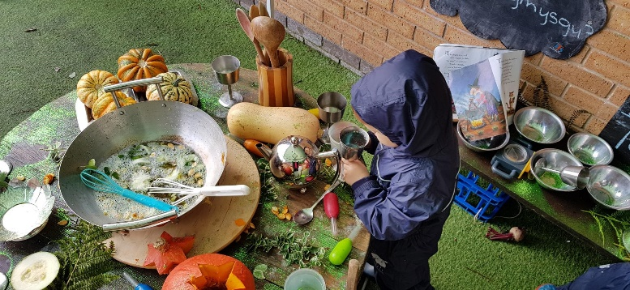
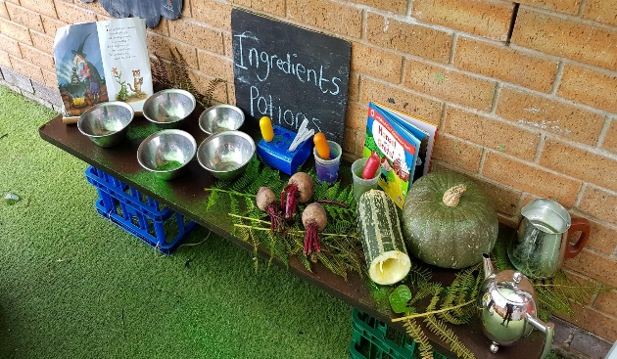

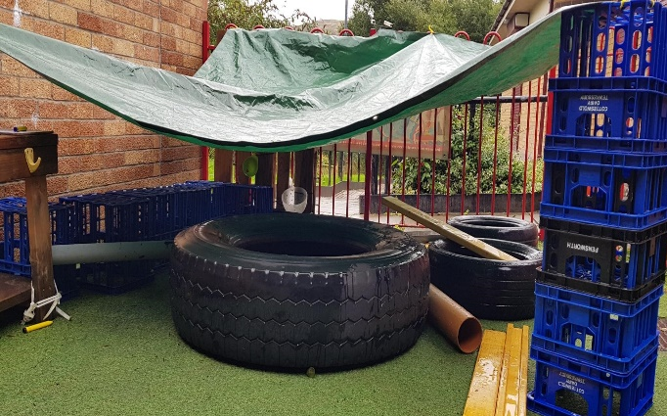
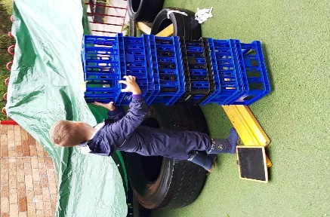

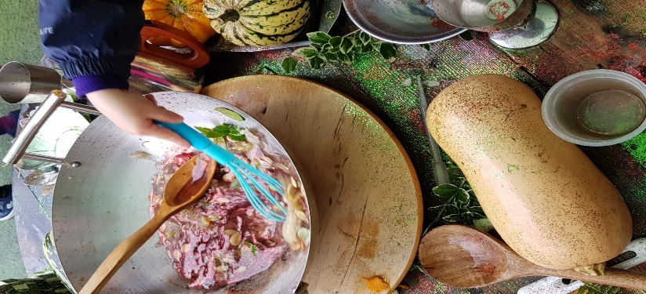

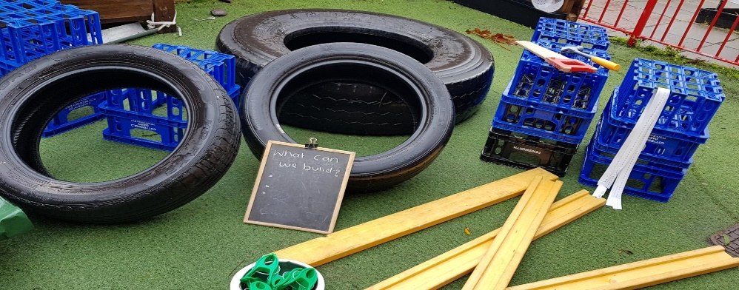

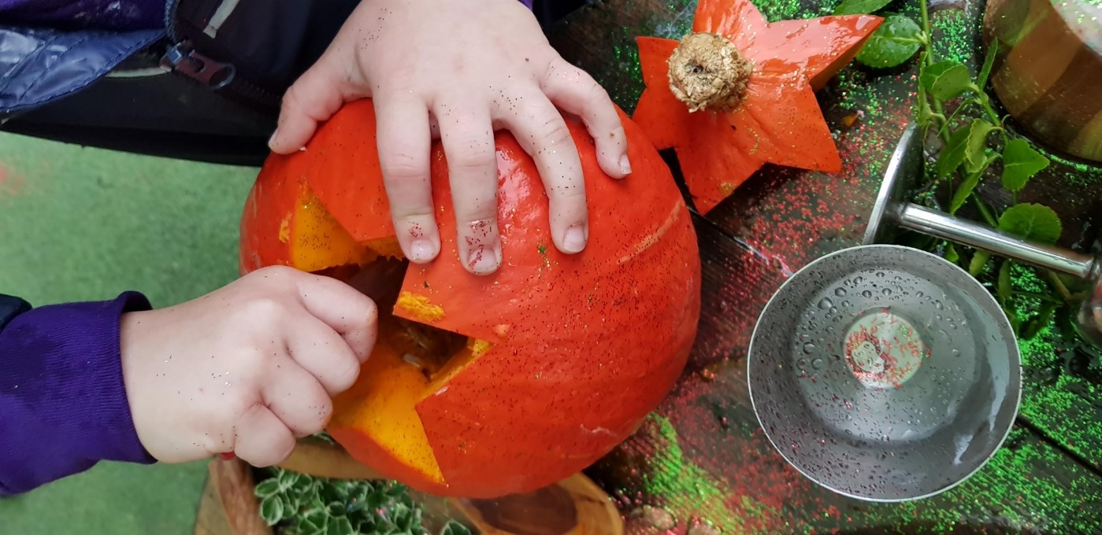

Academic Review – Component 4b

The learning experience chosen as a direct result of observing and assessing children aged two to five years of which 25% are identified as children with Additional Learning Needs. Practitioners were enthused towards outdoor play as a result of training at learning through landscapes whose values represent the importance of adults promoting cross curricular activities and the importance of allowing children to connect and be fascinated with the natural world allowing for space, stimulation, language and sensory opportunities. Reviewing the Leuven scales for emotional well-being and involvement of each child at the setting 1 week prior, it identified that deep level learning and improvement in behaviours were evident when accessing the outdoor environment and the more practitioners participate in outdoor play and acknowledging the beneficial links to children’s learning (Woods 2013) Suggests the likelihood of practitioners becoming fully engaged. Early Learning HQ reports outdoor play improves the mental health and emotional intelligence of children reinforced by Waldorf (???) who emphasises that willing, feeling and thinking are the three forms of human expression that supports his approach towards holistic education.

Plymouth University completed a study ‘Natural connections’ based on schools offering quality outdoor learning environments.

Based on 125 schools in the SWOE the findings were;
95% | found it more enjoyable
92% | improved health and wellbeing
93% | improved social skills
92% | pupils engaged more in learning
85% | positive impact on behaviours
94% | a greater understanding of nature
64% | pupils believed they achieved more
79% | practice improved as a result
72% | staff had improved health and wellbeing
90% | children felt happier
69% | they had greater job satisfaction

With this is mind and showing regards to the Additional Learning Needs and Education Tribunal (Wales) Act - Welsh Government (2017) it reinforces the need for children to receive in-depth planning enabling them to access their natural environment and proposes quality training opportunities to increase the competency and skill set of the childcare workforce which in return will strengthen the understand of the importance of Person Centered Planning which according to SNAP Cymru (???) it is essential for children with ALN to identify what is important to them now, and in the future and that this can only be achieved when adults that care for a child work together to plan for them.
The introduction of Wales new curriculum welsh government (2018) focuses on 6 core aims developed from the recommendations of the curriculum and assessments review undertaken by Professor Graham Donaldson’s Successful Futures (2015) has identified that to promote health and well-being in children it is fundamental that childcare practitioners take ownership of their learning environment both inside and out to provide flexible and creative planning to follow the child’s individual development needs to enable them to flourish holistically in a modern environment., Gleave 2009; O’Brien & Murray, 2006) expresses the importance of outdoor play for promoting health and wellbeing in children and childcare services additionally Edward O. Wilson (1984) shares a similar belief that changes need to be introduced to childcare environments as they are at risk of not knowing what it is like to be human if they remain isolated from natural play which supports the welsh government future generations wales act (???) in promoting a bilingual, happier and healthier wales which supports the structure and need for quality education within a robust and resilient environment and LOTC 2009 research agrees that children who receive regular opportunities to learn in an outdoor environment are more likely to develop a healthy lifestyle and well-being

According to United Nations Convention of the rights of the child all children have a right to an education which should develop every child’s personalities and talents to the full potential, so the environment resources were placed strategically to provide a rich open-ended experience showing regards to the nurseries health and safety policies and risk assessments providing tools and equipment that were suitable for small hands.

Froebel (???) understood the importance of practitioners in taking responsibility for developing the physical environment both inside and outside and acknowledged the importance of children developing their own interest and learning through their own play without direction from the practitioner. forest schools Association 2017 agrees that outdoor learning should be child led. Many ‘loose parts’ a term coined by architect Simon Nicholson (1971) describes how materials can be manipulated in many ways and used to encourage curiosity and exploration and to promote the development of physical literacy and learning opportunities, confidence, resilience and well-being whilst enabling practitioners to monitor the physical capabilities of children.

Piaget j, (??) was one of the first childhood theorists to recognize similar patterns of behaviours in children under 5 years of age which they adapted and repeated in many situations which referred to as Schemas were observed throughout the experience yet Chris Athey (???how children learn) suggests that Piaget refers to schemas as a general cognitive structure rather than her belief that schemas evolve from perception and early action and encompasses the way in which children make sense of their relationships and environment.

The choice of creating a construction area in the outdoor environment and incorporating a variety of natural wooden construction resources was following on a Froebel approach. Froebel (???) suggested that access to natural wooden materials will enable a child to develop an understanding of how things connect. Additional materials in the form of recycled crates, guttering and boxes were added to enhance the area enabling the practitioner to observe children use their imagination and creativity in in self-directed play further supporting Froebel’s principle that children learn more by experience things for themselves, rather than being shown what to do.
White, J 2014 tells us children need small spaces for that feeling of being out of sight and for their imagination to grow which allows them to identify with how the world works and how they identify themselves within it that the experience of the den as a secret space or place enables children to feel a sense of control.

Surprisingly two children actively engaged in the experience for a long period of time and worked collaboratively with each other in developing social space to which peers were invited to play. Practitioners showed respect towards Montessori (??) principles of respecting the characteristics of each child and their ability to follow their own development path and as a result Children were observed stacking and connecting materials together to build themselves a shelter and could be seen linking objects together in complex ways using resources available with adults scaffolding children’s learning an idea originated by Vygotsky (??) on the social and participatory nature of learning and dictates that a child can achieve more without intervention.
The theoretical approach refers the zone of proximal development (ZPD) which supports self-directed learning. This was observed as children showed an elemental interest in transporting water from one place to another in a metal goblet and was confident in making journeys within the garden avoiding obstacles and broom rides to recycle the collected water from the tarpaulin into the water butt. The individual experience of those children enabled the practitioner to record their physical skills and abilities which included fine and gross motor skills, travelling, movement, control and manipulation that they believe would not have been possible within their indoor environment.

Upon evaluation, the outdoor space was well equipped but small in comparison to other local services which resulted in a timetable in place for the use of wheeled vehicles. Mailloux, Z MA (???) explains that the vestibular sense within your inner ear is one of the most important senses to develop as it supports eye and head movements and balance and coordination essential for riding a bike, scooter or balancing on the wooden resources in the outdoor space. Hanes, DA and McCollum, G (2016) further suggests that vestibular abnormalities can affect poor concentration and certain cognitive functions which is representational of Wiener-Vacher SR, Hamilton, AH and Wiener SI understanding of the importance of developing the vestibular sense at an early age as it represents the development of the brain and how it interacts with other body parts to support balance, position and body orientations within the environment. Practitioners should therefore be considerate and effectively plan for children to participate in activities that ensure the development of this sense is represented in through play as essentially any activity that requires movement activates the Kinaesthesia nervous system located in muscles so the more opportunities for risky play such as climbing running, jumping, and moving objects from one activity to another, the energised the brain will become, providing an energetic burst to the body and mind supporting the perfect environment for learning.

Throughout the process children displayed high levels of self-esteem and engagement particularly during the potion making station a concept developed by Emily Gravett book of Spells. Not all of the children appeared keen to participate initially but with time to explore and look at the pages of the book their senses were piqued as their engagement levels and communication which was a key point of observation for the practitioner central to the creativity of the experience and practitioners were able to observe aspects of sustained shared thinking as children worked together and alongside each other as they explored the tactile and sensory aspects of the donated seasonal fruits and vegetables with curiosity and confidence. They independently accessed utensils to scrape, squirt, mash and stir and transported to other areas of provision to smear, spread and create patterns on paper and foil supporting early mark making skills Welsh Assembly Government (2008) Foundation Phase Curriculum.

The success of the activity and it’s learning objectives was only possible due the successful implementation of staff in following the activity plan and using continuous provision to enhance the learning experience.
Alfano (???) former director of child research at fisher price explains her findings that children play better outdoors, and it increases flexibility and variety of skills that impacts their whole body. Appropriate clothing is also essential when outdoors to protect children from elemental conditions which may be damaging to their health and the importance of this is reiterated in the Welsh Assembly Government (2009) Outdoor Learning Handbook which refers to opportunities galore for children learning outdoors and that greater emphasis on this should be developed on outdoor play.

On evaluation a further suggestion for improvement would have been to extend the experience with the involvement of parents. to observing and supporting the facilitation of their play supporting the Malaguzzi (???) which is a fundamental approach by Reggio (???0 pedagogy of an ethical community where there is a great emphasis on the relationships between families and the community which are integral in supporting children’s experiences of play.
Social engineering advocated by Plato, (428-347 BC) suggests that to become human, natural supervised play must occur which would improve behavior and academic performance and later Aristotle, (384 BC) who studied at Plato’s academy recognised the importance of formalising an agreement to support education as he saw this as a way of life that should be recorded within the city’s constitution which is a similar outcome that Huw Lewis former Education Minister is hoping to achieve with his project FaCE the Challenge Together (June 2015) which is about the importance of family and community engagement with Rewriting the future being one of the four main themes in raising ambition and attainment within Welsh schools. Governors Cymru Services, (September 2018) understands the important role that parents play in supporting their child to achieve and that involvement from the beginning is likely to result in improved learning, increased staff morale and improvement in the school’s reputation and children’s behaviours.

The Welsh Government (2005) Programme for Young People, it provides information about the planned 21st Century Schools and the educational capital programme it aims to invest in developing learning environments within Wales t improve educational outcomes in partnership with families, professionals and communities ensuring a sustainable system to improve our carbon footprint.

Welsh Assembly Government Education for Sustainable Development and Global Citizenship (ESDGC) is embedded into daily practice and practitioners are aware of the importance of sustainability and their carbon footprint. The sustainability policy encourages adults and children to think critically about how they impact the environment and the resources they use daily. The use of local recycling Centre’s have supported creative environments from a canal boat to large wooden coils for tables as the actively work in partnership with families meeting the outcomes of FaCE in the participation of an accredited award with the Curiosity Approach that is a key development of the nursery in bringing curiosity, intellectual thinking and experiential learners in a technological age where outdoor play is often replaced by hours in front of a TV or iPad. This modern-day approach is based on research by Froebel (??) and Maria Montessori (??) who said

“adults admire their environment; they can remember it and think about it – but a child absorbs it. The things he sees are not just remembered; they form part of his soul. He incarnates in himself all in the world about him that his eyes see, and his ears hear”.

Lewis, (2018) presented their findings that parents of children with an ADHD diagnosis who access the service for weekend camping trips displayed improved or no behaviours typical to the condition. Lewis informs us that children feel so at ease with nature and able to develop their own learning in their own space and time. likewise, in an article by Pankseep (2007) who tells us laughter is the clearest signal and that natural play urges are being engaged and those deprived of social games such as rough and tumble games are more likely to display ADHD tendencies. (Potegal & Einon (1989) advises that ADHD in children needs to be formally evaluated as it is well documented in their research that animals who displayed similar behaviours to ADHD had an inability to regulate aggressive tendencies later in life when isolated from outdoor play in their early years. Louv (2006) informs us that our values and behaviours as adults may be impacted by restrictions to nature and the outdoors which would agree with the concerns raised by Potegal and Einon which is a cause for concern.

Lewis (2018) further raised concerns that Care Inspectorate Wales and their inspection and registration framework is flawed system of inspection as there is no consideration of the outdoor environment as a contributory factor for registration of a service only makes judgements based on free access from the indoors to the outdoors, but space measurements are not counted in play space ratios and shared a report by Care Inspectorate Scotland

Comparison of outdoor and indoor based day-care service provision (achieving “excellence”).
Grade 6 (Excellent) | Children’s Day-care  Services | Outdoor Based  Settings
Quality of care and support | 6% | 17%
Quality of environment | 3% | 17%
Quality of staffing | 5% | 17%
Quality of management and leadership | 4% | 8%
These findings supports his call for action as outdoor play has a positive impact on children which the (NCT 2018) agrees that children In the early years must have opportunities to develop their fine motor skills such as holding a pen or using a fork whilst eating and this can only be understood when children develop their gross motor skills and are able explore the whole movement of body and mind.

On conclusion, Wilson (2012) suggests using a gentle approach of immersion when encouraging children to care for their environment to support their natural curiosity in connecting with nature and likewise, Steiner (1861) expresses how ‘awe and wonder’ is the initially start to effective learning and that children need opportunities to develop their spirit, minds and body through creative play.
Numerous research projects on the importance of play and connecting with nature has been undertaken and well documented scientific research studies and publications tells us that when a child has daily contact with nature it positively impacts their social, academic, psychological and physical health and interaction with nature (Kellert, 2005) and (Bell et al., 2003) identified during a study in Scotland that adults were more likely to continue to visit woodlands if they visited frequently as a child.

The best classroom and the richest cupboard is roofed only by the sky. Macmillan M.

