University of Wales Trinity Saint David
School of Engineering

CP Laboratory Case Study
Manufacturing Systems and Simulation
ACMA6002
Robert Dale Gubbins
2316959
05/10/2026

Contents
1 Introduction 3
2 Process Selection 3
3 Current State Model Development 4
3.1 Model Development and Structure 4
3.2 Model Verification and Experimental Setup 7
4 Waste Identification 7
5 Value Analysis 9
5.1 Customer Value and Value-Adding Activities 9
5.2 Quantification of value-adding and non-value adding time 10
6 Simulation Analysis 11
7 Opportunity Identification (Lean Evaluation) 12
7.1 Increasing Drilling Capacity 12
7.2 Increasing Cap Dispenser Capacity 13
7.3 Overall Evaluation of Improvement Opportunities 14
8 Conclusion 16
9 References 16
10 Appendices 18
10.1 Appendix A – Arena Verification Run: 100 parts, 10-Replication Output Summary 18
10.2 Appendix B – 8 Hour Simulation Results 19
10.3 Appendix C – Two-Drill Scenario Simulation Result 21
10.4 Appendix D - Two-Drill and Increased Dispenser Capacity Simulation Results 23

Introduction
Discrete Event Simulation (DES) is a modelling technique used to represent system operation through discrete changes occurring over time. DES is particularly applicable to manufacturing systems, where components progress through different processes and resources, allowing system performance to be evaluated without disrupting live production (Turner and Garn, 2022). It can identify manufacturing inefficiencies and assess Lean improvement opportunities prior to physical implementation (Oleghe and Salonitis, 2016).
This report applies DES to the Festo Industry 4.0 CP Laboratory, a modular automated production system representing a modern manufacturing environment. The current state model is used to evaluate key performance indicators (KPIs), identify process waste and value-adding activities, and assess potential opportunities for Lean improvement.

Process Selection
The selected process is the Festo Industry 4.0 CP Laboratory, a modular automated manufacturing system represented in Arena. As shown in Figure 1, the simulation begins with the arrival of components through the Parts-In Create block, which represents the model entry point rather than a physical CP Lab process. Components then undergo automated optical inspection before progressing sequentially through drilling, cap dispensing, pressing, labelling and finally the Output module, where completed assemblies leave the system. 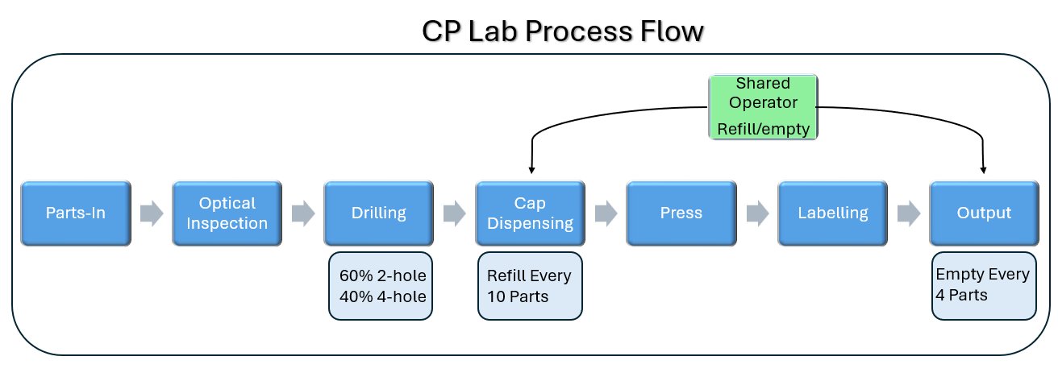
Figure 1 - CP Lab Process Flow
The model incorporates the specified 60:40 product mix, with 60% of components receiving two drilled holes and 40% receiving four. A single production operative is shared between replenishing the cap dispenser after every 10 components and emptying the output station after every four completed assemblies. These operating constraints are included within the current state simulation boundary. The process is well suited to DES because its sequential events, variable processing and movement times, shared resources and capacity constraints can directly influence queueing, resource utilisation and throughput (Goldsman and Goldsman, 2015).

Current State Model Development

Model Development and Structure
The Arena model was developed using the process data provided within the CP Lab case study. Processing times were defined in seconds, with minimum, average and maximum values represented using triangular probability distributions where applicable. Fixed transfer times between stations were entered directly from the supplied data, as summarised in Table 1.
Process Function |  | Min(s) |  | Average(s) | Max(s)
1.Parts in From Robot Assembly |  | 15 |  | 18 | 21 |  | Legend
2.Automated Optical Inspection |  | 2 |  | 2.4 | 3.4 |  | Part Creation Time
Camera to Drilling |  |  |  | 8.2 |  |  | Movement times
3.Drilling (2 Holes) |  | 16 |  | 18 | 20 |  | Process Times
3.Drilling (4 Holes) |  | 30 |  | 33 | 36
Drill to Dispensing |  |  |  | 7.3
4.Top Cap Dispensing |  | 2.7 |  | 3 | 3.5
4.Refill (every 10x cycles) |  | 110 |  | 120 | 135
Mag Back to Press |  |  |  | 7.3
5.Hydraulic Press |  | 11.7 |  | 12.3 | 12.9
Press to Label |  |  |  | 8.2
6.Label Printing |  | 6.2 |  | 7 | 8.7
Label to Output Station |  |  |  | 8.2
7.Output Station |  | 3.6 |  | 4.1 | 5.1
7.Remove Parts (Every 4x Cycles) |  | 20 |  | 26 | 32
Table 1 - CP Lab Model Input Data
The primary entity represents a component progressing through the CP Lab system. Resources were defined for the Camera System, Drill, Dispenser, Press, Printer and Output Robot, together with a single production operative shared between cap-dispenser replenishment and removal of completed assemblies from the output station. Equipment resources are seized and released by their respective process modules.
Routing and control logic reproduce the principal operating constraints of the system. Components are assigned to two-hole or four-hole drilling according to the specified 60:40 product mix, while Hold modules regulate progression according to downstream availability. Counter-based logic initiates dispenser replenishment after every 10 components and output removal after every 4 completed assemblies, with both activities competing for the shared operative. Figure 2 shows the completed current state Arena model.

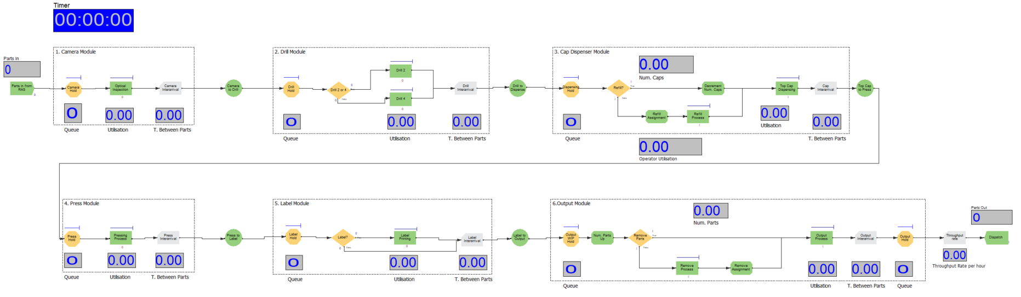Figure 2 – Current State Arena Simulation Model

Model Verification and Experimental Setup
The completed model was verified using 100 components across 10 replications to check entity flow, the 60:40 drilling distribution, periodic process logic and shared resource allocation, consistent with the principle that simulation verification should establish that the model has been implemented as intended (Sargent, 2010). As shown in Table 2, all 100 components completed the process, while the drilling distribution closely reflected the specified product mix. The model also produced the expected 10 dispenser refills, 25 output removals and 35 operator seizures. The reported transfer time of 39.2 seconds also matched the combined fixed movement times specified within the model, providing an additional check that the transfer stages were implemented correctly. Supporting Arena output summary is provided in Appendix A.
Performance Measure | Identifier | Expected | Simulation Result
Components entering | Entity 1.NumberIn | 100 | 100
Components completing | Entity 1.NumberOut | 100 | 100
Two-hole drilling route | Drill 2 Number In | ≈60% | 61.3%
Four-hole drilling route | Drill 4 Number In | ≈40% | 38.7%
Cap-dispenser refill cycles | Refill Process Number In | 10 | 10
Output removal cycles | Remove Process Number Out | 25 | 25
Operator 1 seizures | Operator 1.NumberSeized | (10+25) = 35 | 35
Transfer time | Entity 1.TranTime | 8.2 + 7.3 + 7.3 + 8.2 + 8.2 = 39.2s | 39.2s
Table 2 - Model Verification Results
Following verification, the current state experiment was configured for an eight hour production shift with no fixed entity limit. Thirty replications were performed to provide the dataset used for subsequent analysis, with the current state Arena output provided in Appendix B.

Waste Identification
The current state simulation identified waiting, excess work-in-progress (WIP) and uneven process flow as the principal forms of waste. Waiting and excess inventory are recognised forms of Lean waste that can restrict manufacturing flow and operational efficiency (Rajab, Afy-Shararah and Salonitis, 2022). Key results from the eight hour, 30-replication run are summarised in Table 3, with the supporting Arena output provided in Appendix B.
Performance measure | Identifier | 8 Hour mean
Components entering system | Entity 1.NumberIn | 1,600.80
Completed assemblies | Entity 1.NumberOut | 1,186.60
Throughput | Calculated from:  NumberOut ÷ 8 hours | 148.3 assemblies/hour
Shift-end WIP | Calculated from:  NumberIn − NumberOut | 414.2 components
Drill Hold waiting time | Drill Hold.Queue.WaitingTime | 3,610.7 s
Drill Hold average queue | Drill Hold.Queue.NumberInQueue | 200.8 components
Entity total time | Entity 1.TotalTime | 3,845.5 s
Entity waiting time | Entity 1.WaitTime | 3,737.7 s
Table 3 - Simulation Performance Summary
Table 3 shows that waiting is the dominant waste within the current system. The greatest restriction occurs at the drilling station, with the Drill Hold queue recording an average waiting time of 3,610.7 seconds and an average queue length of approximately 201 components. Across the complete process, completed entities accumulate an average of 3,737.7 seconds of waiting within a total system time of 3,845.5 seconds. Furthermore, an average of approximately 1601 components enter during each shift compared with approximately 1,187 completed assemblies, resulting in approximately 414 components remaining within the system at shift end. These results demonstrate significant waiting times, WIP accumulation and restricted production flow.
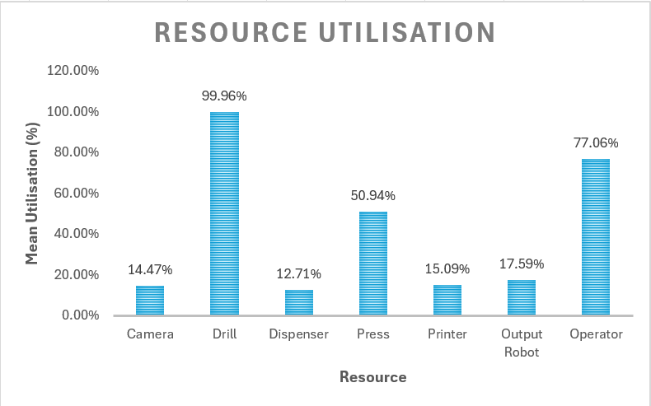
Figure 3 - Resource Utilisation Across 30 Eight Hour Replications
The resource utilisation profile in Figure 3 supports these observations. Drill utilisation reaches 99.96%, compared with 50.94% for the press and below 18% for the camera, dispenser, printer and output stations. This imbalance indicates that the drilling stage is constraining flow and leaving substantial downstream capacity unavailable for productive use. The shared operator also reaches 77.06% utilisation, although this is not the primary current state constraint.
Overall, the simulation identifies a connected pattern of waiting, excess WIP and uneven flow centred on the drilling bottleneck. From a Lean perspective, these activities increase lead time without adding customer value and provide a clear focus for process improvement, with DES providing a means of quantifying manufacturing waste and supporting improvement decisions (Vilela et al., 2022).

Value Analysis

Customer Value and Value-Adding Activities
Within Lean thinking, value is defined from the perspective of the customer, with value-adding activities being those that transform the product or provide a feature for which the customer is willing to pay (Xiao et al., 2022). Activities that consume time or resources without increasing customer value are considered non-value adding and should therefore be reduced or eliminated where possible (Kumar, Devadasan and Elangovan, 2022).
Applied to the CP Lab, drilling, cap dispensing, pressing and required labelling can be considered value-adding because these operations physically transform the component towards its finished specification. By contrast, waiting, queuing and unnecessary movement do not alter the product and therefore represent non-value adding activity. Optical inspection is necessary for quality assurance but does not directly transform the component and is therefore classified as necessary but non-value adding.

Quantification of value-adding and non-value adding time
The Arena simulation was used to quantify how the total time spent within the system was distributed between value-adding, non-value adding, waiting and transfer activities. The results from the 30 eight hour current state replications are summarised in Table 4, with the supporting Arena report run output provided in Appendix B.
Time classification | Identifier | Mean time (s) | Proportion (%)
Value-adding | Entity 1.VATime | 43.1 | 1.1%
Non-value-adding processing | Entity 1.NVATime | 25.5 | 0.7%
Waiting | Entity 1.WaitTime | 3,737.7 | 97.2%
Transfer | Entity 1.TranTime | 39.2 | 1.0%
Other | Entity 1.OtherTime | 0.0 | 0.0%
Total | Entity 1.TotalTime | 3,845.5 | 100%
Table 4 - Entity Time Classification
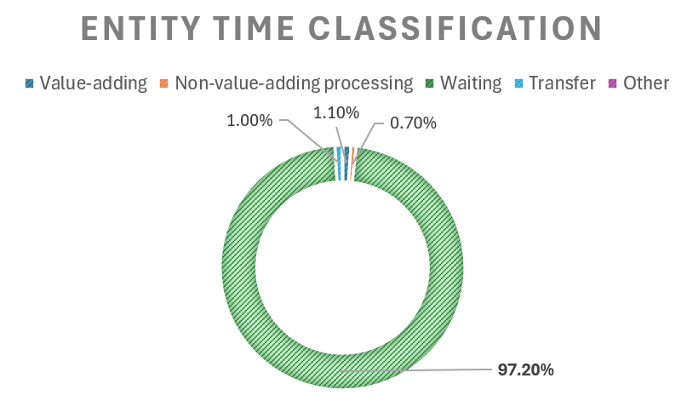
Figure 4 - Entity Time Distribution Pie-Chart
As shown in Table 4 and Figure 4, only 43.1 seconds, approximately 1.1% of the average 3,845.5-second entity time, is classified by the simulation as value-adding. In contrast, waiting accounts for approximately 3,737.7 seconds (97.2%), demonstrating that the overwhelming majority of time within the current system does not contribute directly to product transformation. Transfer and non-value adding processing account for comparatively small proportions of total time.
The DES results therefore demonstrate that the main opportunity is not simply to reduce individual processing times, but to reduce the extensive waiting generated by restricted process flow. This supports the drilling constraint identified in Section 4 as the primary focus for Lean improvement.

Simulation Analysis
The current state simulation was analysed across 30 eight hour replications, with the principal production and flow KPIs summarised in Table 5.
KPI | Identifier / Calculation | Current state result
Component arrival rate | Entity 1.NumberIn ÷ 8 h | 200.1 components/hour
Completed assemblies | Entity 1.NumberOut | 1,186.6 per shift
Throughput rate | Entity 1.NumberOut ÷ 8 h | 148.3 assemblies/hour
Average entity total time | Entity 1.TotalTime | 3,845.5 s (64.1 min)
Average entity waiting time | Entity 1.WaitTime | 3,737.7 s (62.3 min)
Drill utilisation | Drill.ScheduledUtilization | 99.96%
Operator utilisation | Operator 1.ScheduledUtilization | 77.06%
Drill Hold average waiting time | Drill Hold.Queue.WaitingTime | 3,610.7 s
Drill Hold average queue | Drill Hold.Queue.NumberInQueue | 200.8 components
Approx. shift-end WIP | Entity 1.NumberIn − Entity 1.NumberOut | 414.2 components
Table 5 – Current State Key Performance Indicators
The system completes an average of 1,186.6 assemblies per eight hour shift, equivalent to 148.3 assemblies per hour. This is below the component arrival rate of 200.1 per hour, resulting in approximately 414 components remaining within the system at shift end. Average entity time is 64.1 minutes, of which 62.3 minutes is waiting, confirming that lead time is dominated by queueing.
Drilling is the principal current state bottleneck, operating at 99.96% utilisation with an average upstream queue of approximately 201 components and a waiting time of 3,610.7 seconds. Operator utilisation is also relatively high at 77.06%, suggesting that the shared operative may become more restrictive if upstream capacity is increased. Overall, throughput and lead time are principally constrained by drilling, although improvements should be evaluated at system level because production bottlenecks can migrate following capacity changes (Liu et al., 2023).

Opportunity Identification (Lean Evaluation)
The current state analysis identified drilling as the principal restriction on production flow. Improvement scenarios were therefore evaluated within the verified simulation model to assess whether relieving this constraint would improve system-level performance.

Increasing Drilling Capacity
As drilling was identified as the current state bottleneck, its capacity was increased to allow two components to be processed simultaneously. The associated Hold logic was adjusted so that a component could progress when either unit of drilling capacity was available. This successfully relieved the original drilling restriction, reducing drill utilisation from 99.96% to 66.60% and removing the severe congestion previously observed immediately upstream of drilling.
However, the improvement did not translate into better overall system performance. Completed component output decreased from 1,186.6 to 1,030.7 assemblies per shift, equivalent to a reduction in throughput from 148.3 to 128.8 assemblies per hour. This finding is consistent with Rocha and Lopes (2022), who demonstrated that manufacturing changes perceived as likely to increase output can produce poorer production performance when evaluated through DES. Average entity time also increased from 3,845.5 to 5,202.4 seconds. These results indicated that although the original drilling constraint had been relieved, another restriction had emerged elsewhere within the system. The principal results from the two-drill scenario are shown in Figure 5, with the complete simulation output provided in Appendix C.
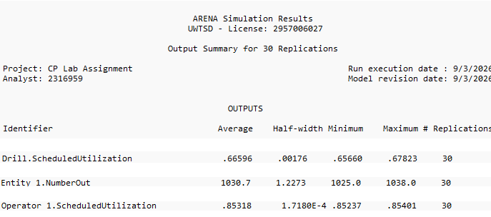
Figure 5 - 30-Replication Summary Results for the Two-Drill Scenario
Further examination of the two-drill results showed that the original drilling congestion had shifted downstream. Mean waiting at the Dispensing Hold increased from 44.5 to 1,117.9 seconds, while Output WIP Hold waiting increased from 82.4 to 4,267.0 seconds. Operator utilisation also increased from 77.06% to 85.32%, indicating greater demand on the shared operative. The additional drilling capacity therefore relieved the initial bottleneck but exposed downstream constraints that had previously been less significant, demonstrating how production constraints can migrate following changes in system capacity (Liu et al., 2023). Supporting mean performance measures are provided in Appendix C.

Increasing Cap Dispenser Capacity
Following the two-drill scenario, the substantial increase in Dispensing Hold waiting and operator utilisation indicated that the cap-dispensing stage and its associated replenishment requirement had become increasingly restrictive. A second improvement scenario was therefore evaluated in which the increased drilling capacity was retained, while the dispenser refill interval was increased from 10 to 20 components. This represented an increase in effective dispenser capacity by reducing the frequency of operator intervention. 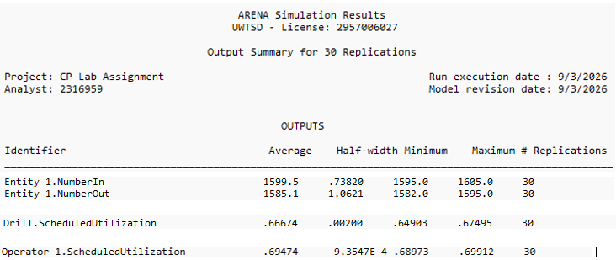
Figure 6 - 30-Replication Summary Results for the Two-Drill and Increased Dispenser Capacity Scenario
As shown in Figure 6, completed output increased to 1,585.1 assemblies per shift and operator utilisation decreased to 69.47%. Supporting mean measures in Appendix D show that average entity time decreased to 218.9 seconds and waiting time to 117.2 seconds, while Dispensing Hold and Output WIP Hold waiting reduced to 38.2 and 38.6 seconds respectively. This demonstrates that the downstream congestion observed following the drilling improvement had been substantially reduced.
Operator utilisation also decreased from 85.32% to 69.47%, despite the higher production output. This indicates that reducing the frequency of dispenser replenishment relieved demand on the shared operative and enabled the additional drilling capacity to translate into improved system-wide flow. Supporting mean performance measures and complete Arena simulation output are provided in Appendix D.

Overall Evaluation of Improvement Opportunities
The results demonstrate the importance of evaluating improvement opportunities at system level rather than considering individual resources in isolation. Increasing drilling capacity alone relieved the original bottleneck but reduced overall throughput as congestion migrated downstream. When this change was combined with increased dispenser capacity, however, system performance improved substantially. The principal results across the three simulation configurations are compared in Table 7.

Performance measure | Current state | Two drills | Two drills + dispenser capacity
Completed assemblies / 8 h | 1,186.6 | 1,030.7 | 1,585.1
Throughput (assemblies/h) | 148.3 | 128.8 | 198.1
Drill utilisation (%) | 99.96 | 66.60 | 66.67
Operator utilisation (%) | 77.06 | 85.32 | 69.47
Dispensing Hold waiting (s) | 44.5 | 1,117.9 | 38.2
Output WIP Hold waiting (s) | 82.4 | 4,267.0 | 38.6
Average entity time (s) | 3,845.5 | 5,202.4 | 218.9
Table 6 - Comparison of Current State and Improvement Scenario Performance
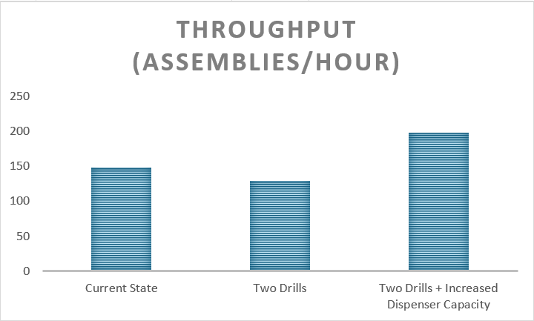
Figure 7 - Mean Throughput Across Current State and Improvement Scenarios
The comparison demonstrates that relieving an individual bottleneck does not necessarily improve overall performance. While additional drilling capacity shifted congestion downstream, the combined scenario achieved the highest throughput at 198.1 assemblies per hour, a 33.6% increase over the current state, while reducing average entity time from 3,845.5 to 218.9 seconds.
Further improvement opportunities remain. Adding operator capacity could reduce competition between dispenser replenishment and output removal, while reducing the 39.2 seconds of fixed transfer time could minimise non-value adding movement. Buffer capacities and replenishment frequencies could also be optimised to improve flow and reduce the risk of bottleneck migration. However, these alternatives were not simulated; therefore, their effects cannot be quantified from the present study (Oleghe and Salonitis, 2016).

Conclusion
This study developed and verified a Discrete Event Simulation of the Festo CP Lab to evaluate current state manufacturing performance and identify opportunities for Lean improvement. The model represented the specified product mix, processing and transfer times, shared operative activities and periodic replenishment and output-removal requirements. Simulation of the verified model enabled system performance to be quantified through throughput, waiting time, WIP and resource utilisation, while value analysis showed that only 1.1% of total entity time was value-adding, with waiting accounting for 97.2%.
The current state analysis identified drilling as the principal bottleneck, operating at 99.96% utilisation. Increasing drilling capacity relieved this constraint but shifted congestion downstream and reduced overall throughput, demonstrating the limitations of local optimisation. Addressing the subsequently exposed dispenser constraint increased throughput to 198.1 assemblies per hour, 33.6% above the current state, while reducing average entity time from 3,845.5 to 218.9 seconds. Overall, the study demonstrates how DES can complement Lean analysis by quantifying waste, identifying interacting constraints and evaluating improvement opportunities at system level before physical implementation.

References
Goldsman, D. and Goldsman, P. (2015) ‘Discrete-Event Simulation’, in Loper, M.L. (ed.) Modeling and Simulation in the Systems Engineering Life Cycle. London: Springer, pp. 103–109. doi: 10.1007/978-1-4471-5634-5_10.
Kumar, D.R., Devadasan, S.R. and Elangovan, D. (2022) ‘Mapping of non-value adding activities occurring in classical manufacturing companies with lean strategies’, Proceedings of the Institution of Mechanical Engineers, Part E: Journal of Process Mechanical Engineering, 236(3), pp. 894–906. doi: 10.1177/09544089211051595.
Liu, D., Guo, Y., Huang, S., Wang, S. and Wu, T. (2023) ‘Dynamic production bottleneck prediction using a data-driven method in discrete manufacturing system’, Advanced Engineering Informatics, 58, 102162. doi: 10.1016/j.aei.2023.102162.
Oleghe, O. and Salonitis, K. (2016) ‘Manufacturing system lean improvement design using discrete event simulation’, Procedia CIRP, 57, pp. 195–200. doi: 10.1016/j.procir.2016.11.034.
Rajab, S., Afy-Shararah, M. and Salonitis, K. (2022) ‘Using Industry 4.0 capabilities for identifying and eliminating lean wastes’, Procedia CIRP, 107, pp. 21–27. doi: 10.1016/j.procir.2022.04.004.
Rocha, E.M. and Lopes, M.J. (2022) ‘Bottleneck prediction and data-driven discrete-event simulation for a balanced manufacturing line’, Procedia Computer Science, 200, pp. 1145–1154. doi: 10.1016/j.procs.2022.01.314.
Sargent, R.G. (2010) ‘Verification and validation of simulation models’, Proceedings of the 2010 Winter Simulation Conference, Baltimore, MD, USA, pp. 166–183. doi: 10.1109/WSC.2010.5679166.
Turner, C.J. and Garn, W. (2022) ‘Next generation DES simulation: A research agenda for human centric manufacturing systems’, Journal of Industrial Information Integration, 28, 100354. doi: 10.1016/j.jii.2022.100354.
Vilela, F.F., Braga, C.C., Cruz, J.R.B., Bócoli, G.M. and Montevechi, J.A.B. (2022) ‘Discrete event simulation and lean production: quantification of waste in a pharmaceutical industry’, Journal of Lean Systems, 7(2).
Xiao, Y., Li, C., Thürer, M., Liu, Y. and Qu, T. (2022) ‘Towards Lean Automation: Fine-grained sentiment analysis for customer value identification’, Computers & Industrial Engineering, 169, 108186. doi: 10.1016/j.cie.2022.108186.

Appendices

Appendix A – Arena Verification Run: 100 parts, 10-Replication Output Summary
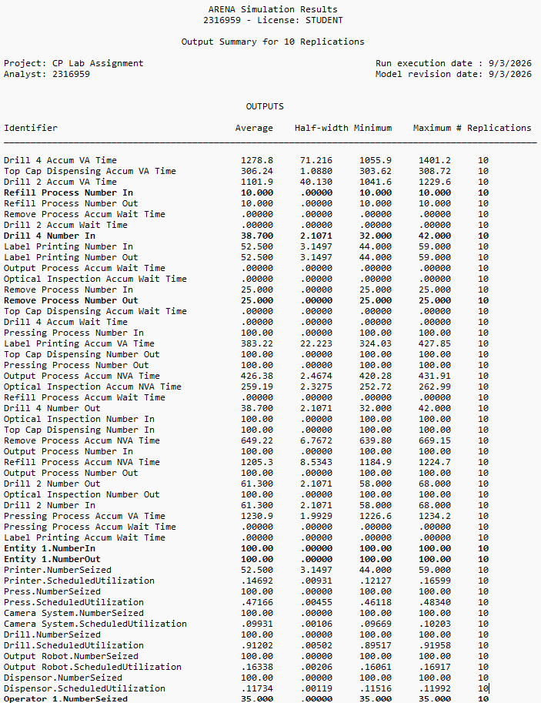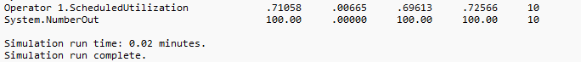

Appendix B – 8 Hour Simulation Results
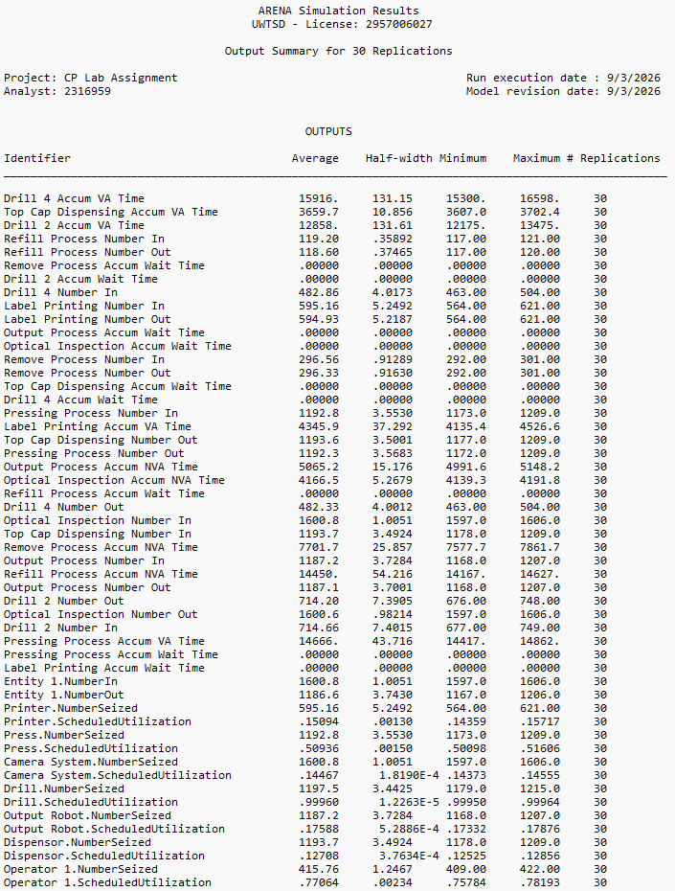

KPI | Identifier | Mean across 30 replications
Value-adding time | Entity 1.VATime | 43.1 s
Non-value adding processing time | Entity 1.NVATime | 25.5 s
Waiting time | Entity 1.WaitTime | 3,737.7 s
Transfer time | Entity 1.TranTime | 39.2 s
Other time | Entity 1.OtherTime | 0.0 s
Total entity time | Entity 1.TotalTime | 3,845.5 s
Drill Hold waiting time | Drill Hold.Queue.WaitingTime | 3,610.7 s
Drill Hold average queue | Drill Hold.Queue.NumberInQueue | 200.8
Dispensing Hold waiting time | Dispensing Hold.Queue.WaitingTime | 44.5 s
Press Hold waiting time | Press Hold.Queue.WaitingTime | 22.6 s
Output WIP Hold waiting time | Output WIP Hold.Queue.WaitingTime | 82.4 s
Output Hold waiting time | Output Hold.Queue.WaitingTime | 10.6 s
Where a mean statistic was not provided within the Arena Output Summary, the reported value was calculated as the mean of the corresponding statistic across the 30 individual replication summaries.

Appendix C – Two-Drill Scenario Simulation Result
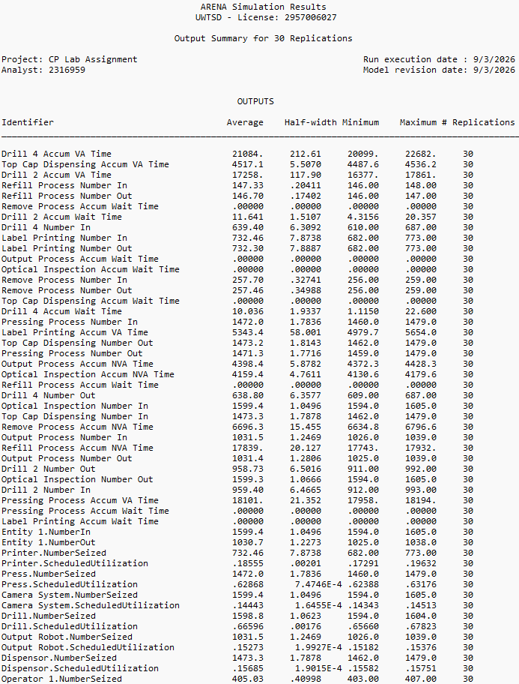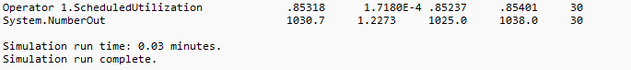

KPI | Identifier / Calculation | Result
Completed assemblies | Entity 1.NumberOut | 1,030.7 / shift
Throughput | Entity 1.NumberOut ÷ 8 h | 128.8 / h
Drill utilisation | Drill.ScheduledUtilization | 66.60%
Operator utilisation | Operator 1.ScheduledUtilization | 85.32%
Average entity total time | Entity 1.TotalTime | 5,202.4 s
Dispensing Hold waiting time | Dispensing Hold.Queue.WaitingTime | 1,117.9 s
Output WIP Hold waiting time | Output WIP Hold.Queue.WaitingTime | 4,267.0 s
Where a mean statistic was not provided within the Arena Output Summary, the reported value was calculated as the mean of the corresponding statistic across the 30 individual replication summaries

Appendix D - Two-Drill and Increased Dispenser Capacity Simulation Results
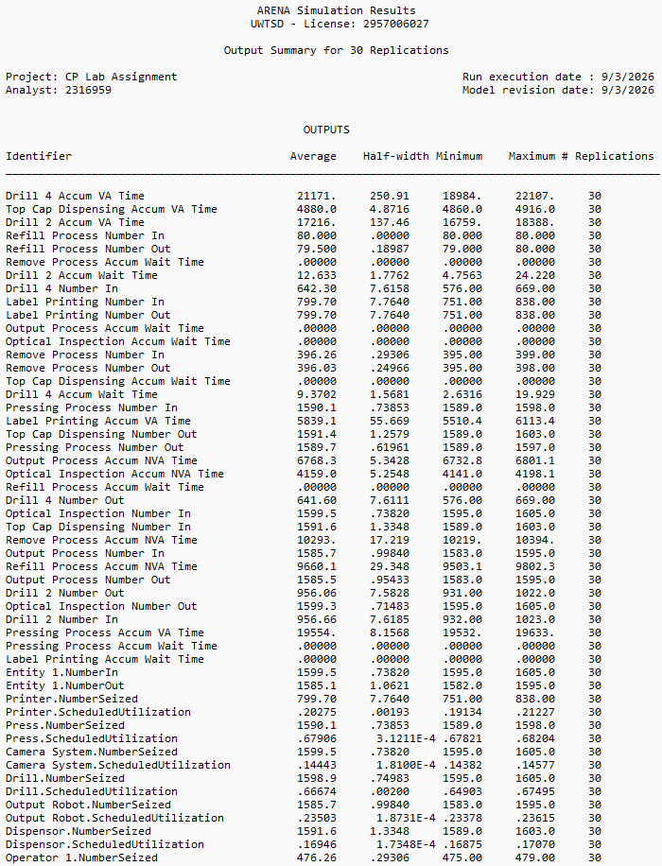

KPI | Identifier / Calculation | Result
Completed assemblies | Entity 1.NumberOut | 1,585.1 / shift
Throughput | Entity 1.NumberOut ÷ 8 h | 198.1 / h
Drill utilisation | Drill.ScheduledUtilization | 66.67%
Operator utilisation | Operator 1.ScheduledUtilization | 69.47%
Average entity total time | Entity 1.TotalTime | 218.9 s
Average entity waiting time | Entity 1.WaitTime | 117.2 s
Dispensing Hold waiting time | Dispensing Hold.Queue.WaitingTime | 38.2 s
Output WIP Hold waiting time | Output WIP Hold.Queue.WaitingTime | 38.6 s
Where a mean statistic was not provided within the Arena Output Summary, the reported value was calculated as the mean of the corresponding statistic across the 30 individual replication summaries.

