Written Report

Horhocea Cristiana Mara, Student no. 1604608 | Module:
Project Management | Lecturer: Joy Botu
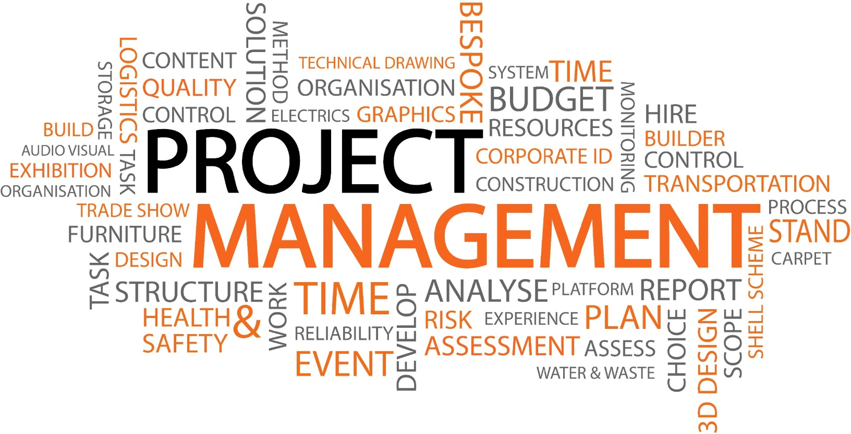

Table of Contents
1.0 The project………………………………………………………………………………2
1.1 Schedule……………………………………………………………………….2
1.2 Scope……………………………………………………………………………3
1.3 Requirements………………………………………………………………3
1.4 Deliverables…………………………………………………………………4
1.5 Cost……………………………………………………………………………..4
1.6 Time…………………………………………………………………………….5
1.7 Human Resources………………………………………………………..6
1.8 Risk………………………………………………………………………………6
1.9 Quality Control…………………………………………………………….7
1.10 Communication…………………………………………………………..7
2.0 Conclusion……………………………………………………………………………….8
3.0 References………………………………………………………………………………..8

1.0 The project
Project | Click-to-book Booking System
Company | LONDON SKYLINE
Period | 6 months (01/05/2019 – 30/10/2019)
Project Manager | Horhocea Cristiana Mara

‘London Skyline’ is considered to be a famous hotel in Central London that now wants to create a new booking system called ‘Click-to-book’ which is easy and quick to use and offers guests many opportunities. It brings flexibility to customers, employees and management, as it is a real time system which allows customers to check the availability of the hotel and every room’s features and it allows them to take a real time tour through the place. They can book the rooms by themselves and also check the prices, the lobby, the lounge, the spa, the gym all in real time as a virtual tour, and also the special offers for birthdays, anniversaries any other forms of celebration and they can request special arrangements such as balloons, flowers, confetti, wine, cake and so on.
This new booking system makes everything easier for the employees, as all they have to do is welcome customers to the hotel, direct them to the room they’ve chosen online and offer any assistance needed.

1.1 Schedule
The Schedule is represented by the timetable of the project. It has to be created before starting the project. In this project, the below chart has been used to demonstrate how the time has been split between the tasks in order to create the Click-to-book system.
ID | TASK NAME | START DATE | FINISH DATE | DURATION
1 | DESIGN | 01-MAY-19 | 15-MAY-19 | 2.14w
2 | SCREENING-PAGES | 15-MAY-19 | 15-JUNE-19 | 4.57w
3 | SUPERVISING PROCESS | 01-MAY-19 | 29-OCT-19 | 25.71w
4 | PRESENTATION LAYER | 12-JUNE-19 | 12-JUL-19 | 4.14w
5 | INTERNAL NETWORKING | 12-JUL-19 | 02-AUG-19 | 3.14w
6 | SERVER MAPPING | 02-AUG-19 | 15-SEP-19 | 6.29w
7 | ACCOUNT CREATION | 15-SEP-19 | 01-OCT-19 | 2.57w
8 | IMPLEMENTATION/HANDOVER | 02-OCT-19 | 30-OCT-19 | 4.14w
1.2 Scope
The scope of a project highlights its’ goals and objectives through a project plan listing out all the achievements step by step.
In this project, the main goal is to give customers the opportunity to operate with a new, modern and innovative booking system which saves time and money. As the technology is very advanced nowadays, it is easy for everyone to use a computer or a smartphone, instead of spending amounts of time over the phone with the operators or wasting their time with the check-in process.
It also gives the management the option to see who is staying in each room providing them with the guests’ personal details, as well as if they have any special request such as feather free bedding or free of gluten or dairy. It is a good and easy way of communication between the staff and the customers.

1.3 Requirements
The requirements are basically the expectations of the stakeholders of the specific company, what they expect from the project manager and also from the project plan itself and it is a project manager’s duty to meet all the requirements by the end of the project. Sometimes, there might be situations when the requirements of the stakeholders change in the middle or during the project process, therefore the project manager must be vigilant, make decisions and act accordingly.
In this project, the main requirement given by the stakeholders is to offer customers the opportunity to have their say, to book the rooms they like, the way they want, so that they can feel welcome, special and appreciated. This gives customers satisfaction and so avoids complaints or disappointment if the company cannot comply with their wishes. Considering this requirements, the new booking system has been chosen with a great IT expertise in software development. The IT team will be involved in the project for the whole period and they agreed with the time period and with all of the company’s requirements.
The following table briefly demonstrates how the management can communicate and connect with the guests of the hotel and try their best to comply with their requests:
Room booked | Special requests suitable for the room type booked | Confirmed/Agreed by the Management
#501 Queen Twin | DVD Player & bottle of Prosecco | √
#203 Deluxe Suite | Flowers & balloons for 25th anniversary | √
#125 Family Room | Extra bed & baby cot | √

1.4 Deliverables
The deliverables of a project are the products or services delivered at the end of the project. The input to the process can be anything, such as information, documents, equipment, plan, money, software, while the output can include contracts, project plan, software, apps, tools, consultation.
In this project, the main deliverable is the Click-to-book operating system. An agreement has been signed with the software developers and all the requirements have been arranged and also agreed by them, to make sure that they will get the project done by the due date.

1.5 Cost
The cost represents the sum of all expenses set by the organization for the project plan. The budget will be prepared through a budgeting process and will be approved by the head of the company by the start date of the project.
In the ‘London Skyline’ project, the direct and indirect costs have been estimated and resulted into a perfect budget which has also been approved.
The table below will show the budget for the project divided in tasks:
1 | Design | £ 25,000.00
2 | Screening/Pages | £19,000.00
3 | Supervising | £10,000.00
4 | Presentation Layer | £13,000.00
5 | Internal Networking | £22,000.00
6 | Server Mapping | £17,000.00
7 | Account Creations | £9,000.00
8 | Implement & Handover | £11,000.00
 | Total | £126,000.00
According to the above estimated budget, the total cost is £126,000.00, which of 30% will be spent on the wages of the personnel involved in the project and the rest of 70% is represented by other expenses such as materials, indirect cost and machineries.

1.6 Time
Time is the key in every project. In order to get the final out put done before the deadline, time has to be estimated according to each task. By undergoing surveys on previous projects and their time durations, project managers can come up with an estimated time for their future project.
As per that, to the London Skyline booking project has been assigned a certain number of days to every task and the duration of the project has been planned with a lot of research in regards of booking systems development.
According to the calculation of the time, everything is expected to go on as planned without any unplanned event or any inconvenience and so that we will get the project done approximately one or two weeks before the due date.
There has been assigned one extra day to each task, except the Supervising task, in case the team will be experiencing any accidents, sickness of employees, network failures, etc.…
TASK | ACTUAL NO. OF DAYS | EXTRA DAYS | TOTAL OF DAYS
Design | 15 | 1 | 16
Screening/Pages | 30 | 1 | 31
Supervising | 200 | N/A | 200
Presentation Layer | 25 | 1 | 26
Internal Networking | 20 | 1 | 21
Server Mapping | 40 | 1 | 41
Account Creation | 15 | 1 | 16
Implementation & Handover | 30 | 1 | 31
According to the table, the Supervising task has been assigned the highest number of days as it is the key process in every project; without supervising, the staff and the project itself cannot be properly monitorized and kept under control.

1.7 Human Resources
The Human Resources Management is an important field in every company or organization; it is contributing by recruiting and training every employee. In this project, the booking system developers are part of the human resources team, as well as the IT people, senior employees, technicians and project managers. It is recommended to get a maximum output from each team member as this will reflect in the result of a successful project.
According to this chart, the IT team plays the main role in creating the new booking system in the company and the senior employees are very important as well. In terms of supervising, project managers can be mentioned, in this case I am the project manager of this new project. Everyone has agreed on a working programme on a 12 hours basis, from 8AM to 8PM with a break of one hour. Every tean member has signed a contract which mentions an advance payment of 35% at the beginning of the project and the rest of 65% at the end of the project.

1.8 Risk
Risk is an uncertain or sudden event that gives direct impact on the project process which will affect the objectives as well. Facing a risk could result in positive as well as negative but its high chance of negativity. Regarding this as a project manager I must manage those risks in a perfect manner it’s known as risk management. Pre plans must be done identifying what will the risks we will be facing in future and how to react fast towards it. It is one of the best qualities of a project manager. (PMI, 2018)
The Risk Management Cycle begins from identifying risks, to evaluating risks, to proper reaction and finally to monitoring, responding and working on negativity to change in to positivity and it goes round and round in a cycle.

1.9 Quality Control
In order to obtain a high quality result of the project, the project manager must follow the Quality Control process. Quality also plays with cost and time, for example if the investment is increased, the quality of the product automatically increases as well. The Quality Control process is similar to the Balance Scorecard, which is used to balance the financial factors with others in order to bring stability to the organization. There are three steps in the Quality Control process:
- Quality Planning
- Progression quality assurance
- Controlling the entire process
There 3 factors will be used in this project as the process will run on as planned, while it will be supervised to make sure that everything is going on as it should.

1.10 Communication
In a project management the project team must be well communicated in between each other’s in the team. This must be well organized by the project manager. When a project team works together the more they communicate make them come up with more challengeable outcome. As when they on discussions easily someone in the group could find a better way in the process this makes the team to a redirection and easy way to reach milestones. (Burke, R., 2013)
In the process of a project plan, there has to be great communication between all the employees involved in the plan. Therefore this means that the team has to be well organized by the project manager. Many project fail due to lack of communication. The stakeholders must make sure that everybody understands the vision of the project; this is the only way that they will be able to work together towards the goal.
In this project, the vision has been highlighted since the beginning for all the team members as well as for the stakeholders so that they understand that the project has to be finished by November. Meanwhile the project will continue as planned and all the updates and changes will be communicated in real time directly and will also be emailed to each person.

2.0 Conclusion
This report demonstrates a clear understanding of the process of a project plan and also a clear view as a project manager assigned to finish a project. A project has to be assigned a start date as well as a deadline. As the Project Manager of the new and innovative booking system ‘Click-to-book’ I have been asked to create a modern booking method to make the life of customers and employees easier by saving time and money. The main aspect in project management is to balance the 2 factors quality, cost and time which means every projects aim is to get good quality productivity in low cost and within the time frame. The above mentioned terms are also followed in project management, but with 3 corners, simply as a triangle. In a triangle, all 3 sides must be balanced to get the exact triangle look. If not, it will reflect a different design; just like in a project, the project manager and the team must balance all 3 factors: cost, time and quality; this is what will bring them a successful result.
Moreover, by writing this report, I have gained a vast knowledge on how to carry out a real project plan, the skills and requirements that a project manager has to meet and also about current ongoing projects in the United Kingdom; all of these will help me for sure in my future business career.
3.0 References
Harold, K. (2009). Project Management a System Approach to Planning, Scheduling and Controlling. New Jersey: John Wiley.
PMI. (2018). PMI Learning. Retrieved from Project Management Institute website: https://www.pmi.org/learning/library/managing-human-resources-project-management-1740
PMI (2019) What is Project Management? Retrieved from https://www.pmi.org/about/learn-about-pmi/what-is-project-management
ProjectManager (2018) Project Planning for Beginners. Retrieved from https://www.projectmanager.com/training/project-planning-for-beginners
ProjectManager (2017) What are Project Deliverables? Retrieved from https://www.projectmanager.com/training/what-are-project-deliverables
Robert, K. (2009). Effective Project Management. Indiana: John Wiley

