Social Media Posts:
Instagram:
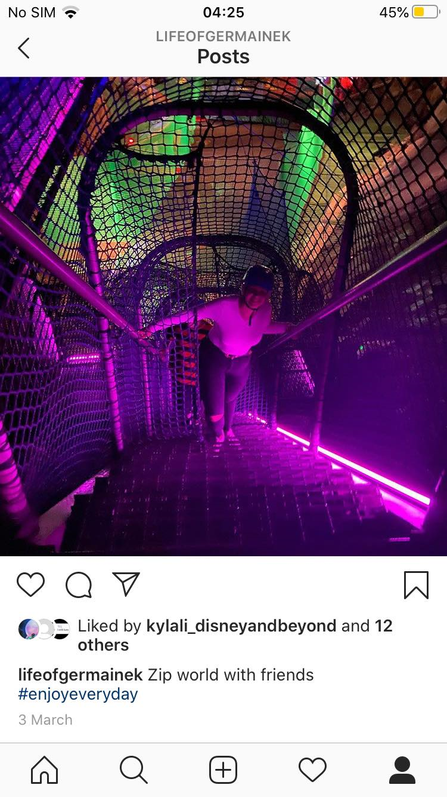
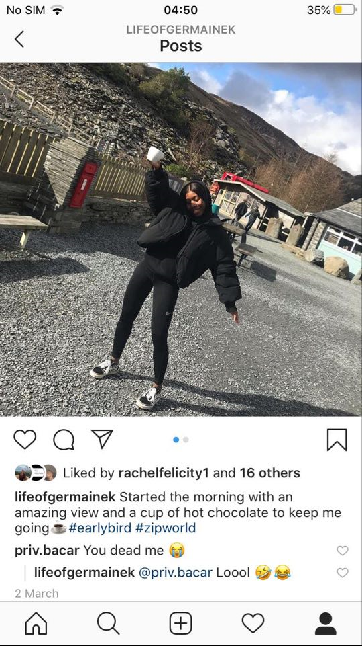
Posted on:03/03/2020
Posted on: 02/03/2020


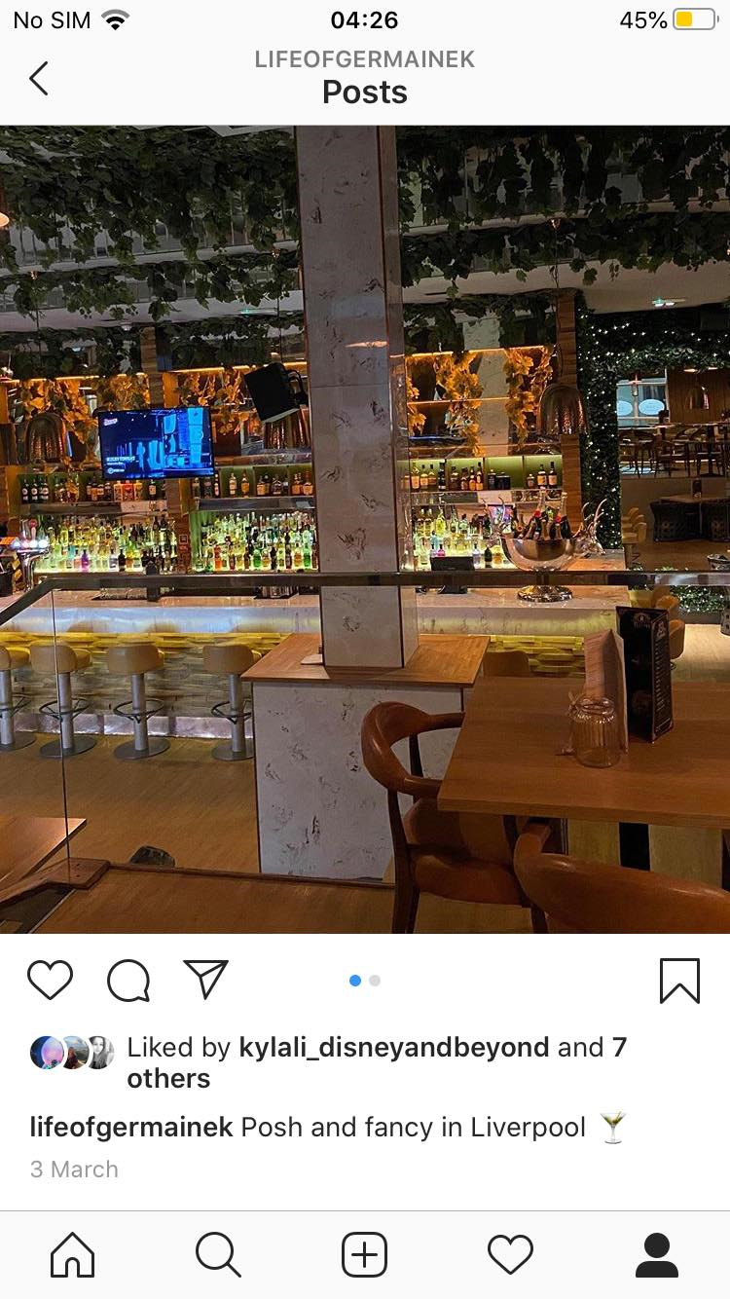
Posted on: 03/03/2020
Posted on: 03/03/2020

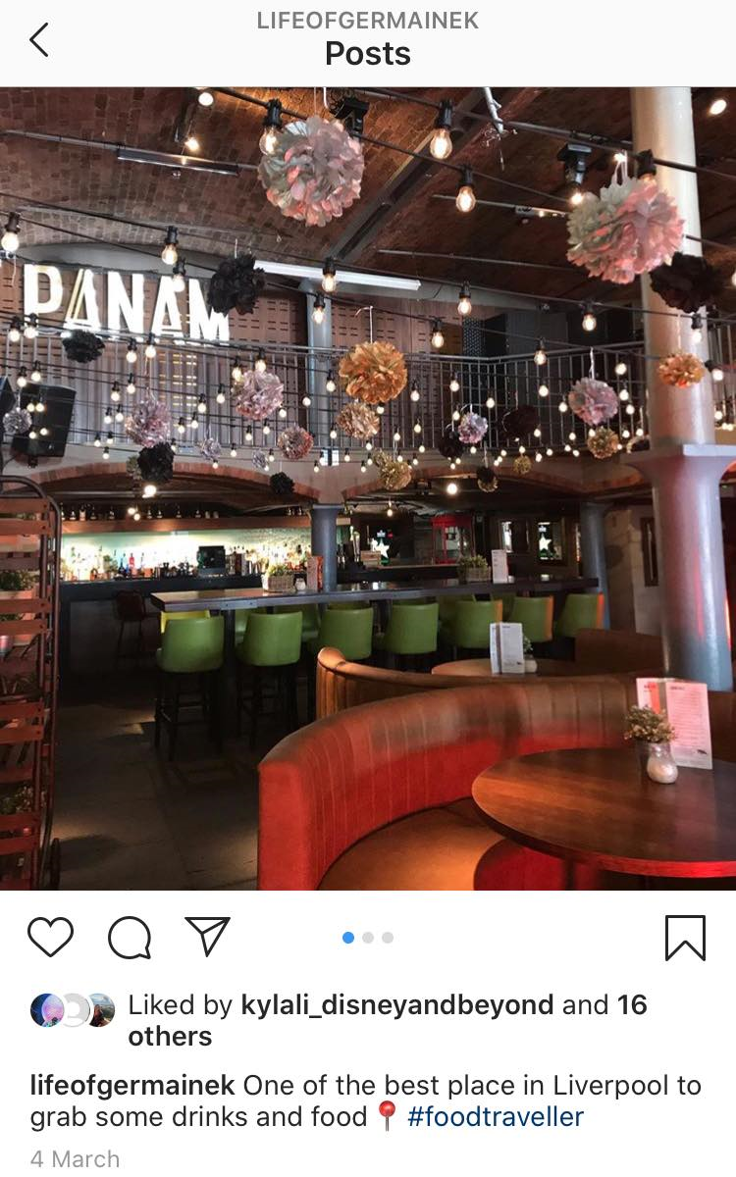
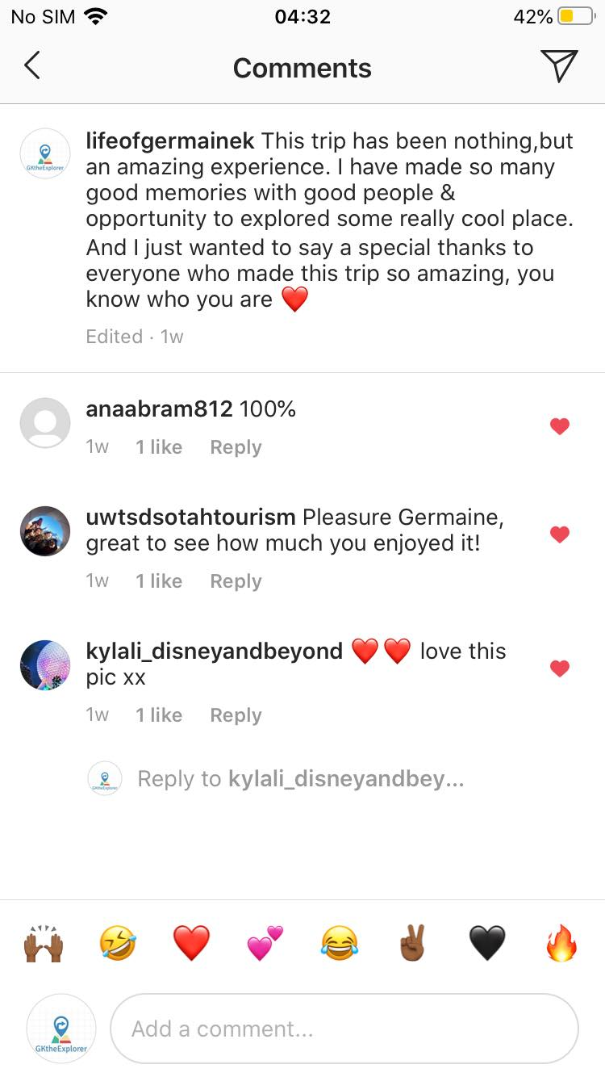
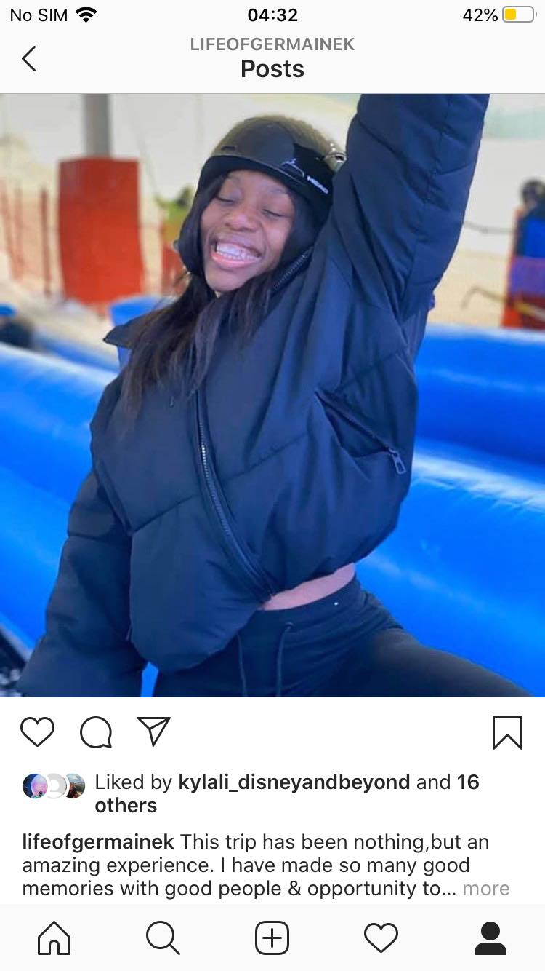
Posted on: 04/03/2020

Posted on: 06/03/2020

Posted on: 05/03/2020
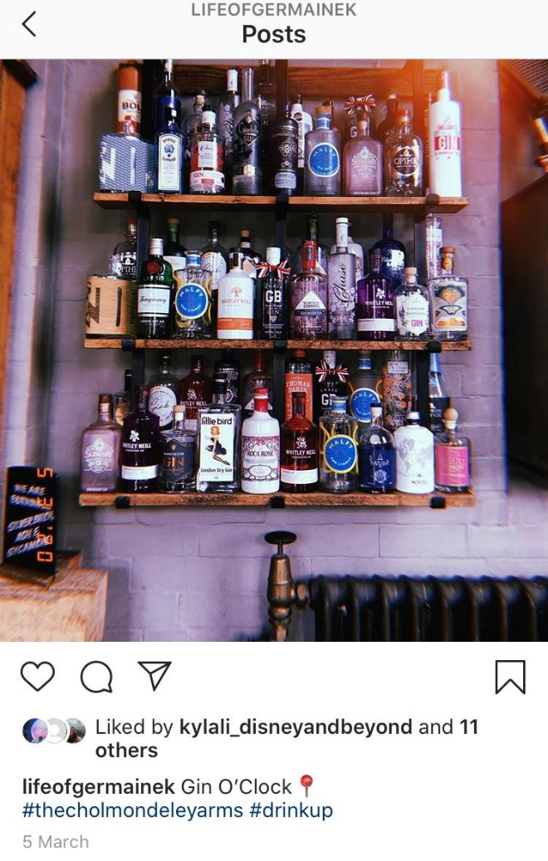
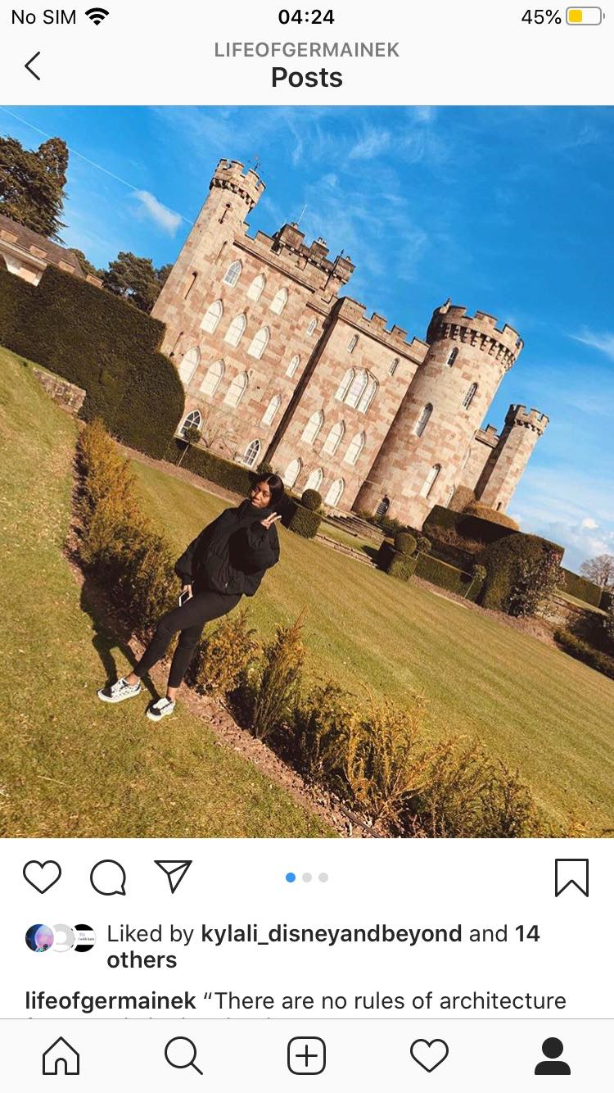
Posted on: 05/03/2020


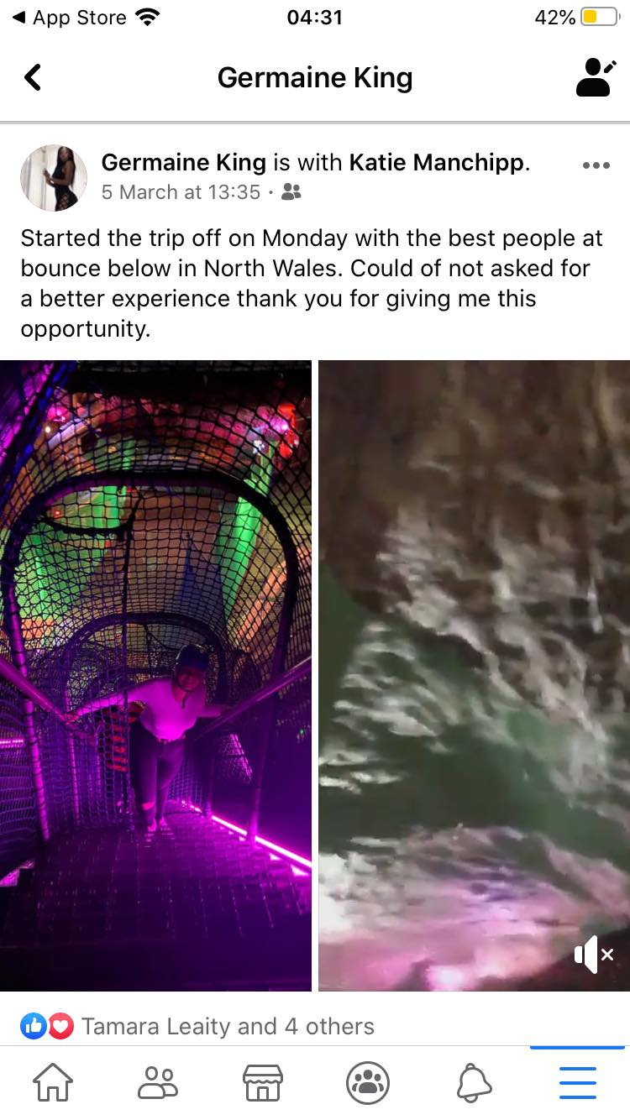
Facebook:

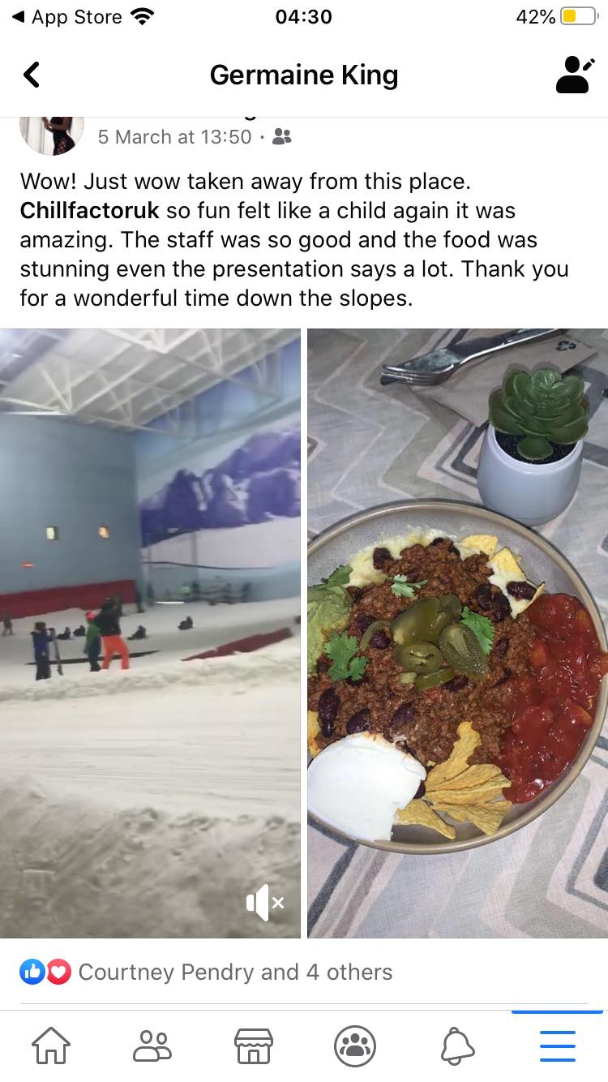

Snapchat:
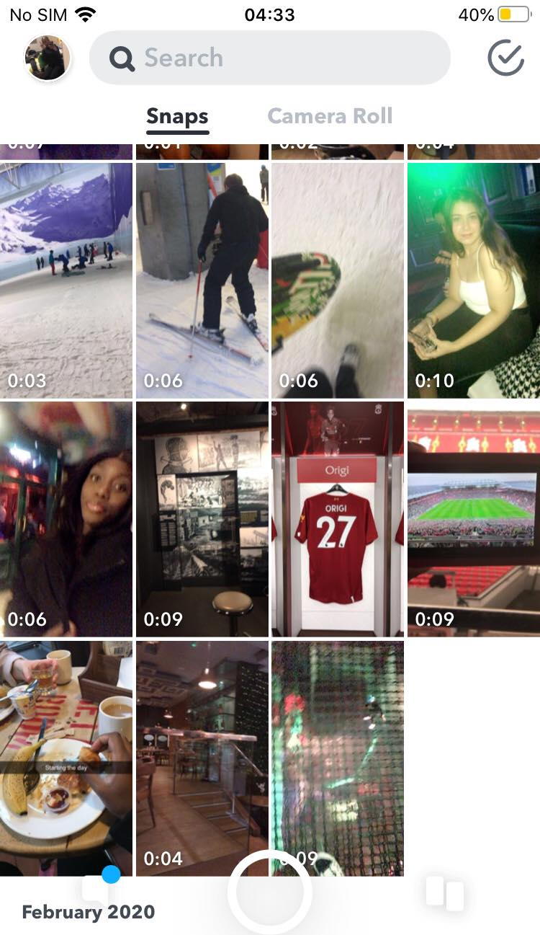
Overall, for my snapchat I end up losing all the pictures and videos that I posted, because I forgot to save them on my snapchat memory. Although Instagram and Facebook have to be one of the best social media platforms I have used to promote my travel strategy, because I got more likes and comments on those platforms ,compared to snapchat that I didn’t get any respond.

