A critical evaluation and the identification of next teaching and learning steps focusing on a case study of an individual learner or a group of learners, based on an observed critical incident (equivalent to 5000 words).

Introduction
The impact on Child development and progress should always be a key consideration when planning and reflecting on lessons. Through observation, it is important to be aware of critical incidents that may need to be investigated further or from different points of view. This promotes what can be done to help, and next steps in line with the research or findings behind these initial thoughts. A definition of a critical incident is portrayed brilliantly by Tripp (1993) “Incidents tend to be ‘typical’ rather than ‘critical’ at first sight but are rendered critical through analysis.” This quote shows how your first thoughts or impressions when looking at an incident can determine what you think the reason for that is. Through critical thinking and analysis, there could be underlying reasons or issues present that lead to certain behaviours that may seem ‘typical’ everyday behaviours. Throughout this case study, behaviours observed from within a classroom environment will be highlighted and discussed by using past research, reflective models, and possible next steps will be highlighted. The importance of reflecting on experiences and incidents to help children’s learning and being able to promote a positive learning environment will also be discussed in order to think beyond a single incident.

Observation
Throughout observations, BERA (2018) guidelines have been adhered to in order to ensure anonymity of the school, and all associated with it.
“The confidential and anonymous treatment of participants’ data is considered the norm for the conduct of research. Researchers should recognise the entitlement of both institutions and individual participants to privacy and should accord them their rights to confidentiality and anonymity.” (BERA guidelines (2018)).
The Observations took place in School X, located in south west Wales which has an age range of pupils between 3 to 11 years of age. There are approximately 471 current pupils and as a school they take huge pride in the sense of community within the school and have also created strong links with the community itself. The observations took place within foundation phase, and the children were a mixed ability class. There were twenty-five children within the class. From an Estyn report (2018) School X has a percentage of 21% pupils entitled to free school meals (FSM) and from the inspection are recognised as a green school with a good standard reported throughout all departments and hierarchy of the school. The lesson observed was structured as five different tasks. The Children within the class had a good understanding of the structure of the lesson and the expectations of the teacher.

Methodology
Throughout the case study, various observation strategies were used in order to gain the best insight of what was happening within the classroom without affecting the learning environment in a negative way. The children’s skills, the interaction between child one and two and the achievements or perceived view of the task that they were attempting were all observed. The observer used various techniques and initially these were to be a participant in the task and ask open questions, but without using language that could influence the children’s answer. The initial questions were to check understanding of the learning objective and the aim of the task. There were also times where the observer acted as a non-participant in order to be able to more natural interaction between the pair, meaning the observer was not involved in the challenge at all. Child one attempted role play and tried to engage with the challenge. The non-participant approach was necessary due to the fact of the dynamics of the pairing, and there were a lot of potential aspects present contributing to lack of engagement and behaviour of child two, which if the observer involved their self too much it may not have been a natural portrayal of the children’s role in the task. Mark Kirby (2000) touches on the Hawthorne effect in his writing and explains how people may change their behaviour if they are aware, they are being watched. This could have been a disadvantage of the methodology due to the fact the observer used questioning at first. This then links that the ‘Hawthorne effect’ may have been a feature in the children’s behaviour after that initial dialogue with the observer. The observer used a lot of written records and notes, but tried to record information away from the child so that it did not distract or influence the task they were taking part in. As stated in The Reggio Emilia approach (1998),
“We use written notes, observation charts, diaries and other narrative forms, as well as audiotapes, photographs, slides, and videotapes. These allow us to make visible the process of children’s learning, the ways to construct knowledge, the emotional and relational aspects;”
The methods chosen by the observer relate to this and by writing notes and diaries it allowed the observer to be able to portray the children’s learning and thought process. In the book it goes on to explain “Observation involves much more than simply perceiving reality, but also constructing, interpreting, and revisiting it.” (Edwards, C. P et al. 1998). This shows how by using written notes it allows the observer to revisit information that they have recorded when analysing the incident. The observer was able to form a timeline to behaviours surrounding the incident and help link to previous research when looking into reasoning behind it. Time and event samples were used to see if the timing of a lesson had an effect of the children’s engagement or behaviour. To do this, the time of each observation was recorded, and then through evaluation It could be seen if the time of the day had any potential effect on the child being observed. Some key points considered when observing the class were to enter a new observation with a new view, being careful not to transfer anything seen in previous lessons into the current situation. A possibility of sociograms being used when observing the class could have been an interesting way of identifying social relationships within the class. It allows the observer to see who interacts with who and if that interaction works both ways within the communication. It was decided that Sociogram’s would not be a technique used in this incident due to the challenge only involving a pair, so it was clear to the observer through non-participant observation what the relationship was like between the two children. Through analysis, there were also negatives surrounding this technique, “A major disadvantage of the sociogram is that it does not explain why certain relationships exist, how they developed, nor does it indicate the intensity of feelings held.” (Cargan, L. 2007). This is important to highlight as there is no reasoning behind the findings of a sociogram. More research and critical thinking would be needed as a primary focus within findings of a sociogram, rather than it just supporting the Case study that was being observed. A diverse range of observation techniques should be used at different times as it can help to paint a bigger picture of a class or a situation. Various techniques will be more successful than others in certain situations.

Four Purposes

The case study is based on an independent learning challenge, working in pairs and learning maths through role play scenarios. The learning objective was to identify Tens and units, using money in a fruit and vegetable store in a role play environment. There was no teacher input and no worksheet or end of challenge discussion or questioning to assess learning. At the beginning of the challenge, it was clear child 1 was motivated to work and was engaged, whereas child two displayed avoidance techniques and poor behaviour. There was no engagement from child two, which did influence child ones learning and engagement as the lesson progressed. Through observation, links were made to the core aims of the new curriculum, published in Donaldson’s successful futures (February 2015). With role play, independent learning and discovery displayed within the case study, this promotes the purpose of enterprising, creative contributors, ready to play a full part in life and work. This is displayed through the creative nature of the task and allowing children to structure learning their selves through role play and independent planning. Referring to Donaldson (2015) and the aims, the role play challenge gives the opportunity for the children to lead and play different roles within a team or their pair, while also allowing them to express skills and emotions within a real life situation that they may have experienced before. This links again the Piaget’s (1936) theory of ‘schema’ and how past experiences can allow for new knowledge to be connected and called upon when in similar situations. The second aim that the case study related to would be the development of Ethical, informed citizens of Wales and the world. Through the social skills needed to role play, participating in a challenge of shopping, use of money and communication with others is needed to achieve the learning outcome. It promotes how to be a part of society and informs them of challenges they might face in society and how the be resilient and overcome them. Through participation in the challenge, children were given the opportunity to understand the impact of their actions and decisions and touching on the importance of respecting others needs and wants within society. These are valuable skills and link directly to Donaldson’s successful futures (2015). The challenge was very creative and allowed the children power over how they learnt a topic while displaying the skills needed in order to be creative, ethical and successful in what they are doing. The third aim this challenge links to is healthy, confident individuals, ready to lead fulfilling loves as valued members of society. The challenge of the fruit stall allowed them to develop confidence to shop and work on social skills. It allowed the children to make healthy decisions by purchasing fruit and vegetables from the shop. Opportunities to show confidence to participate, develop skills and knowledge to manage day to day life as best as they can and to develop knowledge on healthy eating and diet are all presented within this challenge (Donaldson 2015). From a task which is seen as fun by the children, it has a enormous effect across a wide range of the curriculum aims and will develop skills needed for lifelong development. The dynamics of the pair and the behaviour shown by child two did have a negative effect on the task and the links to the aims of the curriculum. There has been much thought on the next steps in order to help the links to curriculum, engagement and learning if presented with a challenging situation as portrayed in the case study.

Literature review

There is a vast amount of research completed on young children in education, which includes different aspects of development, wellbeing as well as other important areas. The critical incident that has been identified held a lot of information and potential aspects to evaluate. Through the challenge, Child 1 displayed willingness to learn and motivation towards the task, whereas child 2 was not engaged, displayed bad behaviour within the challenge and contributed to the loss of motivation of child 1 by using distraction. The first area I critically evaluated was the knowledge and understanding of child 2.
Jean Piaget (1936) explains how ‘schema’ are the “building blocks of knowledge” and the basis of his research with schema was that children recall knowledge that has already been learned to help in a certain situation, they then connect new knowledge to it. However, in a specific challenge or task that child 2 was presented with, the use of role play and real-life situations dealing with buying items from a shop, the dialogue that involves and counting money may not necessarily be previous knowledge. This links to the environment the child is in at home and Erik Ericson (1963) explains through his findings that parents and carers need to understand each stage of their child’s development. If this is the case then they will be able to link in with curriculum work and values, helping the child meet their potential and help them through any crisis they have. It is a possibility that Child 2 has not had the experience of going shopping and handling real money before, potentially due to lack of involvement with day to day experiences with parents or even the fact that society is becoming more digitally competent and less real money is being handled and shopping is done online or with debit cards. If this is the case, then Child 2 will really struggle to call on past experiences in order to help himself in this independent learning task. As well as past experiences, additional research could link to this incident. One being the skillset that the child already possesses and is it possible for the child to complete this task independently.
“each of us has simultaneously and actual level of development in any domain and a zone of proximal development which is uncovered after some help and which will typically exceed the actual level.” (Lev Vygotsky, 1935).
Vygotsky’s research states how to reach an individual’s proximal development, they will need help in order to do this. In the independent task Child 1 and 2 were both in a pair but were not working together. As an independent task there was no input from the teacher, so there was no option for help from the teacher in order to understand and complete the task. Vygotsky refers to this help as ‘scaffolding’ and is seen to build up to learning new knowledge with the help of others. Unfortunately, this wasn’t the case in this incident as child two didn’t seek for help and child one didn’t seem willing to help but rather more engaged at the beginning with what he had to do. On the other hand, the observer saw how positive the challenge can be in learning (see appendix 1.c) and development with both children working together effectively and taking turns to play different roles while helping and peer assessing the situation. This highlights the importance of social aspects within the challenge. Leading on, due to child 2 being so withdrawn from the task from the start, research exploring avoidance techniques could be a possibility. Covington (1992) has in depth research on avoidance of a task and from analysing this, this may have been an option as child two didn’t want to feel embarrassed or display to his peers that he didn’t understand a task. This then developed into poor behaviour and therefore promoting a different reaction from child one where he was no longer engaged either. This behaviour display takes away from the fact that child two may not understand the task and more towards the child trying to be funny or impress or distract peers, as displayed when child two was falling off their chair and throwing items. This had a significant effect on child 1 as he was motivated to complete and attempt the task and through observation child one set up the shop, prepared the money and created an environment ready for his independent learning. However due to the behaviours displayed by child two these did not develop into a learning experience for either child.
Another area is behaviour and the different types displayed were a big aspect of the incident. It is interesting how and why these may have been present, especially by child 2. Glasser (1965) Reality therapy illustrates a very interesting model and research into the class environment and the options that children can are presented with in order to promote positive behaviour. The theory follows the needs of the child, which are separated into five different categories. The categories all represent a need for the child and within this incident some were met but possibly not all for child 2. This leaves the opinion open for the needs of the child not being engaged which may have led to the lack of display of poor behaviour by child two. Within the incident and referring to Glasser (1965) I do believe that the children were given ‘power’, ‘fun’ and ‘survival’, three of the five categories. They were given responsibilities by the fact of allowing them to adapt how they worked or performed their own role play situations, knowing that they were in a safe and in a fun environment. However, ‘belonging and love’ and ‘freedom’ may be slightly less prominent than the other categories. The children received no monitoring, feedback, praise and did not feedback on their own learning at any point during the challenge. This could have led to lack of motivation as they may have thought either no one is checking or just the fact that there is no one to show that they are doing something right or wrong may have been hard for the children. Skinner (1972) states that “one can promote behaviours that counteract and inhibit the undesirable behaviours through positive reinforcement.” Referring to Skinner there would be no positive reinforcement in the task to try to counteract child two’s behaviour by giving positive reinforcement to child one. This may have been a factor in child one’s eventual loss of motivation. The other potential issue when relating to the freedom aspect of the theory might be that although the children were aloud to role play independently, they were told the learning outcome and what they had to do. This may have taken away from allowing the children to make choices on how or what they are learning. For example, by making it just a fruit and vegetable shop, this may not be child one and two’s interest and would much rather a toy shop. The children might relate this to lack of fun and it does limit the amount of input the children have into a task that is meant to be independent.
One other huge factor to a child’s development and progress may be from environmental and social factors in their day to day life. Bronfenbrenner’s ecological systems theory (1979) explains the concept of how immediate family within your ‘microsystem’ right through to larger society in your ‘macrosystem’ can all play a huge role in a child’s development (see appendix 3). The connections, activities, roles that the child has throughout each of the four systems is said to have a direct impact on the child’s development. If some systems do not contain positive experiences and development, then it is going to be hard for that child to develop further. Although, the child’s independent development should never be overlooked, it may be a possibility that within the task set in class child two has not experienced strong connections throughout the microsystems or beyond to establish development in the area of dealing with money, and shopping in a real life situation. Throughout the analysis there were different aspects to the one incident, although different elements were displayed by child 2 which triggered critical thinking, it is important to address the effects that this behaviour and incident had on child 1. Illustrated well in a book by Neil Salkind (2004) according to Vygotsky “social interaction leads to changes in children’s thinking (and then their behaviour),” This relates directly to the incident with child one’s initial motivation and engagement being effected by child two’s lack of engagement and display of poor behaviour within the challenge. This puts emphasis on assessment for learning and highlights that groups/pairings are extremely important when children are performing an independent task. The social aspects can either have a positive or very negative effect depending on the interaction between the students.

Evaluation – next steps
Research is of high importance when identifying patterns and the critical evaluation of all possibilities can allow for a bigger picture to be portrayed. Throughout the case study these are options or suggestions to why certain behaviours were displayed within the incident. However, it is important to consider suggested next steps to address and overcome any potential issues that may arise within the classroom and school. I will also be referring to the assisted reflective conclusions model in order to identify areas for potential improvement and that will benefit my development when progressing into the teaching environment. Within the Case study there is scope to potentially include additional assessment for learning strategies. For example, at the end of the challenge, including questioning and feedback from the children within their groups. This would give the teacher insight into whether that period of independent learning has been successful and if the children had achieved the learning outcome. The option of exemplars could also be used as an assessment for learning strategy. Before starting a new challenge, the teacher could allow the children to view the intended outcome in visual form. This would help the children to structure how to achieve the learning outcome instead of just being aware of what they are expected to achieve by reading the learning outcome provided. Summative and formative assessment is a huge contribution to effective teaching and learning and I will ensure to use these types of assessment alongside each other to ensure continuous assessment and end of topic or unit assessment for a whole picture of each child’s progress. I will put emphasis on Formative assessment as I feel this is a key tool to promote on going learning and staying in touch day to day with the children’s understanding. As mentioned by Dylan William (1998: Page 3) “Strengthening the practice of formative assessment produce significant, and often substantial, learning gains.” Through the case study observations, a key aspect which could be implemented could be scaffolding or teacher input where needed. In order to help the children, teacher input or presence may be enough to ensure the children stay engaged rather than being left completely independent for a whole task with no end piece of work or discussion following a task. Using the ARC model of reflection allowed me to address my feelings towards the experiences observed and allowed me as the observer to display the importance of analysing an incident from first impressions. The progression of the model then allowed me to break down understanding of the incident within context. This helped as through this stage of reflection I looked in depth at various research theories to identify potential reasons or areas to consider when trying to reach a conclusion. Naturally, this model leads onto evaluation of the lesson and what worked well and encouraged a positive learning environment. This allowed me to highlight positives in which I could implement or adapt into my own teaching. Lastly, the conclusion and action section of the model. This is an extremely important section and I believe this will be very important to the case study reflection as well as moving forward within my own personal development. This model can be compared to Gibbs (1988) reflective cycle where an emphasis is placed on the feelings that are related to the incident. The model also explains how positives and negatives of the experience can help draw conclusions and allow for analysis of where certain aspects of the incident may have gone wrong. This shows reflection links closely to what could be done next, and this is essential in order to progress and improve. This approach will help ensure children understand and continue to develop in their learning while enjoying the environment they are in. Furthermore, Schon D (1995) and his model of reflection separates the reflection into different points of view. It reflects directly to the experiencer’s processes and feelings at the time of the incident. On the other hand, he also takes into consideration previous events and research to account new information. This could be a very good way of creating clarity of the reflection process, however a disadvantage might be trying to blend the conclusion or next step ideas to suit the individual due to the initial separation. By identifying issues or possible solutions this will strengthen me as a teacher and promote good practice by encouraging change in areas that may not have worked as well as I had thought. I think by reflecting on my feelings towards incidents or lessons this also helps manage personal wellbeing, which is an important part of being a teacher. By reflecting, the teacher now has a tool to use to ensure they identify what made them feel a range of emotions and whether bad or good, help avoid those situations or promote them depending on the outcome.

Conclusion
In conclusion, by using next steps following on from observation, identifying the incident and reflection, they are an integral part of effective teaching and learning. The processes followed throughout this case study all reinforce the growth of professional standards that apply to practitioners in Wales. I believe that the next steps suggested all contribute to creating long term effective practice. There have been reflection models highlighted and discussed to promote the benefits of reflection and the success that can bring while developing professional standards. “The new professional standards for teaching and leadership reflect practice that is consistent with the realisation of the new curriculum.” (2011). Throughout the case study there is a clear link to the new curriculum and through critical analysis I do believe that effective reflection leads to the planning of positive next steps, while blending with the new curriculum aims and areas of learning. Therefore, allowing the observer or teacher to plan based on children as individuals and for development and growth rather than just teaching to test. Through reflection, it means you can see a range of views, opinions, facts and issues without just viewing something once and deciding a reason for it. This allows for next steps to be planned and implemented to benefit both children and teacher.

Word count: 4298

Reference List
Black, P,. Wiliam, D,. (1998) Inside the black box: Raising standards through classroom assessment. Kings college: London
British educational research Association [BERA] (2018) Ethical Guidelines for Educational Research, fourth edition, London.
Bronfenbrenner, U,. (1979) The ecology of human development, experiments by nature and design. London
Cargan, L. (2007) Doing social research. Unites states of America. Roman and Littlefield publishers. (page 146)
Cox, T. ARC model of reflection. University of Wales Trinity Saint David.
Donaldson, G. (2015) Successful futures. Crown Copyright. Cardiff
Engler, B,. Personality theories. (2012) Page 224, Eighth edition. New York: Houghton Mifflin harcourt publishing company.
Estyn (June 2018) Estyn, Her Majesty’s Inspectorate for education and training in Wales. [online] Available at: https://www.estyn.gov.wales/sites/www.estyn.gov.wales/files/documents/Pontarddulais%20Primary%20School.pdf
Glasser, W,. M.D,. (1965) Reality therapy a new approach to psychiatry. New York: Harper & Row.
Kirby, M. (2000) Sociology in Perspective. Oxford: Heinemann educational publishers.
P. Edwards, Carolyn., Gandini, Lella., Forman, E. George. (1998) The Hundred languages of children: The Reggio Emilia approach – advanced reflection. 2nd Ed. London: Ablex publishing corporation.
R, Callara,. (2008) Nursing education challenges in the 21st century. New York: Nova science publishers.
Salking, Neil, J. (2004) An introduction of theories of human development. University of Kansas. SAGE publications. (Page 279.)
Schon, D,. (1995) The reflective practitioner: How professionals think in action.
Simply Psychology (2018) Erik Ericson’s stages of psychosocial development. [online] Available at: https://www.simplypsychology.org/Erik-Erikson.html.
Simply psychology (2018) Jean Piaget theory of cognitive development. [online] Available at: https://www.simplypsychology.org/piaget.html.
Tripp, D. (2012) Critical incidents in teaching: Developing professional judgement. London: Routledge.
Vygotsky, L,. Edited by Lloyd, P., Fernyhough, C,. (1999) Critical Assessments, Volume III The zone of proximal development. London and New York: Routledge.
Welsh government, H.W.B. 2011. HWB. [Online]. [26 October 2019]. Available from: https://hwb.gov.wales/professional-development/professional-standards.

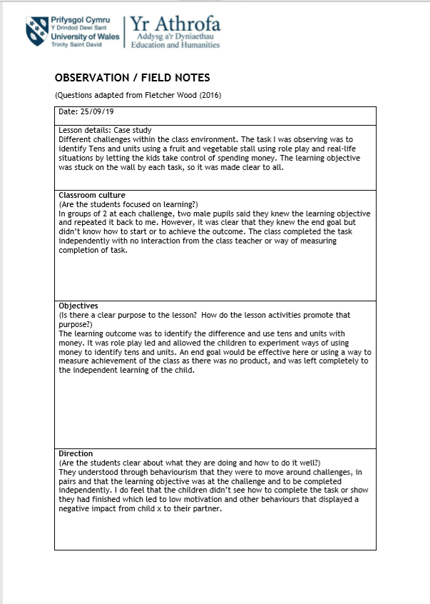
Appendix 1.a

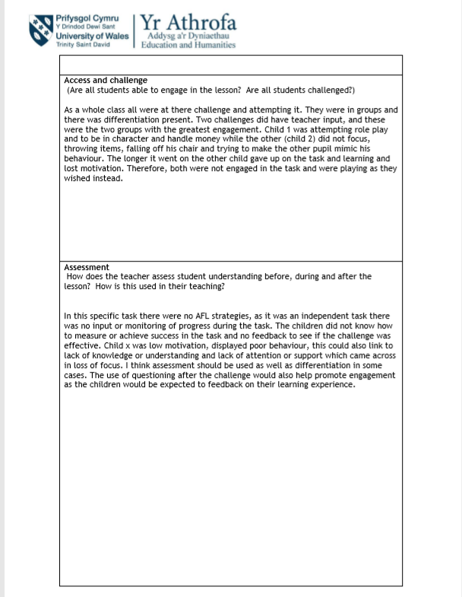

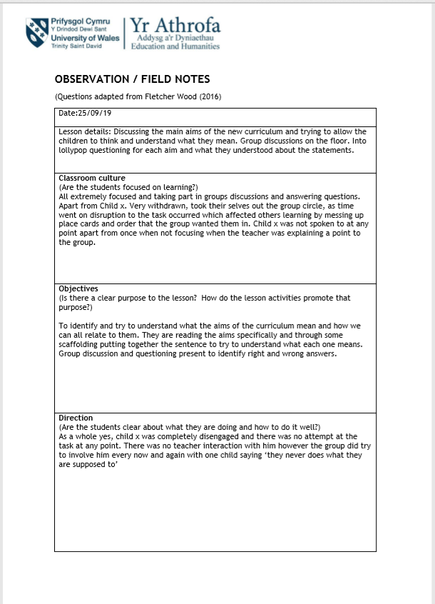
Appendix 1.b

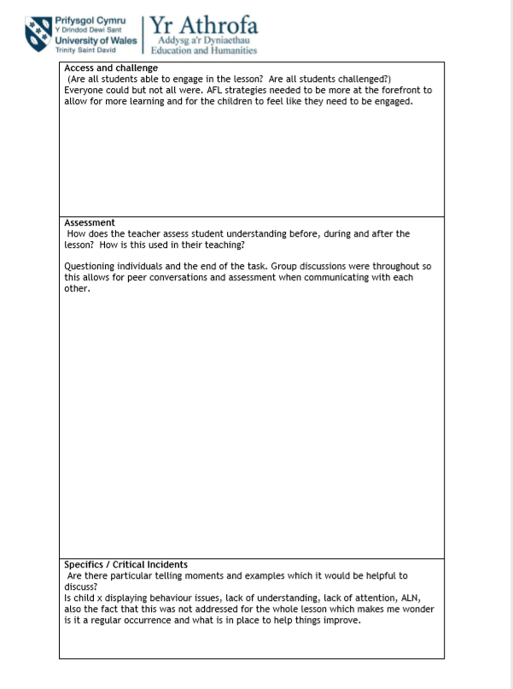

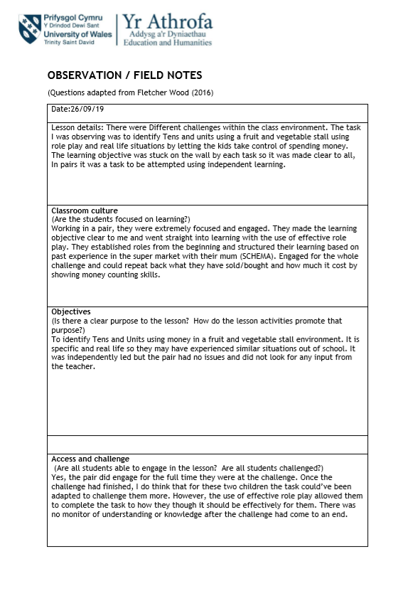
Appendix 1.c

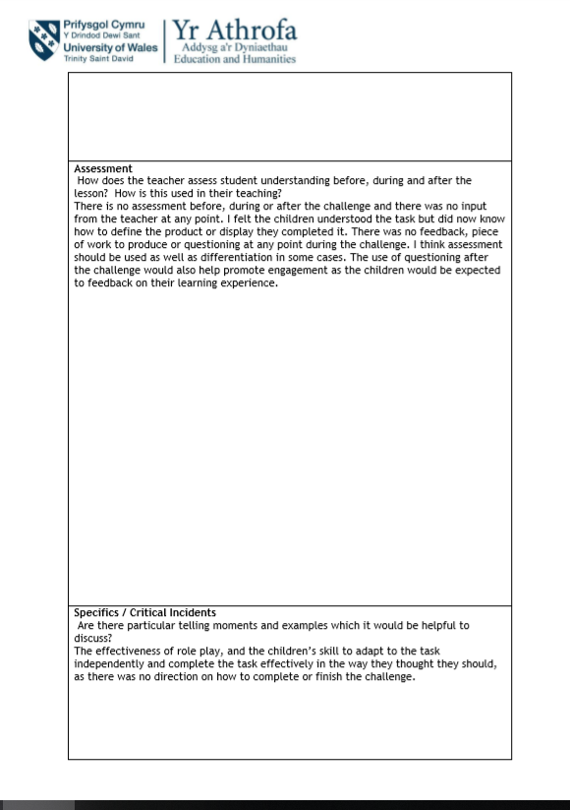

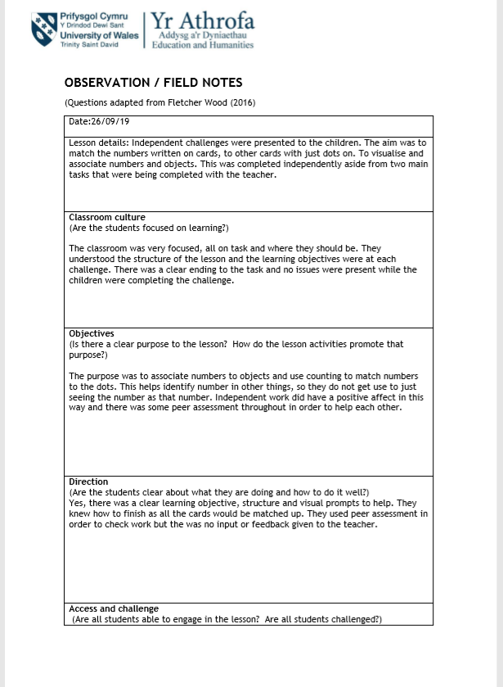
Appendix 1.d

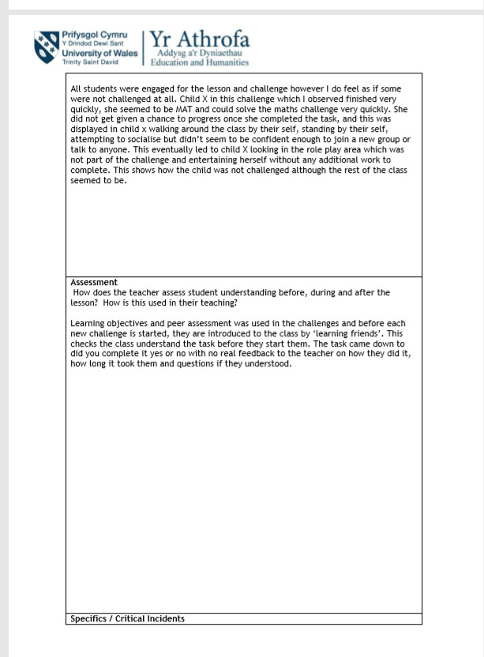

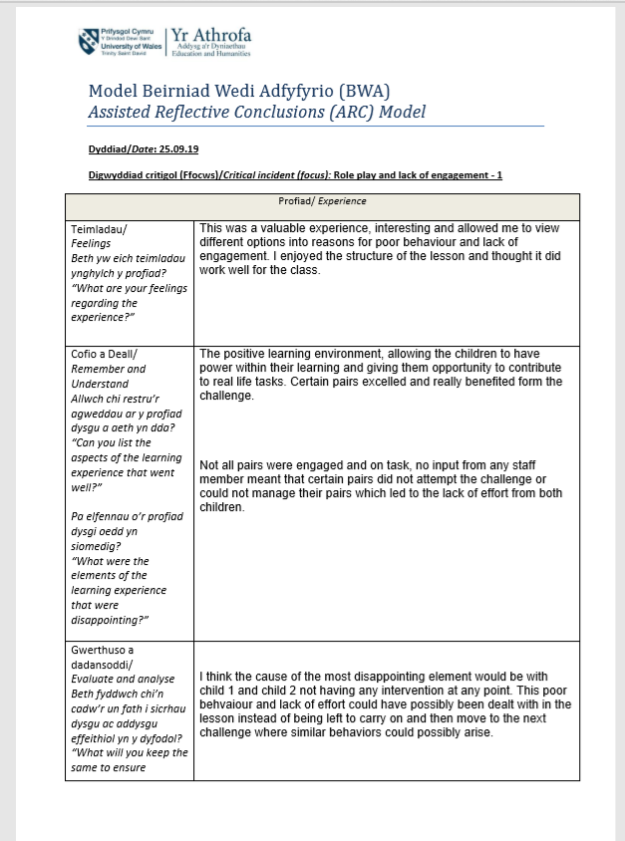
Appendix 2.a

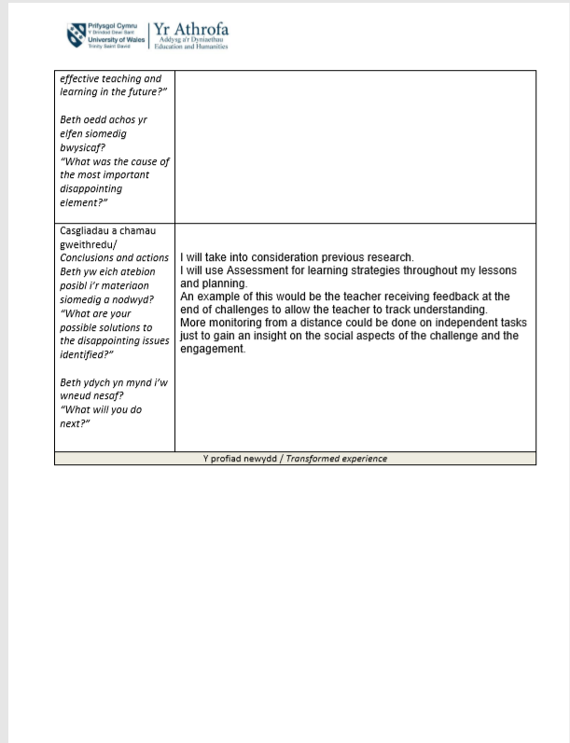

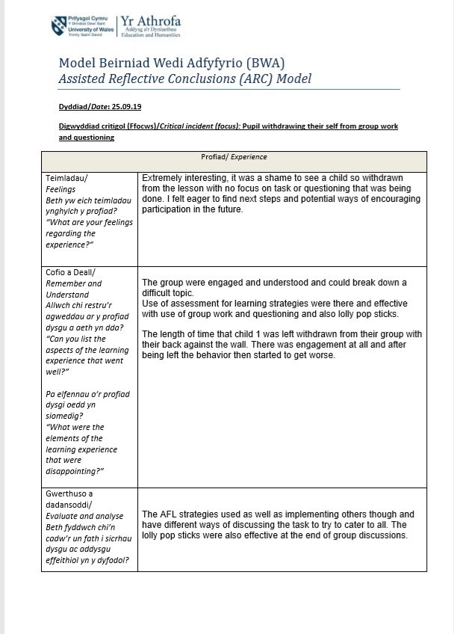
Appendix 2.b

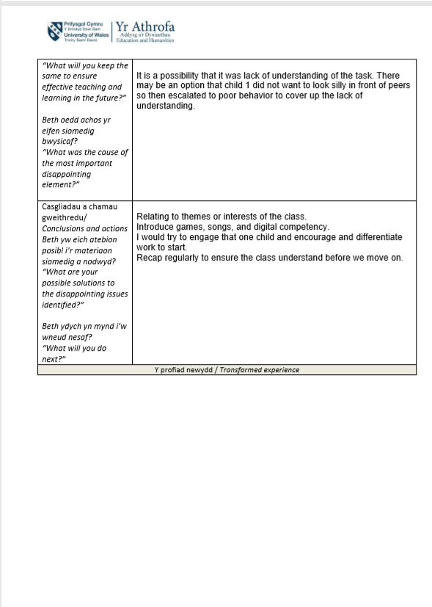

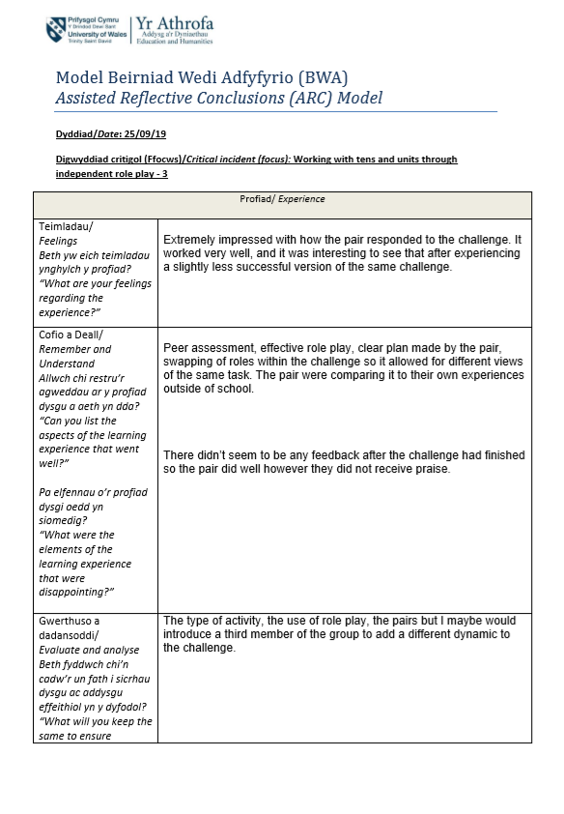
Appendix 2.c

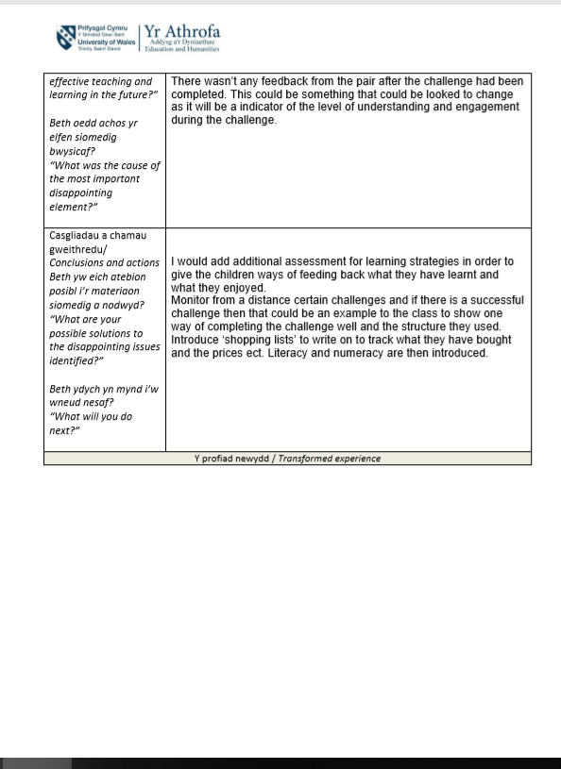

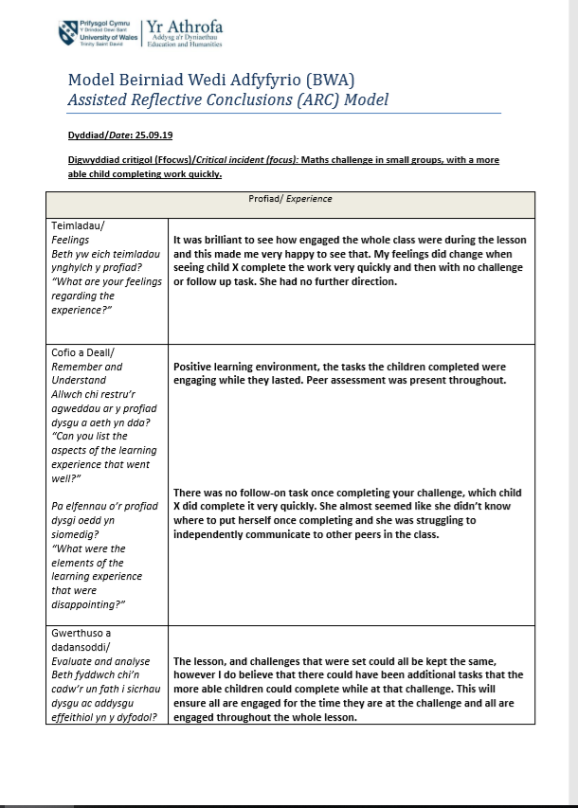
Appendix 2.d

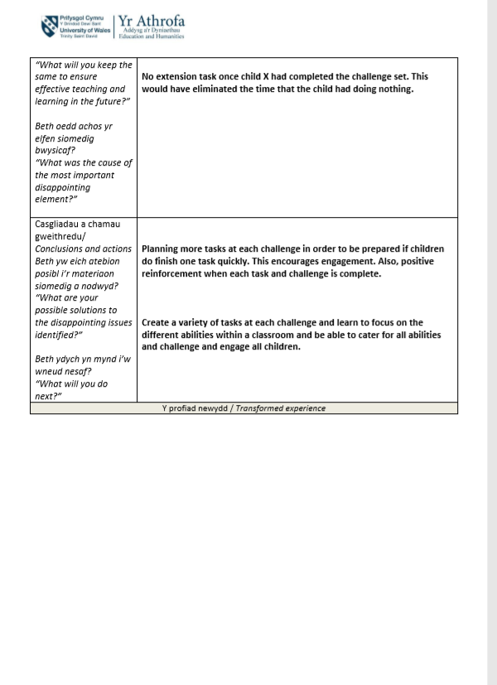

Appendix 3
Picture of Bronfenbrenners ecological systems theory:


