Mechanised Demolation Service

Developing Innovation and Creativity for Business Advantage

Name: Costel Crap

ID: 2132995

Executive Summary
The Mechanised Demolition Service specialises in professional demolition solutions through highly effective and quality controlled equipment for construction industries and property developers who require efficient and environmentally friendly ways of demolition. The service will be based on the Shopify platform for convenient booking with the added bonus of the visibility with the integration of some top marketplaces. Some of the advertising techniques are social media advertising, pay per click advertisements and e-mail marketing. Data protection and privacy will be in compliance with GDPR and PECR regulations and there will be secure access passwords that include encryption. The goal of this approach is to place the service for the leadership in technologically advanced Demolition solutions with purely environmentally friendly approaches.

Table of Contents
Executive Summary 2
Introduction 5
A) Innovative Product Proposition 5
1. Product Description 5
2. Target Customers 6
3. Sales Channels 6
4. Venture Name 6
5. Sustainability Strategy 6
6. Competitor Analysis 6
7. Competitor Sales Channels 7
B) eCommerce Website Proposal 7
1. Platform Selection 7
2. Content Creation 7
C) Marketing Strategy 8
1. Promotion Channels 8
2. Customer Reach 8
3. Customer Journeys 9
D) Privacy and Data Protection 9
1. GDPR Compliance 9
2. PECR Compliance 10
3. Security Measures 10
Conclusion 11
References 12

Introduction
Technological innovations of the contemporary world have dramatically changed the business environment and made flexibility and creativity vital (Ringberg et al., 2019). The rationale for this report is to investigate the feasibility of initiating a Mechanised Demolition Service, implemented with the use of technology in demolishing structures. Based on the proposition provided, the service to be provided is efficient and eco-friendly demolition services to be accomplished with the help of mechanized tools. Companies in the construction industry and property developers who are targeting that need green, efficient demolition services. Thus, applying the mechanisms of design thinking and innovation, the Mechanised Demolition Service will solve the problem of the increasing need for environmentally friendly methods of modern demolition. The components of the business proposition include the development of an online services booking platform that is user-friendly, the identification of effective ways to target and reach the desired audiences, and compliance with the principles of data protection. Concerning these goals, the service’s vision is focused on setting the company apart from rivals and delivering technologically diverse, value-for-money demolition solutions for clients.

A) Innovative Product Proposition

1. Product Description
The Mechanised Demolition Service will provide professional demolition services focused on environmentally sustainable methods as well as utilization of mechanized equipment. This service will fulfil the client’s need of demolishing a structure and at the same time, show the client how sustainability can be incorporated in it in a way that adheres to the company’s principles while effectively dismantling a structure. Mechanized equipment will be used to offer accuracy and efficiency in the processes without wastage of resources, hence a conservation of the environment. The service will be specialized in various forms of demolition exercises including home, business among others taking into consideration safety of the project site as well as the environment in which the project is being executed. In addition, the operation will entail aims of recycling and dumping of demolished materials to enhance the environment. The Mechanised Demolition Service is introduced to respond to the current market need for technologically inventive and environmentally friendly methods of demolition.

2. Target Customers
The direct target market of the Mechanised Demolition Service targets property developers, construction companies, and urban planners who are interested in new efficiency and strategies that are environmentally friendly and technologically advanced. This target audience commonly engages in the demolition of structures within the urban setting and in busy business locations; there is always a demand for the latest mechanised demolition solutions. These clients are willing to spend money on sophisticated and efficient techniques of demolition that provide accuracy and consideration for the environment during the process, the companies that clients are looking for are those who can provide services without much interruption.

3. Sales Channels
The Mechanised Demolition Service will mostly entail an online portal through which clients will be able to book services and manage the process. This way avoids overhead expenses of having physical working stations and increases the coverage of the service. Further, collaborations in several industry forums and marketplaces will increase outreach and reach out to a more diverse clientele seeking effective and environmentally sustainable demolition services (West, 2022). Mechanized demolition service has better efficiency, better control and safety as compared to manual demolition; also they are environmental friendly. However, they involve high fixed cost, skills are specialist in nature, and primarily technology driven which can be cumbersome to apply in regions with low technology development.

4. Venture Name
The name of the venture therefore will be “EcoDemolish” as a way of signifying that the company will embrace environmental concerns in its operations as well as embrace new technologies signifying mechanical equipments in the demolition business.

5. Sustainability Strategy
To enhance and maintain the Mechanised Demolition Service effectively, the company shall pay for brand-new technology and implements used in demolition. In relation to the improvement of service offerings, it will be done based on the client’s feedback in terms of efficiency and effectiveness in their timely updates. Besides, integration with green construction firms and environmental activities will increase the service’s sustainability aspect and improve its recognition in green demolition (Chuah et al., 2020).

6. Competitor Analysis
The primary market threats for MDS are intensified competition with small to medium size firms that still employ conventional non-environmentally friendly demolition techniques, and the constantly evolving environmental legislation (Johansen et al., 2021). These competitors are sometimes driven hard by operational costs and, therefore, do not necessarily consider environmental issues. However, the newer companies providing green demolition services might offer viable eco-friendly solutions but they may not have the cutting-edge technology and the all-encompassing methodology that is employed at EcoDemolish and may prove to be more costly in the end. To compete effectively, EcoDemolish will emphasise the use of new mechanized equipment, controlling for the environmental impact through proper and effective waste management of the destroyed structures or buildings through recycling. Through balancing the themes of technology and sustainability, the service strives for a niche in the transitional demolition market, thus implementing and providing a competitive advantage due to the agenda of performance and an orientation on environmentally friendly orientations (Johansen et al., 2021).
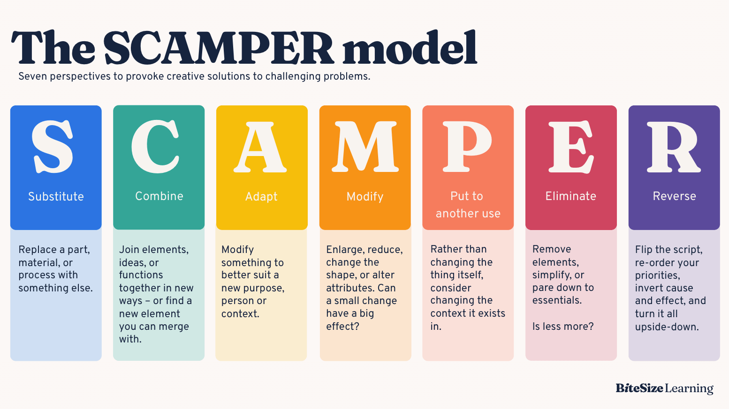
Figure 1: SCAMPER model
(Source: Influenced by Johansen et al., 2021)
To enhance its competitive edge, EcoDemolish will apply the SCAMPER model: Replacing conventional practice with advanced technology, Demolition concurrent with environmental consideration, Changing practice in response to changing laws, Adjusting traditional practice pattern to increase efficiency, Recycling the waste materials generated for other use, Avoiding extra steps, and Inverting unsustainable methods.

7. Competitor Sales Channels
Majority of the competitors mainly market their services through the company’s website as well as the online selling platforms. The Mechanised Demolition Service will also use these channels but high priority will be paid to customer care and satisfaction.

B) eCommerce Website Proposal

1. Platform Selection
SaaS Solution
eCommerce shall be implemented through the use of Shopify to create the Mechanised Demolition Service online store. This strong SaaS application is perfect for start-ups, as it has options for uniqueness in the theme selection, and safe payment methods that are accompanied by versatile analytical features (Cavillier, 2019). These features will help in the efficient running of the online service booking system and assist in the expansion of the business by the efficiency of the program.
Marketplace Integration
Integrated web marketing techniques for the Mechanised Demolition Service will entail usage of listing portals/ market spaces peculiar to the construction sector. These existing channels bring the direct interface with a wide customer base while at the same time increasing the service profile (Tasavori, Kwong and Pruthi, 2020). Thus, the use of several platforms will help target a wide range of consumers, which will lead to increased brand awareness and audience for the business.

2. Content Creation
Copy and Photography
To attract clients and to ensure that more clients invest in the Mechanised Demolition Service, there is need to ensure that service descriptions are done professionally with quality pictures (Brunner et al., 2019). A service listing will detail the potentials in demolition, safety, and the environment for each service to be offered. This approach intends to develop the confidence of the clients, create awareness and share with them as much information as possible to enable them make the right decision of using the service.
Payment Services
The Mechanised Demolition Service will have the provision of payment through credit cards, PayPal, and through bank transfers (Bhandari and Talukder, 2023). To deal with the issue of payment data security the website will be PCI-DSS compliant to meet the enhanced standards of data protection for clients. Offering various forms of payment opportunities is a strategy used to ensure that multiple clients have emphasis on their preferences in payment options and ensure safe and efficient payments for all users of the service.

C) Marketing Strategy

1. Promotion Channels
Social Media
Social media platforms will be used to market the products and also interact with customers through WEibo, FACEBOOK, INSTAGRAM and TWITTER. Blog entries, narratives, and ads will depict special aspects of the environment-friendly headphones and stress the company’s environmental conservation agenda (Shwetha and Dhariwala, 2021). This is a strategy that seeks to develop a horde of like-minded people who are conservatives of natural resources.
Paid Search
Google AdWords will be employed in this regard to popularize a Mechanised Demolition Service with payments being made for the advertisements (Srinivasan, 2020). Pay per click services also involve the provision of advertising that focuses on phrases that are relevant to demolition and construction services to guarantee a firm’s visibility in the results list. This strategy targets to reach those clients who specifically look for fast and effective demolition services.

2. Customer Reach
Target Customers
The Mechanised Demolition Service is aimed at client’s niches of professionals and companies working in construction and, especially, renovation spheres. They are located in the urban and suburban regions that experience high levels of constructions and remodeling. This group is interested in efficient, safe, and reliable demolition services. These companies prefer working with companies who have no hidden charges have good records on safety and observing high standards in customer service. Internet searches and reading reviews are important in their choice, so the service should have a well-developed web presence and good word-of-mouth.
Email Marketing
Email marketing will be important to update the clients regarding the new services, sales, and developments in the Mechanised Demolition Service. The initial and specific email list will be created from the clients and customers during the pre-launch stage with a landing page. This approach will create a pool of subscribers and create awareness before the actual launch of the service hence launching the service strong. The company’s message will keep the interest level high, inform the prospects of the new products launched by the company, and keep the prospects or customers of the company updated.

3. Customer Journeys
Customer journey mapping is critical when it comes to identifying processes clients go through when using the Mechanised Demolition Service. The company will employ means of data analysis tools that will help the firm analyze clients’ engagements over the service, the way they approach various stages and search for possible difficulties. Stakeholders will be able to identify areas of strength and which aspects require special attention with the help of this data to improve the service delivery. Each stage will determine how customers interact with the end product, and through that, the clients can spot weaknesses and improve on the painful as well as fruitful areas. These insights will be used in the subsequent activities, with the aim of enabling continuous improvement towards achieving a flawless service delivery to the clients, hence enhancing clients’ loyalty. Critical thinking will be employed so as to evaluate the data obtained from the customers’ journey and come up with a realization of their behavior and needs. It will facilitate for consideration to be given to any loops and areas where the service can be optimised and made to be more customer friendly, thus operating within the company’s triple bottom line.

D) Privacy and Data Protection

1. GDPR Compliance
In terms of GDPR compliance and the Data Protection Act 2018, the Mechanised Demolition Service shall state the handling and use of customer data (Rustad, 2019). The principles of collecting, processing, and storing the gathered information will be clear; customer permission must be received to do so. The measures include proper protocols for acquiring, storing, and erasing personal info to protect customer’s rights and privacy. Overall, through increased protection of the clients’ data, this service seeks to gain credibility with the clients to avoid compromising their data or handling it to fraudulent individuals.

2. PECR Compliance
Marketing communications for the Mechanised Demolition Service will ensure that it follows all the guidelines set out in the PECR for electronic marketing communication. This will include avails of the options where the customers can easily unsubscribe from the marketing emails, besides acknowledging their right to be forgotten (Ashley, 2020). The service will incorporate tools for controlling the interactions, as well as guarantee that users’ data can be deleted if desired. Therefore, by following the PECR act, the service will show adequate commitment to the consumer’s private life and guarantee that the marketing scheme is more customer-friendly.

3. Security Measures
Cloud Security
Security to the cloud infrastructure will also be recommended and implemented when hosting the Mechanised Demolition Service website. This will include employing two-factor authentication and highly secure access controls to safe guard the organizational data. Security audits will be arranged at frequent intervals with the intent of establishing whether the cloud infrastructure is current with certified norms and modes (Tissir et al., 2021). Anti-virus software will be put into proper use so as to create a firewall and this software will be regularly updated, while the patching of the problematic areas will be done as required. With these measures in priorities, the ‘Mechanised Demolition Service’ seeks to guarantee security of clients, with an endeavor to eliminate or reduce cases of leakage to the utmost.
Encryption
The Mechanised Demolition Service will guarantee that data is protected in terms of data encryption both in motion and in storage. Data encryption will also ensure that the transfer of information between the users and the website is secure, and there is no case of hacking or other forms of break-ins (Yu et al., 2024). Further, the data stored in the various cloud structures will be secure from hustle and electronic break-ins. Thus, to maintain user data protection, and gain client trust, the Mechanised Demolition Service should integrate strict encryption measures; additionally, it is mandatory to adhere to the modern legislation on the protection of personal data.

Conclusion
The Mechanised Demolition Service is strategically located to meet the emerging demand in the market of modern technologically efficient and eco-friendly demolition solutions. It will be a web-based service mostly, promoted by the webstore based on Shopify and by connecting this webstore to the main marketplaces such as Amazon or eBay. The promotion plan will entail social media marketing and advertisement places on search engines as well as a proper e-mail marketing campaign to attract the clients. Important data that concerns the customers shall be processed meticulously to improve the service delivery and ultimately the level of user satisfaction. The rules followed under GDPR and PECR will guard and respect the privacy of the people’s data. Through such a strategic approach, the company will be widely recognized as the Mechanised Demolition Service innovative, green, and client-oriented.

References
Ashley, K.C., 2020. Data of the Dead: A Proposal for Protecting Posthumous Data Privacy. Wm. & Mary L. Rev., 62, p.649.
Bhandari, S. and Talukder, D., 2023. Technological Innovation and Customer Responses on the Usage of Apple Pay vs Google Pay. ICL Journal, p.117.
Brunner, C.B., Ullrich, S. and De Oliveira, M.J., 2019. The most optimal way to deal with negative consumer review: can positive brand and customer responses rebuild product purchase intentions?. Internet Research, 29(1), pp.104-122.
Cavillier, Q.A., 2019. A Digital Platform connecting Academia and Small Businesses: An opportunity for Knowledge Management Experiments (No. 9799). EPFL.
Chuah, S.H.W., El-Manstrly, D., Tseng, M.L. and Ramayah, T., 2020. Sustaining customer engagement behavior through corporate social responsibility: The roles of environmental concern and green trust. Journal of Cleaner Production, 262, p.121348.
Johansen, S.S., Nielsen, P.A., Stec, K. and Kjeldskov, J., 2021, August. Experiences of personal sound technologies. In IFIP Conference on Human-Computer Interaction (pp. 523-541). Cham: Springer International Publishing.
Johansen, S.S., Nielsen, P.A., Stec, K. and Kjeldskov, J., 2021, August. Experiences of personal sound technologies. In IFIP Conference on Human-Computer Interaction (pp. 523-541). Cham: Springer International Publishing.
Páramo, Á.J.L., García, Á.H. and Peláez, J.C., 2021. Modelling e-mail marketing effectiveness–An approach based on the theory of hierarchy-of-effects. Cuadernos de gestión, 21(1), pp.19-27.
Ringberg, T., Reihlen, M. and Rydén, P., 2019. The technology-mindset interactions: Leading to incremental, radical or revolutionary innovations. Industrial Marketing Management, 79, pp.102-113.
Rustad, M.L., 2019. How the EU's General Data Protection Regulation Will Protect Consumers Using Smart Devices. Suffolk UL Rev., 52, p.227.
Shwetha, T.S. and Dhariwala, H., 2021. Influence of reduced noise levels on human health during quarantine lockdown. Green Technological Innovation for Sustainable Smart Societies: Post Pandemic Era, pp.145-167.
Srinivasan, D., 2020. Why Google dominates advertising markets. Stan. Tech. L. Rev., 24, p.55.
Tasavori, M., Kwong, C. and Pruthi, S., 2020. Resource bricolage and growth of product and market scope in social enterprises. In Social Entrepreneurship and Bricolage (pp. 75-100). Routledge.
Tissir, N., El Kafhali, S. and Aboutabit, N., 2021. Cybersecurity management in cloud computing: semantic literature review and conceptual framework proposal. Journal of Reliable Intelligent Environments, 7(2), pp.69-84.
West, E., 2022. Buy now: How Amazon branded convenience and normalized monopoly. MIT Press.
Yu, C., Yang, C., Dong, W., Chen, Y. and Yuan, Q., 2024. Retaining Bus Riders: A Lifecycle Longitudinal Analysis of Behavioral Status Transitions from Entry to Exit. International Journal of Transportation Science and Technology.



