
Business Report - Comparison of Two Hospitality Organisations
Shangri-La Hotel Group and Travelodge Hotels

Module: Financial Management for the Hotel Industry
Module code: BMIH5007
Lecturer: Dr. Ernest Wavei
Student: Tatiana Elena Bacalu
Student ID number: 2224927
Word count: 2.104
Date: 09/05/2024
Executive summary
This report aims to evaluate the financial methods, marketing positions and corporate social responsibility (CSR) efforts of Shangri-La Hotels and Travelodge Hotels. Financially speaking, there are success stories at the top end of the hospitality industry such as Shangri-la hotels while Travelodge hotels succeed in the budget accommodation sector. However, even though they target different customer groups there are areas in which each company can grow as well as challenges. What is needed for Shangri-La to increase its global presence is more attention paid towards CSR while operational efficiency should be used by Travelodge hotels with regards to market expansion. These strategic growth plans along with CSR initiatives will have to be implemented by both organizations if they want to stay competitive and sustainable globally.

Table of Contents
Introduction: 3
Total Revenue Analysis: 3
Market Position Assessment: 6
Growth Potential Evaluation: 9
Financial Commitment to CSR Analysis: 10
Recommendations: 10
Conclusion: 11
Reference: 12

Introduction:
The report gives a summary of the Shangri-La Hotels and Travelodge Hotels. These hotels are known to be luxurious worldwide with their many branches while Travelodge offers low-cost accommodation. This study will mainly look into their financial management strategies in relation to total revenue, market share, growth prospects and commitment to Corporate Social Responsibility (CSR). This will help in knowing if they have similar or different approaches towards financial performance and sustainability.

Total Revenue Analysis:
Shangri-La Hotels and Travelodge Hotels performed differently based on the total revenue analysis. From 2022 to 2023, the consolidated revenue of Shangri-La Hotels increased by 46.5% from $1,462.1m to $2,141.8m (Shangri-la.com, 2024). Similarly, this tendency can be seen in EBITDA figures as well where there was a huge rise of 199.4% in the company’s own and those of its subsidiaries to stand at $522.2m from $174.4m over the same period (Shangri-la.com, 2024). Similarly, the effective share of EBITDA by company’s associates and subsidiaries rose by 97.8% reaching $873.6m in 2023 which is indicative robustness financial performance too.
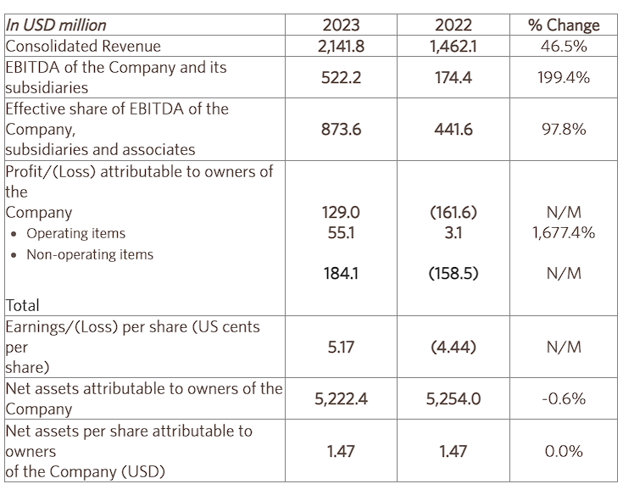
Figure 1: 2023 Final Results Highlights
(Source: Shangri-la.com, 2024)
On the other hand, Travelodge Hotels saw a noteworthy increase in overall revenue, with £1,035.2 million in 2023 compared to £910.8 million in 2022, or a 13.7% increase (Travelodge.co.uk, 2024). Important performance indicators like occupancy, average room rate, and RevPAR (Revenue per Available Room), which showed gains all around, further highlight this upward trajectory. Notably, Travelodge's adjusted EBITDA for the year was £243.9 million, demonstrating a respectable 23.6% margin (Travelodge.co.uk, 2024). However, compared to £48.5 million in the prior year, the EBITDA for the fourth quarter decreased slightly to £42.7 million, mostly attributable to investments made in brand advertising programs (Travelodge.co.uk, 2024).
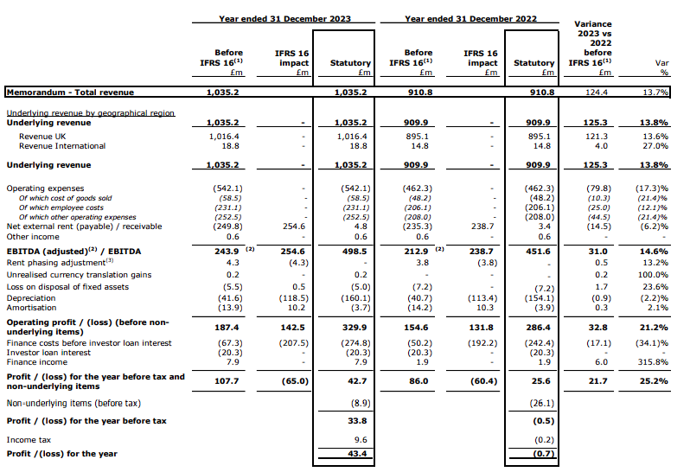
Figure 2: Results of operations for the year ended 31 December 2023
(Source: Travelodge.co.uk, 2024)
In order to analyze where the money comes from, Shangri-La Hotels offers luxurious services for rich people while Travelodge Hotels provide cheap places for people to stay when they are traveling either for leisure or business. The following are the factors that contribute to revenue increment at Shangri-La Hotel; having its branches all over the world, providing top quality services and identifying itself well in the market (Emmanuel et al., 2024). Conversely, Travelodge hotels rely on their geographical positioning plan which involves putting them near major roads so as to attract many customers thus making more sales, efficient day-to-day running system and being able to distribute their products directly without any middlemen involvement hence making higher returns (Hujić and Salihić, 2020). How Shangri La makes money shows that it has followed successful expansion strategies supported by good economic times; however, Travelodge achieved a rise in income because they were resilient in business even when others experienced financial problems and engaged continuously with brand promotion through advertising as well as other moves like those for customer service improvement (Pai et al., 2020). Still, both suffer from high costs caused by inflation amidst intense rivalry across different sectors hence needs to transform always if they are to sustain top-line growth in an ever dynamic hospitality field.

Market Position Assessment:
The market position assessment reveals the different strategies used by Shangri-La Hotels and Travelodge Hotels in the hospitality industry. Shangri-La hotels are known for their luxurious facilities and high-end services which target the elite class thus taking a premium market position that serves their needs of individualized attention during travel and indulgence while staying at the hotel (Shangri-la.com, 2024). Leveraging its global brand presence and iconic properties in prime locations, Shangri-La Hotels commands a niche market segment characterized by discerning clientele with high disposable incomes.
On the contrary, Travelodge Hotels is situated in a different place in the market; this hotel provides money-saving services that are designed for budget travelers who want to keep their expenses low while still enjoying good quality (Wu, 2021).
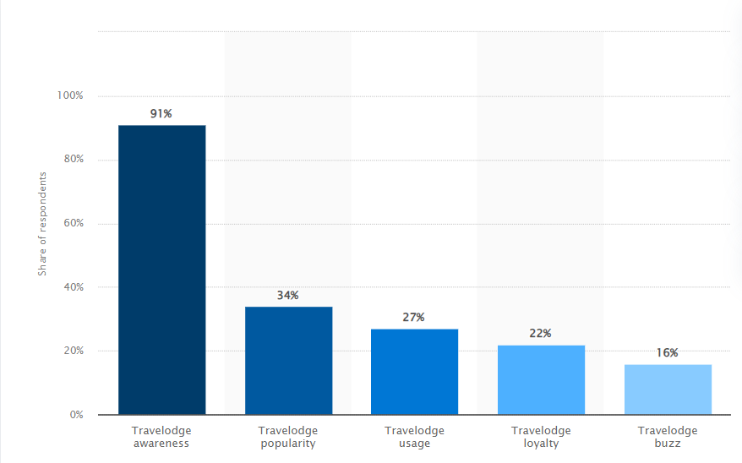
Figure 3: Travelodge brand awareness, usage, popularity, loyalty, and buzz among hotel customers in the UK in 2022
(Source: Statista.com, 2024)
In terms of hotel customers, awareness about Travelodge brand stands at 91% across Britain (Statista.com, 2024). The company aims to attract various types of people who travel for leisure and work by having cheap accommodations near places where they can easily go like airports or busy streets – this may include individuals or groups such as families with children, single persons on tours or business executives attending conferences among others.
The brand perception of Shangri-La Hotels according to market research data and customer surveys is that it equals luxury, elegance and exceptional service. The luxury chain achieves premium positioning among rich travelers who are looking for something exclusive and sophisticated through its amenities of high standard as well as personalized care extended towards clients on top creating unique images for different brands within it (Correia et al., 2020). Furthermore, what makes Shangri-La hotels more competitive against other players in this industry is their wide range of rewards schemes which are supported by frequent innovation around guest experiences they offer while operating at the highest level’, said one expert interviewed during our study.’
In the light of another comparison’ Travelodge Hotels has been positioned itself as an affordable hotel brand since establishment; hence their main target audience comprises cheap travelers who need convenient places to stay overnight. According to customer reviews also competitor analysis reports transparency when it comes down giving out prices remains one major factor which enables customers trust Travelodge hotels easily especially those travelling low budgets but expecting good services from such (Travelodge.co.uk, 2024). However, there should be more expansion plans implemented across various locations so that people can have access points near them whenever needed at pocket friendly rates.
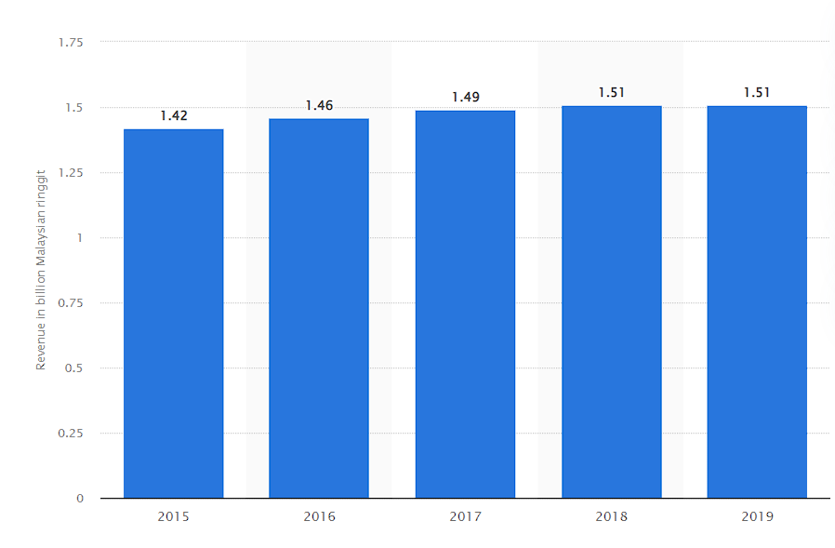
Figure 4: Total assets of Shangri-La Hotels (Malaysia) Berhad for the fiscal years 2015 to 2019
(Source: Statista.com, 2024)
When it comes to the luxury hospitality market, Shangri-La hotel is still a smaller company, but it has always had an exclusive share in this highly profitable segment. As at the close of FY2019, the total assets base for Shangri-La Hotels (Malaysia) Berhad, stood at RM1.51 billion (Statista.com, 2024). Shangri-La Hotels may have a lower percentage of the market than other hotel chains such as those operating in mass markets; however, they focus on rich tourists and offer expensive facilities which helps them make more money while strengthening their brand among its target customers.
Meanwhile, Travelodge Hotels has a wider market penetration and higher market participation due to its broad budget hotel network that serves various customers. The company’s operational efficiency, pricing strategy, and ability to scale up business operations have positioned it as a strong contender in the low-cost accommodation sector while helping it win over many mid-range and economy travelers.

Growth Potential Evaluation:
The study of how much something can increase its sales or customers gives some good news and bad news about both Shangri-La Hotels and Travelodge Hotels. This is because they are operating in an industry that keeps changing every now and then. With a lot of branches all over the world and being one of the most respected brands globally, Shangri-La Hotels has many ways through which it can grow significantly. It does this by for example coming up with ideas such as strategic expansions as well as unique customer satisfaction programs (Ahmad, 2024). Shangri-La Hotels plan to grow by moving into new markets, especially in the Asia-Pacific region where more people are becoming rich and they want more luxurious holidays. In the spirit of expanding my presence and gaining a larger piece of lucrative markets, Shangri-La Hotels has opened flagship hotels in strategic locations and forged partnerships with established developers as well as investors.
Shangri-La Hotels, furthermore, will strive for sustainable development by using digital technology systems which improve individualized service delivery that anticipates future demands arising from changes in customers’ behavior with time. However, even as it maintains this hopeful outlook for continuous growth, there could be problems such as geopolitical issues or economic fluctuations coupled with unfriendly business environments created by some governments which require setting up anticipatory plans based on these potential hindrances while keeping their eyes on the goal of global hotels’ expansion. The future for Travelodge Hotels looks bright. They feel confident in their business model, market position, and operational set up. In order to satisfy the increasing need for low-cost lodging, they will have to decrease expenses as well as move into areas without many hotels. They wish to provide cheap accommodations for a greater number of people in their own nation and globally too.
Travelodge Hotels is interested in rapid growth without spending too much. They aim to achieve this through partnerships, franchising and few property ownerships (Travel, 2019). They have changed their branding, purchased additional buildings and invested in technology that enhances customer satisfaction as well. Additionally, they are quick to react when there are changes in the travel industry such as new types of trips being sought by people. However, there exist challenges including increased competition and evolving customer needs. Travelodge Hotels’ reputation could also be affected negatively if it grows too quickly hence it must be cautious enough and alter approaches whenever necessary.

Financial Commitment to CSR Analysis:
The approaches of Travelodge Hotels and Shangri-La Hotels towards corporate social responsibility (CSR) differ. Only sometimes does Travelodge support CSR, whereas Shangri-La is always involved in it. What this means is that Shangri-La frequently gives away huge sums of money to community development or conservation projects. They may put funds into energy-saving schemes or waste disposal systems, each with a separate budget.
Some people say that Travelodge is putting profit before social responsibility; however, others who know the company well think it should do more for corporate social responsibilities. Critics point out that perhaps Travelodge is too concerned about cutting costs and generating revenues, thereby ignoring some significant societal projects. This may imply they are not spending adequate amounts of money on areas crying for help. Rather than prioritizing communities’ welfare or environmental problems, their primary target could be to make as much profit as possible. In order to cut down expenses, some of these methods may involve charity partnerships and adopting energy-saving plans among others but still there cannot be any comparison between any two since no much cost has ever been incurred towards corporate social responsibility (CSR) activities by Travelodge. No matter how much money they spend, all businesses are aware that corporate social responsibility (CSR) is crucial for their reputation and survival (Al-Shammari et al., 2022). The CSR initiatives of Shangri-La Hotels are robust and help foster good relations with the public, which in return increases customer retention as well as attracting ethically-minded visitors. Also, Travelodge Hotels’ efforts in this area make it more likely for people to see them as good citizens who care about their communities; this, on the other hand, increases stakeholder confidence in these organizations’ sustainability measures more generally.

Recommendations:
Shangri-La Hotels must use its strong financial position and global brand presence better so as to expand CSR initiatives (Sinha and Fukey, 2020)). This means injecting more funds into community involvement schemes and green projects; such investments not only build their image as a accountable business but also create stakeholder engagements that can last for decades. The study reveals the extent of Shangri-La’s commitment towards CSR through various undertakings which have resulted in increased brand reputation alongside sustainable development. Therefore, following this finding, it would be consistent with their values while also helping them gain competitive advantage within the hospitality industry if they increase efforts around this area as per evidence indicated.
Utilize the nimbleness and operational efficiency of Travelodge Hotels to find new markets. This indicates entering new areas in a deliberate manner as well as adopting franchise partnerships that drive market penetration and revenue growth. While only limited resources have been set aside for corporate social responsibility (CSR), sustainability commitments by the firm attract value-conscious customers, which nurtures attachment to the brand.

Conclusion:
To conclude, this study examines the economic policies, business statuses and corporate social responsibilities of Shangri-La Hotels and Travelodge Hotels. Shangri-La Hotels show strong financial results through deliberate expansion in the luxurious accommodation industry whereas Travelodge Hotels remain steady within the inexpensive lodging sector. Even though they serve different types of customers, both companies have unique market positions that drive sales volumes up thus improving brand equity. The review identifies expansion opportunities and hurdles faced by each firm hence underscoring innovation, strategic development areas as well as CSR activities. In order to increase its international presence, Shangri-La should focus on corporate social responsibility which aligns with their luxury market niche advantage while for travel lodge hotels.

.

Reference:
Shangri-la.com (2024), “Shangri-La Group Releases 2023 Full Year Results” Available at: https://www.shangri-la.com/group/media/media_post?post=Shangri-La%20Group%20Releases%202023%20Full%20Year%20Results [Accessed on: 06.05.2024]
Statista.com (2024), “Total assets of Shangri-La Hotels (Malaysia) Berhad for the fiscal years 2015 to 2019” Available at: https://www.statista.com/statistics/1199667/shangri-la-malaysia-total-assets/ [Accessed on: 06.05.2024]
Statista.com (2024), “Travelodge brand awareness, usage, popularity, loyalty, and buzz among hotel customers in the UK in 2022” Available at: https://www.statista.com/forecasts/1335657/travelodge-hotels-brand-profile-in-the-uk [Accessed on: 06.05.2024]
Hujić, N. and Salihić, F., (2020). Marketing in tourism-direct marketing as marketing communications technology.
Emmanuel, A.U., Hilda, O.O. and Adenubi, A., (2024). The Application of Eco-Aesthetic Principles into the Design Proposal of Hotels.
Pai, C.K., Liu, Y., Kang, S. and Dai, A., (2020). The role of perceived smart tourism technology experience for tourist satisfaction, happiness and revisit intention. Sustainability, 12(16), p.6592.
Shangri-la.com (2024), “Luxury Hotels and Resorts” Available at: https://www.shangri-la.com/brand/ [Accessed on: 06.05.2024]
Wu, S.Y., (2021). A Study on Promotion Strategies and Purchase Intention during the epidemic situation-In the Travelodge Industry.
Correia, A., Kozak, M. and Del Chiappa, G., (2020). Examining the meaning of luxury in tourism: a mixed-method approach. Current Issues in Tourism, 23(8), pp.952-970.
Travelodge.co.uk (2024), “Strategic progress driving excellent results” Available at: https://m.travelodge.co.uk/press-centre/press-releases/Strategic-progress-driving-excellent-results [Accessed on: 06.05.2024]
Sinha, M. and Fukey, L.N., (2020). Circular Economy: Assessing a Progress of Resources Efficient Practices in Hotel Industry. In Circular Economy for the Management of Operations (pp. 89-117). CRC Press.
Ahmad, A.A., (2024). Corporate Governance and Its Determinants: A Study on Shangri-La Hotel (Malaysia) Berhad. Available at SSRN 4694743.
Al-Shammari, M.A., Banerjee, S.N. and Rasheed, A.A., (2022). Corporate social responsibility and firm performance: A theory of dual responsibility. Management Decision, 60(6), pp.1513-1540.
Travel, T., (2019). Hospitality. Total contribution of travel and tourism to gross domestic product (GDP) worldwide in.
Travelodge.co.uk (2024), “TVL FINANCE PLC YEAR ENDED 31 December 2023” Available at: https://www.travelodge.co.uk/nw/sites/default/files/Thame_and_London_Quarterly_Report_to_Note_Holders_2023_Q4_FINAL.pdf [Accessed on: 06.05.2024]

