STUDENT NAME: | AFZAL AHMED
STUDENT NUMBER: | 1806872
LECTURER NAME: | Afzal Mannua
MODULE TITLE: | Problem solving and decision making
MODULE CODE: | BMSK4004_LON

Table of contents:

Introduction…………………………………………………………………………………………………….. Page 2
Problem for the assignment: Customer Complaints…………………………………………. Page 2
Brief description of workplace to give understanding of possible problems……. Page 2-3
The Problem in my workplace:.……………………………………………………………………….. Page 3
What is a customer complaint?…………………………………………………………………………Page 3
Advantages and disadvantages of compliance in the workplace to reduce
customer complaints……………………………………………………………………………………… Page 3-4
Seven steps process to problem-solving and decision-making:………………………… Page 4-6
Adkar Model…………………………………………………………………………………………………….Page 7
Decision Making Process…………………………………………………………………………………..Page 7-8
SWOT Analysis………………………………………………………………………………………………….Page 8-10
Fishbone Analysis……………………………………………………………………………………………..Page 11-13
Proposed solution 1 & 2……………………………………………………………………………………Page 13
My recommendations……………………………………………………………………………………….Page 13
Conclusion……………………………………………………………………………………………………….. Page 14
References………………………………………………………………………………………………….…….Page 15-16

Introduction
The purpose of this assignment is to discuss a problem faced in the workplace and to discuss how the problem was solved and what kind of decisions were made. I will explain what the problem is from my workplace and the reason I chose it. I will explain the advantages and disadvantages and I will give examples of the problem in my workplace and how I overcame it.
Furthermore, I will explain seven steps of problem solving, the types of decisions, factors affecting decision making and ingredients of good decision making. As part of this assignment, I have chosen to look deeper into the fishbone analysis and SWOT analysis to explain the problem, then I will propose two solutions and decide which one is best to use.
Finally, I will end with a conclusion outlining what I have gained from this experience and detail how it was achieved using my personal experiences and theory's which will be referenced throughout. The problem I have decided to write about is how compliance or the lack of it in the workplace leads to complaints in the workplace.

Problem for the assignment: Customer Complaints
The main problem I am discussing is lack of compliance leading to customer complaints in the workplace. Not following rules and guideline can lead to major issues in a workplace. Some very important tasks in terms of compliancy are health and safety regulations, customer complaints and even law and enforcement. For example, if a member of staff is assigned to check the fire alarms and fire safety equipment on a weekly basis but does not bother checking and sign the risk assessment logbook, this is deemed as non-compliant and can lead to major issues. Such as, if documents are signed while checking fire safety equipment in a workplace and it is not working, then it can lead to major problems if a fire occurs. The insurance company will not cover costs or even worse it can lead to fatalities if people are in the building. Another example could be, if a workplace or an educational establishment has a strict opening time of 9am, and the employee or student decides to turn up at 9.10am, this would make them non-compliant and can lead to customer complaints and damage the company reputation. Compliance ensures businesses are following rules and regulations set out by the company to enable workers to work within a structure to meet their goals and objectives. (Abdullah et al, 2016). Essentially, it is to avoid mistakes in the workplace which can lead to major issues if not done properly.

Brief description of workplace to give understanding of possible problems.
The company I work for is Tesco.com, an online store with a warehouse which deliveries groceries to the customers doorstep. They deliver fresh and ambient goods within a time frame according to their time slot and promise quality and freshness for each order. They promise customers to work harder for them to be better than the competition.

The Problem in my workplace:
My role is Quality/Customer assurance officer. The problem faced in my workplace is a high number of customer complaints from customer via the call centre. The complaints are vast, but I have narrowed them down to three main reasons, missing products, damaged products and poor quality of products. The Tesco customer service team operate remotely in Wales and they have no direct communication with the warehouse and delivery team who deal with the day to day operations. Subsequently, instead of contacting the warehouse and looking into the complaints in details, they were compensating customers an average of twenty pounds per complaint. Some customers were receiving a minimum of twenty pounds compensation and on top of that, they got to keep their shopping. This raised alarm bells with the directors and my role was to investigate and find solutions to reduce the customer complaints and reduce giving customers compensations and improve the reputation for online shopping with Tesco’s. Furthermore, I needed to find out how many complaints were genuine problems and how many people were playing the system to get “free money”

What is a customer complaint?
A customer complaint highlights a problem which could be from a bad product, service or employee within a business. Customer complaints can be turned into a positive with great customer service by turning a bad situation into a good one. “Data suggests that nine out of ten times, a customer will continue doing business with you even after a slip-up—but only if you wholly fix the situation the first time” (Ciotti, 2019)

Advantages and disadvantages of compliance in the workplace to reduce customer complaints.
Advantages:
- There is a system in place to benefit the workforce and company. It helps create an ethical workplace which helps develops individuals to feel part of a team and hold some accountability in what they do. Unacceptable behaviour can be stamped out and employees will start identifying what is right and wrong. (Root III and Thompson, 2019).
- Compliance give an element of pride for employees and makes them feel special and part of a bigger plan. It can develop a family feeling and build a long-term relationship and create a unique workforce who want to better themselves and drive the company forward. Colleagues build trust and can easily spot the wrongdoers if anyone is non-compliant. (Root III and Thompson, 2019).

Disadvantages:
- One of the disadvantages is the task can become tedious and unmotivated employees can make mistakes leading to major problems. Ongoing staff training is a must for this to work and the management need to implement strict rules and guidelines to enable staff are compliant. Furthermore, managers will need to participate and not just leave tasks for employees as they are accountable for the overall operations of a company or organisation. Neglecting mistakes made by staff will leave a knock-on effect and the new members will pick up the bad culture and it will be very difficult to establish compliance in the workplace. (Root III and Thompson, 2019). A simple strategy I have come across is called check the checker, this ensures all work is double checked to avoid mistakes.
- Another disadvantage which could happen due to the above is a high turnover of staff. the ones who are motivated and want to climb up the ladder love to follow guideline, however if an employee who is not interested in the company can cause conflicts and make errors which can affect overall staff morale. (Root III and Thompson, 2019).

Seven steps process to problem-solving and decision-making:
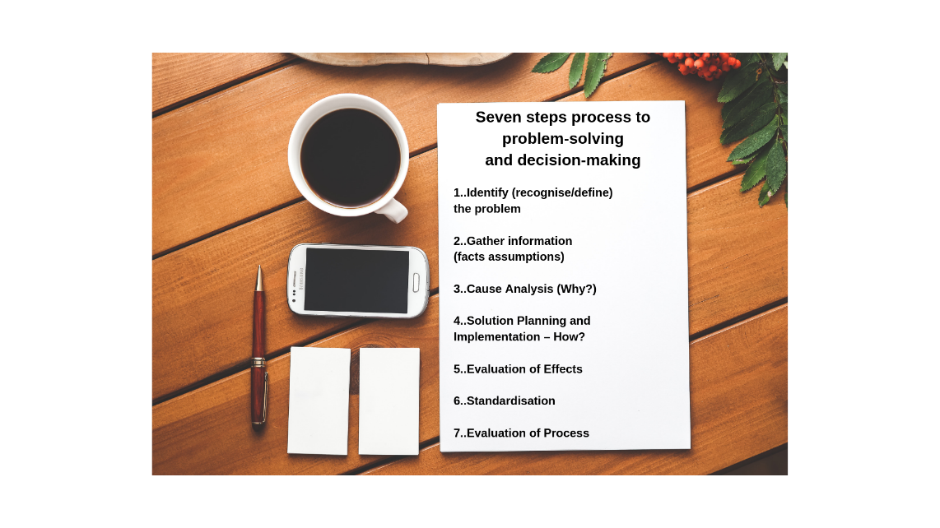
- Identify (recognise/define) the problem
The first thing when looking into the problem is that there are too many customer complaints. The company I work for has targets to meet and need to keep overall complaints below seven percent overall for all orders.
The first thing I noticed about the problem was the increase of paperwork I was receiving in the morning and the extra emails. My workload seemed more, and I was working more hours. Furthermore, there was a backlog of customer complaints which were not dealt with which increased the number of complaints.

- Gather information (facts assumptions)
I then need to ask myself what are the complaints consisted of? It boiled down to three reasons, quality issues with products, missing items and late deliveries. Here is an example of how we gather information after identifying the problems.
Total Orders | Quality | Missing | Late | Overall Complaints
2261 | 5.11% | 4.06% | 4.64 | 13.81%

The information above clearly shows where the complaints were coming from. After collecting the data, I then held a meeting with the main three departments to find out why this was happening. The warehouse manager oversaw replenishment and that all goods were stocked and stacked correctly. Products with short shelf life must be rotated and chilled and frozen items must be stored in freezers within a twenty-minute time frame on receiving deliveries. The manager from the picking department oversaw the picking of items for customers and to make sure the quality of items was packed appropriately. They also oversaw making sure the items were picked correctly so customers were receiving the correct number of items per order to avoid missing complaints. The delivery manager was in in charge of making sure the vans were out on time and order delivered within the allocated time slots and the correct order was delivered to the right customer. In addition, they oversaw the loaders who would load the shopping into the correct vans.
- Cause Analysis (Why?)
We had to then see why these customer complaints has increased? Is it the customer overreacting and not understand company policies when ordering? Are they taking advantage of an easy customer care procedure where there is no monitoring of actual complaints? Or is its poor staff commitment and lack of customer care. Or lack of staff training or performance?
My job as the Quality/Customer assurance officer was very tricky as I was not very popular, and I had to audit and monitor managers work ethics and team managements roles. I had to adopt a strategy of being the “glue”, this meant I had to try join all departments to work together to create a winning formula. Rather than each department working against each other and blaming one another for the complaints I needed to find a way to find new strategies, new training, create new systems and keep staff morale high. Then we could make informed decisions together and help improve the overall performance of the company (Steel, 2019).



- Solution Planning and Implementation – How?
How can we solve the problems? I will investigate the different ways to reduce customer complaints. As there are three department in Tesco.com which need to work together to get the best results, there will be more than one way to solve the issues.
- Evaluation of Effects
Here I can evaluate the effects of the solutions and ask myself if I have used all the information, is it clear to all the teams, is it a realistic plan, is there a plan b and how are we going to monitor complaints better going forward (Adair, 1977).
- Standardisation
Once we found the solution we can then see if this can be implemented in all seven Tesco.com centres nationwide. We will check if this is something store specific or if we can easily share and add into staff training immediately.
- Evaluation of Process
I will explain how I carried out the seven-step progress and will have to evaluate and see if the outcome and solutions were effective. It focuses of people adjusting to change, how they adapt to change and believe in a new way of operating.

Adkar Model
The ADKAR model is one of the most significant models in guaranteeing the change procedure happens efficiently (Walu Onya, 2019). There are 5 key elements to the ADKAR Model:
Awareness – Staff need to know exactly of the changes and why they are being implemented. If they are not told and see everyone changing the way they work, they will lose motivation and not adapt to the new changes. I had to make sure all employees were aware of the steps which would be taken for the new changes to work.
Desire – I had to make sure the staff understood the changes and explain they were important for it to work and that they would be the ones contributing to make them. This helped me get them on board
Knowledge – Staff training was essential for everyone to develop new skills; new employees would get the new strategies explained to them on inductions day.
Ability – Putting people into the right positions was necessary. The right people with the correct skillset were assigned tasks suitable for them.
Reinforcement – Pickers, replenishment staff and drivers were told they would be getting rewards for high performance, this made employees maintain a high level of performance knowing they were rewarded for hard work and commitment.

Decision Making Process;
- Definition
Decision making is choosing between two or more options which will affect the future. Decision making is an everyday occurrence from people in charge of businesses or a parent deciding what is best for their children. There is a five-step model to decision making which is a classic approach. However, it is not recommended to use in all situations. The five steps are to define the object, collect relevant information, generate feasible options, make the decision and implement and evaluate (ADAIR, 2019).
-Types of Decision making
Moreover, there are three types of decision that management can be faced with, routine, adaptive, and innovative.
A routine decision is made when there is a tick box style of task, for example, a stationary or consumable order for an office. However, even though this task may sound tedious or boring, the person who does this task must make sure it is done properly so it is done more efficiently the next time (SAGE Journals, 2019).
Adaptive decisions are made when problems and solutions are not the norm and not completely understood. A simple example could be a change of opening hours for a business to meet customer demand or a change of strategy for a sports team trying to win a game, for example, changing a bowler in the cricket from a fast bowler to a spinner.
Innovative decisions are usually made when a problem is unclear or strange, creativity is needed to overcome it. There are so many examples of innovative decisions being made especially from inventors and entrepreneurs. They find a problem within the company and then offer solutions, for example to monitor staff arriving at work, companies now have a clocking in and out system either by using a pin system or a card instead of signing in and out on a paper.
-What makes a decision a good decision?
There are several factors which affect decision making such as, stress, money and energy. Good making decisions need to have a system in place. Involving the whole team, delegate, brainstorming, being creative and having an objective will help.

SWOT Analyses:
Here it would be good to implement the SWOT analysis for each department. We will use the theory to look at each department's strengths, weaknesses, opportunities and threats. Once I have gathered the information, I will be able to demonstrate how I ended up in a better decision (Williams, 2009).

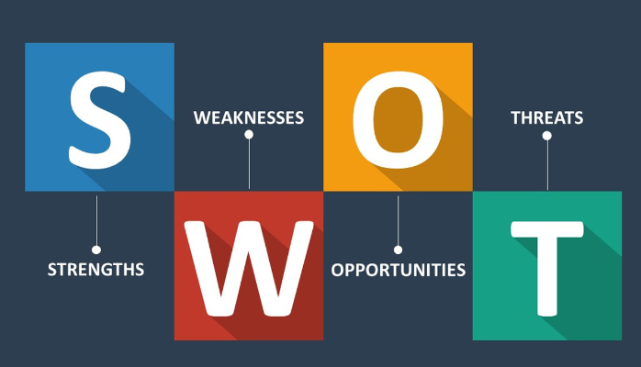

Warehouse team:
Strengths:
The warehouse team have staff available twenty-four hours a day. They have a night replenishment team to make sure the process of goods entering the warehouse and being packed away before the start of the day is completed correctly. The day team of replenishment can also take over and liaise with night team and make sure all information is handed over correctly.
Opportunities:
Are the teams taking advantage of being the only department who are in the warehouses for twenty-four hours all year round? Is there a possibility of strengthening the team by managing rotas better to give staff enough rest so they can perform better? As the nights team do most of the replenishment, can the day team start to double check the products have been rotated. Can staff take advantage of down time instead of chatting to each other or using mobile phones?
Weaknesses:
Are the team lacking staff training? Do they have enough communication between staff and is there a handover being exchanged? Do the staff engage with one another or do they end their shift and just leave hoping the next staff in will automatically pick up the workload?
Threats:
Are the workers aware that their jobs are crucial for the operating of the business? Existing positions can be replaced with external staff leading to more costs and losses to the company. Customers are complaining about certain products which can be identified to the department and then even further micromanaged to find out who was the team member who stacked the items. This can lead to turnover a high turnover of staff, leading to more costs in recruitment and training.

Picking Department:
Strengths:
This team would be the people who pick the items for customers, they had the vital role of checking they scanned the correct product and pack into trays for customers. They needed to be fast and precise and make sure the items are picked and delivered in time for loading then delivery. This was a very large team with plenty of staff and managers.

Opportunities:
The team could eliminate mistakes and make sure each item is double checked before delivering. Rotating staff will keep them motivated and not find the job tedious. The picker can pick the longer dates for certain customers that complain regularly.
Weaknesses:
If there are any difficult employees, it can ruin the whole morale of the team. The management ned to make sure the bad apples are identified. Then keep them highly motivated or be removed and replaced with better staff, this leads to a high turnover of staff.
Threats:
This role is usually a low paid role within the company and the staff usually consist of agency workers. these staff member usually don’t feel part of the company and make mistakes.

Delivery Team:
Strengths:
This is the face the customer sees and the final piece of the puzzle. The customer can be shown their shopping there and then and eliminate complaints.
Opportunities:
Here we could offer world class customer service and have the edge over the competitors. We could train the drivers to check off the shopping and offer them refund on the spot for any damaged or missing items which can reduce the customer complaints.
Weaknesses:
Are the drivers delivering within the time slot? Is the delivery team loading faster enough so drivers can leave on time? Can the drivers communicate better with loaders and help to load vans faster?
Threats:
The agency drivers that are recruited externally do not feel part of the team. Leading to poor customer service, they are not a true representative of the company, the customer complaints can be reduced if we hire these drivers and put them through the company training process and offer company benefits to feel a sense of togetherness. This can effectively increase the team performance and be a rewarding experience. All the drivers can pull together and support one another and understand each other better (Morgan, 2017).

Fishbone analysis:
-Definition
Fishbone analysis can also be known as the cause and effect analysis, it is a form of brainstorming and getting to the root cause of the problem. The design looks like a skeleton of a fish hence its name fishbone diagram. For instance, it helps consider all possible causes of the problem rather than looking at obvious ones (Mindtools.com, 2019).
-Why it is important for decision making
It is important to figure out the problem and investigate the detail to determine the root causes. Fishbone theory gives the opportunity to unfold all possible scenarios and discover who or what is not performing to the highest standards. It is important to use this theory to find solutions in a structured and precise way (Dattatraya et al, 2019)

Fishbone analysis – cause and effect analysis:

METHOD
- New training structure
- Gel teams to work together
- Clear communication
- New Vans
- New Equipment

- Erasing bad habits
- Improvement of team working
- Accountability
- Review pay gaps
- Improve customer facing roles

- Lack of authority
- No rewards system
- Lack of staff training and development
- Low performance not punished
MATERIALS
ENVIRONMENT
MACHINE
PEOPLE
MEASUREMENT
- Lack of urgency in staff
- Lack of management authority
- No pride in job
- Planning routes better

- Online system failures
- Van breakdown delaying delivery
- Short staff
- Lack of speed in picking products

- Lack of staff training
- Lack of motivation
- Lack of staff communication
- Staff rotation

Customer Complaints
Fishbone Analysis Theory:

Analysing the fishbone theory there are several root causes. The way the problem will be tackled is not just a matter of fixing one problem, it will need a collective team effort to solve the root causes. The three departments will need to be working together to be able to keep customer complaints down.

The quality assurance team have identified the three main departments, warehouse, picking and delivery. The delivery team are the final piece of the puzzle and are the only ones that meet the customers face to face. The picking team need to make sure the delivery team have the orders picked correctly and packed in time. The Warehouse team need to make sure the stock is replenished in time for the pickers to find the stock on the shelves ready to pack.

Proposed solution 1
The first solution is to hold daily meetings with the leaders of each department to communicate any issues found, for example, if a wrong item was picked due to warehouse staff misplacing an item and sent out for delivery then the customer will potentially receive the wrong item. However, by holding this meeting, the delivery manager will be aware of this problem which could lead to a customer complaint. Now they have the information, they can let the driver know. Then the driver will communicate with the customer at the door step and apologise for the inconvenience. This will resolve two issues; the customer can be refunded for the wrong item and, they will not call customer services to complain.

Proposed solution 2
Now if the same problem occurs and the customer received wrong item, in the meeting, instead of the delivery team communicating with the customer, subsequently the picking department can call the customer to check if they have received the wrong item after their delivery had arrived. This will show the customer that we follow up and show that the company cares and are double checking their shopping with them. This gives them a sense of loyalty and will want them to shop again with us knowing they are looked after. The picking team would manage the complaints and email all departments with any updates.

My recommendations:
Personally, I would go with proposed solution one as it stops the customer realising the error themselves and they have a delivery driver who meets and greets them to apologise and refunds them on the spot. It minimises the chances of customer complaints on the phone. As suggested in proposal two, if the picking department call too late, they may miss the opportunity to stop the complaint. The driver also could retain the customer by delivering great customer service. In addition, the driver can double check all the rest of the shopping to double check. Another way to reduce the complaints is for the driver to give the store number to the customer so they can call the dot com centre directly. The complaints are measured on the customer service centre in Wales and no calls are taken directly in the dotcom centre. This is a great way to reduce the percentage of overall complaints. My role as the “glue” will help me reassure the team and communicate any changes effectively. Initially, the tasks will take time to get used to, drivers usually like to drop the shopping off and rush to the next address. However, having an effective communication plan in the daily meetings with clear objectives will help the team come on board. As the changes take place, the day to day meetings will become normalised and will give an advantage over the competitors (Williams, 2009). Holding meetings rather than emails will minimise miscommunication and build a stronger bond amongst team workers. “Research by UCLA psychology professor emeritus Albert Mehrabian found that 7 percent of a message was derived from the words, 38 percent from the intonation, and 55 percent from the facial expression or body language” (Van Praet, 2019).

Conclusion
In conclusion, I have explained the root causes of the problem of customer service complaints. I have broken down the key elements of what each department has done to contribute to bad performance. I used two theories in SWOT analysis and Fishbone theory to explain in more detail about causes of customer complaints and solutions. I have used examples of my real-life experiences and used examples from books and online journals. In addition, I have covered what is customer complaints, advantages and disadvantages, and how to overcome it. I have understood the importance of breaking down a problem and digesting all aspects of a problem. Moreover, I have learned how to communicate the root causes of a problem to others and offer solutions and overcome problems. The main concept I can take is having a clear understanding of a problem, communicating the problem and using the existing people to fix them and use external sources if needed. In this scenario I had to “be the customer” and see the problem through the customers eyes and ask myself what I would want, this helped me during the whole process (Sander, 2012).

References:
- Abdullah, N., Indulska, M. and Sadiq, S. (2016). Compliance management ontology – a shared conceptualization for research and practice in compliance management. Information Systems Frontiers, [online] 18(5), pp.995-1020. Available at: https://link-springer-com.ezproxy.uwtsd.ac.uk/content/pdf/10.1007/s10796-016-9631-4.pdf [Accessed 3 Aug. 2019].
- Adair, J. (1977). decision making and problem solving. 1st ed. London: Training Extras, pp.17,18.
- Adair, J. (1977). decision making and problem solving. 1st ed. London: Training Extras, p.38.
- Ciotti, G. (2019). How to Talk to Your Angriest Customers. [online] Helpscout.com. Available at: https://www.helpscout.com/helpu/customer-complaints/ [Accessed 29 Aug. 2019].
- Dattatraya Shinde, D., Ahirrao, S. and Prasad, R. (2019). Fishbone Diagram: Application to Identify the Root Causes of Student–Staff Problems in Technical Education. [online] Link-springer-com.ezproxy.uwtsd.ac.uk. Available at: https://link-springer-com.ezproxy.uwtsd.ac.uk/article/10.1007%2Fs11277-018-5344-y#citeas [Accessed 30 Aug. 2019].
- Mindtools.com. (2019). Cause and Effect Analysis: Identifying the Likely Causes of Problems. [online] Available at: https://www.mindtools.com/pages/article/newTMC_03.htm [Accessed 29 Aug. 2019].
- Morgan, P. (2017). Business student's guide to study and employability. 1st ed. Los Angeles: SAGE, p.204.
- Root III, G. and Thompson, J. (2019). Advantages & Disadvantages of Ethical Compliance in an Organization. [online] Smallbusiness.chron.com. Available at: https://smallbusiness.chron.com/advantages-disadvantages-ethical-compliance-organization-20548.html [Accessed 3 Aug. 2019].
- SAGE Journals. (2019). Knowledge and Process for Routine Decision Making - Richard Fox, 1998. [online] Available at: https://journals.sagepub.com/doi/10.1177/003754979807100410 [Accessed 20 Aug. 2019].
- Sander, P. (2012). What would Steve Jobs do? 1st ed. New York: McGraw-Hill, pp.95-96.
- Steel, A. (2019). The glue to managing change | NAO blog. [online] NAO blog. Available at: https://www.nao.org.uk/naoblog/glue-to-managing-change/ [Accessed 18 Aug. 2019].
- Van Praet, D. (2019). Why Email Is Only 7 Percent as Effective as Talking. [online] Psychology Today. Available at: https://www.psychologytoday.com/gb/blog/unconscious-branding/201407/why-email-is-only-7-percent-effective-talking [Accessed 30 Aug. 2019].
- Walu Onya, S. (2019). THE ADKAR MODEL. 1st ed. [ebook] Available at: https://static1.squarespace.com/static/567bb0614bf118911ff0bedb/t/5bab49b68165f5740584d433/1537952191124/Initio_the+ADKAR+model.pdf [Accessed 1 Sep. 2019].
- Williams, K. (2009). Strategic Management. 1st ed. London: Stephanie Jackson, pp.19.
- Williams, K. (2009). Strategic Management. 1st ed. London: Stephanie Jackson, pp.58-59.

