International Hotel Industry – Business Skills
Module - B4X 01917

Written Assignment: THE Hotel LAW AND THE Legislative risk

Student Name: Stilyana Mincheva
Student Number: 1816276
Lecturer: Dale Clark
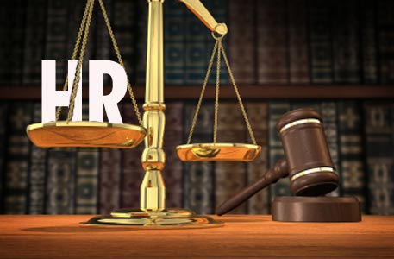
Contents

- Preamble Page 2
- Discussion Page 2
- Liability Page 2-3
- Data Protection Page 3-4
- Safety and Health; Food Hygiene Page 4-5
- Risk Management Page 5-6
- Licensing Page 6
- Hotel Proprietors Act 1956 Page 6
- Conclusion Page 6-7
- References Page 7

Preamble

Hospitality is one of the fast-growing sectors of the economy, covering various sectors: leisure, accommodation, food, entertainment and more. Laws in each country set standards for each business sector, and in the hospitality industry there are a few laws that companies must comply with. These laws and rules apply to both customers and employees. These include workers' health and safety law, employment law, environmental legislation, food hygiene and safety law, alcohol license, privacy and property law, and several other regulatory documents and contracts. It is important for industrial entrepreneurs and managers to be aware of these laws in order to promote employee well-being, provide adequate guest service, manage business risk exposure and maintain full compliance with state laws.
This report will present a study of the following factors: Liability; Data Protection; Health and Safety; Food Hygiene; Risk Management; Licensing; Hotel Proprietors Act 1956.

Discussion

The report will be analysed each of the above factors as well as the effect that each of them has on the hotel and hospitality industry. In addition, arguments will be put forward to illustrate how each factor can put the company in a situation of legal risk.

Liability

The responsibility of the hotel is related to the legal liability that the hotel bears to the customer as a temporary shelter. As the consumer buys trust based on a specific accommodation offer, the hotel must justify this choice by providing safety, quality service and timely delivery of the service offered. It is mandatory for guests to check the hotel policies before registering to check the liability limits applicable to the establishment. In general, day-to-day work is based on specific rules and laws that determine the rights and obligations of both service providers and users of those services.


Data Protection

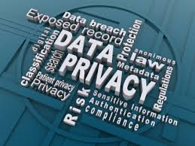

One of the sectors with the highest risk of security breaches in the protection of personal data is the hotel industry. Much of the customer data is processed daily, including card data, names, addresses, and so on. This highlights the risks faced by companies. Everyone should be able to trust their hotel or the place they visited to keep their personal data at any time. All companies are legally obliged to meet certain data protection requirements, and as an IT provider, each company is responsible and must ensure that all IT infrastructure provided to customers contributes to data protection.
The data protection law of 2018 controls the way personal data is used by organizations, companies, or the government. Anyone responsible for the use of personal data must adhere to strict rules called "data protection principles".
Failure to comply with data protection laws in the UK may lead to disastrous consequences in the hotel sector. Perhaps the most difficult is to recover the damage caused by customer mistrust and reputation of the brand, which can be difficult to recover. The result of non-compliance may also include significant financial penalties and legal complications where interested parties can seek compensation for inadequate security measures taken to protect them. Most businesses store most of the secure information on computers, which means their IT infrastructure must be able to limit unauthorized access and prevent violations. Every company in the hotel industry must make sure that there are restrictions on access to the different levels of information and that all the main security features in their IT infrastructures are used. The most common ways to protect data in the travel industry are encrypting payment card information, training cyber security staff, using firewalls, and network surveillance techniques to ensure network security.

Safety and Health. Food Hygiene

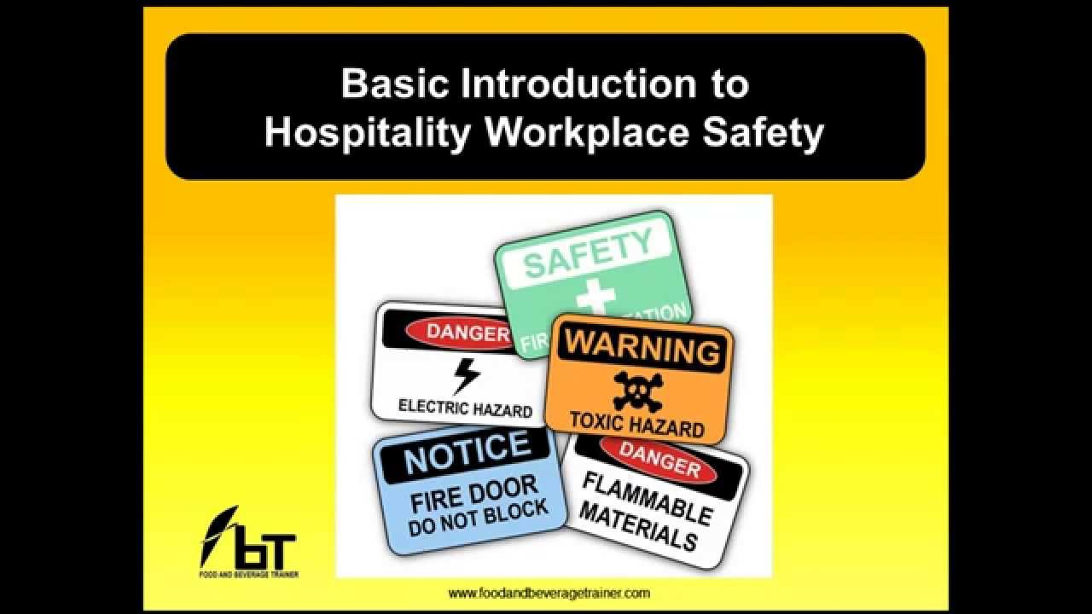
The hospitality sector is quite a risky sector in terms of the safety and health of employees as well as customers. It is important to manage people's health and safety because: by preventing injuries at work, it contributes to high productivity and protects the most important resource for business, namely people, it makes economic sense by reducing accidents, namely the costs involved. Part of managing a business is controlling the risks in the workplace. To do this, managers need to think about the reasons that can hurt people and decide if the company is doing enough to prevent them. This is known as risk assessment and is something that is required by law. Risk assessment is about identifying and accepting reasonable and proportionate control over workplace risks. Describing how health and safety will be managed in the business and getting to know the staff is enough commitment to prevent potential threats. This description will be a health and safety policy that will clearly define all rights and obligations of staff and guests. Also, companies in the hospitality industry need to make sure they have well trained staff in terms of health and safety at work. (Grose, V.,1996)
As regards food safety, hospitality workers should be well trained and aware of food safety standards and regulations. It is of utmost importance that the rules of personal hygiene at the workplace are respected, as well as the proper storage of the products used and their proper treatment and storage.



Risk Management
The main threats to hospitality can include everything from bacteria-free guests to cyber threats. Some of the most common types of risks faced by service providers are Property Risk; Food Safety; Liquor responsibility; Bedbugs; Premises; Transport; Accessibility and Security, Risk of injury, etc.
It is essential that every member of the tourism industry develops an effective risk management strategy. Risk management helps managers and employees identify, analyse and evaluate the various threats they face on a daily basis to avoid or reduce risks arising from a variety of sources, such as financial difficulties, legal consequences, accidents, natural disasters, breaches of data, cybersecurity and more.

Licensing

When starting a business in the hotel, restaurant and service sectors, it is essential to get all kinds of licenses needed to operate properly and lawfully. As noted above, the hospitality industry is heavily regulated by state and local laws requiring detailed licensing. Some of these licenses are: General business license; Tax registration numbers; Food and Safety License; Liquor License; Location permissions; Authorization and Alarms; Entertainment or Broadcast License.

Hotel Proprietors Act 1956

Under the Hotel Owners Act of 1956, the definition underlying the hotel industry is: any establishment whose principal activity is the provision of a public utility which provides one or more of the following: food service and drinks; room service; uniform bed linen, and the use of furniture and accessories. Under the terms of this law and the London Local Government Act 2004, the hotel owner may be liable in certain circumstances for loss or damage to the property of the guest, although this has not been the fault of the owner or hotel staff.
All these legal frameworks and rules are designed to maintain and ensure high business standards, considering all public safety measures when opening such a business, and thus guiding all new operators in this area of activity. As the owners and managers of a similar kind of establishment, the main obligation is to comply with laws and regulations in order to provide a quality product to the customer that guarantees high standards and accordingly leads to the development of a profitable business and, last but not least, to prevent potential consequences.

Conclusion

From the above analysis it can be concluded that the hotel industry is a very dynamic and complex industry in the international field. It covers a huge volume of customers and employees, which leads to high responsibility and high risk. When starting such a business and looking for further development, the owners and management team they are entrusted with must consider all aspects of regulation, legislation and proper functioning. The risks they face are significant, spanning several areas such as customer protection, data, safety and health, employees and property itself. All this requires constant control of the business, considering all internal and external factors that can affect the business, as well as good information on any changes in the legislative and regulatory framework.

References

- Barht, S. (2011), Hospitality Law: Managing Legal Issues in the Hospitality Industry 4th Edition, Wiley, New Jeresy, USA;
- Fayol.H, (2013), General and Industrial Management,Martino Fine Books, USA;
- Guillet, B. D., & Mattila, A. S. (2010), A Descriptive Examination of Corporate Governance in The Hospitality Industry, International Journal of Hospitality Management, 29(4), 677-684;
- Grose, V. (1996), Managing Risk: Systematic Loss Prevention for Executives (Englewood Cliffs, N.J.: Prentice Hall); Kauffman, R., Moiseichek. M, (2012), Integrated Risk Management for Leisure Services, Human Kinetics Inc., USA;
- Legislation.gov.uk. (2019). Hotel Proprietors Act 1956, Available at: http://www.legislation.gov.uk/ukpga/Eliz2/4-5/62 (Accessed 26.07. 2019);
- Morris.K., Ohlin.J., Sliger.S, (2017), Hotel, Restourant, and Travel Law:A Preventive Approach, Kendall Hunt Puplishing, USA;
- Vaughan, E.J. (1997), “Risk Management”, John Wiley & Sons, Inc., United States.

