University of Wales Trinity St David
Programming 2 Assignment
Mike Dacey - Programming 2 (ACCA4006)
Jack Rawlins - 1707007
Contents
Part A 2
Part B 2
Problem 1 2
Problem 2 3
Problem 3 5
Part C 8
Exercise 1: 8
Appendix 8
Appendix 1 8
Appendix 2 9

Part A
- There are many ways to problem solve when developing code, one way is to break down the code as much as possible, this would be done by using functions as when you are running through a very long and poorly structed program then finding bugs or errors can be a pain, functions remove this problem as any time something is repeated it can just call a function instead which can make the code a lot easy to read, follow and find problems as well as making it easier to code as you go as you can just call the appropriate functions, this when used with breakpoints which is where you can stop the code once it reaches a the breakpoint it will then allow you to read the current values of all the variables that have been used which means you can see if the values are being passed in and out of functions correctly or that they are being stored at all, using these together as well as running the code every time you do something with a variable to test that the correct result by maybe temporarily printing the value or by using breakpoints means that you are likely to have a code that works very well on the first complete run through and when it comes to tidying up and finishing the code functions make it that much easier to do this by making it flow much better.

Part B

Problem 1
When choosing an option form the menu there is no problem what so ever if anything other than a number is entered it will display an error message and prompt the user to try again and will continue this cycle until you input a value that is valid despite what the question states there is no problem in this case for the provided code, the closest thing to this problem is that when a number is typed in and a letter after it the code will ignore the text after it and just run the number which, isn’t a problem as if the user wanted option 1 the only way they could not get this is if they put 2 or 3 even if they put letters after it and as a result in no way creates a problem as it does not affect the outcome at all.
1 User enters a valid menu option
Description: | The user will input a value into option that should work
Test Steps:
- Message asks for user input
- Number 1, 2 or 3 is entered
Response: | The program should except the input and continue without error
Status: | Date: | Description:
Pass | 24/03/18 10.20 | Each value passed

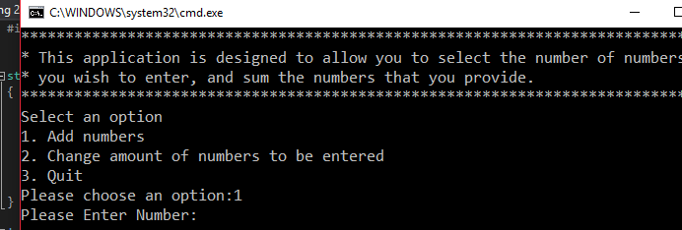
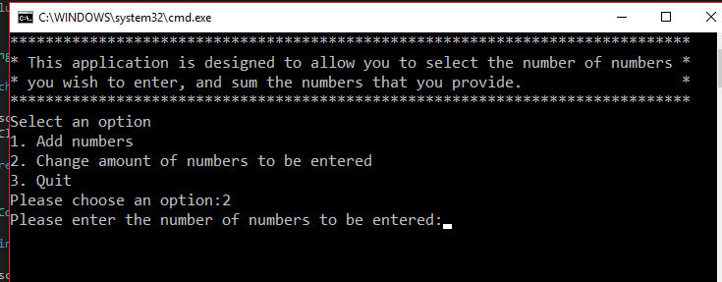
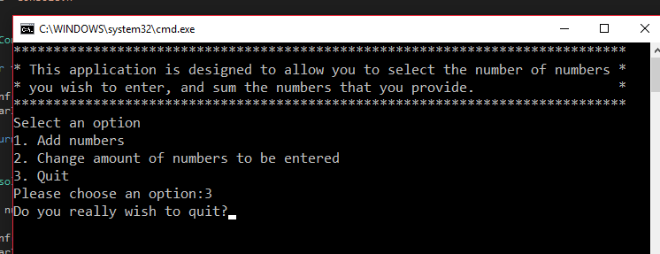

2 User enters an invalid menu option
Description: | The user will input value that should not be excepted
Test Steps:
- Message asks for user input of a number
- User inputs word or character (abc, hello)
User inputs invalid option (10, 35)
- Repeat for both
Response: | The program should give an error message saying that the input value does not work is unknown and prompt the user to try again until a valid input
Status: | Date: | Description:
Pass | 24/03/18 10.50 | Passed for all values
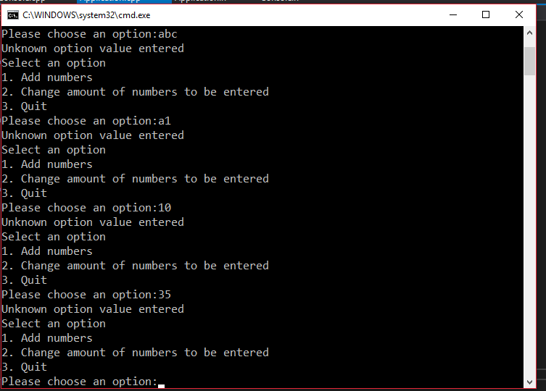

Problem 2
When trying to exit the code you user can enter 3 for option 3 which will end the code however when it asks if they are sure the user must answer “YES” for it to quit meaning any other input will not work or be accepted which may lead to the user getting stuck in the code as they have no way of knowing the need to type “YES” exactly.
3 User enters a valid value to exit
Description: | Test if the correct value is entered
Test Steps:
- Message asks for user to input a number
- Enter 3
- Type “YES”
Response: | The program should begin to quit after this has been entered
Status: | Date: | Description:
Pass | 24/03/18 11.20 | Value accepted, program quit
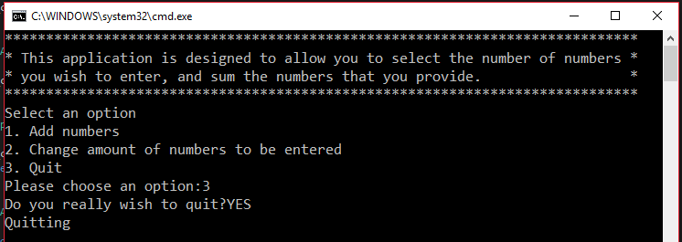
4a User enters an invalid value to exit
Description: | Test invalid inputs
Test Steps:
- Message asks for user to input a number
- Enter 3
- Type “Yes”, “yes”, “y”
Response: | Despite meaning the same as “YES” these will not work and will just loop the user back to the menu
Status: | Date: | Description:
Failed | 24/03/18 11.30 | All inputs got rejected
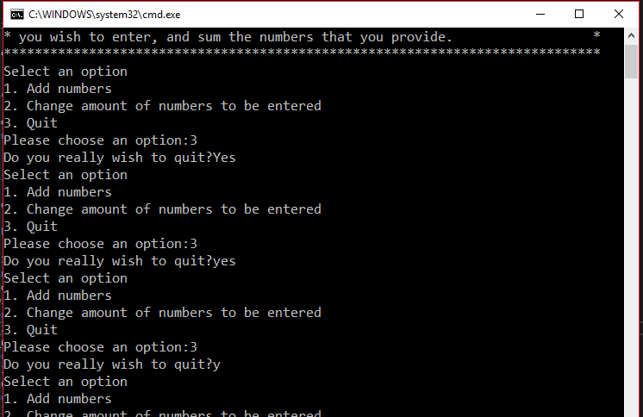

4b User enters an values after amendment (see appendix 1)
Description: | Test amended program, now it tells the user how to quit removing the problem as the user can now easily see what it is they need to do to quit unlike before where they couldn’t have known as well as giving other ways to quit
Test Steps:
- Message asks for user to input a number
- Enter 3
- Type “YES”, “yes” and “y”
Response: | The user will now know what to type to exit the code as they are now told what it is they need to do to quit
Status: | Date: | Description:
Passed | 24/03/18 11.40 | Program was quit successfully
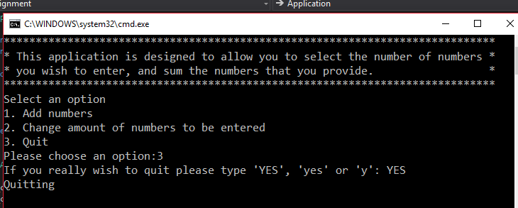
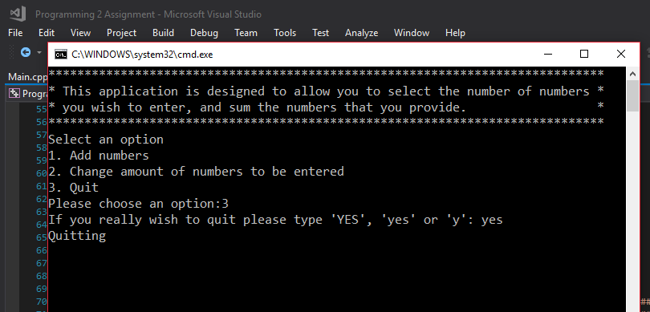
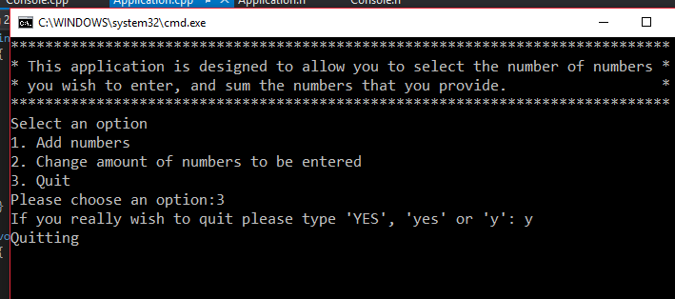

Problem 3
When the program finishes doing the math, it puts #’s surrounding the number however when the number has more than one digit it goes out of line this is because there is a set amount of #’s so they never change no matter how many numbers there are meaning it needs to be able to change depending on the amount of digits there are
6 One digit display test
Description: | Testing the display with one digit
Test Steps:
- Message asks for user to input a number
- Enter 1
- Input digits that add up to single digit number (1+1+1+1+1)
Response: | This should give us the result of 5 and the display around the number should be formatted correctly
Status: | Date: | Description:
Passed | 24/03/18 11.50 | Display formatting was correct
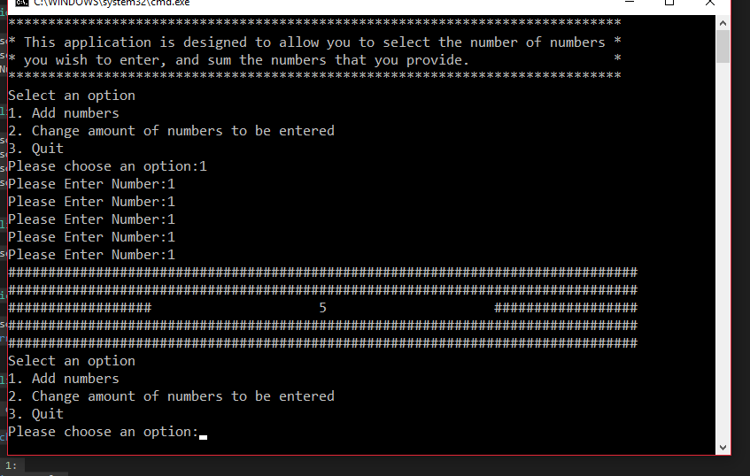
7 Multi-digit display test
Description: | Testing the display with multiple digits
Test Steps:
- Message asks for user to input a number
- Enter 1
- Input numbers that add up to numbers with 2 digits or more (1+2+3+4+5 or 20+20+20+20+20)
Response: | Due to it having more than one digit the formatting for the display will be displaced are it is longer pushing the #’s along further than they should be
Status: | Date: | Description:
Failed | 24/03/18 12.10 | The display wasn’t formatted correctly
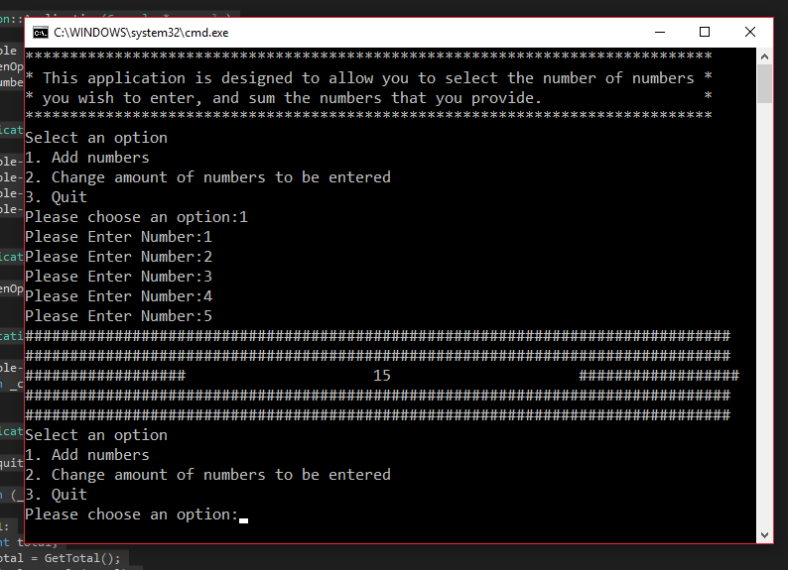
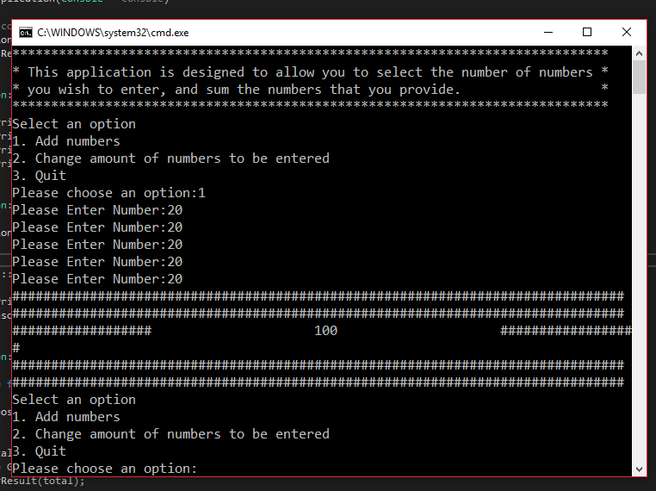
7b Amended Multi-digit display test (see appendix 2)
Description: | Testing the display with multiple digits
Test Steps:
- Message asks for user to input a number
- Enter 1
- Input numbers that add up to numbers with 2 digits or more (1+2+3+4+5 or 20+20+20+20+20)
Response: | After the fix it now correctly formats the display with numbers that have more than one digit
Status: | Date: | Description:
Failed | 24/03/18 12.30 | The display was formatted correctly for odd numbers
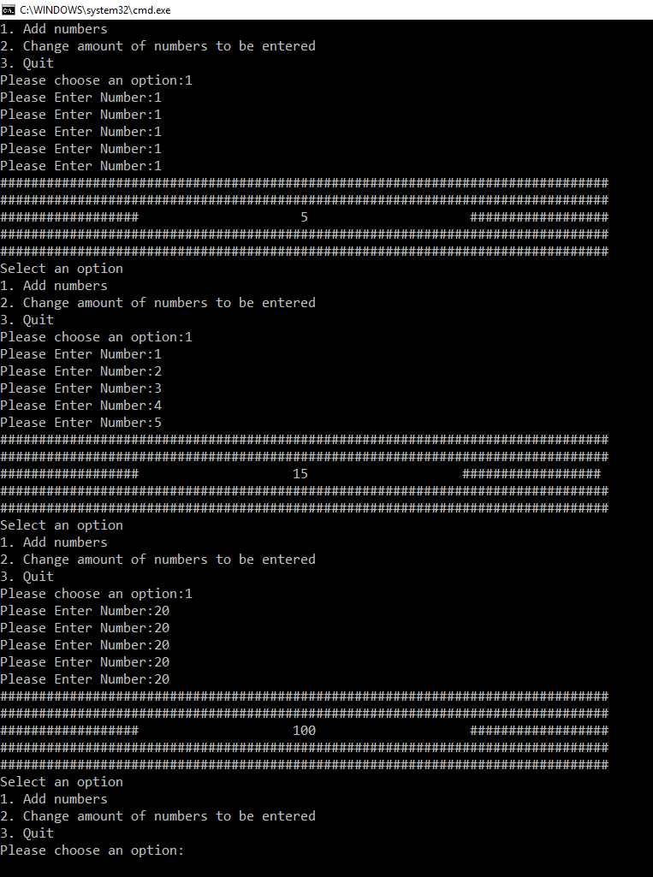

Part C

Exercise 1:
- The easiest part of this would be to display the message “you win” or “you lose” as all this would require is a printf or cout statement, this also goes for displaying any of the hints like the difference or wither its odd or even.
- Then you would need to receive the number the user enters that will be used to guess the value later by storing it in a variable which would be just as easy to create.
- You would make variable that would count as they guess so that they do not exceed their limit of 5 guesses.
- Create an if statement for comparing the values.
- The next hardest thing would be to create the random number as you would need to include things like time.h and srand then setting the highest and lowest values which would need to be stored in its own variable.
- You would then need to find if it was a negative number which could be done by seeing if the random number is less than 0 if it is then it is a negative value.
- Then the next hardest you will need to us an if statement for the next hints as you will compare the random value with the users by finding the difference
- Then using the if statement to see if the last chosen number is within the specific hint that the user is on unless the user has input a word in which case they lose a guess and don’t get a hint.

Appendix

Appendix 1
Application.cpp
#include "Application.h"

Application::Application(Console * console)
{
_console = console;
_chosenOption = 0;
_numNumbersReqd = 5;
}

void Application::DisplayMenu()
{
_console->PrintLine("Select an option");
_console->PrintLine("1. Add numbers");
_console->PrintLine("2. Change amount of numbers to be entered");
_console->PrintLine("3. Quit");
}

void Application::ChooseOption()
{
_chosenOption = ReadNumber("Please choose an option:");
}

int Application::ReadNumber(string prompt)
{
_console->Print(prompt);
return _console->ReadInteger();
}

bool Application::ProcessOption()
{
bool quit = false;

switch (_chosenOption)
{
case 1:
int total;
total = GetTotal();
DisplayResult(total);
break;
case 2:
_numNumbersReqd = ReadNumber("Please enter the number of numbers to be entered:");
break;
case 3:
quit = IsQuitting();
break;
default:
_console->PrintLine("Unknown option value entered");
break;
}

return quit;
}

int Application::GetTotal()
{
int total = 0;
int index;

for (index = 0; index < _numNumbersReqd; index++)
{
total = total + ReadNumber("Please Enter Number:");
}

return total;
}

void Application::DisplayResult(int result)
{
_console->PrintLine("###############################################################################");
_console->PrintLine("###############################################################################");
_console->PrintLine("################## " + to_string(result) + " ##################");
_console->PrintLine("###############################################################################");
_console->PrintLine("###############################################################################");
}

bool Application::IsQuitting()
{
string response;
bool quit = false;
//Here i changed it so the user could see what to enter
_console->Print("If you really wish to quit please type 'YES', 'yes' or 'y'");

response = _console->ReadString();
//Here i cahnge the quit works for more than just "YES"
if (response == "YES" || "yes" || "y")
{
_console->PrintLine("Quitting");
quit = true;
}

return quit;
}

Appendix 2
Application.cpp
#include "Application.h"

Application::Application(Console * console)
{
_console = console;
_chosenOption = 0;
_numNumbersReqd = 5;
}

void Application::DisplayMenu()
{
_console->PrintLine("Select an option");
_console->PrintLine("1. Add numbers");
_console->PrintLine("2. Change amount of numbers to be entered");
_console->PrintLine("3. Quit");
}

void Application::ChooseOption()
{
_chosenOption = ReadNumber("Please choose an option:");
}

int Application::ReadNumber(string prompt)
{
_console->Print(prompt);
return _console->ReadInteger();
}

bool Application::ProcessOption()
{
bool quit = false;

switch (_chosenOption)
{
case 1:
int total;
total = GetTotal();
DisplayResult(total);
break;
case 2:
_numNumbersReqd = ReadNumber("Please enter the number of numbers to be entered:");
break;
case 3:
quit = IsQuitting();
break;
default:
_console->PrintLine("Unknown option value entered");
break;
}

return quit;
}

int Application::GetTotal()
{
int total = 0;
int index;

for (index = 0; index < _numNumbersReqd; index++)
{
total = total + ReadNumber("Please Enter Number:");
}

return total;
}

void Application::DisplayResult(int result)
{
int space;
//Here i tried to get it to work so that when ever it was an even number it would add a space to even out but couldnt get it to work so only odd numbers are formatted correctly
int buffer = 0;
int temp = 0;
space = to_string(result).length() / 2;
for (int i = 0; i < 100; i++)
{
temp = to_string(result).length() * 10;

for (int buffer = 0; buffer < 100; buffer++)
{
temp = temp / 10;
if (temp < 0)
{
break;
}
}

}
_console->PrintLine("###############################################################################");
_console->PrintLine("###############################################################################");
_console->Print("##################");
DisplayGap(space);
_console->Print("" +to_string(result));
DisplayGap(space);
if (buffer % 2 != 0)
{
_console->Print(" ");
}
_console->PrintLine("##################");
_console->PrintLine("###############################################################################");
_console->PrintLine("###############################################################################");
}

bool Application::IsQuitting()
{
string response;
bool quit = false;
//Here i changed it so the user could see what to enter
_console->Print("If you really wish to quit please type 'YES', 'yes' or 'y'");

response = _console->ReadString();
//Here i cahnge the quit works for more than just "YES"
if (response == "YES" || "yes" || "y")
{
_console->PrintLine("Quitting");
quit = true;
}

return quit;
}
void Application::DisplayGap(int space)
{

for (int i = 0; i < 21 - space; i++)
{
_console->Print(" ");
}
}

