Drawing the line in Exaggeration: How far is too far?

Christopher Jones
Swansea College of Art, UWTSD
cjones.145777@student.uwtsd.ac.uk

1 .ABSTRACT

This research paper entails research into how much of an effect that the stylization level of a character has on how far the characters movements can be exaggerated in animation mainly utilizing a practice-based research methodology, along with supporting statements from well-known animators. The exaggeration effect is tested on two bipedal rigs with different levels of stylization, one closer to standard human proportions with another having more a more stylized build.
Over the course of research, it is discovered that the threshold for exaggeration on a more realistically proportions character is much lower than what is available to a character with heavier stylization in their body type. This was attributed to the fact that the common audience member is more likely to be aware of the way in which a human being would naturally move, so it is more critical of the movements. The same familiarity is not available to the stylized rig, so the threshold for getting away with more exaggeration in the movements and poses is at a considerably higher level in comparison.

2. INTRODUCTION

The primary purpose of this paper is to define the impact that a character’s level of body stylization has on the level of exaggeration that the character can have in its poses before they reach the point in which their movements are no longer believable. As a secondary goal, this paper is to help educate and increase the reader’s understanding of the concept of Exaggeration as a principle of animation to the ends that it will improve their endeavours in any art related mediums such as life drawing, concept art, storyboarding and animation whether it be 2D or 3D in nature.

Exaggeration as a principle was first publicized by Disney Animator’s Frank Thomas and Ollie Johnstone in their book “The Illusion of Life: Disney Animation” first published in 1981. Frank Thomas and Ollie Johnstone were part of the team of core Disney animator’s, known as Disney’s Nine Old Men, who established the rules now known as the twelve principles of animation. The purpose of these principles of animation was to help create more realistic animation and to provide what’s known as the illusion of life to the animation.

The twelve principles of animation are as follows:

- Squash and Stretch
- Anticipation
- Straight Ahead Action and Pose to Pose
- Appeal
- Ease in and Ease Out
- Arcs
- Secondary Action
- Timing
- Follow Through
- Staging
- Solid Drawing
- Exaggeration

Exaggeration itself is a broad concept to cover regarding animation as it doesn’t only apply to things such as the character itself. It has a profound effect on everything a member of the audience see’s on screen or the emotions and feelings they feel when they watch it. All these individual elements need to work together in order to provide the feeling that the filmmaker is going for whether that be happiness, rage, comedy, or even the feeling of disgust.

On the contrary to the above, there is a need for a single element of the composition to go against the exaggeration and to be grounded in realism. This is to provide a level of contrast to the audience that shall be subconsciously used to measure the exaggeration against.

For example, in Stephen Hillenburg’s popular animated series SpongeBob SquarePants (1999), the titular character SpongeBob is an overly exaggerated happy-go-lucky character often portrayed as fool, in direct contrast to this is a secondary member of the cast, Squidward who is the “straight man” in the show, a character whose purpose is to maintain their composure and react to the antics of the other characters. Without the contrast of Squidward, SpongeBob would exist in a world where everybody is an extremely happy character, but the real-world element of Squidward being the antithesis of this provides the grounded reality necessary to make SpongeBob appear to be exaggerated even further.

At its core, the principle of exaggeration is about isolating a particular trait about something whether it be a character, object and environment and amplifying it whether that be its physical appearance, movements or the general emotion it’s giving off.

3. METHODOLOGY

There is a plethora of research methodologies available to use for this paper, but only the select few that are most appropriate to research, document and explain the impact that the effect that the stylization of a character has on its animation will be utilized. The chosen methodologies for this research paper will be practice-based research and qualitative research. This mixture of research methodologies are the two best methods available to research the subject of exaggeration.

A practice-based approach to the research is an ideal choice due to the fact that animation in itself an entirely visual medium, thus logically it would be most appropriate to approach the research in a visual way to best understand it. As animation is a subject where the most improvement and understanding of the skill is to be gained through simply practice, it is most appropriate that any theories and techniques should be put through the same course of action.

To further support the above statement, a quote from the author of the 2001 publication The Animator’s Survival Kit follows. “The fact remains that there is no replacement for the hard work” (R. Williams, 2001, p24)

In addition to this, a quote from Milt Kahl, one of the previously mentioned nine old men appears in the publication, Kahl stated:

“If you’re going to lampoon something or do a satire – you have to understand the straight way. It gives you a jumping-off point. It gives you contrast. You just do it and do it… and do it!” (R. Williams, 2001, p24)

Animation itself, however, is a medium that can often be subjected to the opinion of its viewers, so to supplement the theories and ideas that are being explored through the practice-based research, qualitative research will be applied to the subject in order to back up any of the theories and the ideas behind the claims made within.

Qualitative research will be used to further refine, understand and explain the ideas and theories used and will provide a stable launching point for the rest of my research. Two specific methods of qualitative research that will be used are the case study model, the method of taking an in-depth look at one particular test subject, and the narrative model, the method of compiling information as it happens over a period of time.

The practice-based approach to the research will provide a form of primary research to this research paper, as stated the best way to understand how animation works is to practice animation. The qualitative research method will provide this paper’s secondary research, this will be gained mainly be reading the theories and ideas published by fellow animators such as Disney’s Nine Old Men, and animation pioneers who made the technological leap from 2D to 3D along with their accumulated knowledge such as John Lasseter who is best known for his work as the director of the 1995 movie “Toy Story”, the first fully CGI feature film. These people and other’s like them have published many papers regarding all aspects of animation, including some regarding the principles of animation and more specifically, exaggeration.

4. CRITICAL AND CONTEXTUAL REVIEW

The Illusion of Life: Disney Animation has a quote regarding Walt Disney’s view on realism and exaggeration, “When Walt asked for realism, he wanted a caricature of realism. One artist analysed it correctly when he said, “I don’t think he meant ‘realism.’ I think he meant something that was more convincing, that made a bigger contact with people.” (Thomas and Johnston, 1981, p66)

This means that exaggeration isn’t meant to fully come across as a result of the body but as an embodiment of the feelings behind the bodies actions. There are two parts to the exaggeration, the conceptual or the intent behind the movement in which feeling and emotion are delivered and the concrete, the direct movements and poses that we as viewers see that act as a vehicle in which the intent moves through.

To further support this idea, John Lasseter published a paper on applying the principles of animation to 3D computer animation and stated:

“The animator must go to the heart of anything or any idea and develop its essence, understanding the reason for it, so that the audience will also understand it. If a character is sad, make him sadder; if he is bright, make him shine; worried, make him fret; wild, make him frantic.” (J. Lasseter, 1987, p41)

This means that the animator should define an aspect of the animation and take it to the extreme to amplify its effectiveness, for example, if the character is slouching to give off the feeling of exhaustion, the character’s slouched posed should be pushed so far that the character is as slouched as far as is physically possible, and perhaps even further than that.

When searching to find research papers written regarding this subject it was found that there aren’t many research papers focusing on exaggeration alone as a principle of animation. If exaggeration was to be mentioned to be mentioned in these papers, it was always briefly covered, usually in a segment that was shorter than the segments related to the other principles of animation. This paper may be one of the first to experiment solely with the exaggeration principle as its core subject.

5. PROJECT-SPECIFIC RESEARCH

The practice-based research specific to this paper is to test how far the principle of animation can be pushed before the suspension of belief is lost and how this differs based on the stylization of the character’s involved.

To begin, the above statement will be further elaborated on using the human face as an example.

When a person feels the emotion of happiness and smiles, multiple muscles across the face change position as they contract. The most prominent of these changes to the face being the shape of the mouth with the corners raising and getting further away from the centre of the face. This single muscle movement creates a ripple effect across the face, changing other aspects of the face. The corners of the mouth push up, causing the cheeks to raise up higher. The cheeks push up towards the eyes which causes the bottom eye to squint, in turn, the squint causes the top eyelid to lower which then slightly pulls down on the eyebrows and skin of the forehead.

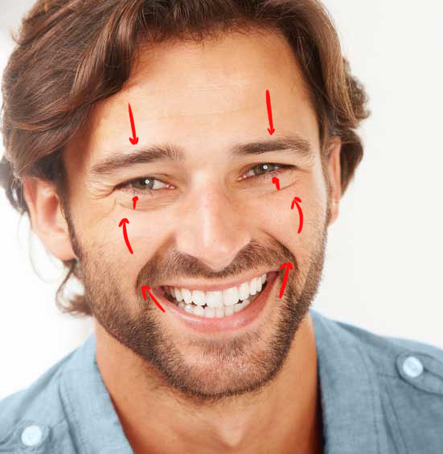
These changes in the facial muscles and the direction of their movements are outlined below as Figure 1.
Figure 1. Man smiling a big white toothed smile, with arrows indicating the movement of the facial muscles.

So, when these particular traits of the human face are isolated and pushed even further to their logical extremes, the intended effect is that these changes will make the character look even happier than they previously were. However, in this specific case, the exaggerated features cause a major issue. The features have been pushed too far and the previously established illusion of life has been broken, in this particular case it has created a phenomenon known as the “Uncanny Valley".

The uncanny valley is defined by WhatIs.com as the “unsettling feeling when androids and visual simulations closely resembling humans but are not convincingly realistic”. (M. Rouse,
2016.) An example of the uncanny valley effect can be seen as Figure 2 below.


Figure 2. Man smiling a big white toothed smile, with exaggerated features demonstrating the uncanny valley effect.

The above figure shows that with exaggeration it’s possible to capture the concrete movements, the actual visible mechanics of the movements themselves without capturing the intent or feeling that are intended to be behind the movements. What this has established, however, is that a breaking point exists and now that it has been found, the level of exaggeration can be reduced to a lower level so that the highest level of exaggeration can be used without reaching the point where the intent of the movement is lost.

This is the effect that too much exaggeration has on realistic proportions, but how does this differ when the proportions are more stylized?

Keith Lango, a former character animator at Valve states:

“The poses you choose should be true to that anatomy. More normally proportioned and human the character looks, the narrower the range of what 'pushed' can be before things feel broken. The more cartoon the design the greater the range of “pushed” before things break.” (K. Lango, 2008.)
Figure 3. Psylocke Rig created by Truong CG Artist.
To summarise Lango’s statement, the further away you take a character’s design from human standard human anatomy and proportion, the more you can exaggerate the character’s movements before it reaches the point at which the illusion of life is considered broken and the feeling behind the movement is lost. He continues to state that it is important that the character retains a sense of both balance and weight in their exaggerated poses. This implies that the more stylized the characters are, the higher the limit on their animation potential and the more exaggerated those animations can be before they reach the point where they encounter issues such as the uncanny valley.

Ultimately for the research, one specific movement will be highlighted as it’s subject. The traits of this animation will have its traits identified. These traits will then be exaggerated to the point where the intent behind the movement is lost, and then finally the level of exaggeration will be reduced until the idea of the original concept of the movement has returned.

To test Lango’s statement regarding the effects that stylization has on exaggeration, the same sets of animations will be created on two different rigs before they are pushed to their extremes. One of the rigs will have proportions closer to a real human and the other will have heavier stylization and more exaggerated proportions.

To represent the more realistic proportions, the Psylocke rig created by Truong CG Artist will be used. This rig can be seen as figure 3 below.

To represent the more stylized proportions, the Gnome rig modelled by Julien Ebel and rigged and textured by Truong CG Artist will be used. This rig can also be seen as figure 4 below.
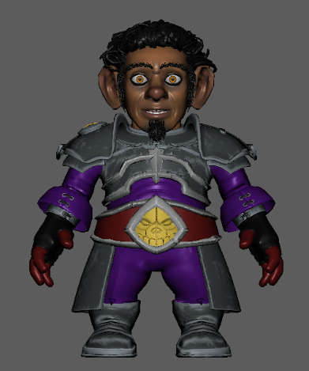
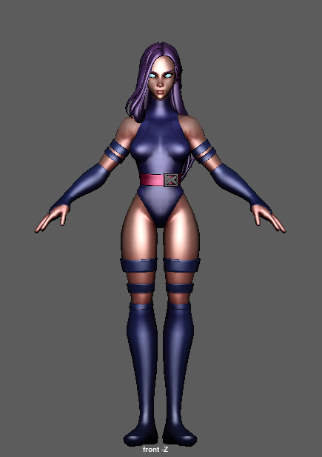
Figure 4 Gnome Rig created by Julien Ebel and Truong CG Artist.

These two rigs will be used to create the same animation, with 3 levels of intensity of exaggeration for each for a total of 6 animations. Each of these animations will be a basic 24 frame walk cycle.

The first set of animations will consist of a low exaggeration walk cycle, with no additional follow through animation.

The second set of animation will consist of a walk cycle but with the exaggeration raised to be so high that the movements appear to be unnatural on both rigs. The goal of this stage is to push the animations so far that they are no longer suitable for the character’s body.

The third set of animations will be an additional walk cycle but with the level of exaggeration reduced to the highest possible point where the exaggeration is high but the intent behind the movements is still completely clear.

6. RESULTS

The first set of animation walk cycles, titled “Psylocke_Anim_Walk_Basic.avi” and “Gnome_Anim_Walk_Basic.avi” are to serve as a baseline in which to compare the remaining four animations too. There is very little exaggeration in the way that the character’s move. The mechanics behind the walk cycle are mainly involving the dip of the body, the movement of the arms and the movement of the legs.

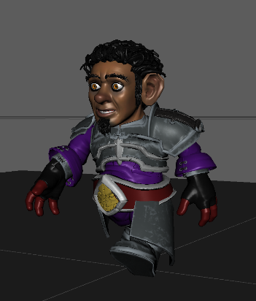
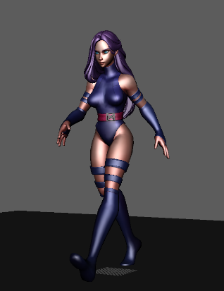
The below images show the current exaggeration on the leg and arm movement as well as the extremely limited torso twist. They are displayed as Figure 5 and 6 respectively.
Figure 5. Gnome Rig, basic walk animation. Frame 13.
Figure 6. Psylocke Rig, basic walk animation. Frame 13
An expected piece of evidence was encountered during this stage of testing that helps support Lango’s previous statement regarding the level of exaggeration that is permissible for a stylized character. When animating on the two rigs, it was much easier to create a suitable looking animation the Gnome rig than it was to create an animation on the Psylocke rig. This could be attributed to the fact that the Gnome rig is much more stylized, so the expected range of movement is at a different level of expectation.

The second stage of animation was to now exaggerate the characteristics that made up the previous walk to a level in which the illusion of life is lost and the animation appears to be incorrect. These animations are titled “Psylocke_Anim_Walk_Exaggerated.avi” and “Gnome_Anim_Walk_Exaggerated.avi”.

For the Psylocke rig, the dip of the body on every step was dropped to be closer to the ground, the swing of the arms was taken further and follow through animation was added to the hands. A twist of the upper torso was added on each step to enhance the movement of the arms. Additionally, the hip has been slightly moved sideways on each step to accentuate each step and follow through animation has been added to the breasts and hair. The neck has also been stretched when the body reaches its highest point to further emphasise the head bounce.

For the Gnome rig, the dip of the body has also been lowered to the ground, but due to the rig’s shorter legs compensation for each step had to be added, so the character swings their body to the side on each step to make the stride look bigger. The swing of the arms has been increased and the twist of the upper torso has been added to give the arms more range of movement. Additionally, the Gnome’s shoulder guards and head have been raised at the steps highest point to further emphasise the bounce of the character.

Another unexpected piece of evidence was discovered, when pushing the poses on the Psylocke rig it didn’t take long for the character’s exaggerated movements to get to the point where the character’s believability was diminished. However, on the contrary to this, the exact opposite problem had occurred on the Gnome rig. The character’s smaller proportions made it a much more difficult task to push the Gnome’s poses to such an extreme that it affected the character’s believability of movement. The Gnome’s limbs were so short that it was a struggle to position them in ways that appeared overly exaggerated, so the majority of the character’s exaggeration had to come from the twist of the torso and the swaying from side to side on each step.

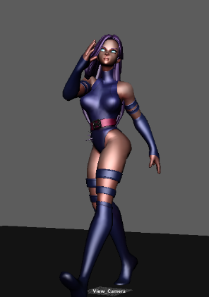
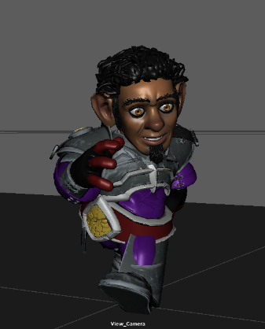
The below images show the exaggerated features of the second set of animation such as the enhanced body twist, note the difference in the level of the exaggeration in torso twist and arm swing. They are displayed as Figure 7 and 8.
Figure 7. Psylocke Rig, exaggerated walk animation. Frame 13.
The third and final set of animations will be based on the previous exaggerated walk cycle, the goal behind this stage was to reduce the amount of exaggeration in the movements to more a more believable level so that the highest point of exaggeration without removing intent can be located. This stage of development mainly involved working backwards from the previous animation, so the majority of the large movements were toned down drastically. These animations are titled “Psylocke_Anim_Walk_Reduced.avi” and “Gnome_Anim_Walk_Reduced.avi”.

For the Psylocke rig, the dip of the body was raised higher up so that the steps weren’t so dipped, the torso twist was retained but was reduced to more believable levels. The head bounce was completely removed, and the distance of the arm swing was reduced. The hip swing was reduced down but is still present, as well as the follow-through animation on the breasts and hair.

For the Gnome Rig, the dip on each step was reduced and the character’s swaying was made less drastic. The head bounce was completely removed and bounce of the shoulder guard was retained, but slightly reduced. The twist of the torso was also heavily reduced. The end result for the Gnome still conveys a great deal of weight in the movement, just not as cartoonish as the previous incarnation.

The below images show the third and final set of animations, note the reduced level of exaggeration in comparison to the previous animation.
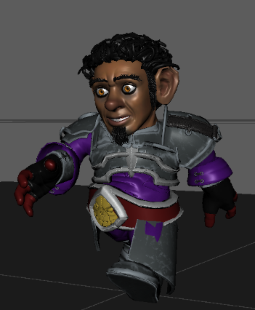
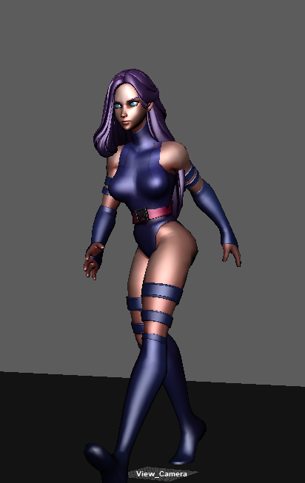
Figure 10. Gnome Rig, exaggerated walk animation. Frame 13.
Figure 9. Psylocke Rig, reduced walk animation. Frame 13.
Figure 8. Gnome Rig, exaggerated walk animation. Frame 13.

7. EVALUATION AND CONCLUSION

As I developed the research proposal for this paper, I was firmly in opposition to the statement provided by Keith Lango that suggested that the level of exaggeration than you can apply to an animation is based purely off the stylization level of the character itself.
The practice-based research approach that was taken towards this topic has convinced me that my initial thoughts towards this statement were incorrect.

Of the two rigs that I conducted my research on, it was indeed the Gnome rig that can have its poses pushed to a further point before the exaggeration rose to such a point where audience immersion was lost. I consider the Gnome rig to be the easier to animate, due to this stylized body. To further confirm this, I believe the reason that the Psylocke rig was harder to animate was due to its proportions being closer to the standard anatomy of a human when directly compared to the Gnome rig.

I believe that this is the case because people are generally aware of how a person with standard human proportions would walk so it is easier for the human mind to identify a human body that is moving unnaturally. On the contrary to this, as the standard audience member is traditionally going to have less understanding of how a creature with proportions outside its own would move, the mind’s attitude towards it is more forgiving and thus the illusion of life is not as easily broken.

There is, however, another factor that I encountered that I believe to be extremely relevant on why the Gnome rig was able to have it’s poses pushed further than that of the Psylocke rig. On the Psylocke rig, it wasn’t difficult to push the poses to a point at which the exaggeration was at too high a level, however, the Gnome rig did not have this same attribute. I found it was a much harder task to push the poses of this rig so far that the exaggeration was too big, and I believe that this is directly related to the length of the Gnome characters limbs. I was physically unable to push the character’s limbs so far that the exaggeration was too much, so the standard for how exaggerated the animation could be was limited, this led to the character being animated in a much more subdued way than the Psylocke rig. So, while the threshold for the exaggerated movement is technically higher for the Gnome rig, it was unable to be animated to that extreme. The opposite can be said for the Psylocke rig.

While the length of the limbs is directly related to the stylization of the character, I wonder if I would reach the same conclusion if the Gnome rig was replaced with a stylized rig that had a more stretched out frame, so that the limited movement of the limbs would not be a factor.

8. REFERENCES

Lango, K. (2008). Pushing poses. [online] Keithlango.blogspot.com. Available at: http://keithlango.blogspot.com/2008/09/pushing-poses.html [Accessed 29 Oct. 2018].

Lasseter, J. (1987). Principles of Animation applied to 3D Computer Animation. San Rafael, California.

Workopolis (2014). Man smiling a big white toothed smile. [image] Available at: https://careers.workopolis.com/wp-content/uploads/sites/5/2014/12/Smiling_pic.jpg [Accessed 25 Oct. 2018].

Skains, R. (2018). [online] Tandfonline.com. Available at: https://www.tandfonline.com/doi/full/10.1080/14682753.2017.1362175?fbclid=IwAR0quxhSicrO0aO2E8-xQbkqcu8mXPdx0sgK2gDlFD3-EsdHwt7cc22LzUY& [Accessed 1 Nov. 2018].

WhatIs.com. (2016). What is uncanny valley? - Definition from WhatIs.com. [online] Available at: https://whatis.techtarget.com/definition/uncanny-valley [Accessed 3 Nov. 2018].

Gumroad. (2018). Truong CG Artist. [online] Available at: https://gumroad.com/truongcgartist [Accessed 4 Nov. 2018].

Williams, R. (2001). The Animator's Survival Kit. Faber.

Thomas, F. and Johnston, O. (1981). The illusion of life. New York: Hyperion.

SpongeBob SquarePants. (1999). [series] Nickelodeon.

9. APPENDICES

Smith, S. (2018). Sense of Place Visualization for the Whaling Station remains of South Georgia Island.

Dudoskiy, J. (n/a). Types of Research - Research Methodology. [online] Research-Methodology. Available at: https://research-methodology.net/research-methodology/research-types/ [Accessed 24 Oct. 2018].

Silverman (2018). What is Qualitative Research. [online] Uk.sagepub.com. Available at: https://uk.sagepub.com/sites/default/files/upm-binaries/44074_Silverman_4e.pdf [Accessed 9 Dec. 2018].

Leonard, K. (2018). Six Types of Qualitative Research. [online] Bizfluent. Available at: https://bizfluent.com/info-8580000-six-types-qualitative-research.html [Accessed 9 Dec. 2018].

Libguides.usc.edu. (2018). Research Guides: Organizing Your Social Sciences Research Paper: 3. The Abstract. [online] Available at: http://libguides.usc.edu/writingguide/abstract [Accessed 11 Dec. 2018].

