E-portfolio
Evidence of learning comprising of two separate artefacts items

Tehreem Arshad-2120566
Module-BMHP5014_BIRM Lecturer-Robert Nartowski
Submission date:17th February 2023

Contents-
Introduction-…………………………………………………………………………2
Mind Map-……………………………………………………………………………2
Explanation-………………………………………………………………………….2
Speech-………………………………………………………………………………4
Explanation-………………………………………………………………………….5
References- ………………………………………………………………………….6

Introduction-
The following e-portfolio is an attempt to raise awareness for “Abortion” project related to health and social care. The mind map and a speech will help to promote the given cause, educate the world from a very young age. This e-portfolio seeks to highlight the key factors of “Abortion” and to make women comfortable to voice their opinion and rights.
The loss of pregnancy before a fetus develop to form a life before 28 weeks in a mother’s womb (Assefa, 2019). It is to choose if one wants to bring the baby into this world. Ntontis & Hopkins (2018) says the debate of a loss that naturally occurs in comparison to end a life before it began will always be a concept of altercation. The two artefacts “a mind map” and a blog is chosen to raise awareness and to offer help and support to vulnerable women.
Mind Map

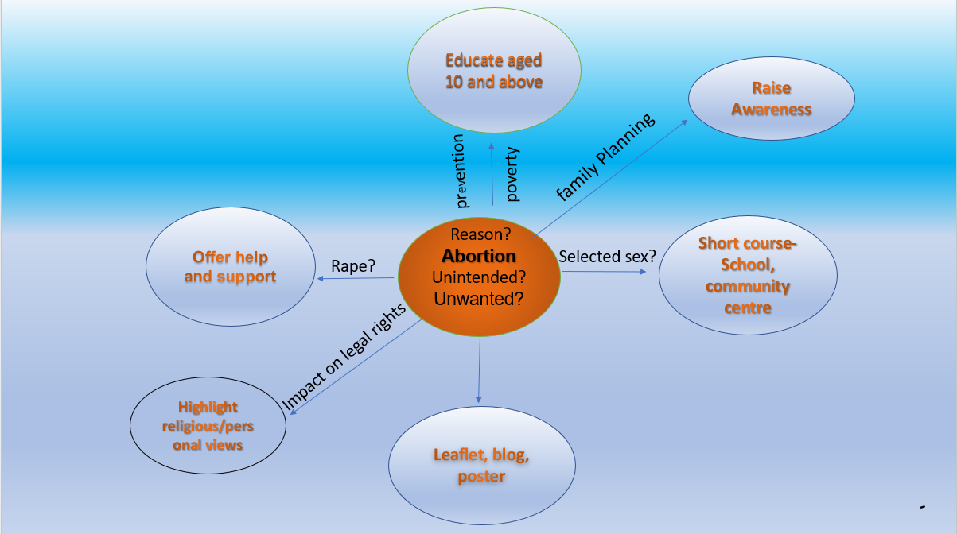
Explanation-
The loss of pregnancy before a fetus develop to form a life before 28 weeks in a mother’s womb (Assefa,2019). It is to choose if one wants to bring the baby into this world. Ntontis & Hopkins (2018) says the debate of a loss that naturally occurs in comparison to end a life before it began will always be a concept of altercation. The two artefacts “a mind map” and a “speech” is chosen to raise awareness and to offer help and support to vulnerable women.
The very first step to understand the mind map is to understand the reasoning of making a choice to end an innocent life before it comes into the world. The term “unintended pregnancy” is a worldwide issue as it has negative outcome in both mother and baby’s health (Hamdela, et al., 2012). This calls for the necessity to educate individuals about family planning or the use of contraception. The subjective aim of the mind map is to raise awareness of the key parts that root out of Abortion. To conceive a baby without realising because of minimum understanding of the right use of protection can play a role not only in mother and baby’s life but also can impact the society.
Increasing number of populations demands stability which is difficult to offer. Family planning can lessen poverty rates (CLELAND, et al., 2006). Less poverty can better the situation and offer better lifestyle whereas having more children effects on the quality of life they receive. A family that has many children has higher chance of living a poor life in comparison to the one with few children as mentioned by (CLELAND, et al., 2006). Access to Family planning in community should be encouraged in schools, health practices as it is beneficial for the children and society.
By arranging short courses on Family Planning and its benefits community can be made aware and it can reduce the number of abortions. Community centres play a huge role in spreading the cause. By distributing the leaflets all the right support and help can be made available to families and to offer a better understanding of abortion.
A pregnancy related to rape is another form of unwanted pregnancy says (Holmes , et al., 1996) and (Seymour, et al., 2020).Rape is a forceful act, and it can result in pregnancy mostly. An option of a safe abortion should be made easily accessible by health care centres.
The safe abortion care as described by (Gareth, 2022) can improve the quality of abortion. These services can reduce the number of maternal deaths (Nathalie, et al., 2013). Basic knowledge about the safety and precautions of abortions can prevent of the loss of many lives.
The World Health Organisation www.who.int/news-room/fact-sheets/detail/abortion provides detailed information on safety regulations and guidance and is also developing quality abortion care monitoring.
The need of spreading the awareness in younger children aged ten and above is highly due to prevent teenage pregnancies. A short course on safety abortion should be made mandatory in schools. The likelihood of teenage mothers to encounter long term mental health has poor understanding at present (Xavier, et al., 2018). To raise awareness at a very young age can help overcome issues such as mental health. Teenage pregnancy leads to borderline personality disorder (Mu-Hong & Shih-Jen, 2021). Prevention of teenage pregnancy will not only prevent abortions but also will help reduce several illnesses related.
Religious views regarding abortion-
It is generally seen that religious views objecting abortion influence legal rights of women’s abortion (Selebalo-Bereng & Patel, 2019). Many religions focus on the importance of a life and classify the termination of fetus as a murder. Thus, in such countries the safe availability to abort a fetus is dependent on religious practices (Berry, et al., 2011).
The Roman Catholic Church supports the concept of saving a life under any circumstance (Wu & Ida, 2018). It is to provide basic protection to a life even if it is unborn. 26% people live in such countries where abortion is banned or dependent on safety of a mother (Finer & J.B.Fine, 2013). In consideration of no danger to life of the mother the choice to terminate pregnancy is there.
Other faiths such as Judaism and Islam, abortion is forbidden in the religious practices unless it is causing harm to the mother and must not be performed on demand (Aramesh, 2007). Women residing in such faith practicing countries can suffer distress if the pregnancy is due to rape. Therefore, to safely abort the fetus the right support and access should be legalised. Failure to visualise abortion as a legal right of a woman has resulted in women going through unsafe ways of abortion which is not only fatal for the mother but also adds long term complications.
Abortion is often interpreted because of a sexual act in the concept of being pregnant outside marriage or rape (Shahawy & Diamond, 2018). However, it is essential to understand that in such cases the right, help and support should be available to the victims of rape.
Abortion due to preference of boys is seen as low social status of women in society (Farina, et al., 2009). The mind map doesn’t support killing of female under the shadow of legalising abortion.
In conclusion as much as it is essential to educate our generation to safe quality of abortion, and to understand the need to legalise this act for the right reason, and access to support and help, the ideology of selected gender abortion cannot be over-looked.

Speech
Have you ever wondered why is it difficult to tell a joke on abortion? Because it is all about the delivery!
Ladies and gentlemen, Today I have chosen such a topic “abortion” which caused altercation in the past and present generations and will continue to show ramifications unless the right approach is taken to educate everyone on the importance of abortion. This is something that cannot be taken as humorous by anyone in the world. In some cases, it is an utmost relief to women whereas on the other hand it is very pernicious.
The question arises is it ok to end a life before it is born? Who decides which fetus should come to the world? Or why fetus has any less value than the lives who have come to the world already? What is the cause that is asking for abortion? Isn’t all life sacred?
Many faith-based societies give fetus equal right to live as any other living being (Aramesh, 2007). Under the laws of living beings, it is within the rights of this fetus to be born. However the mothers should have a voice to choose whether they want to go through an immense change.
Abortion is not an answer to avoid disability (Gould, 2019). It is not right to seek abortion just to get rid of a unhealthy child however if it is harmful for the mother and the baby, safe abortion care should be provided.
In some unfortunate cases of rape or teenage pregnancy do you not think it is better to terminate the pregnancy. Who would take responsibility for the baby? Many teenage mothers who were forbidden to abort the fetus have now put the baby up for adoption (Laura, et al., 2023). These mothers have felt the burden has been moved of their shoulders. Putting up for adoption raises questions on the quality of life of these children.
Let us not forget the enormous issue of selected survival of gender. Abortion should not be performed to kill girls (Farina, et al., 2009). Both male and female have equal right to be born. Yes, even today many countries perform unsafe abortions to end the possibility of girls being born (Sattar, et al., 2021). Girls are the ones who make up homes and a very important part of society then is it that less rights are available to women to abort safely. Should it not be a woman’s choice to decide as she is the carrier and it is her body that is going to go through many changes.
Access to safe abortions under such circumstances should be available at health centres. The safety abortion care and guidelines to family planning education should be mandatory in schools to avoid teenage pregnancy. Risks to the mother’s health due to unsafe abortions can be avoided with the right help and service.
Let us teach our young ones the value of life, the right to live and not be the reason behind an abortion which will not only end an innocent life but also cause harm to the mother’s mental well-being as well as physical.
Explanation-
The aim of the speech is to raise awareness about abortion. Brief approach to visualise the importance of saving a life. The speech highlights the background of abortion, reason to demand an abortion. To identify if abortion is being accessed for the right reason for example unintended pregnancy as a result of rape. The speech outlines the basic knowledge and access of family planning to save other health related issues regarding to pregnancy.
The speech focuses on the impact of religion and the availability of women’s rights to abortion in certain countries or societies. Lack of access to safe abortion women have been left with no choice but to undergo unsafe ways to abort.
In the speech the value of all living being has been given same value regardless of their health and abilities to live a life with all due rights. Abortion cannot be performed to end a life which has possible chance of being disable. The speech eliminates discrimination against all the health aspects which might influence mothers to decide if abortion is the right move.
Abortion for the right reason not discrimination in regards to disability and selective gender. All lives are sacred, boy and a girl, disable.
The speech is an attempt to voice the safe rights of abortion made available to women. The funding is provided by the local community to tackle the rising issue of teenage pregnancy. The need to educate adolescences to prevent teenage pregnancy and understand the concept of family planning which may help better economy as well as mother’s wellbeing.
The decision to abort the fetus requires fundamental help and support. I will present the speech in local community centre, coffee mornings in schools. An online petition will be formed by myself with the help of few other fellow parents to make short courses mandatory on family planning in secondary schools. Leaflets and support will be available. Support and help include listening, talking, and providing help and directing teenage girls and women to right services. The basic listening and talking support will be beneficial as it will promote the idea to access abortion for right reason or to avoid unintentional pregnancy.

References
Aramesh, K., 2007. Abortion:An Islamic ethical view. Iranian Journal of Allergy Asthma, and Immunology, 6(5), pp. 29-33.
Berry, D. et al., 2011. Measuring religiosity/spirtuality in diverse religious groups;A consideration of methods. Journal of Religion and Health , Volume 50, pp. 841-851.
CLELAND, J. et al., 2006. Sexual and reproductive health 3 family planning : the unfinished agenda. The Lancet, 368(9549), pp. 1810-1827.
Farina, G. A., Narjis, R. & Dr.Babar, T. S., 2009. ‘And they kill me, only because I am a girl’…a review of sex-selective abortions in South Asia. The European Journal of Contraception & Reproductive Health Care, 14(1), pp. 10-16.
Finer, L. & J.B.Fine, 2013. Abortion Law aroung the World:Progress and Pushback. American Journal of Public Health, 103(4), pp. 585-589.
Gareth, L., 2022. All women must be able to access to safe abortion services, says WHO. [Online]
Available at: https://doi.org/10.1136/bmj.o591
[Accessed Saturday February 2023].
Gould, J. B., 2019. Epistemic Virtue, Prospective Parents and Disability Abortion. Journal of bioethical inquiry, 16(3), pp. 389-404.
Hamdela, B., G/mariam, A., Tilahun, T. & Baradaran, H. R., 2012. Unwanted Pregnancy and Associated Factors among Pregnant Married Women in Hosanna Town, Southern Ethiopia. [Online]
Available at: https://web-p-ebscohost-com.ezproxy.uwtsd.ac.uk/ehost/pdfviewer/pdfviewer?vid=0&sid=31917ef2-0455-423f-98e1-55872649261d%40redis
[Accessed Saturday Februray 2023].
Holmes , M. M., Resnick, H. S., Kilpatrick, D. G. & Best , C. L., 1996. Rape-related pregnancy: Estimates and descriptive characteristics from a national sample of women. American journal of obstetrics and gynecology, 175(2), pp. 320-325.
Laura, K. et al., 2023. Health Care and Adoption Service Experiences of People Who Placed Children for Adoption During Adolescence: A Qualitative Study. Journal of Pediatric and Adolescent Gynecology, 36(1), pp. 58-64.
Mu-Hong , C. & Shih-Jen, T., 2021. Taiwanese Journal of Psychiatry. [Online]
Available at: https://doi.org/10.4103/TPSY.TPSY_6_21
[Accessed Sunday February 2023].
Nathalie, K. et al., 2013. A review of evidence for safe abortion care. Contraception, 88(3), pp. 350-363.
Sattar, T., Ahmad, S., Zakar, R. & Maqsood, F., 2021. Watering the Plant in Another’s Courtyard: An Ethnographic Exploration of Daughters’ Devaluation Through Sex-Selected Abortions Among the Rural Married Females in South Punjab, Pakistan. Journal of interpersonal violence, 36(9-10), pp. 4490-4519.
Selebalo-Bereng, L. & Patel, C. J., 2019. Reasons for Abortion: Religion, Religiosity/Spirituality and Attitudes of Male Secondary School Youth in South Africa. Journal of religion and health, 58(6), pp. 2298-2312.
Seymour, J. W., Fix, L., Grossman, D. & Grindlay, K., 2020. Oxford University Press. [Online]
Available at: https://web-s-ebscohost-com.ezproxy.uwtsd.ac.uk/ehost/pdfviewer/pdfviewer?vid=0&sid=dbdbd7a0-6e51-43a7-9b93-e1c8cf0ccfb6%40redis
[Accessed Saturday February 2023].
Shahawy, S. & Diamond, M. B., 2018. Perspectives on induced abortion among Palestinian women: religion, culture and access in the occupied Palestinian territories. Culture, health & sexuality, 20(3), pp. 289-305.
Wu, B. & Ida, A. K., 2018. Ethnic Diversity, Religion, and Opinions toward Legalizing Abortion: The Case of Asian Americans. Journal of ethnic and cultural studies, 5(1), pp. 94-109.
Xavier, C., Benoit, A. & Brown, H. K., 2018. Teenage pregnancy and mental health beyond the postpartum period: a systematic review. Journal of epidemiology and community health, 72(6), pp. 451-457.

