

Student Name: Akua Oforiwaa Mfum
Student ID: 2509126

Module Code: LCHS 4003
Module Name: Introduction to Health and Social Care
Lecturer name: Eleni Koutsogeorgou Andreou

Table of Contents
Task 1 - Poster 2
Task 2 – Pharmacy Services 3
Origins and Historical Context 3
Current Functioning 3
Significance in Enhancing Quality of Life 4
Reference List 4

Task 1 - Poster
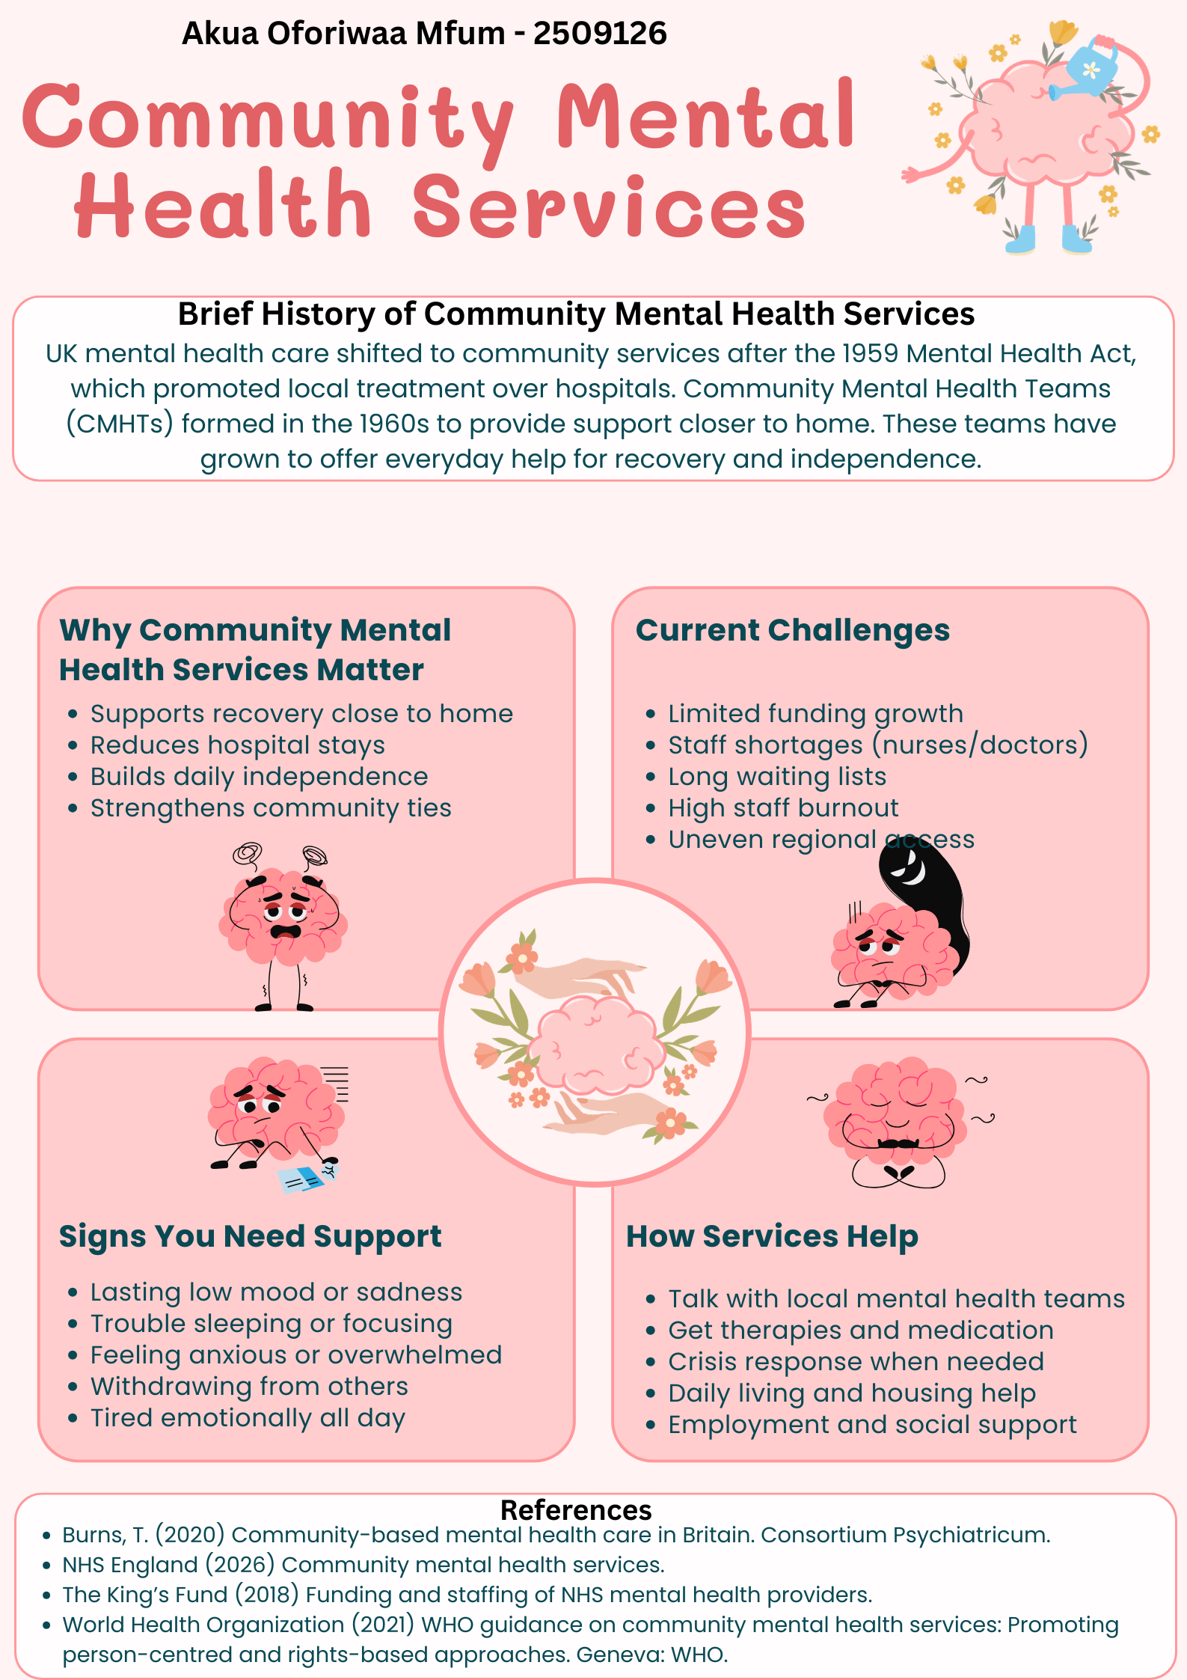

Task 2 – Pharmacy Services

Origins and Historical Context
With the establishment of the National Health Service (NHS) in 1948, which made medications free for everyone at the time of need, community pharmacy services in the UK started to take shape. Prior to this, chemists typically made their own medications in tiny stores and gave locals simple guidance. Significant developments occurred during the post-war era: pharmacies became essential locations for properly distributing prescription drugs throughout towns and cities, and the government sought to provide healthcare for everyone. After World War II, when diseases like tuberculosis were widespread, this change assisted in meeting the increasing need for remedies.
Pharmacy roles grew during the ensuing decades. Strict safety regulations for medications were established by the 1968 Medicines Act, which divided them into categories such as over the counter and prescription-only. Reports like the Nuffield Enquiry pushed chemists to do more than only dispense medications by the 1980s. They began providing immunisations, health examinations, and advice on quitting smoking. Increased prevalence of chronic illnesses like diabetes and heart disease, a lack of physicians, and a desire for care outside of hospitals have all influenced this growth. As practical, open-late centres in every community, pharmacies filled a void and improved access to healthcare by reducing wait times (Hassell et al., 2007).

Current Functioning
Community pharmacies in the UK now provide much more than just prescription drugs. According to the 2024–2026 Community Pharmacy Contractual Framework, advanced roles include using the Pharmacy First program to treat common illnesses including sore throats and urinary infections. Blood pressure checks, emergency contraception, and care planning for long-term conditions are all performed by chemists. Every year, more than 11,000 pharmacies deliver about 2 million consultations, distribute around 1.2 billion goods, and offer services like cholesterol screenings and flu shots.
By integrating with GPs through electronic prescriptions, they lessen the need for surgeries and fewer follow-up appointments. In certain regions, new trials from 2026 permit independent prescribing, and supervision regulations have been revised to allow technicians to perform more duties. Pharmacies serve both rural and urban regions, and they remain open on weekends and evenings. But problems still exist: several pharmacies have had to close because funding has not kept up with demand. Burnout is caused by staff shortages, particularly among qualified chemists, and regional differences exist in service quality. Digital tools increase productivity, yet there are gaps since not everyone has access to technology. Although the system is generally well-accessible, more resources are required for equitable delivery (Department of Health and Social Care, 2025).

Significance in Enhancing Quality of Life
By making healthcare quick, simple, and individualised, pharmacy services significantly improve quality of life. Regular check-ins guarantee proper medication use for patients with long-term conditions like asthma or hypertension, reducing hospital admissions by up to 20% in some studies. People feel more in charge of their health as a result of avoiding difficulties, saving time, and reducing stress. Nearby assistance, such as delivery programs that promote their independence at home, is beneficial for elderly people who may find it difficult to travel.
Services also address isolation: counselling on mental health, weight control, or quitting smoking enhances relationships, mood, and vitality. Free treatments for mild illnesses help families save money and worry less. By redirecting 1.9 million GP consultations annually, pharmacies economically save NHS expenses and free up clinicians for more challenging patients. Friendly, nonjudgmental encounters help vulnerable populations, such as immigrant or low-income communities, build trust. In the end, these programs prioritise prevention over treatment, resulting in happier, healthier lives with improved family and work attendance (The Pharmaceutical Journal, 2018).

Reference List
Burns, T. (2020) Community-based mental health care in Britain. Consortium Psychiatricum.
Department of Health and Social Care (2025) Community Pharmacy Contractual Framework: 2024 to 2025 and 2025 to 2026. Available at: https://www.gov.uk/government/publications/community-pharmacy-contractual-framework-2024-to-2025-and-2025-to-2026
Hassell, K. et al. (2007) ‘Community pharmacy and public health in Great Britain, 1936 to 2006’, Journal of Public Health, 29(4), pp. 367–376.
NHS England (2026) Community mental health services. Available at: https://www.england.nhs.uk/mental-health/adults/cmhs/
The King’s Fund (2018) Funding and staffing of NHS mental health providers. Available at: https://www.kingsfund.org.uk/insight-and-analysis/long-reads/funding-staffing-mental-health-providers
The Pharmaceutical Journal (2018) NHS70: major moments in pharmacy 1948–2018. Available at: https://pharmaceutical-journal.com/article/infographics/nhs70-major-moments-in-pharmacy-1948-2018
World Health Organization (2021) WHO guidance on community mental health services: Promoting person-centred and rights-based approaches. Geneva: WHO.

