My reflective report

Student: Mihaita Robert Nedelea
Student Number: 2129063
Module: Academic and Employability Skills
Module Code: BMSW4001
Lecturer Name: Muhammad Hossain

Introduction
In this report, I will discuss my professional growth throughout this module, from the beginning in May to the present. To stand out in the competitive job market, I need to be able to recognise my specific learning needs, talents, and capabilities, as well as the areas of my skill set that need to be updated or expanded. I want to use this to show that I understand the abilities I've learned in this module.
One approach that can be established to help both personal and professional development as well as continual learning is reflection. To record the thoughts and experiences, this might also incorporate the reflective writing process. Reflective writing and academic learning have a strong connection since it highlights the importance of self-improvement, critical thinking, and awareness of one's own actions and decisions. Students can recognise their position when collaborating with others through reflective writing.
Importance of academic skills
Your productivity and achievement in school can both be increased by having strong academic skills. Many abilities are also transferable to the industry, in addition to assisting you in obtaining the academic qualifications you may need to start a career.
Your job will benefit from, for instance, developing your ability to handle various tasks, collaborate with others, and digest information rapidly. Your future job and general performance may be improved by enhancing and developing your academic skill set.
Academic skills acquired during the course
I learned more academic skills during the course, and I can use these in my future work. I'll mention a few of them along with their advantages below.
Time management
Time management is the skill of effectively organising and planning one's time. I could have improved my study habits and allotted adequate time to do my homework at school by using these skills. At work, deadlines might come up quite frequently, so knowing how to plan my calendar will make me more effective.
Research skills
Research is a requirement for academic reports. These skills include being aware of the questions I want to answer, finding trustworthy sources, and using effective search strategies.
Reading comprehension
Reading comprehension is the ability to understand what I have read. This ability will aid me in my exam preparation, research, and report writing. I might utilise these abilities at work to decipher written instructions, obtain data, or interact with co-workers.
Computer skills
My performance at work and school will benefit from my understanding of how computers work. I could write reports, make graphics, conduct research, and use software all on a computer.
Group work
I must work with my colleagues to create a presentation for this class. Learning how to work effectively in a group can help me improve my leadership, communication, and conflict-resolution skills. I might work on projects in my professional life that include a team or many departments.
Presentation and public speaking skills
I can deliver an oral presentation with assurance and success thanks to a set of abilities known as presenting skills. These skills include the ability to speak assertively, employ eye contact and body language, and create helpful printed or slide-based presentations.
Goal planning
My productivity might increase if I learn how to develop and maintain realistic goals. My ability to set and track goals will help me in both the business and academic worlds.
Multitasking
Multitasking is the ability to work on several projects at once. These skills will help me when I prepare reports for my classes in a classroom setting. At work, I could have a range of responsibilities. By developing my ability to set priorities, make plans, and carry out these tasks, I can increase my chances of success.

Gibbs' Reflective Cycle
The Gibbs Reflective Cycle was developed by Graham Gibbs in 1988 to organise learning from experiences. Since it is cyclical, it lends itself particularly well to repeated encounters, allowing you to draw lessons and build goals from both positive and negative situations. It offers a framework for analysing events.
Gibbs' reflective cycle, which was initially developed for nursing, has gained popularity across many disciplines, and is commonly used as a significant example of reflective practise.
The description, feelings, evaluation, analysis, conclusion, and action plan are the six main components of this cycle.
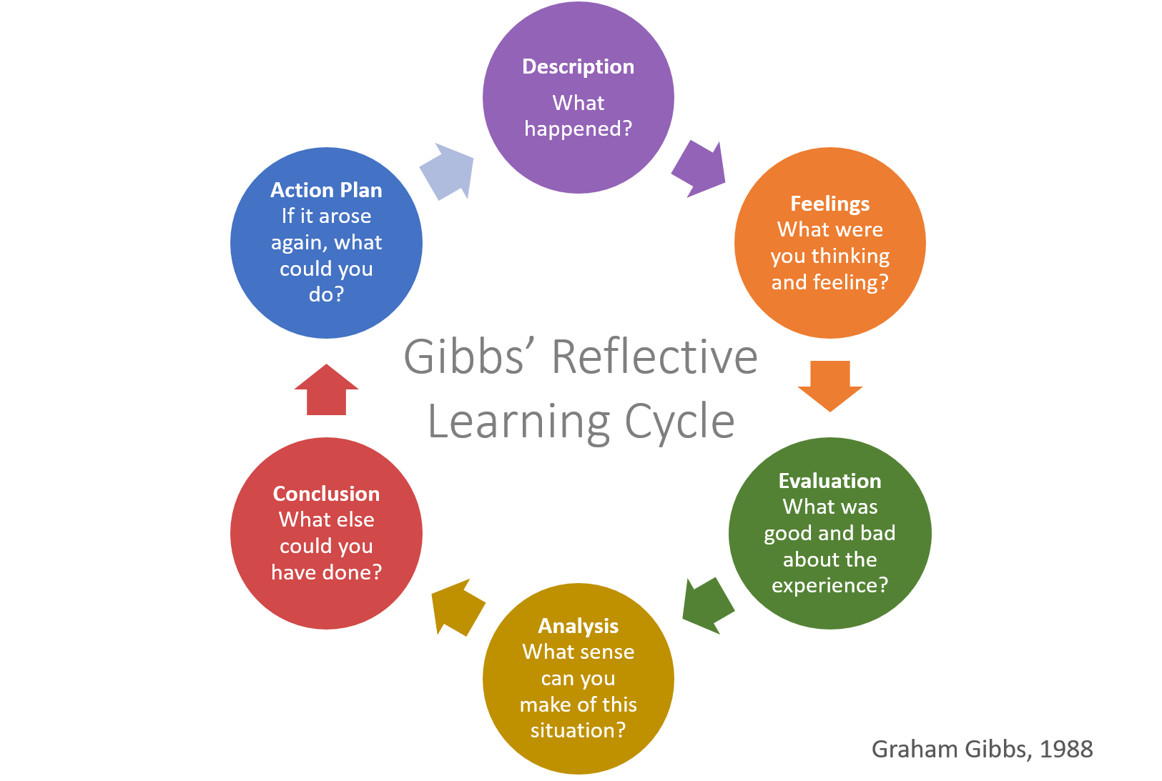

Next, in my report I will use this Gibbs’ Reflection model to describe my experience during this module. I will describe both my individual experience, when I worked on the academic report, as well as the experience of working in a team, when I worked on the Power Point presentation.

Description
In this report, I will consider, examine, and assess how this course has benefited my academic and employability skills. After that, I'll think about the skills I still need to acquire and how I can strengthen them.
I gained a better understanding of the value of academic and employability skills thanks to this course. I've picked up a lot of new skills, like how to prepare a report, how to paraphrase, and how to cite sources. By enrolling in this course, I have gained a lot of essential knowledge, all of which are crucial to me in my quest for a better profession.
Group work is a crucial activity because it brings together people with different cognitive styles and mindsets to collaborate on a project with comparable goals and objectives. The group work in the programme provided me with a completely new learning opportunity by exposing some of my weaknesses and strengths that even I was unaware of. We came to the conclusion during the group assignment that the group required a leader with proven leadership abilities. As a result, we select leaders based on a set of traits that include the capacity to motivate followers, to lead effectively, and to influence others.
To give someone responsibility is not an easy undertaking since people have competing natures, I realised through this procedure. Prior to now, I believed that group work did not allow individuals to fully utilise their talents. The idea of teamwork was completely foreign to me, but after participating in group activities throughout the module, I became aware of its many advantages.
Feelings
During this course I had mixed feelings. I had emotions and I was excited about new experience. The weekly debate of the subjects was interesting to me. I also believed that the concepts I learnt in this course helped me think differently and were beneficial in helping me land a better career.
My feelings occasionally fluctuated between confusion and unconfident, but as the teacher gradually explained to us, we must do with reports, my feelings began to alter. Because it was about my experiences during the course and everything I learnt, I found that writing this report to be a challenge. Now I was feeling confident and determinate to complete my task.
Evaluation
I've now discussed my thoughts on the course and will now assess the entire experience. I have gained knowledge of a variety of skills, including time management, organisation, communication, teamwork, and writing. For me, learning about all these skills is crucial because they are necessary for obtaining better employment. The teacher provided us with a variety of exercises for developing various kinds of skills. I'll begin to recognise my skills and shortcomings by regularly reflecting on my accomplishments, and I'll then plan each step.
Analysis
I have appreciated the group talks throughout the course since they have encouraged me to learn more and develop my skills. I've evaluated how my teamwork and communication abilities have improved because of the class discussion groups. I also became aware of how much my time management abilities had advanced. I'm better able to manage my time now.
Conclusion
Academic skills are essential for success and for achieving career objectives. Improvements in academic performance and employability are found to be very beneficial for both career and personal growth. I am incredibly grateful for everything I have learned throughout this course. To assess how effectively I have grown as a person, I tried to describe, assess, and analyse my experience during this year's academic sessions.
Action Plan
I've learned more about the value of reflection, evaluation, and analysis of the past because of writing this reflective report. I believe that doing this module has given me a lot of knowledge and skills, all of which I am now utilising in my job. To increase my expertise, I am now communicating with my colleagues more efficiently, prioritising the critical and urgent tasks first, and participating more in group discussions.
However, I need to start acquiring two skills: problem-solving and decision-making. By reading books and conducting research, honing my note-taking techniques, paying closer attention in class, and asking more questions, being an active listener, and reflecting on my own methods, I will be able to develop these skills. Self-reflection entails looking inward at one's own strengths, weaknesses, and objectives.

References
Tarrant, P. (2017) Reflective practice and professional development. First edition. Thousand Oaks, CA: SAGE Publications.
Jasper, M, 2007, “Professional development, reflection and decision-making”, Wiley-Blackwell, New York.
Cottrell, S. (2010) Skills for success: the personal development planning handbook. 2nd ed. Basingstoke: Palgrave Macmillan.
Menz, M. (2020) ‘Integrating academic skills and employability - revisiting the learning journal’, Journal of perspectives in applied academic practice, 8(1), pp. 115–120. doi:10.14297/jpaap. v8i1.393.
Riebe, L. et al. (2010) ‘Teamwork: effectively teaching an employability skill’, Education & training (London), 52(6/7), pp. 528–539. doi:10.1108/00400911011068478.

https://scholar.google.com

