30/01/2019
Games Physics
Gordon Dickers – Games Architecture & Mechanics – ACDA5004
Matthew Dickinson – 1708355 – BSc Games Development

Table of Contents
Introduction 3
1. Dragster Simulation 3
1.1 Task background 3
1.2 Euler’s method 3
1.2.1 Description 3
1.2.2 Advantages & Disadvantages 4
1.2.3 Implementation 4
1.3 Other Integration methods 5
1.3.1 Semi-Implicit Euler 5
1.3.2 Midpoint 6
1.3.3 Velocity Verlet 6
1.3.4 Runge-Kutta 4 6
1.4 Numerical Integrators – Analysis 7
1.4.1 Measuring inaccuracy 7
1.4.2 Plotted Results 8
1.4.3 Explicit Euler 8
1.4.4 Semi-Implicit Euler 8
1.4.5 Midpoint 9
1.4.6 Velocity Verlet 9
1.4.7 Runge-Kutta 4 10
2. Vectors & Planes 11
2.1 Task 1 – Distance between two points 11
2.1.1 Test of pToPDistance() method 11
2.2 Task 2 – Distance Squared between two points 12
2.2.1 Test of pToPDistanceSqd() method 12
2.3 Task 3 – A plane class 12
2.4 Task 4 – Projection of one vector onto another 13
2.4.1 Test of ProjectionTo() method 14
3. Task 3 – Sphere to sphere collision detection 15
3.1 Class structure 15
3.2 Collision Detection method 15
3.3 Testing 16
3.3.1 Test 1 16
3.3.2 Test 2 17
3.3.3 Test 3 17
References 18

Introduction
Physics simulations and collision detection are important for all modern games. Without these, game objects would be unable to interact with each other or the player input [1, pp. 51-52]. Games make use of rigid body dynamics (rigid; non-deforming, dynamics; following newtons laws of motion) to create a simplified simulation of real-world forces on game objects [2, pp. 519-520]. This report will detail the implementation of integration methods for simulating linear motion, common 3D vector and plane methods, and basic bounding sphere collision detection.

Dragster Simulation

Task background
The task involved the simulation of a spring powered dragster driving forward until it came to a stop. The motion of the car was modelled using basic Newtonian physics. To calculate the acceleration of the car the following equation was used:
$F=ma →a=\frac{F}{m}$
Where F is the sum of forces acting on the car, m is the mass of the car and a is the acceleration.
The acceleration is then used together with timestep to numerically solve a new value for the velocity using the equation:
$$v_{n}=v_{n-1}+(a)dt$$
Where v_{n} is the new velocity, v_{n-1} is the old velocity and dt is the timestep used to iterate the simulation.
From this the position is calculated:
$$x_{n}=x_{n-1}+{(v}_{n})dt$$
Where x_{n} is the new position, x_{n-1} is the old position and v_{n} is the new velocity from the previous equation. These calculations were used to update the car’s position as time passes.

Euler’s method

Description
The process described above is known as Euler’s method. It is a numerical integration method used to solve differential equations known as initial value problems where we know:
- the initial values
- a derivative function for these values
- and a time interval, h. [2, p. 525]
Euler’s method uses a known initial value and approximates the next value by measuring a tangent along the curve of current values at a length of the time interval, h.

Advantages & Disadvantages
The advantage to using Euler’s method is the small number of calculations required to gain a “close-enough” approximation of the update value. As game physics for many genres does not have to be realistic, only convincing to the player, this tolerable level of inaccuracy makes it cheaper to use than other methods.
The disadvantage to using Euler’s method is the level of inaccuracy obtained when using large timesteps as this is not a desirable trait when performing complex physics calculations such as bullet trajectories in a first-person shooter game. When the timestep is small enough the error in the results decreases, however this removes the original benefit of requiring fewer calculations for its approximation. It may be more advantageous to use a different numerical integration method to achieve better accuracy.

Implementation
The method was implemented as a function that takes a value for the timestep as an argument and utilizes global constants for determining the total forces on the car.
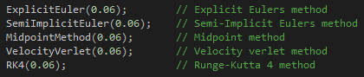
Figure 1. Integrator function calls with timestep arguments
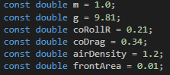
Figure 2. Constants for dragster simulation
This implementation of Euler’s method (or Explicit Euler) calculates values for position and velocity using the equations in section 1.1.
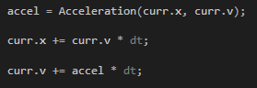
Figure 3. Algorithm for Explicit Euler
Below are the functions used to calculate the total forces and the acceleration.
Figure 4. Acceleration() Function
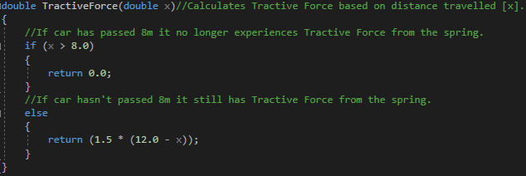
Figure 5. TractiveForce() function
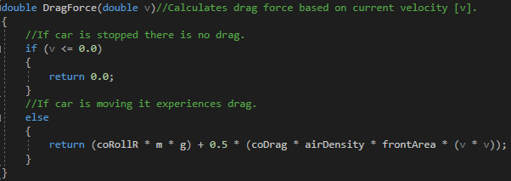
Figure 6. DragForce() function

Other Integration methods
Many other numerical integrators are used in the game development industry. The main factors for choosing an integration method are its accuracy and its resource cost. Some games require more accurate physics simulation, other games require a method with a low performance impact.

Semi-Implicit Euler
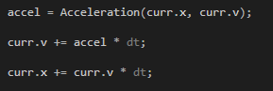
Figure 7. Algorithm for Semi-Implicit Euler
Semi-Implicit Euler or symplectic Euler calculates the velocity first in the same way as Explicit Euler but uses the new velocity to calculate the new position [2, p. 535].

Midpoint
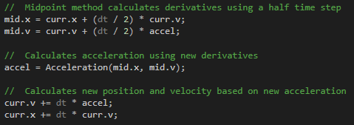
Figure 8. Algorithm for Midpoint
The midpoint method uses the Explicit Euler method with a half timestep and uses the results of this to calculate a new acceleration value which is then used to obtain a new position and velocity [2, p. 530].

Velocity Verlet
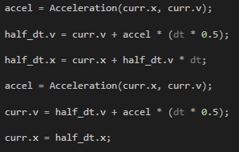
Figure 9. Algorithm for Velocity Verlet
The Velocity Verlet method calculates the acceleration twice, once using an old position and velocity, and again using a velocity calculated using a half timestep [2, p. 533].

Runge-Kutta 4
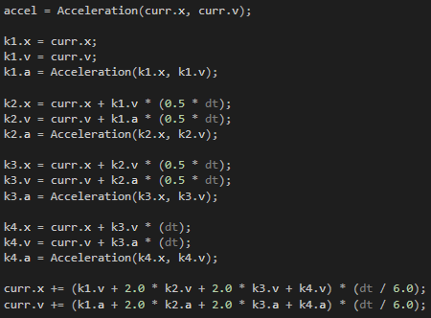
Figure 10. Algorithm for Runge-Kutta order 4
Runge-Kutta calculates the acceleration at four different states using positions and velocities at different timestep values and takes the weighted average of the values calculated using these new acceleration values [2, p. 531]. It completes 4 times the integrations per timestep used in Euler’s method.

Numerical Integrators – Analysis
All the numerical integrators were first tested at a very small timestep (h = 0.00006s) to obtain a good approximation of the real distance travelled.
Integrator  (h=0.00006s) | Time  (s) | Velocity  (ms⁻¹) | Acceleration  (ms⁻²) | Position  (m)
Explicit Euler | 6.85836 | -8.13152e-05 | -2.0601 | 43.2033
Semi-Implicit Euler | 6.85794 | -4.87688e-05 | -2.0601 | 43.198
Midpoint | 6.85782 | -5.95186e-05 | -2.0601 | 43.1963
Velocity Verlet | 6.85824 | -9.45347e-05 | -2.0601 | 43.2016
Runge Kutta 4 | 6.85806 | -3.33525e-05 | -2.0601 | 43.1993

After taking an average of the results the car appears to have travelled approximately 43.20m at 6.586s, the method closest to the average being Runge-Kutta 4.
Using these values, all the methods can be examined at the original 0.06s timestep to see which methods achieve the best accuracy.
Integrator  (h=0.06s) | Time  (s) | Velocity  (ms⁻¹) | Acceleration  (ms⁻²) | Position  (m)
Explicit Euler | 7.26 | -0.0982511 | -2.0601 | 48.9358
Semi-Implicit Euler | 6.84 | -0.0634949 | -2.06011 | 43.4566
Midpoint | 6.78 | -0.0645269 | -2.06011 | 41.8295
Velocity Verlet | 6.96 | -0.0548192 | -2.06011 | 45.1525
Runge Kutta 4 | 6.84 | -0.0204642 | -2.06011 | 43.4901

Measuring inaccuracy
The deviations from the h = 0.00006s approximation (43.20m) are below:
Integrator (h=0.06s) | Deviation
Explicit Euler | +5.7358
Semi-Implicit Euler | +0.2566
Midpoint | -1.3705
Velocity Verlet | +1.9525
Runge-Kutta 4 | +0.2901

From this table it can be seen that Explicit Euler has the greatest error and Runge-Kutta 4 has a very small error as a fourth order integrator. A surprising result is the high accuracy of the Semi-Implicit Euler method. This could be due to an error in implementing the RK4 function as this was expected to have the highest accuracy.
With this taken into account, for its simplicity and its accuracy, Semi-Implicit Euler appears to be a very good choice of numerical integration method for a game physics engine.

Plotted Results
To illustrate the differences between these integrators, the data from each simulation is written into a .csv file which can be used in Microsoft Excel to plot graphs of the variables over time with a timestep of 0.06s.

Explicit Euler (h = 0.06)

Figure 11. Graph of Explicit Euler's method

Semi-Implicit Euler (h = 0.06)

Figure 12. Graph of Semi-Implicit Euler's method

Midpoint (h = 0.06)

Figure 13. Graph of Midpoint method

Velocity Verlet (h = 0.06)

Figure 14. Graph of Velocity Verlet method

Runge-Kutta 4 (h = 0.06)

Figure 15. Graph of Runge-Kutta order 4 method

Vectors & Planes
The provided vector class contains several functions required for basic vector math. Below are implementations of methods that are frequently used in vector classes found in physics engines.
(In this premade vector class, the attributes for the x, y and z components are made private to preserve data encapsulation).

Task 1 – Distance between two points
In two-dimensional space, the length of a line between two coordinates is calculated using the equation:
$${Distance between points}_{(p1, p2)}= \sqrt{{( x_{1} - x_{2} )}^{2}+ {( y_{1} - y_{2} )}^{2} }$$
The length of this line is equal to the distance between the points 1 and 2.
Similarly, the three-dimensional distance between two points or vectors is calculated using:
$${Distance between points}_{(p1, p2)}= \sqrt{{( x_{1} - x_{2} )}^{2}+ {( y_{1} - y_{2} )}^{2}+ {( z_{1} - z_{2} )}^{2} }$$
The equation is identical with the addition of the three-dimensional Z axis component. The distance between vector points is also the magnitude of the vector joining them.
Below is the method implemented to calculate the distance between two vectors.
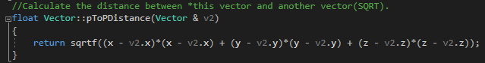
Figure 16. Method for pToPDistance()

Test of pToPDistance() method
The method was tested using two vectors, v0 (0, 0, 0) and v1 (4, 0, 0). The distance between the two will equal 4 as the vectors differ only along the x-axis by 4.
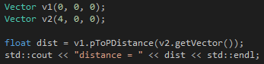
Figure 17. Test for pToPDistance()
Figure 18. Result of pToPDistance() test
The method has correctly returned the distance between v0(0, 0, 0), and v1(4,0,0) as 4.

Task 2 – Distance Squared between two points
The purpose of using squared distance is to reduce the number of times a square root function is called as it is an expensive operation to use. If a comparison of two lengths is required, then it is cheaper to use the squared distance.
Below is the method implemented to calculate the squared distance between two vectors.
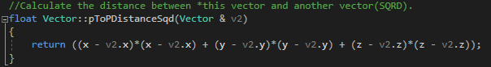
Figure 19. Method for pToPDistanceSqd()

Test of pToPDistanceSqd() method
Here the method was tested using the same vectors used in the earlier test for pToPDistance. The result should be the square of the distance from the previous test. The result of this test should equal 4² = 16.
Figure 20. Test of pToPDistanceSqd()
Figure 21. Result of pToPDistanceSqd()
The method correctly returned the square of the distance as 16.

Task 3 – A plane class
The plane class contains two vectors that represent the normalized plane normal and a point on the plane.
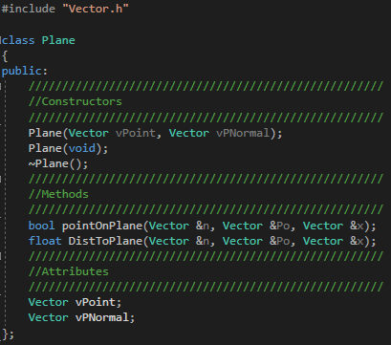
Figure 22. The plane class
The class includes two methods, pointOnPlane() and DistToPlane(). The pointOnPlane() method is responsible for checking if a point lies on the plane by using the equation of a plane and the plane normal. The DistToPlane() method uses the normalized plane normal to calculate the distance a separate point is from the plane.

Task 4 – Projection of one vector onto another
Projection of one vector onto another is useful in game development. It allows a vector to be decomposed into components of the same direction as another vector. This is useful for physics when evaluating the total forces in a direction, or in graphics where projection matrices are used to cast light or shadows onto objects.
To calculate the projection of a vector onto another, the dot product of the two vectors is needed. The dot product equation for two vectors, a and b, is:
$$a.b=a_{x}b_{x}+a_{y}b_{y}+a_{z}b_{z}$$

The dot product has been implemented in the method below:
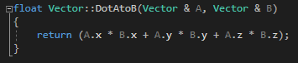
Figure 23. Vector Dot Product method
The equation for the projection of a vector a onto a vector b is:
$${proj}_{\vec{b}}\overset{⃑}{a}=\frac{\vec{a}.\vec{b}}{\vec{b}.\vec{b}}\vec{b}$$
This has been implemented by the projecting vector A calling the method and vector B being called as an argument. The method multiplies the vector B by the result of the division of the two dot product operations and returns the projection as a Vector.
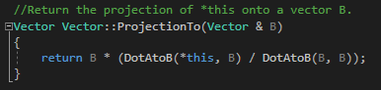
Figure 24. Vector Projection method
To make the calculation easier to view, the * operator has been overloaded to allow a vector to be scaled in a format like scalar multiplication.
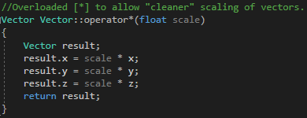
Figure 25. Overloaded * operator

Test of ProjectionTo() method
To test this method two vectors will be used, v1(3, 3, 0) between the x and y-axes, and v2(6, 0, 0) lying on the x-axis. The projection of v1’s x component onto v2 should produce a vector of (3, 0, 0).
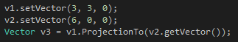
Figure 26. ProjectionTo() test
Figure 27. Result of v1.ProjectionTo(v2)
The method returned a vector to v3 with the correct x, y, z components (3, 0, 0).

Task 3 – Sphere to sphere collision detection

Class structure
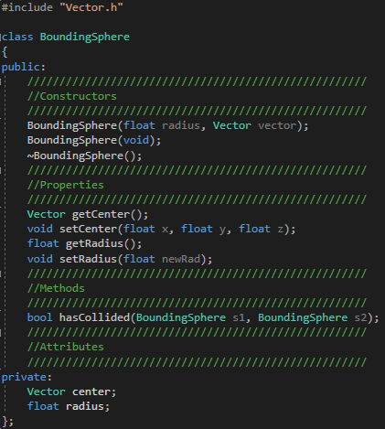
Figure 28. The BoundingSphere class
The structure of the sphere class contains a Vector to store the position of the sphere’s center point in 3D space, and a float that contains the length of the sphere’s radius.
There is one class method that checks if the two sphere objects passed into it are close enough to have collided and returns a Boolean value based on the result.

Collision Detection method
The method used to implement sphere to sphere collision takes advantage of spheres having a smooth surface with the distance from the center, the radius, being the same in all directions.
Therefore, we can see how far the surfaces of two spheres are from each other by using the following equation:
$$Dist. between {surfaces}_{ (c1, c2)}=\sqrt{{( x_{c1} - x_{c2} )}^{2}+ {( y_{c1} - y_{c2} )}^{2}+ {( z_{c1} - z_{c2} )}^{2} }-(r_{c1}+r_{c2})$$
Where the x, y, z are the center coordinates of each sphere and r is the radius of each sphere.
However, as we are only comparing distances, we can make use of the squared distance method from the earlier vector class in task 2.2 and use the sum of the circle radii squared instead.
$$Sq dist. {between}_{ (c1, c2)}=\left({( x_{c1} - x_{c2} )}^{2}+ {( y_{c1} - y_{c2} )}^{2}+ {( z_{c1} - z_{c2} )}^{2}\right)-{(r_{c1}+r_{c2})}^{2}$$
This has been implemented by checking the sumRadii² against the pToPDistanceSqd() between the two center points. If the radii of the circles are greater than or equal to the distance, then the bounding spheres are either in contact or have collided with one another.
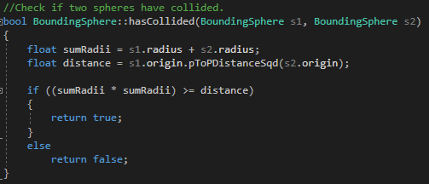
Figure 29. Collision detection method

Testing
The method was tested by creating two vectors that were separated from each other by 3. These vectors were then used to construct bounding spheres, each with a different radius.
The method was tested by using an if statement that checks the bool output from the hasCollided() method and outputs the result.
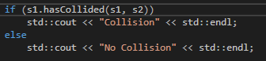
Figure 30. Test for hasCollided() method
The method was also tested by outputting the distance apart the center points and sphere surfaces were and the sum of the radii to confirm the collision.
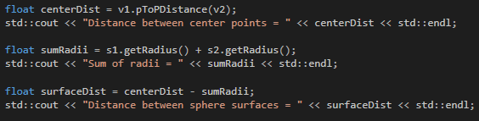
Figure 31. Further checks for collision

Test 1
The spheres were initially given a radius of 1, and a distance of 3 apart. The test should output no collision.
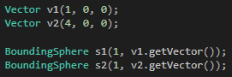
Figure 32. Sphere values in test 1
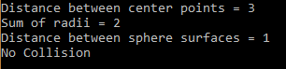
Figure 33. Collision test 1 result
The spheres have a gap between them of 1 so are not touching. The method has correctly returned “No collision”.

Test 2
The spheres were kept in the same location, but both given a radius of 2.
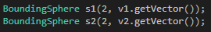
Figure 34. Sphere values in test 2
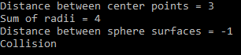
Figure 35. Collision test 2 result
The spheres are intersecting each other by a distance of 1. The method has correctly returned “Collision”.

Test 3
One sphere was given a radius of 1, the other a radius of 2.
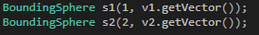
Figure 36. Sphere values in test 3
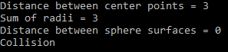
Figure 37. Collision test 3 result
There is no gap between the spheres, so they are touching. The method has correctly returned “Collision”.

References

[1] | J. Gregory, Game Engine Architecture, boca raton: CRC Press, 2018.
[2] | L. M. B. James M. Van Verth, Essential Mathematics for Games and Interactive Applications, Boca Raton: CRC Press, 2015.
[3] | J. N. Christopher Clapham, The Concise Oxford Dictionary of Mathematics, 4th ed., New York: Oxford University Press, 2013.

