Student Name: Malinka Pavlova
Student Number: 1906953
Module Title: BMSW4002
Assignment Title: Effective Team Working and Communication
Lecturer Name: Benedict Maher

Table of contents
Introduction…………………………………………3
Effective Team Working Strategy ……………….3
Communication - Description…………………….4
Models of Communication. ……………………...5
Components of Effective Communication………6
Active Listening…………………………………….6
Assertiveness………………………………………7
Personal Evaluation……………………………….8
Conclusion……………………………………….....9
References……………………………………….....9
Appendix 1…………………………………………11
Appendix 2…………………………………………14
Appendix 1…………………………………………18

Introduction
This report aims to demonstrate my understanding of effective team working and communication as well as their importance in the Health and Social Care Sector. The report discusses some of the main communication theory models as Aristotle, Berol and Shannon and Weaver. The communication in my workplace will be analysed and referring to the theories the ways of improvements will be presented.

Effective Team Working Strategy

To work effectively in a group or a team requires an understanding of how they function (SkillsYouNeed, 2020). University talks about ‘group working’, as employers use ‘team – working’. Both group and team are formed of individuals, who want to accomplish something as working together. A group is defined as numbers of people sharing something in common, who meet together in relation to their shared characteristics. A team is a number of individuals who work as one to achieve a particular task/goal, to which they are all committed (Morgan, 2017).

The members of a high performing team understand each other, support and encourage each other during the task duration. All members of such team put their egos aside to work for the good of the team. In reverse to that, if there is tough competition between the members of the team, their pride and ambition obstruct the willingness to assist others and they blame each other when failure (Morgan, 2017).

At University, working as a group for the first time, that was our problem. The pride and the ambition of one individual, the bad communication, the missing support for each other, as well as having not enough information of each member’ work before the presentation, and lack of understanding and support from the group leader resulted in that we did not perform well as a team.

How could we have improved? For a leader, we should choose someone who can bring people together, not someone who has good computer skills. The arguments between me and the leader should be avoided or tried to be constructive. I should lower the volume of my tone and allowed others to present their views and arguments. After all, I compromised and accepted one of another members idea for the good of all. However, we lost sufficient time in arguing.

We should meet all together to discuss the project. We set a WhatsApp group to communicate, therefore it did not work well as we did not respond on time. We did not give support to the team member, who was behind the schedule. Instead of that I was pressing her to finish on time her part.

In our defence, we were very confused as our lecturer was giving us contradicting information. We also did not have sufficient time to establish as a group and to know each other well.

The conflict we experienced is a personal/relational type. The root sources of this conflict type are self-image, identity, and lack of respect. We used a compromise strategy to resolve the conflict. All group members were given up something in favour of compromise. It resulted in a solution that did not please much any of us, but it did not offend or upset anyone too much (SkillsYouNeed, 2011-2020).

What could be the difference if we work as a team? If we work as a team, most of the conflicts could be avoided. In a team-working scheme, the leader is a responsible and understanding, with knowledge and experience. The members respect him. Working all day together, the team has more time to develop its dynamic structure and good communications between themselves. In case of conflict, the appropriate approach would be collaboration (SkillsYouNeed, 2011-2020).

Communication - Description
Communication can be described as exchanging ideas, thoughts and information resulting in mutual understanding between two or more individuals, or between two or more organisations. It requires a sender, a receiver and a message transmitted by channel. The idea is encoded by the sender as words, gestures, pictures, then he selects the communication channel (verbal or nonverbal) for the receiver to access them. The channels are telephone, voicemail, e-mail, online, letter, media. Receiving the message, the recipient decodes those symbols to be able to understand the sender. It is considered meaningful communication when the receiver correctly understands the sender (Griffiths and Dunham, 2015).

Models of Communication
There are various models of communication: Aristotle model, Berol’s model, Shannon and Weaver model, Schramm’s and more (MSG, 2020).

The first model of communication was designed by Aristotle. According to his model, the sender plays the leading, active role of the communication, while the receiver role is passive. The sender carefully prepares the thoughts and puts them into words to impress the receiver (listener) to respond and react accordingly. Aristotle’ model is the most common one, used in public speaking, lectures and seminars (MSG, 2020).

Berol’s model of communication is taking in consideration the emotional aspect of the massage. The sender converts his thoughts into words and creates a massage. The process is called Encoding. The message is sent to the recipient by the medium. The receiver receives the message and tries to understand and respond. The process is called Decoding. To have a smooth conversation the speaker and the listener have to have the same level of understanding, which in a real situation that is not always happening (MSG, 2020).

The most popular model is the Shannon and Weaver model. The sender is called the Source of information. From his brain, that information is transmitted to the mouth and comes as a signal, reaches the recipient alongside some noises and distractions. The recipient passes the message to its final destination or individuals (MSG, 2020).

Components of Effective communication
Components of effective communication are active listening and assertiveness (Griffiths and Dunham, 2015).

Active Listening
Listening actively is fully concentrating on what is being said rather than listening passively. It involves all our senses. We need to show interest non-verbal by maintaining eye contact, smiling, or verbal by saying a few words to let them speaker be encouraged to continue. It will make the speaker feel comfortable, and communication goes easier (SkillsYouNeed, 2011-2020).

The listener should stay neutral and in a non-judgmental manner, trying not to take sides or opinions at least at the beginning of the conversation. Actively listening also involves patience. We need to give the speaker an adequate time to develop his thoughts and feelings (SkillsYouNeed, 2011-2020).

Verbal signs of active listening are positive reinforcement, remembering, questioning, reflection, clarification and summarisation. As listeners, we can say words or phrases such as ‘yes’, or ‘good’, or ‘indeed’, although it is better to explain why we agreed. Remembering the key points of the message or the speaker’s name is part of active listening. By asking relevant questions and/or making a statement we demonstrate that we pay attention to what the speaker has said (SkillsYouNeed, 2011-2020).

Reflecting or paraphrasing what the speaker said can reinforce the massage and demonstrate that we understand his thoughts. Clarifying to insure that we correctly understand the message by asking open questions. Summarising the main points of the received message and repeating them back to the speaker gives him a chance to correct if we did not understand him (SkillsYouNeed, 2011-2020).

Assertiveness
Assertiveness is the ability to express ourselves honestly and directly without dishonour or disrespect others (Griffiths and Dunham, 2015).

Assertiveness is the most important skill for handling conflict. In our interactions with others, at work, at university, with customers, employers, colleagues, being assertive helps to express ourselves clearly, openly without undermining the rights of others or our own. Being assertive enables us to act in our best interests, and to stand up for ourselves without undue anxiety (SkillsYouNeed, 2011-2020).

How do we express the assertiveness? The first step is to describe our thoughts about a particular situation – I think. Secondly, we have to describe our feeling about that situation – I feel. Finally, we make a respectful request – I want (Griffiths and Dunham, 2015).

Being assertive helped me to resolve a situation at my previous workplace. I had a disagreement with our subcontractor. His work was not done according to the project’ requirements. I talked to my boss, describing the situation - I think. I expressed my feeling, saying that I was not happy with his report (the job) - I feel. And we had a meeting to specified what I wanted to be changed - I want. I was very confident about the contract requirements. My assertive behaviour convinced my boss and the subcontractor, and they agree with my suggestion. As a result, our work was accepted by the Authorities at once without any comments.

Personal Evaluation
Working as an interpreter in the Health Sector I am successfully practising my communication skills. In those communications, I am in the position of a recipient. I receive a message from the patient in Bulgarian or Russian language and pass it to the doctor, translated in English. Then I receive a message from the doctor in English and send the translated message in Bulgarian to the patient.

While giving presentations I use Aristotle’ model of communication. I am a very confident speaker and an active listener. I pay attention to the audience and use non-verbal ways to communicate with them. In my work as an interpreter, the communication model I use is Berol’s model, as in this model the emotional aspect of the communication is considered. With me being the interpreter, the conversation between the doctor and the patient is going smooth, and the language barrier is eliminated.

I have good interpersonal skills (Appendix 1). I have a meaningful and successful relationship with people. I understand them, and they understand me. I choose to study and further to develop a career in Health and Social Care as I am capable of dealing with different types of people regularly.

My listening skills are classed as good (Appendix 1). I communicate with others with verbal and non-verbal signals. Nevertheless, I need to practise my listening skills and avoid picking bad listening habits.

My emotional intelligence is above the average (Appendix1). I understand well other people and deal well with my emotions and the emotions of others (Appendix 2 and 3). Working in Social Care will be an enjoyable and successful career, particularly in counselling people when they experience problems.

My verbal communication skills are above average (Appendix1). I use appropriate language and have knowledge when to talk and also when not to talk. I express myself well to others. Nevertheless, sometimes people wrongly understand my message, based on the tone I used. The way to improve is to pay attention to cross-culture differences and trying to keep the tone of my voice lower.

I communicate well in group/team situation, and my skills are above average (Appendix 1). As a confident person, I feel comfortable to contribute to group settings. I feel assertive when expressing my thoughts and ideas to other team members. However, in case of disagreement, I take time to understand the views of the others and if they have better ideas, I agree with them.

Conclusion
This report analysed my communicational skills and my experience working in a team. Studying the theories of communication and models and analysing their application in practice gave me knowledge and awareness of my barriers of communication and the ways to avoid or prevent them. I am successfully using the models of communication depending on the occasion. To be a good leader, working in a team, I have to be more assertive. The study on assertiveness gave me knowledge of how I can avoid the common barriers of communication. My abilities to work with people is giving me opportunities to have a successful and enjoyable carrier in Health and Social Care Sector.

Reference
Griffiths, B.A. and Dunham, E.B. (2015), ‘Communication’, in Maund, A, Schriek, M. and Tinkler, P. Certificate in Higher Education: Skills forWorkplace Student Yeardbook; Chapter 3. London: Sage Publication, pp 45-65

Juneja, P. (2020), Communication Models. Available at: https://www.managementstudyguide.com/communication-models.htm (Accessed: 2 January, 2020).

Morgan, P. (2016) The Business Student’s Guide to Study and Employability. London: Sage Publication

SkillsYouNeed (2011-2020) Active Listening, Available at: https://www.skillsyouneed.com/ips/active-listening.html (Accessed: 3 January, 2020).

SkillsYouNeed (2011-2020) An Introduction to Conflict Resolution, Available at: https://www.skillsyouneed.com/ips/conflict-resolution.html (Accessed: 1 January, 2020).

SkillsYouNeed (2011-2020) Assertiveness, Available at: https://www.skillsyouneed.com/ps/assertiveness.html (Accessed: 2 January, 2020).

SkillsYouNeed (2011-2020) Barriers to Effective Communication, Available at: https://www.skillsyouneed.com/ips/barriers-communication.html (Accessed: 2 January, 2020).

SkillsYouNeed (2011-2020) Communication Skills, Available at: https://www.skillsyouneed.com/ips/communication-skills.html (Accessed: 1 January, 2020).

SkillsYouNeed (2011-2020) Conflict Resolution, Available at: https://www.skillsyouneed.com/ips/conflict-resolution.html (Accessed: 3 January, 2020).

SkillsYouNeed (2011-2020) Team-Working, Groups and Meeting, Available at: https://www.skillsyouneed.com/ips/teams-groups-meetings.html (Accessed: 3 January, 2020).

Appendix 1

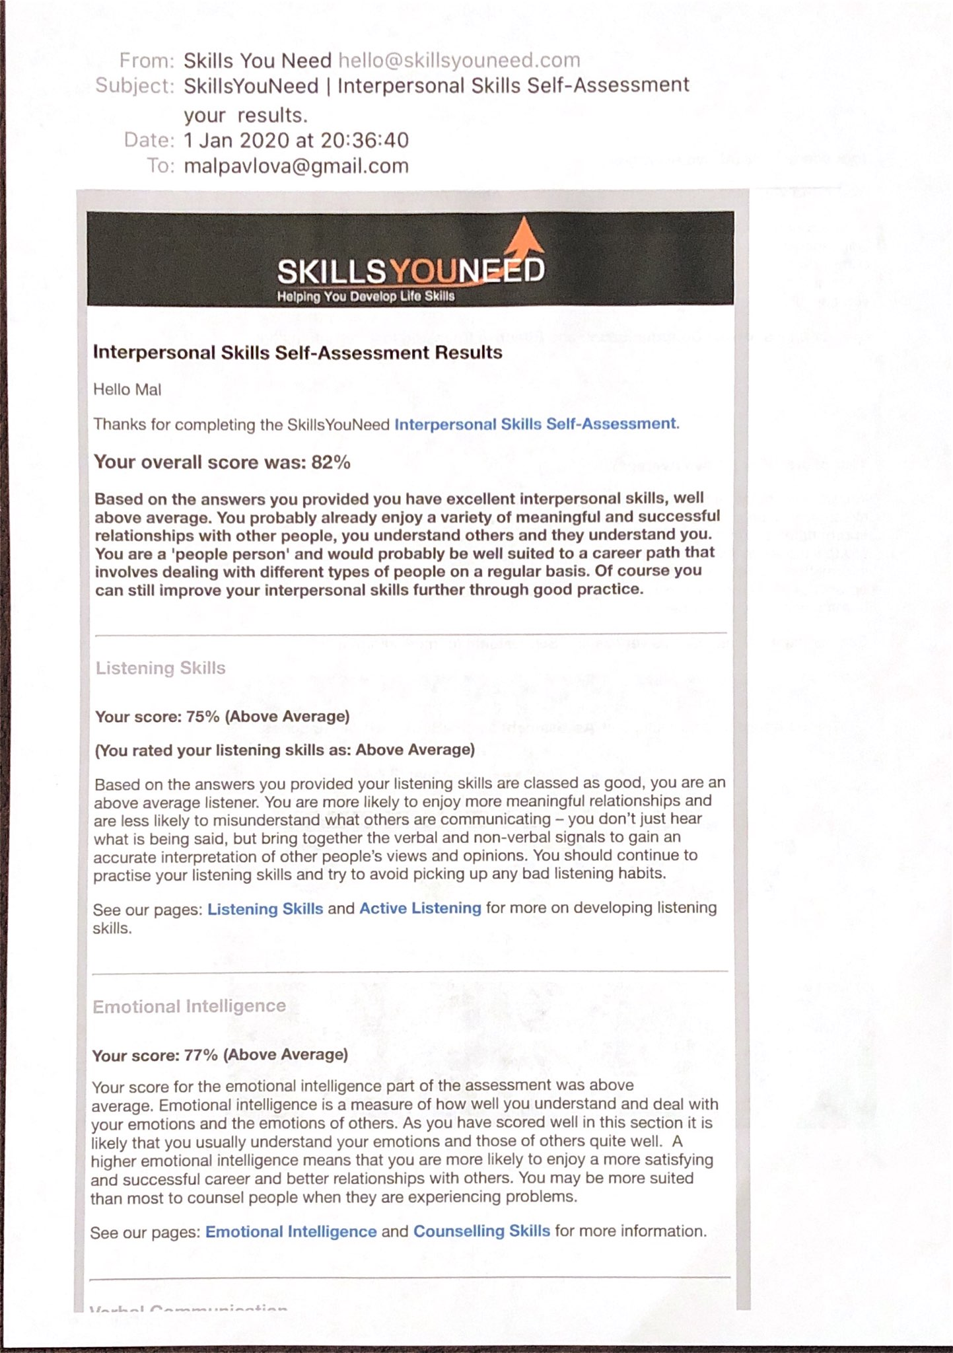
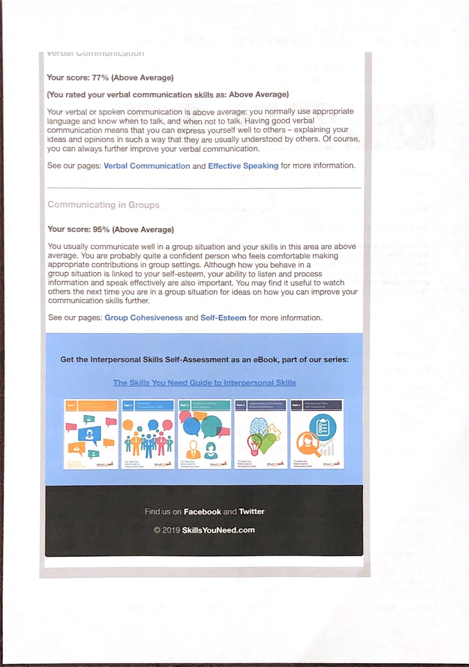

Appendix 2

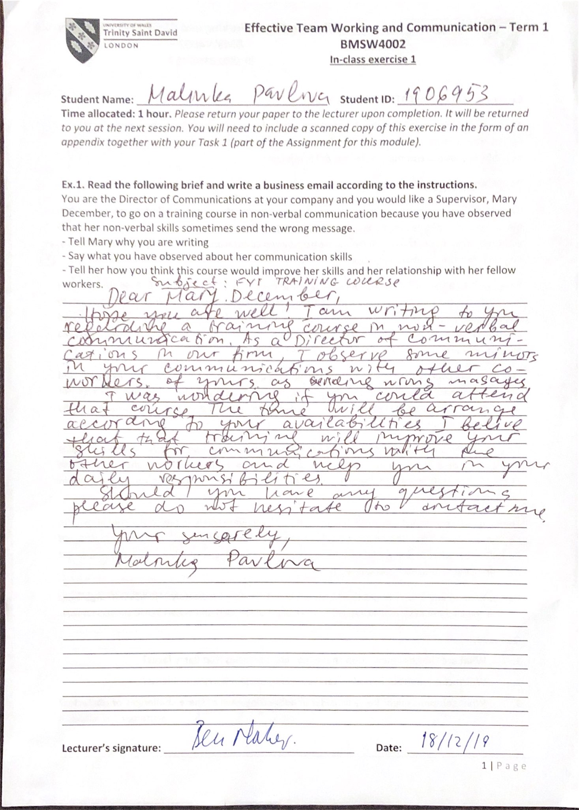
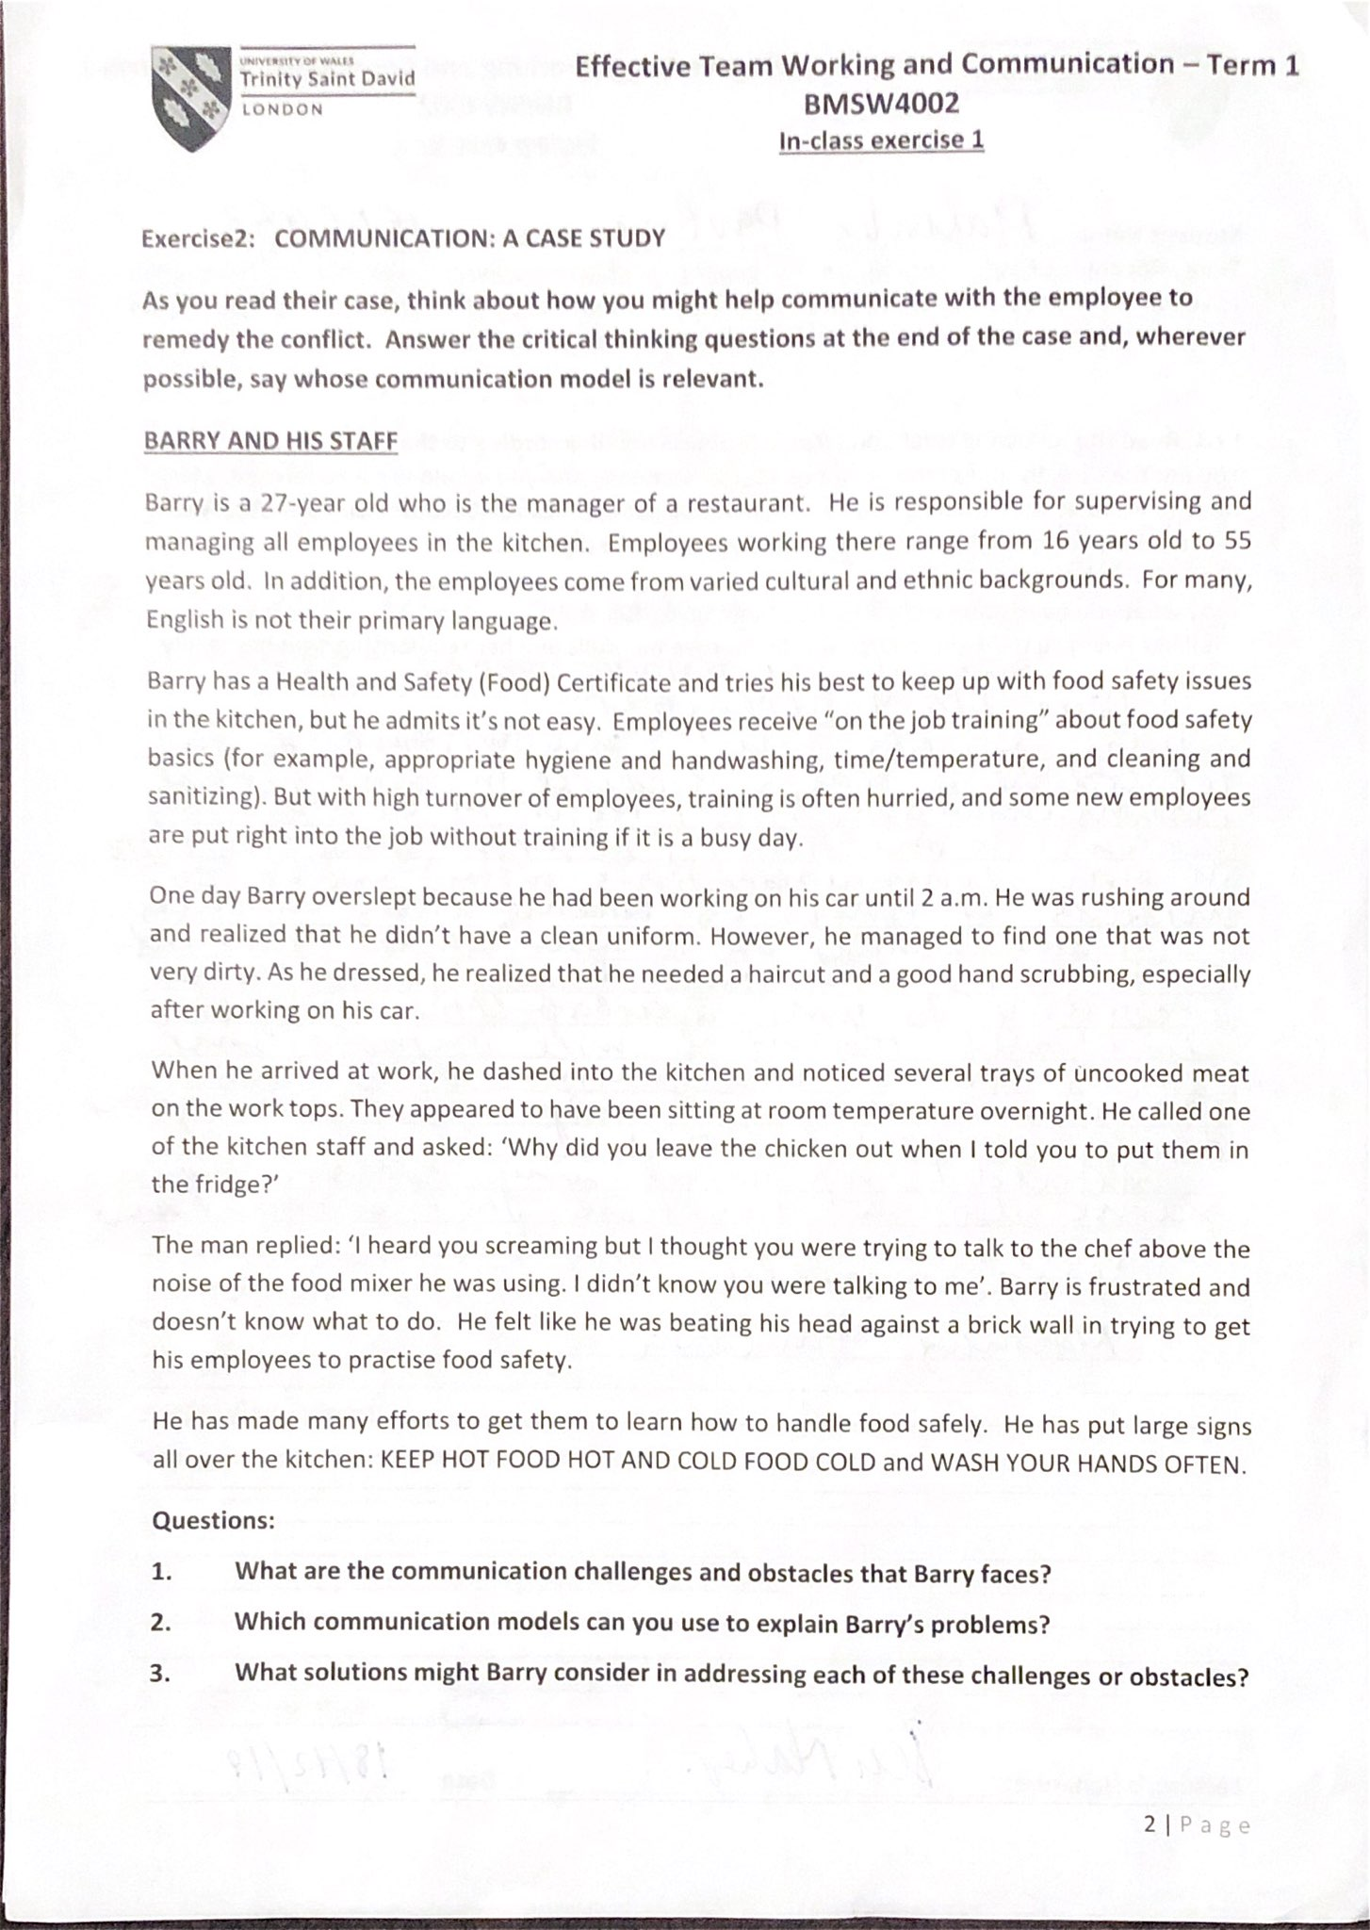
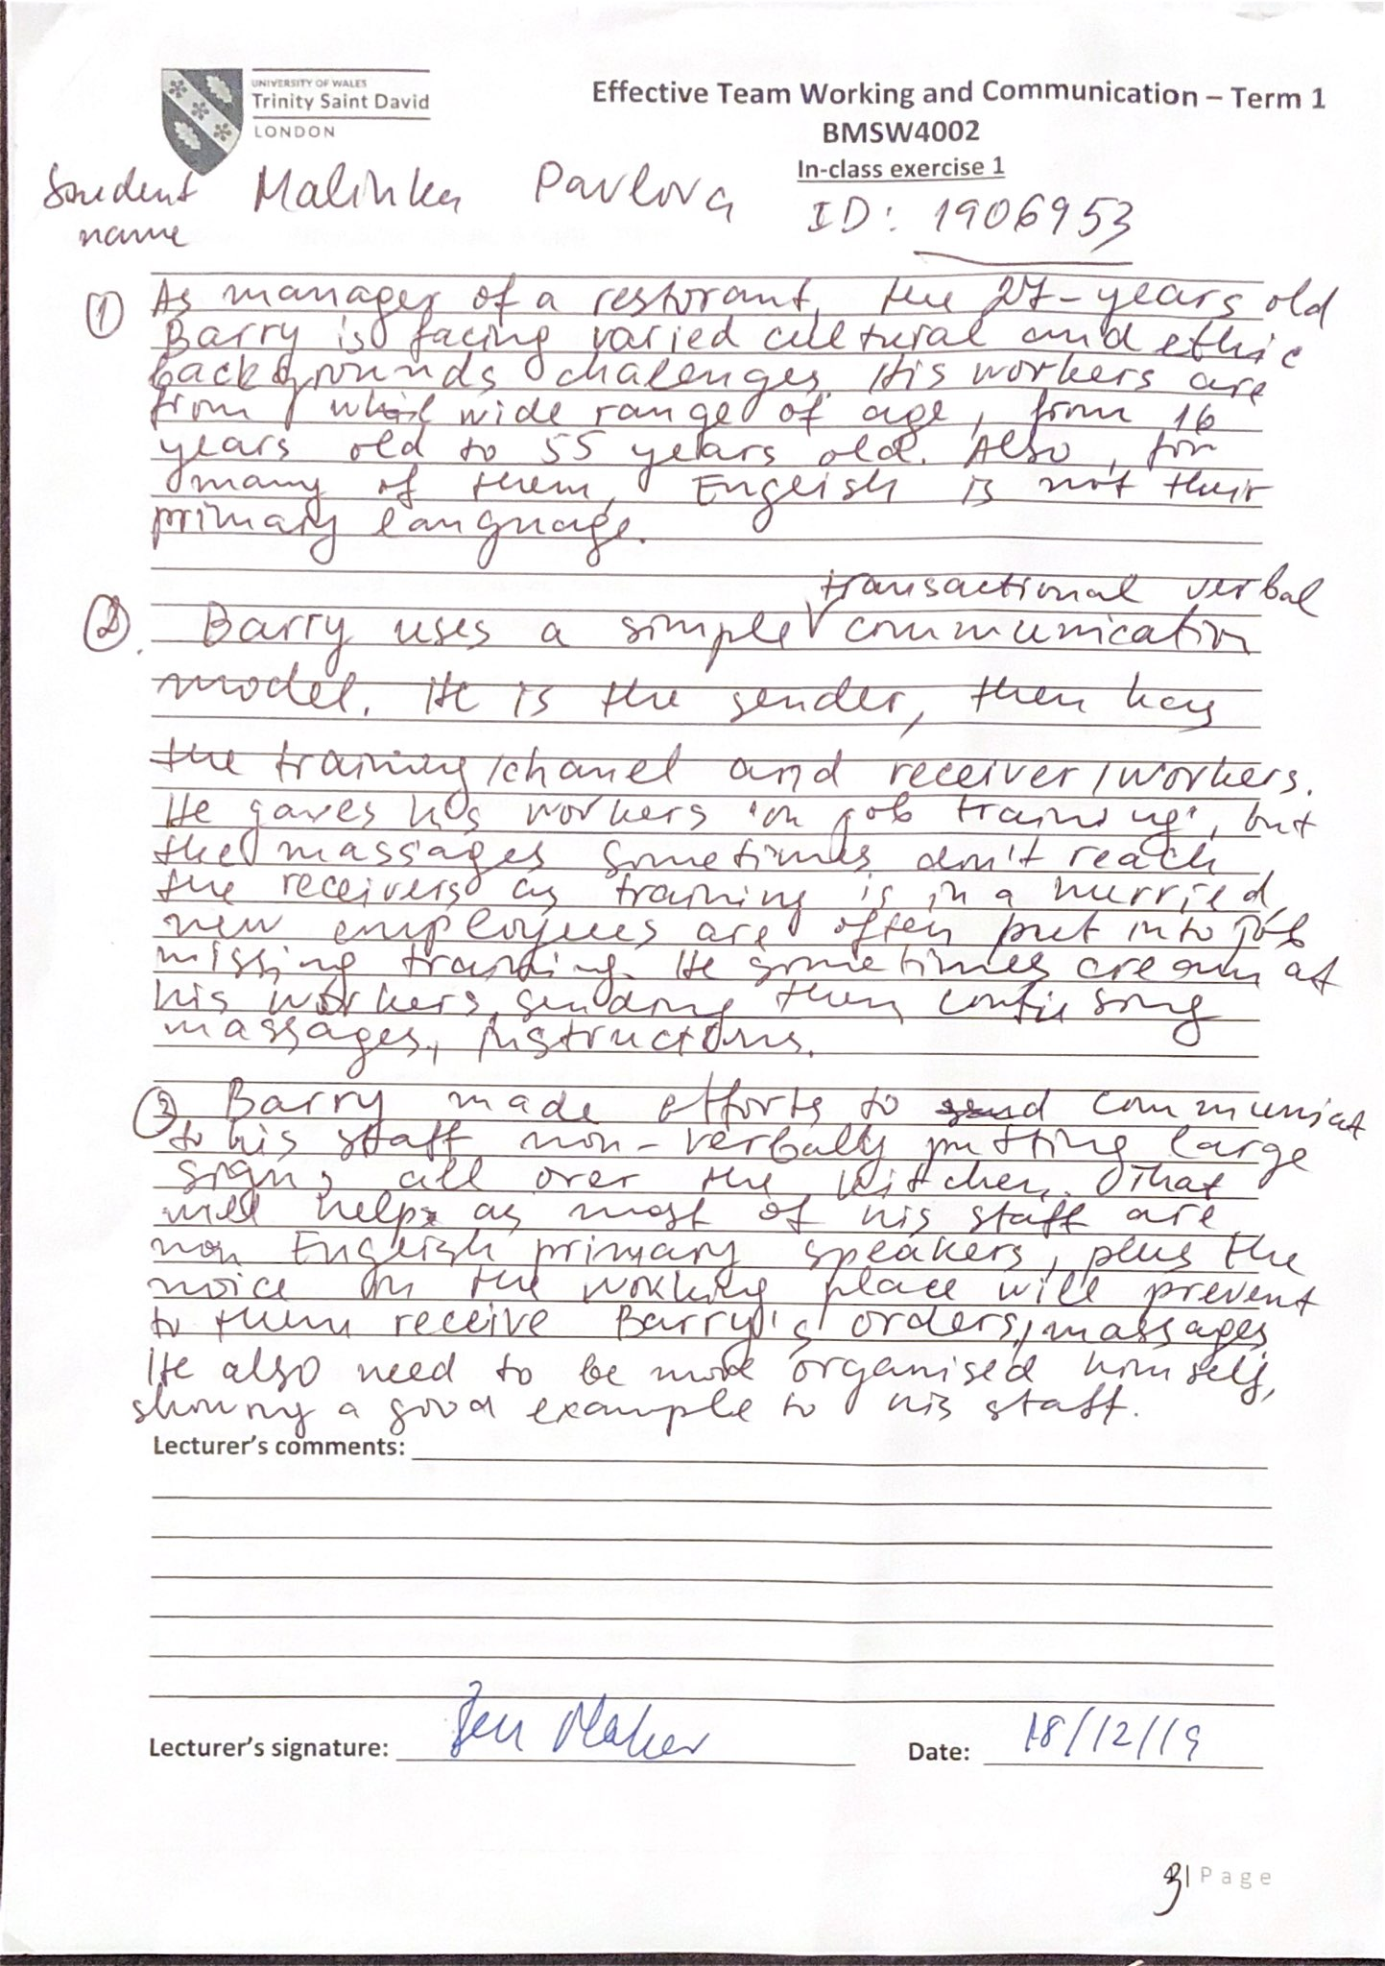

Appendix 3


