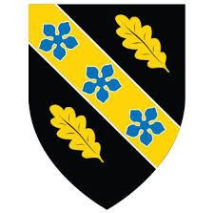

STUDENT NAME: ROMNY OZUNA LEON
STUDENT ID: 2512062
TITLE: Business Plan
MODULE NAME: Business and Entrepreneurship
MODULE CODE: LCLM4006
TEACHER: SAID USMAN

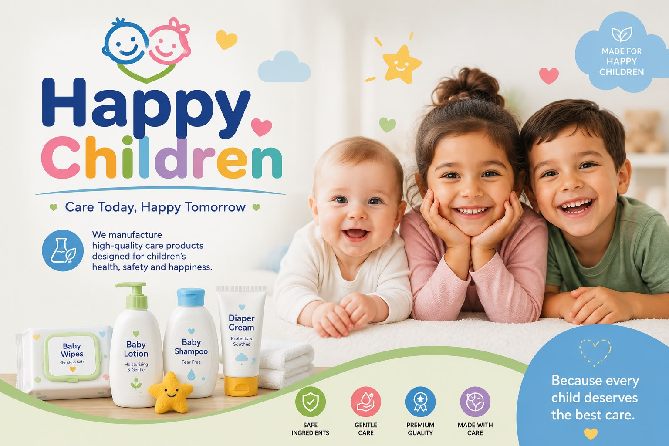

1. Executive Summary

Happy Children is a new startup focused on the manufacturing and retail of natural personal care products designed specifically for children and teenagers. The main objective of the company is to provide a safe, high-quality, and eco-friendly alternative to traditional baby care items by using all-natural ingredients, primarily Aloe Vera.

The company's value proposition centers on offering chemical-free products that protect sensitive skin at affordable prices. Our business model directly addresses modern environmental and social concerns by committing to sustainable operations. According to the British Business Bank (2024), businesses that adopt sustainable and responsible practices are more likely to build customer trust and attract investment. Therefore, Happy Children commits to using 100% recyclable plastic packaging and participating in community projects such as beach clean-ups and tree-planting initiatives.

To launch operations, Happy Children requires an initial investment of £100,000. This funding will be used to secure raw materials from sustainable suppliers on the Isle of Wight, purchase specialized production equipment, and execute a targeted digital marketing strategy. The brand aims to achieve a strong market position within its first year, expanding distribution from our online platform into local pharmacies, supermarkets, and specialized baby stores.

2. Table of Contents
Contents
1. Executive Summary 1
2. Table of Contents 2
3. Overview of the Business Idea 2
4. Market Research (PESTEL Analysis) 5
5. Competitive Analysis 5
6. Marketing Communications 6
7. Financials 7
8. Reference List 8

3. Overview of the Business Idea

Product and Service Offering
Happy Children will produce and trade a premium range of natural skincare and hygiene products for children. The initial product line includes:
- Liquid soaps in fun, child-friendly shapes to encourage good hygiene habits.
- Gentle shampoos and conditioners.
- Moisturizing skin creams and soothing diaper creams.

All products will be manufactured using high-quality Aloe Vera sourced from specialized organic growers on the Isle of Wight to guarantee purity and minimize the carbon footprint associated with long-distance transport.

Legal Format
The business will operate under the legal structure of a Private Limited Company (Ltd.) registered in the UK. According to official guidance from Companies House (2025), this format is ideal for new entrepreneurs because it provides limited liability, which protects the founders' personal assets against business debts. It also establishes a professional corporate image that is highly attractive to potential investors and allows for the easy distribution of shares among future business partners.

Management Structure

Organizational Chart of Happy Children
Manager
Responsible for business planning and management systems.

Administrative Assistant
• Responsible for financial management, inventory control, and customer service.
Marketing Specialist
Responsible for social media, sales, and promotional strategies.
Production Supervisor
• Responsible for quality control and ensuring that the correct processes are followed in the manufacture of cosmetics.

4. Market Research (PESTEL Analysis)

- Political: Happy Children will comply with UK trade regulations and health standards required for manufacturing and selling child cosmetics.
- Economic: Inflationary pressures in the UK have caused a general rise in raw material and manufacturing costs. Despite this, market data from Fortune Business Insights (2024) shows that the organic baby care sector is experiencing steady growth, as families prioritize health products.
- Social: There is a massive shift in consumer behavior toward health and wellness. According to Mintel (2024), UK consumers are increasingly choosing natural and environmentally friendly personal care products, especially for babies and young children.
- Technological: Using digital systems and e-commerce platforms improves production tracking and sales control, making technology an essential component for modern retail survival.
- Environmental: Environmental sustainability is a major concern for modern consumers. Happy Children addresses this by utilizing recyclable plastic packaging and joining community initiatives such as tree planting and beach cleanups.
- Legal: The UK cosmetics market is governed by strict safety standards regulated by the Office for Product Safety and Standards (OPSS, 2025). The business must secure all necessary permits and health registrations before product launch.

5. Competitive Analysis

Competitors
The market for children’s personal care is highly competitive, divided between large traditional corporations and smaller premium brands:
- Direct Competitors: Small and medium UK-based organic cosmetic brands, such as Charlie's Lab and Little Butterfly London.
- Indirect Competitors: Established global brands like Johnson & Johnson and The Honest Company.

Competitive Advantage
Happy Children stands out by bridging the gap between premium organic quality and affordability. Unlike mass-market brands, our formulas are 100% chemical-free and built around locally sourced UK ingredients (Isle of Wight Aloe Vera). Another advantage is our transparent commitment to social causes builds emotional loyalty with modern parents.

6. Marketing Communications

To build brand awareness and drive sales, Happy Children will implement a multi-channel digital marketing strategy tailored to reach modern parents in the London area:

- Social Media Campaigns: We will create engaging, educational short-form video content on TikTok, Instagram, and Facebook focusing on natural skincare and product benefits. A dedicated WhatsApp Business account will handle instant customer queries.
- E-commerce Website: A professional website will host our online catalog, allowing customers to view ingredient lists, check prices, and place online orders across London.
- Grand Opening Promotions: During the launch phase, we will partner with social media influencers and offer discounts, free samples, and promotional bundles.
- Strategic B2B Alliances: We will present our product line to local pediatric clinics, independent pharmacies, supermarkets, dermatology departments, and natural product stores.

Main Marketing Communication Goals:
- Project a corporate image based on quality, safety, and commitment to children's well-being.
- Promote our natural children's cosmetics brand throughout London.
- Ensure high visibility across both physical and online sales channels.

7. Financials

Funding Strategy
Happy Children will begin operations with an initial investment of £100,000 to cover operating costs and setup:
- Personal Savings: £50,000 (50% of total equity) provided by the founder.
- Partner Contributions: £30,000 (30% of total equity) sourced from private partners to cover opening costs.
- Bank Loan: £20,000 (20% debt) secured via a small business loan scheme for equipment and raw materials.

Budget Breakdown

Month | Jan | Feb | Mar | Apr | May | Jun | Jul | Aug | Sep | Oct | Nov | Dec | Totals
Fixed cost | 3000 | 3000 | 3000 | 3000 | 3000 | 3000 | 3000 | 3000 | 3000 | 3000 | 3000 | 3000 | 36000
Variable cost | 2100 | 1100 | 1094 | 1000 | 2000 | 2250 | 1700 | 3000 | 1900 | 3100 | 2570 | 2100 | 23914
Total | 5100 | 4100 | 4094 | 4000 | 5000 | 5250 | 4700 | 6000 | 4900 | 6100 | 5570 | 5100 | 59914
Sales | 9000 | 7800 | 6900 | 4800 | 7500 | 4700 | 7200 | 7700 | 6400 | 5804 | 7800 | 6900 | 82504
Profit or Loss | 3900 | 3700 | 2806 | 800 | 2500 | -550 | 2500 | 1700 | 1500 | -296 | 2230 | 1800 | 22590
Unexpected | 1158 | 1158 | 1158 | 1158 | 1158 | 1158 | 1158 | 1158 | 1158 | 1158 | 1158 | 1158 | 13896

START-UP | COST
Machinery and Equipment | 10000
Raw Material | 2700
Office Furniture | 3500
Computers and Printer | 2000
Website Design | 1095
Packaging and Labels | 1895
License and Permits | 1500
Adaptation of the Premises | 3500
TOTAL | 26,190
TOTALS
Fixed Cost | 36000
Variable Cost | 23914
Opening Expenses | 26190
Unexpected | 13896
TOTAL | 100,000

*Note: Minor net losses projected in June (-£550) and October (-£296) are caused by seasonal demand shifts and inventory restocking, which are fully buffered by our £13,896 contingency reserve.

8. Reference List

British Business Bank (2024). Small Business Finance Markets Report 2024. Available at: https://www.british-business-bank.co.uk [Accessed 24 July 2026].

Companies House (2025). Set up a private limited company. Available at: https://www.gov.uk/limited-company-formation [Accessed 24 July 2026].

Fortune Business Insights (2024). Baby Care Products Market Size, Share & Industry Analysis, 2024-2032. Report ID: FBI101234. Available at: https://www.fortunebusinessinsights.com/baby-care-products-market-101234 [Accessed 2 July 2026].

Office for Product Safety and Standards (2025). Cosmetic Products Enforcement Regulations Guide. London: Department for Business and Trade.

Mintel (2024). Natural and Organic Personal Care – UK. London: Mintel Group Ltd.

9. Conclusion
This business plan demonstrates that Happy Children has the potential to become a successful business in the UK children’s personal care market. The growing demand for natural and environmentally friendly products creates an opportunity for the company to offer safe, affordable and high-quality alternatives for parents. Although the business may face challenges such as increasing production costs and strong competition, careful financial planning, effective marketing strategies and a commitment to sustainability provide a solid foundation for future growth. Overall, Happy Children presents a realistic and achievable business idea with the potential to build a trusted brand while contributing positively to both consumers and the environment.

