

MASTER OF BUSINESS ADMINISTRATION
Module: Strategic Management
Module Code: LCMB7003
Assessment Component: Individual Report
Title: “Evaluating the Strategic Position and Competitive Advantage of Apple's MacBook Air in the UK Laptop Market”
Lecturer: Amare Desta and Ghulam Mujtaba

Student Name: Jubel Ahmed
Student ID Number: 2432469

Word Counts: 5350

Acknowledgment
USE OF GENERATIVE AI IN ASSESSMENT

RESEARCH | For this assessment, you can use Generative AI to support you in research and data analysis. | Yes ☐  No ☒
STRUCTURE | For this assessment, you can use Generative AI to support you in structuring your submission, including creating a draft argument structure, identifying parts  and headings, etc. | Yes ☐  No ☒
PROOFREADING | For this assessment, you can use Generative AI to check your own text/creation for grammatical and syntactical mistakes, including getting suggestions to  rephrase your work. | Yes ☐  No ☒
WRITING | For this assessment, you can use Generative AI to create text for submission. | Yes ☐  No ☒
CREATIVE | For this assessment, you can use Generative AI to create creative materials, such as images. | Yes ☐  No ☒
PROGRAMING | For this assessment, you can use Generative AI to create and check code. | Yes ☐  No ☒
NONE | For this assessment, you are not allowed to use any type of Generative AI support. This includes research support, structure support, writing/proofreading  support and creative support. | ☐

Table of Contents
Introduction 4
Section 1: Strategic Analysis of Apple's MacBook Air in the UK Laptop Market 5
1. Organisational Context and Overview 5
2. External and Internal Analysis 7
2.1 External Analysis: PESTEL 7
2.2 Internal Analysis: VRIO 9
2.3 SWOT Analysis 11
3. Comprehensive and Holistic View of the Organisation 14
3.1 Corporate Social Responsibility (CSR) Strategy 14
3.2 Balanced Scorecard 15
4. Strategic Choices and Implementation 18
4.1 Business-Level Strategic Choices 18
4.2 Recommended Strategy 18
4.3 Implementation challenges and mitigation: 19
Section 2: Reflection 21
Description 21
Feelings 22
Evaluation 22
Analysis 22
Conclusion 23
Action Plan 23
Conclusion 24
References 25

Introduction
This report is the strategic management consultant's report to Apple regarding the competitive landscape of Apple's MacBook Air in the UK laptop market. The analysis starts with an introduction to the organisation with respect to its background, mission and business model and then proceeds to analysing the external and internal environment using the PESTEL, VRIO and SWOT frameworks. The report then focuses on the business as a whole by examining the corporate social responsibility (CSR) strategy in place and the balanced scorecard's four performance perspectives. On the basis of this evidence, the report analyses the strategy options of Apple at the business level and suggest a strategy using Porter's Five Forces and Ansoff's matrix. Implementation challenges and mitigations are also explored. The report ends with a reflective piece of writing to acknowledge the research and writing process with the Gibbs Reflective Cycle.

Section 1: Strategic Analysis of Apple's MacBook Air in the UK Laptop Market

1. Organisational Context and Overview
Company Overview
Apple Inc. was established in California, USA in 1976 and it is currently a global technology firm with total net sales of $416.2 billion in 2025/2026 (2025/2026 Financials available on Apple Inc., 2025). Apple makes, distributes and sells a wide variety of products, and in the UK has had a presence for many years, with all the retailers and online platforms being well established.
Mission and Vision
The aim of Apple is to deliver the most exciting user experience for its customers by means of hardware, software and services, and this has always driven Apple's product designs, so it does now. Its vision is founded on this purpose and is to continue to be the most trusted and admired tech brand in the world for design and usability, not price competing.
Business Model and Product Focus
The concept of the Apple business model is tightly aligned hardware with software and service, sold in its own stores, online and via a vast network of authorised stores and retailers in the UK. This report will only focus on the specific product in the UK market, the MacBook Air - Apple's line of thin and light laptops, which was last updated to M5 in March of 2026 (Apple Inc., 2026a; Apple Inc., 2026b). The MacBook Air is available in the UK in two sizes, 13-inch and 15-inch, and comes in from £1,099 and £1,299 respectively, the lightest MacBook is 1.23 kg with up to 18 hours battery life (Apple Inc., 2026a). The narrowing follows the above-mentioned assignment brief, because the Apple product is sold in many countries and by a single product, a more detailed and precise strategic analysis, based on the existing, UK-relevant evidence, is permitted.

Industry, Competitors, and Market Position
The report concentrates on MacBook Air in the branded laptop retail market in the United Kingdom. The UK laptop market is big, mature and very competitive as Lenovo, HP, Dell and Asus vie for share of the market, so design, software integration and brand loyalty are key areas that can win over customers. Overall, Apple's shipments of Macs grew 21.3 per cent year on year to 6.4 million units (9.4 per cent of the worldwide PC market) behind Lenovo, HP and Dell (Omdia, 2025). In fiscal year 2025, Apple's global Mac segment (which includes the MacBook Air) accounted for $33.7 billion in net sales, a 12 per cent increase from the previous year (Apple Inc., 2025).
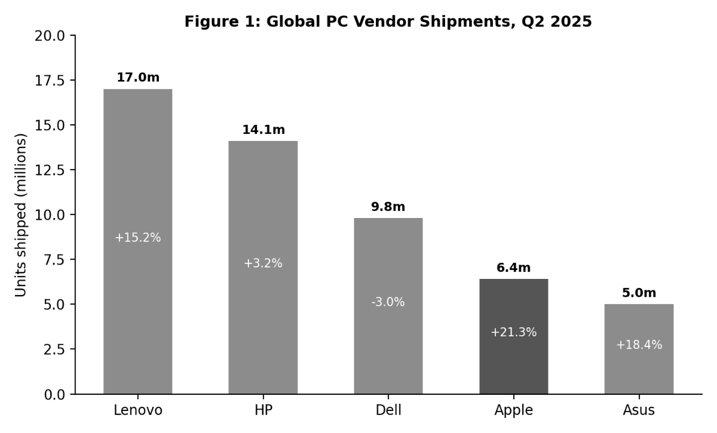

Figure 1: Global PC Vendor Shipments, Q2 2025 (Omdia, 2025)
Although the company is not yet as big as Lenovo, HP and Dell in terms of numbers of units sold, Apple enjoyed the greatest year-on-year increase in sales from its top ten PC vendors (as seen in Figure 1) in Q2 2025 (Omdia, 2025). The surge of sales growth is indicative of the belief that Apple is making inroads in a competitive market, which is examined in more detail in the next few sections.

2. External and Internal Analysis

2.1 External Analysis: PESTEL
A PESTEL framework is a helpful environmental scanning instrument to recognize external factors that influence a company's strategy (Çitilci and Akbalık, 2020), usually used in conjunction with different instruments like SOAR to produce a more comprehensive framework of strategic alternatives (Muhardi et al., 2020). Applied to the UK laptop market, it emphasizes the things that are most important to Apple's MacBook Air.
Political factors: Large technology corporations, such as Apple's, have come under public and government investigation on their tax strategies in Europe, and bad news can affect a corporation's reputation even if the tax position is perfectly legal (Baudot et al., 2020). Trade policy is also a live political issue, as tariff regimes on goods produced elsewhere in the world are constantly evolving, and continue to wreak uncertainty in global PC supply chains, despite the exemption of laptops for the time being (Omdia, 2025).
Economic factors: The global PC market rose sharply during the year to Q2 2025, as total shipments grew 7.4 per cent to 67.6M, including a surge from business customers as they rush to upgrade their old PCs to support Windows 10 end of support (Omdia, 2025). Multibillion dollar Apple saw a bigger recovery, with shipments increasing by more than 21 per cent, though increasing memory and component costs are an economic challenge for the entire industry, and could result in hikes in laptop prices in the near future, including for the MacBook Air.
Social factors: Adults in the UK still use the internet in their day-to-day lives extensively, with 94 per cent saying they have internet access at home, and 32 per cent of adults using laptops more frequently than smartphones to complete tasks that may be difficult on a mobile device, for example, filling in forms and comparing products (Ofcom, 2025). Some UK internet users are now using only a smartphone to go online, with over 18 per cent having done so, compared to 12 per cent in 2019, making portability, ease of use and design even more crucial for a top laptop brand to keep new users on board in the UK (Ofcom, 2025).

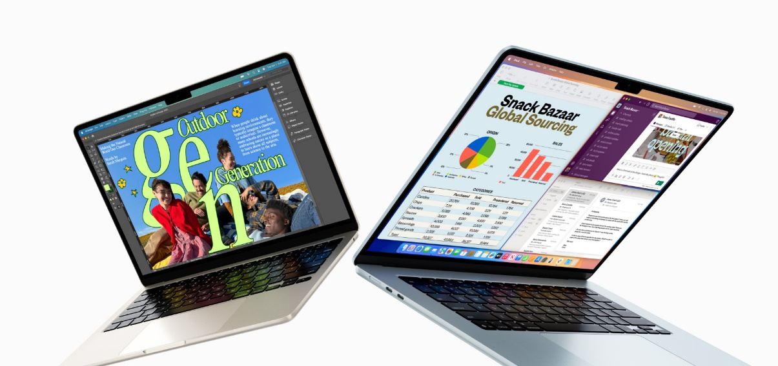
Technological factors:

Figure 2 Apple's MacBook Air (Apple Inc., 2025)

Apple's shift to its own silicon will change the Mac lineup, and Apple's latest MacBook Air with the M5 chip delivers up to 3.8 times speedup on AI tasks compared to a PC laptop with Intel's Core Ultra X7 chip from the same category, according to Apple Inc. (2026a). That's a continual chip development that puts Apple one step ahead of the other players who are based on third-party chips, and it's one of the key points of the MacBook Air's appeal to UK customers. The rate of chip upgrades also provides short competitive life for any particular chip, and Apple has to continually pour millions of dollars into research and development to assail the competition.
Legal Factors: UK and EU regulations pertaining to product safety, reparability, and data protection remain significant in influencing laptop design, purchase and maintenance (Prete et al., 2026). Hardware companies, including Apple, must now be mindful of batteries and components that make access and facilitating easy — a new compliance rule for future MacBook Air designs already coming under fire in the name of the right to repair (Hussein et al., 2024).
Environmental factors: Apple has prioritized using recycled materials in its products and a more circular economy in its devices, and the MacBook Air now has a 55 per cent recycled content by weight, is produced using 50 per cent renewable electricity, and is shipped in 100 per cent fibre-based packages, in addition to its expanding refurbished and trade-in programmes, which extend the life of hardware (Apple Inc., 2026a; Schoordyk, 2026). This type of environmental activity has become an expectation of customers in the UK laptop market, not an option, and is also aligned with Apple's overall sustainability goals outlined in this report.
Table 1: PESTEL Analysis of Apple's MacBook Air in the UK Laptop Market
PESTEL Factor | Key UK Issue
Political | Tax scrutiny in Europe; tariff and trade policy uncertainty affecting import costs
Economic | Global PC shipment growth (+7.4%) alongside rising memory and component costs
Social | High UK internet access (94%) but rising smartphone-only browsing (18%) shifting device use
Technological | Custom Apple silicon (M5 chip) driving performance and battery life gains
Legal | Right-to-repair rules, product safety, and data protection compliance
Environmental | Recycled materials, carbon reduction targets, and growing refurbished/trade-in programmes

2.2 Internal Analysis: VRIO
It is assessed here if Apple's internal resources can provide the MacBook Air with any sustained competitive advantage over competitors in the UK by examining whether each is valuable, rare, hard to imitate and well organised (VRIO framework) (Pan, Chen and Zhan, 2019).
Custom Apple silicon: Apple's own M-series chips are giving the MacBook’s Air a performance and battery life edge that has transformed the rest of the Mac world (Harris et al., 2020). According to Apple, with the latest M5 MacBook Air, AI tasks can be as much as 9.5 times quicker than the original M1 MacBook Air (Apple Inc., 2026a). It is a valuable asset, scarce in laptop manufacturers that still use third-party chips, and hard to copy easily as it takes many years to invest in the chip design and also have a tight hold on both the hardware and software components. Apple has very tightly coupled this chip strategy around their own product roadmap, so it fulfils all the 4 VRIO criteria.
Integrated hardware and software design: Product design at Apple tightly connects hardware, operating system, and services, a specific method it uses to achieve a competitive edge that has been noted (Barley et al., 2020). It is also tough to replicate for rivals as it requires a control over both the physical product and software operating on it, which most UK laptop rivals don't have to the same extent as the company has mentioned it is using a separate OS provider, like Microsoft.
Ecosystem and switching costs: Customers who have other Apple devices like their iPhone or iPad are provided additional convenience when the MacBook Air can integrate features like Continuity and iCloud and research on the importance of digital ecosystems for loyalty suggests that this leads to higher repeat purchase rates as well as fewer intentions to switch to a competitor (Son et al., 2020). This "ecosystem effect" can be beneficial and reasonably unique as developing a comparable hardware/software ecosystem would take competitors years.
Internal capabilities and supply chain: Apple's size provides power to its component vendors and contract manufacturers, as well as purchasing power with its brand power, which has been cited as a key contributor to its competitive advantage (Hong, 2025). A focus on investment in supply chain digitalisation has also been connected with better financial performance where this is combined with sustainability objectives, which is beneficial for Apple in controlling cost and delivery at scale across a large and complex global supply chain (Huang et al., 2026). Overall, the VRIO Analysis indicates that Apple's biggest strengths are with custom silicon and its integration of its network, these are valuable to Apple, and are both rare and difficult for UK competitors to duplicate quickly.

Table 2: VRIO Analysis of Apple's Key Internal Resources
Resource | Valuable | Rare | Costly to Imitate | Organised | Competitive Implication
Custom Apple silicon (M-series) | Yes | Yes | Yes | Yes | Sustained competitive advantage
Integrated hardware/software design | Yes | Yes | Yes | Yes | Sustained competitive advantage
Device ecosystem and switching costs | Yes | Yes | Partially | Yes | Temporary to sustained advantage
Supply chain scale and capabilities | Yes | Partially | Yes | Yes | Temporary competitive advantage

2.3 SWOT Analysis
The external and internal factors combined are summarised in the following SWOT analysis of some of the major problems faced by the MacBook Air in the UK laptop market.
Table 3: SWOT Analysis of Apple's MacBook Air in the UK Laptop Market
Category | Key Points
Strengths | Integrated silicon, hardware and software design; strong device ecosystem; leading PC shipment growth (+21.3% in Q2 2025)
Weaknesses | Premium pricing versus Windows rivals; limited public disclosure of UK or MacBook-specific sales data
Opportunities | Continued chip performance gains (M5); growth in refurbished and trade-in market; rising UK demand for portable, high-performance laptops
Threats | Aggressive competitor strategies (e.g. HP); rising memory and component costs; growing smartphone-only browsing among UK users

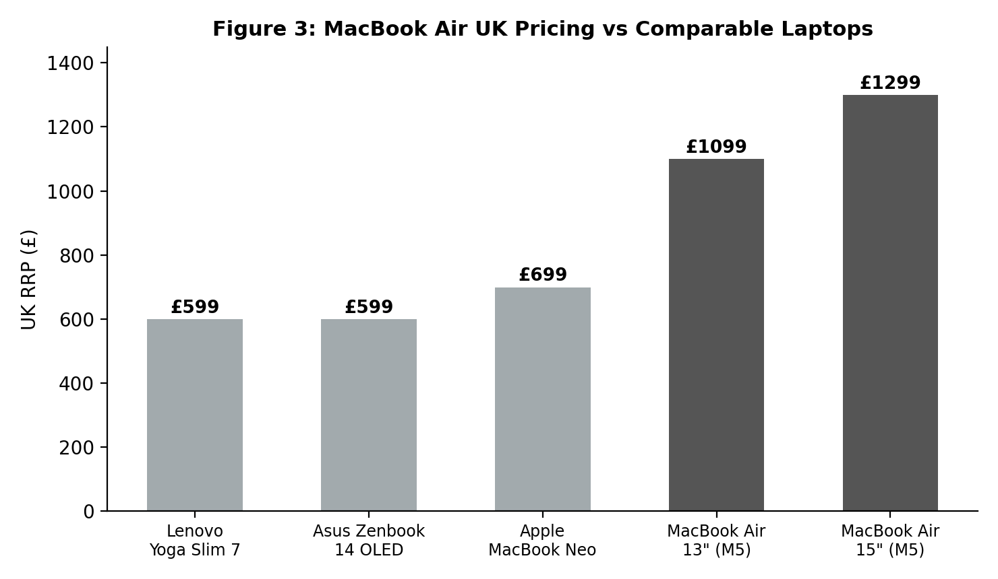
Figure 3: MacBook Air UK Pricing vs Comparable Laptops (Apple Inc., 2026a; based on UK retail listings)
The 13-inch MacBook Air is priced from £1,099 in the UK while the 15-inch is priced from £1,299 in the UK, as Figure 2 illustrates, while both budget-specific Windows ultrabooks, the Lenovo Yoga Slim 7 and Asus Zenbook 14 OLED, start around £599, with prices, at least in part, determined by their targeted audiences, and the budget-specific MacBook Neo, which starts at £699 in the UK, is Apple's response. (Apple Inc., 2026a). The price gap also evidence that the MacBook Air is not a budget item and that this is its biggest drawback, which can be observed in the SWOT analysis above.
The real advantage is the strong ties among the Apple silicon, device design and the rest of the device system, which makes it hard for rivals to match fast. Price is the biggest problem, as the MacBook Air is hundreds of pounds more expensive than many well-received Windows laptops in its class that appeal to consumers with similar budget constraints, which can make it hard to afford for more budget-conscious buyers in the UK. The most promising area of opportunity is the ongoing increase in the performance of chips and the expansion of the refurbished and trade-in market that will allow for a more price-sensitive market in the UK without them having to pay less for new devices (Schoordyk, 2026). The major challenge is from other competitors following their own pricing strategy and product choices to defend the notebook share these include HP, which aggressively cut its notebooks as well as other PC components, while cost pressures are experienced across the entire PC industry due to rising component prices (Liu, 2024; Omdia, 2025). All considered, this SWOT format provides a sound picture of a product with a very good competitive position, albeit one that will remain under intense pressure regarding price sensitivity and component costs in the UK market.

3. Comprehensive and Holistic View of the Organisation

3.1 Corporate Social Responsibility (CSR) Strategy
Apple is a company that can make money and do good at the same time, a trend that mirrors the current trend toward hybrid business models which seek to integrate the profit-making aspect and the social question simultaneously, so that they are not perceived as separate issues (Alberti and Varon Garrido, 2017). Its CSR focuses on recycled materials, targets to reduce carbon usage, and a growing focus on circular economy with trade-in and refurbished goods, which is becoming a more significant part of Apple's international marketing strategy in various markets, including the UK (Al-Sakaf, 2025). The company is also working towards a stakeholder value approach, which attempts to align with the needs of the shareholder, employee, supplier, and customer, while not focusing solely on the profit of the shareholder, in accordance with a business that relies on a large and complex global supply chain (Pangarkar and Pangarkar, 2022). This stakeholder philosophy is very closely allied to business goals because delivering customer, employee and supplier satisfaction helps ensure steady product quality and repeat sales, which are crucial to Apple's overall UK strategy.
Making sustainability pledges into hard-won profits is not easy, though. Sustainability claims must be supported by actual cost changes or operational changes, otherwise they can seem like a hollow promise to customers, not a genuine part of a company's strategy (Cabral Ribeiro et al., 2026). Sustainable cost accounting generating the true cost of environmental action alongside the normal financial accounting numbers could enable a company such as Apple to demonstrate that the company's recycling initiative and its same carbon claims are not just good intentions, but real numbers, too. (Celestin, 2018; Barakat et al., 2023) This is important as the conflict between short-term profits and long-term investments that include sustainability continues to be one of the most challenging strategic dilemmas for today's large tech firms (Zopounidis and Lemonakis, 2024). Besides, Apple's ongoing investigation over its tax position in Europe also indicates that there is a connection between CSR reputation and financial strategies and that trust in one will quickly be transferred to the other (Baudot et al., 2020). For Apple UK, that means that CSR must go hand-in-hand with transparency in reporting, not just as a campaigning message to promote products.

3.2 Balanced Scorecard
The balanced scorecard was a concept devised by Kaplan and Norton (1992), which considers the performance of the business under four scenarios rather than just financial performance.
Table 4: Balanced Scorecard for Apple's MacBook Air
Perspective | Objective | KPI | Target | Initiative
Financial | Grow Mac/MacBook Air sales while protecting margin | Mac segment operating margin; average selling price | Maintain margin despite rising costs | Sustainable cost accounting and supplier cost management
Customer | Grow loyal, repeat MacBook Air customers | Cross-device ownership rate; repeat purchase rate | Increase ecosystem attach rate year on year | Deepen Continuity/iCloud integration and marketing
Internal Business Process | Faster development cycles, resilient supply chain | Product development cycle time; supplier lead time | Reduce lead time; improve on-time delivery | Supply chain digitalisation and diversified sourcing
Learning & Growth | Build chip design and engineering capability | R&D investment; engineering headcount growth | Sustain annual chip performance gains | Continued R&D investment and cross-team collaboration

Financial perspective:
The goal is to continue the Mac and MacBook Air growth trajectory while maintaining margin given the increased costs of components. While it is true that cost control alone has little impact on the overall company performance, non-financial drivers such as design quality and customer satisfaction have proven to have the genuine impact on the overall company performance (Shah, 2024). The UK is enjoying strong growth on top of a robust base for global Mac sales, with net sales for the company in FY25 reaching $33.7 billion, representing a 12 per cent decline from the prior-year figure (Apple Inc., 2025). Here KPIs should comprise Mac segment operating margin, average selling price and UK laptop revenue growth against specific and annual KPI targets set at a senior level.
Customer perspective:
The goal is to retain and cultivate brands loyal to them and those with other Apple products. The net sales in the Mac segment of Apple's worldwide operations increased from FY24 to FY25 as illustrated in Figure 2 below.
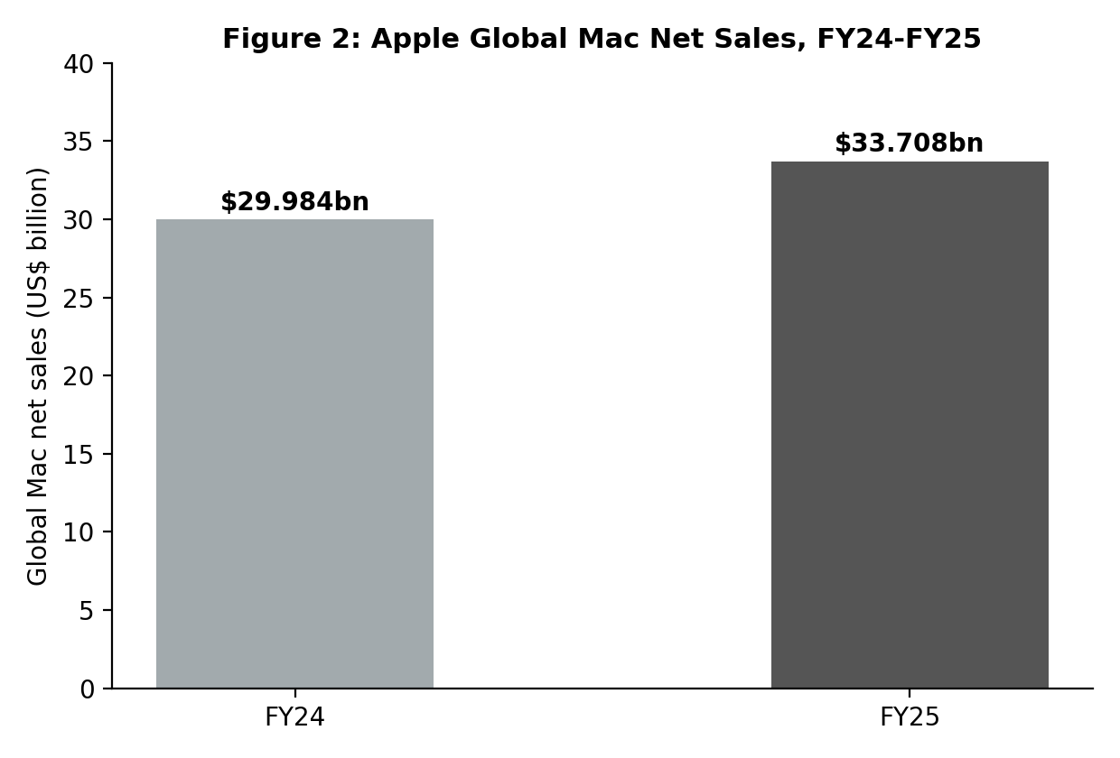
Figure 4: Apple Global Mac Net Sales, FY24-FY25 (Apple Inc., 2025)
As per Figure 4, during FY25, the net sales of Mac increased from $30.0 billion in FY24 to $33.7 billion and has risen globally (Apple Inc., 2025). The importance of this growth is because deliberate, integrated product design has been proven to be one of the factors influencing customer preference when it comes to purchasing Apple products (Barley et al., 2020) and digital ecosystems – which are packages of multiple devices – has been proven to drive repeat purchase behaviour and decrease the likelihood of a switch to a competitor brand (Son et al., 2020).
Internal business process perspective:
The goal is to achieve quicker product development timelines and more sustainable and resilient supply chains. The environmental and social measures are implemented as part of normal business operations, not as an afterthought, for technology and manufacturing firms of this magnitude (Duman et al., 2018), and Apple's investment in supply chain digitalisation with its goal of tracking performance more closely across all stages of the business aligns with this same purpose. Examples of useful KPIs here include product development cycle time; supplier lead time reliability and percentage of materials recycled in each new MacBook Air generation.
Learning and growth perspective:
The goal is to continue to grow internal design, engineering, and chipping talent, finding these internal strengths to be a key driver of Apple's success (Hong, 2025). Ongoing investing in this capability reinforces the broader "Mac strategy" that is detailed throughout this report (Harris et al., 2020). These points are where investments should be targeted and include ongoing investment in research and development of chips, tight integration between hardware and software design teams, and structured knowledge-sharing across Apple's global engineering teams, which are what make the MacBook Air competitive to Windows-based laptops (Tomashuk, 2023).

4. Strategic Choices and Implementation

4.1 Business-Level Strategic Choices
There is a long way to go to the business level, as Apple has the opportunity to operate on either cost leadership or differentiation, focusing on price comparison and design, performance and integration into the ecosystem respectively. However, cost leadership would be very challenging in the UK for Apple as other companies like HP, Dell, Lenovo and Asus are competing for the lower prices and would be hard to defeat solely on cost (Kim et al., 2020). Differentiation seems to be more suitable for Apple because disruptive and design-oriented business models that rely on real product innovation have been proven to provide sustainable competitive advantage instead of day-to-day price-cutting strategies (Bhandari, 2020). The strategy of a focus would also be too restrictive for a product line of Apple's size, as all of these customer groups in the UK appreciate the same significant mix of quality, range, usability and battery life in the MacBook Air.

4.2 Recommended Strategy
Clearly presenting differences in chip performance, product design and broader Apple ecosystem, while sustaining investments in sustainability and consistency of international marketing is the recommended strategy (Al-Sakaf, 2025). This is supported by Porter's Five Forces, which has been applied to the UK laptop market, where: There is strong competitive rivalry as there are a large number of competing products on the market – for many people the decision of switching from one laptop brand to another is simple; competitors like HP are still investing in their competitive strategy to maintain market share (Liu, 2024). The ease of customization combined with Apple's other factors such as the ecosystem make it easy for the MacBook Air to maintain customer allegiance despite competing laptops cheaper on the surface. Moreover, the perils of the tablets with keyboard attachments and Chromebooks are steadily increasing in the education and budget segment, further underscoring the value of the MacBook Air's performance and design to UK customers.
The safest and most trusted way to grow is to engage existing Mac users in the ecosystem more deeply, and upgrade the chips for them to keep their products more competitive, which is what Ansoff's Matrix suggests can be done by market penetration in the UK where the trend is already strong in most markets globally, based on Apple shipping more Macs and seeing rampant market sales in the rest of the world (Omdia, 2025; Apple Inc, 2025). This strategy is further reinforced by the product development approach used, for example with the recent introduction of the new M5 chip, which provides existing loyal customers with yet more incentive to upgrade their MacBook Air more frequently (Apple Inc., 2026b). The refurbished and trade-in segment are also attractive markets, offering a less-risky option to tap into more economical customers in the UK without impacting the new device price as well (Schoordyk, 2026).
This comprehensive approach has the potential to bring a lot of value, as consumers who value the design, find it easy to connect with other devices, and appreciate a higher price will be more inclined to continue to reward Apple with their loyalty. Another research area, which demonstrates the impact of a well-integrated device ecosystem over time on purchase behaviour and resistance to competitor offers, is that of loyalty in the context of digital ecosystems (Son et al., 2020). All these factors together ought to enable Apple to hold off the attacks from the Windows laptop sector and keep its Mac business growing without compromising its image as a high-end product.

4.3 Implementation challenges and mitigation:
Cost and Supply Chain Risk
Importing another new MacBook Air into the UK market would represent a significant cost increase for customers, which is already being constrained by rising margins throughout the entire PC space, and needs to be managed carefully (Omdia, 2025). Continued dependence on suppliers and contract manufacturers outside UK and EU also brings additional risk, especially if trade and/or tariff policy changes and impacts flows of components.
Building Dynamic Capabilities
Responding to these pressures necessitates more than merely cutting the costs. The resource-based view emphasizes that the advantage that firms may achieve is not only based on valuable resources but also depends on the firm's ability to re-configure resources over time as circumstances evolve (Kero and Bogale, 2023). This requires Apple to constantly juggle designs and supply of chips alongside pricing and cost dynamics, rather than looking after each individually; the MacBook Air's high-status appeal is based on its capabilities, not merely its cost-control.
Ethical and Sustainable Supplier Management
Additionally, ethical leadership in supplier relationships contributes to resource-based competitive advantage as sustainable initiatives become part of a supply chain can diminish risk to the reputation and operation of the company over time (Atobishi and Podruzsik, 2025). Following this logic, Apple should take strides to promote fair labour and environmental practices in its supply chains, not just at the factory, in order that the MacBook Air brand isn't ridden with bad publicity associated with sourcing.
Circular Economy and Environmental Implementation
A close relationship between strategic management and the concept of industrial ecology to establish environmental action as an integral part of the business model can lead to incremental progress on overall Sustainable Development Goals and reduce exposure to material cost (Sullivan, Thomas and Rosano, 2018). This would be realised if the refurbished and trade-in scheme was expanded, as it would allow Apple to continue to keep price-sensitive customers from the UK who may want to move to a rival with a lower price.
Agile Response & Monitoring Sustained Advantage
For the capital-intensive sectors, structured and agile decision-making processes enable fast response to cost shock without jeopardizing their sustainability objectives, a concept applicable to the low-cost carriers to hardware manufacturers (Seker, 2025). At the same time, Apple needs to use structured assessment frameworks instead of blind trust to determine if its resource benefits are truly sustainable in the long term; sustainable competitive advantage needs to be monitored and not assumed after being obtained (Zhe et al., 2023).

Section 2: Reflection
It is a personal, reflective account of the process that was followed while researching and writing this report and hence is presented in first person. I have applied the Gibbs Reflective Cycle which consists of 6 stages, Description, Feelings, Evaluation, Analysis, Conclusion, Action Plan.
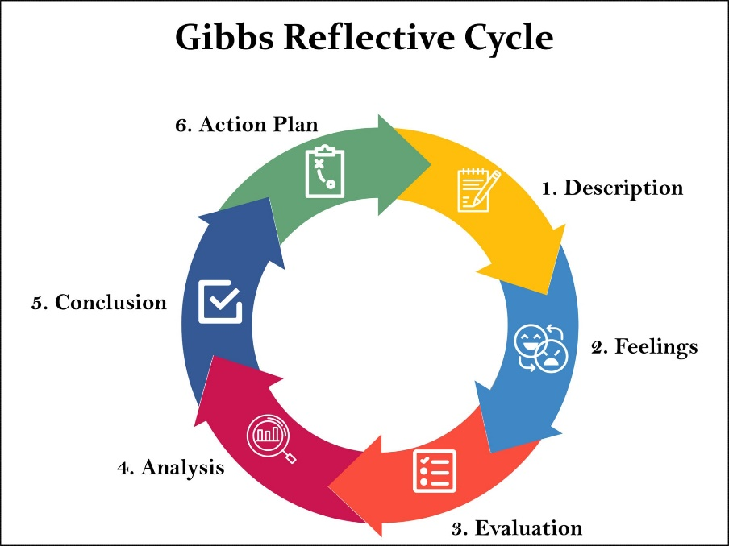

Figure 5 Gibbs Reflective Cycle (Omdia, 2025)

Description
In this assignment, I had to take up the role of a strategic management consultant and examine the competitive position of an organisation I selected in a particular market. My product was Apple's MacBook’s Air and the brief specified a focus on the laptop market in one of the markets, the United Kingdom, rather than apple's global business as a whole. I had to consider the external factors affecting the MacBook Air, and had to use PESTEL to establish the political, economic, social, technological, legal and environmental factors that impact the UK laptop market. I also looked at the internal environment, and I did look at the idea of, if Apple has resources like its integration, its custom silicon, could it have a true competitive advantage? All these findings were compiled into a SWOT analysis and the strengths, weaknesses, opportunities and threats most critical to the project were identified.
I extended this, then used the balanced scorecard, porter's five forces and ansoff's matrix to recommend a differentiation strategy, along with the implementation aspects of cost pressures and risk within supply chains.

Feelings
I was confident at the beginning as I knew Apple was a well-known brand in the world but also had pressure because it was a deep analysis based on evidence and not just opinions. I also found myself needing to change my chosen organisation mid-way through this project, from a service-based business to a specific hardware product, which was initially disconcerting but gave me the impetus to consider the brief requirement to identify one product in one market. I got more comfortable as I started reading some academic literature about Apple's product design and in-house capabilities, partly because I could find a middle ground of literature to support my arguments with substance and not just speculation.

Evaluation
My research process was successful, that was what went well. To give my research some academic credibility, I looked for any academic papers on Apple product approach, internal ability and sustainability, and to provide some real number data, rather than speculation, I sourced Apple's own published financials and independent market research from Omdia and Ofcom. Unfortunately, Apple doesn't release separate MacBook Air or UK sales figures, but the fact that I used real FY24 and FY25 numbers for global Mac net sales coupled with the current PC market shipment data helped make my SWOT and balanced scorecard sections feel better. It was much tougher to balance the word limit for each section while still ensuring that all aspects of the framework provided by the brief were covered: PESTEL, VRIO, SWOT, the balanced scorecard, Porter's 5 forces and Ansoff's matrix.

Analysis
Everything has come together for me now and I feel like I see why the brief was for one product in one market, and not a whole global company. Having focused my analysis on the MacBook Air in the UK meant I could be precise and use recent data whenever it was available, but have been conscious that I could not go beyond what is public available product level data, and so the analysis was stronger than a general one about MacBooks around the world. I also learned that when building frameworks, it is best that they are linked together; not just separate boxes to fill with content. In fact, I used my VRIO analysis of Apple's Ecosystem as my primary argument across my report by directly connecting it to the balanced scorecard customer perspective. I also observed that some frameworks would just naturally complement each other: I had the SWOT threats lined up with the rivalry and buyer power forces I went on to discuss under Porter's Five Forces.

Conclusion
Overall, I think this assignment enhanced my strategic management application skills to a real live business problem. I have gained an understanding of how to incorporate academic research and the financial data provided by the company with independent market research, and gained a lot more confidence to develop a well-supported, coherent recommendation rather than just a description of the product using the frameworks such as the balanced scorecard and Five Forces.

Action Plan
For future assignments, I will find out early in the assignment if they have chosen the right organisation and product and then read and compare it very carefully with the requirements of the brief before I begin writing as I don't want to have to restructure my analysis halfway through, which wouldn't work for them. I also aim to begin my literature search earlier to allow me to have more time to compare sources before I begin writing and to summarise complex frameworks more concisely at the outset, leaving me more time to give to analysis/evaluation rather than description. Lastly, I will continue to use real company data and independent market research where I can as this gave my recommendations a greater depth and utility for this assignment.

Conclusion
In this report, Apple has been analysed using the following techniques: PESTEL, VRIO, SWOT, balanced scorecard, Porter's Five Forces and Ansoff's Matrix to identify the strategic position of the MacBook Air in the UK laptop sector. Apple has a solid and developing market share, with Apple silicon, a loyal device ecosystem and an increasing global Mac user base, but at a premium to more competitively priced Windows laptops. The differentiated approach suggested, combined with further investment in chip performance, ethical procurement and circular economy, is a realistic pathway to a long-term competitive advantage. Adopting a dynamic approach to capability-building, rather than a static one, will continue to be crucial to the strategy as used.

References
Alberti, F.G. and Varon Garrido, M.A. (2017) 'Can profit and sustainability goals co-exist? New business models for hybrid firms', Journal of Business Strategy, 38(1), pp.3-13.
Al-Sakaf, H.F.T.A. (2025) International marketing strategy of the enterprise (based on the materials of the company 'Apple Inc.'). Bachelor's thesis. Poltava University of Economics and Trade.
Apple Inc. (2025) Annual Report on Form 10-K for the fiscal year ended 27 September 2025. Cupertino, CA: Apple Inc. Available at: https://s2.q4cdn.com/470004039/files/doc_financials/2025/ar/_10-K-2025-As-Filed.pdf (Accessed: 6 August 2026).
Apple Inc. (2026a) MacBook Air 13-inch and MacBook Air 15-inch. Available at: https://www.apple.com/uk/macbook-air/ (Accessed: 6 August 2026).
Apple Inc. (2026b) 'Apple introduces the new MacBook Air with M5', Apple Newsroom, 3 March. Available at: https://www.apple.com/newsroom/2026/03/apple-introduces-the-new-macbook-air-with-m5/ (Accessed: 6 August 2026).
Atobishi, T. and Podruzsik, S., 2025. Ethical entrepreneurial leadership and corporate sustainable development: A resource-based view of competitive advantage in small and medium enterprises. Sustainability, 17(13), p.6109.
Barakat, B., Milhem, M., Naji, G.M.A., Alzoraiki, M., Muda, H.B., Ateeq, A. and Abro, Z., 2023. Assessing the impact of green training on sustainable business advantage: exploring the mediating role of green supply chain practices. Sustainability, 15(19), p.14144.
Barley, B., Kitamura, A., Loar, T., Ramon-Samayoa, E., Yuzon, J. and Daim, T.U. (2020) 'An investigation of the motivations and strategies behind Apple's product design', in Innovation Management in the Intelligent World: Cases and Tools. Cham: Springer International Publishing, pp.3-27.
Baudot, L., Johnson, J.A., Roberts, A. and Roberts, R.W. (2020) 'Is corporate tax aggressiveness a reputation threat? Corporate accountability, corporate social responsibility, and corporate tax behavior', Journal of Business Ethics, 163(2), pp.197-215.
Bhandari, B. (2020) Sustainable competitive advantage in a disruptive world through disruptive business models. [Thesis].
Cabral Ribeiro, P.C., Vidal Vieira, J.G., Costa, H.G., Eis Duarte, T. and Borges Amaral, P.R. (2026) 'Marketing, profit strategies and sustainability: a challenge for companies in different sectors', Academia Revista Latinoamericana de Administración, pp.1-33.
Celestin, M. (2018) 'The impact of sustainable cost accounting on business profitability: balancing financial performance with environmental responsibility', Brainae Journal of Business, Sciences and Technology, 2(4), pp.694-705.
Çitilci, T. and Akbalık, M. (2020) 'The importance of PESTEL analysis for environmental scanning process', in Handbook of Research on Decision-Making Techniques in Financial Marketing. Hershey, PA: IGI Global, pp.336-357.
Duman, G.M., Taskaynatan, M., Kongar, E. and Rosentrater, K.A. (2018) 'Integrating environmental and social sustainability into performance evaluation: a balanced scorecard-based grey-DANP approach for the food industry', Frontiers in Nutrition, 5, p.65.
Harris, J.D., Lenox, M., Goldberg, R. and Brooks, C. (2020) Apple Inc.: the future of the Mac. [Case study].
Hong, T.K. (2025) Leveraging internal capabilities for competitive advantage: a case study of Apple Inc. [Thesis].
Huang, F., Zhang, Z., Liu, C., Wu, D., Fu, W., Chen, Y. and Abbass, K. (2026) 'The digital path to profitability: how supply chain digitalization drives financial performance through sustainable integration', Business Strategy and the Environment.
Hussein, H., Albadry, O.M., Mathew, V., Al-Romeedy, B.S., Alsetoohy, O., Abou Kamar, M. and Khairy, H.A., 2024. Digital leadership and sustainable competitive advantage: Leveraging green absorptive capability and eco-innovation in tourism and hospitality businesses. Sustainability, 16(13), p.5371.
Kero, C.A. and Bogale, A.T., 2023. A Systematic Review of Resource-Based View and Dynamic Capabilities of Firms and Future Research Avenues. International Journal of Sustainable Development & Planning, 18(10), p.3137.
Kim, J.H., Seok, B.I., Choi, H.J., Jung, S.H. and Yu, J.P., 2020. Sustainable management activities: A study on the relations between technology commercialization capabilities, sustainable competitive advantage, and business performance. Sustainability, 12(19), p.7913.
Liu, M. (2024) 'Maintaining market share: HP's competitive strategies in the notebook sector', SHS Web of Conferences, 207, p.01028.
Muhardi, M., Mafruhat, A.Y., Cintyawati, C., Ramli, T.A., Sabar, R., Ahmad, H., Shaharruddin, S. and Bohari, A.M. (2020) 'New holistic strategy of sustainable rural development management - experience from Indonesia: a PESTEL-SOAR analysis', International Journal of Sustainable Development and Planning, 15(7), pp.1025-1033.
Ofcom (2025) Adults' media use and attitudes 2025. London: Office of Communications. Available at: https://www.ofcom.org.uk/siteassets/resources/documents/research-and-data/media-literacy-research/adults/adults-media-use-and-attitudes-2025/adults-media-use-and-attitudes-report-2025.pdf (Accessed: 6 August 2026).
Omdia (2025) 'Worldwide PC shipments up 7% in Q2 2025', 9 July. Available at: https://omdia.tech.informa.com/pr/2025/jul/worldwide-pc-shipments-up-7-percent-in-q2-2025 (Accessed: 6 August 2026).
Pan, W., Chen, L. and Zhan, W. (2019) 'PESTEL analysis of construction productivity enhancement strategies: a case study of three economies', Journal of Management in Engineering, 35(1), p.05018013.
Pangarkar, N. and Pangarkar, N. (2022) 'The stakeholder value map: a new tool to measure success with diverse groups', Journal of Business Strategy, 43(5), pp.298-305.
Prete, M.I., Piper, L., Greco, V. and Guido, G., 2026. Sustainable development, attractiveness, and competitive capacity of touristic local territorial systems (LTSs) in south Italy: a strategic positioning: M. Irene Prete et al. Place Branding and Public Diplomacy, 22(1), pp.78-95.
Schoordyk, N. (2026) Apple in 2025, with and beyond the iPhone: Apple's strategic opportunity in the refurbished iPhone market. [Thesis].
Seker, S., 2025. Evaluation of agile attributes for low-cost carriers to achieve sustainable development using an integrated MCDM approach. Management Decision, 63(4), pp.1229-1261.
Shah, J.H. (2024) The influence of non-financial metrics on overall company performance. Master's thesis. Sveučilište Algebra Bernays.
Son, Y., Oh, W., Han, S.P. and Park, S. (2020) 'When loyalty goes mobile: effects of mobile loyalty apps on purchase, redemption, and competition', Information Systems Research, 31(3), pp.835-847.
Sullivan, K., Thomas, S. and Rosano, M., 2018. Using industrial ecology and strategic management concepts to pursue the Sustainable Development Goals. Journal of cleaner production, 174, pp.237-246.
Tomashuk, I., 2023. Competitiveness of agricultural enterprises in market conditions and ways of its increase. Green, Blue and Digital Economy Journal, 4(1), pp.64-81.
Zhe, C., Chen, C., Yueyang, Z., Xiong, X. and Xiao, T., 2023. Evaluation of scientific research in universities based on the theories for sustainable competitive advantage. Sage Open, 13(2), p.21582440231177048.
Zopounidis, C. and Lemonakis, C. (2024) 'The company of the future: integrating sustainability, growth, and profitability in contemporary business models', Development and Sustainability in Economics and Finance, 1, p.100003.

