Leading and Implementing Workplace Change
BMSW6103
Executive Summary
This report it is about understanding the role of the change management model, leadership and organisational culture while implementing change in an organisation. This report focuses on implementing effective change management for ASDA to achieve competitive advantages over other firms. Due to the recent pandemic, buying habits of customers have been changing. Due to increased online sales, ASDA developed a plan for shifting from an offline to an e-commercial retailing business. PESTLE has been conducted for identifying the driving factors of the change. Transformational leadership has been selected for leading employees toward effective change. Change management model including “Lewin’s Change Theory,” “John Kotter’s 8-step of change management” and “Pettigrew's Model of Change” has been briefly discussed in this report.
Table of Contents
Introduction 4
Section 1: Critical Evaluation of Adopted change management process 5
Overview of the Company 5
External Factors Acted as Change Drivers 7
Selected Leadership Style 10
Impact of Digital Transformation Change on Organisational Culture 12
Area of improvement in the Change Management Process 12
Area of Improvement 13
Section 2: Critical Evaluation of the Change Management Models 14
Analysis of Change Management Models 14
Identification of suitable change management model 18
Section 3: Implementing Change Strategy 21
Propose Change Management Plan 21
Suitable Leadership Approach 23
Step by step process to implement the change strategy 25
The probable impact of the implementation of change strategy on the culture of ASDA 26
Conclusion and recommendation 27
Reference 28

Introduction
The main purpose behind writing this report is to critically understand the role of the change management model in minimising the impact of external threats. In the digital era, every business is going through digital transformation, which helps to achieve competitive advantages over rivals. Digital transformation refers to a process, which is used for creating new business culture, model and customer experiences using digital technology. The main purpose of this report is to implement a suitable change management model for ASDA while shifting from offline to online retailing.
ASDA has been selected as it is going through the challenges of adopting digital transformation. Other retailers in the UK including Tesco, Sainsbury and Morrison have adopted digital transformation. Thus, ASDA needs to change its traditional business model and switch to E-commercial retailing (Asda, 2023). Thus, managing change and adopting an “E-commercial” business model is important for ASDA to achieve competitive advantages over rivals.
For managing change in ASDA, “Lewin’s Change Theory,” “John Kotter’s 8-step of change management” and “Pettigrew's Model of Change” has been used. Google Analytics and other Website traffic measurement tools will be used for measuring the success of the implemented change.
This report includes three sections and each of the sections provides a critical overview of change management theories, implementation and adopted change management process. This study will help to implement a successful change management model for ASDA, which would help to achieve competitive advantages over rivals.

Section 1: Critical Evaluation of Adopted change management process

Overview of the Company
ASDA company was founded in 1949 by the Asquith family and it was first a retail business associated with dairy products. It was established in England and has become one of the largest retail supermarket chains in the United Kingdom. As per the CEO of ASDA, online sales of this company have become doubled after the first quarter of the coronavirus pandemic. This “Structural shift” from traditional "Brick and mortar" stores to online shopping needs a strong change (Asda, 2023). After the recent pandemic, customer shopping habits have changed. ASDA reported a 3.8% jump in online sales after June 2020. Online sales of grocerieshave increased and ASDA needs to increase its delivery capacity by 65% during the pandemic. In 2022, ASDA accounts for 10 to 15% of the commercial net sale. However, online sales of Tesco and Sainsbury remain high compared to ASDA.

Figure 1: Slow Sales Growth at ASDA
(Source: Statista, 2023)
The above statistics reveal that the sales of ASDA in 2014 were 23.588 million dollars, which has been reduced to 23.555 million dollars in 2020 (Statista, 2023). The limited online delivery capacity of ASDA is one of the major challenges of this company while implementing effective digital transformation. Lack of technical knowledge and poor collaboration between team members has been identified as a major weakness. The online capacity of ASDA is 700,000 slots (Asda, 2023). However, online demand after the recent pandemic has increased. During Christmas, online demand increased and cross millions of orders. In the Retail supermarket of the UK, Asda holds a share of 13.2%. Compared to Asda, Tesco holds 41% of the market share with an online delivery capacity of 1.3 million weekly. Thus, it is important for Asda to increase its online delivery capacity and implemented digital transformation for achieving competitive advantages over Tesco and Sainsbury.

External Factors Acted as Change Drivers
After the recent pandemic, the shopping behaviour of customers has changed. Online sales have doubled after the recent COVID-19 pandemic. Thus, the recent change in customer buying behaviour acts as a change driver. PESTLE analysis has been selected as an effective tool for evaluating external factors, which acts as a change driver for ASDA. This Environmental analysis tool has helped to analyse the impact of political, social, economic, environmental and technological factors in driving change for ASDA.
PESTLE Factors | Analysis | Impact
Political | - Zero tax on the delivery of food, grocery and other human essentials  - 11.1% inflation rate of food and beverages (Ons.gov.uk, 2023)  - Increased cost of living | - “Zero tax” on online food delivery increases profit margin and reduces grocery product prices  - Online sales will help to cope with increased food inflation
Economic | - In 2022, the inflation rate increased up to 10.9%  - Per capita income in the UK declined at a rate of -1.58%  - The current GDP Of the UK is $3.1 trillion (Gov.uk, 2023)  - Fuel and electricity prices have been increased by 17.3% and 6.7% respectively (Ons.gov.uk, 2023) | - Increased rate of inflation impact and reduce the income of people forced to spend less  - The increased price of fuel and electricity increases the demand for online delivery
Social | - The population of the UK has increased with a growth rate of 0.34%  - Increased good demand and consumption of food | - Increased population and food demand lead to increased demand for online grocery delivery
Technological | - Almost 98% of the people in the UK use the internet  - 58 million people use their phones for ordering online products and services | - Increased internet penetration rate after the pandemic drive the change
Legal | - “Consumer Right Act 2015” (Gov.uk, 2023) | - Ensure rights and protect online transactions on E-commercial websites
Environmental | - Each delivery produces 1.81g of CO2 (Gov.uk, 2023) | - Using electric vehicles will help to reduce CO2 emissions by online delivery of groceries
Table 1: PESTLE analysis
(Source: Self-developed)
As per the above analysis, increased food inflation has driven the change in ASDA. “Zero tax” on online food delivery will be beneficial for reducing the price of grocery products. On the other hand, the increased internet penetration rate of the UK influence ASDA to adopt a digital transformation (Gov.uk, 2023). As per the analysis of technological factors, 58 million people use phones to order groceries. Thus, this huge online demand drives the change and influences ASDA to adopt an e-commercial retailing business model for enhancing sales and profit. Environmental factors play a crucial role in driving the change. ASDA has developed a plan for delivering food through the electrical vehicle, which will help reduce the environmental impact of online delivery.

Selected Leadership Style
A change leadership style has been adopted for managing change in ASDA. A change leadership style focused on managing and improving the adaptability of an organisation and change leaders helps to describe the benefits of adopting change. Change leader follows the 3C model of change management, which focus on developing collaboration, communication and commitment (Andriopoulos and Dawson, 2009). Leaders play an effective role in understanding training needs among employees. Thus, a change in leadership style will be appropriate for encouraging employees to adopt change. Managing “Change Resistance” among employees is one of the crucial tasks. Change leaders have expertise in managing employee change resistance. They play an effective role in providing necessary training to the employees and helping to implement a change without any resistance from employees and the organisation.
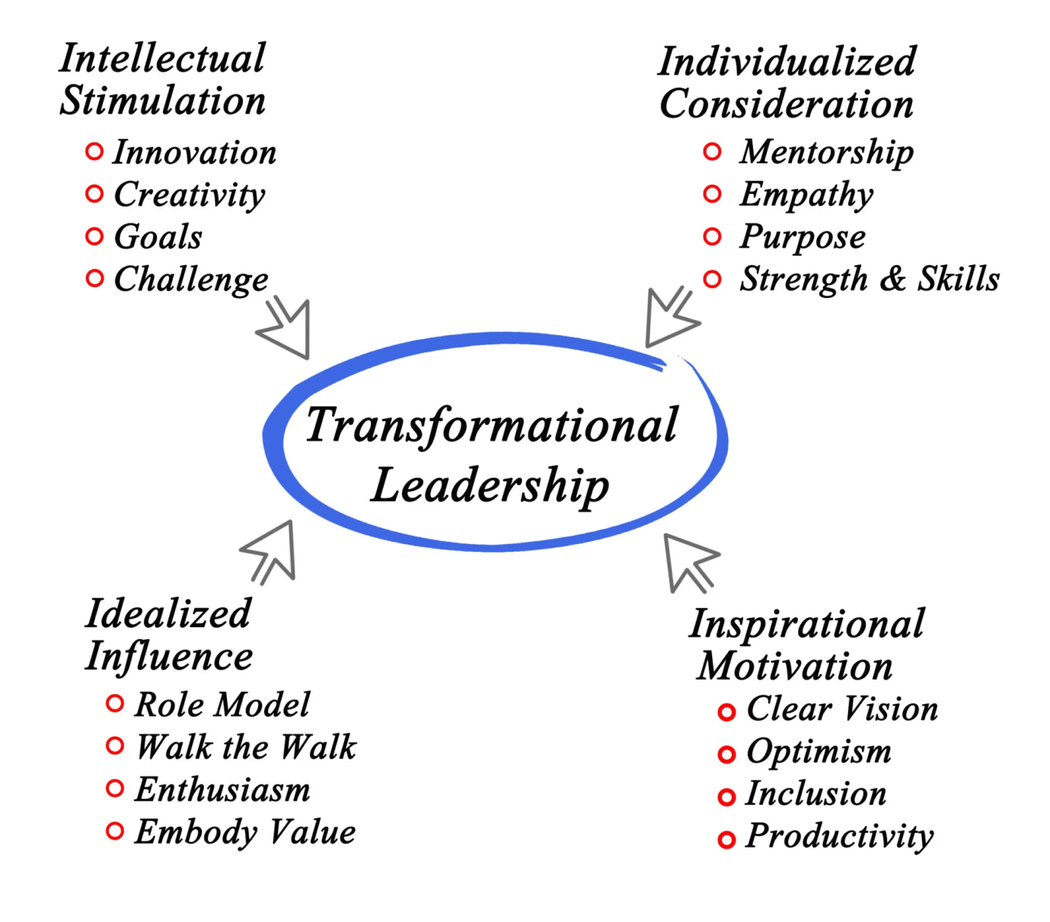
Figure 2: Transformational Leadership for change management
(Source: Asbariet.al., 2020)
Transformational leadership is appropriate for making change comfortable and ensuring the successful implementation of change in the organisation. Transformational leaders focus on encouraging employees for accepting change. It allows leaders to understand individual needs and issues while adopting change. Transformational leadership style is effective in reducing change resistance and motivating employees to cope with the change. They help to mitigate the fair of uncertainties, which leads to change resistance among employees of ASDA.
Transformational leadership style can be applied effectively at ASDA during times of change. This leadership approach involves inspiring and motivating individuals towards a common goal through visionary thinking, charisma, and personalized attention. By focusing on employee engagement and empowerment, transformational leaders create a positive organizational culture that supports change initiatives (Anderson, 2010). The success of such an approach has been demonstrated in various studies; it was found that transformational leadership reduced resistance to change and increased employee motivation. Therefore, implementing a transformational leadership style would enable ASDA to overcome challenges associated with its recent acquisition and ensure successful integration of new systems and processes.

Impact of Digital Transformation Change on Organisational Culture
Before adopting the change management of digital transformation Asda followed communal organisational culture that has been associated with the functional and hierarchical organisational structure of this company. In support of this culture, this company enhance better performance among employees and meet the common objectives to maintain a better relationship with the organisational structure (Hussain et. al., 2023). This culture maintains a positive environment in the organisation. However, it failed to meet digitalisation requirements that have taken a huge marketing range. That’s why this company implement digital transformation change in the organisational culture. Digital transformation creates an opportunity for digital culture and creates virtual team members to enhance the international business process of this company. After implementing digital transformational organisational change this company ensure to provide excellent digital service to the customers in support of the virtual team members. This leading change in this company ensures acts with integrity. It also helps to improve the operational management of this company with digital logistic organisational culture.

Area of improvement in the Change Management Process
From the annual report of this company, it has been identified that in normal seasons the online services of this company are about 70000. However, during the time of Christmas and New Year or other types of events, the online purchasing product numbers of this company have increased by approximately millions (Das et. al., 2023). Focusing on this particular area, it has been identified that this area of inventory management could perform better in the change management process. Digital transformation change management provides an opportunity for this company to hire Zero-Contract hour employees during peak season. Rather than the permanent employees hiring of Zero-Contract hour employees become effective for this company to improve productivity in support of digital transformation change management.

Area of Improvement
Leaders of an organisation plays a vital role in the aspect of change management. It is also applicable for Asda to implement its digital transformation change management. the previous leadership of this company failed to implement effective digital transformation-related changes in the organisation and its different business functions (Przewozniczek and Komarnicki, 2023). That’s why adoption of the change leadership can become effective for this company to effectively apply change management for different business purposes. For example, the current volatility of Asda has been increased by only 9.6% from the previous year. By adopting a digital transformation stock marketing process the change leader can encourage this company to enhance its volatility range by 15% in support of the reverse logistic process (Hughes, 2022). Due to a lack of change management, this company has faced uncertainty in supplier-effective connectivity. With digital transformation change and change leadership, this company can maintain digital communication to enhance the productivity of the company. Moreover, the lack of supplier communication creates complexity for this company to maintain both international and national business operations (Sabet et. al., 2023). As a result, due to ambiguity, the overall productivity of employees has been decreased. Change leadership style can effectively maintain business operations in support digital code of practice to implement complexity management.

Section 2: Critical Evaluation of the Change Management Models

Analysis of Change Management Models
Change management is a process that leads to organisational change to reduce current issues in the organisation. Among different types of change management models here “Lewin’s Three-Step Model,” “John Kotter’s 8-step of change management” and “Pettigrew's Model of Change” these three change management models have been discussed.
Lewin’s Three-Step Model- Lewin’s Three-Step Model is associated with Lewin’s Change Theory which has different steps to effectively implement organisational change. Kurt Lewin was a German-American psychologist, and in support of the social and business value, this model has been represented to implement organisational change. According to Lewin, there are three stages of resistance to change. The first stage is the creation of inner resistance to change and the second use of social habits and customs. Following this particular aspect, this change management model is based on three basic stages which are unfreeze change and refreeze (Jiang et. al., 2023). In this stage of unfreeze the organisation has to accept the change which is necessary as per the requirement of its change and involves breaking down of current or existing status of the organisation to ensure a new way of business operation building.
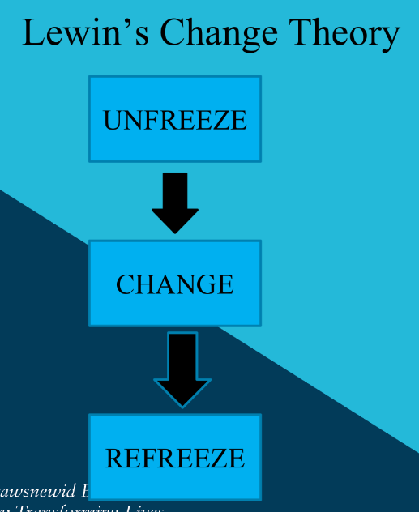
Figure 3: Lewin’s Three-Step Model
(Source: Wang, 2023)
In this particular stage development of compiling messages has been conducted to identify major issues of the organisation such as declining sales, poor financial reasons and productivity issues. After the identification of a major issue, this particular stage effectively implements changing beliefs among employees' attitudes and provides a strong reason behind the implementation of change. In the second stage of change to resolve the uncertainty of the organisation the company ensured new directions (Wang, 2023). After capturing a new direction to protective change, the company had to accept the benefit of the change and successfully implement the change in the organisation. At last, in the stage of refreeze, the organisation can reshape their change management and impress a new way of working. In this particular stage, the company can internalise their institutional changes and incorporate it every business purpose to maintain stability and enhance the productivity of employees.
Kurt Lewis' three-step model provides a structured framework for managing changes within organizations. According to this model, change occurs in three stages: unfreezing, moving, and refreezing (Cameron and Green, 2012). Unfreezing refers to preparing people for change by creating discomfort or dissatisfaction with the current state. Moving involves implementing the desired changes and transitioning to the new state. Refreezing stabilizes the new state and reinforces the changes made. Applying this model requires careful planning and communication throughout each stage to minimize resistance and maximize buy-in from stakeholders. In conclusion, Lewin's model offers a practical way to manage change in complex organizations like ASDA.
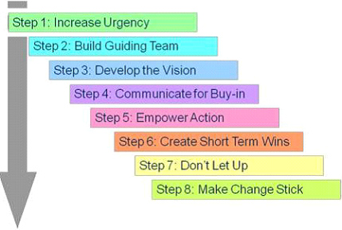
Figure 4: John Kotter’s 8-step Change Management Model
(Source: Beer, 2022)
John Kotter’s 8-step Change Management Model- On the other hand, John Kotter’s 8-step change management model is associated with the establishment of a sense of urgency, the creation of a coalition, the development of vision, the sharing of the developed vision, empowering clear obstacles, securing short-term goals, consolidate moving and anchor the change. In support of these stages first of all the identification of the need for change to establish the urgency of change management has been conducted. After that by creating a clear vision and sharing the vision with the employee’s empowerment among people has been generated to reduce obstacles. This process also involves the achievement of short-term goals and effectively implementing change in the organisation. This particular change management model is known as the easy step model which provides clear description and guidance for the change management implementation (Beer, 2022). In support of Kotter's Change Management Theory, this particular model has been adopted by 75% of companies for the implementation of change. As a part of the award-winning strategy, this model transforms changes following the urgency of Change management implementation.
John P. Kotter's eight-step change management model outlines a systematic process for leading large-scale transformations within organizations. Each step builds upon the previous one, culminating in a comprehensive plan for achieving lasting change. The first step is to establish a sense of urgency around the need for change (Kotter, 2012). This creates a compelling reason for why things must improve and sets the tone for what follows. Next, a guiding coalition should be formed comprising key influencers who will drive the change effort forward. Then comes crafting a vision that serves as a clear and simple guide for the future state of affairs. Communicating the vision widely helps gain support and understanding across all levels of the organization. The next steps involve removing barriers to progress by designing a strategy that aligns with the vision and eliminates obstacles. Short-term wins are critical to build momentum and demonstrate the viability of the change effort. After that, continue building momentum by consolidating gains and expanding efforts into broader areas. Finally, institutionalizing the changes achieved so far means embedding them into the DNA of the organization via structures, processes, and cultural norms. In summary, Kotter's model emphasizes the importance of strong leadership, collaboration, clarity, and persistence when navigating significant changes within organizations. Its application to ASDA could potentially facilitate their post-acquisition integration efforts and position them for long-term success.
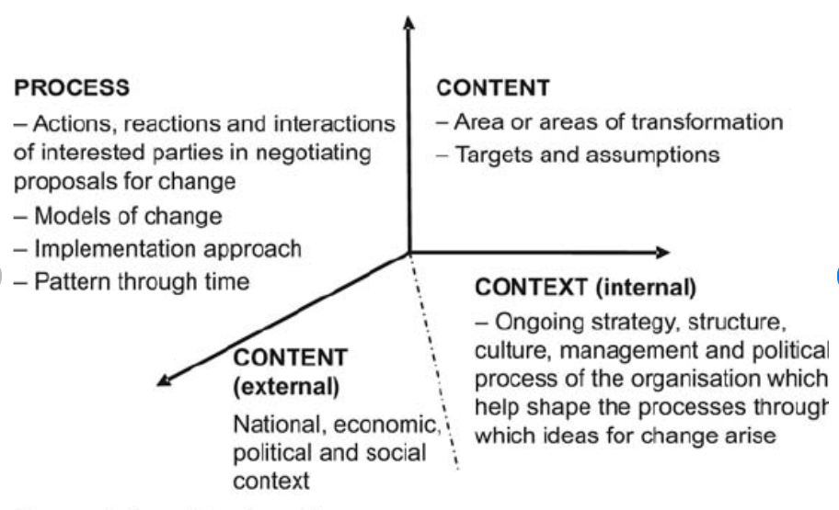
Figure 5: Pettigrew's Model of Change
(Source: Ichimura et. al., 2022)
Pettigrew's Model of Change- This particular model involves two stages such as process and content. The content stage is also divided into internal and external content where the areas of change management have been selected such as in the scope of internal contain the organisational structure and culture has been selected. On the other hand, for external content economic and political context of the organisation has been referred. In the contradiction process, the stage involves the effective implementation of the organisational change model and the pattern of the change that has been associated with the implementation of the change management strategy. This particular Change management is based on the essential dimension of strategic change in the organisation. In support of 5 factors such as oppositional change, linking strategy, human resource change, leading change and environmental assessment and coherence it effectively implements organisational change (Ichimura et. al., 2022). Adoption of this particular model in the aspect of organisational leading change becomes effective in the implementation of change in internal and external factors of the organisation.
Pettigrew's model of change suggests that successful transformation requires addressing four interrelated elements: strategic orientation, organizational capability, structure, and culture. Strategic orientation encompasses defining goals, developing strategies, and allocating resources (Kotter, 1990). Organizational capability entails acquiring necessary skills and knowledge. Structural components include formal systems, policies, procedures, and physical arrangements. Culture represents shared values, beliefs, attitudes, behaviours, and customs. Addressing these dimensions simultaneously enables more holistic and sustainable change. Failure to do so may result in incomplete or un-sustained modifications. Pettigrew's model highlights the complexity involved in driving meaningful change within organizations and underscores the need for thorough analysis and tailored approaches.
All these three change management modelshave the potential to effectively implement organisational change and manage changes to reduce the complexity and uncertainty of the organisation. Proper identification of organisational change and the use of effective change management strategy is also associated with these change management models.

Identification of suitable change management model
Anyone from the aforementioned change management models can be used to make digital transformation in the business environment of Asda Plc. However, John Kotter's 8-step change management model can be most suitable for making digital transformation in this enterprise. This change management model is easy to understand and simple to be adopted due to having step-by-step processes. 8 different steps are included in this change management model. All these steps along with the usage of these steps in making digital transformation in Asda have been evaluated below.
Step 1: Create Urgency
Creation of urgency in making organisational changes is required to avoid organisational resistance. This stage recommends developing a sense of urgency around the need for change. Different strategies can be followed by the management of Asda to develop urgency of digital transformation in marketing and other business activities. The analysis of opportunities that can be gained from digital transformation can be evaluated by employees of this enterprise. After that, this enterprise should request customers and employees and other stakeholders to help in digital transformation. Team meetings can be arranged with employees to elaborate the beneficial aspects of this organisational change.
Step 2: Form a powerful coalition
This stage of this change management model suggests convincing employees that this change is necessary for the growth of business. In this aspect, strong leadership and visible support from key people in the organisation are required to convince employees (Langendorf, 2021). After the formation of "change coalition", this needs to work as a team to enhance the adaptation of digital transformation in the business environment of this enterprise. Leaders of this enterprise can ask for emotional commitment from employees to adopt this organisational change.
Step 3: Creation of a vision
This is one of the most effective stages of this change management model. The creation of a vision of organisational change can help everyone to understand the purpose of making organisational changes (Almaslamaniet.al., 2020). The management of this supermarket can focus on convincing employees of digital transformation by elaborating on the vision of this plan. In this aspect, the determination of values that are central to this change is essential to follow this step. After that, an adequate strategy can be made to execute this vision. The confidence level of employees of this enterprise can also be increased with the help of making a suitable vision of this organisational change.
Step 4: Communicate the vision
This is another important stage of this change management model. This stage suggests this enterprise communicate to every employee along with the description of the vision of organisational changes. The purpose of digital transformation in marketing and other business activities can be elaborated to employees to adopt this change successfully (Jiang et.al., 2023). The arrangement of sufficient team meetings can be an effective way to communicate with employees regarding the purpose of the proposed organisational change.
Step 5: Removal of obstacles
This stage should be followed to adopt organisational changes smoothly. Digital transformation can be done by increasing technical knowledge and efficiency of employees. Lack of technical knowledge can be an obstacle to adopt this organisational change (Grudzien, 2020). As a result, sufficient training programs for old employees and recruiting efficient new employees can be two effective ways to remove obstacles that can be faced by ASDA during digital transformation. The arrangement of training programs for old employees of this enterprise can be an effective way to remove obstacles of this organisational change. This strategy can help the management of this enterprise to enhance the knowledge of old employees in digital technologies. As a result, old employees of this enterprise will not resist the adaptation of digital technologies for marketing purposes or other business activities.
Step 6: Creation of short-term wins
The creation of a short-term target can be an effective way to achieve success through digital transformation. This enterprise can set a target to attract a certain number of customers toward the business environment through digital marketing (Bitterman and Hess, 2021). Following this stage can be helpful for enhancing the confidence level of employees of this supermarket.
Step 7: Building change
Different change projects have failed due to early declaration of victory. This stage suggests organisational change. The management of ASDA can implement digital marketing strategies in a business environment after proper analysis of employee efficiency and upcoming results.
Step 8: Anchoring change in business culture
The organisational change should be a part of the core of this supermarket. In this aspect, the enhancement of activities regarding digital transformation and adequate investment for this organisational change is required. The recruitment of new employees who have adequate knowledge of digital marketing can be an effective way to involve this organisational change as a part of core of this enterprise.

Section 3: Implementing Change Strategy

Propose Change Management Plan
In support of John Kotter’s 8-step Change Management Model here change management plan for Asda to implement digital transformation change has been adopted.
Change Management Plan for Asda
Step 1 | Step 2 | Step 3 | Step 4 | Step 5 | Step 6 | Step 7 | Step 8
Create Urgency | Development of a powerful coalition | Creation of vision of change | Vision communication or share | Empower employees to act on the vision | Short-term wins | Build on change | Anchor the change in Asda Company
Stakeholder analysis for the change management implementation,  Analysis of data acquisition for the urgency of change | Identification role of change management team members in implementation of change,  Stakeholder workshops, sponsorship coalition | Use of strategic change management approach  Implementationplanning with digital tools such as Slack, asana  Use of software based digital CRM | Role of organisational member during the time of change management implementation,  Provide coaching for employees about changes | Take interview for employees to understand their thought about changes,  Conduct workshop presentation,  Use expertise models of communication for teambuilding | Planning for workshops,  Implementation of Workshops | Create change management projects,  Transfer workshops | Support employee belief,  Qualify career path with digital and technical skill,  Provide training to adopt digital skill
Initiate |  | Plan | Manage |  |  |  | Reinforce
Table 2: Change Management Plan for Asda
(Source: Self-Developed)
From the above change management planning, it has been identified that Asda for the implementation of digital transformation change management has to complete all these 8 stages. In the first stage, this company for maintaining urgency for adopting change needs to collect proper data for the requirement of change. For example, as mentioned that this company faced online operational issues (Wang, 2023). That’s why by analysing data regarding the need for the change and current range of online operation this company set urgency. By encouraging all members and sponsors towards the change implementation this company can maintain a coalition. This company can set change management vision such as software CRM or customer relationship management plan or digital inventory plan. In the fourth step, this company needs to communicate the vision by implementing different roles of different members such as a set manager role for providing guidance to employees for adopting change (Beer, 2022). After that, it is essential to encourage employees for adopting change in support of the workshop presentations and interviews. In 6th step, this company can complete their change management workshop goals and in 7th step, it can transfer the workshops (Li et. al., 2023). In this transferring process, this company can create different digital transformation projects, for example, use digital tools to build virtual teams, solve customer problems online, maintain financial calculations in support of digital tools and use digital technology in the customer satisfaction process (Ichimura et. al., 2022). In this way, this company can anchor or incorporate change in different business functions. This company also can provide proper training to employees to ensure their career growth towards technology.

Suitable Leadership Approach
Leadership is important for leading employees and the organisation toward effective change management. Change management required effective leadership, which helps to minimise employee resistance. The transformational leadership approach is suitable for implementing “Kotter's 8-step change management model” in ASDA for shifting offline retail into the e-commercial business model. Fear of uncertainties, fear of losing position and lack of understanding about the need for change in an organisationleads to change resistance among employees. Transformational leadership is effective for generating an “Urgency or need for change.” Change leaders create transparency over the change management possesses and the need for implementing change has been explained to the employees (Abu-Rumman, 2021). A clear idea about the change and its expected outcomes will be to eliminate the fear of uncertainties.
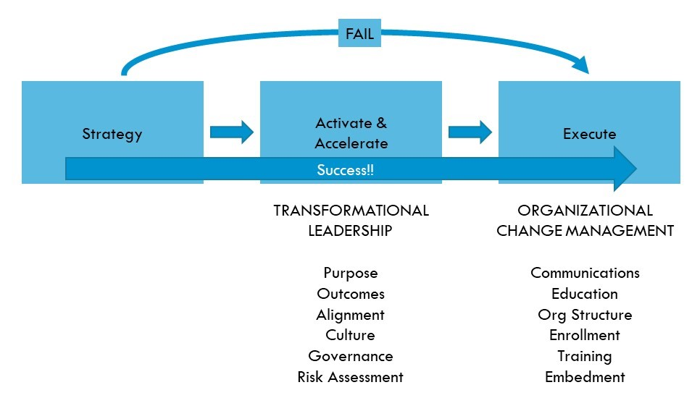
Figure 6: Relationship between Change management and transformational leadership
(Source: Asbari, 2020)
As per Asbari, (2020), Transformational leadership and change management are correlated. Leaders play an effective role in identifying change, which is required for implementing successful change management. Transformational leadership is effective in inspiring team members for adopting changes (Qurotul Aini et.al., 2020). Transformational leadership plays a vital role in motivating, encouraging and inspiring employees to create change. During the digital transformation of ASDA, existing employees of the firms need to be motivated for improving their technical skills. Enhancing collaboration and communication between employees of marketing, sales and IT is important for successful shifting from traditional to online business model. Transformational leaders play an effective role in guiding team members toward the expected outcomes of a change. Furthermore, developing a vision for change is required for increasing transparency in the change management process. Transformational leaders of ASDA should develop a vision and communicate with the team members for implementing change successfully.

Step by step process to implement the change strategy
Identifying the urgency for change in the first step is crucial for implementing the change strategy at ASDA. Collecting data on the advantages of shifting to e-commerce and the benefits it brings can aid in building a compelling argument for transformation and securing approval from stakeholders (Hanelt et al. 2021). Factors such as enhanced revenues, heightened productivity, and lowered expenses are examples of information that could be gathered. Once ASDA has established the necessity for change, the second step is forming a coalition of advocates becomes imperative. Executives, managers, and impactful figures should join forces to endorse the change initiative and expedite integration throughout the company. Their commitment is indispensable for the success of the alteration process (Li et al. 2021). Developing a clear and motivating vision of the future state following the implementation of the change initiative is critical for ASDA in the third step. Consistent and widespread communication of this vision is essential to provide every employee with a sense of direction and purpose. In the fourth step, dissemination of the vision among all personnel through diverse media such as town halls, webcasts, mails, posters, etc., guarantees overall understanding of the newly charted course and each individual's part in realizing the desired outcomes. To ensure a smooth shift to e-commerce, ASDA must eradicate impediments that may hinder progress by tackling restrictions like policies, approaches, structures, or operations that block the adjustment endeavour in the fifth step. In order to effectively manage changes within ASDA in the sixth step, it is not only vital to get rid of obstacles and enable individuals to act upon the vision but also to make sure that employees possess the appropriate tools, resources, and backing to implement the transformation plan. This necessitates significant investments in advanced technologies, instruction, and professional growth programs to enhance the proficiencies of employees across various job families. A few techniques ASDA can adopt include supplying online learning platforms, organising digital skill workshops, and encouraging cross-functional teamwork to boost ingenuity and inventiveness. By setting up a favourable work atmosphere where employees feel reinforced and ready to flourish, ASDA can expedite the rate of alteration and accomplish its key goals sooner. It is likely that some employees will resist the change due to fear of uncertainty or loss of control. Therefore in the seventh step, it is essential for ASDA to plan for resistance by anticipating common objections and preparing responses. This could involve providing education and training on the new system, offering support and resources, and addressing concerns directly. By being proactive, ASDA can mitigate resistance and increase the chances of successful implementation. Finally in the eighth step, ASDA needs to monitor progress regularly and adjust course as needed. This involves tracking metrics related to the goals of the change initiative and evaluating results against those metrics. If necessary, ASDA should modify their plans to stay aligned with the overall goal of becoming a leader in e-commerce.

The probable impact of the implementation of change strategy on the culture of ASDA
The adoption of the change strategy proposed in the study is forecasted to greatly impact the culture of ASDA. As the enterprise evolves towards e-commerce, there will be enhanced importance placed on partnership and collaboration amidst teams liable for promotion, sales, and IT. This migration towards digitalisation may entail alterations in worker perspectives and demeanours, motivating pliability, plasticity, and keenness to fresh conceptions. Furthermore, directive models with transformational leadership styles are likely to come to the forefront as executives steer workers towards the planned results of the modification exertion. Eventually, the completion of the variation programme may precipitate a cultural mutation within ASDA, one that accentuates agility, creativity, and consumer orientation.

Conclusion and recommendation
It can be concluded that the management of ASDA can focus on digital transformation like other retail companies to attract more customers toward the business environment. However, the lack of knowledge of existing employees in digital technologies can be a major challenge for this enterprise to adopt this organisational; change. Change management and transformational leadership are linked. Leaders have an important role in detecting change, which is necessary for successful change management implementation. Transformational leadership is good at motivating team members to make changes. Improving collaboration and communication among marketing, sales, and IT staff is critical for successfully transitioning from a traditional to an online business model. Transformational leaders are effective at directing team members towards the desired results of a transformation. The aforementioned negative effects can be mitigated with the help of recruiting employees who have adequate knowledge of digital marketing. The recruitment of technical experts in the business environment can be helpful for increasing efficiency of other employees. The recruitment of efficient employees can be a long-term recommendation for this enterprise. The arrangement of training programs for existing and newly recruited employees can be a mid-term recommendation for this enterprise. The collection of feedback from customers after digital transformation will be a short-term recommendation for this enterprise. All these steps are important to adopt digital transformation adequately. Avoiding these steps can hamper the progress of digital transformation in the business environment of this supermarket.

Reference
Abu-Rumman, A., 2021. Transformational leadership and human capital within the disruptive business environment of academia. World Journal on Educational Technology: Current Issues, 13(2), pp.178-187.
Almaslamani, F., Abuhussein, R., Saleet, H., AbuHilal, L. and Santarisi, N., 2020. Using big data analytics to design an intelligent market basket-case study at sameh mall. In Proceedings of the European Conference on the Impact of Artificial Intelligence and Robotics, ECIAIR (Vol. 2020, pp. 3444-3455).
Anderson, D. 2010. Beyond change management [ebook] how to achieve breakthrough results through conscious change leadership (2nd ed., Jossey-Bass organizational development). San Francisco, Calif.: Chichester: Pfeiffer; John Wiley [distributor].
Andriopoulos, C. and Dawson, P. 2009. Managing Change, Creativity and Innovation. Los Angeles: SAGE.
Asbari, M., 2020. Is transformational leadership suitable for future organizational needs? International Journal of Social, Policy and Law, 1(1), pp.51-55.
Asbari, M., Santoso, P.B. and Prasetya, A.B., 2020. Political and antidemocratic transformational leadership critics: is it still relevant?(A literature study). International Journal of Social, Policy and Law, 1(1), pp.12-16.
Asda, 2023 Background of the company [online] Available at: https://www.asda.com/[Accessed on 22nd August 2023]
Beer, M., 2022. Human resource systems for sustainable companies. In Sustainable Human Resource Management (pp. 1-56). River Publishers.
Bitterman, A. and Hess, D.B., 2021. Going dark: The post-pandemic transformation of the metropolitan retail landscape. Town Planning Review, 92(3), pp.385-394.
Cameron, E., and Green, M. 2012. Making sense of change management: A complete guide to the models, tools, and techniques of organizational change (3rd ed.). London; Philadelphia: Kogan Page
Das, S., Myla, A.Y., Barve, A., Kumar, A., Sahu, N.C., Muduli, K. and Luthra, S., 2023. A systematic assessment of multi‐dimensional risk factors for sustainable development in food grain supply chains: a business strategic prospective analysis. Business Strategy and the Environment.
Gov.uk, 2023 PESTLE analysis of UK [online] Available at: https://www.gov.uk/ [Accessed on 22nd August 2023]
Grudzien, P., 2020. Comparative Analysis of Energy Intensity and Profitability in Emerging E-Grocery Retail Models.
Hanelt, A., Bohnsack, R., Marz, D. and Antunes Marante, C., 2021. A systematic review of the literature on digital transformation: Insights and implications for strategy and organizational change. Journal of Management Studies, 58(5), pp.1159-1197.
Hughes, M., 2022. Reflections: how studying organizational change lost its way. Journal of Change Management, 22(1), pp.8-25.
Hussain, Z., Jabbar, A. and Kong, K., 2023. Power, dominance and control: implementing a new business intelligence system. Digital Transformation and Society, 2(2), pp.129-148.
Ichimura, Y., Dalaklis, D., Kitada, M. and Christodoulou, A., 2022. Shipping in the era of digitalization: Mapping the future strategic plans of major maritime commercial actors. Digital Business, 2(1), p.100022.
Jiang, M., Chen, L., Blome, C. and Jia, F., 2023. Digital technology adoption for modern slavery risk mitigation in supply chains: An institutional perspective. Technological Forecasting and Social Change, 192, p.122595.
Jiang, M., Chen, L., Blome, C. and Jia, F., 2023. Digital technology adoption for modern slavery risk mitigation in supply chains: An institutional perspective. Technological Forecasting and Social Change, 192, p.122595.
Kotter, J. P. 1990. A Force for Change: How Leadership Differs from Management. New York: Free Press.
Kotter, J.P. Leading Change, 2012, Harvard Business Review Press.
Langendorf, M., 2021. Applying Europe’s Digital Agenda in Mediterranean Partner Countries: Opportunities and Pitfalls. IEMed. MEDITERRANEAN YEARBOOK.
Li, J.Y., Sun, R., Tao, W. and Lee, Y., 2021. Employee coping with organizational change in the face of a pandemic: The role of transparent internal communication. Public relations review, 47(1), p.101984.
Li, L., Wang, Y. and Zhang, Y.Y., 2023. A critical examination of M&S's current strategic and marketing position, as well as potential sustainable competitive marketing strategies. International Journal of Science and Business, 18(1), pp.108-117.
Ons.gov.uk, 2023 GDP of UK[online] Available at: https://www.ons.gov.uk/ [Accessed on 22nd August 2023]
Przewozniczek, M.W. and Komarnicki, M.M., 2023, July. To slide or not to slide? Moving along fitness levels and preserving the gene subsets diversity in modern evolutionary computation. In Proceedings of the Genetic and Evolutionary Computation Conference (pp. 955-962).
Qurotul Aini, Q.A., Mukti Budiarto, M.B., POH Putra, P.O.H. and Untung Rahardja, U.R., 2020. Exploring e-learning challenges during the global COVID-19 pandemic: A review. JurnalSistemInformasi (Journal of Information System), 16(2), pp.47-65.
Sabet, M., Palanisamy, P. and Mishra, S., 2023. Scalable modular synthetic data generation for advancing aerial autonomy. Robotics and Autonomous Systems, 166, p.104464.
Statista, 2023 Slow Sales Growth at ASDA [online] Available at: https://www.statista.com/statistics/618252/sales-forecast-for-asda-united-kingdom-uk/[Accessed on 22nd August 2023]
Wang, Y., 2023. A Model Predicting CRM Resource Effect on Business Performance through CRM Capabilities. Wireless Communications and Mobile Computing, 2023.

