Identify an issue or marketing opportunity

Name: Kulsum Khatun

Student ID Number: 2226792

Module Title: Marketing Essential BMIH4005

Lecturer’s Name: Luciana Suardi

Moxy Hotel

Word count: 1356

A marketing plan is a tool that is used by companies to organise, execute and track their marketing strategy over a period of time. This approach enables companies to strategically target specific audience/s within their marketing. A targeted marketing approach can be an effective way of gaining new customers and retaining old customers. However, if a marketing plan is not in place or not followed, this can can impact on sales figures, resulting in closure as a worst-case scenario. In this essay, a marketing plan for Moxy Hotel will be presented using the SOSTAC (Situation, Objectives, Strategy, Tactics, Action and Control). Consideration is also given to issues within Moxy’s marketing strategy whilst using the SOSTAC framework. Prior to this analysis, a SWOT analysis is provided in relation to Moxy.
With the rise of the cost-of-living in the UK and beyond, it is likely that customers are looking for more affordable options when making a hotel reservation. Given Moxy are a 3-star hotel and known as the ‘’economy lifestyle brand’’ (Amadeus October 2014), the cost-of-living crisis presents an opportunity for Moxy to gain new customers. However, it could be suggested that one weakness that Moxy has is that it has a confusing concept at the heart of its offering to customers (Khatun, 2023). The reason for this is that a hotel is conventionally known as a place to rest. In contrast to this, Moxy offers a “hotel with a non-stop party life style” (blogmarketing81.home.blog, 2019). Alongside the above, there are also many opportunities and threats for Moxy. For instance, an opportunity for Moxy is that it can consider expanding into foreign countries (Khatun, 2023), making it a worldwide company. In contrast, a threat for Moxy is that other budget hotels could replicate the social element provided by Moxy and if competitively priced, this could detract customers away from Moxy.
Beyond the analysis offered, consideration should also be given to lack of reach that Moxy have had through their social media marketing channels. When analysing statistics in relation to Moxy from digital marketing website SimilarWeb (See appendix 1), it can be seen that Moxy’s social media strategy has not been effective. The chart shows how Moxy are consistently receiving traffic to their website through organic search but have much less traffic to their social media channels. It is important to note that Moxy’s target audience are ‘'millennial travelers’’ (Hospitality ON, November 2021) who are aged between the ages of 26 and 41 (Roller 2023) and typically have access to social media. If Moxy is reaching more people through organic search as opposed to its social media, it could be suggested that Moxy is reaching a generic group of people more often as opposed to its target market or ideal customer. The risk with this is that generic customers may be conducting searches online for budget hotel options and potentially have no interest in the social element being offered by Moxy.
In addition to the above, Appendix 2 shows the contrast in terms of traffic to social media channels for Moxy and Butlins. Since travel restrictions were imposed following the COVID-19 differoutbreak, Butlins began concentrating its marketing towards millennial’s through it Butlins Big Weekenders campaign. It was recently reported that Butlins have sought to reposition themselves as the “ultimate getaway for adult-only weekends” (Prolific North, 2022). It can be seen from Appendix 2 that, with a very few exceptions, Butlins has had more traffic to its social media channels than Moxy. It is noteworthy that Moxy are not very active on their social media channels, posting once every few days on their Instagram and Facebook accounts and having only posted once on their Twitter account in 2016. In combination with all their social media platforms, Moxy have just over 100 thousand followers which is very few in comparison to other 3-star hotels. It is therefore suggested that greater results need to be achieved by Moxy in relation to its social media marketing so that the company can ensure it is reaching its target market more effectively.
Moxy have replaced their reception for customer check in/out with a 24/7 open bar with board games. This is not a drastic change to make for competitors in a short period of time therefore this can work against them by other companies, nevertheless Moxy hotel have collaborated with the prestigious Marriot international brand, giving them a huge strength.
When a PESTLE analysis was carried out it was found that Moxy Hotel were set to have supported the Ukrainian refugees by blocking 320 rooms for a whole month they are also known to have been ‘’super compassionate and proactively accommodating for our guests and others from Ukraine’’ (Good Start Packing March 2022) also Economically the Sterling pound at its lowest against the American dollar ‘’Predicted to Experience Tough Year against Euro and Dollar in 2023’’ (Pound Sterling Live February 2023). In terms of social aspect Moxy have an event rooms to hire out for occasions and meetings. Moxy has also created an app which can be downloaded and with 5G/4G coverage it allows customers to book and other online customer service through the app, however data privacy is getting breached through hacking regularly exposing client private information. ‘’In 2018 Marriott announced that hackers had attempted to access its Starwood Hotels & Resorts Worldwide guest reservation database. Further investigation revealed unauthorised access to the system as far back as 2014, two years before Marriott acquired Starwood’’ (SiteMinder 2023)
Also in September 2018 Moxy hotel was also reviewed on TripAdvisor regarding very relaxed atmosphere on the use of illegal drug use in the Heathrow branch which can be a legal issue, Lastly Moxy is not known to be environmentally friendly which is something very important with the current issue with global warming.
The aim of this marketing plan is to get Moxy hotel to use their social media platform such as Facebook, Instagram and Twitter more regularly by offering opportunities for winning competitions all the followers have to do is 3 simple steps. Like, follow and tag.
A Gannt chart has been created (see appendix 3) to show the 12 months period where success can be measured. By December it would be clear which platform gained the most followers. By end of the year of starting the competitions Moxys followers should have gone up by at least 25% so roughly over 30,000 more.
Moxy hotel wants to be known for being playful, fun and affordable. They want to be recognised for its individuality and open-mindedness. Moxy targeted audience is aimed typically for more the ‘’younger generation’’ (Brandettes), Featuring its compact but attractive bedrooms with all necessary amenities supplied so guest leave feeling content. The organisation differentiates from other hotels in its industry with its reputation of creating a lively, vibrant social spaces for individuals to meet and make new friends.
The value proposition will be communicated to Moxy directly through their social media platform. Social media is a ‘’portal to direct connection with your ideal customers and a pathway to powerful insights’’ (Sproutsocial February 2023)
As the value proposition will be communicated directly it will be important to take into consideration other segments such as positioning and targeting of the organisation. This value proposition idea is to make the customers feel that for carrying an act out which is free and only takes a few seconds they can potentially be a winner. The perception is if for an example if 1000 people enter the competition the chances of winning is 0.5% of people which is very less.
This marketing plan has outlined that it would be advisable for Moxy to hire a social media manager to run their plat forms as they are not very active on there. Also as their targeted audience is Millennial customers it is known that ‘’90.4% of Millennials are active on social media’’ (Gitnux February 2023), however most traffic which comes to Moxy is through organic search. This method with typically be more by the older generation therefore this report highlights that maybe although their targeted audience is Millennials it may actually be the older generation whom are using them more.

References
Cunningham, H. (2014) Keeping up with the millennials: how Moxy is reaching a new audience through distribution , Amadeus.com. Available at: http://www.amadeus.com/en/insights/blog/keeping-up-with-the-millennials-moxy-hotels (Accessed: February 12, 2023).
Elphick, D. (2023) Hotel data breaches: What Independent Hoteliers Need To Know about data security, SiteMinder. Available at: https://www.siteminder.com/r/hotel-data-breaches/ (Accessed: March 9, 2023).
Inman, P. (2022) Why is sterling falling and what does it mean for the rest of the world?, The Guardian. Guardian News and Media. Available at: https://www.theguardian.com/uk-news/2022/sep/26/why-is-sterling-falling-and-what-does-it-mean-for-the-rest-of-the-world (Accessed: March 9, 2023).
Khatun, K. (2023) A comparison of the marketing methods of two multinational hotel brands. University of Wales Trinity St David.
Millennials' Travel Trends & Statistics in 2023 (2023) All-in-one Software for Attractions. ROLLER. Available at: http://www.roller.software/blog/millennials-travel-trends-and-statistics (Accessed: January 29, 2023).
Millennials, Meet Moxy Hotels (2016) Brandettes. Available at: https://brandettes.com/moxy-hotels-marketing-to-millennials/ (Accessed: March 9, 2023).
Moxy is Marriott’s newest, economy lifestyle brand, targeting millennial travelers. It is a design-led, moderate tier brand with a chic, modern, and edgy personality. (2021). hospitality-on.com. Available at: http://www.hospitality-on.com/en/worldwide-hospitality-awards/moxy-
Our new TV advert is here! (2022) Butlin's Big Weekenders. Butlin's Big Weekenders. Available at: https://www.bigweekends.com/news/new-tv-advert (Accessed: March 9, 2023).
Pound sterling: Market selloff and growing interest rate chasm sees losses against Euro and dollar extend (no date) Pound Sterling Live - Today's British Pound Exchange Rates, News and Forecasts. Available at: https://www.poundsterlinglive.com/gbp-live-today (Accessed: March 9, 2023).
Prior, D. (2023) Butlin's hands consumer PR brief to brazen, Prolific North. Available at: https://www.prolificnorth.co.uk/news/agency-news/2022/04/butlins-hands-consumer-pr-brief-brazen (Accessed: March 9, 2023).
Review: Avoid!!! not safe! relaxed about drugs! - moxy London Heathrow Airport, Hounslow (no date). Available at: https://www.tripadvisor.co.uk/ShowUserReviews-g528813-d13120977-r621143262-MOXY_London_Heathrow_Airport-Hounslow_Greater_London_England.html (Accessed: March 9, 2023).
Smith, A. (2023) The impact of social media across every part of your business, Sprout Social. Available at: https://sproutsocial.com/insights/impact-of-social-media-on-business/ (Accessed: March 9, 2023).
Supporting Ukraine - NH CEO Driving Van and Using Credit Card Points to Provide Ukrainian Refugees Shelter (no date) Good Start Packaging CEO Flies to Poland to Help Ukrainian Refugees. Available at: https://www.goodstartpackaging.com/supporting-ukraine/ (Accessed: March 9, 2023).
The most surprising Generation X social media statistics and Trends in 2023 (2023) GITNUX. Available at: https://blog.gitnux.com/generation-x-social-media-statistics/#:~:text=90.4%25%20of%20Millennials%20are%20active,who%20influence%20their%20purchasing%20decisions (Accessed: March 8, 2023).

Viola, E. (2019) SWOT Analysis. blog.marketing1819b_8.1. Available at: https://www.blogmarketing81.home.blog/2019/05/07/swot-analysis/ (Accessed: January 19, 2023).

Appendices
Appendix 1:
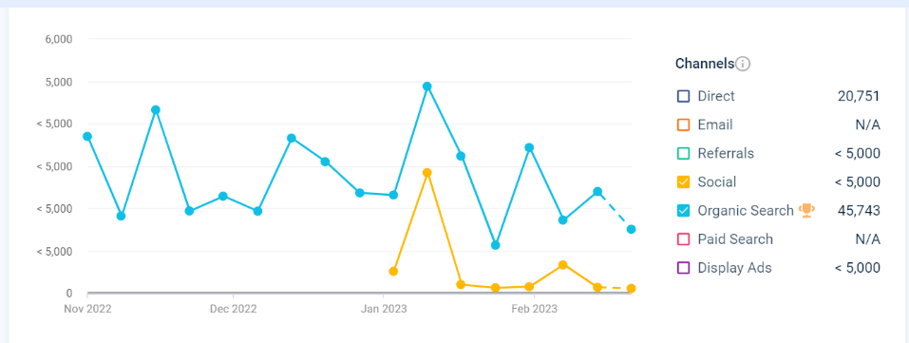

Appendix 2:
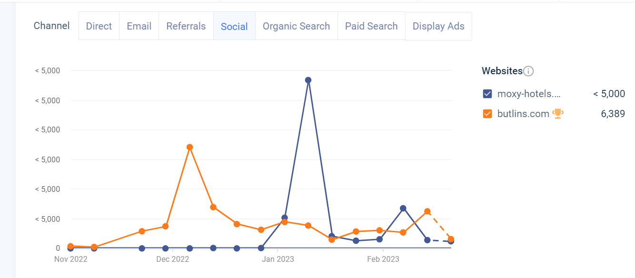

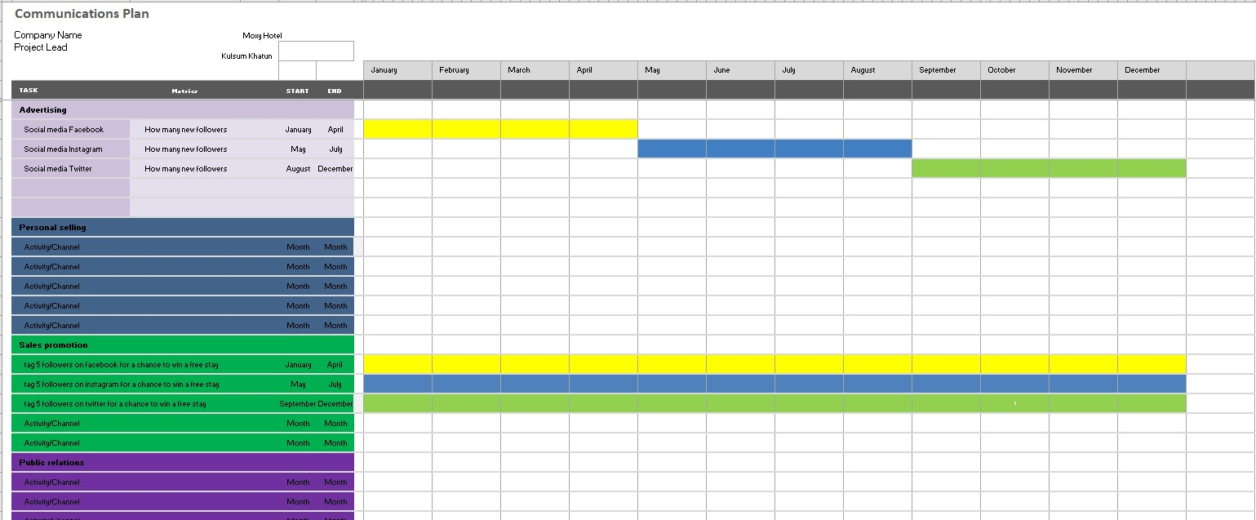
Appendix 3

Marketing plan presentation slides:


