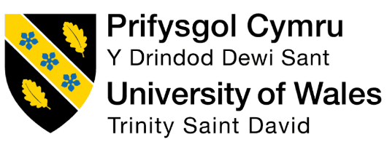

Name: Yasin Farooq
Student ID: 2337209
Module Code: LCBB 4013
Module: Stakeholders Engagement
Lecturer: Nishi Ramsurrun

Stakeholder Management Plan for the Proposed Leeds Public Park Project
Table of Contents
1 Introduction 1
1.1 Project background and context 1
1.2 Relevance and Purpose of the Project 1
1.3 Identification of six key stakeholders 1
1.4 How each stakeholder benefits 2
2 Application: Stakeholder Engagement Strategies 2
2.1 Stakeholder analysis using power, influence and interest 2
2.2 Justification of Stakeholder map and quadrant 3
2.3 Communication Plan 6
2.4 Consultation strategy and engagement approach 7
3 Ethical Consideration in Stakeholder Consultation, Participation and Feedback. 8
3.1 Consultation methods and ethical purpose 8
3.2 Ethical issues in data collection and consent 8
3.3 Bias and representational fairness 9
3.4 Diversity, Equity and Inclusion 9
3.5 Feedback collection and review process 10
4 Conclusion and Reflection 10
4.1 Conclusion 10
4.2 Reflection on learning 11
5 Reference list 14
6 Appendices 19
6.1 Appendix A 19

List of Figures
Figure 1: Identification of six key stakeholders in the proposed Leeds public park project 2
Figure 2: General stakeholder relationship model illustrating the Organisation and its wider stakeholder environment 4
Figure 3: Stakeholder Power–Interest Map for the Proposed Leeds Public Park Project 5
Figure 4: Communication plan for the proposed Leeds public park project 7
Figure 5: Kolb’s reflective learning framework applied to the reflection section 13

Introduction

Project background and context
This portfolio suggests the creation of a new community park on the city land that is not utilized in Leeds. The park is proposed to be multifunctional open green area which includes walking paths; a children play area, seating, lighting, natural planting and zone of biodiversity. The given type of project is applicable in Leeds since the parks and green spaces policy in the city highlights that the presence of community green spaces helps individuals to leisure, exercise, improve community cohesion, as well as promote biodiversity and local environmental quality (Leeds City Council, 2022). Leeds planning guidance also mentions that accessible green space must also offer safe physical activity, play and contact with nature, and enhance air quality and ecological value.

Relevance and Purpose of the Project
The project park matters since the availability of quality green space helps in physical wellbeing, mental health, and social integration. The Health and Wellbeing Strategy of Leeds provides that local parks and green spaces positively influence mental and physical well-being and must be available to every community. Recent scholarly literature also demonstrates that the size, connectivity, paths, and seating characteristics of green spaces correlate with a better psychological and physical health effect (Zhang and Tan, 2019; Ye et al., 2024; Yi et al., 2025).

Identification of six key stakeholders
This project has six stakeholders, which are local residents, Leeds City Council, the planning authority, environmental or community groups, local businesses and contractors or developers. These categories have direct connection in terms of project approval, delivery, daily use, environmental control and local economic influence.
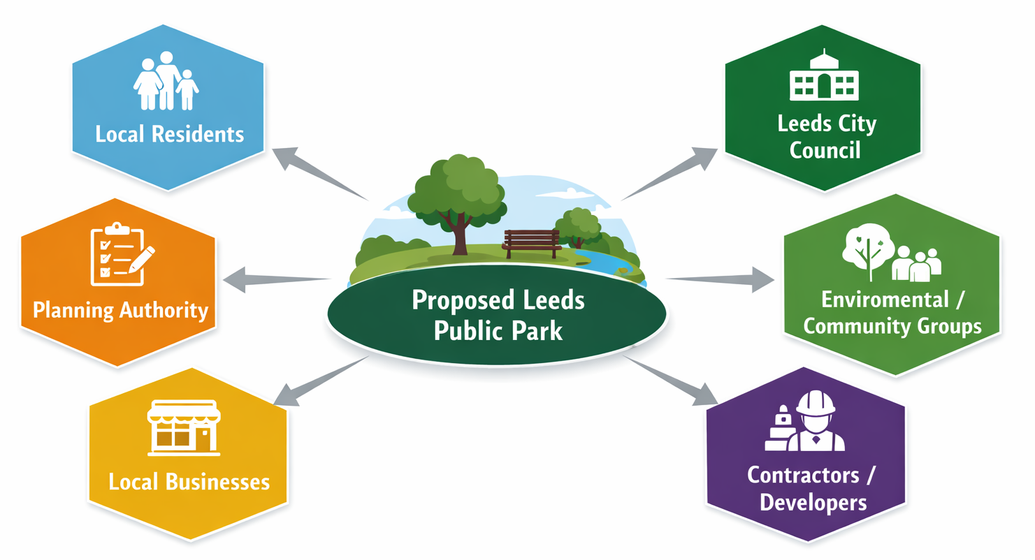
Figure 1: Identification of six key stakeholders in the proposed Leeds public park project

How each stakeholder benefits
The positive effects are that residents enjoy recreation and wellbeing; the council enjoys urban enhancement and social value; planners enjoy sustainable place-making; environmental organizations enjoy biodiversity access; business enjoys increased foot has been made; and contractors have enjoyed delivery work. When access is properly designed, inclusive green space can also be used to enhance participation among the disadvantaged groups ((Tabas et al., 2024)

Application: Stakeholder Engagement Strategies

Stakeholder analysis using power, influence and interest
Stakeholder analysis is applied to determine which stakeholders are the most powerful in influencing the project results and thus should be addressed by management to varying degrees of attention (Freeman and Phillips, 2002). Stakeholder literature in the context of project proposes the theory of stakeholders to be at the center, as project success lies in the ability to balance the interests of many groups as opposed to concentrating on time, the cost and scope (PMI, 2023; Prabhakar, 2019). Practically, this can be operationalized by means of power-interest matrix that can assist in grouping the stakeholders based on their capacity to influence the decisions and their interest in the project (Cernikovaite, 2019). This is significant to a proposed public park since the plan entails public land use, community wellbeing, quality of the environment, and political legitimacy of the locality. The studies of the green infrastructure in cities reveal that the perceptions of the stakeholders affect the adoption of the project and the social value of green (Nastran et al., 2022).
Much of the power, influence and interest in Leeds City Council is high due to the fact that it is a sponsor, land-use decision maker, and the custodian of the public value. The power of the planning authority is also strong as the statutory approval is necessary to the project in continuation. The power of local residents tends to be less official, yet the interest is great since the park influences the daily life, safety, recreation and neighborhood identity. The environmental and community groups might not dictate approval but in areas where the biodiversity, accessibility or landscape issues create formal objections or reputational pressure, they can become significant. Close proximity businesses are not central as compared to residents, yet they are important since construction and higher pedestrian traffic can have an impact on trading terms. Contractors cannot be underestimated in the course of delivery: their strategic power is less than that of the council, but their operational power is great due to the fact that the quality of the implementation, safety and timekeeping are in their hands. In this analysis, the stakeholder theory is applicable since various groups define various types of value and risk throughout the project lifecycle (Mahajan et al., 2023). A detailed power–influence–interest table of the key stakeholders is provided in Appendix A and informs the stakeholder mapping and engagement strategy discussed below.

Justification of Stakeholder map and quadrant
The stakeholder map is an extension of the analysis discussed earlier in that it makes the analysis practical by rendering a theoretical framework into an actual engagement system (Freeman, 2023 ; Krkac, 2023). On the basis of the reasoning of the power interest matrix, the stakeholders are segmented based on the degree of attention they need on the part of the manager: handle closely, remain satisfied, remain informed and spy on (Holtzhausen, Fullerton and Lewis, 2025). The studies prove the fact that this sort of visual plotting is still efficient as it helps managers to differentiate between formal authority, contextual influence, and different degrees of stakeholder concern (Bourne and H.T. Walker, 2020; Ugural and Aghili, 2026). The stakeholder theory also lends credence to this strategy in the fact that it notes that projects can only generate value when the interests of various groups impacted by the projects are realized and addressed instead of being viewed as minor to delivering the technical aspect (O’Riordan, 2021;Gutterman, 2023). In Figure 2, a general relationship model of stakeholders has been provided in which it is evident that organisations work within a wide network of stakeholders whose interests may influence the Organisation decision and outcome.
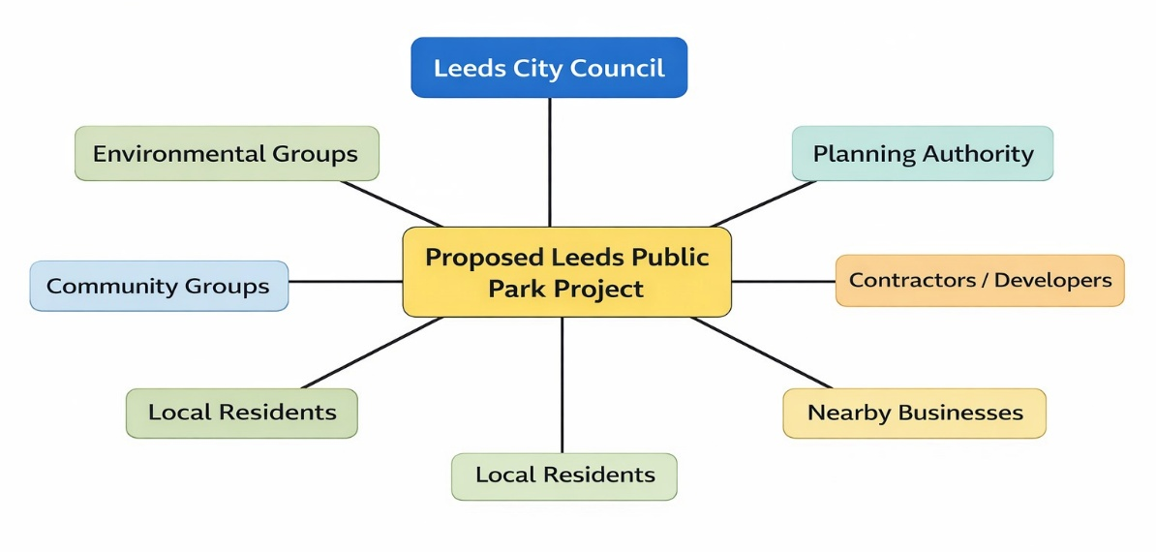
Figure 2: General stakeholder relationship model illustrating the Organisation and its wider stakeholder environment
Source: (Mamun, 2024)
The Leeds City Council fits into the category of manage closely, since it has a high degree of authority in making decisions and the direct interest of regeneration of the local area, wellbeing and delivery of policies in the locality. The planning authority also is in a better position as it can accomplish its goal of keeping satisfied given its high level of authority; however, it has high levels of involvement that are more likely to be regulatory and not relational or community-based. The local community groups and the residents fit into this category since they are more informed as their formal authority is less, yet their interest is high and their backing is essential to the project legitimacy. A well-structured residents’ association might in certain instances, move towards taking a more proximate position especially in scenarios where opposition takes a political turn. The environmental groups also occupy the seat of keep updated, but its power can be very high in case some ecological objections are raised. Monitor is generally the most appropriate area to have nearby businesses as they are the ones with less direct interests than residents, yet they might be concerned about any disturbance and presence of visitors. Contractors are unique since their salience varies with time: prior to approval they are less central, whereas during implementation they need to be tightly managed since they are so influential on cost, quality, schedule and community-related construction behaviour (Langston, 2022). It demonstrates the dynamic nature of importance of stakeholders and not fixed . To translate the stakeholder analysis into a practical engagement framework, Figure 3 maps the key stakeholders according to their relative power and interest in the proposed Leeds public park project
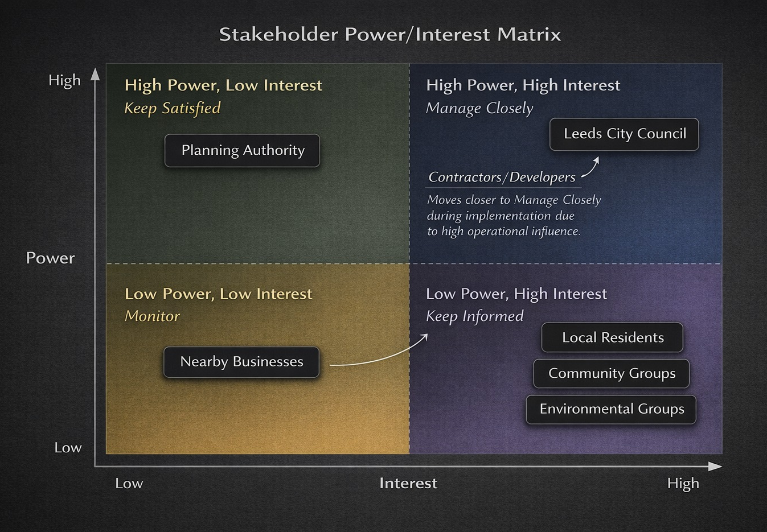
Figure 3: Stakeholder Power–Interest Map for the Proposed Leeds Public Park Project

Communication Plan
A communication plan is the operationalization of the stakeholder theory that transforms the analysis into a personalized engagement (Shah and Guild, 2022; Limani et al., 2024). According to the recent developments in the field of project management, the quality of communication is tangentially connected with stakeholder satisfaction, trust and net project performance, especially when various actors may have different expectations and information requirements (Borsch, 2022; Ali, Rehman and Qadeer, 2025). Digital participation tools are suitable in the context of urban planning by enhancing the sense of engagement, although, in this respect, digital participation tools have the greatest potential when used in conjunction with more traditional ones instead of as an alternative to them (Goncalves et al., 2025). This implies that communication to a public park has to be focused and not standardized.
Various channels are required since the stakeholders will not have the same interaction with the project. The residents need regular and easy access to communication since they are the primary end user and which directly impact the design and construction decisions. The planners and council officers require written reports since their work is related to governance and compliance. Workshop-based dialogue is advantageous to the environmental groups since the technical issues pertaining to biodiversity, tree cover and inclusion are usually better discussed instead of being updated in one way. Businesses require realistic, opportune notifications regarding access and disruption. The frequent operational briefings of contractors are essential since the risks of the delivery are revealed in a short time on the site. Such a focused approach is more powerful than a one-size-fits-all strategy since it integrates message type and format and timing with the salience and information needs of the stakeholders. Figure 4 summarizes the communication plan for the main stakeholders involved in the proposed Leeds public park project
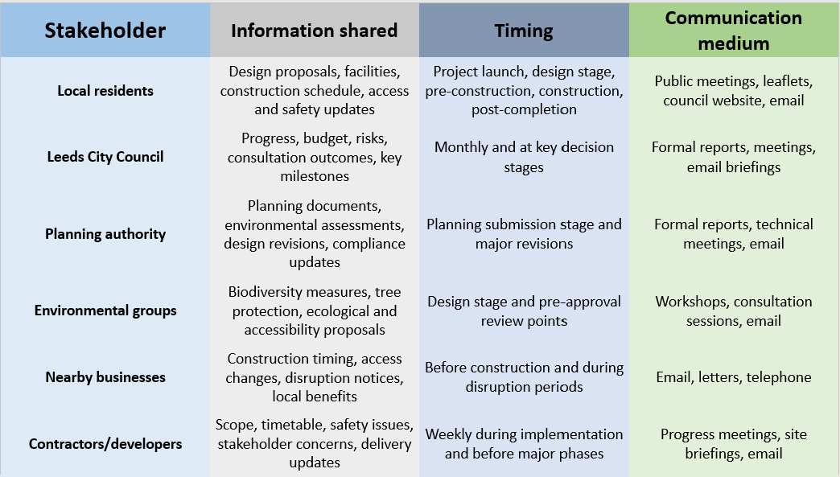
Figure 4: Communication plan for the proposed Leeds public park project

Consultation strategy and engagement approach
The consultation plan or the proposed Leeds public park project must integrate face-to-face meetings, Web-based surveys, drop-ins, focus groups, local notice boards and council consultation Web page. Theoretical grounding in this is the participatory approach to planning where it is believed that the communities being impacted should not be informed but should be given a chance to influence the results in a meaningful manner (Duea et al., 2022; Sebunya and Gichuki, 2024). Studies of urban engagement indicate that engagement no longer happens in a bare consultation style, but has shifted to more collaborative types of engagement, and digital tools can reach a wider audience when deployed in conjunction with face-to-face solutions, but not in place of them (Horlings et al., 2021) . The urban green and nature-based planning research also reveals that the perception of different stakeholders can vary significantly between groups, and in such a case, the engagement may enable issues of concern and preferences to emerge early in the process (Nastran et al., 2022).
In the case of this park, preliminary consultation during concept should be done to check the local needs, pre-planning consultation should be done to get opinions on the design, safety and biodiversity, planning stage consultation should be done to respond to the objections clearly and finally, post-completion consultation should be done to determine whether the park is delivering as per expectation. Such a mixed approach is suitable as it will reach all age groups, integrate digital and non-digital participation, increase transparency, and find out support or resistance before the conflict goes out of control. It is thus a manifestation of both the stakeholder theory and participatory planning because it views consultation as a relationship-building and problem-solving process as opposed to a formal process.

Ethical Consideration in Stakeholder Consultation, Participation and Feedback.

Consultation methods and ethical purpose
The transparency, fairness, respect, proportionality and accessibility should be the building blocks of the ethical consultation (Tursunbayeva et al., 2021). Theoretically, this would shape up with procedural justice which contends that only when individuals are able to comprehend the process, perceive the way decisions are being made and feel that they are fairly treated can they be able to participate. The new stakeholder-engagement literature also highlights the ethical roots of stakeholder theory, in that projects must transcend limited management in favor of more inclusive sorts of stakeholder engagement that acknowledge marginalized stakeholders and the value of the wider populace. In the case of a proposed public park, ethical engagement thus does not only involve seeking opinions, it is also about making stakeholders to be involved in a way that it is meaningful and dignified.

Ethical issues in data collection and consent
Surveys, interviews, meeting sign-ins and online forms are the common characteristics of consultation and therefore ethical engagement should entail responsible data practice (Roberts and Allen, 2018). In this case, the topics of information ethics and privacy-by-design thinking are applicable to the case because the stakeholders are supposed to be aware of the personal information that is being gathered, why it is required, how it will be used, and the duration of storing it. The new guidance issued by the UK ICO emphasizes that the right to be informed is one of the requirements of the UK GDPR that organizations should provide people with clear and concise information about privacy (ICO, 2023). Practically, it implies that the documents to be consulted when dealing with the park must contain informed-consent wording, confidentiality wording where necessary, valid justification to processing of responses and the provision of safe storage of names, contact as well as written comments. These ensure that trust is fortified and there is a lower possibility of the participation process being extractive or opaque.

Bias and representational fairness
One of the greatest areas of ethical issue is representational bias (Howard, 2018). Without consultation based on the public meetings or digital form, the voice of the most vocal or confident individuals can prevail, and less vocal residents, carers, renters, young people or those with limited digital access can be overlooked (Carlos et al., 2019). The procedural-justice studies provide that identification and engagement of stakeholders may turn out to be unfair, when the process of inclusion is conditioned by convenience, historical presumption or partial mapping. The recent research on digital exclusion also indicates that individuals cannot equally engage in digitally related processes in government, and the same can replicate inequality unless inclusion is planned intentionally (Djatmiko, Sinaga and Pawirosumarto, 2025). The bias should then be minimized by having several channels of consultation, neutral questions, open reporting of participants involved, and equal sampling of neighborhood groups.

Diversity, Equity and Inclusion
The aspect of diversity, equity and inclusion (DEI) is particularly essential to consider in a project like a public park since the park is destined to be used by many people in the community (Yogev, 2024). Recent planning studies on accessibility and social inclusion in nature-based and other public-space environments indicate that equal access is not a given; instead, it has to be structured both into the space and the process of participation. The identical logic is backed by research on the inclusive co-design of a public space, which emphasizes that the needs of various users must be considered in the design of a public space and not just the preferences of dominant groups. Because of this reason, older people, disabled users, families with children, minority groups, people who do not have access to the internet and, in some cases, non-native English speakers should be actively consulted. An easy venue, access via wheelchairs, using plain language, translated material where necessary, day and evening consultation hours, online and offline channels of participation should be considered as practical measures. This enhances not just equity but also quality of local knowledge acquired on safety, play, seating, lighting, accessibility and biodiversity.

Feedback collection and review process
The feedback can be gathered via surveys, drop-in, focus groups and submitted in writing and then be sorted by the themes (access, safety, facilities and environmental concerns). There should be a clear process of review, demonstrating issues that were approved, dismissed or modified and the reasons. The explicit procedural justice is consistent with this approach of closing the loop in that perceived participation is visible and accountable, and decision-relevant and not symbolic.

Conclusion and Reflection

Conclusion
Finally, the stakeholder engagement is the core of the success of the proposed public park as the value of the project is not only in the physical delivery, but the perception of whether it is perceived as a valid, useful and inclusive project by the people it will impact on. In recent stakeholder-engagement studies, it has been established that project success grows more and more reliant on cooperative and inclusive relationships as opposed to technical control. In the case of this park, the most essential stakeholders are Leeds City Council, or the planning authority, the local residents, the environmental, as well as the community groups, the local businesses, or the contractors, but the council and residents are particularly important, as one of them offers the formal authority and the other the value of the legitimacy of the use and the long-term use.
Individualized communication and consultation are important since the stakeholders are not equally powerful with information needs/concerns. An individual approach enables the project team to interact with regulators in a formal manner, in a consultative manner with the community groups and in an informal manner with the residents, which enhances trust and minimization of unnecessary conflict. The urban community-engagement research points to meaningful engagement as being an indicator of improved knowledge collection, higher conformity to local requirements and more robust success. Long term sustainability of the park is also enhanced because of ethical and inclusive involvement. The body of knowledge about the role of green spaces in the cities reveals that new green projects may perpetuate inequality unless the access to green spaces, their representation, and environmental justice are approached with attention. Hence, clear, equitable and open stakeholder management will not be an added feature to this project; it will be a precondition of a socially acceptable park, ecological and sustainable in the long run.

Reflection on learning
Based on the Reflective Cycle designed by Kolbs, this assignment helped understand that stakeholder engagement is not as simple a task as encompassing a list of interested parties. Recent reflection literature has observed that structured reflective paradigms can assist learners to go beyond description into analysis and action-population, which can be applied in this case since the stakeholder management necessitates both process and judgement (Dutta, 2023).
What? I came to know that the process of stakeholder identification is just a beginning. What is more imperative to do is to understand the disparities that lie between their power, influence, interest and values. E.g. the residents might be less formally authorized as compared to the council, however, their opinion highly influences the legitimacy and long-term acceptability. This demonstrated to me that project relationships cannot be entirely hierarchical.
So what? This is important since a lack of proper engagement may spoil projects despite having a good design. In the event of weak consultation, unilateral or unavailable, issues can arise too late, trust may be lost and popular opposition may increase. The literature on community engagement and urban green-space justice indicates that inclusive engagement leads to a better quality of decisions and prevents situations in which particular groups are better off than others. I also got to know that communication should be adjusted to the needs of stakeholders. Residents might have a better reception to plain-language updates, meetings with visible feedback loops, whereas a formal report might have been effective with planners.
Now what? As a stakeholder manager in the future, I will put more emphasis on early mapping, inclusive consultation design, and clear description of the impact of feedback on decision. I would also address ethics as a project quality concern instead of an independent compliance challenge. In general, this assignment demonstrated that stakeholder engagement is effective in the delivery of projects, as well as trust, equity, and sustainability in the long-term.
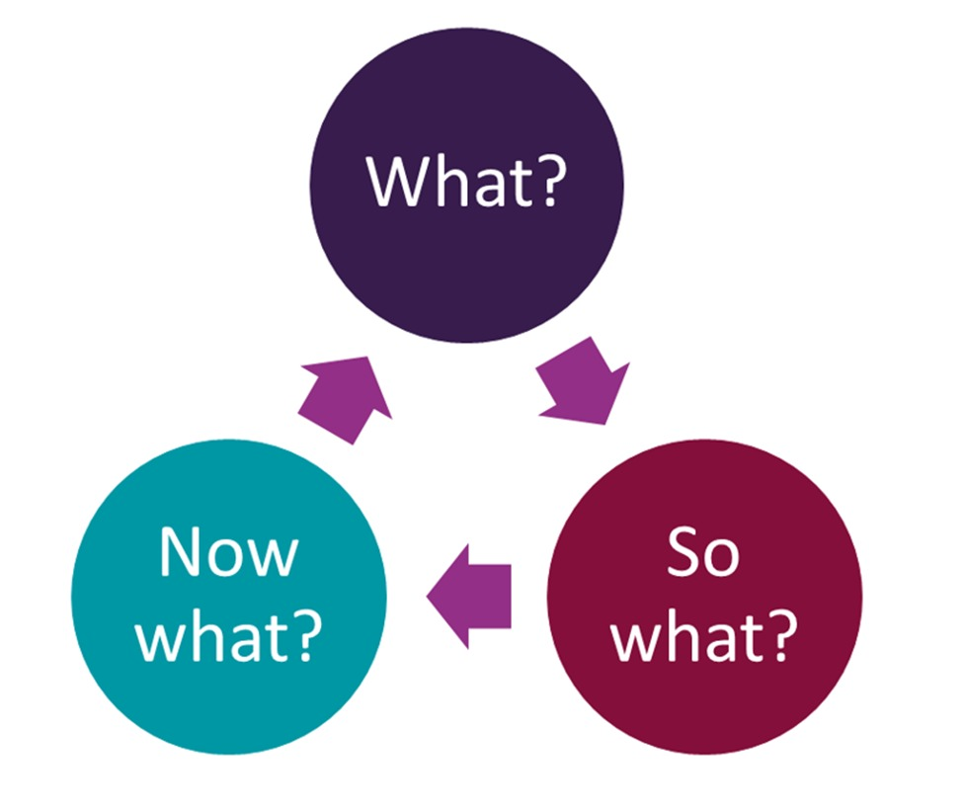
Figure 5: Kolb’s reflective learning framework applied to the reflection section

Reference list
Ali, M., Rehman, S.U. and Qadeer, A. (2025). Fulfilling Stakeholder Needs and Concerns: A Path to Satisfaction in Construction Projects. Construction technologies and architecture, [online] 17, pp.73–80. doi:https://doi.org/10.4028/p-5rmm6f.
Borsch, P. (2022). The Role of Project Management Standardization in SMEs: Analyzing the Linkages Between Knowledge Management, Project Management, and Stakeholder Satisfaction. [online] Uwasa.fi. Available at: https://osuva.uwasa.fi/items/ca863e1b-bf8b-4a04-a323-35bdc0fbbc88.
Bourne, L. and H.T. Walker, D. (2020). Visualizing and mapping stakeholder influence. [online] ResearchGate. Available at: https://www.researchgate.net/publication/235299660_Visualising_and_mapping_stakeholder_influence.
Carlos, J., Young, A.G., Myers, M.D., Bedeley, R.T. and Wigdor, A. (2019). Giving voice to the voiceless: The use of digital technologies by marginalized groups. Communications of the Association for Information Systems. [online] Available at: https://www.researchgate.net/publication/333034416_Giving_voice_to_the_voiceless_The_use_of_digital_technologies_by_marginalized_groups.
Cernikovaite, M. (2019). The impact of influencer marketing on consumer buying behavior in social networks. Vilniustech.lt. doi:https://doi.org/9786094761614.
Djatmiko, G.H., Sinaga, O. and Pawirosumarto, S. (2025). Digital Transformation and Social Inclusion in Public Services: A Qualitative Analysis of E-Government Adoption for Marginalized Communities in Sustainable Governance. Sustainability, [online] 17(7), pp.2908–2908. doi:https://doi.org/10.3390/su17072908.
Duea, S.R., Zimmerman, E.B., Vaughn, L.M., Dias, S. and Harris, J. (2022). A Guide to Selecting Participatory Research Methods Based on Project and Partnership Goals. Journal of Participatory Research Methods, [online] 3(1). Available at: https://pmc.ncbi.nlm.nih.gov/articles/PMC9258244/.
Dutta, S. (2023). Gibbs’ reflective cycle (Adapted from Gibbs, 1988). [online] ResearchGate. Available at: https://www.researchgate.net/figure/Gibbs-reflective-cycle-Adapted-from-Gibbs-1988_fig1_371536633.
Freeman, R.E. (2023). Stakeholder Management: Framework and Philosophy. Issues in business ethics, [online] 53(1), pp.61–88. Available at: https://link.springer.com/chapter/10.1007/978-3-031-04564-6_3.
Freeman, R.E. and Phillips, R.A. (2002). Stakeholder Theory: A Libertarian Defense. Business Ethics Quarterly, 12(3), pp.331–349.
Goncalves, J.E., Slingerland, G., Sarabi, S. and Dane, G. (2025). Do Digital Tools Empower Citizens in Urban Planning? Evaluating Digital Tools Through the Lens of Human-Computer Interaction. 19th International Conference on Computational Urban Planning and Urban Management. [online] Available at: https://www.researchgate.net/publication/393446429_Do_Digital_Tools_Empower_Citizens_in_Urban_Planning_Evaluating_Digital_Tools_Through_the_Lens_of_Human-Computer_Interaction.
Gutterman, A.S. (2023). Stakeholder Theory. [online] ResearchGate. Available at: https://www.researchgate.net/publication/369194606_Stakeholder_Theory.
Holtzhausen, D., Fullerton, J.A. and Lewis, B.K. (2025). Stakeholders. Principles of Strategic Communication, pp.139–166. doi:https://doi.org/10.4324/9781032626291-7.
Horlings, L.G., Lamker, C., Puerari, E., Rauws, W. and van der Vaart, G. (2021). Citizen Engagement in Spatial Planning, Shaping Places Together. Sustainability, 13(19), p.11006. doi:https://doi.org/10.3390/su131911006.
Howard, J.C. (2018). Representativeness Bias. pp.425–443. doi:https://doi.org/10.1007/978-3-319-93224-8_24.
ICO (2023). Right to be informed. [online] ico.org.uk. Available at: https://ico.org.uk/for-organisations/uk-gdpr-guidance-and-resources/individual-rights/individual-rights/right-to-be-informed/.
Krkac, K. (2023). Stakeholder Mapping. Springer eBooks, pp.3117–3123. doi:https://doi.org/10.1007/978-3-031-25984-5_353.
Langston, C. (2022). The empirical relationship between contractor success and project innovation. Engineering, Construction and Architectural Management, ahead-of-print(ahead-of-print). doi:https://doi.org/10.1108/ecam-05-2021-0460.
Leeds (2022). Leeds City Council elections | Leeds.gov.uk. [online] Leeds.gov.uk. Available at: https://www.leeds.gov.uk/elections/leeds-city-council-elections [Accessed 15 Mar. 2026].
Limani, E., Hajdari, L., Limani, B. and Krasniqi, J. (2024). Enhancing stakeholder engagement: Using the communication perspective to identify and enhance stakeholder communication in place management. Cogent Business & Management, [online] 11(1). doi:https://doi.org/10.1080/23311975.2024.2383322.
Mahajan, R., Lim, W.M., Sareen, M., Kumar, S. and Panwar, R. (2023). Stakeholder Theory. Journal of Business Research, [online] 166(1). doi:https://doi.org/10.1016/j.jbusres.2023.114104.
Mamun, A. al (2024). Figure 2. Stakeholder theory. [online] ResearchGate. Available at: https://www.researchgate.net/figure/Stakeholder-theory_fig2_273743680.
Nastran, M., Pintar, M., Železnikar, Š. and Cvejić, R. (2022). Stakeholders’ Perceptions on the Role of Urban Green Infrastructure in Providing Ecosystem Services for Human Well-Being. Land, 11(2), p.299. doi:https://doi.org/10.3390/land11020299.
O’Riordan, L. (2021). Stakeholder Value Creation. Encyclopedia of Sustainable Management, pp.1–10. doi:https://doi.org/10.1007/978-3-030-02006-4_369-1.
PMI (2023). Revisiting the definition of project success. [online] Pmi.org. Available at: https://www.pmi.org/learning/library/revisiting-definition-project-success-6098.
Prabhakar, G.P. (2019). (PDF) What is Project Success: A Literature Review. [online] ResearchGate. Available at: https://www.researchgate.net/publication/41891079_What_is_Project_Success_A_Literature_Review.
Roberts, L.D. and Allen, P. (2018). Exploring ethical issues associated with using online surveys in educational research. [online] ResearchGate. Available at: https://www.researchgate.net/publication/275104401_Exploring_ethical_issues_associated_with_using_online_surveys_in_educational_research.
Sebunya, J. and Gichuki, A. (2024). The Impact of Participatory Planning on Sustainable Development: A Literature Review. Journal of strategic management., 4(4), pp.1–9. doi:https://doi.org/10.70619/vol4iss4pp1-9.
Shah, M.U. and Guild, P.D. (2022). Stakeholder engagement strategy of technology firms: A review and applied view of stakeholder theory. Technovation, 114, p.102460. doi:https://doi.org/10.1016/j.technovation.2022.102460.
Tabas, A.M., Rehman, M.A., Khitous, F. and Urbinati, A. (2024). Stakeholder and customer engagement in circular economy ecosystems: A systematic literature review and research agenda. Business Strategy and the Environment. doi:https://doi.org/10.1002/bse.3989.
Tursunbayeva, A., Pagliari, C., Di Lauro, S. and Antonelli, G. (2021). The ethics of people analytics: Risks, opportunities and recommendations. Personnel Review, 51(3), pp.900–921. doi:https://doi.org/10.1108/PR-12-2019-0680.
Ugural, M.N. and Aghili, S. (2026). Addressing stakeholder dynamics in megaprojects: a framework for governance. Engineering, Construction and Architectural Management, [online] pp.1–24. doi:https://doi.org/10.1108/ecam-07-2025-1219.
Ye, X., Ren, X., Shang, Y., Liu, J., Feng, H. and Zhang, Y. (2024). The role of urban green spaces in supporting active and healthy ageing: an exploration of behaviour–physical setting–gender correlations. ArchNet-IJAR. doi:https://doi.org/10.1108/arch-04-2023-0096.
Yi, K., Shi, X., Wei, M. and Zhang, Z. (2025). Benefits of Various Urban Green Spaces for Public Health Based on Landscape Elements: A Study of Public Visual Perception. Forests, [online] 16(4), pp.648–648. doi:https://doi.org/10.3390/f16040648.
Yogev, Y. (2024). Equity and Inclusion in the National Park Service: Historical Challenges, New Possibilities. pp.153–177. doi:https://doi.org/10.1007/978-3-031-74653-6_7.
Zhang, L. and Tan, P. (2019). Associations between Urban Green Spaces and Health are Dependent on the Analytical Scale and How Urban Green Spaces are Measured. International Journal of Environmental Research and Public Health, 16(4), p.578. doi:https://doi.org/10.3390/ijerph16040578.

Appendices

Appendix A
Table 1: Power–Influence–Interest Matrix
Stakeholder | Power | Influence | Interest | Justification
Leeds City Council | High | High | High | Controls funding, land allocation, governance and strategic approval.
Planning authority | High | High | Medium | Holds statutory authority to approve, amend or delay the scheme.
Local residents | Medium | Medium | High | Main users of the park; can support, oppose or reshape the project through consultation and public pressure.
Environmental/community groups | Medium | High | High | Can influence public debate, biodiversity expectations and planning scrutiny.
Nearby businesses | Low | Medium | Medium | Limited formal authority, but affected by visitor flows, access and disruption.
Contractors/developers | Medium | High | Medium | Strong operational influence during implementation, although less strategic authority before approval.

