

Do front-line officers feel desensitised to Domestic Abuse (DA) and to what extent?

Cameron Keegans
2319868

BSc (Hons) Professional Policing Practise

Acknowledgements
I would firstly like to thank to thank my university supervisor for their continuous support, advice and knowledge during this period. I am very grateful for all her support, including the group and individual sessions.

Secondary, I would like to thank my work colleagues in helping me complete this dissertation, who were able to provide me with their knowledge, experience and advice on how to balance the work life balance along with a lot of support.

Finally, I would also like to thank my friends, family and girlfriend who have shown me a tremendous amount of support, motivation through this three-year period and without their help, completing this project would have been very difficult.

Declarations:
- Declaration - This work has not previously been accepted in substance for any degree and is not being concurrently submitted in candidature for any degree. Signed: C. Keegans Date: 13/06/2026

- Statement 1 - This dissertation is being submitted in partial fulfilment of the requirements for the degree of BSc. Signed: C. Keegans Date: 13/06/2026

- Statement 2 - This dissertation is the result of my own independent work/investigation, except where otherwise stated. Other sources are acknowledged by footnotes giving explicit references. A bibliography is appended. Signed: C. Keegans Date: 13/06/2026

- Statement 3 - I hereby give consent for my dissertation, if accepted, to be available for photocopying and for interlibrary loan, and for the title and summary to be made available to outside organisations. Signed: C. Keegans Date: 13/06/2026

- Statement 4 - I hereby give consent for my dissertation, if accepted, to be available on the university’s IT system to those who have consent to use the system. Signed: C. Keegans Date: 13/06/2026

Abstract:
This dissertation critically explores whether front-lines police officers develop feelings of desensitisation due to repeat exposure to domestic abuse (DA) incidents and examines how these feelings contribute to officers’ wellbeing and operational decision-making. A mixed methods approach was utilised, using an anonymous questionnaire completed by front-line police officers. The use of both quantitative and qualitative data was analysed to identify common themes linked to professional judgement, emotional responsiveness and officer wellbeing.
The findings found that many participants reported that they felt less emotionally effected by DA incidents over a prolonged period of time, which suggests that repeat exposure to DA incidents contributed to feelings of officer desensitisation. Some officers reported that they felt that by developing these feelings of officer desensitisation, it was beneficial by improving their confidence, assisting their decision- making and regulating their emotion when dealing with intense incidents.
Overall, desensitisation is a complex emotional response that can enable officers to build resilience operationally, however it may also have a negative effect on officer wellbeing. The research outlines the importance of organisational support to assist officers developing these feelings and provide a deeper understanding into an under-researched area of front-line policing.

Aims and objectives
This dissertation will aim to examine whether front-line police officers experience feelings of desensitisation as a result of repeat exposure to domestic abuse incidents and examine the extent to which desensitisation influences decision-making and officer wellbeing.

Research objectives
How does repeat exposure to domestic abuse contribute to officers feelings of desensitisation?

To what extent does desensitisation impact officer decision making?

To what extent does desensitisation impact officer wellbeing?

Contents page

Chapter One – Introduction (Page 7)

Chapter Two – Literature Review (Pages 8-12)
2.1 – Introduction
2.2 – Desensitisation in context
2.3 – Policing and repeat exposure to Domestic Abuse
2.4 – Desensitisation and decision making
2.5 – Desensitisation and wellbeing
2.6 – Gaps in literature and rational
2.7 – Conclusion

Chapter Three – Research Methodology (Pages 13-15)
3.1 – Introduction
3.2 – Research Philosophy
3.3 – Research Design
3.4 – Sampling Strategy
3.5 – Data Collection
3.6 – Data Analysis
3.7 – Ethical Considerations
3.8 – Limitations

Chapter Four – Analysis of Results (Pages 16-20)
4.1 – Introduction
4.2 – Participants characteristics
4.3 – Desensitisation through repeat exposure
4.4 – Impact of desensitisation on decision making
4.5 – Impact on officer wellbeing
4.6 – Organisational support
4.7 – Conclusion
Chapter Five – Findings, Conclusion and Recommendations (Pages 21-23)
5.1 – Introduction
5.2 – Key Findings
5.3 – Recommendations for policing
5.4 – Limitations
5.5 – Recommendations
5.6 – Conclusion

Chapter Six – References (Pages 24-26)

Chapter One – Introduction
Domestic Abuse (DA) call types remain one of the most complex and resource intensive call types across the United Kingdom (UK). According to the Office for National Statistics (2024), DA call types place a high amount of pressure on forces due to the high volume of call demand across the UK, with these call types being resource intensive due to the abusive nature of these incidents. Front-line police officers will likely will the first emergency responders to arrive at the scene, meaning they will play a vital role in gathering evidence and safeguarding victims. However, as a result of front-line officers being the first on scene, they are exposed to traumatic experiences on a regular basis.
Due to the high frequency of front-line officers attending these traumatic incidents, it has raised concerns into the potential effects that may occur as a result of repeat attendance. Police officers are expected to remain professional and show empathy. However, repeat exposure may hinder these standards over a prolonged period. Previous literature carried out suggests repeat exposure to distressing stimuli can be attributed to officers developing feelings of desensitisation (Figley, 1995). This may influence officers’ decision making and wellbeing whilst responding to DA call types.
Despite there being previous research surrounding the effects that front-line police officers develop, such as stress, burnout and trauma fatigue. However, there is limited research exploring the link between officers developing desensitisation when frequently attending DA call types. Understanding how often desensitisation occurs is vital for officer wellbeing and the quality of service provided to the victims.
This dissertation is split into 5 main chapters. Chapter one is the introduction to the review. Chapter two provides an overview of previous literature carried out surrounding officer desensitisation, wellbeing and decision making. Chapter three explains the research methodology, along with the structure, design, data collection methods and ethical considerations. Chapter four introduces the analysis of results, comparing desensitisation through repeat exposure, impact of desensitisation on decision making, impact on officer wellbeing and organisational support. Chapter five includes the findings from the questionnaire, conclusion and any further recommendations for the future review. Finally, chapter six is the bibliography for all the reference used throughout the review.
This research aims to contribute to the overall prior knowledge surrounding front-line police officers’ wellbeing and decision-making. The findings from this study could potentially assist police forces gain a further understanding into the possible consequences desensitisation and encourage the development of strategies focusing on preserving officer wellbeing and adopting a victim-based style of policing, overall improving victim satisfaction.

Chapter Two – Literature Review
2.1 Introduction
With Domestic related incident support being in high demand across the UK, accounting for 15.4% of all offences (Office for National Statistics ONS, 2024) domestic abuse (DA) remains of the most common call type you experience as a response officer. Police officers are often the first people to respond to DA calls therefore playing an important role to ensure that safeguarding measures are put in place to protect victims and build trust with members of the community, which in turn will encourage victims to report incidents. However, due to the high volume of these calls, and repeat attendance from police officers, this can cause police officers to become desensitised which not only may affect decision making but in the long-term, affect their mental wellbeing.
Porter (2025) highlights how police officers who are repeatedly attending DA calls are placed under increased stress, which leads to emotional numbing and a decline in metal wellbeing. This literature review focuses on existing research carried out surrounding the topic of front-line police officers repeat exposure to domestic incidents with a particular focus on desensitisation, how this affects decision making and the negative effects it has on officer mental wellbeing.
2.2 Desensitisation in this context.
Desensitisation is defined as a “reduction in emotional responsiveness that develops following repeated exposure to distressing stimuli” (Figley, 1995). This links in with policing as front-line officers are repeatedly attending DA related calls due to the high call demand, often from the same victim, perpetrator and location. As a result of this repeated exposure, officers sometimes develop a sense of emotional numbing whereby it becomes difficult to treat each repeat call as a stand-alone instance led by empathy or compassion. In turn, this can affect their decision making. A study conducted by the American Psychiatric Association (2013), described this numbing response by officers as a “coping mechanism” due to the traumatic nature of the role. Developing this mechanism enables officers to continue with their role whilst suppressing their need for mental wellbeing support. Although these findings can be generalised and applied to this context, it is important to acknowledge that these findings are the result of research based in America.
Although desensitisation is going to remain a central theme throughout this chapter, it is important to note that this definition is also closely linked to burnout and compassion fatigue. Burnout is defined as repeat exposure to stressors within a job, which is heightened by exhaustion and reduced personal accomplishment (Maslach, Schaufeli and Leiter, 2021). Even though burnout is caused by exhaustion, there is no direct link to say that it is attributed to exposure to traumatic incidents such as DA calls. Conversely, burnout within policing is often linked to internal stressors such as high workloads and call demand. On the other hand, compassion fatigue is defined as “a state of emotional and physical exhaustion resulting from prolonged exposure to the suffering of others” (Figley 1995). Although desensitisation and compassion fatigue are closely related, compassion fatigue reflects emotional and physical exhaustion resulting from prolonged exposure as opposed to a reduction in emotional responsiveness. Therefore, is more closely aligned with definitions of burnout whereas desensitisation appears to initially function as a coping response.
Whilst the above definitions are closely linked and often appear interchangeable, it is important to recognise that they also each have nuanced involvements. Desensitisation is different from burnout and compassion fatigue as it focuses loss of emotional responsiveness that develops through repeat exposure to distressing incidents. Desensitisation is characterised by emotional numbness rather than empathy overload which allows officers to carry out their job effectively in high-risk situations (American Psychiatric Association, 2013). Therefore, desensitisation is the most fitting to assist me in examining the repeat exposure to DA incidents as it allows for the examination of the effects of frequent domestic exposure on emotional response and therefore, possible impact on officer wellbeing as well as decision making.
2.3 Policing and repeat exposure to Domestic Abuse
Police forces across the UK are being placed under pressure due to the high call demand for incidents of DA (Robinson, 2023). Within this demand, DA calls account for 6% of all calls in South Wales, of which 24% will be repeat victims (HMIC, 2014). The college of policing (2020), recognise that font line police officers are frequently attending DA calls, often with the same victim and locations. They also highlight that whilst officers are regularly attending the same victims and locations, there is lack of a long-term solution to assist officers with demand or safeguarding. College of policing (ibid), also emphasise that incidents of DA are not one-off incidents but a pattern of repeating and long-term behaviour which leads to officers being exposed to the same calls repeatedly. When faced with the same call from the same victim and location, this may create an emotional numbness throughout or across a career.
DA incidents place a high demand on forces across the UK and dealing with incidents such as these come with serious responsibilities such as safeguarding. As front-line police officers are typically the first to respond to these calls and with great frequency as discussed, it increases workload and heightens emotional demand (Myhill and Johnson, 2016). Myhill and Johnson (ibid) also highlight how repeat exposure to these calls can influence the officer's decision making, especially when the victims do not support prosecutions against the perpetrator. The findings from their research highlight that repeat exposure to DA calls causes officers to become emotionally numb due to the frequency of attending calls of a similar nature. This provides a good insight into how repeat exposure can have a negative effect on officer mental wellbeing, decision making and victim confidence.
Loftus (2010), in her research paper further highlights how repeated attendance to ‘violent’ calls becomes normalised due to the frequency of encountering DA incidents. As a result of officers normalising these types of incidents, it can make it harder to differentiate between what is seen as normal or more serious. This is compounded by the actuality that these DA calls is a daily occurrence for many front-line police officers. This is further supported by Reiner (2010), who states that violence within DA calls is normalised and culturally accepted as “part of the job”. Having this view can influence the decision making for attending officers as they might not identify the actual or potential danger that often comes with the calls, which may increase risk to victims and raise concern for safeguarding.
2.4 Desensitisation and decision making
A key role for front-line police officers upon attending a DA related incident will be to conduct a risk assessment of the situation that they are faced with. Making the correct risk assessment will enable to officers to put the correct level of safeguarding in place for the victim. However, officers risk assessments can vary based on experience, life experiences and empathy. This is highlighted by Myhill and Hohl (2023), who labelled this as the “officer effect”. This study suggests that the grading of risk assessments will fluctuate depending on the officer completing the assessment. The grading of the assessment will be affected by the officer's own empathy and emotional engagement towards the victim. This study highlights how an officer's emotional engagement or lack there-of can have a significant effect on their decision making at calls, as well as their judgement for safeguarding of victims, indicating the fundamental role desensitisation plays in DA incidents.
Research conducted by De Jong et al (2008), highlighted the prevalence of officers adopting a “victim blaming attitude” when dealing or attending to DA related calls, which can be attributed to high call demand. Officers who adopt this attitude often remain doubtful of the victims account which can jeopardise the safeguarding of the victim. Although this study was based upon data from the US, there is also research in the UK which supports this finding. For example, research by Hester (2013) examined several DA related files and revealed a victim blaming mindset. As a result, victims of DA received less protection, insufficient actions were taken by the police, and an overall loss of confidence by victims.
As a police officer, it is important to establish the difference between your emotions and your professional objectivity whilst dealing with incidents although, it can be difficult to differentiate within certain circumstances. Research conducted by Lennie et al (2020), found that within distressing situations, police officers will suppress their initial emotions to allow their professional objectivity to remain forefront. This can prove difficult in some cases whereby an officer's emotions do not align with their professional objectivity leading to tension between the two. When there is tension between the two emotions for a prolonged period officers unconsciously develop a sense of emotional disengagement to assist them in dealing with traumatic incidents. When applied to DA incidents, it is easy to see how this emotional disengagement can affect their decision making.
Although there are many ways in which desensitisation impacts police officers in a negative way, there are also studies which found that desensitisation can have positive effects. Research conducted by Hansen (2025), found that although regular attendance to traumatic calls can hinder officers through developing mental health conditions such as post-traumatic stress disorder (PTSD), their research found that in some cases traumatic calls can be linked with “personal growth” equipping officers with the experience and knowledge to better their role and assist their decisions making. This was a finding based upon the evaluation of all emergency services personnel and would likely be more easily applied to a paramedic scenario.
2.5 Desensitisation and wellbeing
According to Dodge et al (2012), wellbeing is defined as “The balance point between an individual’s resource pool and the challenges faced.” An officer considered to have stable wellbeing have the resources available to them that would allow them to meet a particular psychological challenge.
As previously stated, repeat exposure to traumatic incidents can affect front-line officers' mental health, causing them to develop disorders such as depression or PTSD. A study conducted by Stevelink et al (2020) evaluates the high number of front-line police officers who struggle with mental disorders and have attributed their development to prolonged attendance to traumatic incidents. This study is further supported by Beckley (2025) who also found that front-line police officers were experiencing difficulties with their mental health, which effected their wellbeing. However, from the research conducted for this chapter, there are limited studies based within the UK over a prolonged period. From the limited research found, it does suggest that repeat exposure to traumatic incidents can be linked to officers developing mental health disorders such as anxiety, depression or PTSD (Syed et al 2020). However, it is important to recognise that due to the limited research it makes it difficult to compare studies and show a true representation of findings. Desensitisation defined as emotional disengagement by Lennie et al (2020) can serve as a defence mechanism for an officer's wellbeing, enabling them to carry on in their professional role and so, can be viewed as a tool to preserve wellbeing.
Although many studies indicate that repeat exposure to traumatic incidents can lead to a decline in officer mental wellbeing, there are ways to assist front-line officers combat these challenges. The College of Policing (2022) has created a set of guidelines to assist supervisors when their staff are experiencing mental challenges, these guidelines help identify the warning signs to enable early intervention and long-term prevention. Although there is help and support available to officers, there is often a stigma which surrounds and prevents some officers from benefiting from this (Corrigan et al, 2014)
2.6 Gaps in the literature and rational
This literature review has provided consistent research to suggest that there are limited findings surrounding how repeated exposure to domestic related incidents can lead to officer desensitisation, which in turn affects the service provided to victims and victim satisfaction towards police. The literature is more generally focused on officer burnout (reference) whereas desensitisation is a coping mechanism that allows for officers to carry out their professional role through suppressing their need for mental wellbeing support. In turn, this is likely to affect the quality of service delivered to a victim in a situation of DA. By investigating the extent to which front-line officers become desensitised through repeat exposure to complicated and emotionally sensitive domestic incidents this study will contribute to the literature available.
Secondly, upon completing this literature review, most research which has been conducted surrounding repeat exposure has been completed utilising officers from specialist departments as opposed to front-line police officers further supported by MacEachern et al (2018). This highlights the need for further research involving front-line officers, to gain a better understanding and obtaining a more accurate view on the matter.
This study will aim to explore an area of research within a policing context that is comparatively unexplored. DA incidents place a huge demand within police forces across the United Kingdom; it is vital that forces recognise and understand how to assist their officers when dealing or responding to this exposure. Although burnout, trauma exposure and compassion fatigue among officers have all been examined in previous literature, desensitisation brought on by frequent exposure to DA incident have had a lesser number of studies. This study has explored the complex relationship between desensitisation, decision-making and wellbeing within UK policing. The research helps gather a greater understanding of the pressures and demands of modern front-line policing.
2.7 Conclusion
Overall, from conducting a thorough analysis of the current literature available, this paper can deduce a distinct connection between desensitisation defined as a “reduction in emotional responsiveness that develops following repeated exposure” (Figley, 1995) and a reduction in officer mental wellbeing and therefore, affect the quality of the service provided to the victim.
This literature also highlights the ongoing demand that DA incidents places on UK police forces, whilst exposing officers to repeat traumatic experiences. As a result of frequent attendance to these calls, it can often influence officers’ decision making and judgement for safeguarding measures towards victims which was highlighted by Myhill and Hohl (2023).
Further research showed the importance of distinguishing between personal emotions and professional objectivity. When dealing with trauma incidents officers will supress their personal emotions to allow for their professional judgement to take over, ensuring that the best outcome for the victim is obtained. However, studies highlighted that this may sometimes prove difficult when the two do not align, and conflict occurs.
Although there is research which acknowledges that these problems are becoming more prevalent, there are still gaps within this research area. There is limited research on linking desensitisation to front-line officers’ responses to DA incidents, as most of the research conducted to date has been utilising officers from specialist departments.
Despite their being studies suggesting that repeat exposure to DA incidents can effect officer wellbeing in a negative manner, there is research suggesting that organisational factors such as supervision training and peer support can assist in mitigating the negative effects, for example, the college of policing creating a set of guidelines to assist supervisors support their staff.

Chapter Three – Research Methodology
3.1 Introduction
This chapter will identify and highlight the framework used to examine the extent to which front line police officers become desensitised through repeat exposure to domestic incidents. It will also cover the research philosophy, design, sampling strategy, data collection, analysis, ethical considerations, reliability and limitations. This paper will adopt mixed methods survey, using both quantitative and qualitative data from front line police officers, with a sample size of 50officers.
3.2 Research philosophy
This research will utilise a pragmatic research philosophy, which is best suited to appropriately answer the research question. Pragmatism acknowledges that individual perceptions and observable patterns can be used to measure and understand desensitisation (Creswell, 2014). By adopting a mixed methods approach, using both quantitative and qualitative data, it will enable a wider range of responses, allowing a broader well-rounded viewpoint from current serving front line officers on their viewpoint of desensitisation within front-line policing.
3.3 Research design
This study will utilise a cross-sectional survey, using both quantitative and qualitative data. By using this method of data collection, it will allow for the patterns across officer’s responses to be analysed, with their length of service considered (Bryman, 2016). This allows exposure levels and self-reported desensitisation to be compared against each other. Using this survey is suitable and links to my research question as it allows a larger sample size (50 front-line officers), it offers officers to option to remain anonymous, which is important as this is a sensitive topic and decreases social desirability in contrast to conducting interviews. The survey will link directly to the research objectives as exposure frequency will be measured quantitatively and officer wellbeing to be measured with wellbeing indicators.
3.4 Sampling strategy
The data that will be gathered will need to be collected from front-line police officers to allow for an accurate sample to answer the research question. The survey will aim to gather responses from front-line police officers who all have a varied amount of service. This allows to gain a broader response and is important for comparison. I will aim to get 50 front-line police officers to answer this survey, this number is sufficient for a well-balanced analysis and providing positive insights (Israel, 2013). When looking for participants to undertake in this survey, it will include a criterion of front-line officers, to have experience attending domestic calls and unsuitable to non-operations members of staff, again this will assist in gaining a more accurate understanding. Although this paper has been focusing on research across the UK, the survey I will be conducting will collect data from just one force.
3.5 Data collection
To ensure that this survey collects accurate data that is suited to the research question, it is imperative that the survey is suitably structured. To ensure that the correct type of data is collected to answer the research question, the survey will be split into main sections. The sections of the survey are as followed.
Demographics – This section will enable to gain a basic overview of the officer completing the survey, it will include questions such as length of service, their role and frequency of attending domestic calls.
Exposure measurements – This section will aim to get an estimate number of times in which the officers have attended a domestic related call per month. This will give an insight into the demand which domestic related calls attribute.
Decision making impact – This section would seek to identify if the officer experienced any changed in empathy or discretion because of repeat attendance to domestic related calls.
Wellbeing indicators – This section aims to obtain an understanding of the officer’s wellbeing and whether they have experienced any issues, and why.
Open ended questions – Throughout the survey, open ended questions will be utilised to gain a deeper understanding, not limit their answers and give context to quantitative data.
3.6 Data analysis
As previously stated, the data gathered from this survey will be analysed using both quantitative and qualitatively. Using the quantitative data gathered, I will aim to examine these results using statistics such as percentages which will assist me in identifying pattern trends (Bryman, 2016).
The qualitative data gathered from the survey will be from the open-ended questions and analysed to again identify reoccurring patterns or themes throughout.
Using both the quantitative and qualitative measures will provide a deeper understanding by allowing me to measure patterns using statistics and personal experiences rather than only utilising one of these (Creswell, 2014).
3.7 Ethical considerations
Due to the nature of domestic abuse incidents, especially within policing, I will need to ensure that ethical considerations are prominent throughout. Ethical approval will be approved prior to gathering any data, which will have been signed off by the university.
Before participants take part in the survey, the outline of the research will be made apparent, and consent will be obtained from them. Participants will be informed that partaking within this survey will be voluntary and they can withdraw at any point (British Society of Criminology, 2015).
With domestic and traumatic incidents being sensitive topics, it is crucial to ensure that anonymity and confidentiality guidelines are adhered too throughout. I will ensure that all data is secured safely in line with GDPR along with the university guidelines. Participants will be given the opportunity to skip certain questions due to the sensitive nature of the topics. Finally, I will signpost participants to wellbeing and support services at the end of the survey, as well as requesting a debrief.
3.8 Limitations
However, the limitations of these methods must be considered as there are several. Firstly, using a sample size of 50 participants to conduct the survey and only using officers from one police force. Utilising a smaller sample size will mean the findings may not support as firm of a conclusion that is truly represented of the wider population.
Secondly, participants may feel less likely to report feelings of desensitisation or effects on their mental health due to the professional nature of their job and the policing culture of recent.
Finally, as the study is collecting self-report data, this may lead to participants answers being affected by social desirability due to some questions relating to officers’ mental wellbeing, which is often a difficult subject for individuals to elaborate on.
Despite these limitations, this study will seek to provide a better understanding of officers repeat exposure to domestic incidents and the effect on their wellbeing.

Chapter Four – Analysis of Results
4.1 Introduction
This section will analyse data gathered from questionnaires completed by front-line police officers, addressing the research objectives set out at the beginning of this dissertation. This analysis will examine how repeat exposure to DA incidents contribute to desensitisation, the extent to which desensitisation impacts officers’ decision-making and the extent to which desensitisation impacts officer wellbeing.
4.2 Participants characteristics
For my research, I requested police officers from within my force to take part within my questionnaire to assist with the dissertation. The first 6 questions, where identifying the participants characteristics. A total of 49 officers participated within this questionnaire, with 45 of them consenting to participation. 93.9% of the sample were front line officers and 6.1% being non front line. Participants’ ages were varying throughout, however the largest portion being 25-35 (51%), followed by 18-24 (28.6%) with 46-55 and 56 or over being (4.1%).
The sample contained varied lengths of policing experience with 3-5 years and 6-10 years accounting for 30.6%, while 26.5% serving 0-2 years and 12.2% having over 10 years. Most participants were based within response policing (55.1%) with others from neighbourhood, detectives, specialist and supervisory roles. Exposure to DA incidents was high, with 61.2% attending daily or more than once per day, proving that the sample had sufficient experience to the research topic.
4.3 Desensitisation through repeat exposure
Results from question 6 highlight a pattern of emotional change within frontline police officers due to repeat exposure to DA incidents. Most participants answered in the mid – high score range (3-5), on a scale of 0-5, when asked to what extent does repeat exposure to DA incidents influenced their emotional response to these situations. These responses suggest that front-lines officers feel moderately to significantly impacted due to frequent attendance to DA incidents. In addition to this, 75% of front-line police officers stated that they felt less emotionally effected when dealing with DA incidents currently, compared to earlier on in their career which is gathered from question 7.
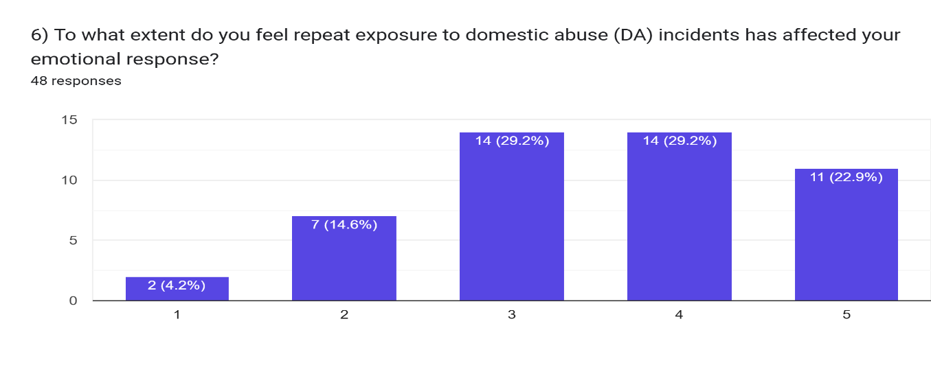
These findings are further reinforced by qualitative data gathered from question 8 as front-line officers described their emotional responses to frequently attending DA incidents as ‘neutral’ and ‘detached’. These findings are supported by Figley’s (1995) definition as he highlights the lack of emotional responsiveness from front-line officers after repeated exposure to traumatic stimuli.
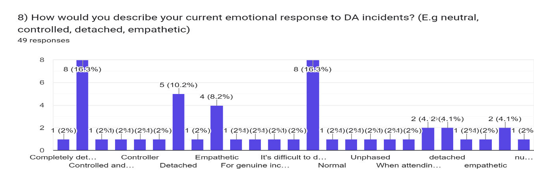
The results also suggest repeated attendance to DA incidents increases the likelihood of officers developing feeling of desensitisation. This reflects Loftus (2010), who found that frequent attendance to traumatic incidents is normalised by front-line officers due to the repetitive nature and daily frequency, reducing their emotional responsiveness to them.
Additionally, these findings closely align with the American Psychiatric Association (2013), as they highlight the development of emotional numbness is often adapted as a coping mechanism because of regular exposure to traumatic incidents.
These findings suggest that desensitisation among front-line police officers is developed over a period and frequent exposure to traumatic incidents. By demonstrating that repeated exposure to traumatic incidents influences the growth of desensitisation among officers this addresses the first research objective.
4.4 Impact of desensitisation on decision making
Research suggests that desensitisation plays a crucial role when it comes to officers’ decision-making skills, however its impact it complicated. In question 9, 56.3% of front-line police officers acknowledged that familiarity with repat incidents has affected their professional judgement. This highlights that more than half of the sample recognises that their professional judgement and decision making has been affected due to repeat exposure.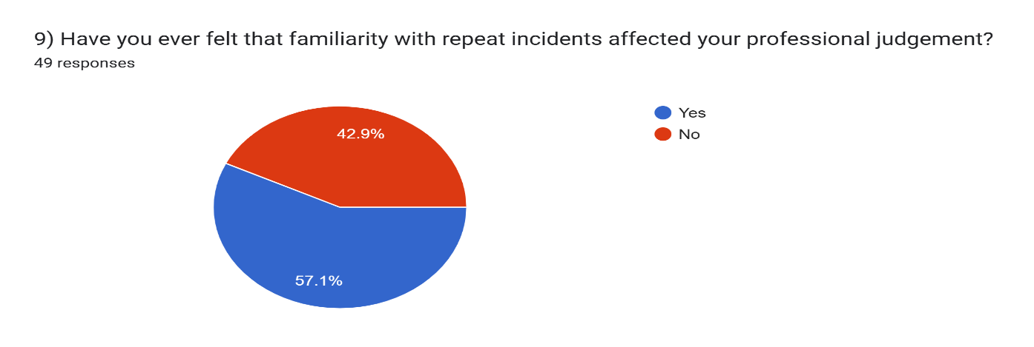This is further supported from the answers obtained from question 10 as participants highlighted a moderate – high influence on their decision making due to frequent exposure.
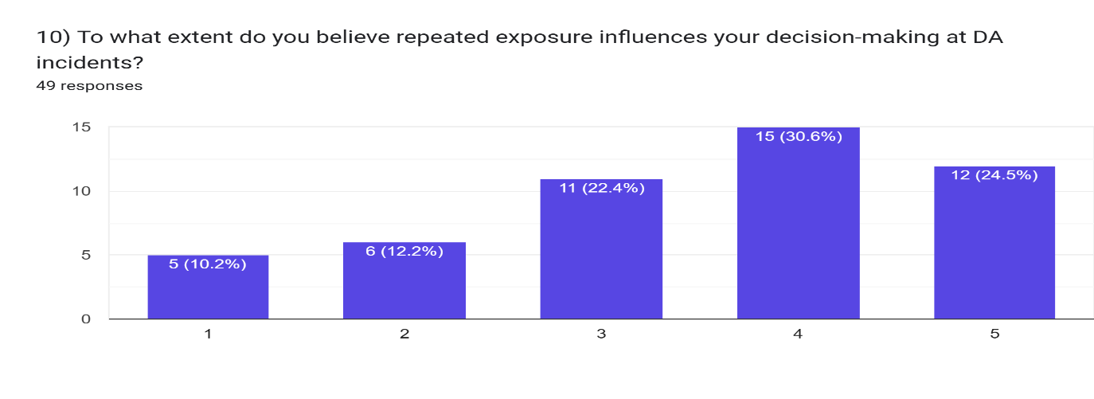
Qualitative responses from question 11 help gain a deeper understanding of the potential impacts. Some participants “stay calm” and “perform more efficiently”. These findings suggest that desensitisation can also have a positive impact on front-line officers, allowing them to remain calm and make quicker decisions in high intensity situations. However, data from question 11 also highlights the negative impact that desensitisation can have. Some participants recognised that repeat exposure to traumatic incidents can lead to “assumptions” being made, which could potentially affect their professional judgment or decision-making.
These findings align with Myhil and Hohl (2023) who highlighted how officers’ emotional responsiveness can influence their decision making and risk assessment, affecting their professional judgement.
These results demonstrate that desensitisation can have a positive effect such as providing officers with calmness but also provides negative effects such as reduced empathy. Desensitisation addresses the second research objective by having a moderate yet significant impact on decision making both with potential positive and negative effects.
4.5 Impact on officer wellbeing
Responses from question 12 indicate that frequently attending DA incidents has had a moderate impact of front-line officers’ mental wellbeing. Responses to this question were spread across the chart. It is important to note that not all participants acknowledged negative impacts as some participants reported no effect. Which suggests that the factors are dependent on the varied individual experiences. 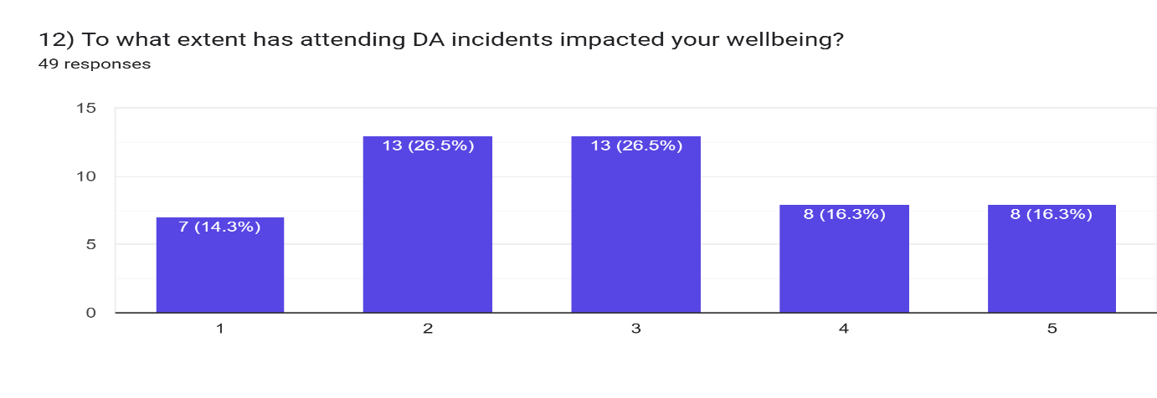 Question 13 focused on certain consequences linked to repeat exposure. The most prevalent experiences because of repeated exposure to DA incidents were reduced empathy (70.8%), followed by officer burnout (54.4%), emotional fatigue (43.8%) and stress (39.6%). These findings suggest that desensitisation can be linked to more negative effects because of frequent exposure to DA incidents.
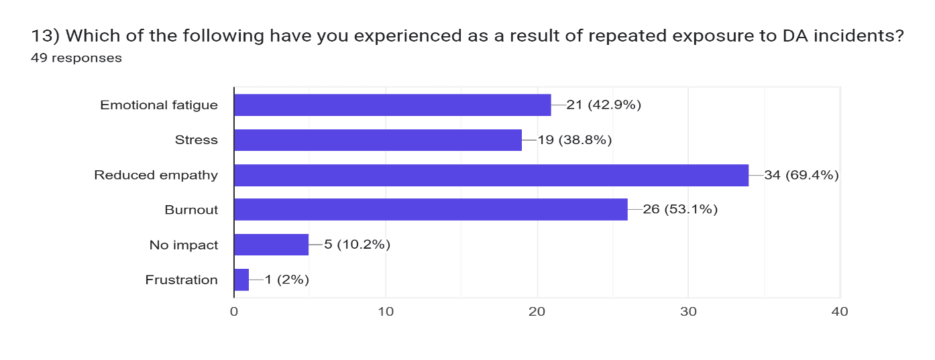
These findings align with Stevelink et al, (2021) who highlighted the large number of front-line officers who struggle with their mental health due to exposure to traumatic incidents. These findings are also consistent with Syed at al. (2020), who’s research highlighted links between repeated exposure to traumatic incidents to officers develop mental health conditions.
Overall, these results address the third research objective by acknowledging how desensitisation affects officer wellbeing, particularly reduced empathy and officer burnout.
4.6 Organisational support
Responses to question 14 highlighted that only 18.8% of officers felt supported by their organisation in managing the emotional impact of DA work, while 45.8% of participants do not feel supported and 35.4% felt partially supported.
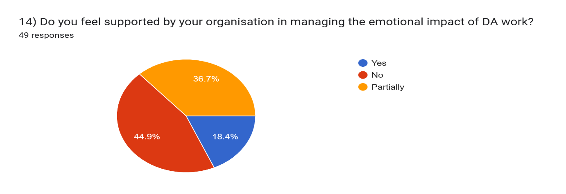
These findings do not align with the College of Policing (2022) recommendations as the college of policing highlights the importance for supervisors to recognise when their staff need support and early intervention. A lack of support from the organisation could lead to officers’ mental health deteriorating further.
Furthermore, these findings are consistent with Corrigan’s (2014) research, as he acknowledged the stigma surrounding police officers seeking support for their mental health although there are often resources available for them to utilise.
This theme highlights important context for previous findings, by acknowledging that organisational factors shape the management of desensitisation.
4.7 Conclusion
In summary, the findings suggest that repeat exposure to DA incidents, contribute to feelings of desensitisation amount front-line police officers. Desensitisation will have a significant effect on officers’ professional judgement, mental wellbeing and decision making. Moreover, results highlighted the significant impact that repeat exposure to DA incidents have on officers’ wellbeing, such as emotional fatigue, stress and burnout. Finally, whilst officer’ wellbeing may be impacted, their wellbeing could be negatively affected further due a lack of organisational support surrounding their wellbeing, which highlights the importance early intervention. Overall, the results obtained from the questionnaire align with exiting literature and providing a useful insight into experiences of front-line officers.

Chapter Five – Findings, Conclusion and Recommendations
5.1 Introduction
The aim of this study is to examine whether front line police officers develop feelings of desensitisation when attending frequent DA incidents and the extent to which these feelings influence their decision-making and wellbeing. Findings from this study suggest that officers who are frequently exposed to DA calls are affected by feelings of desensitisation, which affects their professional judgement, along with having an impact on their wellbeing. This chapter will outline the implications of these findings, discuss the broader significance of findings, highlights the limitations and propose recommendations for future research.
5.2 Key findings
The findings from this study propose that front-line officers who attend frequent DA calls developed feelings of desensitisation. Participants within this survey reported that due to high call demand with calls of a DV nature, over time, they become less emotionally effected by these types of calls, describing their responses as neutral, controlled or detached. These results support Figley’s (1995) definition of desensitisation which is utilised in my literature review section. Due to the high frequency of front-line police officers attending DA incidents, which is usually involving the same victims and perpetrators, it is not surprising that officers develop empathy fatigue. This is reinforced by Loftus (2010) who found that front-line officers who are regularly exposed to violence normalise these incidents and view them as routine. Despite desensitisation often being viewed in a negative light, findings suggest that some officers develop desensitisation as a coping mechanism due to the extreme nature of the job.
Findings from the study also highlighted the role that desensitisation has on front-line officers’ decision making. The results showed that desensitisation has both positive and negative effects on officers’ mental wellbeing. The first consideration would be due to the high frequency of officer’s exposure to traumatic calls, they have gained confidence through repeated attendance, which has enabled them to adapt to their situation. This suggests that repeat exposure may assist officers growing their professional judgement and regulate their emotions. On the other hand, other officers felt that regular attendance could lead to officers becoming complacent and making assumptions, in turn effecting their professional judgement. This is reinforced by Myhil and Hohl (2023), who emphasised how officers’ emotional responsiveness affects their ability to make decisions.
A further finding from this study was the impact that reoccurring exposure has on front-line officers’ mental wellbeing. Reduced empathy towards DA victims, emotional exhaustion, burnout and stress were highlighted by participants as effects of regularly attending DA calls. These findings are further backed by research conducted by Stevelink et al (2020) suggesting exposure to traumatic incidents can have a negative effect on officer’s mental wellbeing. Some officers develop emotional detachment from DA incidents as a coping strategy to assist them in avoiding emotional detachment, long term exposure to these incidents has the potential to cause emotional exhaustion over a sustained period. This highlights the balance needed between desensitisation and emotional availability for officers to carry out their day-to-day roles effectively within minimal effect on their mental health.
The research objectives successfully met throughout the findings of this study. The findings from this study suggest that desensitisation can be linked to repeat exposure to DA incidents, which also influences officers’ wellbeing and decision making in high intense situations. Despite desensitisation being used as a coping mechanism for some officers, it also brings to light the potential consequences it has on decision making and reduced emotional responses from repeat attendance.
Moreover, the findings acknowledge the potential for further awareness surrounding desensitisation within policing being beneficial. By gaining a better understanding of desensitisation among officers, officers can reflect to prevent a lapse in professional judgement and improved decision making.
5.3 Recommendations for policing
This study has highlighted implications for modern day policing. Findings identified the demand and pressure that is placed among front-line police officers who frequently attend DA calls. It is important for officers to develop emotional regulation to assist them in their decision making and remain professional, however, prolonged exposure to traumatic incidents can lead to officers becoming emotionally detached.
5.4 Limitations
During this study, few limitations have been identified and will need to be acknowledged for transparency. Firstly, the sample size used to obtain responses from officers was relatively small, meaning that there is a limited number of responses from a single force area, making it difficult to generalise across other forces within the UK. Secondly, the responses obtained were self-reported responses, meaning that the participants responses may have been biased or influenced by personal experiences. Finally, the use of a questionnaire to obtain responses restricted the depth of answers from both quantitative and qualitive methods. Whereas the use of a focus group would have provided a deeper and further detailed response of their experiences.
5.5 Recommendations
Recommendations for further research should consider adopting a longitudinal method to measure how desensitisation, decision-making and wellbeing is affected over a prolonged period to provide a more accurate reading. Another recommendation for further research would be to utilise a larger sample group size, including various forces or locations. This would assist in gathering a more accurate varied number of responses from varied locations, meaning that the responses would be broader and easier to generalise. Additionally, the use of a focus group as well as questionnaire, as this would allow for participants to explain their experiences in greater detail. Finally, future studies could examine if levels of desensitisation vary from front-line police officers, compared to specially trained DA officers and why this might occur.
5.6 Conclusion
To conclude, this study demonstrates how front-line officers who frequently attend DA related calls, can lead to feelings of desensitisation. In turn, these feelings of desensitisation affect officers’ mental wellbeing and decision making in intense situations. Even though emotional detachment can cause officers to develop emotional fatigue, causing stress and burnout, it can further assist officers in making decisions in an intense environment due to repeated exposure to these incidents. Overall, this study acknowledges that desensitisation is a complex emotional response, it is important for officers to gain a better understanding of it and promote effective support to enable officers to deal with DA incidents effectively.

Chapter Six – References
American Psychiatric Association (2013) Diagnostic and statistical manual of mental disorders (5th edn.). Washington, DC: American Psychiatric Publishing.
Andersen, J.P. and Papazoglou, K. (2015) ‘Procedural justice and police trauma: The role of organisational stressors’, Criminal Justice and Behaviour, 42(7), pp. 717-734
Beckley, A., den Heyer, G., Birch, P. and Wang, J. (2025) Mental health and well-being among police officers: A three-country comparison through the application of the job demands-resources model, Journal of Forensic Practise, 10.1108/JFP-02-2025-0013. Doi:10.1108/JFP-02-2025-0013
British Society of Criminology (2015) Code of ethics for researchers in the field of criminology. Available at: https://www.britsoccrim.og
Bryman, A. (2016) Social research methods. 5th edn. Oxford. Oxford University Press.
College of Policing (2020) Authorised Professional Practise: Domestic Abuse. Ryton-on-Dunsmore: College of Policing.
College of Policing (2022) Effective supervision: Evidence-based guidelines on effective supervision to support wellbeing, learning and performance in policing. Ryton-on-Dunsmore: College of Policing. Available at: https://assets.college.police.uk/s3fs-public/2022-04/Effective-upervision-guidelines.pdf
Corrigan, P.W., Druss, B.G., Perlick, D.A., 2014. The Impact of Mental Illness Stigma on Seeking and Participating in Mental Health Care. Psychol Sci Public Interest.
Creswell, J.W (2014) Research design: Qualitative, quantitative and mixed methods approaches. 4th edn. Thousand Oaks, CA: Sage.
DeJong, C., Burgess-Procter, A. and Elis, L. (2008) ‘Police officer perceptions of intimate partner violence: An analysis of observational data’, Violence Against Women, 14(6), pp. 683-696. https://doi.org/10.1891/0886-6708.23.6.683 (Accessed:2026)
Dodge, R., Daly, A.P., Huyton, J. and Sanders, L.D., 2012. The challenge of defining wellbeing. International Journal of Wellbeing, 2(3), pp.222-235. Available at: https://doi.org./10.5502/ijw.v2i3.4.
Figley, C. R. (1995) Compassion fatigue: Coping with secondary traumatic stress disorder in those who treat the traumatised. New York: Brunner/Manzel
Hester, M. (2013) ‘Who does what to whom? Gender and domestic violence perpetrators in English police records,’ European Journal of Criminology, 10(5), pp.623-637. https://doi.org/10.1177/1477370813479078
HMIC. 2014. South Wales Police’s Approach To Tackling Domestic Abus. [Available at: I am the title]
Israel, G.D (2013) Determining sample size. Gainsville: University of Florida, Institute of Food and Agricultural Sciences.
Jessica Robinson (2023) Improving Police Data Collection to Measure Repeat Demand: A focus on Domestic Violence and Abuse, Policing: A journal of Policy and Practise, 17(3), pp
Karaffa, K. M. and Koch, J.M. (2016) ‘Stigma, police officers and mental health treatment-seeking’ Psychological Services, 13(1), pp. 65-71.
Lennie, S.J., Crozier, A. and Sutton, L. (2020) ‘Robocop – the depersonalisation of police officers and their emotions: A diary study of emotional labour and burnout in frontline British police officers’, International Journal of Law, Crime and Justice, 61, 100365. https://doi.org/10.1016/j.ijlcj.2019.100365
Loftus, B. (2010) Police culture in a changing world. Oxford: Oxford University Press.
MacEachern, A.D. et al (2018) Secondary traumatic stress: prevalence and symptomology amongst police officers.
Manzella, C. and Papazoglou, K. (2014) ‘Training police trainees about the effects of trauma exposure on officers’, International Journal of Mental Health, 43 (4), pp. 71-78
Maslach, C., Schaufeli, W. B. and Leiter, M. P. (2001) ‘Job burnout’, Annual Review of Psychology, 52, pp. 397-422.
McCeary, D.R. and Thompson, M.M. (2006) ‘Development of two reliable and valid measures of stressors in policing: The operational and organisational police stress questionnaires’, International Journal of Stress Management, 13(4), pp. 494-518.
Myhill, A. and Hohl, K. (2023) ‘The “officer effect” in risk assessment for domestic abuse: Findings from a mixed methods study in England and Wales’, European Journal of Criminology, doi:10.1177/14773708231156331.
Myhill, A. and Johnson, K. (2016) ‘Police use of discretion in response to domestic violence’, Policing and Society, 26(1), pp. 3-22. https://doi.org/10/1080/10439463.2014.989156
Office for National Statistics (ONS) (2024), Domestic abuse prevalence and trends, England and Wales: year ending March 2023. Newport: ONS. Available at: https://www.ons.gov.uk/peoplepopulationandcommunity/crimeandjustice/articles/domesticabuseprevalenceandtrendsenglandandwales/yearendingmarch2023
Papazoglou, K. and Andersen, J.P. (2014) ‘A guide to enhancing resilience in police officers: The role of emotional regulation strategies’, International Journal of Mental Health Promotion, 16(2), pp. 103-116.
Porter, C.N. (2025) Understanding the mental health of UK police officers. The Police Journal, SAGE. Available at: https://journals.sagepub.com/doi/10.1177/0032258X241280217
Reiner, R. (2010) The politics of the police (4th end.). Oxford: Oxford University Press.
Robinson J. 2023. Improving police data collection to measure repeat demand: A focus on domestic violence and abuse. Policing: A journal of policy and practice, 17(3).
Stevelink, S.A.M., Poie, E., Pernet, D., Gao, H., Elliot, P., Wessely, S., Fear, N.T., Hotopf, M. and Greenberg, N. (2020) ‘Probable PSTD, depression and anxiety in 40,299 UK police officers and staff: Prevalence, risk factors and associations with blood pressure’, PLOS ONE, 15(11), e0240902.doi:10.1371/journal.pone.0240902
Syed, S., Ashwick, R., Schlosser, M., Jones, R., Rowe, S. and Billings, J. (2020) ‘Global prevalence and risk factors for mental health problems in police personnel: a systematic review and meta-analysis’, Occupational and Environmental Medicine, 77(11), pp. 737-747. https://doi.org/10,1136/oemed-2020-106498
Violanti J, M. (2014) ‘Police mental health: Risks, intervention, and future research directions’. Policing: A journal of Policy and Practise, 8(3), pp. 267-280
Violanti, J.M (1999) Trauma and Police Work. Springfield, IL: Charles C. Thomas.

