Student Name: Adji Makangila
Student ID: 2126238
Lecturer’s Names: Gillian Weaver and Raheel Shaikh
Module: Introduction to Physiology
Module Code: BMHP5003

Digestive system
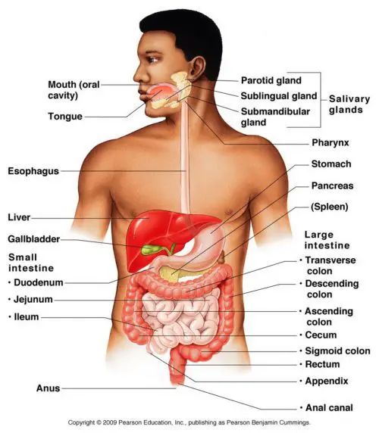
- The digestive system operates to break down food into small pieces to be absorbed in the body as nutrients.

- Nutrients absorbed in the body into the bloodstream are useful to keep the body healthy as the body uses sugars, amino acids, fatty acids, glycerol, vitamins, and minerals to build substances needed for energy, growth, cell repair and a strong immune system to fight disease.

- The process of taking food into the mouth is called Ingestion, and organs that join in it form the digestive system,

- The digestive system works with the endocrine and nervous systems to facilitate metabolism and control the digestive process.

- These hormones tell your body when to make digestive juices and send signals to your brain that you are hungry or full.

- The central nervous system, the brain and the spinal cord are connected to the digestive system when you see or smell food, as the brain can send a signal that causes your salivary glands to react and make your mouth wet to prepare ingestion.

- There are several diseases that can be caused by malfunctioning of the digestive system’s organs, such as the parotic gland (Goiter), Stomach ulcer or stomach (gastro-oesophageal), pancreatic disease (Diabetes type 1 and 2), and gallbladder issues of bile release.
References

@Cleveland Clinic. (2023) Stomach function of the digestive system. Available at: https://my.clevelandclinic.org/health/body/21758-stomach.( accessed on 15th October 2023).

DR. ALEX JIMENEZ (2023), Anatomy of the digestive system. El pass’s Chiropractic Team. Available at: https://dralexjimenez.com/anatomy-of-the-digestive-system/ (accessed on 13th October 2023).

El-Salhy, M., Gilja, O.H., Gundersen, D., Hatlebakk, J.G. and Hausken, T. (2014). Interaction between ingested nutrients and gut endocrine cells in patients with irritable bowel syndrome. International journal of molecular medicine, 34(2), pp.363-371. doi: https://doi.org/10.3892%2Fbr.2016.649

Furness, J.B., Callaghan, B.P., Rivera, L.R. and Cho, H.J. (2014). The enteric nervous system and gastrointestinal innervation: integrated local and central control. Microbial endocrinology: The microbiota-gut-brain axis in health and disease, pp.39-71. https://doi.org/10.1007/978-1-4939-0897-4_3.

Hannah Kingston.( 2023) What are the functions of the liver? Let's get checked. Available at: https://www.letsgetchecked.com/articles/what-is-the-function-of-the-liver/.( Accessed on: 16th October 2023)

Meier, J.J. and Giese, A. (2015). Diabetes associated with pancreatic diseases. Current opinion in gastroenterology, 31(5), pp. 400-406. https://journals.lww.com/co-gastroenterology/abstract/2015/09000/diabetes_associated_with_pancreatic_diseases.10.aspx#:~:text=DOI%3A%2010.1097/MOG.0000000000000199.

Mousa G. Ghannam; Paramvir Singh. (2023) head and neck salivary gland. Available at: https://www.ncbi.nlm.nih.gov/books/NBK538325/#:~:text=Human%20salivary%20glands%20produce%20between,by%20secreting%20lipases%20and%20amylases.

Nardone, G. and Compare, D. (2015). The human gastric microbiota: Is it time to rethink the pathogenesis of stomach diseases? United European Gastroenterology Journal, 3(3), pp.255-260. https://doi.org/10.1177/2050640614566846.

Naschitz, J.E., Slobodin, G., Lewis, R.J., Zuckerman, E. and Yeshurun, D. (2000). Heart diseases affecting the liver and liver diseases affecting the heart. American Heart Journal, 140(1), pp.111-120. https://doi.org/10.1067/mhj.2000.107177.

Obiorah, I., Hussain, A., Palese, C., Azumi, N., Benjamin, S. and Ozdemirli, M. (2017). IgG4-related disease involving the esophagus: a clinicopathological study. Dis Esophagus, 30(12), pp.1-7. DOI: 10.1093/dote/dox091.

Tharakan, A., Norton, I.T., Fryer, P.J. and Bakalis, S. (2010). Mass transfer and nutrient absorption in a simulated model of small intestine. Journal of food science, 75(6), pp.E339-E346. https://doi.org/10.1111/j.1750-3841.2010.01659.x.

Wilson, K.F., Meier, J.D. and Ward, P.D. (2014). Salivary gland disorders. American Family Physician, 89(11), pp.882-888. Available at: https://www.aafp.org/pubs/afp/issues/2014/0601/p882.html?_ga=2.195970085.884261040.1526283311-1580108435.1525766153 (Accessed on 15th October 2023).

