Domestic Abuse and Substance misuse; Is there a link between substance misuse and the likelihood of someone being a victim or a perpetrator of domestic abuse.

BSc (Hons) Professional Policing Practice

Acknowledgements

First and foremost, I would like to thank anyone who has contributed or assisted me in some way to completing this project. Without the help and support of those people, it would not have been possible to complete this project.

Declaration

This work has not previously been accepted in substance for any degree and is not being concurrently submitted in candidature for any degree.
Signed: Date:

Statement 1
This dissertation is being submitted in partial fulfilment of the requirements for the degree of BSc.
Signed: Date:

Statement 2
This dissertation is the result of my own independent work/investigation, except where otherwise stated. Other sources are acknowledged by footnotes giving explicit references. A bibliography is appended.
Signed: Date:

Statement 3
I hereby give consent for my dissertation, if accepted, to be available for photocopying and for interlibrary loan, and for the title and summary to be made available to outside organisations.
Signed Date:

Statement 4
I hereby give consent for my dissertation, if accepted, to be available on the university’s IT system to those who have consent to use the system.
Signed: Date:

Abstract
Over the past few decades, there has been a great deal of academic effort put into the understanding of Domestic Violence which has encompassed various types of research and study, all with the aim of understanding the issue and seeking means to prevent it.

The majority of the research has been found to have at first explore the concept of domestic violence, which then led to research into its causes and how best to prevent domestic violence.

Despite the research that exists being vast, this is still an enormous issue for society today and efforts are ongoing by todays academics to understand the issue.

The aim of this dissertation was to explore the links, if any, between substance misuse and domestic violence, both perpetrator and victim. Through the process of conducting this research, the researcher has narrowed this question down to define substance misuse as alcohol use and further narrowed to explore the impact of alcohol misuse on perpetrators only. The researcher aimed to question police officers on this topic as they were seen by the researcher as a key resource for information that may not be held as statistics given the position of police officers as front line responders to domestic violence and experts in intoxication.

The research identified that there did appear to be a link between alcohol misuse and domestic violence perpetration, the results and conclusions are documented below.

Contents Table
Acknowledgements 2
Declaration 3
Abstract 4
1. Chapter One: Introduction 6
2. Chapter Two: Literature Review 7
2.1 Introduction to Literature Review 7
2.2 Historical context of Domestic Violence 7
2.3 Law enforcement/Criminal Justice system response to Domestic Violence 8
2.4 Research into Domestic Violence 8
2.4 Summary 11
3. Chapter Three: Methodology 12
3.1 Introduction 12
3.2 Data Collection 13
3.3 Data Analysis 14
3.4 Limitations and Benefits 14
3.5 Ethical Considerations 14
4. Chapter Four: Analysis of Results 15
4.1 Introduction 15
4.2 Survey 15
4.5 Findings 16
4.6 Conclusion 19
5. Findings and Conclusion 20
5.1 Introduction 20
5.2 The achievement of objectives 20
5.3 Main Findings 21
5.4 Recommendations / Further Research 22
5.5 Self-Reflection 22
6. Bibliography 23
7. Appendices 26
7.1 Appendix One: Questionnaire 26
7.2 Appendix Two: Questionnaire Results 33
7.3 Appendix Three: Dissertation Proposal 36
7.4 Appendix Four: Ethics Form 40
Outline any anticipated risks that may adversely affect any of the participants, the researchers and/or the University, and the steps that will be taken to address them. 50
Full risk assessment completed and appended? 50
Yes 50
☐ 50
No 50
☒ 50

Chapter One: Introduction

This dissertation will look at the links between substance misuse and domestic abuse. It will discuss the links between substance misuse, such as addiction to controlled substances or alcoholism, and domestic abuse encompassing both victims and perpetrators. It will explore whether substance abuse makes a person more likely to be a perpetrator of domestic abuse and similarly, does it make someone more likely to be a victim or indeed a repeat victim and is this adequately addressed in rehabilitation of offenders and support to victims.

Research suggests that on the extreme end of domestic violence, that being domestic homicide, substance use is a common factor and more generally it is suggested that men who are dependent on alcohol or drugs are 6 times more likely to be perpetrators of domestic abuse. The purpose of this research is to determine if the experience of police officers who are the first responders to incidents of domestic abuse, corroborates this research.

This subject was chosen by the researcher as domestic abuse is something that they have first-hand experience of responding to. It is an important subject and one which they believe to be somewhat overlooked when it comes to rehabilitation of offenders and victims as if substance abuse is a root cause of the behaviour it should be tackled as a priority to prevent reoffending or becoming repeat victims.

Furthermore, the topic of domestic abuse takes up a large proportion of police resources and is a topic that in recent decades has become better researched and various initiatives have been implemented to tackle domestic abuse, these have largely been aimed at better understanding in order to recognise domestic abuse and to be proactive in responding to all incidents. It would be beneficial to further explore the root causes or exacerbating factors involved in domestic abuse and what can be done to prevent offending and re-offending.

2. Chapter Two: Literature Review

2.1 Introduction to Literature Review
Domestic violence has no doubt long been an issue, since the inception of relationships between human beings. What has changed throughout history is how relationships are defined, what behaviours are deemed as criminal and where these two things become what we now call domestic violence.

The purpose of this literature review is to provide an overview of existing literature on the topic of domestic violence and alcohol/substance misuse. The researcher will explore a wide range of literature on the topic and explore how research has led to the topic which is sought to be studied, that being the links between alcohol/substance misuse and domestic violence. Further to this, the researcher will seek to identify any gaps in existing research and look to highlight where the proposed research will fit in to the research which exists.

2.2 Historical context of Domestic Violence
Domestic violence has a long history of being viewed a private matter between intimate partners and families, rather than a criminal matter requiring intervention by the state (Erez, 2002). In many societies throughout history, abuse and/or violence between intimate partners or family members was considered normal. In particular, violence within a marital relationship which was typically between a man and woman, was considered normal and the husband in many cases had the right to carry out acts of violence on his wife. There are examples in history of this type of behaviour being accepted as normal by the authority of the day, Anglo-American laws once provided that a husband as master of his household, could subject his wife to corporal punishment or chastisement, so long as he did not inflict permanent injury upon her (Siegel 1996). It was not until the 19th and 20th centuries that the issues of what we now call domestic violence, began to be recognised as a problem that required legal and social intervention.

In the United States, for example, the first laws criminalising domestic violence was passed in Maryland in 1882. However, it was not until the 1970’s and 1980’s that domestic violence laws became more widespread and comprehensive, this was largely due to the efforts of a rise in feminism and feminist activists who brought attention to gender inequality and the issue of domestic violence and pushed for legal reform which would eventually recognise domestic violence as a crime, but also provide for greater protection for survivors of domestic violence (Schneider 2000).

2.3 Law enforcement/Criminal Justice system response to Domestic Violence
Despite the legislative shift to criminalise inter marital violence or what we now call domestic violence, there were still examples where the authorities did not change how the issue was tackled by law enforcement. One important development in the criminal justice systems response to this was in the case of the United States, some law enforcement agencies implemented mandatory arrest policies during the 1980’s and 1990’s, where police officers were required to arrest individuals, with probable cause of course, who were suspected of committing domestic violence. The policies often set out that these arrests were to be made regardless of whether the victim wished to press charges. (Hirchel et al 2007). Even to this day in the United Kingdom, there is a policy of positive action in cases of domestic violence with reference to police making arrests (College of Policing, 2015)

2.4 Research into Domestic Violence
Research on the topic of domestic violence has over time become a more populous field of research. Some relatively early work on the topic is from the 1970’s, in a study by Straus & Gelles (1980) they conduct a survey of some 2,143 persons in the United States on the subject of family violence. The researchers use of a large-scale survey, which was novel at the time of its release, to compile information on the incidence of domestic violence is one of its strong points. Additionally, the researchers thoroughly analysed the data, offering insights into the trends and traits of domestic violence in American families. They discovered that domestic violence affected a variety of demographic groups and was more common than previously believed. But there are also problems with the study itself, notably the survey did not explore the context or motivations for the violence used and further to this, victim reports were used by the researchers to gauge the prevalence of domestic violence, which may have underreported the real scope of the issue. Lastly, the authors have set out possible causes and solutions to the problem without giving substance to the claims, for example one conclusion drawn is that domestic violence in families is due to the natural stress and conflict which arises and there is little further exploration on the effects of stress on domestic violence. Despite these criticisms, the work was a good starting point at a time when domestic violence was not understood or studied to a great extent and what the work has done is provided a greater understanding on what domestic violence is, including its form and prevalence and is a good starting point for future academics to research the area.

Further research has began to explore the possible reasons for violence within intimate relationships, one such piece of work by Ranzetti (1996) provides a comprehensive examination of intimate partner violence with particular attention to female experience of abuse in intimate relationships. In this piece, Ranzetti highlights the social and cultural contexts in which intimate partner violence occurs, the role of gender, power and social inequality features in the research, as does the role of cultural norm and social institutions including the criminal justice system. A strength of this work is that Ranzetti not only explores the varying forms of abuse experienced by women who have experienced domestic violence, but she also explored the consequences of this violence be it physical, psychological or emotional. Ranzetti suggests that there is a need for a victim centred approach to domestic violence which moves away from the criminal justice centred response of simply punishing perpetrators without addressing the causes of this type of violence. Ranzetti introduces the ideas of support for victims such as emergency shelter and legal assistance as well as the importance of prevention by means of education to address perceived underlying attitudes and beliefs which may contribute to domestic violence.

Hester (2009), explores the dynamics of domestic violence interventions, drawing on interviews with both survivors and professionals working in the field. Through her analysis, she argues that traditional approaches to domestic violence, which focus on criminal justice interventions and the punishment of perpetrators, are often ineffective and can even exacerbate the harm experienced by survivors. Instead, she advocates for a more nuanced and collaborative approach, which centres on the experiences and voices of survivors, recognising the wider social and structural factors that contribute to domestic violence.

Overall, Hester's work is an important contribution to the field of domestic violence research, providing valuable insights into the experiences of domestic violence victims. Her focus on the limitations of traditional approaches to domestic violence is particularly noteworthy, highlighting the need for more holistic interventions. One limitation of the work is the relatively small sample of subjects questioned to produce the data utilised which could suggest that the data attained may not be representative of the wider population of victims and professionals in the field. Herster’s work is one of many studies which have started to explore the idea of holistic interventions, that being seeking to understand the causes of domestic violence and exploring how through intervention these root causes can be negated to prevent domestic violence.

Specific to this dissertation is one such contributing factor, that being the impact of alcohol or substance misuse. In simplistic terms, does alcohol or substance use, make a person more likely to be violent.

In an article by Brisker & Bergman (1998), the topic of the relationship between alcohol use and violence is explored. A wide range of literature is drawn on by the authors to support the argument that alcohol is a significant contributing factor to violence by a person. One strength of the article is the breadth of types of violence considered which included domestic violence and sexual assault which has helped the author to depict the negative impact which alcohol is believed to have on violence. However, the article is just that, an article, and as such relies on other work to draw its conclusions rather than presenting any new data. Because of this, the conclusions drawn are as dated as the information which the article is based on and may not be reliable to draw conclusions today. Despite this, the article is a useful piece of work which begins to explore the relationship between alcohol misuse and violence.

In another article by Langhinrichsen-Rohling & Selwyn (2015), the authors conduct a review of existing literature on the topic of substance misuse and being a perpetrator of domestic violence. This work concludes that substance abuse is a significant risk factor in perpetration of domestic violence, it also suggests that the link between substance misuse and violence may be explained by several factors, including the pharmacological effects of the substances, but also the social and cultural context in which substance misuse occurs. The article also concludes that addressing both substance misuse and domestic violence may be more effective in prevention than only addressing one of the issues. This work reiterates earlier work by Hester, whereby a holistic response is advocated.

Of all the literature that exists on the topic of domestic violence, there appears to have been a funnelling in recent years towards the idea of treatment rather than punishment only. It is recognised that the issue of domestic violence is often repeated by perpetrators, hence the desire to explore methods of prevention which has involved the research into the possible factors which contribute to domestic violence. Research has now come to a point where there are limited case studies based on real work evidence of such interventions working, one such piece of work by Belenko et all (2013) reviews the effectiveness of programmes which have been implemented in the United States which treat criminals with issues of substance misuse with a view to preventing re-offending. The researchers highlight that such an approach can be cost effective as a pose to the cost of imprisonment but that the approach has some key barriers to overcome, those being limit of resources, stigma and a lack of coordination between the criminal justice system and healthcare systems.

In the United Kingdom, a paper by Stevens (2006) exploring similar programmes, concluded that prison-based drug treatment can be effective in reducing criminal behaviour and reoffending. However, Stevens also highlighted that the effectiveness of such a programme is dependent on factors such as the quality of treatment given and the character of the participants. However, this research is based on prison-based treatments which would preclude that the crime has already occurred, thus the research can only surmise reoffending rates, rather than exploring the potential impact of prevention programmes were they to be more widely used when combined with identification of risk for domestic violence. Further research by Chatwin et all (2015), addressed this by reviewing the effectiveness of substance abuse treatment within the criminal justice system, both within a prison setting and within the community. Chatwin noted the same issue as Stevens, that being a lack of resources and funding for such programmes. However, Chatwin did conclude that such programmes are beneficial in that where implemented, there are reduced rates of re-offending, improved mental health outcomes and better long-term rehabilitation outcomes.

2.4 Summary
This literature review has discussed the history of domestic violence and how it has been viewed as a private matter between intimate partners or families, rather than a criminal matter requiring intervention by the state. Research into the topic of domestic violence has over time become a more populous field of research, with some early work done in the 1970s which covered the topic broadly and research since this has begun to explore the causes of domestic violence with the most recent research looking at ways to prevent offending.

Looking back to the original question for this dissertation: Domestic Abuse and Substance misuse; Is there a link between substance misuse and the likelihood of someone being a victim or a perpetrator of domestic abuse.

The research appears from the outset to suggest that substance misuse is indeed a factor in a person being a perpetrator of domestic violence and this is a well-covered topic which has moved past the question of whether the two are connected and onto how domestic violence can be prevented by treatment of substance misuse.

Whilst the researcher of this dissertation does not have the resources to implement a programme of rehabilitation for alcohol or substance misuse in perpetrators of domestic violence, to explore the success of such treatment and thus create a tangible link of theory and real word outcomes. The researcher can seek to add to the theory by exploring the beliefs of police officers in the United Kingdom who deal with domestic violence daily, the research will as originally set out, seek to explore the true extent of the relationship between substance misuse and domestic violence as most research only includes diagnosed instances or the views of those involved, whereas the experience of police officers is a third party expert opinion on intoxication and may be better placed to comment on its involvement. Secondly, having now carried out this literature review the researcher will narrow the question to include the effects on perpetrators only and further to this to explore whether there is support for prevention programmes from within the criminal justice system. Thus, having carried out this literature review a minor addition to the original question will be added by the researcher, the question now reads:

Domestic Abuse and Substance misuse; Is there a link between substance misuse and the likelihood of someone being a perpetrator of domestic abuse. Can programmes of rehabilitation prevent domestic abuse.

3. Chapter Three: Methodology

3.1 Introduction
This chapter will detail the methodology which this research will be using to investigate the link between alcohol, perpetrating domestic violence and rehabilitation of offenders as outlined in previous chapters. It will explore the type of research proposed and compare this to methodologies used by previous researchers as highlighted in the literature review and lastly, this chapter will look at the weaknesses of the proposed research and the limitations that are anticipated.

The objectives of this research have become more defined whilst carrying out initial research and specifically through a thorough literature review, the original question proposed to explore the links between substance misuse and a person being a perpetrator or victim of domestic violence. Through the literature review it had been highlighted how previous research is abundant and it has been well established that there is indeed a link between substance misuse and both being a perpetrator and victim of domestic violence. The researcher had identified that the purpose of this research should be narrowed and furthered to the following objectives of this research:

- To use the experiences of police officers on the front line dealing with domestic violence cases to establish an up to date impartial observation of such cases.
- To establish if officers, considered to be subject matter experts in intoxication, believe there to have been alcohol involved in the cases they have attended.
- To capture data from officers, without having to disclose precise details of a case meaning sensitive information remains that way.
- To establish if officers themselves, support the idea of rehabilitating offenders by treatment for substance misuse.

3.2 Data Collection
This research will be conducted by means of a questionnaire that will be sent to front line police officers only. The questionnaire will be in an online format and will be anonymous, no personal data of any kind will be collected, other than a confirmation that the participant is part of the target audience for the questionnaire, that being a front line police officer. The aim of the research is to have 20 respondents as a minimum, however should more than this respond it will only improve the quality of the data set attained.

Given the relatively low number of people expected to be involved in this research questionnaire, the researcher will seek to ask respondents about the most recent 3 incidents of domestic abuse they have encountered. This will help to get the most from each valuable respondent, meaning that in effect the research will explore three cases per respondent, in theory tripling the core data sought by carrying out this research.

The questionnaire will utilise a Likert scale (S. Jamieson, 2022), which is a popular tool used by many researchers since its inception by Rensis Likert in the 1930’s. The Likert scale used by this researcher in the proposed questionnaire will include the following responses on the sliding scale:

- Strongly agree
- Agree
- Disagree
- Strongly disagree

The researcher has chosen to use a questionnaire as it is a simple and cost-effective means of gathering data and sits within the scope of the resources at the researcher’s disposal. The sample is specific in that only front-line police officers will be asked to take part, this is in order to direct the research at those with the most current experience of dealing with the topic in question and will guarantee an unbiased expert opinion on intoxication through alcohol which is key to the research proposed.

The type of research proposed is quantitative which is described by J Creswell (2014) as a systematic empirical investigation that seeks to understand, explain, or predict phenomena by collecting numerical data and analysing it using statistical methods.

3.3 Data Analysis
The data obtained will be analysed and quantified which will then be best displayed in the form of graphs or charts which will depict the findings of the research and can then be analysed further to identify any outcomes of the research. Due to the restrictions of time and resources as well as the limited word count and scope of this very dissertation, the researcher anticipates a relatively low number of respondents when compared to much larger studies carried out by previous researchers whereby 1000’s of cases have been looked at.

3.4 Limitations and Benefits
From the outset the researcher has identified that there is a swathe of limitations to this dissertation, the first being its scope. Being a relatively small, limited to 10,000 word dissertation and the time constraints placed on the researcher themselves, the study itself has to be limited to a size manageable for the researcher who has previously suggested that the aim of this study is to sample 20 police officers in relation to 3 cases each of domestic violence, meaning in theory around 60 cases will form this study. However, this in itself has a limitation in that it is possible those police officers have attended the same incident.

One of the proposed benefits of asking police officers these questions anonymously, is that the sensitive issue of domestic violence which would ordinarily remain as sensitive data, can be explored for the purpose of the research question without having to disclose those sensitive details such as the names, nature or places where the incidents have occurred. However, this supposed benefit is also a negative in that it is not verifiable and is entirely objective and as mentioned leaves open the possibility of duplicating information.

3.5 Ethical Considerations
The researcher has not identified any significant ethical issues arising as a result of this study. Participants will not be identifiable as they will remain anonymous and the information they provide will be anonymised so as to not reveal any specifics of people or locations involved in the subject matter.

4. Chapter Four: Analysis of Results

4.1 Introduction
The previous chapters have set out the original question, that being: Domestic Abuse and Substance misuse; Is there a link between substance misuse and the likelihood of someone being a victim or a perpetrator of domestic abuse.

And have looked at the research which exists in relation to the topic, through this research the question was narrowed to; Domestic Abuse and Substance misuse; Is there a link between substance misuse and the likelihood of someone being a perpetrator of domestic abuse.
The method used as part of this research has been decided as being in the form of a survey which would be disseminated to and answered by police officers only.

4.2 Survey
The type of survey tools available vary greatly and this researcher has opted to use an online survey tool called SurveyMonkey. This benefits of this tool, are that it has allowed the researcher to easily design a survey questionnaire without having to consult expert statisticians. The survey is easily shared via an open link, or by email to potential participants. And lastly, the survey once complete automatically returns analysis of the responses in the form of charts/graphs which are again easily customisable by the researcher. Further to this the tool is free to use and is extremely useable for the researcher.

The negatives of using SurveyMonkey are that despite having a number of returns and the aim of this researcher was to have 20 plus returns to form the data set, SurveyMonkey only includes the first 10 returns in its analytical data. Due to this the survey was closed sooner than anticipated as further returns were not adding to the data utilised by the researcher.

At the time of ending the survey, some 13 responses were received however only the first 10 are included in the analysis of results. Despite this shortcoming, there are clear trends which can be seen in those 10 responses which will be examined in more depth by this researcher.

4.5 Findings
Of the 10 included responses, 90% were from police officers and 10% were PCSO’s. Both are the target of this research as both attend and deal with domestic incidents which is the valuable insight this research intents to extrapolate information from. This means that the survey itself was successful in targeting its intended audience and has no replies from respondents who would otherwise have been discarded from the analysis of results.

As the following graphic depicts, of the respondents some 40% deal with domestic incidents daily and another 40% said they deal with domestic incidents weekly, this means that around 80% of the respondents to the survey deal with domestic incidents on at least a weekly basis which purports that the respondents are at the very front line of dealing with domestic abuse. This was an aim of the research which looked to target police officers for this research as it was believed that police officers deal with domestic abuse very regularly which appears to be the case.

It is worthy of note however, that the research does not identify what geographical areas or specific role the respondents work in and as such the research would presume that 80% of all officers deal with domestic abuse at least weekly, whereas it is possible the respondents all work in a domestic abuse specific department or simply in an area where domestic abuse is perhaps more prevalent.

The survey asked the following question; Of the domestic incidents you attend, what % involve intoxication in some way?

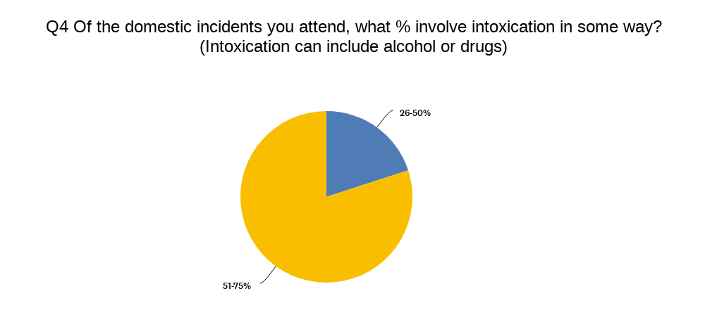

This is an important question for the purpose of this research, the objective of which was to identify how often intoxication is involved in domestic abuse, based on what police officers experience on the ground. This research shows that 80% of the respondents believe that of the incidents they attend, between 51-75% of those incidents involve intoxication through alcohol or drugs. Whilst this appears to show a clear belief by police officers own experiences that intoxication is a factor in domestic abuse incidents, what the research does not show is the means of intoxication, for example is alcohol, drugs or both a factor. Secondly, it does not identify directly whether intoxication on the part of the victim, perpetrator or simply other persons present is what is being referred to by the respondents.

Lastly, the literature review identified the addition of another dimension to this research, that is the leaning towards rehabilitation or intervention in order to prevent both offending and re-offending as the direction in which research into the topic is heading. As police officers would ultimately be the people to identify where this intervention should be put in place and be the ones to push such an approach, the survey asked two simple questions:

Of these results, it is clear to see that the respondents would support such intervention where a risk is identified. What is more pertinent is that none of the respondents held the belief that intervention would not prevent DV, 50% believed it would prevent DV and the other 50% did not know.

4.6 Conclusion
In conclusion, despite the shortcoming of the research being sample size and as identified the broadness of the questions. The survey has targeted its intended audience and has returned results of interest to this research. It is clear that police officers deal with domestic violence on a regular basis and further research should look to develop on this assertation and explore the specific roles and how they interact with domestic violence, for example a response police officer would deal with the immediate response to an incident, whereas a domestic violence unit officer may deal with the aftermath and ongoing support to victims.

It is also clear that intoxication plays a significant role in domestic abuse incidents, however once again this should be explored in more detail by further research. Examples of this could be to identify what is meant by intoxication such as is this alcohol, drugs or something else and secondly who involved in the incident referred to is intoxicated, is it the victim or perpetrator or both, or is it some other involved person all together.

5. Findings and Conclusion

5.1 Introduction
The afore chapters of this dissertation have detailed the phases of this research project, from the initial conception through a detailed analysis of previous research into the topic, culminating in a questionnaire which has yielded insight in an effort to answer the original question, that being:

Domestic Abuse and Substance misuse; Is there a link between substance misuse and the likelihood of someone being a victim or a perpetrator of domestic abuse.

Despite a number of negatives and drawbacks which have been identified and documented throughout this piece of research, trends have been identified and it is possible to identify the needs of further research into this topic. Ultimately, whilst the initial goal has not been definitively answered, the researcher and this dissertation have added to the topic in question and will help to guide and shape future research.

5.2 The achievement of objectives
The aim of this research project was to identify the links between substance misuse and domestic violence. Through this research, that initial goal was further defined, the meaning of substance misuse for the purpose of this research was limited to alcoholism only and secondly the research was focused on perpetrators of domestic abuse as a pose to the broader scope of both victims and perpetrators, in short this research sought to identify whether alcohol is a significant factor involved in a person perpetrating domestic violence.

This project has reviewed in depth, the literature around domestic violence from its early form the review has found how research has begun to narrow from simply defining domestic abuse to identifying the causes of domestic violence and most recently exploring methods and techniques to prevent domestic violence.

Secondly, the project has identified the weaknesses of previous research and has sought to improve on this. One weakness identified was that the link between alcohol and domestic violence was only found in evidence where alcoholism was a diagnosed condition of the perpetrator, rather than simply whether alcohol is a factor and further to this not all perpetrators will have an official diagnosis of alcoholism. Instead the views of police officers has been identified as a possible means to fill this gap, police officers are front line responders to domestic violence and are also experts in identifying intoxication through alcohol.

Lastly, the researcher has aimed to find the views of police officers for the reason previously highlighted and a questionnaire was used to find these views. This research has identified trends in that police officers do indeed attend domestic incidents frequently and there is a high percentage of these incidents where officers have said that intoxication was a factor. Weaknesses in this specific study by this researcher have been identified and commented upon, one being that this researcher was limited to a low number of participants and it was identified that its possible that some of the respondents may have attended the same incident, thus diluting the figures held within the analysis.

5.3 Main Findings
The research which has guided this researcher throughout this dissertation has shown that there is a well-documented link between alcohol, violence and domestic abuse. The most recent research has begun to explore treatment for these factors which are involved, such as on a limited scale there have been research projects where addiction to alcohol is treated and it is hoped that this will prevent re-offending, however there is limited research post this to back up the assertation that treatment will prevent offending.

In the absence of the resources to continue this line of research, this project has sought to further strengthen the assertation that alcohol and addiction to alcohol has a significant influence on domestic violence.

This research sought the views of police officers as main responders to domestic violence and as experts in identification of intoxication through alcohol. The research does suggest that officers attend a relatively high frequency and number of domestic violence incidents, furthermore there is a suggestion or belief by those participants that alcohol was a factor in those incidents. There was also found to be broad support amongst officers for treatment of offenders to prevent re-offending.

The research has found a number of weaknesses in itself, it has found that whilst the study was aimed with anonymity in mind, to prevent any breaches of data protection or ethical issues. This very anonymity has meant that there is a possibility that the sets of data are contaminated in that respondents may have attended the same incident, or the respondent may be an officer in a domestic abuse unit which would contaminate the analysis which suggests officers in general attend a high amount of domestic abuse incidents. These weaknesses are compounded by the small sample size which leaves little room for contamination of participants and this enhanced the effect that this has one the results found.

Despite the weaknesses of this research, it has identified some clear trends and in identification of these weaknesses, this research will greatly assist in future research.

5.4 Recommendations / Further Research
Further research should be conducted into this topic and lessons should be learnt from this dissertation. The researcher would recommend that a larger sample size be attained in any future research. Further to this, the research should follow the methods of this research in that a questionnaire directed at police officers should be utilised. Within this questionnaire, more detail is required to prevent the documented potential contamination of the results, attention should be paid to departments worked, geographical location and more probing information in relation to the incidents referenced obtained.

Research projects with greater resource should explore the existing projects or create new projects, which treat alcohol addiction amongst perpetrators of domestic violence in an effort to identify if by treating this specific contributing factor to domestic violence, offending or re-offending is reduced.

5.5 Self-Reflection
Throughout this study, the researcher has gained knowledge of the research conducted previously and the trends of ongoing research have been identified.
A number of difficulties and weaknesses have been identified whilst progressing through this dissertation and whilst not foreseen from concept of this research, these weaknesses have been embraced and critically reflected upon by the researcher, rather than simply ignoring and drastically re-orientating the research, this researcher has sought to add value to the research by understanding and embracing these weaknesses in a bit to guide future research whilst not completely hindering this project.
The researcher sought to identify if there was a link between intoxication and domestic violence, it has been found that this is a well-researched field and that there is indeed a link between the two and further research is required to further specify this link with the goal of guiding future research into preventing domestic violence.

Bibliography

Belenko, S., Hiller, M., Hamilton, L., & Taxman, F. S. (2013). Treating substance use disorders in the criminal justice system. Current Psychiatry Reports, 15(11), 413. doi: 10.1007/s11920-013-0413-1.

Brisker, Y. S., & Bergman, L. (1998). The Significance of Alcohol for Violence and Accidents. Alcoholism: Clinical and Experimental Research, 22(10), 299S-306S. doi: 10.1111/j.1530-0277.1998.tb04382.x

Chatwin, C., Baldwin, L., Forrester, A., Wylie, L., & Bennett, K. (2015). Substance Misuse Treatment in the Criminal Justice System: A Review of the Literature. Journal of Social Work Practice in the Addictions, 15(4), 313-334. doi: 10.1080/1533256X.2015.1109505

College of Policing. (2021). Arrest and other positive approaches. Retrieved May 5, 2023, from https://www.college.police.uk/app/major-investigation-and-public-protection/domestic-abuse/arrest-and-other-positive-approaches

Creswell, J. W. (2018). Research design: qualitative, quantitative and mixed methods approaches (5th edition.). SAGE.

Erez,E., (2002). Domestic violence and the criminal justice system: An overview. Online Journal of issues in Nursing, 7(1), p.4.

Flatley, J, Kershaw, C, Smith, K, Chaplin, R, and Moon, D (2010), Crime in England and Wales 2009/10 Home Office Statistical Bulletin 12/10 (London: Home Office)

Hirschel, Buzawa, E., Pattavina, A., & Faggiani, D. (2007). Domestic Violence and Mandatory Arrest Laws: To What Extent Do They Influence Police Arrest Decisions? The Journal of Criminal Law & Criminology, 98(1), 255–298.

Hester, M. (2009). Who's Watching Who? A Study of Strategic Interaction in Domestic
Violence and Child Protection Cases. Jessica Kingsley Publishers.

Home Office (2013), Domestic violence and abuse: new definition available at https://www.gov.uk/domestic-violence-and-abuse (accessed on 26 Feb 23)

Jamieson, Susan. "Likert scale." Encyclopedia Britannica, 26 Sep. 2022, https://www.britannica.com/topic/Likert-Scale.

Langhinrichsen-Rohling, J., & Selwyn, C. (2015). The Intersection of Substance Abuse and Intimate Partner Violence Perpetration: A Review of the Literature. Aggression and violent behavior, 24, 19-28. https://doi.org/10.1016/j.avb.2015.04.006

ONS (2023) Crime in England and Wales: year ending September 2022, available at: <https://www.ons.gov.uk/peoplepopulationandcommunity/crimeandjustice/bulletins/crimeinenglandandwales/yearendingseptember2022> (accessed 26 Feb 23)

Renzetti, C. M. (1996). Intimate Partner Violence. Sage Publications.

Schneider, E. M. (2000). The Battered Women’s Movement and the Problem of Domestic Violence. In Battered Women and Feminist Lawmaking (pp. 11–28). Yale University Press. http://www.jstor.org/stable/j.ctt1npsn7.5

Siegel, R. B. (1996). “The Rule of Love”: Wife Beating as Prerogative and Privacy. The Yale Law Journal, 105(8), 2117–2207. https://doi.org/10.2307/797286

Straus, M. A., & Gelles, R. J. (1980). Behind closed doors: Violence in the American family. Doubleday.

Stevens, A. (2006). Prison-Based Drug Treatment: A Review of the Evidence. The Age of Criminal Justice, 33(2), 139-160.

Yu, R (2019) Mental disorders and intimate partner violence perpetrated by men towards women: A Swedish population-based longitudinal study. Available at:
https://doi.org/10.1371/journal.pmed.1002995 (accessed on 27 Feb 23)

7. Appendices

7.1 Appendix One: Questionnaire
Domestic Abuse and Substance misuse; Is there a link between substance misuse and the likelihood of someone being a perpetrator of domestic abuse.
This survey is aimed at serving Police Officers only, participation is anonymous and the responses received to this survey will be used for the purpose of academic research only.

The purpose of this survey is to form part of academic research being undertaken to determine the links between substance misuse and being a perpetrator of domestic abuse, the insight of police officers is hoped to provide a comprehensive picture of the issue at hand given that police officers are subject matter experts in a persons intoxication and are the front line responders to domestic incidents.

Question Title
1. What is your current role?

Police Officer

PCSO

Other Police

Other, non-police

Question Title
2. How often do you attend domestic incidents in your current role?

daily

weekly

monthly

never

Question Title
3. How much of your time on shift is spent dealing with domestic incidents?

0-20%

21-40%

41-60%

61-80%

81-100%

Question Title
4. Of the domestic incidents you attend, what % involve intoxication in some way? (Intoxication can include alcohol or drugs)

0-25%

26-50%

51-75%

76-100%
Question Title
5. Do you agree with the following statement: Most domestic incidents involve substance misuse.

Strongly agree

Agree

Neither agree nor disagree

Disagree

Strongly disagree

Question Title
6. Do you agree with the following statement: Substance misuse has little influence on domestic abuse.

Strongly agree

Agree

Neither agree nor disagree

Disagree

Strongly disagree

Question Title
7. Do you believe perpetrators of domestic abuse are simply bad people, or is there another factor which leads to that behaviour?

simply bad people

poor upbringing/role models

alcohol misuse

substance misuse

misogyny

other

Question Title
8. Do you believe that substance misuse is a significant factor in perpetrating domestic violence?

Yes

No

neither

Question Title
9. Would you support intervention for substance misuse in cases where DV is identified as a risk in a relationship?

Yes

No

Question Title
10. Do you think intervention would prevent DV?

Yes

No

I don't know

7.2 Appendix Two: Questionnaire Results
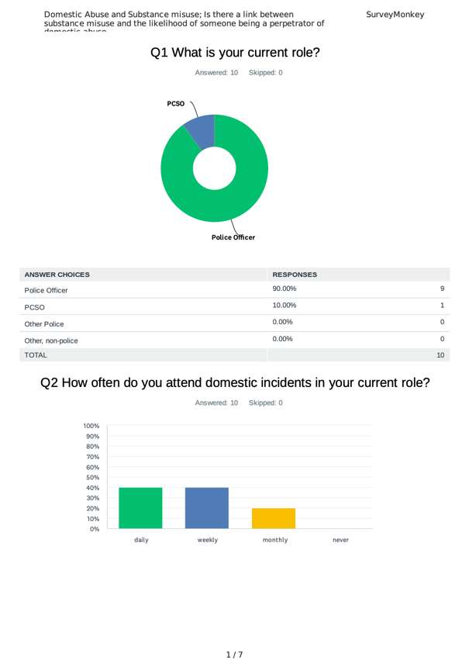
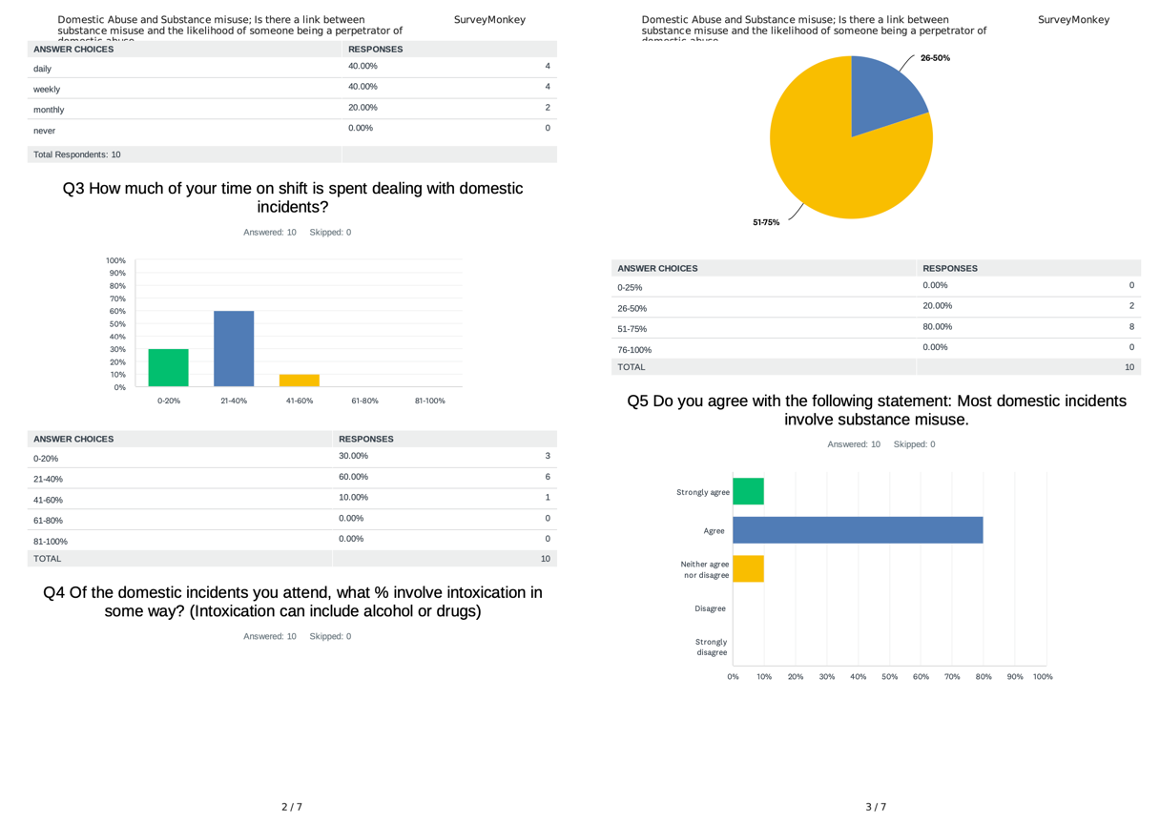
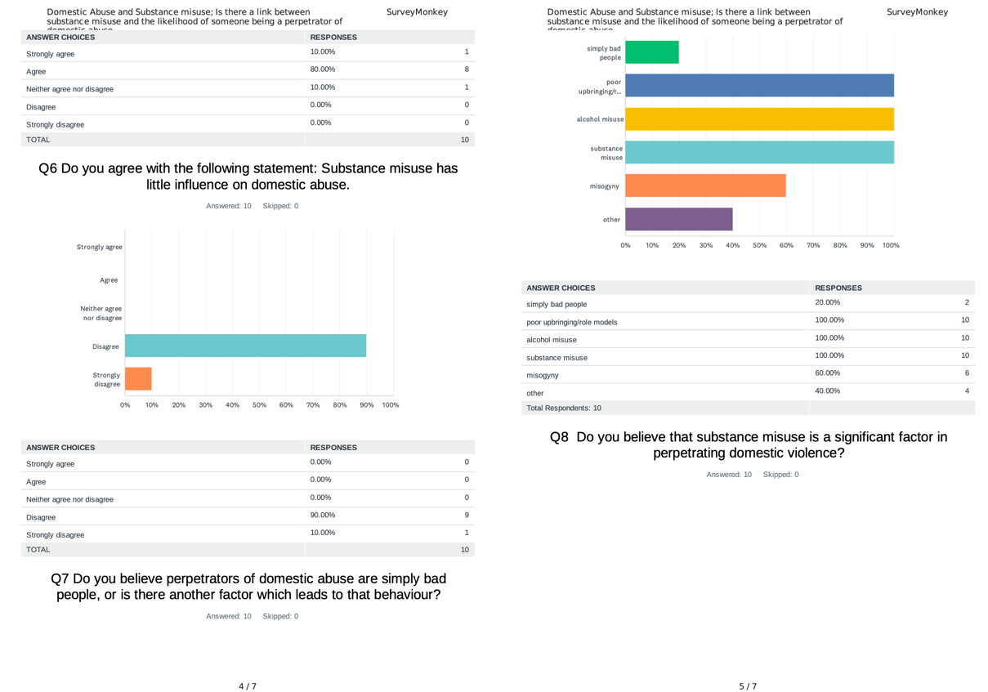
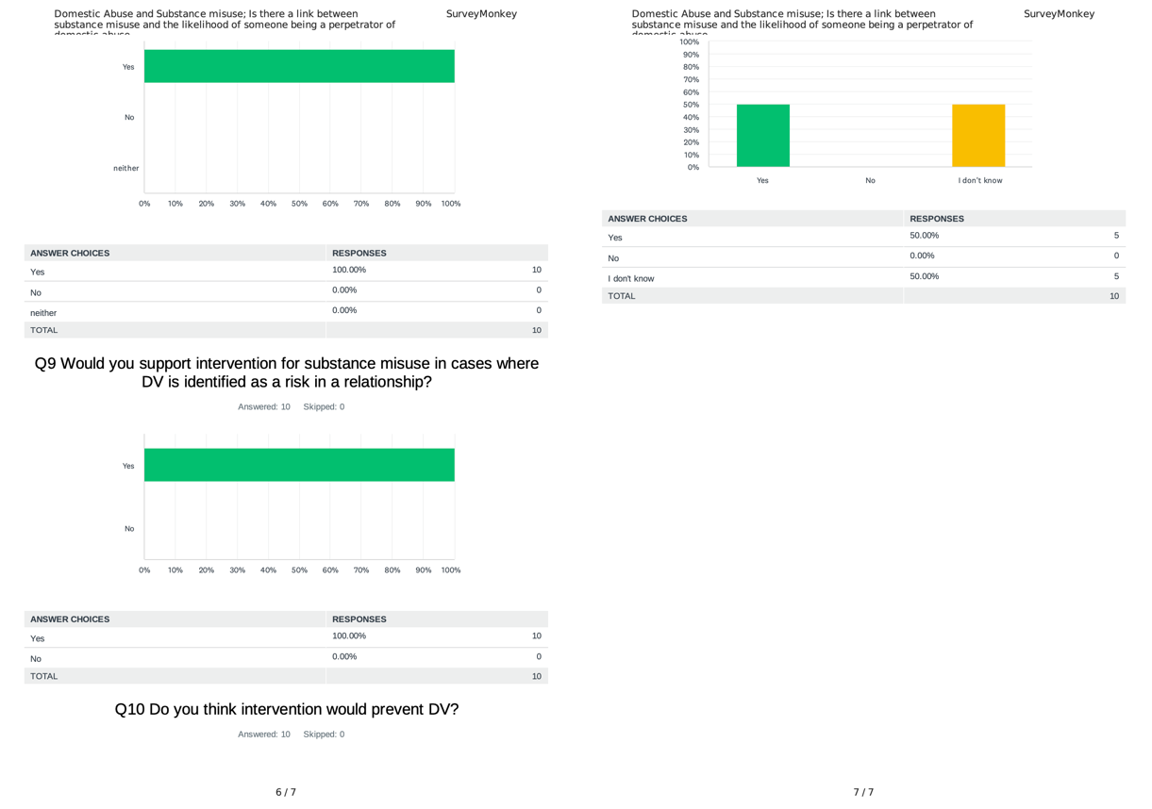

7.3 Appendix Three: Dissertation Proposal
DRAFT RESEARCH TITLE QUESTION:

Domestic Abuse and Substance misuse; Is there a link between substance misuse and the likelihood of someone being a victim or a perpetrator of domestic abuse.

INTRODUCTION:

This dissertation will look at the links between substance misuse and domestic abuse. It will discuss the links between substance misuse, such as addiction to controlled substances or alcoholism, and domestic abuse encompassing both victims and perpetrators. It will explore whether substance abuse makes a person more likely to be a perpetrator of domestic abuse and similarly, does it make someone more likely to be a victim or indeed a repeat victim and is this adequately addressed in rehabilitation of offenders and support to victims.

Research suggests that on the extreme end of domestic violence, that being domestic homicide, substance use is a common factor and more generally it is suggested that men who are dependent on alcohol or drugs are 6 times more likely to be perpetrators of domestic abuse. The purpose of this research is to determine if the experience of police officers who are the first responders to incidents of domestic abuse, corroborates this research.

This subject was chosen by the researcher as domestic abuse is something that they have first-hand experience of responding to. It is an important subject and one which they believe to be somewhat overlooked when it comes to rehabilitation of offenders and victims as if substance abuse is a root cause of the behaviour it should be tackled as a priority to prevent reoffending or becoming repeat victims.

Furthermore, the topic of domestic abuse takes up a large proportion of police resources and is a topic that in recent decades has become better researched and various initiatives have been implemented to tackle domestic abuse, these have largely been aimed at better understanding in order to recognise domestic abuse and to be proactive in responding to all incidents. It would be beneficial to further explore the root causes or exacerbating factors involved in domestic abuse and what can be done to prevent offending and re-offending.

SUMMARY OF RESEARCH OBJECTIVES:

The aims of this study are to identify:
- Is substance misuse and domestic abuse linked?
- Does substance misuse make a person more likely to be a perpetrator?
- Does substance misuse make a person vulnerable to being a victim of domestic abuse?

The research conducted will be guided by the following principles:
- An exploration and understanding of other literature around the topic.
- An evaluation of current services to rehabilitate offenders or support victims.
- Primary surveys will be conducted with responders to domestic abuse, largely police officers but also other involved services.

The surveys conducted will be collated and analysed to be used for the purpose of corroborating existing literature which as previously mentioned suggests a link between substance misuse and domestic abuse and to give backing to the proposed method of reducing offending and victimisation.

LITERATURE REVIEW:

Domestic violence is unfortunately, a common issue within UK society and this is shown by the most recently published Crime Survey for England and Wales (ONS, 2023) which shows that in the year of April 21 – March 22, police in England and Wales recorded 910,980 offences as domestic abuse related. The CSEW also estimates that 5.7% of adults aged 16 – 59 had experienced domestic abuse.

Whilst this figure seems large, it should not be used as a true gauge of incidents of domestic abuse (Flatley et al, 2010), research has previously shown that 47% of victims of domestic abuse had been victimised more than once and 30% stated they had been victimised more than three times.

The UK government defines domestic abuse as follows:

‘Any incident or pattern of incidents of controlling, coercive or threatening behaviour, violence or abuse between those aged 16 or over who are or have been intimate partners or family members regardless of gender or sexuality. This can encompass, but is not limited to, the following types of abuse: psychological, physical, sexual, financial, and emotional’ (Home Office, 2013).

A study by Yu (2019) based on data from Sweden identified 140,000 men whom between January 1998 and December 2013, had received a clinical diagnosis of alcohol or drug abuse. Researchers then looked into the number of these men who had subsequently been detained for assaulting, threatening, or sexually abusing their wives, girlfriends, or female ex-partners.
They discovered that 1.7% of alcohol-dependent men had subsequently been arrested for such offences, which is six times the number in a sample of all males with a comparable age profile. Similarly, 2.1% of drug-using males were subsequently arrested for such offences, which was seven times more than the national average.

Much research has been done on the topic, however the information available largely looks at incidents which are either recorded as crimes, or as with Yu’s research, have led to an arrest. Similarly, in Yu’s work, this only considers persons with diagnosed cases of alcohol of drug dependency. These factors indicate that the research being done is not able to provide a complete picture of the scale of the issue being researched.

This research hopes to identify the gap between the statistics of recorded crime/ domestic abuse arrests and diagnosed cases of substance addiction, with the real world observations of professionals which could encompass incidents which do not lead to arrest or are not recorded as crimes, as well as taking into account those perpetrators or victims who do not have diagnosed addiction to alcohol or drugs, but these influences are a factor.

SUMMARY OF RESEARCH –SURVEY METHOD:

This study will consist of a survey targeted at police officers and other professionals in the field being studied, the questions will be aimed in order to produce quantitative data as a result of the survey which will be for the purpose of this research, the primary data source.

Secondary data from existing literature similar to that previously highlighted, will be analysed against the primary data with any findings critically examined. This method is best suited to this research as it will remain simple and to the point. Given the small sample group the researcher believed that questions aimed toward qualitative data would be prone to returning too broad a data set to answer the question posed.

SUMMARY OF SAMPLING FRAMEWORK:

The target sample for this research will be police officers and professionals in the field of domestic abuse, those asked to take part will only be those involved in the field. This targeted sample of people is preferred to a more generalised questionnaire for the broader public as the research is seeking to identify the observations of professionals who deal with domestic abuse as it is hoped this will depict the larger picture of domestic abuse, rather than that which only leads to recorded crime and arrests as previous research has explored.

ETHICAL ISSUES:

The researcher has not identified any significant ethical issues arising as a result of this study. Participants will not be identifiable as they will remain anonymous and the information they provide will be anonymised so as to not reveal any specifics of people or locations involved in the subject matter.

TIME SCALE:

The time scale for this research has been set out by a schedule of deadlines as dictated by the university institution. Broadly, the study itself should be complete and analysed by August 2023, with final findings and conclusions complete by September 2023.

7.4 Appendix Four: Ethics Form
APPLICATION FOR ETHICAL APPROVAL

In order for research to result in benefit and minimise risk of harm, it must be conducted ethically. A researcher may not be covered by the University’s insurance if ethical approval has not been obtained prior to commencement.

The University follows the OECD Frascati manual definition of research activity: “creative work undertaken on a systematic basis in order to increase the stock of knowledge, including knowledge of man, culture and society, and the use of this stock of knowledge to devise new applications”. As such this covers activities undertaken by members of staff, postgraduate research students, and both taught postgraduate and undergraduate students working on dissertations/projects.

The individual undertaking the research activity is known as the “principal researcher”.

Ethical approval is not required for routine audits, performance reviews, quality assurance studies, testing within normal educational requirements, and literary or artistic criticism.

Please read the notes for guidance before completing ALL sections of the form.

This form must be completed and approved prior to undertaking any research activity. Please see Checklist for details of process for different categories of application.

Delete the Guidance Notes at the end of the form BEFORE submitting your application

SECTION A: About You (Principal Researcher)
Full Name: |  | Daniel MARTIN
Tick all boxes which apply: |  | Member of staff: | ☐ | Honorary research fellow: | ☐
Undergraduate Student | ☒ | Taught Postgraduate Student | ☐ | Postgraduate Research Student | ☐

Institute/Academic Discipline/Centre: | UWTSD
Campus: | Swansea
E-mail address: | 2023879@student.uwtsd.ac.uk
Contact Telephone Number: | Nil
For students:
Student Number: | 2023879
Programme of Study: | Professional Policing Practice
Director of Studies/Supervisor: | Vivienne HARPWOOD

SECTION B: Approval for Research Activity
Has the research activity received approval in principle?  (please check the Guidance Notes as to the appropriate approval process for different levels of research by different categories of individual) |  | YES | ☒ | NO | ☐
 |  |  |  | Date
If Yes, please indicate source of approval (and date where known): Approval in principle must be obtained from the relevant source prior to seeking ethical approval | Research Degrees Committee |  | ☒
 | Institute Research Committee |  | ☐
 | Other (write in) |  | ☐

SECTION C: Internal and External Ethical Guidance Materials
Please list the core ethical guidance documents that have been referred to during the completion of this form (including any discipline-specific codes of research ethics, and also any specific ethical guidance relating to the proposed methodology). Please tick to confirm that your research proposal adheres to these codes and guidelines.
UWTSD Research Ethics & Integrity Code of Practice | ☒
UWTSD Research Data Management Policy | ☒
 | ☐

SECTION D: External Collaborative Research Activity
Does the research activity involve collaborators outside of the University? |  | YES | ☐ | NO | ☒
If Yes, please provide the name of the external organisation and name and contact details for the main contact person and confirmation this person has consented to their personal data being shared.as part of this collaboration.
Institution
Contact person name
Contact person e-mail address

Has this individual consented to sharing their details on this form? |  | YES | ☐ | NO |  |  | ☐
Are you in receipt of a KESS scholarship? |  | YES | ☐ | NO |  |  | ☐
Is your research externally funded |  | YES | ☐ | NO |  |  | ☐
Are you specifically employed to undertake this research in either a paid or voluntary capacity? | Voluntary | YES | ☐ | NO |  | ☐
 | Employed | YES | ☐ | NO |  | ☐
Is the research being undertaken within an existing UWTSD Athrofa Professional Learning Partnership (APLP) | If YES then the permission question below does not need to be answered. | YES | ☐ | NO |  |  | ☐
Permission to undertake the research has been provided by the partner organisation | (If YES attach copy)  If NO the application cannot continue | YES | ☐ | NO |  |  | ☐

Where research activity is carried out in collaboration with an external organisation
Does this organisation have its own ethics approval system? | YES | ☐ | NO | ☐
If Yes, please attach a copy of any final approval (or interim approval) from the organisation

SECTION E: Details of Research Activity
Indicative title: | The study of links between substance misuse and domestic violence, with the aim to establish if these is any correlation between substance misuse and being a perpetrator or victim of domestic violence.
Proposed start date: | 1/3/23 | Proposed end date: | 1/5/23
Introduction to the Research (maximum 300 words)
Ensure that you write for a Non-Specialist Audience when outlining your response to the three points below:
- Purpose of Research Activity
- Proposed Research Question
- Aims of Research Activity
- Objectives of Research Activity
Demonstrate, briefly, how Existing Research has informed the proposed activity and explain
- What the research activity will add to the body of knowledge
- How it addresses an area of importance.
Purpose of Research Activity

The purpose of the study is to investigate whether a persons disposition as a substance misuser, be it someone who is an alcoholic or addicted to substances such as heroin or cocaine, can make that person more likely to be a perpetrator of domestic violence, or indeed increase the chance of becoming a victim of domestic violence.

The study will look at the experience of police officers as well as other professionals in the field and ask what they believe to be the factors which may cause someone to be a perpetrator or victim of domestic violence.

It is hoped that the study will depict the observations of those with the most experience of domestic violence, without having to disclose precise details of incidents which would not be appropriate, and these observations will provide an insight into the factors that contribute most to a person being a victim or becoming a perpetrator of domestic abuse.

(this box should expand as you type)
Research Question

Domestic Abuse and Substance misuse; Is there a link between substance misuse and the likelihood of someone being a victim or a perpetrator of domestic abuse.

(this box should expand as you type)
Aims of Research Activity

- To establish what front line responders to domestic abuse believe to be the contributing factors in relation to a person’s lifestyle/characteristics.
- For these factors to be ranked into an order of most to least impactful.
- To identify where substance misuse falls into this ranking.
- To understand how tackling aggravating factors can be a tool in reducing risk of domestic violence

(this box should expand as you type)
Objectives of Research Activity

- Review literature around domestic violence and its links with substance misuse.
- To conduct a study with Police officers and third party organisations with experience of domestic violence, to identify observations or common factors involved in cases of domestic violence.
- Lastly, to collect analyse and display data to depict findings.

(this box should expand as you type)
Proposed methods (maximum 600 words)
Provide a brief summary of all the methods that may be used in the research activity, making it clear what specific techniques may be used. If methods other than those listed in this section are deemed appropriate later, additional ethical approval for those methods will be needed.
I will use an online survey, which will be shared with police colleagues and local council colleagues who deal with domestic violence support. The survey will ask a series of questions which will enable me to gather data for analysis, to identify whether the observations of those most in contact with both victims and perpetrators of domestic abuse, corroborate or contradict the question asked.

(this box should expand as you type)

Location of research activity
Identify all locations where research activity will take place.
Swansea

(this box should expand as you type)
Research activity outside of the UK
If research activity will take place overseas, you are responsible for ensuring that local ethical considerations are complied with and that the relevant permissions are sought. Specify any local guidelines (e.g. from local professional associations/learned societies/universities) that exist and whether these involve any ethical stipulations beyond those usual in the UK (provide details of any licenses or permissions required). Also specify whether there are any specific ethical issues raised by the local context in which the research activity is taking place, for example, particular cultural and/or legal sensitivities or vulnerabilities of participants.
No research will be conducted overseas.

(this box should expand as you type)
Use of documentation not in the public domain: Are any documents NOT publicly available? | NO | ☒
 | YES | ☐
If Yes, please provide details here of how you will gain access to specific documentation that is not in the public domain and that this is in accordance with prevailing data protection law of the country in question and England and Wales.

(this box should expand as you type)

SECTION F: Scope of Research Activity
Will the research activity include: | YES | NO
Use of a questionnaire or similar research instrument? | ☒ | ☐
Use of interviews? | ☐ | ☒
Use of diaries? | ☐ | ☒
Participant observation with their knowledge? | ☐ | ☒
Participant observation without their knowledge? | ☐ | ☒
Use of video or audio recording? | ☐ | ☒
Access to personal or confidential information without the participants’ specific consent? | ☐ | ☒
Administration of any questions, test stimuli, presentation that may be experienced as physically, mentally or emotionally harmful / offensive? | ☐ | ☒
Performance of any acts which may cause embarrassment or affect self-esteem? | ☐ | ☒
Investigation of participants involved in illegal activities? | ☐ | ☒
Use of procedures that involve deception? | ☐ | ☒
Administration of any substance, agent or placebo? | ☐ | ☒
Working with live vertebrate animals? | ☐ | ☒
Other primary data collection methods, please explain in this box  For example, ‘focus groups’. Please indicate the type of data collection method(s) in this box and tick the accompany box. | ☐ | ☒
Details of any other primary data collection method:  (this box should expand as you type) | ☐ | ☒
If NO to every question, then the research activity is (ethically) low risk and may be exempt from some of the following sections (please refer to Guidance Notes).

If YES to any question, then no research activity should be undertaken until full ethical approval has been obtained.

SECTION G: Intended Participants
Who are the intended participants: | YES | NO
Students or staff at the University? | ☒ | ☐
Adults (over the age of 18 and competent to give consent)? | ☒ | ☐
Vulnerable adults? | ☐ | ☒
Children and Young People under the age of 18? (Consent from Parent, Carer or Guardian will be required) | ☐ | ☒
Prisoners? | ☐ | ☒
Young offenders? | ☐ | ☒
Those who could be considered to have a particularly dependent relationship with the investigator or a gatekeeper? | ☐ | ☒
People engaged in illegal activities? | ☐ | ☒
Others (please identify specifically any group who may be unable to give consent) please indicate here and tick the appropriate box. | ☐ | ☒
Other – please indicate here:  (this box should expand as you type) | ☐ | ☒

Participant numbers and source
Provide an estimate of the expected number of participants. How will you identify participants and how will they be recruited?
How many participants are expected? | 10-20 participants  (this box should expand as you type)
Who will the participants be? | Police Officers, Employees of third party organisations which deal with domestic violence  (this box should expand as you type)
How will you identify the participants? | Each respondent will be numerated and as such no person will be identifiable as personal details will not be requested, the respondents will be anonymous.  (this box should expand as you type)

Information for participants: | YES | NO | N/A
Will you describe the main research procedures to participants in advance, so that they are informed about what to expect? | ☒ | ☐ | ☐
Will you tell participants that their participation is voluntary? | ☒ | ☐ | ☐
Will you obtain written consent for participation? | ☒ | ☐ | ☐
Will you explain to participants that refusal to participate in the research will not affect their treatment or education (if relevant)? | ☐ | ☐ | ☒
If the research is observational, will you ask participants for their consent to being observed? | ☐ | ☐ | ☒
Will you tell participants that they may withdraw from the research at any time and for any reason? | ☒ | ☐ | ☐
With questionnaires, will you give participants the option of omitting questions they do not want to answer? | ☒ | ☐ | ☐
Will you tell participants that their data will be treated with full confidentiality and that, if published, it will not be identifiable as theirs? | ☒ | ☐ | ☐
Will you debrief participants at the end of their participation, in a way appropriate to the type of research undertaken? | ☒ | ☐ | ☐
If NO to any of above questions, please give an explanation
(this box should expand as you type)

Information for participants: | YES | NO | N/A
Will participants be paid? | ☐ | ☒ | ☐
Is specialist electrical or other equipment to be used with participants? | ☐ | ☒ | ☐
Are there any financial or other interests to the investigator or University arising from this study? | ☐ | ☒ | ☐
Will the research activity involve deliberately misleading participants in any way, or the partial or full concealment of the specific study aims? | ☐ | ☒ | ☐
If YES to any question, please provide full details
(this box should expand as you type)

SECTION H: Anticipated Risks

Outline any anticipated risks that may adversely affect any of the participants, the researchers and/or the University, and the steps that will be taken to address them.

If you have completed a full risk assessment (for example as required by a laboratory, or external research collaborator) you may append that to this form.
Full risk assessment completed and appended? |  | Yes | ☐
 |  | No | ☒
Risks to participants
For example: emotional distress, financial disclosure, physical harm, transfer of personal data, sensitive organisational information
Risk to Participant:  PTSD or general distress due to recollection of cases  (this box should expand as you type) | How will you mitigate the Risk to Participant  The purpose of the study will be explained and a warning given before any person takes part.  The questionnaire will ask respondents to confirm that they are not victims of domestic abuse or anything other than the target audience for the study.  (this box should expand as you type)
If research activity may include sensitive, embarrassing or upsetting topics (e.g. sexual activity, drug use) or issues likely to disclose information requiring further action (e.g. criminal activity), give details of the procedures to deal with these issues, including any support/advice (e.g. helpline numbers) to be offered to participants. Note that where applicable, consent procedures should make it clear that if something potentially or actually illegal is discovered in the course of a project, it may need to be disclosed to the proper authorities
(this box should expand as you type)
Risks to investigator
For example: personal safety, physical harm, emotional distress, risk of accusation of harm/impropriety, conflict of interest
Risk to Investigator:  Minimal  (this box should expand as you type) | How will you mitigate the Risk to Investigator:  The investigator understands the topic being studied and no details of incidents will be obtained by the study itself.  (this box should expand as you type)
University/institutional risks
For example: adverse publicity, financial loss, data protection
Risk to University:  Nil  (this box should expand as you type) | How will you mitigate the Risk to University:  (this box should expand as you type)

Disclosure and Barring Service
If the research activity involves children or vulnerable adults, a Disclosure and Barring Service (DBS) certificate must be obtained before any contact with such participants. | YES | NO | N/A
Does your research require you to hold a current DBS Certificate? | ☐ | ☐ | ☒

SECTION I: Feedback, Consent and Confidentiality
Feedback
What de-briefing and feedback will be provided to participants, how will this be done and when?
Participants will be thanked for taking part, but it is not expected that there will be any follow up exchange of information. Of course this study will form part of a dissertation that will be available to them and my own details will be passed should anyone wish to know the findings of the study prior to this.

(this box should expand as you type)
Informed consent
Describe the arrangements to inform potential participants, before providing consent, of what is involved in participating. Describe the arrangements for participants to provide full consent before data collection begins. If gaining consent in this way is inappropriate, explain how consent will be obtained and recorded in accordance with prevailing data protection legislation.
The study will outline its content and explain consent in relation to the information provided being used as part of the study, this acceptance will be a precursor to taking part.

(this box should expand as you type)
Confidentiality / Anonymity
Set out how anonymity of participants and confidentiality will be ensured in any outputs. If anonymity is not being offered, explain why this is the case.
As previously stated, the study is anonymous as such no personal details will be requested and no specific detail of a sensitive nature will be gained by completion of the study.

(this box should expand as you type)

SECTION J: Data Protection and Storage
In completing this section refer to the University’s Research Data Management Policy and the extensive resources on the University’s Research Data Management web pages (http://uwtsd.ac.uk/library/research-data-management/).
Does the research activity involve personal data (as defined by the General Data Protection Regulation 2016 “GDPR” and the Data Protection Act 2018 “DPA”)? | YES | NO
“Personal data” means any information relating to an identified or identifiable natural person (‘data subject’). An identifiable natural person is one who can be identified, directly or indirectly, in particular by reference to an identifier such as a name, an identification number, location data, an online identifier or to one or more factors specific to the physical, physiological, genetic, mental, economic, cultural or social identity of that natural person. | ☐ | ☒
If YES, provide a description of the data and explain why this data needs to be collected:
(this box should expand as you type)
Does it involve special category data (as defined by the GDPR)? | YES | NO
“Special category data” means sensitive personal data consisting of information as to the data subjects’ –  (a) racial or ethnic origin,  (b) political opinions,  (c ) religious beliefs or other beliefs of a similar nature,  (d) membership of a trade union (within the meaning of the Trade Union and Labour Relations (Consolidation) Act 1992),  (e) physical or mental health or condition,  (f) sexual life,  (g) genetics,  (h) biometric data (as used for ID purposes), | ☐ | ☒
If YES, provide a description of the special category data and explain why this data needs to be collected:
(this box should expand as you type)
Will the research activity involve storing personal data and/or special category data on one of the following: | YES | NO
Manual files (i.e. in paper form)? | ☐ | ☒
University computers? | ☐ | ☒
Private company computers? | ☐ | ☒
Home or other personal computers? | ☐ | ☒
Laptop computers/ CDs/ Portable disk-drives/ memory sticks? | ☒ | ☐
“Cloud” storage or websites? | ☒ | ☐
Other – specify: | ☐ | ☒
For all stored data, explain the measures in place to ensure the security of the data collected, data confidentiality, including details of password protection, encryption, anonymisation and pseudonymisation:
Laptop used is password protected, only the researcher has access. The laptop used does utilise iCloud services and again this is password protected and only accessible to the researcher.

(this box should expand as you type)
All Data Storage
Will the research activity involve any of the following activities: | YES | NO
Electronic transfer of data in any form? | ☐ | ☒
Sharing of data with others at the University? | ☐ | ☒
Sharing of data with other organisations? | ☐ | ☒
Export of data outside the European Union or importing of data from outside the UK? | ☐ | ☒
Use of personal addresses, postcodes, faxes, emails or telephone numbers? | ☐ | ☒
Publication of data that might allow identification of individuals? | ☐ | ☒
Use of data management system? | ☐ | ☒
Data archiving? | ☐ | ☒
If YES to any question, please provide full details, explaining how this will be conducted in accordance with the GDPR and DPA (and/or any international equivalent):
(this box should expand as you type)
List all who will have access to the data generated by the research activity:
The researcher

(this box should expand as you type)
List who will have control of, and act as custodian(s) for, data generated by the research activity:
The researcher

(this box should expand as you type)
Give details of data storage arrangements, including security measures in place to protect the data, where data will be stored, how long for, and in what form. Will data be archived – if so how and if not why not.
(this box should expand as you type)
Please indicate if your data will be stored in the UWTSD Research Data Repository (see https://researchdata.uwtsd.ac.uk/ ). If so please explain. (Most relevant to academic staff)
(this box should expand as you type)
Confirm that you have read the UWTSD guidance on data management (see https://www.uwtsd.ac.uk/library/research-data-management/) | YES | ☒
 | NO | ☐
Confirm that you are aware that you need to keep all data until after your research has completed or the end of your funding | YES | ☒
 | NO | ☐

SECTION K: Declaration
The information which I have provided is correct and complete to the best of my knowledge. I have attempted to identify any risks and issues related to the research activity and acknowledge my obligations and the rights of the participants.

In submitting this application I hereby confirm that I undertake to ensure that the above named research activity will meet the University’s Research Ethics and Integrity Code of Practice which is published on the website: https://www.uwtsd.ac.uk/research/research-ethics/
Signature of applicant: | D MARTIN | Date:  24/2/23

For STUDENT Submissions:
Director of Studies/Supervisor: |  | Date:
Signature: |  | Date:

For STAFF Submissions:
Academic Director/ Assistant Dean: |  | Date:
Signature: |  | Date:

Checklist: Please complete the checklist below to ensure that you have completed the form according to the guidelines and attached any required documentation:
☒ | I have read the guidance notes supplied before completing the form.
☒ | I have completed ALL RELEVANT sections of the form in full.
☒ | I confirm that the research activity has received approval in principle
☐ | I have attached a copy of final/interim approval from external organisation (where appropriate)
☐ | I have attached a full risk assessment (and have NOT completed Section H of this form) (where appropriate) ONLY TICK IF YOU HAVE ATTACHED A FULL RISK ASSESSMENT
☒ | I understand that it is my responsibility to ensure that the above named research activity will meet the University’s Research Ethics and Integrity Code of Practice.
☒ | I understand that before commencing data collection all documents aimed at respondents (including information sheets, consent forms, questionnaires, interview schedules etc.) must be confirmed by the DoS/Supervisor, module tutor or Academic Director.
☒ | I have deleted the guidance notes before submitting the PG2 for consideration

RESEARCH STUDENTS AND STAFF ONLY
All communications relating to this application during its processing must be in writing and emailed to pgresearch@uwtsd.ac.uk , with the title ‘Ethical Approval’ followed by your name.
You will be informed of the outcome of your claim by email; therefore it is important that you check your University and personal email accounts regularly.

STUDENTS ON UNDERGRADUATE OR TAUGHT MASTERS PROGRAMMES should submit this form (and receive the outcome) via systems explained to you by the supervisor/module leader.

This form is available electronically from the Academic Office web pages: https://www.uwtsd.ac.uk/academic-office/appendices-and-forms/

Application Process

All staff research projects and all research students must submit the Ethical Approval Form to the University Research Ethics Committee via the Academic Office (pgresearch@uwtsd.ac.uk). Staff research directly in relation to personal study for taught undergraduate or Masters programmes should be submitted via the Institute procedures explained below.

Taught masters and taught undergraduate research Ethical Approval Forms are considered within Institutes. Institutes will provide details of the specific processes for this. Where the Ethical issues within any single ethical application are of particular concern the Institute will refer these to the University Research Ethics Committee. Any student activity that involves the collection of primary data needs to undergo Ethical approval, this includes assignment work as well as dissertations.

