Professional Career Development
STUDENT NAME:TEAN ANNMARIE LETTS
STUDENT NUMBER:1805537
LECTURER:NAVAMI SUDARSAN
MODULE:BMSK 4005

Table of Content
Introduction 2
Understand the skills and knowledge needed for working effectively 2
Demonstrate readiness for employability and personal advancement through an understanding of personal strengths and areas for further development 7
Establish employment goals and develop a personal action plan 13
Conclusion 15
References 16

Introduction
Professional career development is considered to be a crucial step towards ensuring overall growth and development of an individual. The process of professionally developing oneself starts with self-awareness. Self awareness is quite crucial in order to recognise the strength and weak points (Yarbrough et al., 2017). Without the recognition of the strengths and weaknesses it becomes significantly hard and difficult to carryout continuous development and improvement of oneself. Before starting with professional development it is necessary to maintain knowledge and suitable skills which will help in the particular process (Ansmann et al., 2014). This portfolio has discussed the different aspects and necessities associated with effective professional development. In this assignment I have reflected upon my understanding of the employment world along with the evaluation and analysis of my own skills and knowledge. Lastly on the basis of my personal evaluation and understanding I have prepared and presented an action plan which will ensure further development and refinement of my professional skills and knowledge.

Understand the skills and knowledge needed for working effectively
Presently the competition has greatly increased within the business environment. Sole importance is only being provided to the candidates having the appropriate knowledge and competencies. The demands and requirements within the employment market are dynamically changing with the passing time (Bakhshi et al., 2017). It is becoming necessary for the existing professionals as well as job seeking candidates to develop better understanding about the knowledge and skills required to work effectively within the different working environments. As the competition is increasing the demands and expectation of the employers are also increasing. Therefore, professional development needs to be a dynamic and continuous process for the individuals. For surviving within the global business environment it is mandatory for the individuals to carry on with their development and ensure better understanding of employment skills and knowledge.
Understanding of necessary skills for employment:
There is necessity of obtaining and refining certain employability skills in order to secure a better employment opportunity in future. The attainment of the employment skills cannot be limited, in fact more the number of skills more are the competencies of an individual (Collet et al., 2015). Balance created by the individuals in their life, attainment and development of necessary skills helps them to grab best opportunities in their life. Some of the skills that have been identified on the basis of general grounds have been discussed in details below.
Communication skills: Communication skill is considered to be an important and mandatory professional skill required for conveying important messages to others across any organizational environment. Business communication can be categorised as verbal, non-verbal and written communication. The entire process of communication greatly depends on the efficiency of the communication platform (Assiter, 2017). Generally two-way communication processes are preferred within the working environment of an organization. With respect to verbal communications individuals need to concentrate on skills like use of suitable gestures, listening skills, interaction skills, presentation skills and so on for making the process a success. Non-verbal communication greatly relies on the suitable utilisation of gestures, expressions and body language for conveying appropriate messages to the audience. Written communication within business environment is basically carried out in the form of reports, emails, letters, etc (Qenani et al., 2014).
Leadership skills: Leadership skill is considered to be one of the most essential competency or skill of a professional. Leadership skills are needed to be practised by every member of an organization as it helps in leading teams and work groups in the right directions. Attainment of this skill develops the ground or foundation for the development and improvement of other skills like decision making skills, conflict handling skills, problem solving skills and so on (Gott et al., 2019). Without the development of this particular skill it becomes significantly difficult to make suitable use of bigger and promising opportunities in future.
Team working skills: Team work is regarded as the backbone of any kind of business projects to be carried out. Effective team work is all about cooperation, coordination, communication, understanding and adjusting. All these of qualities are mandatory to be practiced and refined in order to ensure that proper team work is delivered (Mackay, 2017). Better team work represented by the entire workforce within an organization is capable of contributing towards the growth and development of a business entity.
Analytical skills: Analytical skill is a necessary skill which is needed to be included in the professional development process of an individual. Without the power to critically analyse any situation it becomes greatly difficult to make any suitable decision or find out solution to a specific problem. Therefore, analytical skill is an essential skill which complements the effective utilisation of leadership and managerial skills in formulating efficient solutions and decisions regarding any organizational situation (Powell-Martin et al., 2019).
Problem solving skills: As the competition is increasing the activities within the organizations are becoming diverse. As a result the present organizational problems have become complex and critical. The professionals are expected to come up with creative and innovative solutions in order to deal with complex problems arising out of present business activities.
Critical thinking skills: The activities within the business environment and working environment of an organization are frequently changing with the changing demands of the stakeholders. Therefore, every member of an organization is expected to analyse their roles and responsibilities from a critical perspective (Brookes et al., 2018). With respect to present day business environment critical thinking is becoming necessary to find out effective solutions and make effective decisions thereby affecting the overall performance of the organizations.
Decision making skills: Decision making process needs to be carried out efficiently and without any delay for the maintenance of the competitive advantages of the organizations. For formulating suitable decisions responsible professionals are expected to view the problems and situations from ma critical perspective, breakdown the entire situation into understandable aspects and identify solutions through assessment of the sources and causes (Yarbrough et al., 2017). Proper decisions can be formulated through the implementation of critical thinking, analysis, leadership and problem solving skills.
Conflict management skills: In present day business environment it is observed that diverse workforces are maintained by the business entities for encouraging generation of innovative and creative thoughts and ideas. When a business environment becomes diverse conflicts can arise over any situation or subject or operation (Qenani et al., 2014). Thus it becomes important to apply appropriate conflict management or handling skills for mitigating the issues from the root. Conflict management involves effective mitigation of confusions, doubts, miscommunications, etc. so that the organizational goals and objectives can be met successfully.
Pressure handling skills: As the competition is intensifying across the global market pressure is also building on the business entities to give their performances. Thus, the employees have to deal with huge amount of pressure to give their best for ensuring better performance and profitability of the organizations (Mackay, 2017). Professionals have to deal with different complicated and critical situations. So, the professionals need to master pressure handling skills and become flexible with the amount of work and responsibilities assigned to them.
Negotiation skills: In business negotiations are considered to be a crucial part to be handled by the professionals. Proper negotiations have to be carried for creating a balance between the interests of the stakeholders as well as the employers. Poor negotiation can result in the poor fulfilment of the needs and demands of any party which is not at all beneficial for the management of growth of the organizations. Suitable negotiations skills along with communication skills, critical thinking skills, analytical skills are required running and expanding the business profitably (Powell-Martin et al., 2019).
Technical skills: With the increased amount of advancements being made in the field of technology it is becoming important for the management and other members of the organization to give importance of technical skills. Technological inventions are being incorporated within the organizational infrastructure for enhancing the efficiencies of the business operations. Therefore, professionals and job seeking candidates need to attain technical skills about handling internet and different platforms of technology.
Self-motivation skills: Self-motivation is needed to encourage continuous professional development of an individual. Self-motivation skills assist an individual to carry on with the generation of innovative and productive ideas and thoughts. This particular skill is highly effective in keeping a professional motivated and persuasive towards giving their best towards the development and growth of an organization.
Reflective skills: Reflective skills are required for helping professionals to measure the progress they have made so far. Self-reflection is an effective way of acknowledging and evaluating experiences gained through academic and professional life. Analysis of the experiences is an effective means of measuring strengths and weakness for ensuring further development (Bakhshi et al., 2017).
Learning style skills: Being acquainted with self-learning styles is helpful towards gaining useful knowledge. Awareness about learning styles assist in obtaining productive knowledge which ensures suitable and beneficial professional development.
Understanding of necessary knowledge for working effectively:
Besides maintaining suitable knowledge about skills required to deliver better performance the professionals are also required to maintain better knowledge about different aspects of the employment environment. This kind of knowledge can include awareness about the different employment regulations, necessary aspects of good practices and good conduct, clear concept about ROTA and so on.
Employment regulations: Professionals are required to maintain a sound knowledge about the various employment regulations. This is necessary for ensuring the welfare of the organizations as well as the workforce. Over the years different acts and legislations have been introduced to main decorum and ethics within the business environment. Some of the important employment legislations which must be given importance by all professionals are, Employment act, Equality Act (2010), Minimum Wage Act (1998), Data Protection Act (2018), Health and Safety Acts, etc (Brookes et al., 2018.). All these acts have been formulated and implemented in order to prevent any kind of fraudulence and unethical activities and operations within the business environment. These legislations and acts regulate the performance of the organization as well as of the employees.
ROTA: The term ROTA generally represents the time management systems with respect to employee engagement. Sometimes ROTA is referred as roster or schedule within the business environment. Proper scheduling of the employee activities by keeping in mind the well being of the workforce to a great extent assists in managing the engagement and commitment on the part of the employees (Ansmann et al., 2014). Under this scenario, the organizations need to focus on suitable stuffing and employee retention strategies so that the employees are able to get the opportunity to showcase their abilities and also learn things simultaneously.
Good practices and Good conduct: Professionals in order to gain suitable appraisals and opportunities need to maintain sound knowledge about good organizational practices and conducts. Good organizational practices represent conveying important and urgent information through suitable communication, contributing towards proper team work, carrying out functional partnership, delivering mutual respect to others, cooperating with others and so on. Proper communication is required for ensuring the sharing of experiences, expertise and other knowledge important for contributing towards organizational success (Yarbrough et al., 2017). Team work and functional partnership are considered to be an important step towards making sure that activities and operations are completed within deadline, satisfaction level of the clients are met, objectives of the business are met, etc. Providing mutual respect falls under showcasing good organizational conduct (Qenani et al., 2014). Every organization has its own culture, value, ethics, guidelines, principles, etc. which are required to be followed by the professionals. Complying with these organizational aspects implies that the professionals are representing good organizational conduct. Absence of good practices and conducts results in missing of opportunities for further development of knowledge and skills and attainment of good opportunities.

Demonstrate readiness for employability and personal advancement through an understanding of personal strengths and areas for further development

Personal SWOT Analysis:
Strengths | Weaknesses
- I have the ability of adapting and getting adjusted with necessary changes  - I like to maintain a positive attitude towards every challenge I face  - I am appositive thinker and believes that keeping a positive upfront helps in achieving self goals and objectives  - I have a straight forward approach and prefers interacting with others for dealing with confusions and doubts  - I usually measure situations and problems from a logical perspective before jumping to any conclusion  - I am a fast leaner and have the ability to generate productive ideas and thoughts  - I am an organised person and prefer to maintain a strict schedule  - I am a good observer | - I have problem in handling intense pressure and tight deadlines  - I need to work upon my confidence level  - I need to improve my listening skills as I talk more and listen less  - I am not good at applying suitable non-verbal communication skills  - I lack critical thinking and analytical skills  - I need to attain proper leadership skills  - I am not capable of showcasing better patience level  - I still need to enhance my decision making skills
Opportunities | Threats
- Being a good observer I have the opportunity of developing effective analytical and critical thinking skills  - Development and improvement of analytical and critical skills will enable suitable decision making and problem solving skills  - Having self organising and managing skills will add an advantage to my continuous professional development  - Learning suitable leadership style or skill will help me become more flexible with respect to different work condition. | - Low confidence level and lack of patience can hamper ability to learn new and useful things  - Poor listening skills can negatively impact my decision making and problem solving abilities  - Inability to represent better non-verbal communication skills can convey wrong message to the audience  - Lack of critical thinking, analytical and reflective skills will hinder further appraisals and promotions

Gibbs Reflective Analysis:
Description
Throughout my life journey till now I have experienced several ups and downs. Some of the experiences had been good while others had been bad. My academic career as well as my professional career has helped me a lot in obtaining useful skills and knowledge. This skills and knowledge assisted me in carrying out my roles and responsibilities at my workplaces. Due to certain difficulties in my life I was not able to take up higher studies after completing my secondary education. I had to find employment in order to support my family. After struggling so hard I got the opportunity of continuing with higher studies in business management.
Feelings
I always kept a positive attitude towards the challenges I had faced till now. However, due to lack of proper patience and confidence at some point of time I had felt anxious. Long-term instances and tight deadlines have always made me anxious and impatient. At one point of time when it was becoming hard for me to fulfil my dreams of higher studies I had felt de-motivated. But with time I started adapting with the changes and kept thinking positively.
Evaluation
On the basis of my experiences during my academic and professional career I evaluated that updated business skills and knowledge are necessary to gain better opportunities in future. Continuous development is mandatory for making sure that personal goals and objectives are met. With the help of self-reflection I have been able to evaluate my strength points and weak points. This evaluation has added benefits to my effective personal development planning. I realised from my learning that self-awareness is greatly important carrying out suitable self-development as well as refinement (Qenani et al., 2014).
Analysis
I analysed that there are several areas of improvements which I have to work upon for attaining better opportunities in life. I need to improve my level of patience and confidence in order to effectively deal with tight deadlines and work pressure. I have to develop critical thinking and analytical skills for enhancing my problem solving and decision making capabilities. Due to lack of leadership I can loss productive opportunities in life. Also this specific skill can help me in supporting self-employment (Gott et al., 2019). I have analysed that attainment of proper self-motivation skills will assist me encouraging further refinement of my existing knowledge and skills. Also I need to identify my learning style so that I am capable of gaining new and beneficial knowledge about the business world.
Conclusion
From the above reflection it can be concluded that I am in need of developing several critical skills which are required to opt a better professional career. On the basis of my reflection and other self-competence analysis I will develop a personal development plan which I will follow effectively to ensure my further development and growth.
Action plan
- Setting SMART objectives for supporting continuous personal development
- Developing an effective personal development plan
- Implementing the plan and following it to achieve the SMART objectives
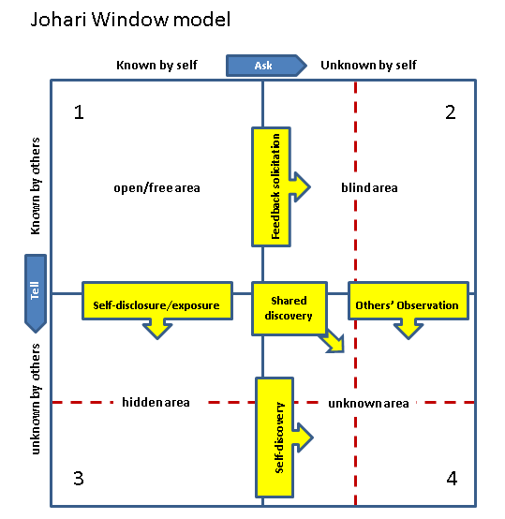
Johari’s Window Analysis:

Applicable to any person, for accurate development of the future, it is much important to improve the consistency level including the development of the personality in the best possible way. One of the currently used technologies or tools that assist the people around the entire world for tracking up the development of personality is the Johari’s window (Brinkert, 2018). Through the processes delivered by this tools, the people are able to analyse their own characteristic features by evaluating their basic nature via the entire procedure of communicating with the other people such as with families, relatives, friends and many more. This model or tool that have been represented as a diagram varies four different types of quadrants which is also known as windows stating the emotional characteristics of self, the motivational feature and many other personal or mental views. Moreover, this model or windows also states whether the emotional or the self-characteristics is limited to personal or varied to others as well. The window that effectivelydepicts the personal characteristic that is known to both self and others as well is known as the open box. On the other hand, the window that effectively depicts the personal characteristic that is known to others, rather than self is widely known as blind box. Similarly, the window that effectively depicts the personal characteristic that is known to self, rather than others is widely known as hidden box. And, the window that effectively depicts the personal characteristic neither to other nor to self is known as the unknown box.
As a result of this fact, I have significantly used this tool in order to evaluate as well as analyse my personal characteristics so that in future I would be able to improve my perception about my personal self to others. For this, in the initial stages I tried to communicate with my friends to whom I am comfortable to share my views and opinions about some significant topics. Including friends, I significantly started to communicate with my family members, my teachers along with my close relatives as well. With their views and opinions towards myself, I initiated to execute the evaluation in the most accurate way. The accumulated outcomes from each of the chosen members, I was able to distinguish the respective data and information as per the characteristic features of open box and close box as well. However, the information regarded the hidden box and unknown box is still not being determined by me. Not only according to the opinions and the views of my friends and families, but also according to my emotional features and characteristic factors including the possessing skills, I have deduced the fact that I have the capability to adapt to various situations, considering both the positive including the negative as well. This feature fall under the category of open box. Moreover, as per them I have also extracted the fact, that I am always a positive thinker and that is why I have the ability to get adapted to any type of situations. With the well behaviour and positive attitude, the factors of open box is completed. On the other hand, the capability of having accurate observations to each and every situational job is one of my personal characteristic that relies on the category of blind box. Other, blind box characteristics are that I possess brilliant mind, bright and majestic in nature.
As per the personal features deduced by them, what I came to know about myself is that I need to initiate a personal development plan in order to enhance my characteristic features for assuring a better future for myself. As per the developed PDP, I would be accurately able to for my future profession. From this model, I have efficiently been analysed myself accurately and understood the fact that how I need to portray myself in front of others. Thus, as per the features, I would train myself for developing my personal characteristic.
Honey and Mumford Learning Style Analysis:
Honey and Mumford Learning Style consists of varying set of questionaries’ that assist a lot for evaluating the learning style of the people around the world (Collet et al., 2016). One of the most crucial step that is utmost necessary for acquiring positive knowledge is to possess positive skills and accurate knowledge about a particular topic. Before acquiring the knowledge, it is much more important for the people to analyse about the entire factors of the learning procedures. This type of style analysis assist the people to get a review idea about the most adaptive learning style that are required for acquiring the best possible knowledge. Currently, there exists four main types of learning styles that is activist, theorist, pragmatist and reflector as well. After responding the provided question what I gathered about myself is that the learning styles that is required to adopt for myself is reflector. As per my views and opinions, I evaluated that I learn things and gain knowledge by observing the various situational activities including thinking about those. What I prefer most about is that I eagerly take active participation in the conduction of lectures, and to watch demonstrative activities as well. Moreover, I also take active participation in research works and productive group tasks as well. The thing which I like about myself is that I analyse my experience in the most efficient way and try to observe it for various perspectives as well. Before summing up decisions, I take the views and opinions of others into consideration. Therefore, I need to take up necessary and accurate steps that would assist me to improve the quality of skills and knowledge that would automatically enhance the productivity of new ideas in the most efficient way. In this way I would be able to secure my future profession too.

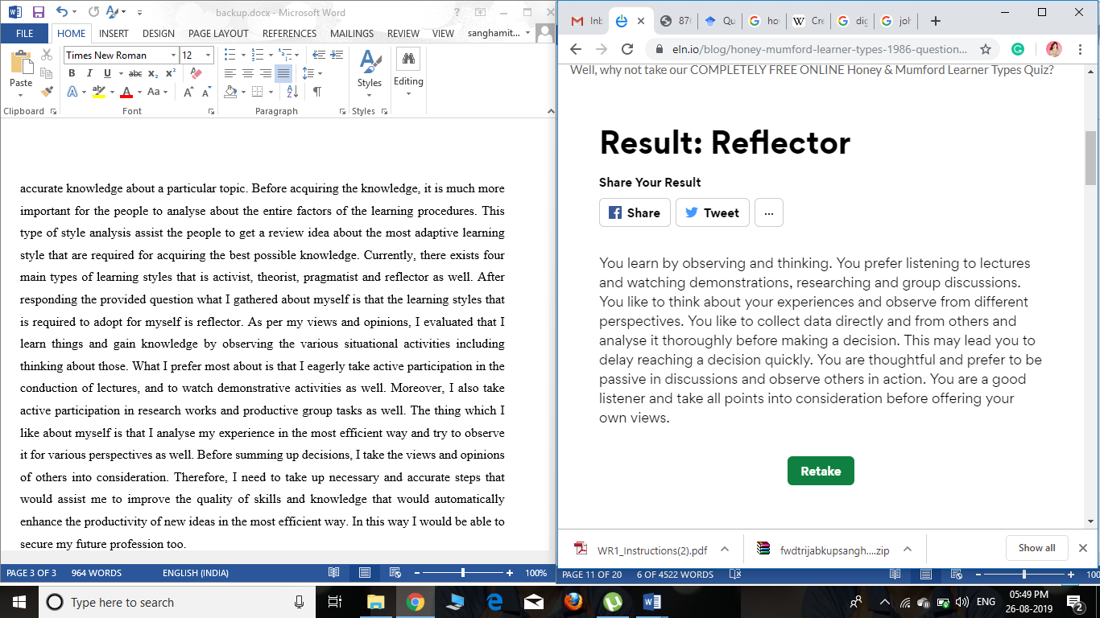

Establish employment goals and develop a personal action plan

Personal Development Plan
Skill to be improved or developed | Required actions | Required resources | Required support | Measuring the progress | Target time period
Leadership skills | - Actively participating in leading teams and groups  - Understanding the essence of team work through active team participation | - Case study analyses  - Suggestions from mentors and other professionals | - Support from mentors  - Support from peers | - Feedback from mentors  - Maintaining performance logs | 6 months
Non-verbal communication skills | - Joining short course for improving communication through gestures, expressions and body language  - Following online video tutorials | - Video tutorials  - Course materials | - Support from mentors and peers | - Feedbacks from mentors and peers | 3 months
Analytical skills | - Utilisation of suitable knowledge  - Application of observation | - Resources providing knowledge about the situation | - Support from co-workers | - Feedbacks from professionals and seniors | 4 months
Reflective skills | - Practising reflective writing using suitable reflective models | - Materials provided in class  - Following case studies and examples | - Support from mentors | - Feedbacks from mentors | 2 months
Listening skills | - Actively participating in discussions  - Taking down notes and tallying  - Listening to any kind of lectures, seminars, etc. | - Offline videos  - Online videos | - Support from mentors and peers | - Feedbacks from mentors | 1 month

Conclusion
By conducting this assignment it can be understood that self-awareness about the necessary knowledge and skills of employment are mandatory for ensuring successful personal and professional development. Not only that but also awareness about personal strengths and weaknesses are required for identifying areas of improvement and development. It can be concluded on an overall basis that professional development depends on both awareness of the employment environment as well as awareness about personal abilities and inabilities.

References
Ansmann, L., Flickinger, T.E., Barello, S., Kunneman, M., Mantwill, S., Quilligan, S., Zanini, C. and Aelbrecht, K., 2014. Career development for early career academics: Benefits of networking and the role of professional societies. Patient education and counseling, 97(1), pp.132-134.
Assiter, A., 2017. Transferable skills in higher education. Routledge.
Bakhshi, H., Downing, J.M., Osborne, M.A. and Schneider, P., 2017. The future of skills: Employment in 2030. London: Pearson.
Brinkert, R., 2018. Career and professional development as levels of engagement in the communication training and development field1. The Handbook of Communication Training: A Best Practices Framework for Assessing and Developing Competence.
Brookes, M., James, P. and Rizov, M., 2018. Employment regulation and productivity: Is there a case for deregulation?. Economic and Industrial Democracy, 39(3), pp.381-403.
Collet, C., Hine, D. and Du Plessis, K., 2015. Employability skills: perspectives from a knowledge-intensive industry. Education+ Training, 57(5), pp.532-559.
Collet, C., Hine, D. and Du Plessis, K., 2015. Employability skills: perspectives from a knowledge-intensive industry. Education+ Training, 57(5), pp.532-559.
Gott, T., Bauer, T. and Long, K., 2019. Student Leadership Today, Professional Employment Tomorrow. New directions for student leadership, 2019(162), pp.91-109.
Mackay, M., 2017. Professional development seen as employment capital. Professional development in education, 43(1), pp.140-155.
Powell-Martin, Z., McLeod, J., Scally, J., Smith, K. and Lumsdaine, S., 2019, May. Analysis of counselling student employment destinations: using action research to enhance the counselling curriculum and improve employability. In BCAP Research Conference 2019: Shaping counselling practice and policy: the next 25 years.
Qenani, E., MacDougall, N. and Sexton, C., 2014. An empirical study of self-perceived employability: Improving the prospects for student employment success in an uncertain environment. Active Learning in Higher Education, 15(3), pp.199-213.
Yarbrough, S., Martin, P., Alfred, D. and McNeill, C., 2017. Professional values, job satisfaction, career development, and intent to stay. Nursing Ethics, 24(6), pp.675-685.

