Ishrat Rehman 2118374
LCHS7009 – C1
Dr Raheela Shaikh
Digital Diabetes Prevention: Is It Reaching South Asian Communities?

Diabetes Prevention: Why It Matters
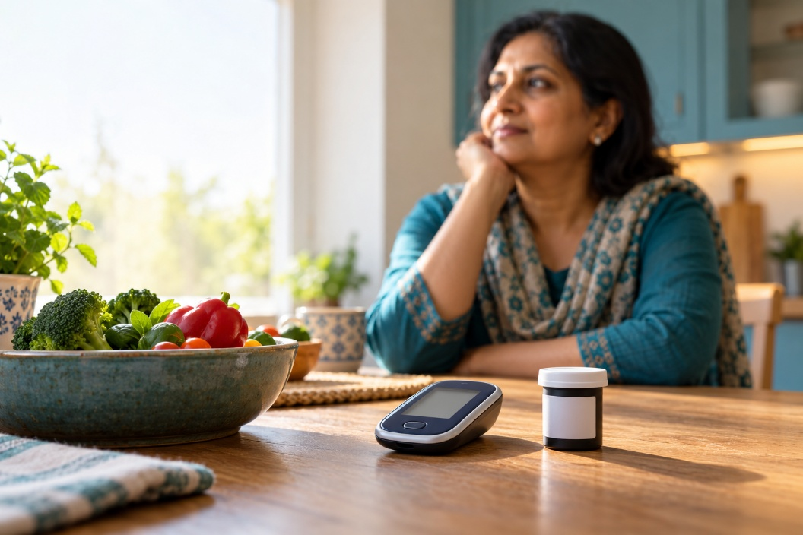
Type 2 diabetes is a public health concern as complications, including cardiovascular disease, kidney damage and sight loss, affect families and increase healthcare demand. South Asian adults face an increased risk at lower BMI, partly associated with excessive accumulation of fat around the abdomen, waist, and trunk (NICE, 2025). In England, diagnosed diabetes prevalence was 13.1% among Indian, 19.9% among Pakistani and 14.9% among Bangladeshi adults, compared with 6.0% among White British adults. These 2011–2019 figures include all types of diabetes and demonstrate inequalities (NHS Digital, 2022).
Created with Canva

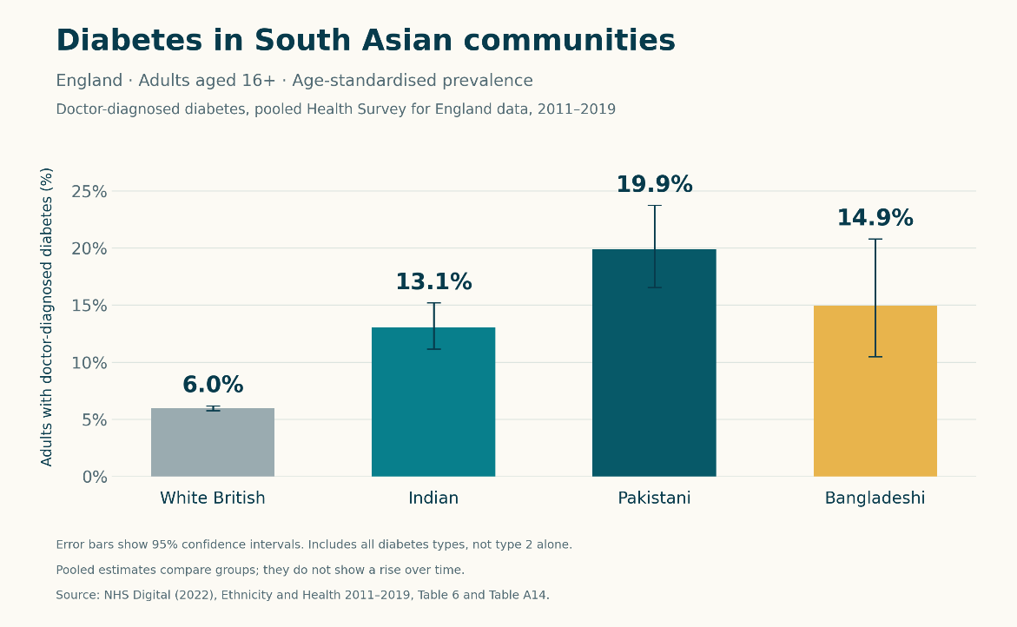
(NHS Digital, 2022)

What support already exists?
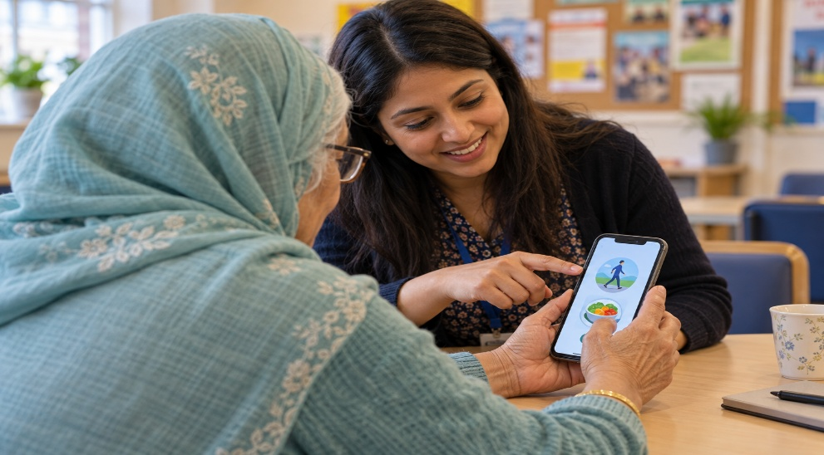
The Healthier You NHS Diabetes Prevention Programme offers face-to-face and digital support. Educational resources, coaching and progress monitoring encourage healthier eating, physical activity and weight management (NHS England,2026). Xyla, one provider, offers nine months of personalised support through an app, telephone or video calls, alongside recipes and learning resources. Flexible delivery can fit around work and caring responsibilities (Xyla, 2026). This encourages healthier eating, physical activity, and weight management, addressing modifiable risk factors before diabetes develops (NHS England, 2025; Moussas-Alvarez et al., 2025).
Created with Canva

Understanding Motivation
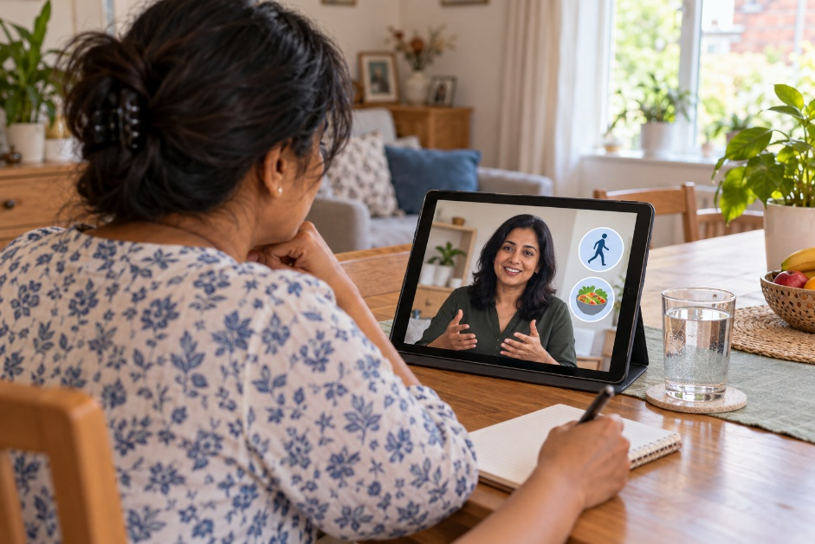
Understanding personal risk and possible complications can make prevention relevant. Explaining healthier habits highlights potential benefits, while achievable goals, feedback and reminders may build confidence and prompt action (Rosenstock, Strecher and Becker, 1988). Accessible delivery could reduce practical barriers. However, motivation alone cannot resolve financial pressures affecting digital access, making practical assistance essential (NHS England, 2023).
Created with Canva

Promising Results
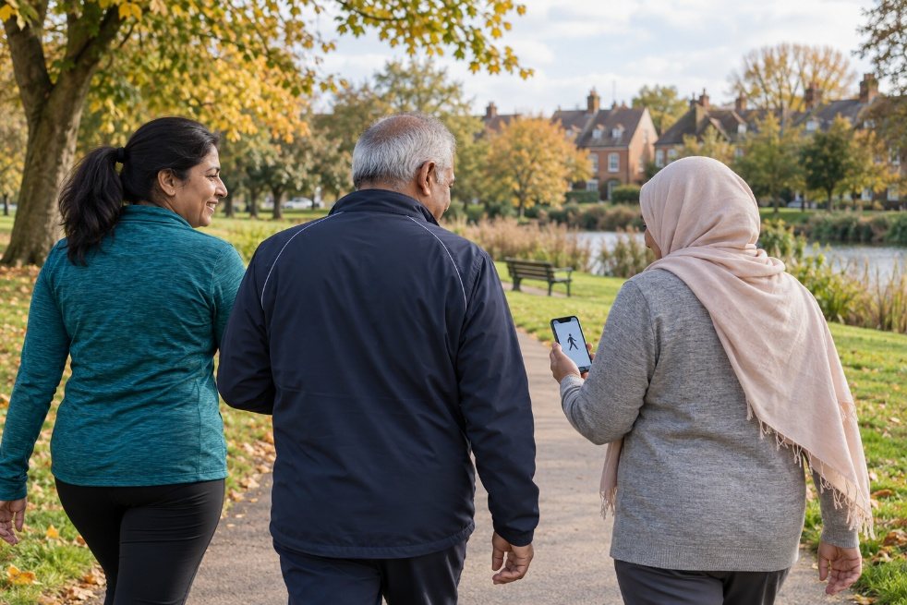
Barron et al., (2023) reported an average weight loss of 2.59 kg among digital participants who engaged at least once, increasing to 4.76 kg among completers. However, completers were a selected subset, digital weights were self-reported, and pandemic-era delivery was compared with earlier face-to-face provision. Differences in participants and circumstances limit causal conclusions. These results suggest weight-management benefits rather than proving long-term diabetes prevention or Xyla-specific effectiveness (Barron et al., 2023).

Created with Canva

Making Access Meaningful
Xyla provides workbooks in 16 languages and translated introductory videos, including Punjabi and Gujarati (Xyla, n.d). However, its published information does not establish whether every app menu, instruction and educational video is available in users’ preferred languages.
Language-specific groups depend on demand. Where a bilingual coach cannot be arranged for telephone appointments, participants may involve someone who speaks English to translate (Xyla, n.d). This raises questions about independence and privacy. App availability also does not establish usability for people with limited digital confidence.

Making Prevention easier to use
Providers should co-design language options and familiar meal examples with diverse South Asian communities. Assisted registration, audio and captions could improve access, while telephone and face-to-face alternatives preserve choice (NHS England, 2023).
Evaluation should include people who withdraw and compare outcomes across groups. The value of digital prevention depends on combining motivation with practical assistance.

For further information

Explore the NHS Diabetes Prevention Programme
Find help using digital support
View existing translated introductory videos

Preview the proposed improvements: https://eksaath.example/accessibility

Ek Saath: Diabetes Prevention Together
Ek Saath: Diabetes Prevention Together
What if diabetes prevention support fits the meals, languages, and routines of the people using it? NHS England (2025) reports that nine in ten people living with diabetes in England have type 2. NICE (2017) recommends earlier risk assessment for South Asian adults, reinforcing the importance of accessible prevention. Type 2 diabetes can cause serious complications, making accessible prevention important (NICE, 2025). However, providing digital advice does not automatically make it understandable or achievable.
Existing services offer coaching and translation resources. However, Xyla’s published information does not confirm that language choice is available throughout its app, while language-specific groups depend on demand (Xyla, 2026). This creates a question worth exploring: could consistent language access make digital prevention easier to use independently?

Introducing Ek Saath
Ek Saath is a proposed smartphone app for South Asian adults aged 18 and over in England who have been identified as being at high risk of type 2 diabetes. It would complement existing prevention services through accessible learning, practical goals, and optional family participation.
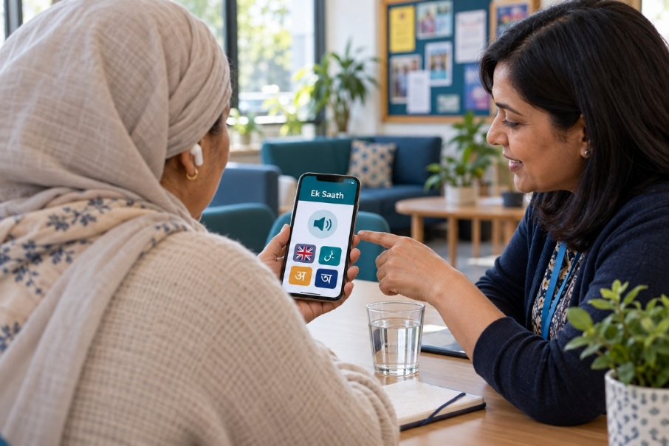
Users would choose their language and dietary preferences. Audio explanations and captioned videos would accompany affordable adaptations of familiar meals. Activity goals would reflect individual abilities and routines. A private dashboard would track progress, with optional contact with a health coach and a shared space for planning meals or activities with a trusted supporter.
Created with Canva

Designing for Behaviour Change
The Health Belief Model would guide the features (Rosenstock, Strecher, and Becker, 1988). Risk explanations would address perceived susceptibility and severity, while practical guidance would demonstrate benefits. Accessible content would reduce barriers, optional reminders would provide cues to action, and achievable goals and coaching would strengthen self-efficacy. These mechanisms could support healthier eating and activity, but beliefs alone cannot overcome poverty or restricted opportunities for exercise.

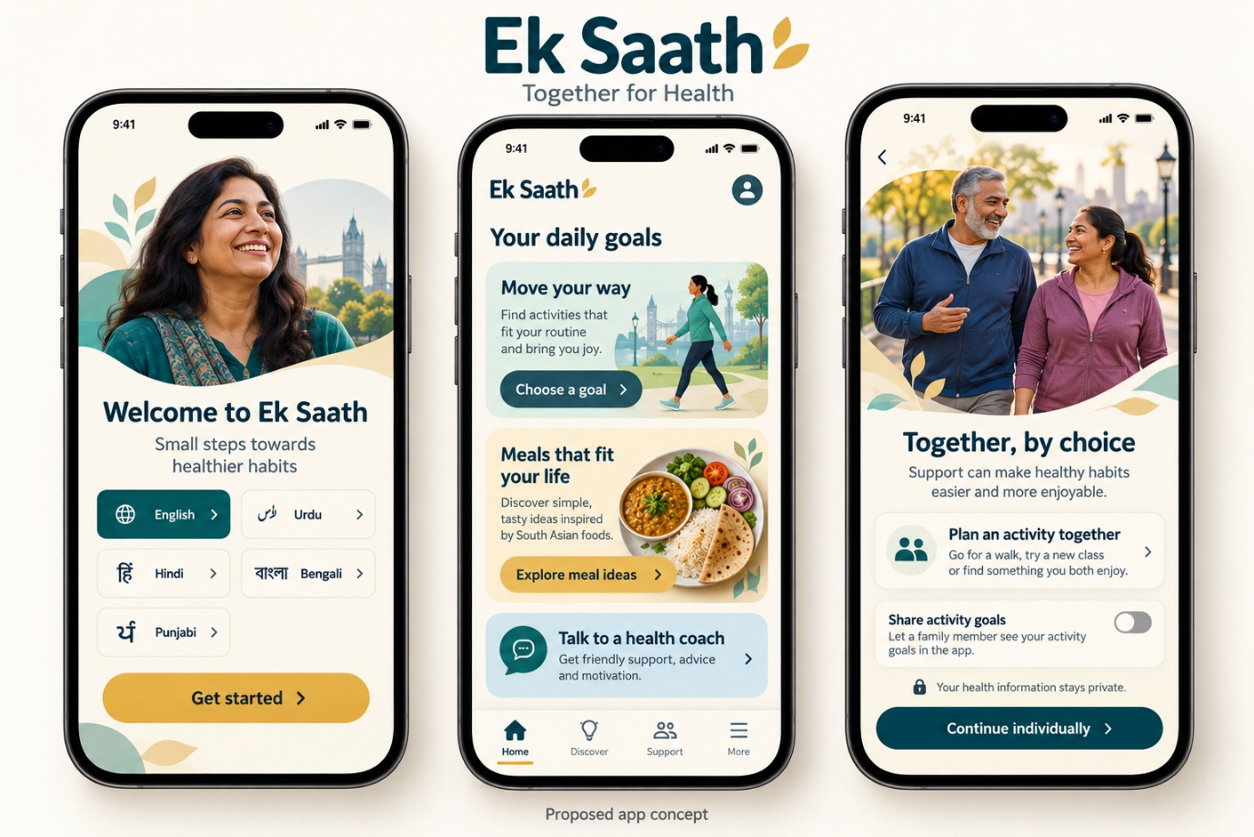
Created with Canva

Building with Communities
NHS England’s (2023) digital inclusion framework highlights the importance of collaboration with voluntary organisations and grassroots community groups. Ek Saath would therefore be developed in collaboration with various South Asian communities, including people with limited digital confidence. Testing language, navigation, and meal guidance with intended users would help identify barriers while recognising differences in beliefs, preferences and household arrangements.
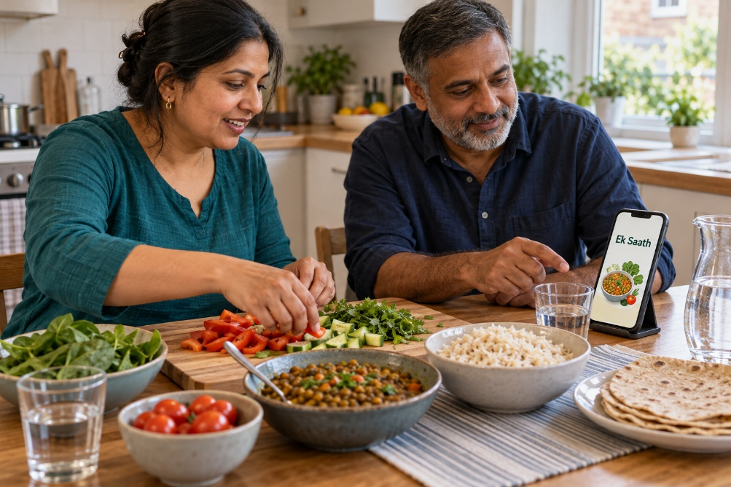
Moussas-Alvarez et al. (2025) found that participants in digital prevention valued coaching and social support. Potential benefits include more relevant advice, flexible access, and support for shared changes.

Created with Canva

Family participation could encourage healthier routines, but it may create pressure or unwanted monitoring (Álvarez-Aguado, 2026). Private goals, consent-based sharing, and an individual pathway would protect autonomy. Translation, coaching, and professional content review would require funding.
Device affordability and limited skills could still exclude users. Assisted registration, downloadable resources, and telephone or face-to-face alternatives would align with NHS England’s (2023) inclusion framework.
A pilot should assess usability, retention, dietary and activity changes, weight, clinically measured HbA1c, and feedback from people who withdraw. Ek Saath’s value would depend on demonstrable health benefits and equitable participation, rather than on downloads alone.

Explore Ek Saath
Preview the proposed improvements: https://eksaath.example/accessibility

References
- Álvarez-Aguado, I., Muñoz La Rivera, F., Vega, V., Figueroa-Figueroa, J., Roselló-Peñaloza, M., González-Carrasco, F., Arriagada-Chinchón, R., Espinosa Parra, F., Spencer, H. and Farhang, M., 2026 ‘ From access to agency: how assistive and emerging technologies mediate self-determination in autistic adulthood’. Disability and Rehabilitation: Assistive Technology, 21(4), pp.1248-1262. (Accessed: 12 October 2026).
- Alyafei, A. and Easton-Carr, R. (2024) ‘The Health Belief Model of Behavior Change’, StatPearls [Internet]. StatPearls Publishing. Available at: https://www.ncbi.nlm.nih.gov/sites/books/NBK606120/ (Accessed: 13 October 2026).
- Barron, E. et al. (2023) ‘Effectiveness of digital and remote provision of the Healthier You: NHS Diabetes Prevention Programme during the COVID-19 pandemic’, Diabetic Medicine, 40, e15028. Available at: https://onlinelibrary.wiley.com/doi/10.1111/dme.15028
- Diabetes UK (2026) Investing in diabetes care (no date) Diabetes UK. Available at: https://www.diabetes.org.uk/investing-in-care (Accessed: 13 October 2026).
- Moussas-Alvarez, D., Hawkes, R.E., Miles, L.M., Dack, C. and French, D.P. (2025) ‘Service users’ experiences of, and engagement with, a nationally implemented digital diabetes prevention programme’, British Journal of Health Psychology, 30(1), e12787. Available at: https://doi.org/10.1111/bjhp.12787. (Accessed: 12 October 2026).
- National Institute for Health and Care Excellence (NICE) (2017) Type 2 diabetes: prevention in people at high risk. PH38. Available at: https://www.nice.org.uk/guidance/ph38/chapter/recommendations (Accessed: 12 October 2026).
- NHS (n.d.) Complications of type 2 diabetes. Available at: https://www.nhs.uk/conditions/type-2-diabetes/complications/
- NHS Digital (2022) Ethnicity and health, 2011–2019: experimental statistics—diabetes. Available at: https://digital.nhs.uk/data-and-information/publications/statistical/health-survey-england-additional-analyses/ethnicity-and-health-2011-2019-experimental-statistics/diabetes
- NHS England (2023) Inclusive digital healthcare: a framework for NHS action on digital inclusion. Available at: https://www.england.nhs.uk/long-read/inclusive-digital-healthcare-a-framework-for-nhs-action-on-digital-inclusion/
- NHS England (2023) Inclusive digital healthcare: a framework for NHS action on digital inclusion. Available at: https://www.england.nhs.uk/long-read/inclusive-digital-healthcare-a-framework-for-nhs-action-on-digital-inclusion/ (Accessed: 12 October 2026).
- NHS England (2025) NHS diabetes prevention scheme helps one million people. Available at: https://www.england.nhs.uk/2025/12/nhs-diabetes-prevention-scheme-helps-one-million-people/ (Accessed: 12 October 2026).
- NHS England (n.d.) NHS Diabetes Prevention Programme. Available at: https://www.england.nhs.uk/diabetes/diabetes-prevention/
- NICE (2025) Overweight and obesity management. NG246. Available at: https://www.nice.org.uk/guidance/ng246/chapter/Identifying-and-assessing-overweight-obesity-and-central-adiposity
- Rosenstock, I.M., Strecher, V.J. and Becker, M.H. (1988) ‘Social learning theory and the Health Belief Model’, Health Education Quarterly, 15(2), pp. 175–183. Available at: https://journals.sagepub.com/doi/10.1177/109019818801500203
- Xyla (2026) Frequently asked questions. Available at: https://preventing-diabetes.co.uk/faqs/
- Xyla (2026) Translated introduction videos. Available at: https://preventing-diabetes.co.uk/intro-language-videos/

