The Role of the Suffering Servant
The “suffering servant” is a biblical story from the book of Isaiah (Isaiah 53) which will be the primary source examined in this essay. For convenience’s sake we will refer to the “suffering servant” simply as the servant where appropriate. This story has been debated among the Abrahamic faiths as it potentially tells of the coming Messiah, but the messianic aspect is debated. Christians believe that the Messiah was Jesus Christ. However, Jews and Muslims believe that this Messiah is yet to come. Other interpretations say that the servant may not be an individual but may be a community that will suffer for humanity in the name of God. The possibilities then are endless to the identity of this servant/community under these loose conditions many events or biblical figures could count as the suffering servant. In this essay we will examine the role that the suffering servant plays in biblical scripture and explore some possibilities of events or people who could count as the suffering servant. First, we must understand that the role of the “suffering servant” may differ between interpretations of who the servant is. In order to identify the role of the servant we must explore each possibility to whom the story relates. Some theologians believe the servant to be Jesus Christ whereas other say the Jewish community as a whole. Each of these would alter the perception and role that the servant has in a biblical context.
It would be prudent to begin this essay by speaking of the similarities between the description of the “suffering servant” and the lines that could link this to existing biblical literature regarding Jesus Christ. Here we will examine Isaiah 53 and compare the “suffering servant” prophecy to the persecution of Christ in order to outline the similarities and differences/contradictions. The quote bellow is taken from Isaiah 53 and is a good representation of the similarities between the prophesy and the story of Jesus.
“Surely he took up our pain and bore our suffering,
yet we considered him punished by God, stricken by him, and afflicted.”
(NIV, Isaiah 53:4)
The phrase” bore our suffering” in the quote above is an indication that this prophecy may be referring to Christ as in the New Testament he bore the sins of all men during the crucifixion and exalted humanity of said sins. Another indicator from this quote that is used as an example of Christ being the suffering servant is the phrase “yet we considered him punished by God.” The bellow quote is taken from Matthew 27 describing the crucifixion of Christ is extremely reminiscent of the above quotation from Isaiah but from the perspective of the potential “suffering servant” (Jesus Christ).
“About three in the afternoon Jesus cried out in a loud voice,
“Eli, Eli, lema sabachthani?” (which means “My God, my God, why have you forsaken me?”)”
(NIV, Matthew 27:46)
If we interpret Jesus to be the “suffering servant” then this would mean that the role this figure plays is the saviour of mankind as through his suffering humanity is cleansed of its sins. Another more biblical way of wording this is that the role of the “suffering servant” is to be the sacrificial lamb that blesses humanity after its death. However, this also implies that the servant is predestined to die despite there being no verses in Isaiah 53 that would suggest that the suffering servant is inevitably doomed to death.
An issue with portraying the “suffering servant” as Jesus is whether the events described in Isaiah should all be taken as literal. If the interpretation is taken literally then there are a few verses that would imply that Jesus and the crucifixion are not what is portrayed. For example, Isaiah 53 states:
“He was oppressed and afflicted, yet he did not open his mouth;
he was led like a lamb to the slaughter, and as a sheep before its shearers is silent,
so he did not open his mouth.”
(NIV, Isaiah 53:7)
This verse states that the “suffering servant” “did not open his mouth” meaning that the servant did not speak during his ordeal. This is contradictory to the persecution of Christ as throughout the crucifixion Christ on many occasions speaks aloud to both spectators and God. This is an active contradiction to the prophesy in Isaiah. There are other contradictions present in this prophesy if we relate it to Christ. One such contradiction is that Isaiah states: “though he had done no violence” (Isaiah 53:9) This contradicts the reason for which Christ was crucified as it is stated that the initial arrest of Christ was due to him becoming violent after seeing that the temple was being used for trade. He is described as such:
“Jesus entered the temple courts and drove out all who were buying and selling there.
He overturned the tables of the money changers and the benches of those selling doves.”
(NIV, Matthew 21:12)
The use of the phrase “overturned tables” would imply a level of anger induced violence. This directly contradicts Isaiah. The servant is said to have “done no violence” this would then imply that Christ was not the servant described by Isaiah. However, if we do not take Isaiah 53:7 literally then it can be implied that Jesus is the “suffering servant” as he is often regarded as a peaceful figure and being the primary source of morality for Christianity which often preaches non-violence. A rather ironic teaching indeed. Despite the potential contradictions Isaiah 53:7 implies that the role of the suffering servant may also be to display piety and non-violence despite the adversity and violence done to the servant. A non-biblical comparison to this would be the way figures such as Mahatma Gandhi or Martin Luther King Jr are commonly viewed due to their use on non-violent protest despite the active violence done to them. This would mean the role of the servant is meant to be a symbol of calm and virtue in the face of adversity and threat of death. To summarise this portion of the role of the “suffering servant,” If we take Christ as the servant the roles played would be those of Godly piety non-violence and bravery in the face of adversity or death alongside being considered as the saviour of mankind as through his sacrifice the sins of man will be washed away with the stipulation that one must believe in both the Abrahamic God and that Christ died for the sins of man. This would imply that the servant is less the servant of God but instead the servant of humanity, due to the saviour aspects of this story relating to humanity rather than faith in God despite the servant’s faith being key to his role. Again, if we take this servant to be Christ then it can also be implied that the servant is merely a sacrificial offering to God in order to remove sin form mankind.
Scholars and theologians alike have wondered as to who the “suffering servant” is referring to in Isaiah however, some have suggested that the servant is not a single person but instead is a community this being the Jewish community. There are multiple examples of how this point can be put forward. If the suffering servant in Isaiah where to be a group of people as opposed to an individual this could have a drastic change to the role that the servant plays in a biblical and historical context as persecution of the Jewish people is not a new phenomenon. Isaiah was written in the 8th century BCE a turbulent time for the Jewish community as a whole. In the 8th century BCE the land of Judea now known as Israel was besieged by the Assyrians. This event is depicted in both biblical and contemporary scholarly sources. Shown bellow is an example of Assyrian wall art depicting the king of the Israelites (Jehu) bowing to the king of the Assyrians (Shalmaneser III) after Judea was defeated.
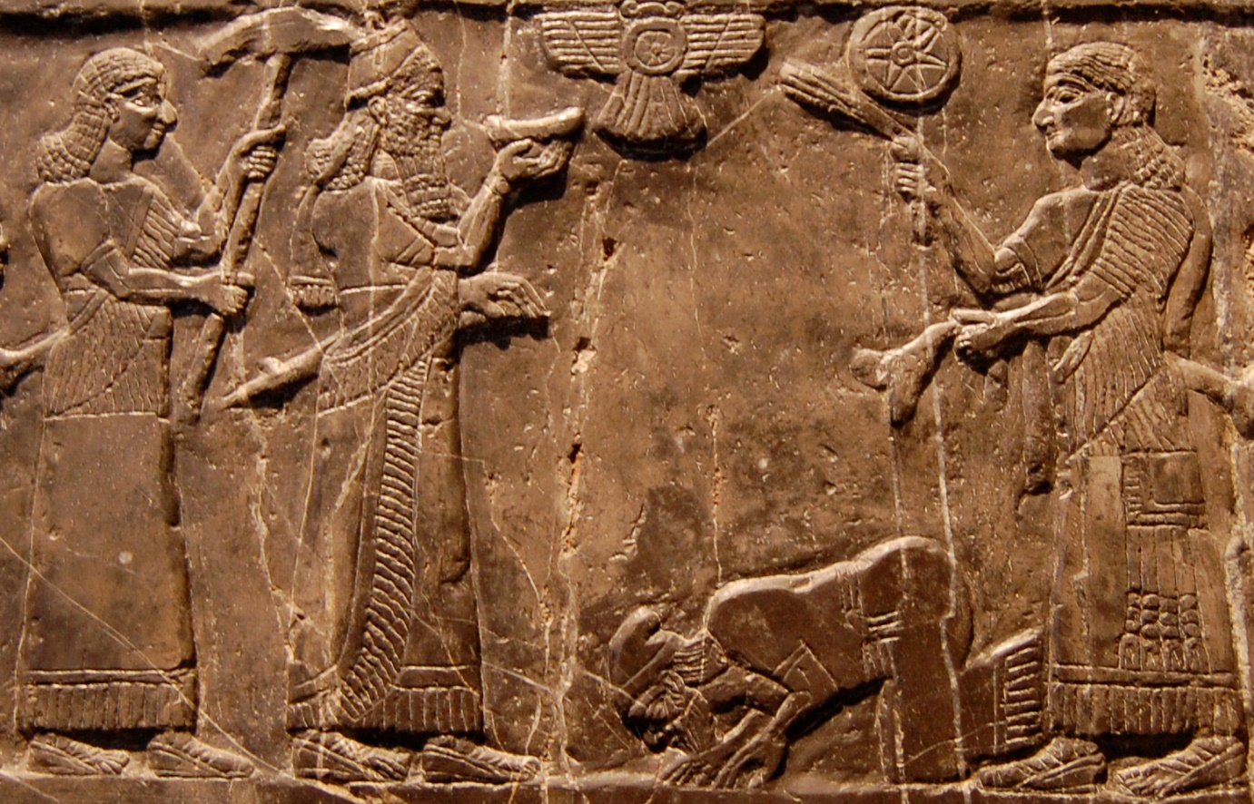
Depiction of Jehu King of Israel giving tribute to King Shalmaneser III of Assyria, on the Black Obelisk of Shalmaneser III from Nimrud (circa 827 BC) in the British Museum (London)
This Image is a brilliant representation of the relations between the Assyrians and the kingdom of Judea. Despite this particular piece being over 100 years older than the period of Isaiah it can be seen as representative of the period to follow its inception. Archaeological evidence has also shown that the Assyrians in particular were extremely brutal in their methods with many pieces of wall art depicting brutal scenes of beheadings, impaled heads and mounds of corpses. This style of brutal Assyrian art is also used in modern media to portray dwarfs in fantasy with the Assyrians being the direct inspiration for the evil chaos dwarfs in the Warhammer fantasy series. With this extremely brief account of the Assyrians and their inspiration on evil characters in modern media it should set the stage for the possibility that the “suffering servant” may refer to the Jewish people in Juda due to the amount of suffering the Assyrians caused to the Jewish people in the late bronze age. This can be supported in biblical writings from the time as there are numerous examples of Jewish prophets and characters in the torah speaking of the war between themselves and the Assyrians. For example, the tale of 2 kings (726-669 BCE) and more importantly to this essay Isaiah (704-681 BCE). Isaiah 10-16 tells us that the Assyrians took over Juda and oppressed the local Jewish population. Isaiah writes:
Woe to those who make unjust laws,
to those who issue oppressive decrees,
to deprive the poor of their rights
and withhold justice from the oppressed of my people,
making widows their prey
and robbing the fatherless
(NIV, Isaiah 10:1-2)
These verses show one example of the distain that the people of Juda held towards their new Assyrian leaders. Painting the picture that they steal from the poor however to this author the most striking phrase is “making widows their prey.” This implies a more predatory aspect to the Assyrian take over depicting them as particularly brutal which is not inaccurate to Assyrian artwork. This would imply (from both Jewish and Assyrian sources) that the Assyrians took immense pride in the suffering they caused. These events may be the true “suffering servant” as the immense suffering the Assyrian empire caused to the Jewish people arguably equates to the suffering that the servant is said to endure in Isaiah 53. Another supporting factor for this is the fact that the Isaiah 10-16 portray the Jewish people as innocent but more importantly as forgotten by God due to the sin that took place in Juda and Israel before the Assyrian take over and during their reign. Isaiah also speaks of the judgment the Assyrians will face by the hand of God. Bellow is an extract from Isaiah 10 which depicts God speaking to Isaiah:

Therefore this is what the Lord, the Lord Almighty, says:
“My people who live in Zion,
do not be afraid of the Assyrians,
who beat you with a rod
and lift up a club against you, as Egypt did.
Very soon my anger against you will end
and my wrath will be directed to their destruction.”
(NIV, Isaiah 10:24-25)
These verses enhance the possibility that the servant is indeed the Jewish community in Juda and Israel as it portrays them as innocents who have been beaten and abused. Interestingly Isaiah says that God equates the brutality of the Assyrians to the methods used by the Egyptians, presumably during the time of Moses where the Jewish people where enslaved by the Egyptian empire. The use of the verse “and my wrath will be directed to their destruction” also asserts the possibility that these events make the Jewish community the servant as through the suffering of Gods chosen people the Assyrians will be vanquished by God absolving Juda and Israel of their oppressors. If this interpretation were taken as true, then the Role of the servant would instead be to be tested by God to maintain their faith to which God will reward their maintained faith with the eradication of their oppressors. However, there are issues with this interpretation if Isaiah 53 is to be taken literally (as previously mentioned the servant was said not to have rose up in violence or anger against the oppressors) then the possibility for the servant to be the communities of Juda and Israel is impossible as through this period Israel and Juda fight against the Assyrians attempting to free themselves of their oppressors. This directly contradicts the verse stating the servant would be non-violent in the prophecy.
Some theologians and scholars have also stated the prophecy may not have come to fruition yet or may have taken place much more recently to the modern day. G Greenberg (2009) writes that during the Holocaust Isaiah 53 was referenced by orthodox Jews to explain the suffering caused by the Nazi party in Germany. This assertion may support that the servant is the Jewish community Greenberg draws comparison between the Holocaust and the verse “lamb to the slaughter” (Isaiah 53:7) which would be an accurate depiction of the atrocities done to the Jewish community. A supporting factor to this assertion is that generally the Jewish community was peaceful and non-violent during their oppression in the 1930s-40s as opposed to the reign of the Assyrians. This non-violence heavily supports the idea that the servant was the Jewish community during the 30s and 40s. However, this assertion may become a dangerous proposition as it may give some anti-Semitic rhetoric to the events in the holocaust as an anti-semite could use this argument to show the abhorrent acts of the holocaust as Gods will and inevitable, an assertion that should never be made regarding the evil that was the holocaust. Where this interpretation the true meaning of Isaiah 53 the role of the servant would be similar to that of the role previously articulated during the Assyrian war where the suffering of the community is designed by God to absolve the sins of the truly faithful.
To Conclude the role that the suffering servant plays in biblical scripture is a nuanced and difficult topic to cover due to the numerous occasions through History and Biblical writings that could portray the servant. Here we have explored 3 of these possibilities to varying degrees of extensivity. Where the role of the servant to go to Jesus Christ then the meaning of this role would be to wash the sins of humanity away through their devoted belief in the sacrifice of Christ. Alongside demonstrating the utter devotion to God through suffering. However, if we instead put the role of the servant as the Jewish community then it can be shown that the role of the servant is to suffer numerous atrocities in order to strengthen their faith in God and through that faith God will reward their suffering with eternal life and through the destruction of those who caused them suffering. It must also be said that the prophecy of the “suffering servant” is not without its flaws in each example as some aspects of each possibility explored in this essay contradict the prophecy if it were taken in a literal manner. Therefore, it is impossible to say what the true role of the servant is as there is no clear-cut answer to who or what the servant is. It must also be stated that religious background is an extremely important aspect to who the servant may be as it is unquestionable that Christians believe this servant to be Jesus Christ, however, to Jewish practitioners the servant may not have appeared yet or may have been their community during one of the numerous occasions Jews were used as scapegoats or entirely oppressed, abused and slaughtered for no reason whatsoever.

Bibliography
Image Source
Source: https://en.wikipedia.org/wiki/Shalmaneser_III#/media/File:Jehu-Obelisk-cropped.jpg accessed 22.08.2023
Depiction of Jehu King of Israel giving tribute to King Shalmaneser III of Assyria, on the Black Obelisk of Shalmaneser III from Nimrud (circa 827 BC) in the British Museum (London)
Biblical Sources
NIV, Isaiah 10-16, 53
NIV, Matthew 21, 27
Sources
Aster, S.Z., 2007. The image of Assyria in Isaiah 2: 5-22: the campaign motif reversed. Journal of the American Oriental Society, 127(3), pp.249-278.
Ginsberg, H.L., 2013. The oldest interpretation of the Suffering Servant. In Vetus Testamentum (pp. 25-28). Brill.
Greenberg, G., 2009. Sacred Death For Orthodox Jewish Thought During The Holocaust: With A Preliminary Inquiry Into Christian Parallels. In Interaction between Judaism and Christianity in History, Religion, Art and Literature (pp. 289-316). Brill.
Holladay, J.S., 1970. Assyrian Statecraft and the Prophets of Israel. Harvard Theological Review, 63(1), pp.29-51.
Levy, T.E., Schneider, T. and Propp, W.H., 2015. Israel's Exodus in Transdisciplinary Perspective. Text, Archaeology, Culture, and Geoscience, Cham-Heidelberg-New York: Springer.
Maller, A.S., 2015. A Post 20th Century View Of Isaiah 53. Rocznik Teologiczny, 57(4), pp.513-526.
Page, S.H., 1985. The Suffering Servant between the Testaments. New Testament Studies, 31(4), pp.481-497.
Reade, J., 1979, January. Ideology and propaganda in Assyrian art. In Power and propaganda: A symposium on ancient empires (Vol. 7). Copenhagen: Akademisk Forlag.
Rosenberg, R.A., 1965. Jesus, Isaac, and the" Suffering Servant". Journal of Biblical Literature, 84(4), pp.381-388.
Schreiber, M., 2009. The real" Suffering Servant": decoding a controversial passage in the Bible. Jewish Bible Quarterly, 37(1), pp.35-45.

Aster, S.Z., 2007
Aster, S.Z., 2007
Reade, J., 1979
Levy, T.E., Schneider, T. and Propp, W.H., 2015, pg 10-12
Holladay, J.S., 1970, pg 29-51
Greenberg, G., 2009, pg 289-316

