

Module: Learning and Collaboration for Global Citizenship
Module code: BMSP4015D
Assignment Title: Portfolio
Student Name: Somerda Iancu
Student ID: 2519996

Table of Contents
1. Introduction 2
2. Task One: Learning Objectives 2
3. Task Two: Reflective Blog Posts 3
3.1 Blog One: My Learning Style 3
3.2 Blog Two: Adapting My Independent Learning 5
4. Task Three: Building an Identity in Professional and Business Communities 5
References 7

1. Introduction
This is my Personal Learning Environment (PLE): This is a learning environment that I am creating intentionally to facilitate my own learning and professional development (PD) with this module and beyond. However, a PLE is not an app or the entirety of a platform, nor is it a total set of tools and systems, but rather it is the synthesis of tools, habits, people, and reflective practices that the learner brings with them for adapting and learning; a recent study shows that learners in an increasingly technology-rich PLE need to become more self-regulated and digitally literate for this flexibility to not turn into an unsustainable disorganization (Xu et al., 2024). The following work is structured into three interrelated parts to support my project development in this idea: two strands relating to my learning and two reflective blog postings, which will discuss my learning and adaptations to my independent study and a plan developing me as myself professionally outside of the classroom. Reflectively written in the first person as per the brief and I have kept Kolb's Experiential Learning Cycle in mind for organizing my reflection.

2. Task One: Learning Objectives
I have set 2 personal aims as a result of this module to help me develop and to guide my career choices for the next couple of weeks. Firstly, I can create a self-directed learning program that I can continue to do without using time set aside for class. In universities, it has become a trend to leave students free to learn at their own pace, particularly when it comes to students who learn this content in blended or online learning formats; in addition, several research articles have emphasized that such learning is not “automatically acquired” but rather a skill that needs to be practiced, planned, and self-regulated (Charokar and Dulloo, 2022). I have chosen this objective to make sure that in contributing to success, the three most important are my planning ability, my ability to monitor and adjust my reading, and my ability to keep my head down when reading, rather than anything else. As Charokar and Dulloo (2022) say, self-determined learning is not only a task but also a lifelong professional skill, so it is possible to make milder and improvements even when feeling under-prepared.
My second goal is to work towards a professional identity just while I'm still in school, instead of waiting until afterwards to consider a job. Turners and Bennetts' research around graduate recruitment and the employability of graduates suggest that professional identity, as defined as ‘understanding one's professional self and communicating that understanding to others,' is no longer viewed as a kick-box resumé item but as one serious indicator of graduate readiness for the world of work (Bennett and Ananthram, 2021). Graduate abilities like how to communicate, adapt, self-manage, etc. are hard to assess using marks only, and this is where the (Bennett and Ananthram 2021) was conceptualized and developed. It's important to me to develop it for my discipline is competitive, and I want to be in a job market with more than just a transcript to my name. Both of these aims are to run in parallel—the first is to help make me learn better, and the second is to help me present what I learn to others better.

3. Task Two: Reflective Blog Posts

3.1 Blog One: My Learning Style
In my initial thinking about this activity, I was thinking of a specific learning style, whether it was visual or kinesthetic, and using this label to guide my studying. Having been reading more broadly, I now believe that such was a misguided expectation. Although people have a vision of matching preferred styles of learning and teaching (known as the meshing hypothesis), there is a vast amount of education research that seems to suggest up to now this is actually an education myth (Brown, 2023). Despite decades of research that have sought to demonstrate the potential for personalized instructional adaptations to benefit students in terms of academic outcomes, the evidence is not consistent, and student and teacher expectations remain high (Brown, 2023). I suppose this was sort of an ‘eye' effect—I did not believe this was going to be the main result of this exercise—I thought it was going to be finding my 'type.'
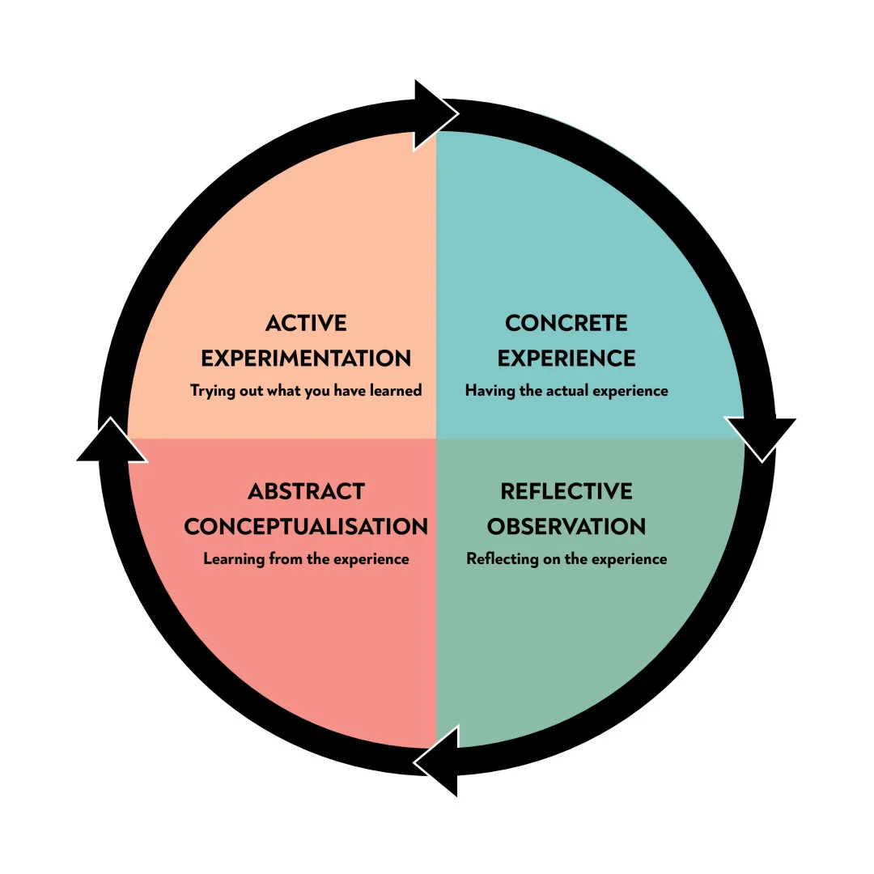
Figure 1: Kolb's Experiential Learning Cycle
Source: (Mcleod, 2025)
My concrete part of the process (Kolb's Experiential Learning Cycle) was to go through a couple of these quizzes, which were not formal but mimicked a learning quiz, and see my grade improve with each attempt. I'm taking a break to see which sense supports learning best. I discovered that it isn't about which one of my senses is my favorite to learn from but about how I learn: I like to learn theory coding through text, and I like to learn procedures coding through practice. Based on the research of Cheng et al. (2025) in the field of education, combining the four processes of Kolb's cycle as an "active experience + guided reflection + conceptual restructuring + experiment" structure can be used for structured teaching to achieve the effect of supporting students to develop self-directed learning and critical thinking, and this result is more significant than any single teaching method. It tells me on an abstract conceptualization level to be considering how I study and adapt it to the task, instead of finding my preferred way of studying.

3.2 Blog Two: Adapting My Independent Learning
In my life, one area that I am thinking about doing after this reflection is establishing independent study as a group of malleable habits. I'll be combining summarizing unit tests with theory-heavy problems and then another set of unit tests with number-crunching problems, and then after each of the tests, a reflection on what was more beneficial for me in order to score higher. Besides, I intend to integrate some short, structured reflection and observations in the teaching process, as the studies in teaching recently (e.g., Cheng et al., 2025) have shown that such integration can help with reflection, self-monitoring, and planning so that the changes will not be made without any additional reasons.
For support, I want to work on using the academic skills service at the university and using my personal tutor; I will be making a more proactive effort to use these supports rather than it being my last resort. Small peer study groups will be employed, as well, to truly test my knowledge, I'll not only have to explain it, I will have to see what I still don't know. My conception of independent learning (the student should be totally solitary) has moved towards something like this: sometimes the process might more properly be called "managed," and, anyway, the student might have to involve, externally, something else that is of help.

4. Task Three: Building an Identity in Professional and Business Communities
My ultimate outcome is to get a standard path out there that's visible and believable on at least the platforms I have at school and have been given the time to work with and use; while I'm still a student, I only have limited platforms and activities anyway. With this plan, LinkedIn will play an important role. A study involving students who had assignments in STEM courses showed that the biggest share of students used LinkedIn as a career development tool for up to 2 years after completion of the assignment and that they became aware that they had developed employment skills, such as creating a connected identity when completing the LinkedIn assignment (Lexis et al., 2023). I'm thinking I will be placing more of my coursework projects that I'm working on, as well as any of my part-time work or volunteering, on there, and I'll be uploading more little bits and pieces of reflection as to what I'm learning, rather than having it dormant when time comes for me to use it for job applications.
As part of LinkedIn, I will be attending at least one networking/industry-related event each term and one small volunteer project that is related to my area of study. This aligns with the results of other studies on employability in the digital age, which found that students with a combination of both platform use and human interaction (as opposed to one or the other) do feel better equipped for their jobs (Berniak-Woźny et al., 2023). I also need to be realistic on the potential of limited digital platforms: digital employability skills such as knowing how to search online for jobs and how to communicate professionally online are not given, but they do need to be learned and practiced (de et al., 2024).
My approach to the end of this module is going to be multifaceted; therefore, it will be essential to maintain an active and honest LinkedIn profile and to participate in a minimum of one ‘red carpet' fair or employer talk-type event each term and jot down what is learned from these events, as well as take active part in at least one volunteering or society activity surrounding my subject matter so that my profile will not only include the presentation but also my involvement in the activity. So, I will keep working with it as an ongoing plan, and it will also be a reflection of that; it is always checked out at the end of each term, so it is moving back and forth and forward, always learning, always reinforcing each other—which is how I'm thinking of working with my independent study habits, too—and it'll become more of a reflection of me, what is actually working for me, rather than one thing I expected to work for me or the other.

References
Bennett, D., & Ananthram, S. (2021). Development, validation and deployment of the EmployABILITY scale. Studies in Higher Education, 47(7), 1–15. https://doi.org/10.1080/03075079.2021.1888079
Berniak-Woźny, J., Plebańska, M., & Wójcik-Jurkiewicz, M. (2023). University students” perception of employability and workability skills for the workplace in the digital era. Zeszyty Naukowe Wyższej Szkoły Finansów I Prawa W Bielsku-Białej, 27(4), 39–45. https://doi.org/10.19192/wsfip.sj4.2023.5
Brown, S. (2023). The persistence of matching teaching and learning styles: A review of the ubiquity of this neuromyth, predictors of its endorsement, and recommendations to end it. Frontiers in Education, 8, 1147498. https://doi.org/10.3389/feduc.2023.1147498
Charokar, K., & Dulloo, P. (2022). Self-directed learning theory to Practice: A footstep towards the path of being a life-long learne. Journal of Advances in Medical Education & Professionalism, 10(3), 135–144. https://doi.org/10.30476/JAMP.2022.94833.1609
Cheng, J., Wu, Y., Huang, L., Wu, Y., & Guan, Y. (2025). Integrating kolb’s experiential learning theory into nursing education: A four-stage intervention with case analysis, mind maps, reflective journals, and peer simulations for advanced health assessment. Frontiers in Medicine, 12, 1616392. https://doi.org/10.3389/fmed.2025.1616392
de, M., Mulcahy, R., Fleishman, D., English, P., Burgess, J., & Crimmins, G. (2024). Digital career competencies: A co-created scale for the digital employability competencies we’ve overlooked. Industry and Higher Education, 38(5), 411–422. https://doi.org/10.1177/09504222241231265
Lexis, L., Weaver, D., & Julien, B. L. (2023, March 1). STEM students see the value of Linkedin as a career development tool and continue to use it in the long-term post-assignment. https://search.informit.org/doi/abs/10.3316/informit.029130613294008
Mcleod, S. (2025). Kolb’s learning styles and experiential learning cycle. In Simply Psychology. https://www.simplypsychology.org/learning-kolb.html
Xu, X., Wang, X., Zhang, Y., & Zheng, R. (2024). Applying ChatGPT to tackle the side effects of personal learning environments from learner and learning perspective: An interview of experts in higher education. PLOS One, 19(1), e0295646–e0295646. https://doi.org/10.1371/journal.pone.0295646

