[10/11/2025]

IWD : Database Design and Development
Assignment 01

Module Name: Introduction to Web and Database Concepts
Module Code: ACCA4023
Student Name: PROLETKA ASENOVA DIMITROVA
Student ID:2441586
Group:3
Lecturer’s Name: Suneth Fernando

Suneth Fernando
[COMPANY NAME]

Table of content
Contents
Introduction to the case study 3
Type of Relationship between Entities (please explain each relationship with appropriate examples from the case study.) 4
Entities interact within the database 4
Logical Design 5
MS- Access 6
Based on your critical thinking, create at least two – three queries 7

Introduction to the case study
The local authority has recently launched a green transport initiative called Eco_Ride - an electric bike rental service available across several public locations like parks, train stations, and university campuses. The aim is to make commuting greener and healthier.
Riders can scan their ID at a rental point, take a bike, and return it to any Eco_Ride station nearby.
While the service is growing in popularity, the management team is facing challenges in handling operations due to its current reliance on paper forms and basic spreadsheets. Rider details and rental transactions are recorded manually, while bike maintenance needs are tracked informally. This results in limited visibility of which bikes are available, currently in use, or undergoing repairs. Consequently, the system experiences occasional double-bookings and unreturned bikes, making it difficult to produce accurate summaries or analyse overall service usage effectively. You have been approached to design and implement a structured database solution that can streamline the operations of this scheme. The solution should enable the team to:
• Register riders by storing essential details such as their name, contact information, and ID numbers.
• Maintain records of all electric bikes, including their type, condition, location, maintenance history and other related details.
• Record bike rental transactions, including rental and return dates, duration, cost and any other related details.
• Track staff involvement, including who serviced or inspected each bike

Entity Relationship Diagram (ERD):

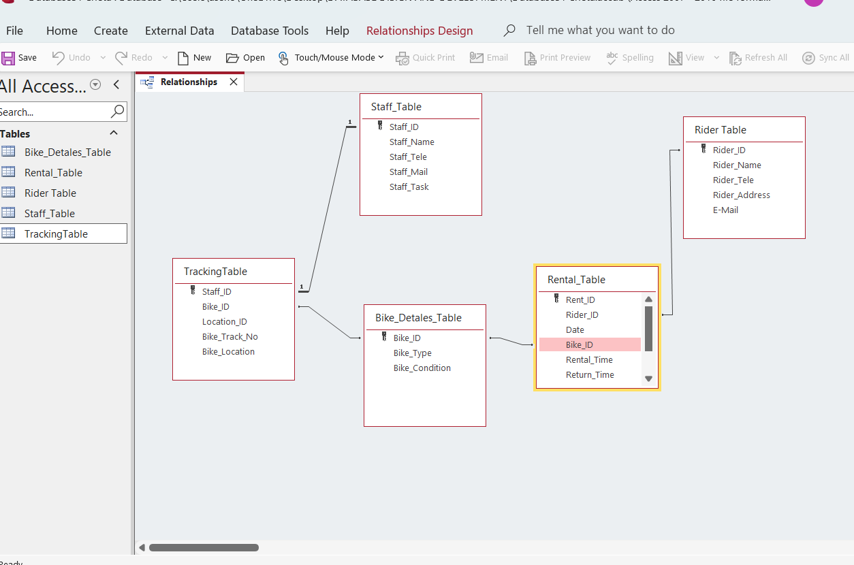

Type of Relationship between Entities (please explain each relationship with appropriate examples from the case study.)

Relationships
- One Rider → Many Rentals
- One Bike → Many Rentals
- One Bike → Many Maintenance records
- One Staff → Many Maintenance records

Entities interact within the database

Entities in the database are connected so they can share information. Each entity has its own data, but they are linked through relationships (for example with IDs or foreign keys). This lets the system match records and work correctly. Because of these connections, the database can show which data belongs together and keep everything organized.

Logical Design
Table Creation in MS – Access (take screenshots of each table (Datasheet view and design view) and paste it here and annotate each screenshot.
Rider Details table (Design view and datasheet view)

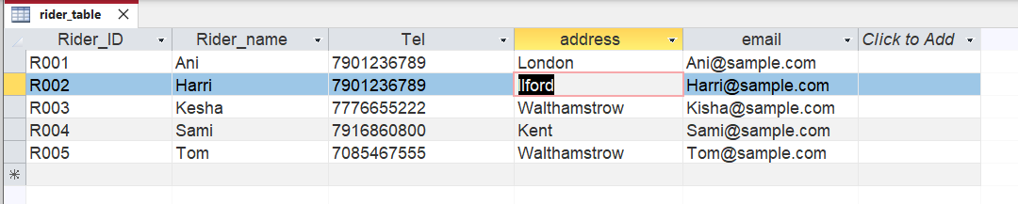

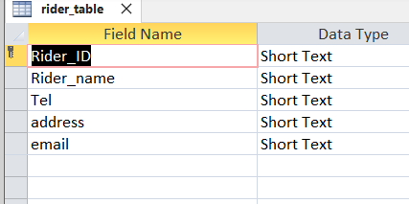

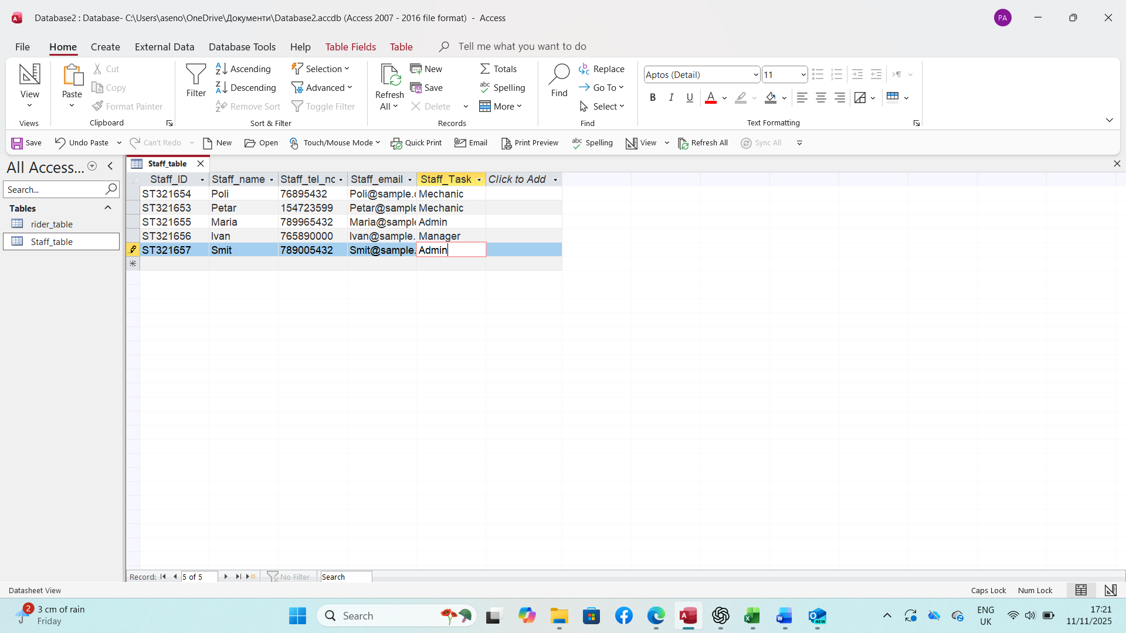

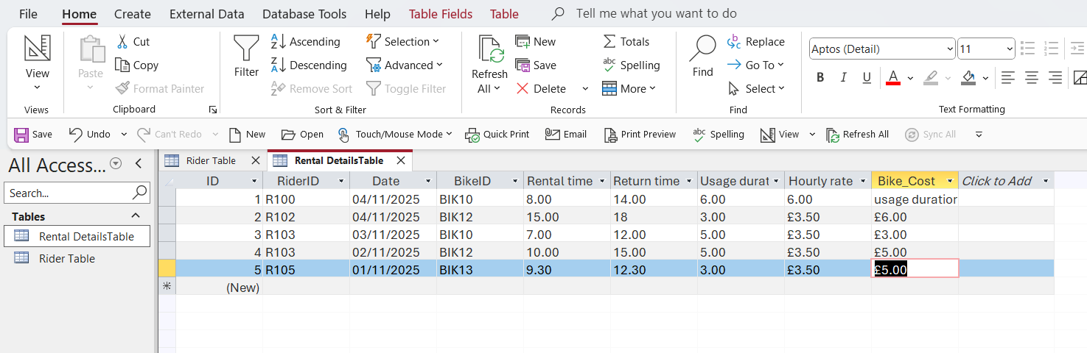

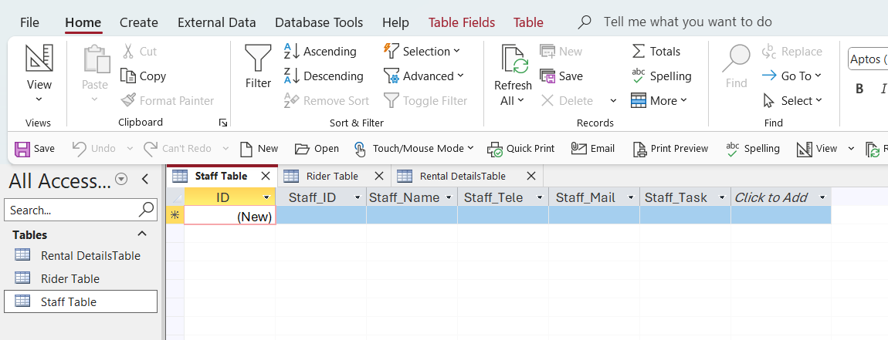

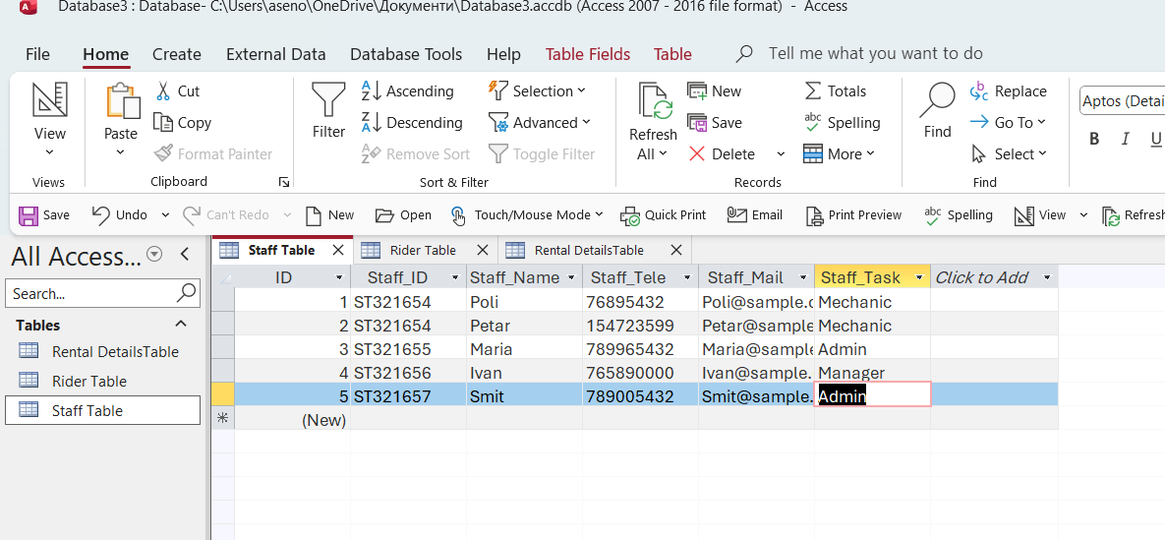

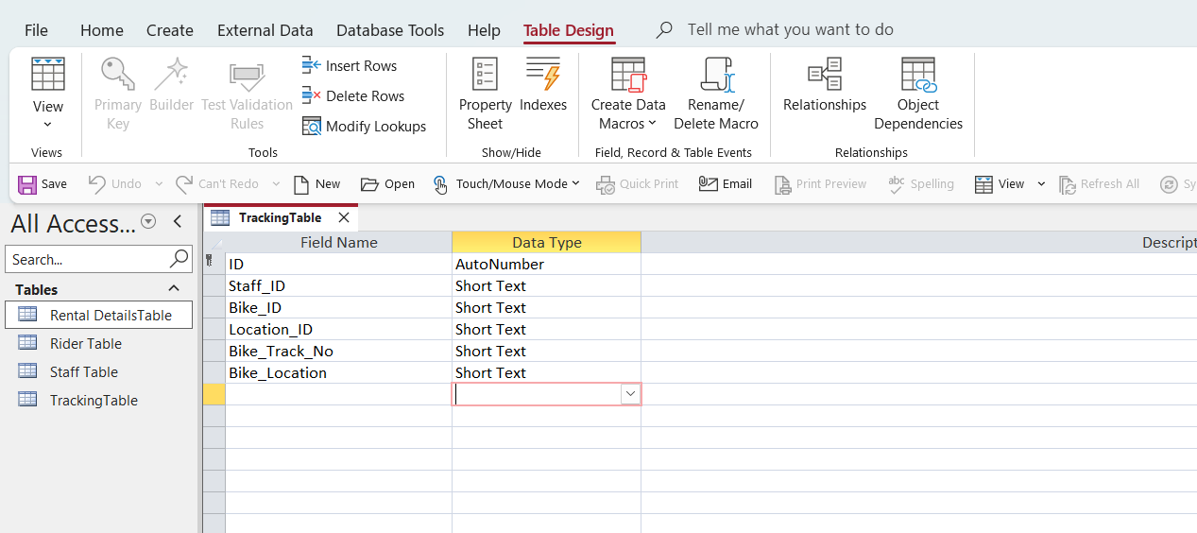
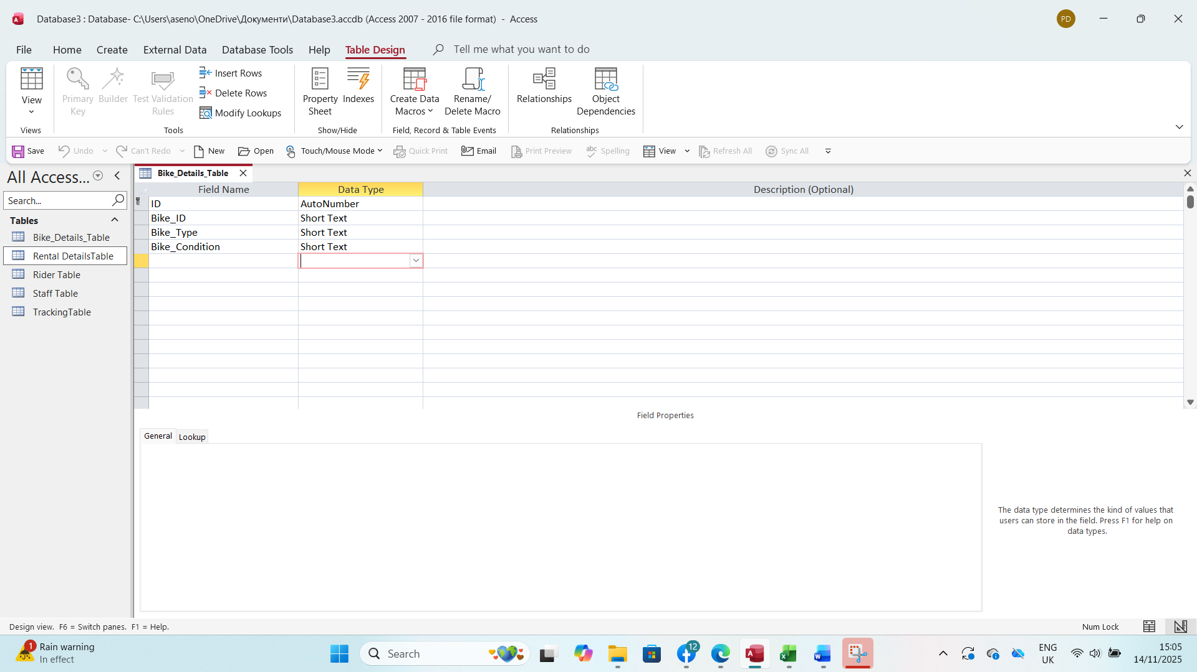
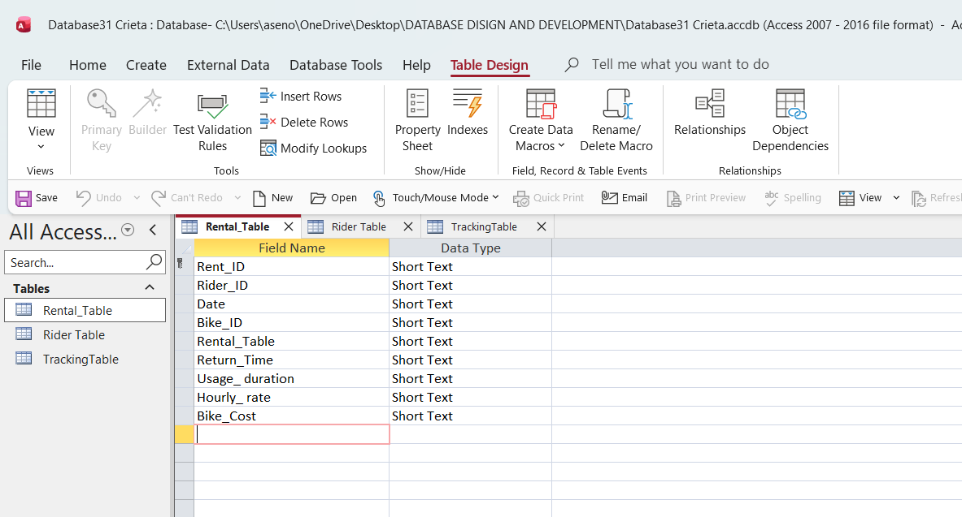

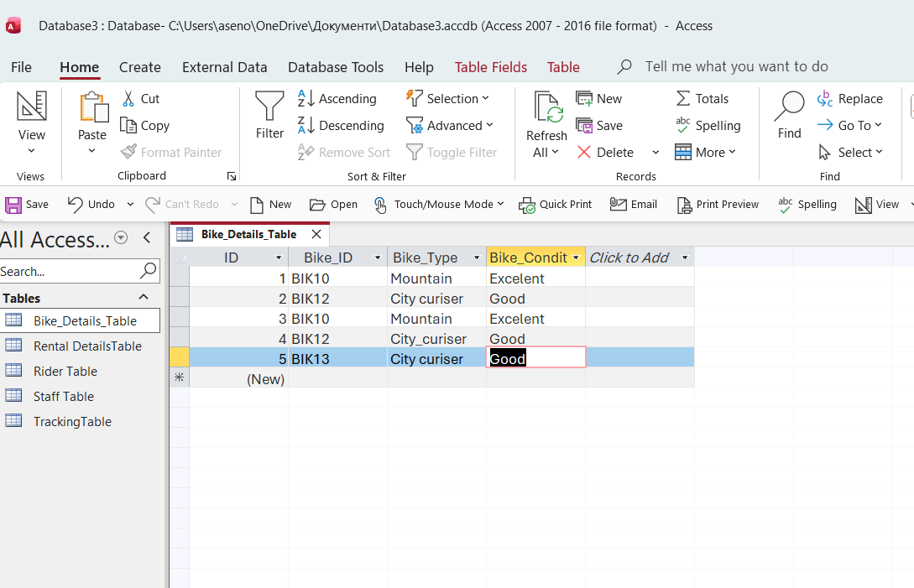

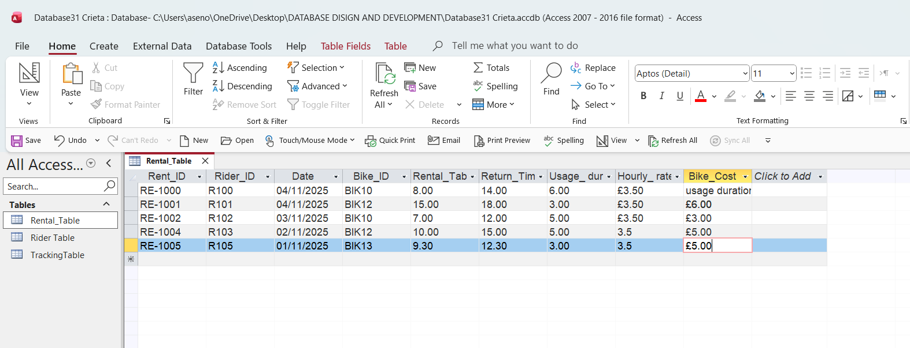
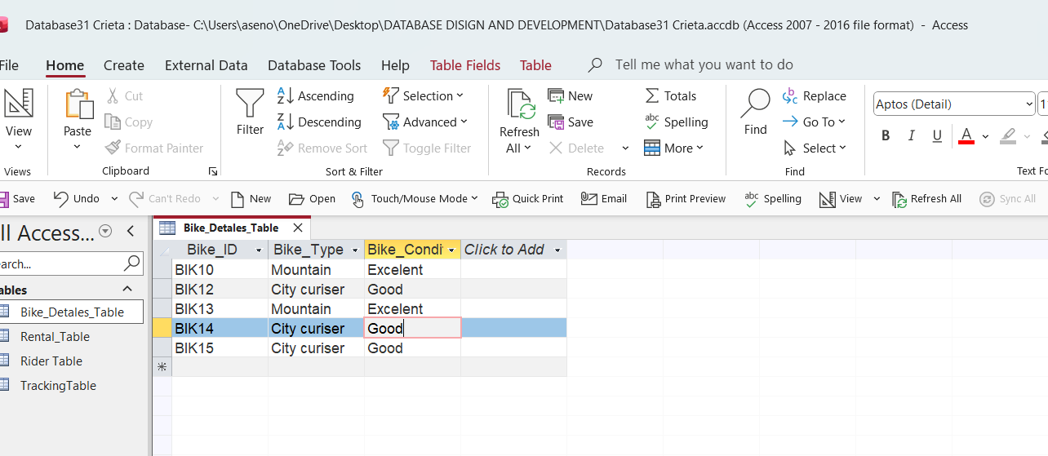

Relationships between tables
Я

Explain what type of key attributes (each table) used to create relationships between tables.

Relationships
- One Rider → Many Rentals
- One Bike → Many Rentals
- One Bike → Many Maintenance records
- One Staff → Many Maintenance records

Testing and Validation
Requirements of the case study
- Manage an inventory : in this case a table called, “product” has been designed and developed to maintain inventory of all the products.
- Customer Information : A table called "Customer” has been designed and developed……..

Product_Table

Bike_ID | Bike_Type | Bike_Condition
BIK10 | Mountain | Excelent
BIK12 | City curiser | Good
BIK13 | Mountain | Excelent
BIK14 | City curiser | Good
BIK15 | City curiser | Good

Customer_Table

Rider_ID | Rider_Name | Rider_Tele | Rider_Address | E-Mail
R100 | Ani | 7901236789 | London | Ani@sample.com
R102 | Kesha | 7901236789 | Ilford | Harri@sample.com
R103 | Kesha | 7776655222 | London | Ani@sample.com
R104 | Tom | 7085467555 | Walthamstrow | Tom@sample.com
R105 | Sami | 7916860800 | Kent | Sami@sample.com

Normalization Process
Take screenshots of 3rd Normal form from MS-Excel and Paste here and annotate each table.

 | Rider_Details table
Rider_ID | Rider_Name | Rider_Tele | Rider_Address | E-Mail
R100 | Ani | 7901236789 | London | Ani@sample.com
R102 | Harri | 7901236789 | Ilford | Harri@sample.com
R103 | Kesha | 7776655222 | Walthamstrow | Kisha@sample.com
R105 | Sami | 7916860800 | Kent | Sami@sample.com
R100 | Tom | 7085467555 | Walthamstrow | Tom@sample.com

 | Staff Table
Staff_ID | Staff_Name | Staff_Tele | Staff_Mail | Staff_Task
ST321654 | Poli | 76895432 | Poli@sample.com | Mechanic
ST321654 | Petar | 154723599 | Petar@sample.com | Mechanic
ST321655 | Maria | 789965432 | Maria@sample.com | Admin
ST321656 | Ivan | 765890000 | Ivan@sample.com | Manager
ST321657 | Smit | 789005432 | Smit@sample.com | Admin

Rider_ID | Date | Bike_ID | Rental time
R100 | 11/11/2025 | BIK10 | 8.00
R100 | 11/11/2025 | BIK12 | 15.00
R102 | 03/11/2025 | BIK10 | 7.00
R103 | 02/11/2025 | BIK12 | 10.00
R105 | 01/11/2025 | BIK13 | 9.30
Staff_ID | Bike_ID | Location_ID | Bike_Track_No | Bike_Location
ST321654 | BIK10 | LO002 | 300-000-100 | University Park
ST321654 | BIK12 | LO003 | 300-000-101 | Uni campus
ST321655 | BIK10 | LO001 | 300-000-101 | Train Station
ST321656 | BIK12 | LO002 | 300-000-102 | University Park
ST321657 | BIK13 | LO002 | 300-000-103 | University Park

 | Tracking table

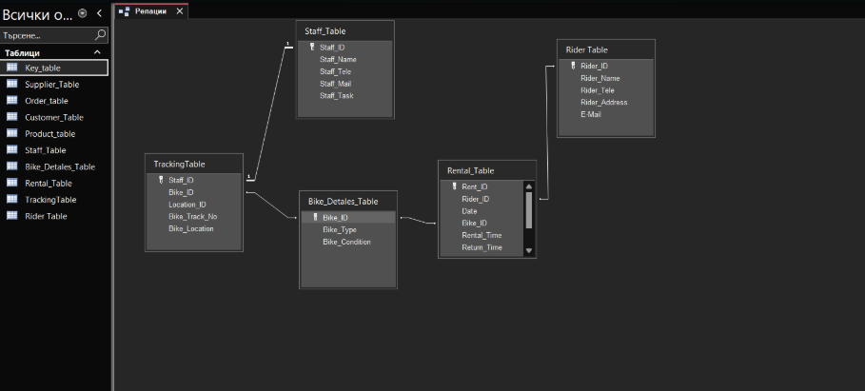

MS- Access

MS Access is a program that helps you create and manage databases. You can make tables to store data, connect them, use forms to enter data easily, run queries to find information, and make reports to show the data.
Forms Creation (take screenshots of all the forms and annotate them)

Rentals

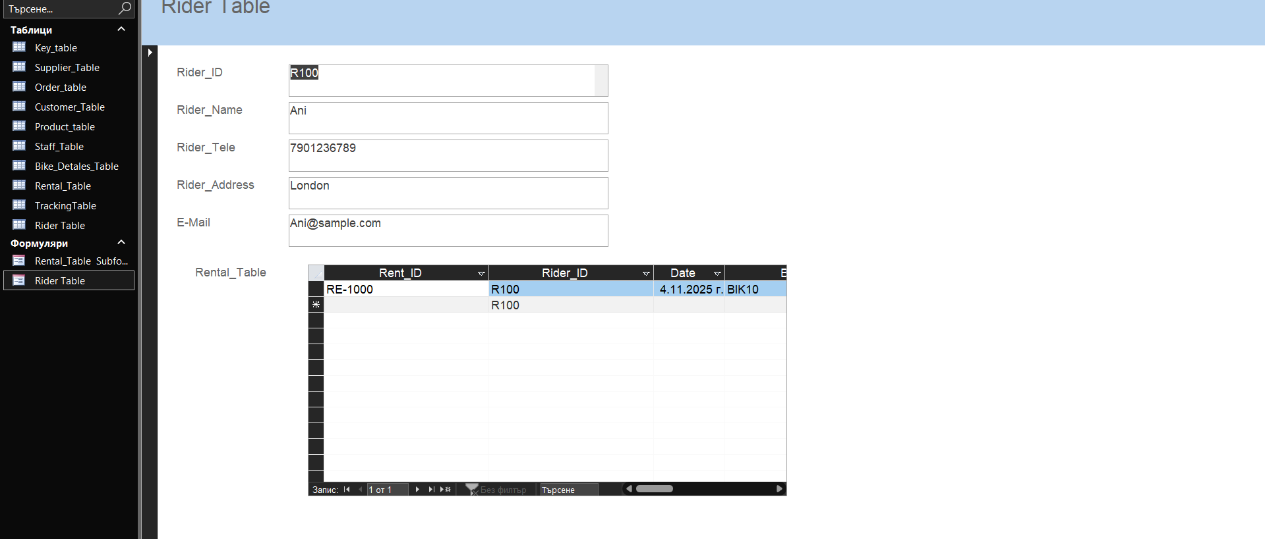
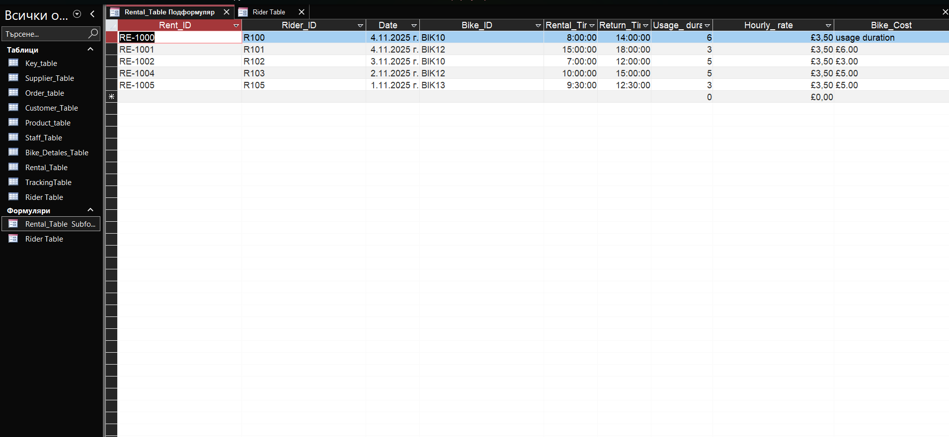

Bikers
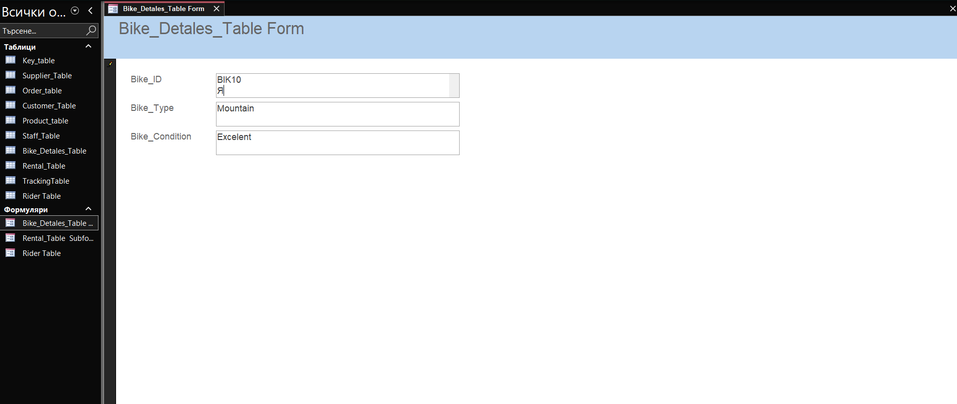
Staff

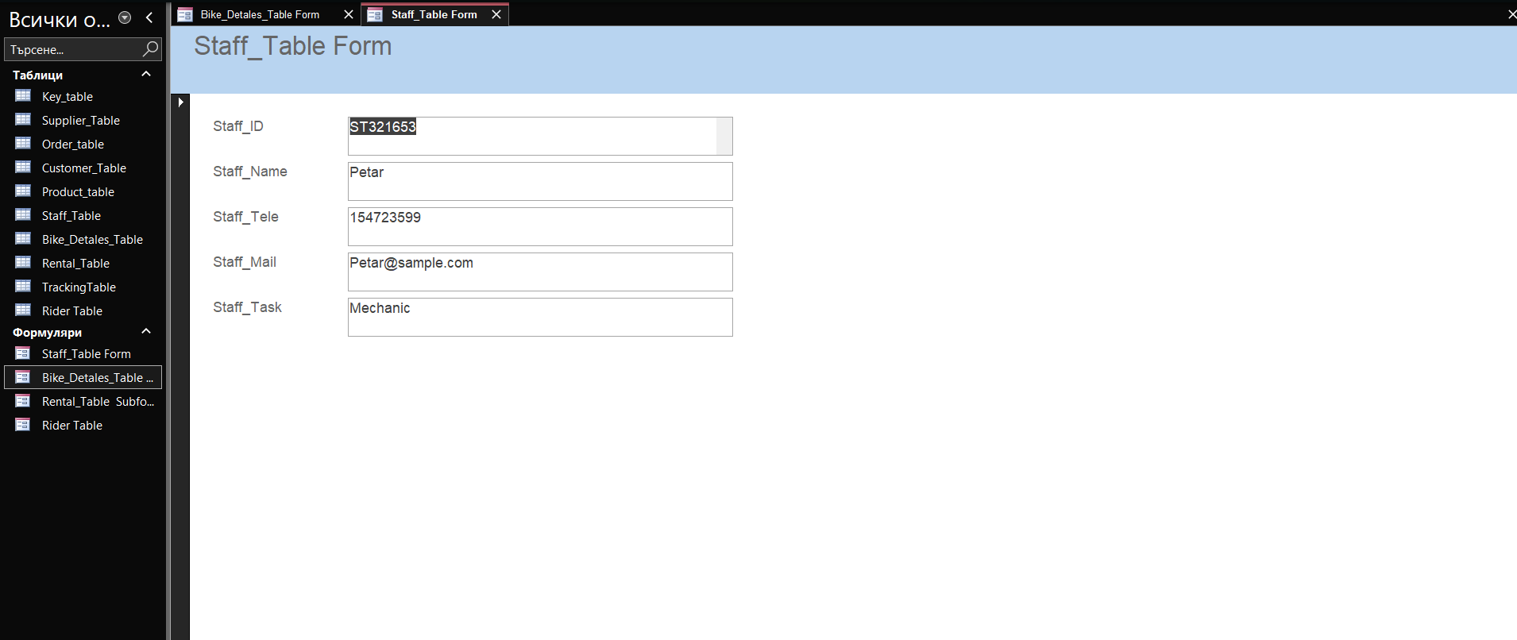
Queries Creation (take screenshots of the design view, datasheet view and SQL view of each query and annotate them)

Based on your critical thinking, create at least two – three queries
SQL view SELECT
Customer_Details.Cust_ID, Customer_Details.Name, Customer_Details.Address
FROM
Customer_Details WHERE
(((Customer_Details.Address) = "East London"));

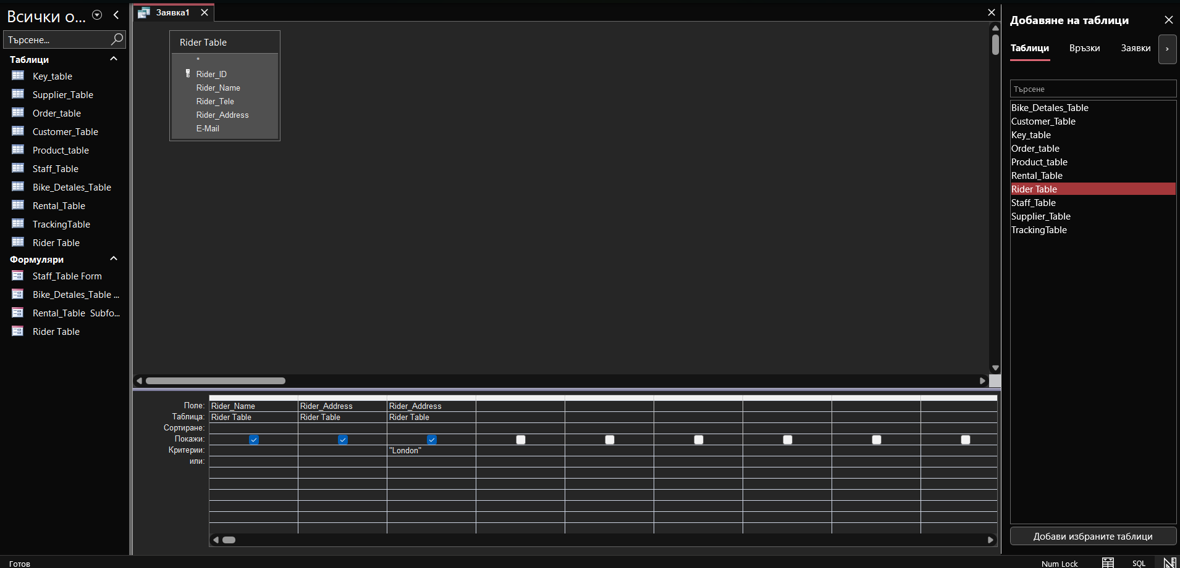

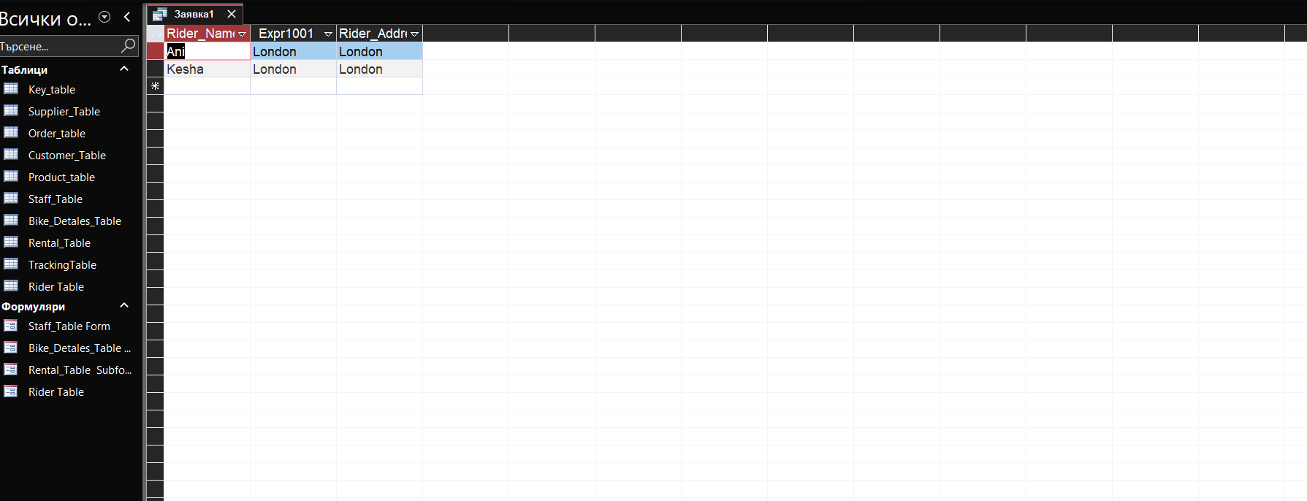
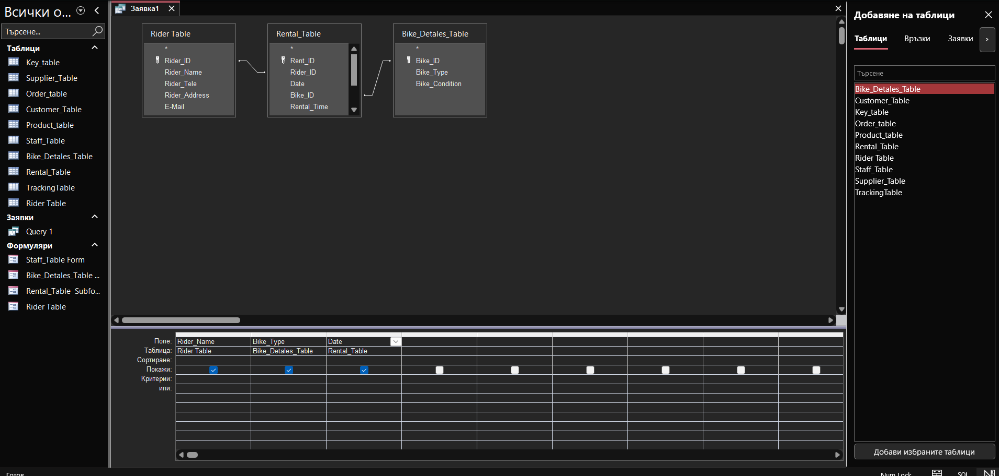
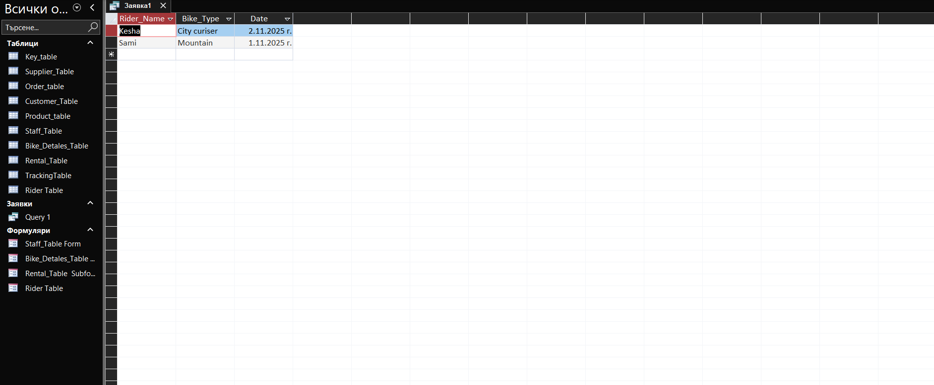
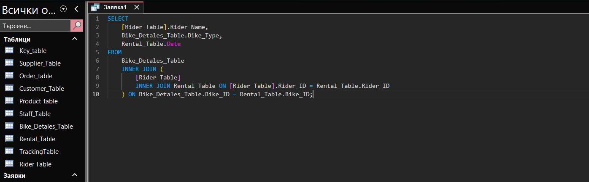
Report Creation (create reports from each query and annotate them)

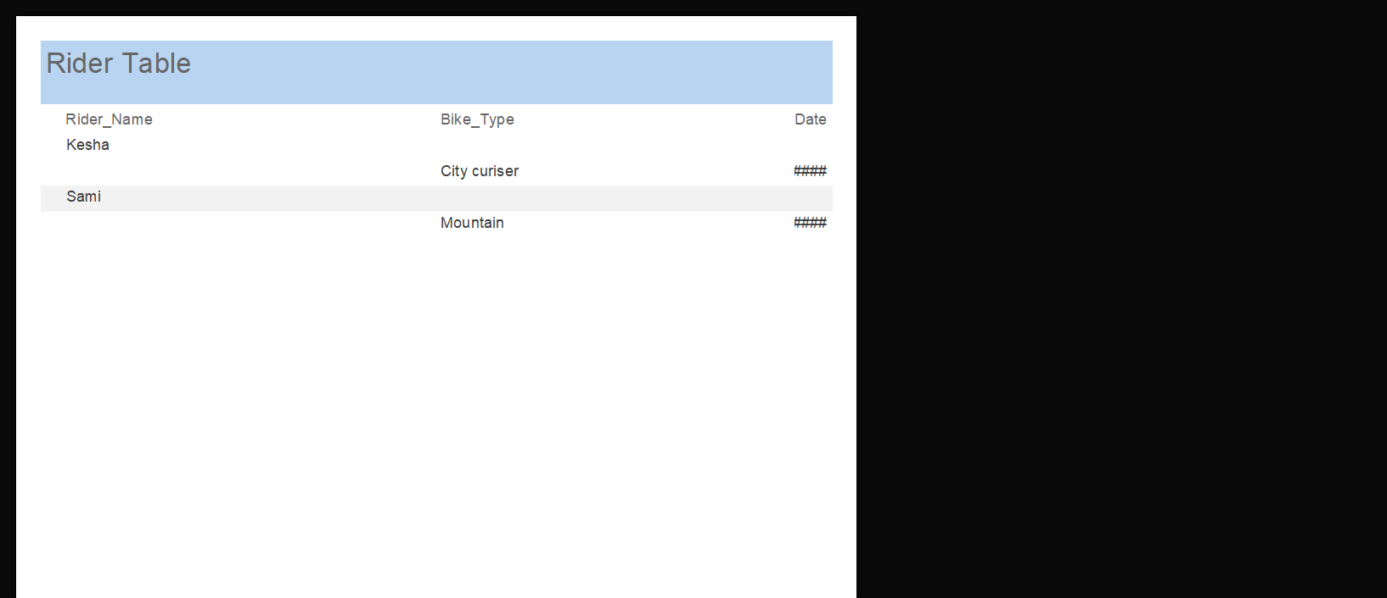
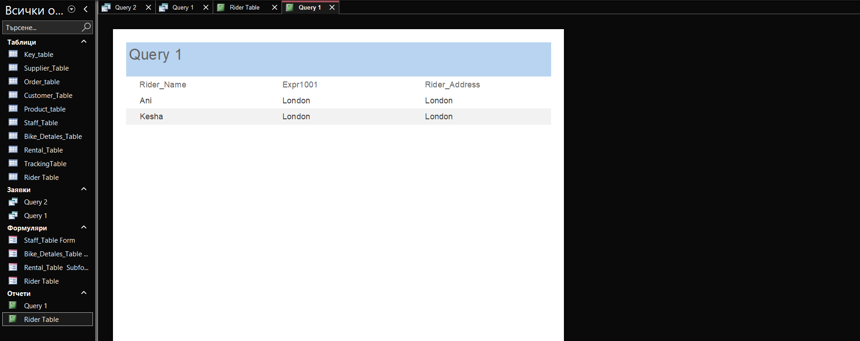
Calculations (show how you implement calculation (if any) and take screenshots)
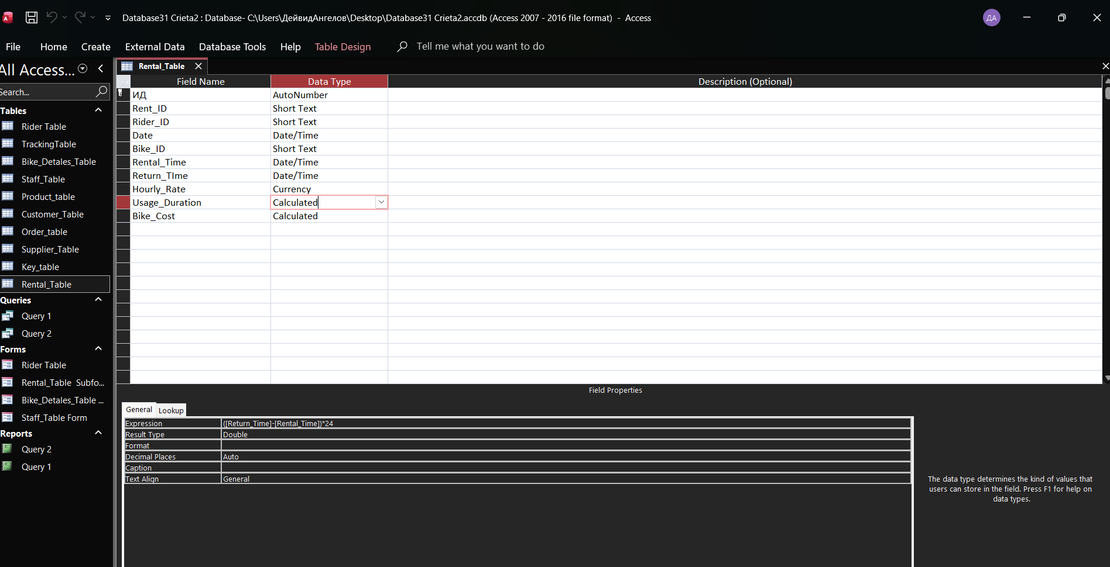
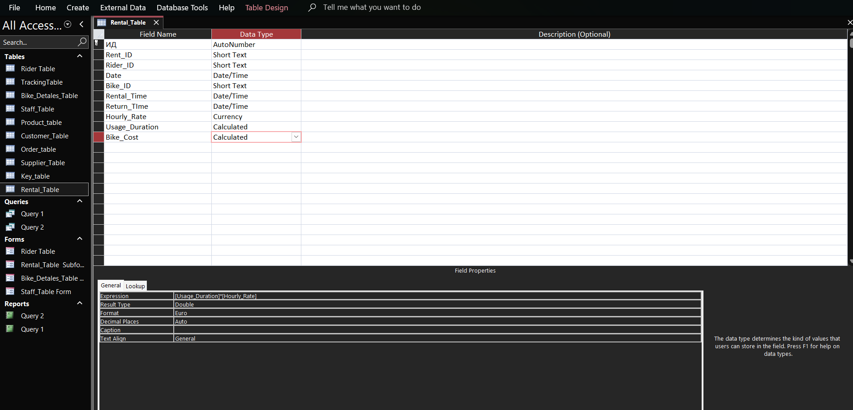
Dashboard Creation (show how to navigate from dashboard to forms and forms to dashboard)
The dashboard is the main page of the system. From the dashboard, the user can open different forms by clicking the buttons or links. When a form is opened, the user can fill it in and then go back to the dashboard by pressing the “Back” button or using the menu. This shows how the user can easily move from the dashboard to the forms and back again.



