
Certificate of Higher Education in Health and Social Care
Psychology in Health and Social Care
Assignment 2
BMHP4003
Module leader: Diya Ganguly
Krystal Gardner
2027750



Table of content
Introduction
Critically reflection on Psychological Theory on the life Span
Reflection
Conclusion
Reference

Introduction
This is a reflective report on the theory we have covered in my presentation, there is four different lifespan theories, but we thought we choose the most interesting theory to focussed on which was Erick Ericson’s theory which is Psychosocial we focussed on stage one age 0-1 which was Infancy we found this engaging and interesting. I Discussed a framework that I found most exciting and related it to my life to reflect how it has impacted me. I Critically discussed as a health and social care professional, how I will apply the learnt psychological perspectives that was learnt in this module and how ill apply it to my future job.

Critically reflection on Psychological Theory on the life Span
In our presentation we focused on stage 1 infancy 0-1 years Trust vs Mistrust in our presentation since we considered Eric Erickson's psychosocial theory more engaging.
Erik Erikson was an ego psychologist who developed one of the most popular and influential theories of development. While his theory was impacted by psychoanalyst Sigmund Freud's work, Erikson's theory cantered on psychosocial development rather than psychosexual development. (Cherry, 2021)
We go through eight phases of development throughout our lives, according to psychosocial theory, from birth to late maturity. There is a conflict, or task, at each level that we must resolve. Each developmental activity completed successfully results in a sense of competence and a healthy personality. (opentextbc.ca, n.d.)

Erickson has eight stages to his theory
Stage 1 Infancy age 0-1 years trust vs mistrust according to Erickson it is the most important period of your child’s life as it shapes their view of thew world as well as their overall personality
Stage 2 Ages 2-3 in early childhood Shame and Doubt vs. Autonomy, according to Erikson, children at this age are focused on developing a greater sense of self-control.
Stage 3 Preschool age 3-5 Initiative vs. Guilt, according to Erickson If children have successfully completed the earlier two stages, kids now have a sense that the world is trustworthy and that they are able to act independently.
Stage 4 School age 6-11 Industry vs. Inferiority, if you master this skill, you will have a skill that will benefit you for the rest of your life.
Stage 5 Adolescence 12-20 Identity vs. Role Confusion, during this stage, adolescents explore their independence and develop a sense of self.
Stage 6 young adult in their mid-twenties.
Stage 7 Adulthood 25-60 years old.
Stage 8 old age 60+ Integrity vs. Despair, At the integrity versus despair stage, the key conflict centres on questioning whether the individual has led a meaningful, satisfying life.

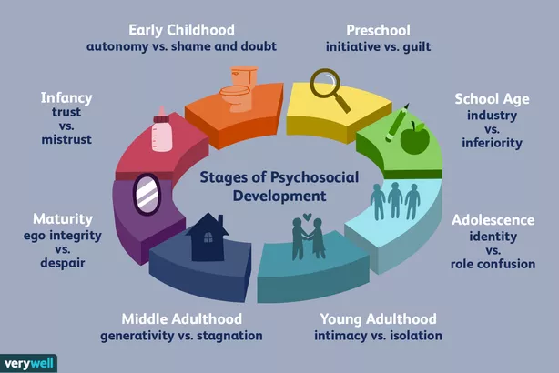

Erikson’s theory of development may be applied in a variety of contexts. These include Parenting, Psychotherapy, Education and Healthcare
Understanding Erikson's stages can assist healthcare providers in being more attentive to their patients' needs. An elderly patient, for example, who is always grumpy, could be suffering from depression. A nurse who understands this is more likely to respond with empathy rather than irritation. (Theodore, 2020b)
I absolutely agree with Eric Erickson's psychosocial theory because many individuals have done study on this topic and found this theory to be extremely useful, I have three children and I find this concept to be a good and clear understanding of each stage of my children’s life, As a parent, I find it important to understand why children act and do things at different stages of their lives, and this theory really puts it in perspective. Erikson's theory also has the strength of being able to link crucial psychosocial development across the lifespan. Erikson, on the other hand, does not go into detail on how the outcome of one psychosocial stage affects personality at a later stage. In addition, The concept fails to clarify what kinds of experiences are required at each level in order to effectively resolve disputes and go to the next.
Many beliefs exist about how babies and children develop into happy, healthy individuals. According to Sigmund Freud, we go through a series of psychosexual stages during which our attention is drawn to specific erogenous zones on the body. Eric Erikson took Freud's ideas and developed a psychosocial development hypothesis. According to Erikson, our sense of self is shaped through our social interactions and the completion of social tasks. Jean Piaget developed a theory of cognitive development that defines how children reason and think as they grow through the stages of development. The focus of Lawrence Kohlberg then switched to moral development. As our cognitive development unfolds, he believes, people go through three stages of moral cognition. (Coursehero.com, 2022)

Reflection
I found Reward and Punishment to be exciting and fascinating because I can apply this to my daily life with my children. I believe that rewarding a child when they need it is always an excellent approach to enhance their confidence and self-esteem. The idea of reinforcement has multiple meanings. Reward promotes positive performance and raises the strength of a conditioning or other learning process. Rewarding behaviour must be appropriate for the circumstances. Punishment obstructs learning and increases anxiety.
Fortunately, a single reinforcement may persist and have an effect for an extended period. In a classic experiment Skinner, 1950), a pigeon pecked at a rate of six thousand times per hour for several hours even though it was only rewarded at five-minute intervals (an intermittent schedule of reinforcement). (M.S, 2018)
Self-efficacy is defined as having the confidence to perform a specific task. I appreciate this concept since it can serve as a basis for motivation, well-being, and personal achievement. This concept has bolstered my confidence in my capacity to succeed in a certain situation, such as doing my assignments.
Albert Bandura (1977), a Canadian American psychologist and professor at Stanford University, was the first to invent the term "self-efficacy." In his own words, he first introduced the concept as a personal assessment of "how well one can execute courses of action required to deal with potential events". (Lopez-Garrido, 2020)
I want to work in mental health sector in the future. Carl Jung's concept has both aided and inspired me. The Carl Jung notion will assist me in comprehending and viewing people as a whole.
Carl Jung (1875-1961) was a genius, Swiss psychologist and attributed as one of the most influential thinkers of psychological history. He lived through a most fascinating timestamp of history watching first-hand all the major and pivotal influences of the turn of the century. Alongside Freud, Jung pioneered the foundations of analytical psychology and the treatment of mental illnesses as a fundamental problem. But Jung also took his work to more serious depths. Throughout his life, Carl Jung steadily put together an original worldview that has captivated millions since. (Faulkner-Hogg, 2020)
Workplace behaviour management I appreciate this notion since it defines how you conduct yourself at work. Every workplace has a different mood and climate, which may be tough. However, dealing with negative behaviour is vital for an organisation.
Arriving on time, communicating respectfully, and being honest will all be part of my workplace behaviour. Working well as part of a team or group; a positive attitude toward co-workers, the workplace, and job tasks; a clean and appropriate appearance; respect for others and individual differences; and a confident arrogance toward colleagues, the workplace, and job tasks are some of the personal qualities and traits.
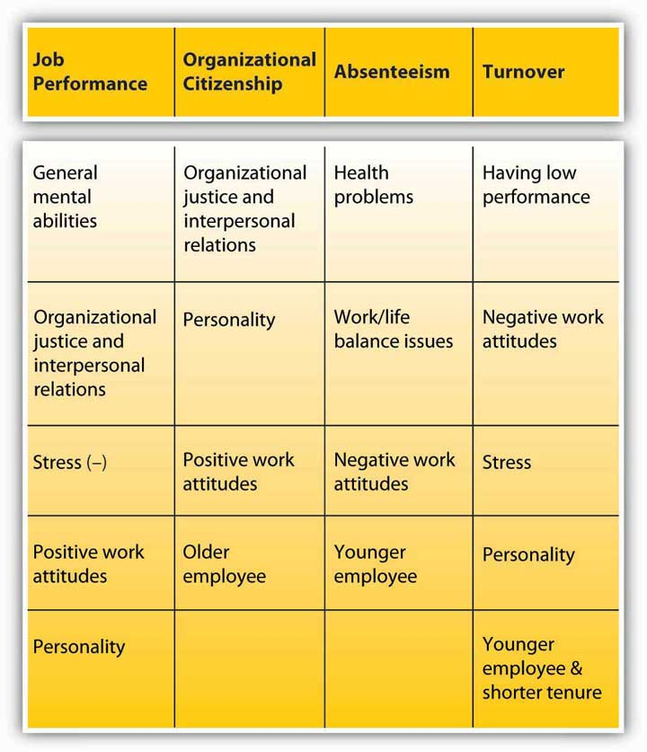
I am extremely interested in learning more about health and social care services. I believe I have received a great deal of skills and knowledge that I can and will apply in both my daily life and my future employment.

Conclusion
In conclusion, I have discussed the critical reflection on psychological theory on the life span in this paper. The three principles I discussed from Eric Erickson's psychosocial theory were reward and punishment, self-efficacy, and behaviour management. I will use these theories and concepts in my profession as a health and social care worker.

Reference

Coursehero.com. (2022). course hero. (Online) Available at: https://www.coursehero.com/file/pgaurlk/Summary-There-are-many-theories-regarding-how-babies-and-children-grow-and/
(Accessed 19 Apr. 2022).

Cherry, K. (2021). Erik Erikson’s stages of psychosocial development. (Online) Very Well Mind. Available at: https://www.verywellmind.com/erik-eriksons-stages-of-psychosocial-development-2795740. (Assessed 19 Apr. 2022).

Faulkner-Hogg, R. (2020). An Introduction to Carl Jung & Jungian Concepts. (Online) Atlas Geographica. Available at: https://atlasgeographica.com/an-introduction-to-carl-jung/
(Accessed 19 Apr. 2022).

Lopez-Garrido, G. (2020). Self-Efficacy Theory | Simply Psychology. (Online) www.simplypsychology.org. Available at: https://www.simplypsychology.org/self-efficacy.html#:~:text=Psychologist%20Albert%20Bandura%20has%20defined%20self-efficacy%20as%20people%27s
(Accessed 19 Apr. 2022).

M.S, N., Pam (2018). What is REINFORCEMENT (Reward and Punishment)? definition of REINFORCEMENT (Reward and Punishment) (Psychology Dictionary). (Online) Psychology Dictionary. Available at: https://psychologydictionary.org/reinforcement-reward-and-punishment/
(Accessed 19 Apr. 2022).

Opentextbc.ca. (N.d.). Lifespan Theories – Psychology. (Online])Available at: https://opentextbc.ca/psychologyopenstax/chapter/lifespan-theories/#:~:text=According%20to%20psychosocial%20theory%2C%20we%20experience%20eight%20stages
(Accessed 19 Apr. 2022).

Theodore (2020b). Erik Erikson (Psychologist Biography). (Online) Practical Psychology. Available at: https://practicalpie.com/erik-erikson/
(Accessed 19 Apr. 2022).

www.bing.com. (n.d.). Behaviour management in workplace - Search. (Online) Available at: https://www.bing.com/search?q=Behaviour+management+in+work+place&cvid=14ec7b0fac1c4267aa26c26c98032e29&aqs=edge..69i57.1017j0j1&pglt=41&FORM=ANNAB1&PC=U531
(Accessed 19 Apr. 2022).

