BA International Hotel Management

Module: Managing Guest Service Operations
Module code: BMIH6003

Student Name: Marin Marius Enache
Student ID: 2241513
Placement Location:Best Western Abbots Barton Hotel, Canterbury
Department: Meetings & Events

Table of Contents
1. Introduction 3
2. Department Reflection: The Guest Experience 4
2.1 Overview of Departmental Operations and Guest Journey 4
2.2 Developed Significant Problem: Management Styles and Staff Motivation 4
2.3 Theoretical Implementation: Leadership and Motivation Theories 4
2.4 Personal Reflection and Learning 5
2.5 Significance of the Issue and Relation to the Academic Literature 6
2.6 Three-step Improvement Plan 6
3. Conclusion 8
Reference List 9
Appendix 10

1. Introduction
The Abbots Barton Hotel, Canterbury, is a hotel of the Best Western type that is well known for offering versatile meeting and event services. The department is the fundamental factor of the successful work of the hotel, where corporate functions, weddings, and personal banquets are organised with the help of the Food and Beverage (F&B) team. Another significant role that is played by the department is the experience of the guests with the concentration on the quality of service and individualisation (Walker, 2021).
The events, their logistics, catering and customer coordination are planned by the department of Meetings and Events in order to ensure that all of them are done in the right way. This job offered individual experience in working with guests, team management, and event delivery, integrating theoretical knowledge bases of the hospitality courses (Wood, 2013).
The department offers conference services, catering services and event packages that integrate F&B operational services and efficient service provision. Close collaboration between event givers, service teams and kitchen teams is also ensuring the satisfaction of the guests (Jones, 2008).
The reason behind the choice of the Meetings and Events is due to its dynamic operations, which require good leadership and teamwork in the quest to balance the demands of the guests and the motivation of the staff. The internship has brought an opportunity to have a glimpse of the work of the managers and guests with my own eyes.

2. Department Reflection: The Guest Experience

2.1 Overview of Departmental Operations and Guest Journey
The guest experience in the Meetings and Events department engages in the planning of the event, the event implementation and assessment. The collaboration will occur between employees in F&B as well as events to offer a seamless guest experience. However, it also became evident that leadership and team communication anomalies were also observed and, at some point, influenced morale and performance (Wood, 2013).
The front-back-of-house integration directly influenced the guest satisfaction outcome because it was also discovered to concur with Jones (2008), who pointed out the necessity of coordination in the hospitality services provision.
2.2 Developed Significant Problem: Management Styles and Staff Motivation
During my time in the Meetings and Events department I personally observed that different managers used contrasting leadership styles, and realise how inconsistent communication can quickly affect staff motivation and the guest service quality.
This mismatch affected the services and the perception of guests, which confirmed that leadership directly influences the motivation of its employees and the quality of its services (Felce, 2019). The issue is linked to the concepts discussed in the Management and Organisational Behaviour (Level 5) that highlight the importance of leadership congruence so that efficiency and team morale could be guaranteed.
2.3 Theoretical Implementation: Leadership and Motivation Theories
The unmet psychological and esteem needs may be another factor that led to the low motivation, which was also noted in the periods when the team members were not recognised during the difficult events according to the framework by Maslow (Walker, 2021). The theory formulated by Herzberg emphasises that the intrinsic motivation aspects, like achievement and recognition, were the motivational aspects; they were absent at times and therefore reduced the engagement.
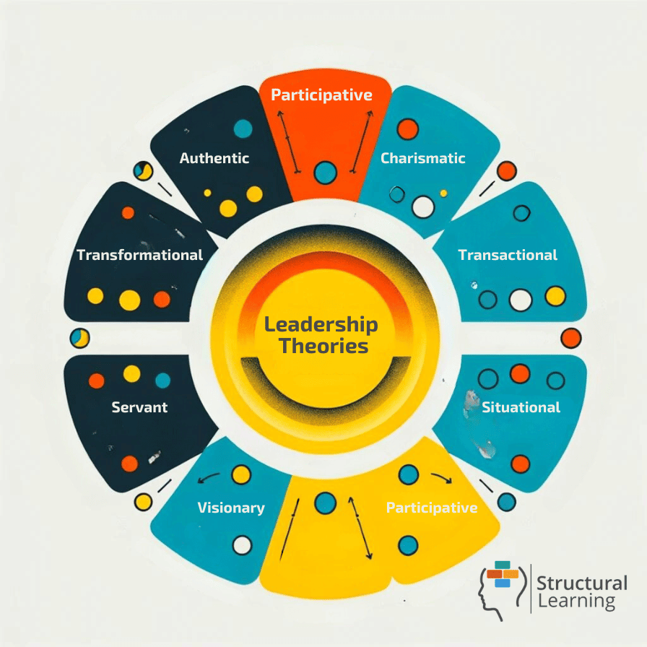
Figure 1: Leadership Theories (Walker, 2021)
The management gap experienced can also be explained using Theory X and Y by McGregor, where certain supervisors managed employees using the Theory X assumptions, which presupposed that employees needed to be controlled, but there are supervisors who used Theory Y, which presupposed that they were free. The latter led to the improvement of morale and motivated service delivery (Wood, 2013).
From my own experience, I have realised that effective management and consistent motivation of staff are key to achieving high guest satisfaction and maintaining service quality during events.
2.4 Personal Reflection and Learning
My contribution to a large-scale corporate event formed the basis of the reflection that I did with the help of the Gibbs Reflective Cycle (1988). First, confusion in F&B schedules existed due to a communication shortage affecting the provision of services to the guests. As this became clear to me, I also resorted to team briefings and role clarification in which team members would become more coordinated and confident.
The experience has made me realise that adaptive leadership and efficient communication are significant in the operations of managing activities related to events (Hagg, 2013). I also determined that self-awareness and proactive communication can be critical in alleviating the operational issues and enhancing teamwork.
In other leadership roles I would like to employ situational leadership to mould my leadership style based on the dynamics of my team as well as the pressure of the service (Bardi, 2010).
2.5 Significance of the Issue and Relation to the Academic Literature
Consequent impacts of leadership discrepancies can be long-term on the culture of service, morale of employees, and the perception by the guests. According to Lashley (2018), the organisational culture in the hospitality industry can thrive when the leaders promote trust and cooperation. Conversely, the deficiency of proper communication affects the service provision and decreases the satisfaction of guests.
Similar to the research concluded by Felce (2019), motivation and recognition programmes are an essential part of keeping the high-quality performance that is witnessed in my placement. Furthermore, Wood (2013) notes that the effectiveness of the hospitality management relies on the proper teamwork, particularly in issues that pertain to event operations where timeliness and precision are paramount.
Stable leadership, therefore, enhances operational efficiency in addition to aligning with the best practices within the hospitality industry, and it aligns the employees and improves the quality of services (Anon, 2010).
2.6 Three-step Improvement Plan
Step 1: Systematised Communication System.
Give daily briefings and debriefings to the team prior to and following every event to address objectives, duties and feedback. This will create transparency and accountability (Jones, 2008).
Step 2: Leadership Training and Development.
Adopt a supervisor leadership development programme in motivational skills, emotional intelligence and feedback on performance. This type of development aligns with the industry trends offered by the Chartered Institute of Personnel and Development (CIPD, 2022).
Step 3: Recognition and Feedback System.
Institutionalise a reward system among the staff, e.g., Employee of the Event, to reinforce positive behaviour and motivate teams (Rutherford and O’Fallon, 2007).
The expected outcomes are high morale among the staff, enhancement of communication, and the satisfaction of the guests, which is consistent with the frameworks of operational excellence in UKHospitality (2023).

3. Conclusion
The placement experience within the Meetings and Events department of the Best Western Abbots Barton Hotel has served to highlight the role of leadership style in motivating the staff and satisfaction of the guests.
The observation and reflection enabled me to gain insights on the significance of communication, recognition and adaptability in leadership. The application of such theories as those of Herzberg and Gibbs helped to transform the process of learning that is grounded in practice intosystematic professional knowledge (Hagg, 2013).
In my future hospitality roles, I will adopt a transformational style of leadership, which would involve teamwork and empowerment. Effective leadership is a sure way to ensure the running of smooth operations and a sustainable culture of delivering guest services that drives satisfaction and loyalty (Wood, 2013).

Reference List
- Anon (2010) A Good Practice Guide for Placement and Other Work-based Learning Opportunities in Higher Education – Good Practice for Placements Guides – Volume 2. 52 (4). doi:10.1108/et.2010.00452dab.013.
- Felce, A. (2019) ‘Managing the quality of higher education in apprenticeships’, Higher Education, Skills and Work-Based Learning, 9(2), pp. 141–148.
- Hagg, E. (2013) Internship Guide: Work Placements Step by Step. 5th Ed. The Hague: Eleven International Publishing.
- Jones, T. J. A. (2008) Professional Management of Housekeeping Operations. 5th Ed. Hoboken, NJ: John Wiley & Sons.
- Walker, J. (2021) Introduction to Hospitality. 8th Global Ed. Harlow: Pearson.
- Wood, R. C. (2013) Key Concepts in Hospitality Management. London: SAGE Publications Ltd.
- Bardi, J. (2010) Hotel Front Office Management. 5th Ed. London: Wiley.
- Rutherford, D. G. and O’Fallon, M. J. (2007) Hotel Management and Operations. 4th Ed. Hoboken, NJ: John Wiley.
- UKHospitality (2023) Operational Excellence in Hospitality. London: UKHospitality Press.
- CIPD (2022) Employee Engagement and Motivation: Best Practice Toolkit. London: CIPD.
- Lashley, C. (2018) Hospitality Management: Principles and Practice. Routledge.

Appendix
Use of Generative AI in Assessment
Category | Description | Yes | No
RESEARCH | For this assessment, you can use Generative AI to support you in research and data analysis | ☐ | ☒
STRUCTURE | For this assessment, you can use Generative AI to support you in structuring your submission, including creating a draft argument structure, identifying parts and headings, etc. | ☐ | ☒
PROOFREADING | For this assessment, you can use Generative AI to check your own text/creation for grammatical and syntactical mistakes, including getting suggestions to rephrase your work. | ☐ | ☒
WRITING | For this assessment, you can use Generative AI to create text for submission. | ☐ | ☒
CREATIVE | For this assessment, you can use Generative AI to create creative materials, such as images. | ☐ | ☒
PROGRAMMING | For this assessment, you can use Generative AI to create and check code. | ☐ | ☒
NONE | For this assessment, you are not allowed to use any type of Generative AI support. This includes research support, structure support, writing/proofreading support and creative support. | ☒ | ☐

