Name: Hannah Collins
CIPD Membership: 48751582
Title: Developing Professional Practice

Table of Context
Activity 1
  - What is an HR Professional………………………………………………………………………………Page 3
  - The CIPD Professional Map……………………………………………………………………………Page 3 1.2.1Professional areas………………………………………………………………………………….Page 4
Activity 2
2.1 Group Dynamics…………………………………………………………………………………………….Page 5
2.2 Conflict Resolutions……………………………………………………………………………………….Page 6
2.2.1 Active listening……………………………………………………………………………………….Page 6
2.2.2 Influencing……………………………………………………………………………………………..page 6
Activity 3
3.1 Project management……………………………………………………………………………………..Page 7
3.1.1 Gantt Chart…………………………………………………………………………………………….Page 8
3.2 Problem solving…………………………………………………………………………………………….Page 8
Activity 4
4.1 Self-Assessment…………………………………………………………………………………………….Page 9
5.0 References…………………………………………………………………………………………………….Page 10

Activity 1
1.1 What Is an HR Professional?
The main role of a Human Resource professional is to provide professional advice and support the delivery of the organisation strategy and objectives through effective people management and performance (Wilkinson & Taylor, 2016).
HR can be an individual working for a small company (HR sole practitioner) or it can be a team of HR professionals working for larger companies. Working closely with operational management HR will have knowledge of, and involvement in all areas of HR to determine people’s needs and to take part in developing policies and procedures. Taylor & Woodhams, (2016) states that "professional is someone who makes proficient use of the expert or specialist knowledge, exercises autonomous thought and judgment, and makes a voluntary commitment to a set of principles."
CIPD, (2015) describes one of the HR roles is to work alongside management on attracting and developing talent to deliver strategy and have an insight that can drive lasting performance.
1.2 The CIPD professional map
Continuous personal development (CPD) is a high priority for an HR professional to continuously develop their knowledge and skills. It gives the HR professional ownership over their own progress and development. HR professionals continue to record CPD to keep their knowledge and skills up to date and to ensure that their credibility as a professional Is recognised (CIPD, 2015).
The CIPD profession map is thought of as a competency framework and is a great way to identify your strengths and areas for development. The CIPD profession map sets out standards for HR professionals around the world. It can be used for personal development or for an organisation to develop their team. It is used to define great HR, diagnose areas of success and improvement, build HR capability, and recognise achievement through professional qualifications and membership (CIPD, 2015).
The profession map in figure 1 maps out the 10 professional areas, 8 behaviours and the four bands of professional competence.
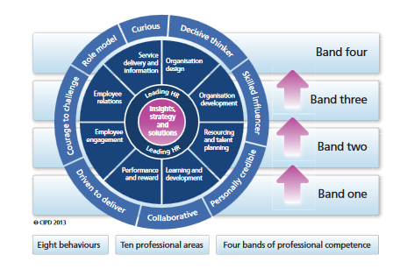

Figure 1: The CIPD Profession Map (CIPD, 2015)

CIPD, (2015) have arranged the profession map into three sections.
The professional areas- describes the activities you need to do for each HR profession at four bands of professional competence.
Behaviours- Describes the behaviours that need to be adapted to four bands in order to carry out the activities.
Bands and transitions- Describes the four bands of professional competence and the transition challenges faced moving from bands.
The profession Map has two core professional areas, Leading HR and Insights, strategy and solutions then are surrounded by eight additional functional areas. The core professional areas are applicable to all HR professionals, whereas the eight professional areas will depend on the specific role of the professional.
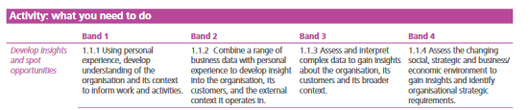
Figure 2: An extract from the CIPD’s Profession Map (CIPD, 2015).

Figure 2 shows and example of a professional area the behaviour expected in each band. The professional area, in this case, develops insights and spot opportunities. It then shows the behaviours in each band which will take you from junior to senior roles.

1.2.1 Professional areas and competencies
As apart of my assignment I completed an assessment of four professional areas; insights, strategy, and solutions, Leading HR, Learning and development and employee engagement. As I do not work with a human resource department I chose the areas that I found more interesting. I also chose to assess myself on 3 behaviour areas; curious, decisive thinking and personally credible.
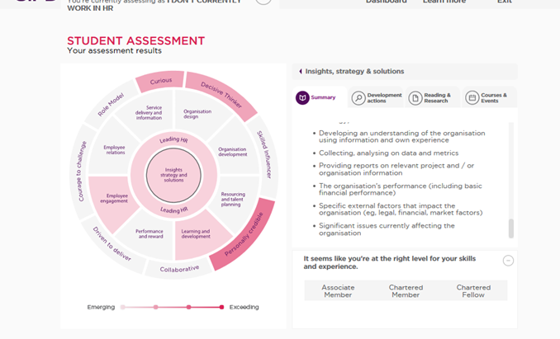

Figure 3: screenshot is taken of the result of the profession assessment (CIPD, 2015)

Figure 3 is a screen shot of my CIPD professional assessment. It summarises each area professional area and what my strengths and weaknesses are for each, for example for insights, strategy, and solutions I have a few gaps in my experience such as using insights from data and good HR practice to spot potential trends and risks for the organisation. This is because I don't work within an HR role.
Activity 2
2.1 Group Dynamics
Group dynamics refers to an interaction between a group of people who are working or talking together. When there are three or more individuals interacting with each a behavioural pattern will start to emerge. There will be the individuals who will take lead of the conversations, these will openly talk about their thoughts. There will be other individuals who will remain quiet and listen rather than get involved. There will be other individuals who are impatient and want to get straight to the point. Group roles are dependent on the combination of the personalities within the group. An individual could act differently around certain personalities, for example, a quiet individual could become dominated by the individuals who are louder (Nazzaro & Strazzabosco, 2009). For a group to effectively operate as a team there must be a presence of different individuals with different agendas.
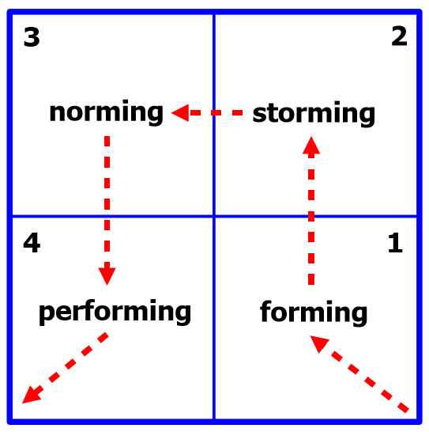
Bruce Tuckman first published his Forming Storming Norming Performing model in 1965. The theory is used to explain a group’s development and behaviour. The theory explains as the team develops through the stages, relationships establish and the leader changes leadership style.

Figure 4 Diagram of Tuckman’s Theory (Business Balls, 2003)

Forming – At this stage the group are underdeveloped and has a high dependence on a leader for guidance and the make the decision. The team relationships are new and individual roles are unclear. At this point, processes are often ignored.
Storming- At this stage, the personalities of the individuals start to unfold. Cliques and conflict start between the group as individuals try to establish themselves. This means the group still needs guidance from the leader to keep them on track toward their goals and stop them getting distracted by emotions and relationships.
Norming- At this stage roles and responsibilities of the individuals are clear and are accepted. The group starts to make decisions as a group and become more committed to the role. The team may even get involved in fun social activities with the group. In the norming stage, the team starts to develop the process and the working style and starts to work without the leader getting involved.
Performing- At this stage the team knows what they are doing and why they are doing it and are able to achieve their goals with no participation from the leader. They require the leader to delegate tasks and projects but do not need instruction. Disagreements still occur at this point however the team is able to resolve it between themselves (Business Balls, 2003).
Many HR professionals can relate to the Tuckman's model while having lead teams of people, however, some groups with an unbalance dynamic do not always work.
2.2 Conflict resolutions
HR professionals must be aware that group dynamics are affected by different factors such as leadership, the structure of the group, power and status issues, communication structures or process. If any of these factors are present within a team then conflicts can occur (Taylor & Woodhams, 2016). An HR professional must be able to manage conflict in a calm and professional manner using the appropriate and effective conflict resolution techniques.
2.2.1 Active listening
Active listening is a common technique used in conflict resolution and is very effective. An HR professional uses the skill of active listening to gather all information in relation to the conflict. There are five active listening techniques to help ensure that you measure the individual that you are hearing what they are saying (Mind Tools, 2017).
- Pay attention – keeping eye contact with the speaker and put aside distracting thoughts
- Show that you are listening – make sure posture is open and inviting and smile and use other facial expressions
- Provide feedback – ask questions to clarify certain points and summarise
- Defer judgment – don't interrupt with counter arguments
- Respond appropriately – treat the speaker the way you wish to be treated
2.2.2 Influencing
Influencing is another technique used for conflict resolution. Taylor & Woodhams, (2016) cite the work from Yemm (2008) that argues a successful HR professional must be able to successfully influence others and possess attributes such as friendliness, empowerment, vision, bargaining skills, knowledge, and ability to build alliances. In order to influence others, an HR professional must have the knowledge and expertise in order to answer any questions they may be asked in any situation (Taylor & Woodhams, 2016).
I have previously used both Active Listening and Influencing a complaint I previously received from employee (1). The complaint employee (1) was regarding another employee (2) about bullying. A meeting was arranged with both employees for the issue to be resolved. Active listening was used to retrieve all the background information of the issue. We summarised the information back to the employees to ensure we understood all the key issues. After the meetings, it was understood that employee (1) was aggravated by employee (2) having power issues. Employee (2) had been given a small side project to do and started to treat employee (1) differently. I then took employee (2) to the side and spoke about his position within the group and whether or not he would like the employee (1) to help him with his side project. Employee (2) agreed to let employee (1) help with the project. The situation was resolved however I kept monitoring the employees until the project was complete.
Activity 3
3.1 Project Management
Project management is one of the most top skills sought by HR professionals today (Kreissl, 2014). It’s a very useful skill to have even for those in very traditional HR roles (Kreissl, 2014).
Recently I was involved in a project creating a new process within the photo studio at Amazon. We wanted to improve our metrics for our rejected images. After imaging products, the images get uploaded to a re-touch team, if the images don't follow a certain guide they get rejected. If images get rejected then the product will have to be recalled and processed again. This wastes time and money when there could have been a way to prevent it. By preventing the rejections then the time and money could be used to process and image new items.
The team we got together consisted of people who worked together on a daily basis and held a brainstorming session. Some of the members of staff weren’t trained up on the areas we were trying to improve, this increased the risk of group dynamics shifting and people not voicing their ideas in fear of embarrassment. We conquered this by persuading the team that no idea is a bad idea because an idea can be developed and someone might bring a fresh perspective to the table. We came up with an idea of having a team where they solely check the images before upload. This individual would have training in the style guide we must follow and check the images follow that guide before they are uploaded.
After our brainstorming session and creating our idea, we arranged a meeting with the European Manager of Imaging. We had to persuade him to allow us to use hours on training and developing the idea. Short term we would lose hours through developing, however, in the long run, it would benefit the metrics. We negotiated that we could work on the project for eights hours a week and we had a time limit of two months before we had to present the product to him.
After assigning individual tasks to the team we held meetings once a week to present what we had completed so far, this kept the team motivated with the project and we were able to solve any problems we came across. These meetings helped us monitor the process
The project was a success, we demonstrated the final product to the European Manager of Imaging. The project was then developed in other Amazon studios around the globe.
Overall the project went well. Brainstorming was a good tool to use while planning a project, collecting ideas from all the team members then discussing the ideas with each. One thing we could improve on is time management, unfortunately we missed the deadline. Moving forward I would like to use the Gantt chart with my team to make sure we stay on track and deliver on time.

3.1.1 Gantt chart
The Gantt chart is a tool used in time management and is very useful if you have a busy schedule to arrange you workload around daily life.
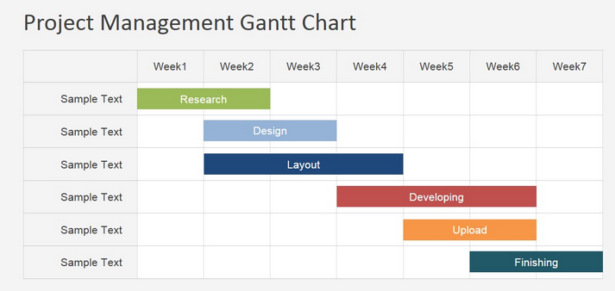

Figure 5: Basic Gantt Chart model (slidemodel, 2017)

Figure 5 is a basic model of the Gantt Chart tool used in project management. It demonstrates how you can plan out your tasks and completion through the weeks. This is a handy tool to make sure you don't miss anything and also improves time management.
3.2 Problem solving
Another technique we could use in the future to solve any problems we may encounter is the De Bono theory published in 1985 called Six Thinking Hats. Using this tool you can often reach a successful solution, but it can also help you view problems from other angles. This is a handy tool to incorporate into work meetings. Each thinking hat is a different style of thinking.
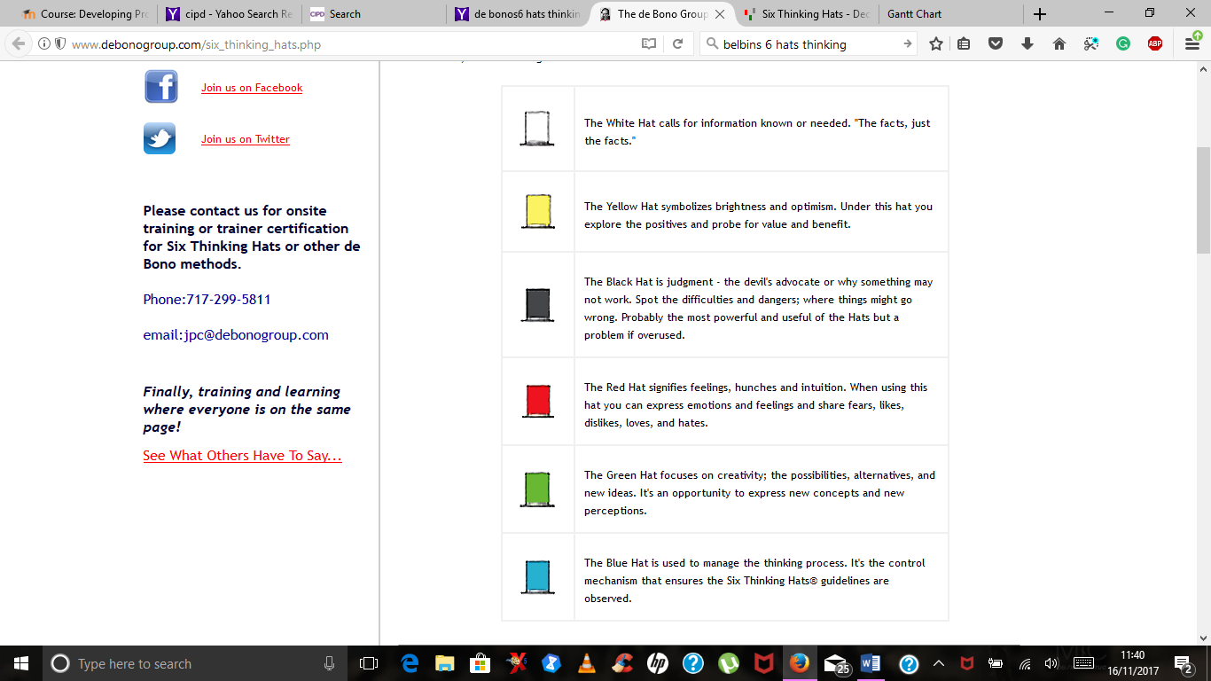

Figure 6: An image to show the thinking styles of each colour hat. (De Bono Group, 2017)

Using this method will help the team learn how to use a disciplined process which will help in many ways such as maximise productivity, use parallel thinking as a group, and go beyond the obvious to discover effective alternative problems (De Bono Group, 2017).

Activity 4
4.1 Self-assessment
In order to get the best out of my continued professional development, I undertook a Honey & Mumford's questionnaire, in order to give me a better idea of my preferred learning style. Learning styles were developed by Peter Honey and Alan Mumford, they identified four distinct learning styles: Activist, Theorist, pragmatist, and reflector.
The results of the questionnaire were that my learning style was an Activist. Activist learn best by doing. They involve themselves fully and without bias in new experiences (Mobbs, 2003). They are enthusiastic about new projects and tackle problems by brainstorming. After the excitement has gone from one activity they have already started looking for the next. They are good at brainstorming, problem solving and puzzles. They best form of learning is on the job or interactive learning (Mobbs, 2003).
Knowing my preferred learning style allows me to seek out learning opportunities that suit me to help me develop. These are some methods of learning which would be a better form of learning for an activist.
Table 1: Learning methods and the advantages and disadvantages
Learning method | Advantages | disadvantages
Job rotation/ shadowing | - Sharing of knowledge  - Ability to ask questions  - Work while you learn | - Dependant on the knowledge of trainer  - Can pick up bad habits  - Personalities a clash  - Learning style of the teacher could differ from your own
On-the-job Training | - One-to-one  - Able to practice what you have learned immediately  - Feedback is given  - Instruction is paced | - Training can be rushed  - No feedback is given  - Might not get the opportunity to practice immediately
Group discussion | - Sharing knowledge  - Can be fun  - Can learn something you never expected to learn | - Group dynamics can change  - Can be distracted by socialising  - Everyone needs to feel included
Each learning style has different attributes and is stronger at different activities. Figure 7 shown below shows the different learning styles and the different attributes taken from Mobbs, (2003) based on the Honey & Mumford research.

Figure 7: An extract of the learning styles and the attributes (Mobbs, 2003).
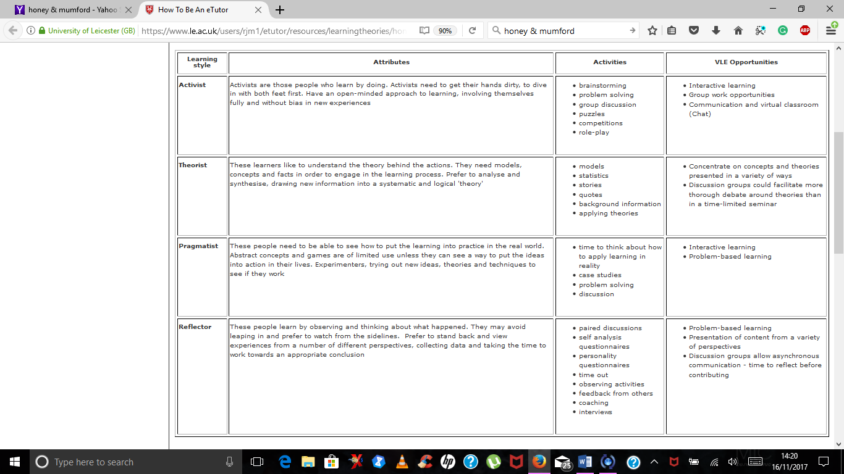
There are many learning methods other than researching online. CIPD, (2015) hold a discussion about different learning methods such as monthly online book clubs, where you can interact with the authors, to ask them questions and to challenge them. Other forms of learning are webinars and seminars, these can be good alternatives to classroom learning.

5.0 References

Business Balls, 2003. Tuckman forming storming norming performing model. [Online]
Available at: https://www.businessballs.com/team-management/tuckman-forming-storming-norming-performing-model-234/[Accessed 15 November 2017].
CIPD, 2015. CPD for HR. [Online]
Available at: https://www.cipd.co.uk/podcasts/cpd-for-hr
[Accessed 16 November 2017].
CIPD, 2015. The CIPD profession map. [Online]
Available at: http://moodle.uwtsd.ac.uk/pluginfile.php/49501/mod_resource/content/1/profession-map-v2.4-jan-2014_moodle.pdf
[Accessed 15 November 2017].
De Bono Group, 2017. Six Thinking Hats. [Online]
Available at: http://www.debonogroup.com/six_thinking_hats.php
[Accessed 15 November 2017].
Kreissl, B., 2014. Why HR should embrace project management. [Online]
Available at: http://www.hrreporter.com/sharedwidgets/systools/_printpost_.aspx?articleid=1209[Accessed 15 November 2017].
Mind Tools, 2017. Avtive listening. [Online]
Available at: https://www.mindtools.com/CommSkll/ActiveListening.htm
[Accessed 15 november 2017].
Mobbs, R., 2003. Honey and Mumford Learning Styles. [Online]
Available at: https://www.le.ac.uk/users/rjm1/etutor/resources/learningtheories/honeymumford.html
[Accessed 16 November 2017].
Nazzaro, A.-M. & Strazzabosco, J., 2009. Group dynamics and team building, Montreal: World Federation of Hemophilia.
slide modes, 2017. Horizontal Bar Gantt Chart Template. [Online]
Available at: https://slidemodel.com/templates/project-management-gantt-chart-powerpoint-template/flat-horizontal-bar-gantt-chart-template/[Accessed 15 November 2017].
Taylor, S. & Woodhams, C., 2016. Managing and co-ordinating the HR function. In: Studying Human Resource Management. London: CIPD, pp. 21-41.
Taylor, S. & Woodhams, C., 2016. Studying Human Resource Management. 2 ed. London: CIPD.
Wilkinson, K. & Taylor, S., 2016. Managing and Co-ordinating the HR Function. In: Studying Human Resource Management. London: CIPD, pp. 22-42.

