

University of Wales Trinity Saint David

Module code: ACCB6017

Module: Usability Engineering

Assignment: User Requirements and Prototype

Submission date: 31st October 2025, 14:00 (2 PM)
Lecturer: Dr Nassir Ibrahim

Student Name: Majib Miah
ID: 2234516

Contents
Introduction 1
A. Four detailed personas & associated scenarios 1
B. Usability Design and Considerations 1
C. Initial Wireframe Storyboards 1
D. Feedback Collection Process on Storyboard Design 1
Conclusion 1
References 1
Appendices 1
Appendix A. MoSCow Prioritisation 1
Appendix B. User Questionnaire and Summary 1

Figure 1 Home Screen 1
Figure 2 Character Select Screen 1
Figure 3 Campus Map Screen 1
Figure 4 Clue Screen 1
Figure 5 Results Screen 1
Figure 6 Google Form Introduction And consent 1
Figure 7 Google Form Questions And Submission page 1

Introduction
This report presents the early research and design process for a digital version of the board game Cluedo, reimagined for the University of Wales Trinity Saint David. The new version is titled UWTSD Cluedo and is based around a mystery storyline: “Oh no! The Vice-Chancellor has been murdered – who did it?” The game is set across the Swansea, Carmarthen, and Lampeter campuses and allows players to explore familiar university buildings while collecting clues to solve the mystery. The aim of this report is to document the early stages of the design process, including user research, persona creation, usability considerations, and the first set of wireframe storyboards. This stage focuses on research and layout design rather than colour or detailed visuals. The purpose is to make sure the app is simple to use, inclusive, and appealing to a range of users before moving on to the next phase of development. A major focus of this project is user experience. Because the game will be played by students and staff with different ages, abilities, and devices, accessibility and clarity are key priorities. The design follows the principles of user-centred design, meaning every decision is based on what real users need rather than what looks most impressive. The report also applies recommendations from well-known authors such as Jakob Nielsen and Don Norman to ensure that usability issues like visibility, feedback, and simplicity are properly considered[1]. The mobile version of UWTSD Cluedo aims to combine fun gameplay with the identity of the university. Players can move around digital maps of UWTSD campuses, visit rooms like the library or canteen, and uncover clues linked to campus life. The goal is not just to solve the murder but also to enjoy a light-hearted and familiar experience that reflects the environment of the university. This report includes four main parts: (A) the development of user personas and their experience requirements, (B) an explanation of usability principles and how they are applied in the design, (C) a set of wireframe storyboards showing the planned interface and navigation, and (D) the process of collecting and analysing user feedback. Together, these sections show how the early design has been created with accessibility, clarity, and engagement in mind.

A. Four detailed personas & associated scenarios
Persona 1 – Oli (The Casual Gamer)
- Age: 40
- Role: Undergraduate Computing student (Birmingham Campus)
- Scenario: Plays quick games between lectures or on the bus.
- Motivations: Wants something short and fun connected to campus life.
- Barriers: Limited time easily distracted.
User / Experience Requirements
- Fast loading and short rounds
- Simple navigation
- Clear icons and optional tutorial
Reflection
Oli represents the typical casual player who wants something fast and simple. His persona influenced the decision to keep the interface uncluttered and the navigation direct, using only a few large buttons on the home screen. Because Oli often plays in short bursts, it was important that the game could be paused easily and restarted without losing progress. His feedback also reinforced the need for a short tutorial that explains how to play without overwhelming the user.
Persona 2 – Natalia (The Mature Student)
- Age: 35
- Role: Part-time Education student (Birmingham Campus)
- Scenario: Juggles work and family, plays occasionally for relaxation.
- Motivations: Enjoys puzzles and stories; dislikes cluttered layouts.
- Barriers: Interrupted sessions, smaller phone screen.
User / Experience Requirements
- Save progress option
- Large, readable text
- Calm visual layout
Reflection
Natalia helped shape the design towards readability and calmness. Her profile shows the importance of accessibility for users who might be distracted or multitasking. This is why features like the “Save Progress” button and a minimal colour scheme were planned. Her input supports the principle that usability should fit around real life — users should be able to stop and continue easily. Her needs also guided the choice of clean fonts and strong visual contrast to improve readability on smaller devices.
Persona 3 – Matt (The Visually Impaired Student)
- Age: 35
- Role: IT student (Birmingham Campus)
- Scenario: Loves creative games but struggles with low contrast.
- Motivations: Wants an accessible, inclusive game.
- Barriers: Partial visual impairment.
User / Experience Requirements
- Screen-reader support and audio cues
- Strong colour contrast
- Adjustable font size and spacing
Reflection
Matt’s persona directly influenced accessibility decisions. His needs led to features such as screen-reader compatibility, larger text, and strong colour contrast. His feedback showed that accessibility isn’t just about compliance but about creating a fair experience for all players. Following WCAG 2.1 guidelines, the interface avoids relying solely on colour to convey information and includes simple shapes and clear text labels. Matt’s perspective helped ensure that inclusivity was a foundation of the design, not an afterthought.

Persona 4 – Toqeer (The Busy Guy)
- Age: 40
- Role: IT Student at UWTSD
- Scenario: likes playing competitive, team-based games with colleagues.
- Motivations: Enjoys games that encourage teamwork and friendly competition.
- Barriers: Limited free time, moderate familiarity with mobile gaming.
User / Experience Requirements
- Clear menus and simple controls
- Stable multiplayer system for group play
- Campus-themed humour and references to make the game feel authentic

Reflection:
Toqeer’s persona added a more professional, time-limited perspective. His lifestyle shaped the idea of having a quick, responsive design with minimal loading times. The ability to rejoin a session and continue where he left off reflects his need for convenience. His feedback also highlighted the importance of reminders or notifications to keep players engaged, especially in multiplayer games where users may take turns at different times.

User Research Process
User and experience requirements were then organised using the MoSCoW prioritisation method (Appendix A). This helped identify which features were essential—such as navigation, accessibility, and multiplayer—and which could be added later once core functionality was stable.
Information was gathered through a short online questionnaire and two informal interviews with UWTSD students and staff. Questions covered gaming habits, accessibility preferences, and opinions on a campus-themed mystery game.
Full details of the online questionnaire, including the participant information statement and anonymised findings, are provided in (Appendix B).
Findings
Most preferred short, easy-to-understand gameplay and liked the idea of using real UWTSD locations. Accessibility feedback highlighted the need for adjustable text size, colour contrast, and optional sound cues. These insights guided persona creation and the initial design priorities.
A detailed MoSCoW table appears in Appendix A.

B. Usability Design and Considerations
The main goal of the UWTSD Cluedo design is to make the game simple, consistent, and accessible to all players. Usability is at the centre of the process, as the app must work smoothly for students, staff, and users with different abilities or devices.
Applying Usability Principles
Jakob Nielsen’s heuristics were used as a checklist during the wireframe stage[2]. The rule of “visibility of system status” influenced the inclusion of navigation labels such as “Next → Character Select” at the bottom of each screen. This gives players constant feedback about where they are and what will happen next. The principle of “consistency and standards” guided the use of identical button shapes and labels across all screens, helping users learn the controls quickly.
Don Norman’s ideas about discoverability also shaped the interface[3]. Every button looks clickable, and important actions like End Turn or Start Game are placed in predictable positions. According to Shneiderman and Plaisant[4], this reduces cognitive load and helps users focus on gameplay rather than searching for controls. These small choices make the interface feel logical and familiar, even to first-time users.
Accessibility and Inclusivity
Accessibility was treated as a design requirement rather than an optional feature. Following the WCAG 2.1 guidelines[5], the layout uses strong colour contrast, scalable text, and simple icons. Audio cues and screen-reader compatibility were considered to support users like Matt, who has partial visual impairment. These features ensure that no player is excluded due to visual or physical barriers. The feedback from participants reinforced that accessibility improvements also benefit everyone, not just users with disabilities.
Error Prevention and Feedback
To reduce errors, confirmation prompts were added before ending a turn or exiting a session. This follows Nielsen’s rule of “error prevention.”[1] Feedback messages appear when players complete actions, giving a clear sense of progress. The design also includes a calm grey-and-white wireframe style to prevent visual clutter, which was particularly important for users like Natalia who prefer a relaxed, distraction-free interface.
Mobile-First Approach
Because most participants said they play games on their phones, the interface was built with a mobile-first mindset. Buttons are large enough for touch interaction, and text fits comfortably within a single column. This design ensures the game is equally usable on both small and medium-sized screens. The mobile focus also supports users like Toqeer, who may play in short breaks during the workday.

C. Initial Wireframe Storyboards
The initial wireframe storyboard presents the planned user flow for the UWTSD Cluedo mobile game[6]. Each frame shows the basic layout and key interactions without colour or final graphics. The storyboard illustrates how users navigate through the main stages of the game — Home → Character Select → Campus Map → Clue Screen → Results.
These wireframes focus on functionality, accessibility, and clarity rather than aesthetics. They demonstrate how buttons, menus, and on-screen elements guide the player through the gameplay process. Navigation labels such as “Next → Character Select” indicate how one screen leads to the next, creating a clear visual narrative of the user journey.
This low-fidelity storyboard allows for easy adjustment and feedback before any colour, typography, or detailed artwork is added in the next development stage.
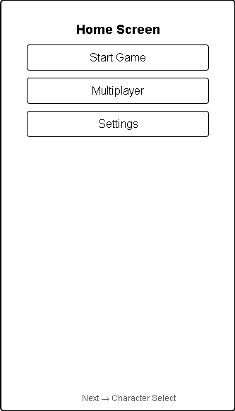
Figure 1 Home Screen

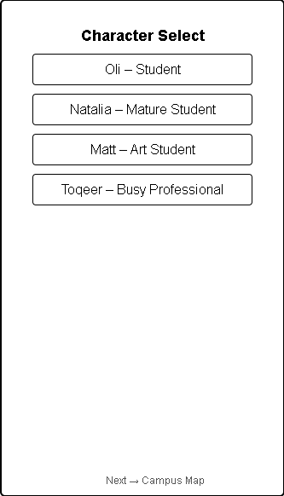
Figure 2 Character Select Screen

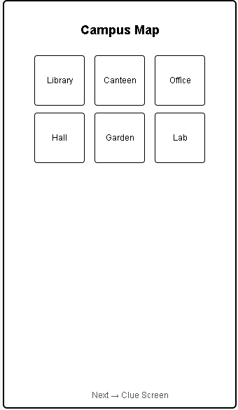
Figure 3 Campus Map Screen

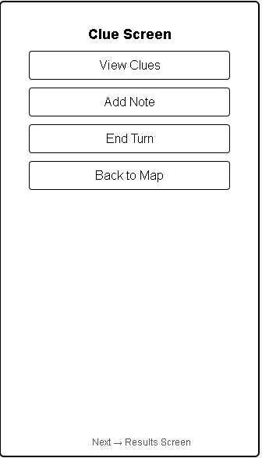
Figure 4 Clue Screen

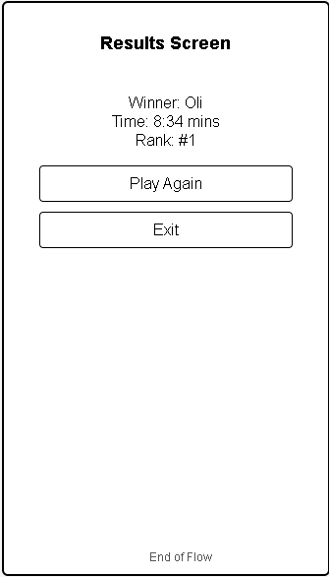
Figure 5 Results Screen

Screen Flow Description
The wireframe storyboard demonstrates how users move through the main stages of the game.
Home Screen
The player begins here and can choose to start a new game, join a multiplayer session, or access settings. Selecting Start Game takes the user to the Character Selection screen.
Character Selection
Players pick a character such as Oli, Natalia, Matt, or Dr Nassir. Once a character is selected, pressing Continue opens the Campus Map.
Campus Map
The map shows different UWTSD locations, including the Library, Canteen, Office, Hall, Garden, and Lab. Tapping a building loads the related Clue Screen for that area.
Clue Screen
Here, users can view or add clues, make notes, and end their turn. Choosing End Turn or Back to Map returns them to the map or advances the next player.
Results Screen
Once the mystery is solved, results display the winner, time taken, and ranking. Players can choose Play Again or Exit to finish the session.
This flow illustrates the main user journey through the app and how each screen connects logically to the next.

D. Feedback Collection Process on Storyboard Design
Feedback on the wireframe storyboard was collected from four participants who represented the personas developed earlier: Oli, Natalia, Matt, and Toqeer. This ensured that a wide range of users were included — from casual students and mature learners to a visually impaired user and a busy professional. Testing was carried out both in person and online using shared screens and mobile devices, allowing participants to explore the prototype naturally.
Each participant was asked to complete short navigation tasks such as starting a new game, selecting a character, and locating a clue. While completing these tasks, they described what they found clear, confusing, or interesting. Notes were taken on usability issues, as well as on participants’ emotional reactions to the design.
Positive feedback included appreciation for the simple layout, consistent button design, and logical flow between screens. Several participants said that using real UWTSD locations made the game “fun and familiar.”
Negative feedback focused on text size, a lack of visual indicators for progress, and limited instruction for multiplayer use.
Emotionally, all participants responded positively, saying the game felt “engaging” and “easy to follow.” These responses mostly matched expectations, though the demand for clearer multiplayer instructions was more frequent than anticipated.
Future improvements will include larger text spacing, stronger visual cues for game stages, and a short onboarding tutorial for new players. In later stages, features such as achievements, sound effects, and campus-themed mini-games could be added to enhance replay value and immersion.

Conclusion
This report has outlined the initial design and research process for the UWTSD Cluedo mobile game. Through user research, personas, usability analysis, and early wireframes, the project has shown how user-centred design can guide a clear and inclusive interface. Each persona helped shape different design priorities, from accessibility and readability to fast loading and mobile-friendly navigation. The use of established usability principles from Nielsen, Norman[7], and WCAG guidelines ensured that the prototype focuses on clarity, feedback, and accessibility. Early feedback confirmed that users found the concept fun, easy to understand, and relevant to university life. The next stage of development will involve creating a high-fidelity colour prototype with improved visual design, accessibility options, and expanded multiplayer functions. Overall, this project demonstrates how thoughtful design and real user input can lead to an engaging, inclusive experience that represents the identity of UWTSD.

References

[1] D. A. Norman and J. Nielsen, “Gestural interfaces,” Interactions, vol. 17, no. 5, pp. 46–49, Sep. 2010, doi: 10.1145/1836216.1836228.
[2] D. Bittner, F. Hauser, F. Engl, and J. Mottok, “Eye Movement Modelling Examples on Usability Heuristics,” in Proceedings of the 6th European Conference on Software Engineering Education, New York, NY, USA: ACM, Jun. 2025, pp. 106–114. doi: 10.1145/3723010.3723035.
[3] A. R. Paradinha, B. Marques, S. Kongeseri, L. V. Costa, and S. Silva, “Exploring the Interaction with Seamless Panels: A Look Into Discoverability, Navigability, and Feedback,” 2025, pp. 320–339. doi: 10.1007/978-3-031-93835-1_20.
[4] C.-S. Lee, Sue-Lyn, and L. Yeap, “Testing Anchors, User Experience and Usability Among 4 Game Elements in a Kindy Immersive Augmented Reality Game,” 2024, pp. 154–167. doi: 10.1007/978-3-031-65343-8_10.
[5] T. Chatziemmanouil and C. Katsanos, “Accessibility Academy: Interactive Learning of the WCAG 2.1 Web Accessibility Guidelines,” in 2024 IEEE Global Engineering Education Conference (EDUCON), IEEE, May 2024, pp. 1–7. doi: 10.1109/EDUCON60312.2024.10578915.
[6] A. J. Mangtani, “Storyboarding Fundamentals,” 2024, pp. 435–455. doi: 10.1007/979-8-8688-0416-8_8.
[7] M. Meyerhoff Nielsen and L. N. Barbosa, “Ensuring online usability and value: A comparative analysis of the design standards, criteria and governance models in Denmark, Portugal, and the UK,” in Proceedings of the 17th International Conference on Theory and Practice of Electronic Governance, New York, NY, USA: ACM, Oct. 2024, pp. 237–245. doi: 10.1145/3680127.3680217.
[8] C. Ryngaert and M. Taylor, “The GDPR as Global Data Protection Regulation?,” AJIL Unbound, vol. 114, pp. 5–9, Jan. 2020, doi: 10.1017/aju.2019.80.

Appendices

Appendix A. MoSCow Prioritisation

Priority | Requirement | Description / Justification
Must Have | Clear navigation | Simple menus so players can move easily between screens.
 | Accessibility options | High contrast, adjustable text size for visually impaired users.
 | Multiplayer mode | Allows up to 8 users to play together on campus theme.
Should Have | Audio feedback | Sound cues when finding clues or finishing a turn.
 | Save and resume feature | Lets players pause and return later.
Could Have | Campus Easter eggs | Hidden references to real UWTSD locations.
 | Leaderboard | Encourages friendly competition between players.
Won’t Have (yet) | 3D animations / voice acting | Deferred for later development to keep prototype simple.

Appendix B. User Questionnaire and Summary
Participant Information and Consent
Purpose of this study
You are being invited to take part in a short online questionnaire as part of a university project for the Usability Engineering module at the University of Wales Trinity Saint David. The aim is to gather opinions about mobile game design and user experience for a prototype called UWTSD Cluedo.
Voluntary participation
Participation is entirely voluntary. You may skip any question or withdraw at any time before submitting the form.
Anonymity and confidentiality
No names, student numbers, or contact details were collected. All responses remain anonymous and will be used only for academic purposes.
Data protection
Responses were collected through Google Forms and stored securely. Data will be deleted after assessment in accordance with GDPR and the University’s data-protection policy[8].
Consent
By completing the form, you confirm that you have read this information and agree for your anonymous responses to be used for this academic project.
UWTSD Cluedo – Online Questionnaire
Platform: Google Forms
Distribution: Shared with UWTSD students and Friends via WhatsApp
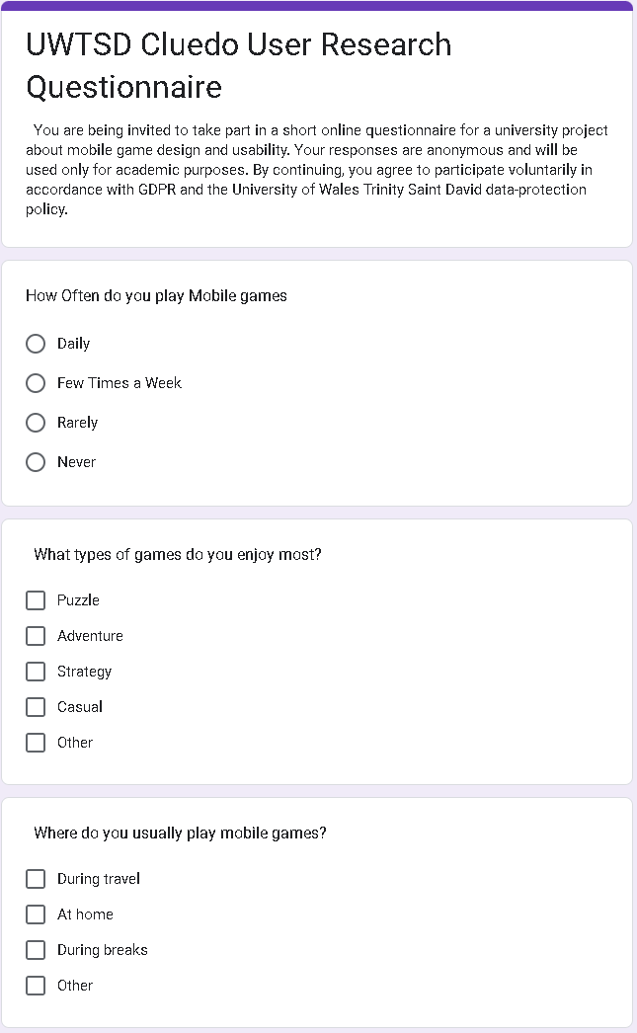
Figure 6 Google Form Introduction And consent

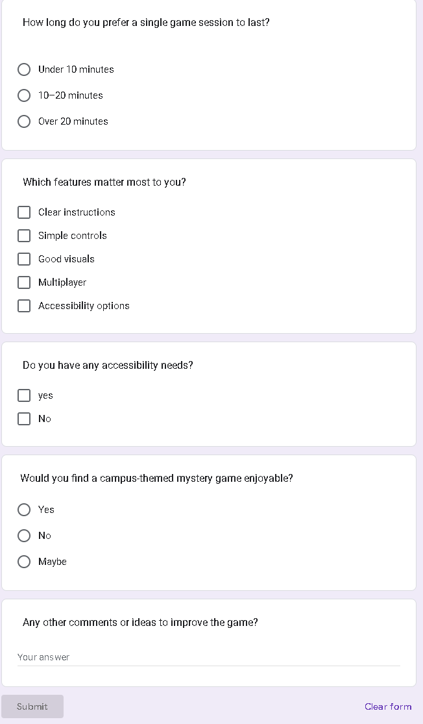
Figure 7 Google Form Questions and Submission page

Questionnaire Summary (Findings)
Participants: 6 respondents (4 students 2 Friends)
- 5 of 6 prefer short, casual gameplay under 15 minutes.
- 4 of 6 mostly play on mobile devices.
- 3 of 6 mentioned accessibility as important (contrast and font size).
- 5 of 6 liked the idea of a UWTSD-based mystery game.
- Common suggestions included simple navigation and a multiplayer option.
These responses were used to shape the user personas and to prioritise requirements in the MoSCoW table (Appendix A).

