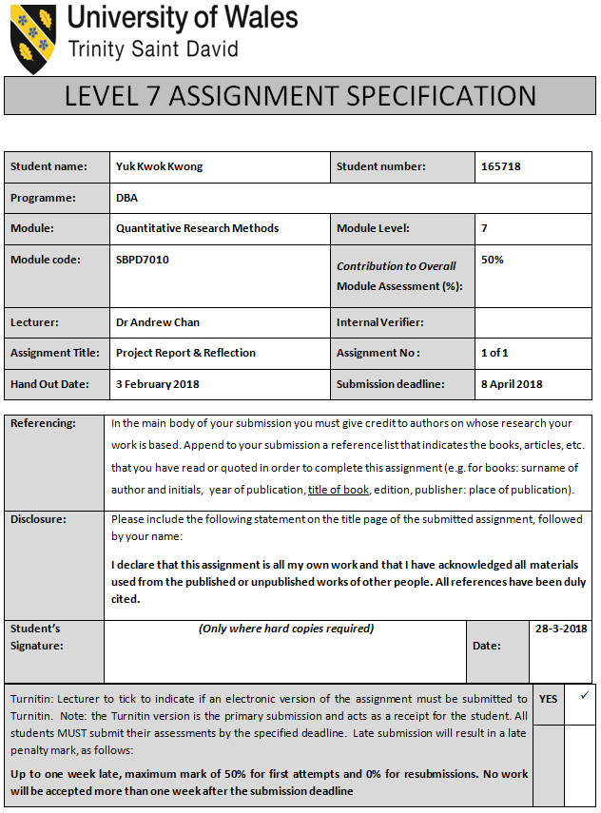

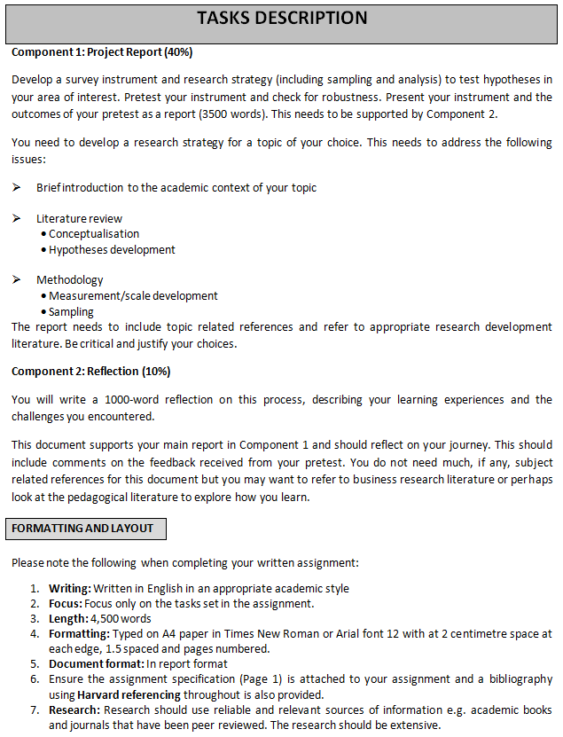

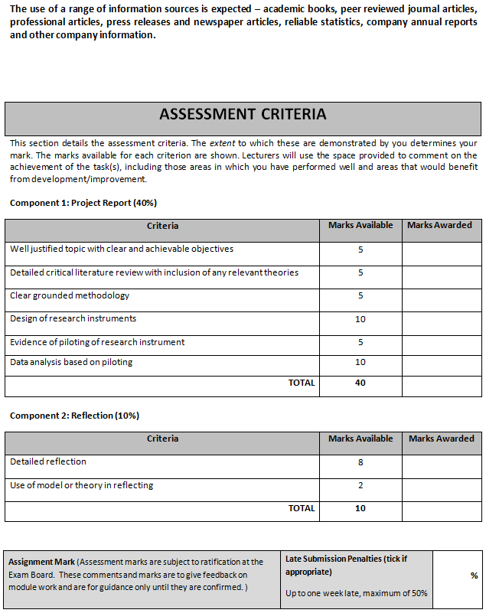

Name or ID Number: Yuk Kwok Kwong, Alex
Word Count: 1062 words
Reflection report
(Excluding word count of references, tables, diagrams & survey forms)
Student I.D. No.: 1605718

I declare that this assignment is all my own work and that I have acknowledged all materials used from the published or unpublished works of other people. All references have been duly cited.

Reflection

For this reflection, it is necessary to integrate a specific model or theory that would allow writing in a structured and comprehensive way. In this regard, Gibbs' Model has been integrated, which comprises elements such as initial experience, description, feelings or reactions, evaluation, analysis, general conclusions, specific conclusions, and personal action plans (Ely & Scott, 2007). The use of this model in this reflection writing enhances its meaningfulness.

The proposed research relating to the evaluation of the impact of ethical standards in the supply chain management of textile organizations on the consumer buying decisions has provided a significant knowledge to me about the issue. I would like to reveal that before conducting this research proposal, I was not sure about the suitable issue of research that would be conducted. I was confused about many topics and issues. I actually wanted to conduct a research that is highly relevant to the modern social issue. I have done extensive researches by using Google search engine and Google scholars to identify articles that would suggest the best issue related to the research for me. I have identified some of the articles and e-books that suggest about the ethical issues in the organizations that significantly influences its stakeholders. I have decided that this is the best area to research; however, I have also realized at that time that it is an extensively large area of research. I realized that I could not cover all the stakeholders in details. I then attempted to narrow the research issue. I realized that customers are the most important stakeholders from the perspective of any business organization, as they directly provide them the needed profit. Moreover, none of the business organizations would like to dissatisfy its customers from the operation it conducts. Thus, it was interesting for me to know and further research how an organization conducts unethical practices, as it would dissatisfy its customers. Thus, I confirmed that this is the best area of research for me.

However, after conducting further research on the issue, I have again realized that this selected area of research is extremely vast. I further identified that the organizations of varied industries have extensively different ethical issues. For instance, I found that the ethical issues in the Information Technology (IT) sector are widely different to that of an organization in the manufacturing industry. Thus, I have again researched and identified from various articles and news reports about the persistence of ethical issues within the textile industry. I also recognized that the ethical issues in this industry have been from its inception, which was centuries back. The industry also witnesses a wide range of ethical issues relating child labour, human rights violation, environmental exploitation, corruptions among others.
Further research also lets me know that there are various ethical standards, policies, and regulations implemented in various nations, yet the issue still persists to the present day. Thus, I have finally realized that this is the most suitable area of research. I have then prepared a brief proposal and showed it my tutor to confirm that if the area of research is appropriate. My tutor was satisfied with the selected research issue and further conveyed that it is a good area and expects good effort from me.

I was motivated after hearing my tutor’s response and then started the proposal part. I have identified few of the proposal samples from the internet and my seniors so as to gain good knowledge about the appropriate writing of the proposal. Correspondingly, I have done some of the background research on the issue. I was then able to frame the specific research question for this proposed study. This was to conduct the study in the most appropriate way. Subsequently, I have framed the research aim along with its objectives. I have also realized that the research objectives are to be framed, as it would ensure conducting a comprehensive study on the issue. Subsequently, based on the research objectives, I have done extensive secondary research and collected many related information, which is systematically presented in the brief literature review of the proposal report. I have also understood the need for collecting information credible secondary information. I have used some of the search terms such as ‘ethical standards’, ‘apparel, and textile industry’, and ‘consumer buying decision’. After using these search terms in the Google search engine and Google scholars, many articles were identified. However, I have used only those articles that were collected from credible databases, and sources such as Wikipedia, Blogs, and social media websites were strictly avoided. I have then again filtered the search results by avoiding the articles that were published prior to 2008, which is mostly to ensure that the information gained is relevant to the modern day context. Correspondingly, I have then read all the articles and used the relevant information at appropriate places in the brief literature review of the proposal, which is highly aligned to the research objectives.
The conducted literature review supported in establishing a conception based on which some of the hypotheses are developed. To test the framed hypotheses, I realized that it is crucial to determine a specific methodology. I believe quantitative analysis through correlation and regression would be appropriate to test the hypotheses. In this regard, I also understood that I need to collect primary data through questionnaire survey from the workers and consumers of the industry. I also realized that it is not feasible to collect primary data from all the textile organizations in the world. Hence, I have further narrowed the research to three organizations, which are A W Hainsworth, Arville, and Blackburn Yarn Dyers Ltd.

For collecting primary data through the survey, I also realized that I need to prepare a questionnaire. Moreover, to test the appropriateness, reliability, validity, and relevancy of the questionnaire prepared, I have conducted a pilot test with 5 respondent workers of each of these organizations along with 10 consumers in the UK. I have further conducted Cronbach’s Alpha tests using the data obtained from the survey and the values suggested that the questionnaire and its outcome are extremely reliable. I am now eager to conduct the proposed research after the approval of the proposal report. I strongly believe that with the guidance of my tutor and my tremendous effort, I would be able to conduct the proposed research in the desired way.

