A Handbook for Early Years Guidelines for
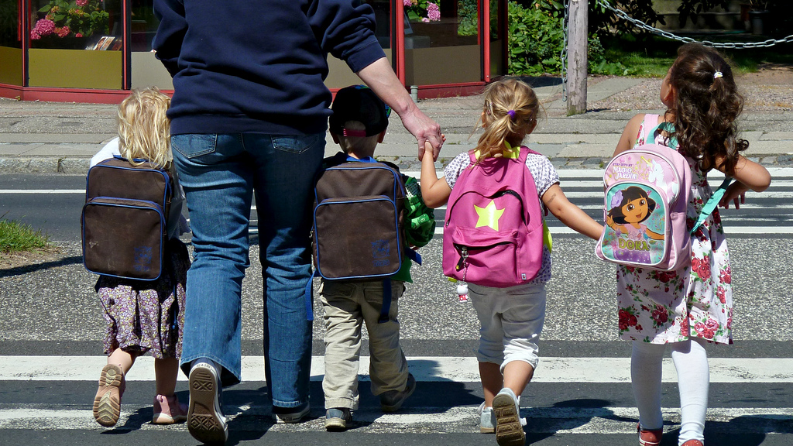
Transitions.
This Photo by Unknown Author is licensed under CC BY-NC-ND

Contents

Section 1: Introduction 3
Aims
Importance of transitions
Section 2: Transitions 4
The unique child

Section 3: keyperson 5
Explanation of a keyperson 6
7 Section 4: Parents\guardians 8
9
Section 5 Sharing information for effective transition 10
Helpful questions for practitioners 11
Section 6 Transition 12
Activities
Visits
Events
Some examples of transition activities and visits 13

References 14

Section 1
Introduction
It is recognised that babies and children over a period of eight years’ experience numerous transitions in their lives, varying from roles and expectations to learning and social groups. (Vogler et al.2008).
There are many meanings to the term transitions that cannot be defined in one definition. Research in Early Years transitions highlights that this is a time which incorporates developmental and immense change which effects social and formative learning transitions. An example of early developmental transitions is a baby going from milk to solids, from crawling to walking. Introducing a sibling to a new baby in the family, meeting new people in social environments such as playgroups and more formal setting such as school.
Every one of these transitions influences the outcomes and wellbeing of the child, states (Vogler et al.,2008).

Aims
This handbook offers guidelines to help early years practitioners encourage, support, accomplish children and their families with ease into a successful, gentle, seamless transition into a formative educational environment.
This handbook will focus on the transition into a nursery\ reception setting within the school. Most schools strive to have a procedure in place to achieve a smooth positive transition.
During these steps the requirements and involvement of the children and their families are well-thought-out during the planning by the early years setting in the school. (Kirklees council 2013).

Importance of transitions
According to (seamless transitions) when a child starts school it is a minefield of emotions, not only for the child but for the parents/guardians. It is imperative that children and parents/guardians feel confident it will be a positive and effective transition.
Children, parents /guardians need to start to establish and develop a relationship with the practitioners and school especially the key person. On doing this, it will help to establish that the children develop and progress the desired outcomes of their future school environment.

Section 2
Transition
The unique child.
Every child is unique, and this must always be excepted, considered and respected in a quality transition. A child learns constantly and with a good quality transition this can enable to help develop the child to be resilient, feel secure, skillful, confident and self-assured. All children mature and develop at their own personal speed and in their own individual ways. (every child matters 2011)
It is important to be inclusive that children no matter about their cultural background, gender or disabilities are respected and valued, that children and their families are not discriminated against. Practitioners need to learn to embrace diversity to improve on their own knowledge and understanding on children who are different. Children are vulnerable they need to feel safe and secure for their all-round wellbeing whoever they are and wherever they come from in life. (every child matters2011).
Article 2 (Non-discrimination): The Convention applies to all children, whatever their race, religion or abilities; whatever they think or say, whatever type of family they come from. It doesn’t matter where children live, what language they speak, what their parents do, whether they are boys or girls, what their culture is, whether they have a disability or whether they are rich or poor. No child should be treated unfairly on any basis. (UNICEF the rights of the child)
Transitions are very individual, what works for one child may not be right for another. A Key Person will play an essential role in any transition (Supporting children’s transitions across the early years foundation stage,2012.).

Section 3
Keyperson
When the child starts in an early years setting it is sometimes common practice that a key person is assigned to the child to keep records, observe and help the child attain outcomes. This is important, but it is not the same as a key-person role. Children develop their confidence and independence from an anchor of loving and secure relationship from the parents and\ or keyperson. (National strategies). Psychoanalysts believe and agree that it is paramount to a child’s wellbeing that a special bond needs to be created. This is recognized as Attachment theory; John Bowlby has used this in his work and he explains that the child needs this for their emotional stability. (Early years foundation forum). Attachment plays a major part on a child’s all-round development and future relationships. (Early years matters.) It is beneficial that children experience positive and caring early attachments, from which they can develop and build their confidence and independence. (Mickelburgh J.2017) John Bowlby described attachment as ‘the bond which ties’ (Svanberg, p.6 cited by Mickelburgh J.2017).
Can you think of a situation as an adult where you are starting a new job or a student beginning a course, how you would feel relieved there was a person there to be your point of contact, encouraging and supporting you to help you settle in and making you feel confident and secure in your new environment. This is what a key person is undertaking in an early years setting. (National strategies, 2008).
The key person is the voice of the child. Article 12 (Respect for the views of the child): When adults are making decisions that affect children, children have the right to say what they think should happen and have their opinions taken into account. This does not mean that children can now tell their parents what to do. This Convention encourages adults to listen to the opinions of children and involve them in decision-making -- not give children authority over adults. Article 12 does not interfere with parents' right and responsibility to express their views on matters affecting their children. Moreover, the Convention recognizes that the level of a child’s participation in decisions must be appropriate to the child's level of maturity. Children's ability to form and express their opinions develops with age and most adults will naturally give the views of teenager’s greater weight than those of a pre-schooler, whether in family, legal or administrative decisions. (UNICEF, The Rights of the child).
Explanation of a key person
- A staff member who is more involved with one particular child more than any of the others in the setting.
- A staff member who develops a relationship with the child and their parents.
- A staff member who encourages the child to explore and feel secure in their setting.
- A staff member who supports and helps the individual requirements of the child (e.g. Going to the toilet, dressing themselves).
- A staff member who is a sympathetically aware to the children’s emotional state, thinking and demeanour.
- A staff member who coordinates and communicates with parents.
(Julian Grenier, Peter Elfer, Julia Manning Morton, Dilys Wilson and Katie Dearnley.Kent county council. 2012).
Provides an anchor for their key children to feel secure to discover the setting away from them.
Develops a connection with parents\guardian.
Physically and emotionally there for them.

Answers sympathetically to key children’s moods and concepts.
Offers eye contact, body language and a supportive voice to let key children recognise they are interested.
Keyperson

Has more contact than others with the child and is a point of contact for parent\guardian.
Settles in new key children in slowly enabling them to become acquainted with the setting and supports their arrival and departure daily.
Implement and provide the developmental and learning environment for the key children in their care.

Implementing a key person method needs thoughtful planning and to involve all members of the early years nursery\reception team including the allocated keyperson, prior to and during the meeting with the parents\Guardian and the child. A strategy needs to be put into place if there is absence of the assigned key person that a suitable additional keyperson who is familiar with the child and their family can take over if required giving reassurance to the child and parents\ guardians.

Discussed should be an agreed settling in period, sharing information on the child for example, likes\dislikes, family members, friends, interests, any concerns they have about the child or any additional learning or physical needs of the child, opportunity for the parents to ask questions regarding curriculum, class routine, how they can prepare their child for school and any additional apprehensions. An Opportunity to arrange taster sessions will be agreed during this time for the child and the keypersons involvement will increase helping develop a strong link to the nursery\reception setting for parents\guardians and child. The keyperson will be a port of call at the end of the day to liaise with the parent\|guardian.

This arranging of a key person starts to build a positive relationship with the parents\guardians and the child, beginning to develop an attachment with the keyperson but not replacing or affecting the attachment to the parents\guardians. Therefore, benefitting the child in the transition process consequently helping to aid a good transition into an early years setting. (Mickelburgh, J.2011)

Section 4
Parents\guardians

Parents\guardians have a significant part to play in the transition procedure ensuring their child is contented and happy with this transition into a formative education setting. Involving parents\|guardians from the very beginning in the child’s transition process by introduction to school life is paramount, as it is the start of a good foundation for a future relationship between staff, school and the parent\guardian. They will be starting to trust, support, school and staff on decisions made for their child’s long term best interest and this will gain mutual respect. (Kirklees,2015).
There is a necessity to understand that during the child’s first phase in life the parents\guardians are their children’s primary educators and have a wealth of knowledge on their child, this information needs to be shared by the early years team to understand everything about the child, helping for a smooth transition. Listening to the parents\guardians will tell us about their culture, language, community and neighbourhood if we are to offer them familiar sights, sounds and experiences that will help their child settle. Sending a child to a new setting or class can be a frightening experience for parents\guardians and children. Lots of parents \guardians taking their children to school for the first time perhaps will have unfortunate recollections about their first days at school and feel threatened by the entire experience. It is imperative that empathy is shown and to make it a warm, friendly, happy, relaxed environment and by doing this it will put the parents\guardians at ease thus influencing their children that school is not so frightening. (central Bedfordshire county council)
How do practitioners communicate to parents\guardians who are bilingual?
Do parents have opportunities to visit school with their child?

Are there taster days for the child to attend and are there a limit?
Would some children benefit to more visits?
Are parents given time to ask questions and time given to respond?
Can all staff communicate with the child and their family?

Is data shared with parents in an appropriate, available system?

By finding out about the child and the family, you have a better understanding how to settle the child into the early years setting. Maslow’s Hierarchy of Needs suggests a simple, clear and resonant description for why children fail. The child has four deficiency needs must be fully met before the child is in any condition to benefit from his school experience. The child requirements are to eat a nutritious diet, to feel warm, a dependable household, and a sense of security before the child can to begin to allow the mind to be permitted to learn at school. Knowing the background of the child and their family helps a better understanding on how to respond and engage the Childs approach to the learning environment (Minton, B.L.2008)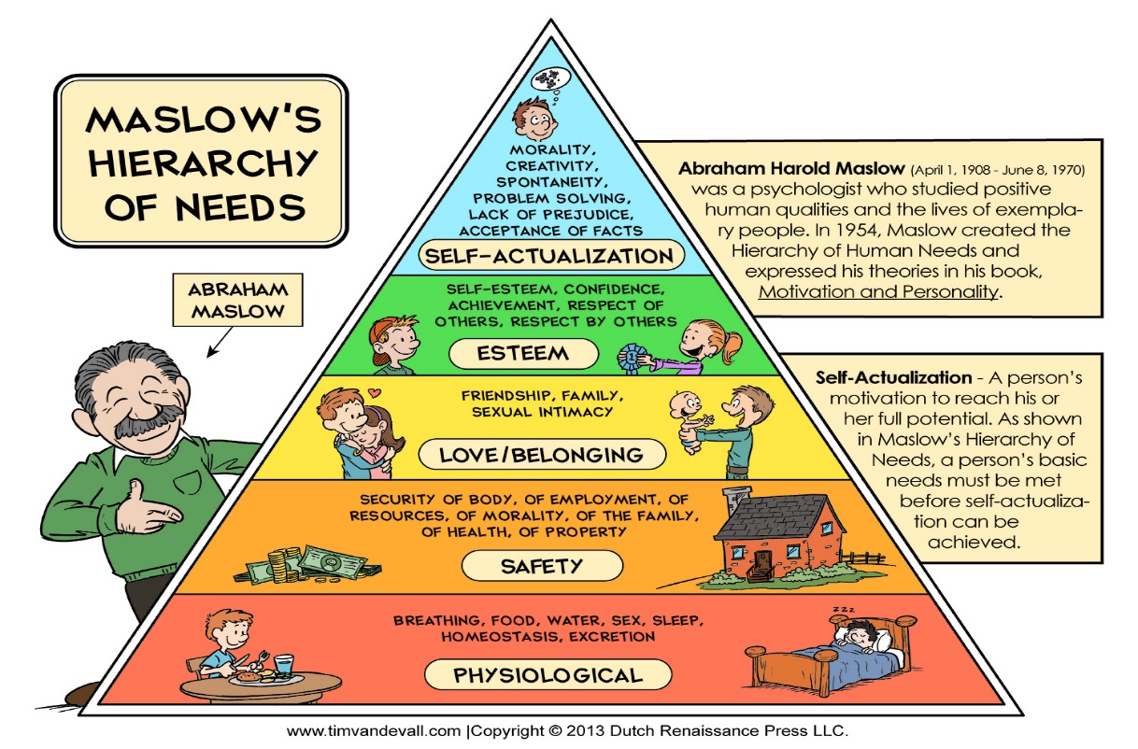
This Photo by Unknown Author is licensed under CC BY-SA

Section 5
Sharing Information for effective transition

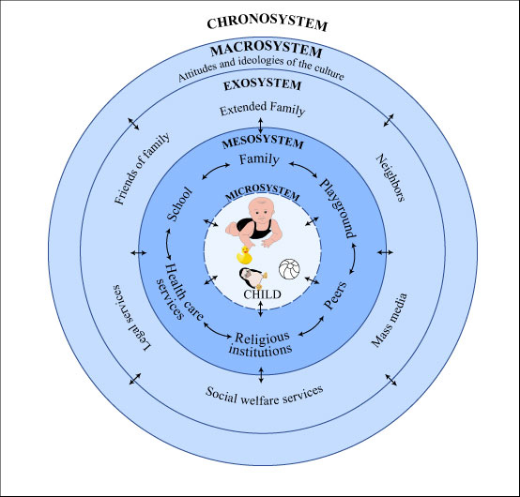
This Photo by Unknown Author is licensed under CC BY-NC-SA

Urie Bronfenbrenner developed the ecological systems theory to clarify in what method everything in a child and the child's setting marks in what way a child grows and develops.
He categorised different parts or stages of the environment that impact on children's development, including the:
- Microsystem. is the immediate environment the child lives in parents\guardians, school.
- Mesosystem. how the different parts of a child's microsystem work together for the sake of the child.
- Exosystem. The child may not relate with frequently but that still have an influence on the child’s life, where parents work, the neighbourhood\community etc.
- Macrosystem. largest and most remote set of people and things to a child but which still has a great influence over the child. Such as government, war etc. (Oswalt, A.2015)

It has become clear how this information contributes to aid the child into a smooth and successful transition when all the information and effective communication is given on the child and how Bowlby, Bronfenbenner, and Maslow theories have an impact on effective practise in the early years environment.
Pre-schools and schools can have contradictory methods to early years education, largely owing to variances in establishment, buildings, ratios, age and phase of the children. It is imperative that these differences are conversed agreeably and professionally. This will permit them to be measured and planned for so that children and families have a smooth transition practice. It is good training for settings to have a Transition policy that can be agreed and shared with the feeder schools. Including and distribution of data with parents\guardians which is a continuing expectancy particularly at this point of transition as it reinforces good practice. (Kirklees council 2013).

Helpful questions for practitioners
Is the child moving with children they know?
What is the child’s routine regarding snack times, lunchtimes, can they feed themselves independently?
Can they use the toilet facilities independently?
Are there any mobility issues?
Are schools aware of different styles and method to early years education to the rest of the classes in the school?
Is there known transition liaison manager within the school?
Are parent\guardians provided with clear information about the setting?
(Kirklees 2013).

Section 6
Transition
Activities
Transition activities help children and families ‘have opportunities to find out information about the new school and become accustomed with new routines and the staff who work in the early years setting. Early years practitioners acknowledged the main reason for not ensuring an effective transition procedure is an absence of communication and information about each other. This can be remedied by considerate shared link and the preparation of transition activities. (kirklees council 2013).
Most parents are initially anxious about the practical issues of when their child would begin and what they would need for school and familiarizing them with the class and the early years staff. Transition should be effective for children and parents\guardians and it is crucial to clarify that a registration has been made at the recognized school and there is a reserved place for that child. As it can be upsetting if children are visiting a school that they are not going to attend. (kirklees council 2013).
Visits
Introducing the child’s keyperson on the this visit and starting to establish a good relationship with the child by getting to know each other and the child’s family.
During the taster visits it is important for the child familiarize with the school buildings which can be daunting task for young children. In school settings the amenities can be strange and unfamiliar for children, the toilets could be in a different location to their classroom. There sometimes are larger outdoor areas shared with older children which can be quite intimidating for the young child. There is Lunch and snack times to get used to and if the child is hungry it can affect their concentration. All these considerations need to be taken into account as this will make the practitioner aware of the child’s needs. (kirklees council 2013).
Events
Include and invite new children to future events in the school such as fetes, disco productions and visits from firefighters, police etc. This will give them a sense of belonging and inclusion thus helping transition. (kirklees council 2013).

Some examples of transition activities and visits

- All about me\me in a shoe box\me in a bag. The child’s favorite things, photo of them as a baby, family pet siblings, drawing etc. Can then be shown on the child’s first day.
- Photo of new children in class setting in a collage that spells welcome.
- Photo of child and their keyperson, one in class and one they keep at home.
- Photos of various areas in the class and school, so they can get familiar to them and talk about them at home.
- Like and dislike photos\pictures.
- What makes them sad and happy photos\pictures.
- Arrange for the child to come to a teddy bears picnic at a local park or in school grounds.
- Arrange for the child to come to class during snack time.
- Arrange for the child to have lunch in school.
- Invite the child to a party in school.
- Invite the child to meet fire fighters, police officers and the local lollipop person. (kirklees council 2013).

Early years matters states:
Getting transition right is vital for every child and is not a single event that merely ‘happens’. Transition should be viewed as a process rather than an event that involves children, practitioners and parents together. Transition has been described as an ongoing journey rather than a destination. (Early years matters,2017).

References
Central Bedfordshire council-smooth transitions in the early years: a good practice. [online]. Available at:http://centralbedfordshire.gov.uk/Images/transition-guidance-pack_tcm3-15239.pdf(accessed 2 november2017)
Chooschoos. supporting children’s transitions across the early years foundation stage. The keyperson in reception classes and small nursery settings. Kent county council2012. [online]. Available at:http://www.choochoos.co.uk/wp-content/uploads/2012/11/Transitions-booklet.pdf(accessed 30 October 2017)
Mickleburgh,J.(2011)’personal, social and emotional development’. Early years foundation stage forum. (21 January)no page no[online].Available at:http://eyfs.info/articles/_/personal-social-and-emotional-development/attachment-theory-and-the-key-person-approach-r64(accessed:22 October 2017).
The early years foundation stage. Every child matters.2017. [online].Available at:http://www.earlyyearsmatters.co.uk/wp-content/uploads/2011/03/eyfs_unique_child_incl_prac1.pdf(accessed1 november2017)
Primary national strategy. Seamless transitions. Supporting continuity in young children’s learning.2011[online].Availableat:https://www.foundationyears.org.uk/files/2011/10/Seamless_Transition.pdf(Accessed22october).
Oswalt,A.(2015)mentalhelp.net.Uri Bronfenbrenner and child development.[online].Available at: https://www.mentalhelp.net/articles/urie-bronfenbrenner-and-child-development/(accessed 2 november2017).
Kirklees council, Kirklees guidance for transitions in the early years.2013.[online]Available at:https://fixby.org/kgfl/primary/fixbypri/web/early-years-transition-guidance-booklet-2013.pdf(accessed15 October 2017).
Minton,B.L.(2008)Maslow’s Hierarchy of needs. Why some children fail (Monday September 15)[online].Available at:https://www.naturalnews.com/024190_child_children_WHO.html(accessed 2 November 2017).
Uri Bronfenbrenner ecological system theory. Image. [online].viewed 2 November. 2017,<https://c1.staticflickr.com/5/4036/4494585596_9b70e2d3ed_z.jpg>
Maslow’s hierarchy of need. Image. [online].viewed2 November 2017,<http://www.timvandevall.com/wp-content/uploads/2013/11/Maslows-Hierarchy-of-Needs.jpg>
Vogler, P. Crivello, G. Woodhead, M. (2008) Early childhood transitions research: A review of concepts, theory and practice. [online]. Working papers in early childhood. [online]Available at:http://oro.open.ac.uk/16989/1/Vogler_et_al_Transitions_PDF.DAT.pdf(accessed 28 0ctober 2017).
UNICEF. The rights of the child. [online]. Available at: https (accessed 1 november2017).
Image. [online]. viewed 2 November 2017. <http://momitforward.com/wp-content/uploads/2012/09/Kids-going-back-to-school.jpg>

