Assessment 2 Coursework
(Written Report)

Data Handling and Business Intelligence
(LCBB5000)

Carmen Marilena Tirziu
(2021003)

Word count:
Part 1: 1764 words
Part 2: 1400 words

Table of Contents
PART 1 3
Introduction 3
Analysing and visualising data with the use of Excel 3
Excel in Business Intelligence 8
PART 2 9
1) How many students like vanilla flavour? 9
2) How many students are male and female? 10
3) What are the Mean and Median of participants who like chocolate and strawberry flavour? 10
a) Data clustering and K-means 11
b) Data and text mining methods 15
c) Excel and SPSS 15
Conclusion 16

PART 1

Introduction

Business Intelligence is a collection of technology and techniques that people use to collect data, transform it into important insights, and then make smarter decisions. Business Intelligence specialists can easily work with data provided to them using Microsoft applications such as Excel. Excel includes essential data mining tools such as Pivot Tables and a plethora of functions that make data analysis easier. (Lancaster, 2020)

Analysing and visualising data with the use of Excel

We can more easily visualise the data with the help of Excel functions, and with everything organised, we have a better chance of drawing the correct conclusions. Excel is simple to use for basic data analysis and calculations. Its functions are an excellent tool for visualising simple statistics with charts and graphs. Despite their widespread use and adoption, spreadsheets only address a small portion of a company's business intelligence requirements. (Shmueli, et al., 2005)

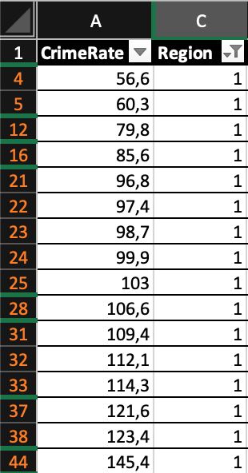
First off, we need to make the most out of the possibilities of this program. Starting off, we have the filter option and after applying it to divide the data we obtain the following information:
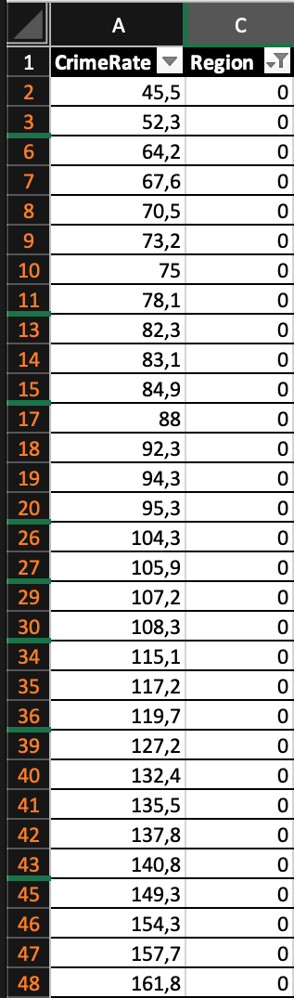

Crime Rate in the Northern region
(Source: Author)
Crime Rate in the Southern region
(Source: Author)

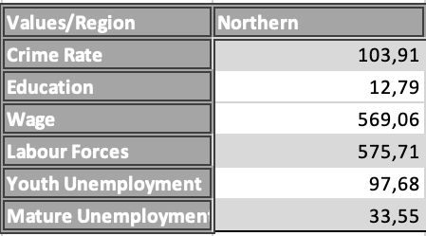
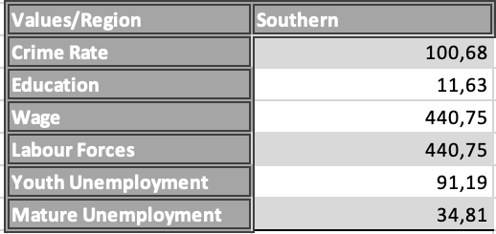
From here, we can use the average function and calculate the average crime rate, wage, and labour forces for the Northern and the Southern region.
Average values for Northern and Southern regions
(Source: Author)
There are numerous conclusions we can draw from the data we have previously provided after thoroughly analysing it.

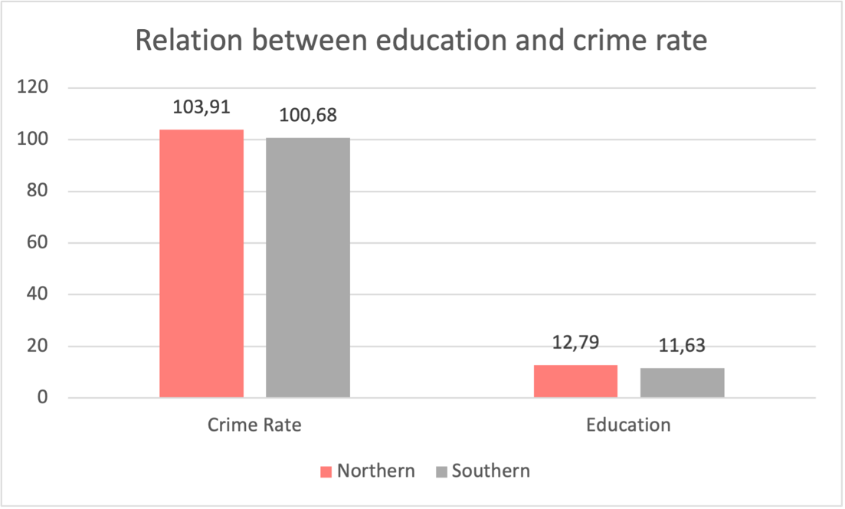

Relation between education and crime rate
(Source: Author)

The diagram provided above contains information on crime rates and educational levels. The challenges that organisations may face when it comes to data understanding are mitigated by Excel tools, which provide vital information. The diagram shows the high average crime rate for both the Northern and Southern regions. As the colourful columns in the graphic show, there is a strong possibility of a link between a lack of education (or a low level of education) and a high rate of crime. Based on the pattern, we can conclude that there is a relationship between the level of education and the crime rate. Indeed, the probability of the hypothesis being true emphasises this, valuing the fact that it is true for both regions.

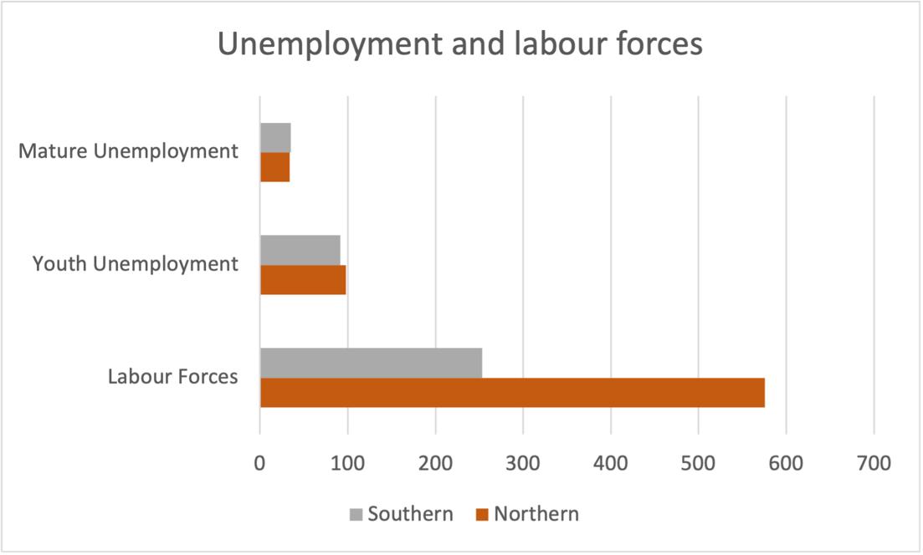

Unemployment and labour forces
(Source: Author)

According to the data provided in the initial document, we can better visualise the differences between the Northern and Southern regions in the graphic provided above. We're looking at the average rates of mature unemployment, youth unemployment, and labour force participation. With the help of comparison, we can best analyse this data. We can see how the average rates for both mature unemployment and youth unemployment are similar. It is obvious to see a high value that represents the labour forces in relation to the low rate of unemployment (in both teens and elders). However, there is a significant difference between the two values (in the Northern and the Southern regions). This can be caused by a variety of factors, and businesses should spend additional time investigating cases of such discrepancies.

Another common use for Excel is visualising data. It is certainly unpleasant and unhelpful as well to find specific data in a large set of columns. Excel provides the VLOOKUP function to find information in a large spreadsheet or if we are always looking for the same type of information. This function provides a region where we can find a value similar to the one we are looking for, based on the attribute we are enlisting. (Microsoft, 2022)

For example, we would like to see the area where a crime rate value has been recorded. We use the VLOOKUP value, and examples of its capabilities are provided below:

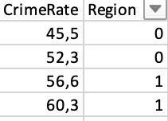

Various values for crime rate, in relation with their region
(Source: Author)
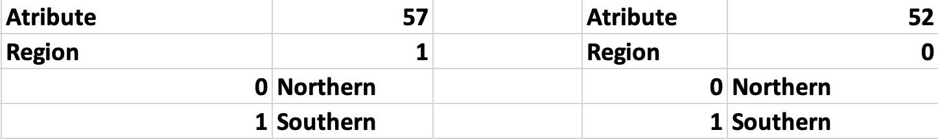

Practical usage for the VLOOKUP function of Excel
(Source: Author)

To test out the function and its practical uses, we have used it to find specific regions where an approximate value of the crime rate has been registered. This can also be done for exact values (such as prices). In the tables provided above we can see how when we have picked the value 57 from the crime rate, the program has approximated it to 56,6, therefore it has decided upon region 1 (the first two left columns). The same can be seen for the second example

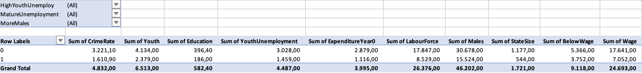
A PivotTable is a user-friendly tool for quickly summarising large amounts of data. A PivotTable can be used to analyse numerical data in depth and to answer unexpected questions about our data. A PivotTable is designed specifically for querying large amounts of data in a variety of user-friendly ways. In our case, we can use this Excel tool to calculate totals for the data provided, as well as quickly determine the percentages that each data represents from the total. (Lewis, 2022)

PivotTable with the data provided in Crime_rate_data.xls
(Source: Author)

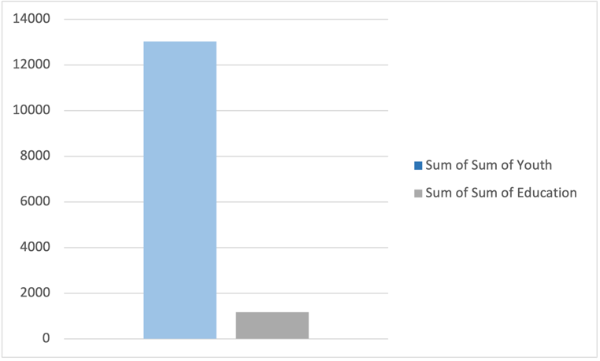
We can see values for total crime rate, youth, education, expenditure year, labour force, males, state size, below wage, and wage using the Pivot Table provided. The previous data is stored in a way that allows us to put it into tables and understand their impact on an organisation’s performance.
Youth and education values
(Source: Author)
Another great resource Excel has are the Pivot Charts. They rely on the information provided in the Pivot Tables. Pivot charts allow us to quickly analyse large amounts of summarised data in a variety of ways. Pivot Charts, unlike traditional charts, can plot data with hundreds or thousands of rows.

The Pivot Chart above shows a significant disparity between the two regions' levels of education and the value of youth. Analysing data would normally be much more difficult due to the large number of variables and information. Pivot Charts are examples of tools that can help us shorten and simplify the work we must do.

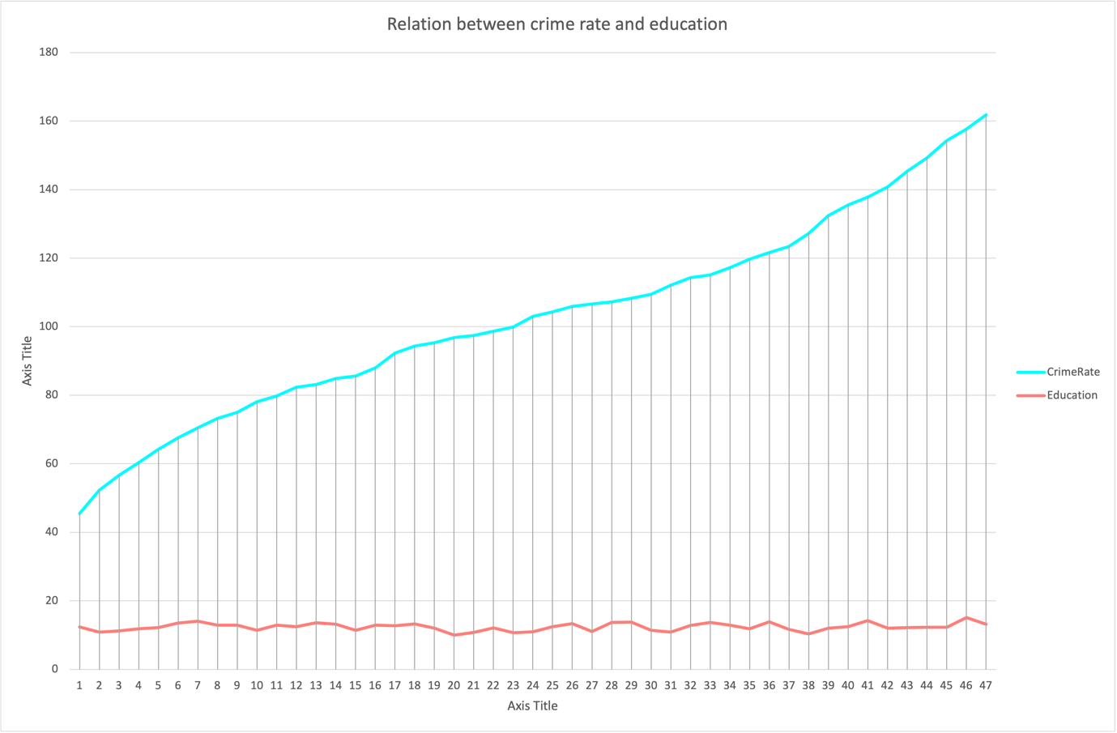

Relation between crime rate and education
(Source: Author)

One advantage of Excel is that it is very reliable and can provide multiple ways of visualising and analysing data, as well as key tools to do so, all with a single click. Here we can see some differences between the two graphics. The first one is overly simplified, whereas the second one provides more depth (in relation to all the data – the first chart presents the sum of all the data, whereas the one provided above breaks the data down into a detailed graph). This visual representation helps people understand the situation and helps us reach the correct conclusions through comparisons and multiple opinions we can discuss. We can see here that, despite the fact that education levels have remained relatively stable, the crime rate has skyrocketed to the present. Here comes the crucial factor of subjectivity into play, which can explain why we arrived at a different conclusion based on the graph provided above. However, we can see that there may be no correlation between crime rates and education in this case.

Excel in Business Intelligence

Analysts, reporting professionals, and Business Intelligence professionals are finding Excel more relevant for full-length implementations with the addition of features like Power Business Intelligence (Power Pivot, Power Query, Power View, Power Maps, and so on) that naturally integrate with Excel. (Alexander, et al., 2014)

Excel is a spreadsheet programme that is used to store, analyse, and report on large amounts of data. Accounting teams frequently use it for financial analysis, but it can be used by any professional to manage long and unwieldy datasets. In order to demonstrate the power and flexibility of everyone's favourite spreadsheet tool, we've provided a variety of ways that businesses could use Excel. Finance professionals know Excel like the back of their hands after decades of using it. (Boogaard, 2022)

First and foremost, as we have seen on previous pages, Excel is one of the best apps for creating charts. This category includes everything from pie charts and scatter charts to line charts, bar charts, area charts, and column charts. If businesses need to represent data in a more visual and digestible manner, Excel's ability to transform rows and columns of digits into beautiful charts is the best way to simplify mountains of data for accurate and to-the-point analysis.

Second, Excel has a plethora of useful functions that can make one's life easier. As we've seen before, the VLOOKUP function is a great way to find data in seemingly infinite spreadsheets of data. It is somewhat difficult to set up, but it is extremely reliable. We should also mention the AVERAGE function that this application has. We believe that this function is the best way of processing information that will be used in charts. It summarises data and aids in the formation of an opinion about an organization's average values and performance.

Furthermore, the Pivot Table and Pivot Chart options in Excel provide users with a very simple add-on that can calculate a variety of values and data, as well as assist with statistics. Users can choose how their information is displayed in Pivot Tables, for example, if they want to see exact percentages of the grand total, this function can provide it. Furthermore, Pivot Charts can be used to create a visual representation of the data stored. Pivot Tables can also be expanded to see the data that was used and valued in the calculations and operations that were performed.

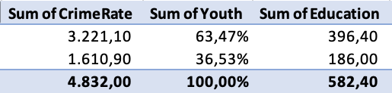

Different ways we can visualise data in Excel
(Source: Author)

Excel appears to be too good to be true, so it does have some limitations that we must discuss for our report to be competent and complete. The world is changing quickly, and companies that make good use of data are seeing growth. Finance professionals can additionally use business intelligence tools instead of traditional data analysis tools like Excel. Business Intelligence software allows you to automatically collect data, sort it, and extract meaningful insights to help their business succeed.

One of the first limitations of Excel that comes to mind is the limitation of file capacity. When it comes to handling large amounts of data, Excel is severely limited. For example, opening a spreadsheet file with too many megabytes or rows may result in an error message being displayed by the tool. To resolve this, you must divide the main file into smaller files, which may have an impact on data analysis. BI tools, on the other hand, can easily handle large amounts of data. With Bi software, you can quickly open a large file and get a comprehensive view of the data set. BI also makes it simple to combine and merge different data sets. (Whinnery, 2020)

Microsoft Excel is a global force to be reckoned with, with millions of users worldwide. This powerful spreadsheet tool is especially popular in the financial industry. For more than two decades, chief financial officers (CFOs) have relied on Excel for data analysis and visualisation. Based on what we've seen so far and the examples provided, we can conclude that Excel is an excellent programme for pre-processing, analysing, and visualising data. Despite some limitations in its capacity and ability to provide useful and easy-to-use charts when dealing with large amounts of data, Excel remains a useful tool that aids in the data processing process.

PART 2

1) How many students like vanilla flavour?

We can count the number of people who like vanilla, chocolate, or strawberry ice cream using Excel and the function COUNTIF, as shown in the table:

vanilla | chocolate | strawberry
95 | 47 | 58

These data points would look like this in a pie chart:

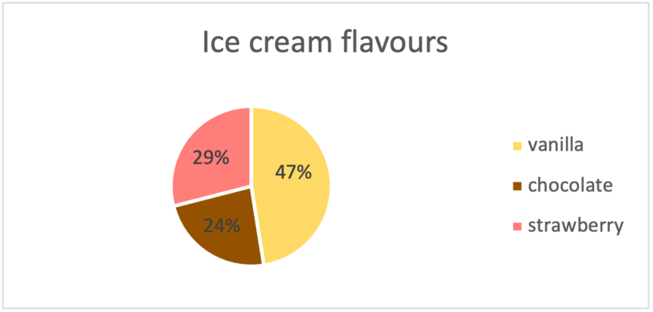
Ice cream flavours – Pie chart
(Source: Author)

We can clearly see from the pie chart and table above that 47% of the 200 students polled prefer vanilla flavour (95 students).

2) How many students are male and female?

We can count the number of male and female using Excel and the function COUNTIF, as shown in the table:

male | female
91 | 109

These data points would look like this in a bar chart:

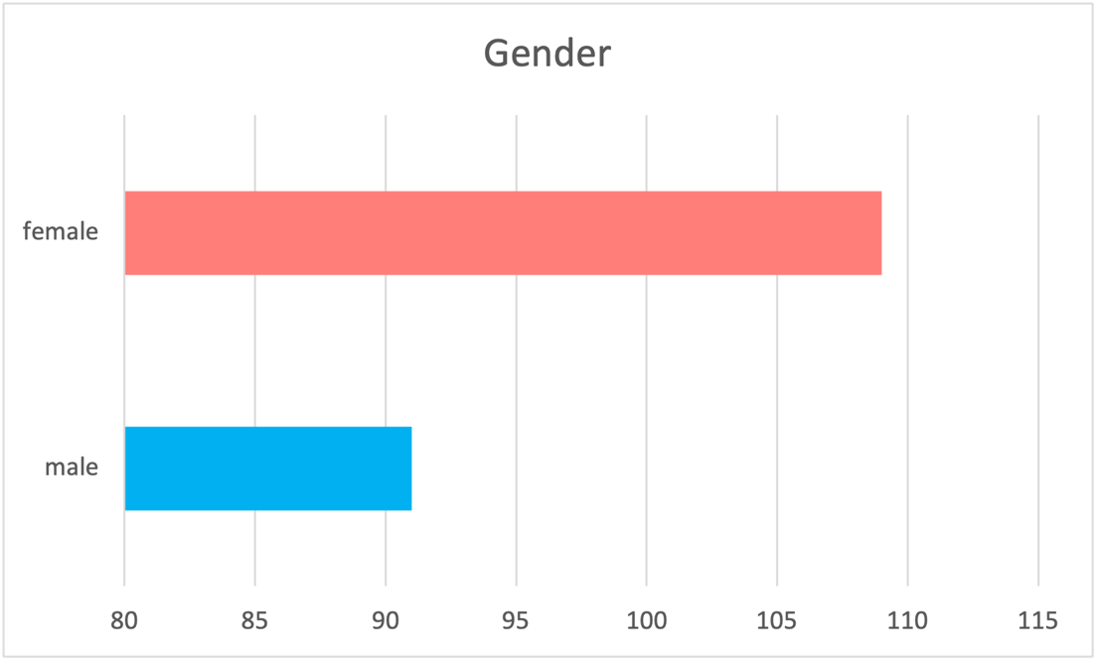

Gender – Bar chart
(Source: Author)

We can clearly see from the bar chart and table above that 91 of the 200 students polled are male and 109 are female.

3) What are the Mean and Median of participants who like chocolate and strawberry flavour?

We have the following data for participants who like chocolate and strawberry flavour.

Chocolate | strawberry
47 | 58

To find the Mean and the Median of these participants we will use Excel functions. First, we calculate the Mean using the AVERAGE function and then we determine the Median by the MEDIAN function provided by the same application. As result, we have:

Mean | Median
52,5 | 52,5

The data we have determined can be put into a bar chart, as it follows:

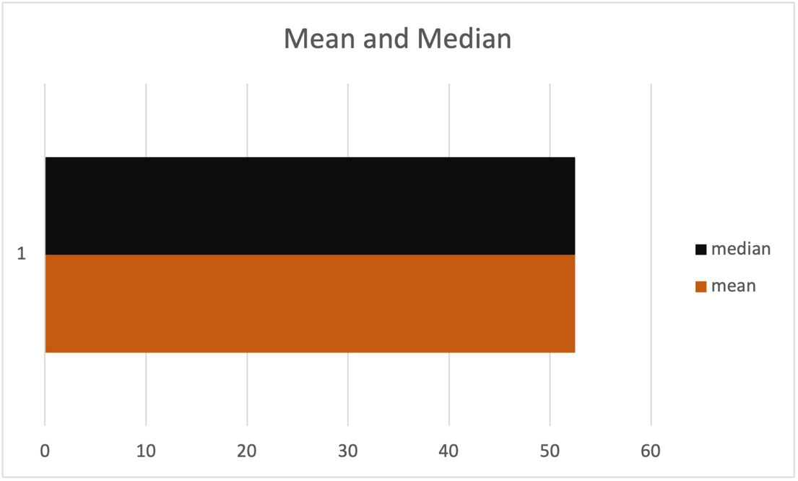

Mean and Median graphic
(Source: Author)

a) Data clustering and K-means

Clustering is the process of organising a collection of abstract objects into classes of related objects. Clustering (also known as cluster analysis) is commonly used to organise data into structures that are easier to understand and manipulate. K-means is a data clustering technique that can sort unlabelled data into a predetermined number of clusters based on similarities. (Aggarwal & Reddy, 2014)

To properly analyse and determine the merges of k-means cluster analysis, we must first provide ourselves with an estimate of the number of clusters in our data. SPSS is a programme that helps its users with data analysis, and one tool it provides is hierarchical cluster analysis. Hierarchical clustering, also known as hierarchical cluster analysis, is an algorithm that organises similar objects into clusters. The endpoint is a collection of clusters, each distinct from the others, and the objects within each cluster are broadly similar. (Bock, 2022) The hierarchical clustering will be used as an input for the k-means cluster analysis.

We must provide one essential rule in this method: Ward's strategy as a clustering method. It will aid us in creating more equal-sized clusters. If we use a different method, we may find groups with many responses as well as very small groups in our data, which is unhelpful.

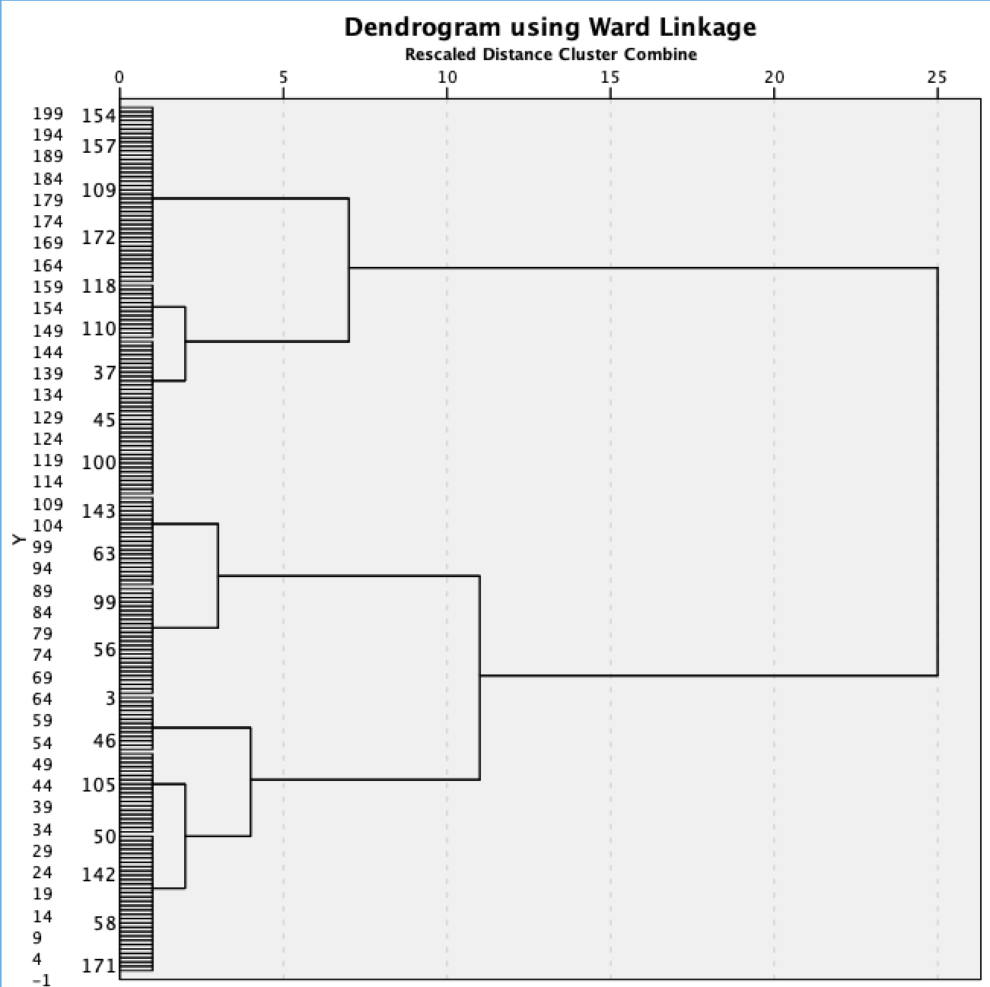

Dendrogram used to determine insight of k-means clustering analysis
(Source: Author)

In this case, we are using a Dendrogram to better visualise our data clusters (we should mention that we have reduced the proportions of the graph for it to fit well on the page). Based on the diagram above, we can conclude that our data can be stored in two larger clusters. The decision-making is purely subjective, and while some people may prefer to work with more clusters, the robust solution is to choose two large clusters.

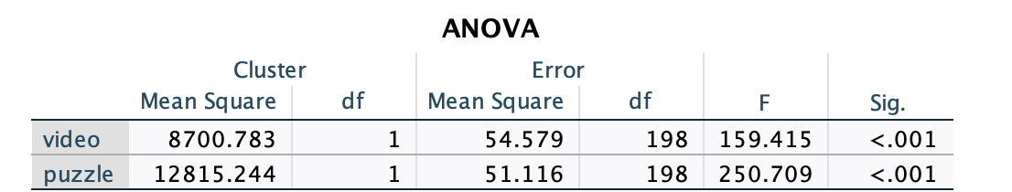

ANOVA table under the k-means cluster analysis
(Source: Author)

We are performing cluster analysis based on the video game scores reported by those polled as well as the puzzle score. The ANOVA table divides data variation into two categories: treatment variation and error or residual variation. ANOVA tables are a great analysis tool provided by SPSS because they allow us to determine whether the variables, we used to help us discriminate between the different clusters. To do so, we examine the significance levels, and if one of the values is determined to be not statistically significant, we can conclude that there is no difference between the clusters under that variable. For us, in each case, the variables were useful in determining the various cluster memberships.

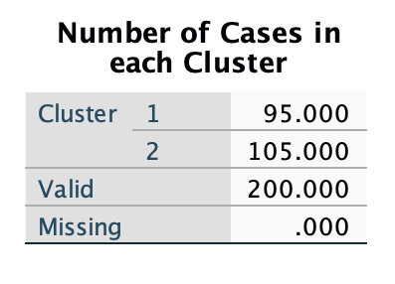
Number of cases in each Cluster
(Source: Author)

We are now examining the sizes of our clusters. The first cluster contains 95 people, while the second contains 105 people. SPSS calculated these values and selected the clusters for us.
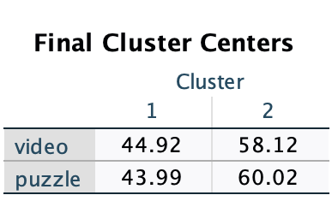
Cluster centres
(Source: Author)

We are inspecting the cluster centres. Normally, SPSS provides values that are approximated to the actual one; however, we changed that so that we can see the data better and visualise the situation to its full analytical potential. The table above shows the average variable values for the individuals who were assigned to the clusters. For example, if we look at the 'video' row, which refers to the points earned by participants in a video game, we can see that the average score is 44.91 (for cluster 1), and the score received for the puzzle is 43.99. The average video game score for a person placed in the second cluster is 58.12, while the average puzzle score is 60.02.

We can see significant differences between variables that determine the same thing (e.g., video game score), and this is predictable because the ANOVA table has told us the same thing (there is a significant difference between our variables).

 | Cluster 1 | Cluster 2 | Variance
video | 44.92 | 58.12 | 13.2
puzzle | 43.99 | 60.02 | 16.03

We can see differences in the average scores taken by survey participants based on the table we created above. We can conclude that there is a group of people who simply outperformed the other in video games and puzzles.

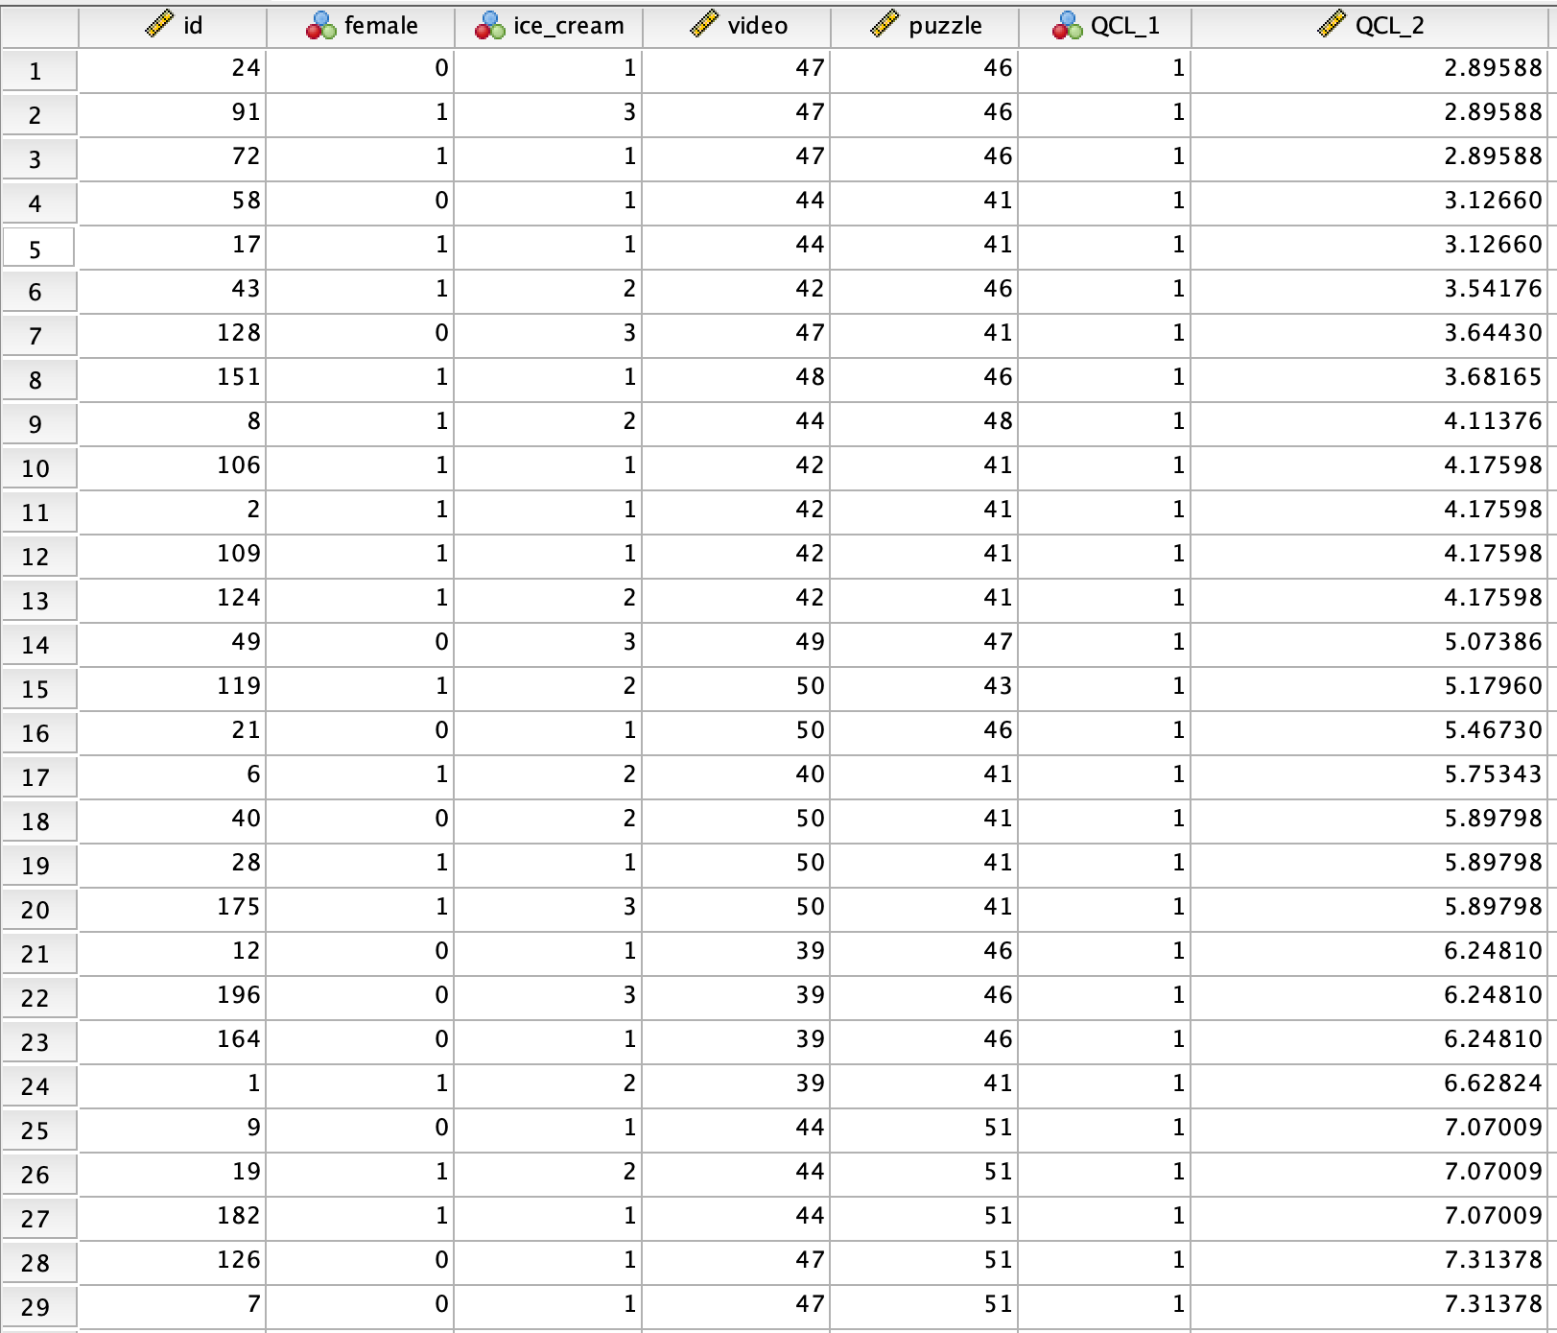

Variables table
(Source: Author)
We sorted the data in the table above based on cluster membership and distance to the cluster centre. The lower the value under QCL 2, the more representative that person is for their group.

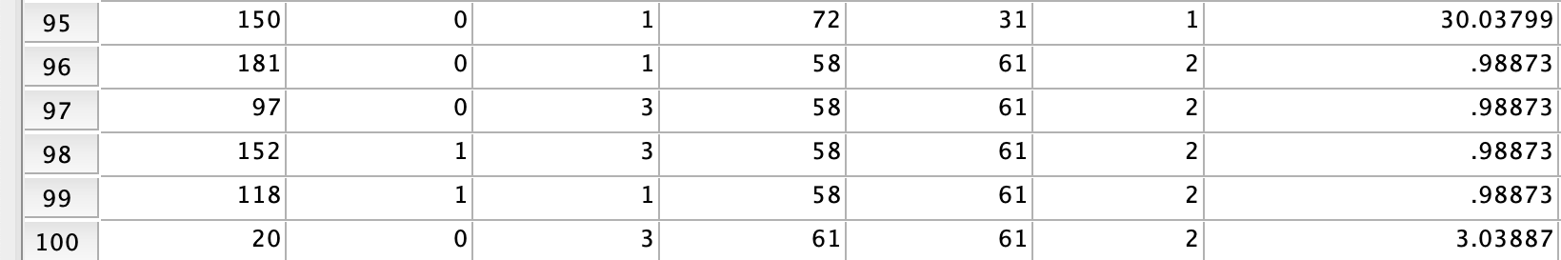

Variables table
(Source: Author)

One last point to mention is that, if we look at row 95, we can see that that person's score membership is cluster 1, but their distance from the centre of the cluster is significantly greater. We interpret this as that person being a member of their group but the least typical.

b) Data and text mining methods

What businesses must do to maximise their enterprise's potential is to use their best tool – data and text mining. Companies can do it this in a variety of ways.

The process of grouping a series of different data points based on their characteristics is referred to as clustering. (Witten, et al., 2021) Clustering assists businesses in better managing their data. Retailers, for example, can use clustering models to determine which customers buy specific products, when, and how frequently. This can assist retailers in targeting products and services to customers in a particular demographic or region.

Data can be presented visually using charts, graphs, maps, diagrams, and other tools. Data visualisation is an important skill because it makes data more understandable to executives, clients, and customers. When presented with data that is simple to understand and interpret, businesses can make faster, more informed decisions. Today, effective, visually accessible mediums such as graphs, 3D models, and even augmented reality are commonly used to accomplish this.

Classification is a fundamental technique in data mining that can be used in almost any industry. It is the process of categorising data points from large data sets based on how they are used. Financial institutions categorise consumers based on a variety of factors to market new loans or project credit card risks. Meanwhile, weather apps categorise data to forecast snowfall totals and other similar figures. Grocery stores also use classification to group products based on who buys them, which aids in forecasting purchasing patterns. (Georgia Tech, 2022)

c) Excel and SPSS

Excel | SPSS
It is used to store information and is used for data entry and manipulation. (It includes pivot tables and various ways of visualising data, as well as functions that make calculations and percentages easier.) | It is a programme designed for statistical data analysis. (It includes many tools for data and text mining, such as pivot tables, clustering tools, etc.)
Data management and storage using predefined operations. | Statistical calculations and data manipulation in accordance with IBM guidelines.
Works fast, and is easy to use. | Reduction in Data Redundancy
Large volumes of customer data must be maintained and handled. | Utilises advanced devices such as supercomputers.

Conclusion

We live in a fast-paced, ever-changing society where businesses must evolve and overcome obstacles to achieve success. For them, particularly in these times, valuing the most potential from data mining and business intelligence is what can make a market difference.

Bibliography

Lancaster, A., 2020. Top 10 Uses of Microsoft Excel in Business, Mallory. [Online]
Available at: https://mallory.com.au/cm/ms-excel-uses-business-workplace/
[Accessed 11 May 2022].

Shmueli, G., Patel, N. R. & Bruce, P. C., 2005. Data Mining In Excel: Lecture Notes and Cases. Arlington: Resampling Stats, Inc..

Microsoft, 2022. VLOOKUP function, Microsoft. [Online]
Available at: https://support.microsoft.com/en-us/office/vlookup-function-0bbc8083-26fe-4963-8ab8-93a18ad188a1
[Accessed 11 May 2022].

Lewis, S., 2022. pivot table, SearchDataManagement. [Online]
Available at: https://www.techtarget.com/searchdatamanagement/definition/pivot-table
[Accessed 11 May 2022].

Boogaard, K., 2022. 21 Cool Things You Can Make in Excel (Other Than Spreadsheets), goskills. [Online]
Available at: https://www.goskills.com/Excel/Resources/Uses-of-Excel-in-business
[Accessed 11 May 2022].

Alexander, M., Decker, J. & Wehbe, B., 2014. Microsoft Business Intelligence Tools for Excel Analysts. 1st Edition ed. s.l.:Wiley.

Whinnery, S., 2020. Data Analysis in Excel vs. Business Intelligence, eCapital. [Online]
Available at: https://ecapitaladvisors.com/blog/data-analysis-excel-business-intelligence/
[Accessed 11 May 2022].

Aggarwal, C. C. & Reddy, C. K., 2014. Data Clustering: Algorithms and Applications. 1st Edition ed. Chichester: Chapman.
Bock, T., 2022. What is Hierarchical Clustering?, DISPLAYR. [Online]
Available at: https://www.displayr.com/what-is-hierarchical-clustering/
[Accessed 12 May 2022].

Witten, I. H., Frank, E. & Hall, M. A., 2021. Data mining [electronic resource] : practical machine learning tools and techniques. 3rd Edition ed. Elsevier/Morgan Kaufmann: Amsterdam.

Georgia Tech, 2022. 10 Key Data Mining Techniques and How Businesses Use Them, Georgia Tech Professional Education. [Online]
Available at: https://bootcamp.pe.gatech.edu/blog/10-key-data-mining-techniques-and-how-businesses-use-them/#classification
[Accessed 12 May 2022].

