

University of Wales Trinity Saint David
School of Engineering

The Application of an Engineering Design Methodology - Industrial/Commercially Available

Engineering Design and Analysis (M7X01379)

George Wright
Student ID: 1804298
13th February 2019

Table of Contents
1 Introduction 1
2 Design Methodology 2
2.1 Problem Identification 3
2.2 Design Specification 3
2.3 Research 4
2.4 Developing Alternatives 7
2.5 Choosing Alternatives 9
2.6 Models 10
2.7 Testing and Evaluating 10
3 Conclusions 11
4 References 12
5 Appendix 14
5.1 Product Design Specification Document 14
5.2 FMEA on Measure Guard 17

Introduction
In this assignment a design methodology was chosen and applied in re-designing an existing product to change its manufacturing and serviceability to make an improvement. The existing product was a Makita electric cordless combi drill where a measure guard was incorporated as an addition to allow the user to drill through a surface to a specific depth. Tools such as ‘Quality Function Deployment’ (QFD) were used to aid the design process of meeting the users’ needs and to create an alternative product. SolidWorks was then used to create a solid model of this final design which underwent a ‘Failure Modes and Effect Analysis’ (FMEA) to pinpoint potential failures with the measure guard, and present recommendations to rectify these for future re-designs before manufacturing.

Design Methodology
The first stage in this assignment was to select a relevant design methodology which would be applied to improve an existing product. Hollers (2017) states that a professional engineer’s daily and critical job is to document ideas and the engineering design process. Hollers continues to state this process is beneficial in creating a thorough design and focussed solution, with the possibility of innovation through documenting, reflecting and re-designing . The list below shows the stages of the design methodology picked:
- Problem Identification
- Design Specification
- Research
- Developing Alternatives
- Choosing Alternatives
- Choosing a Solution
- Model
- Testing and Evaluating
This design process was picked as it includes essential steps that would assist to document, reflect and re-design a chosen problem. The design process is a repeating and continuous procedure in re-designing and improving products. From learning a product’s failures it’s possible to research better solutions to meet customer demands and compete against other products (Engineering Design Process 2019). This continuous process can be seen in another design methodology in figure 1 where there isn’t a requirement to start at a certain stage or what order the stages are done (Hill-Cunningham et al 2018).

Figure 1: Engineering design process (Engineering Design Process 2019).

Problem Identification
The initial design methodology stage was to identify a problem with an existing product by the end-user which would then be improved on. Without a problem identified, the design process can be like doodling (ITEA 2007). The selected product was a Makita electric cordless combi drill as shown in figure 1:
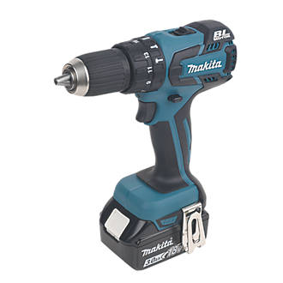
Figure 2: Makita DHP459SFE 18V 3.0AH LI-ION LXT Brushless Cordless Combi Drill (Makita 2019).
The product does not contain a feature that accurately drills into a surface to a specified user depth. Drills of this type would have users suggest placing tape on the drill piece to define a drill depth or purchase a drill depth stop or portable drilling guide (Kay 2019). In some scenario’s users would manually guess the depth which can lead to inaccuracies and frustration of under drilling the surface depth or overdoing it.

Hence, it was decided that this product would be re-designed to include an additional component that the user can use to adjust and execute an accurate drilling depth. This new component, called the measure guard, would come with the drill in one package when bought instead of buying drill depth stops or portable drilling guides separately. This would allow the user to avoid additional cost and lost time and effort. Re-designing the Makita drill will change its manufacture and service to make a user improvement.

Design Specification
It was important to carry out a product design specification (PDS) for this new component as products that underwent a thorough defined specification were 3.3 times likely to be successful (Morgan 2019). A PDS document was created and documented for the measure guard as this would list requirements that the component must have to be successful. The PDS would also be useful in developing design ideas and when cross-referencing against the Solid Works model to confirm details are the same to what we set out. The PDS document reveals details such as dimensions of the component and weight along with the expected product service environment. The PDS is shown in appendix 5.1 and after the initial completion of the document, it was noted that further research was required on what applicable codes and standards the component needed to meet, user requirements, and competing products.

After research completion, the PDS would be amended with the new information to aid the design process. Like the design process, it is important to note the PDS can be an iterative process to continually improve it through research, testing and evaluation (Childs 2014). One assumption in this PDS was that there were no similar products to the measure guard. Thus, if production of this guard was planned in the future, Reed (2019) states that patents should be checked to comply with the Patents Act 1977 (Legislation 2019).

Research
It was important to understand and include in the PDS any applicable codes and standards for the design process. Regulations include section 6 of the Health and Safety at Work Act 1974 which gives a general health and safety obligation on personnel who use articles at work, specifying information and instructions on the safe use (Hughes and Ferrett 2011). This is important because any potential buyers could be employers who need to know the necessary information about the product before providing it to their employees and making them aware of any potential hazards. In addition, the supply of machinery regulations 2008 states machinery must be safely designed and constructed to meet the essential health and safety requirements, CE marked, supplied with English instructions, and has a declaration of conformity (HSE 2019). The PDS was amended to include both legislations to ensure compliance.

QFD was a tool used to carry out research which aided the PDS to ensure the product was designed to what the user wants and so meeting customer satisfaction (Childs 2014). QFD has its advantages as it can potentially reduce costs in the product design stages and shorten the duration (Jiang et al 2014). However, Wolniak (2018) argues it has its limitations if a design engineer uses it for a complex and multi-matrix method leading to the matrix and analysis to become very large and hence difficult to analyze a connection between the customer and technical requirements. Figure 3 below shows the QFD carried out on the measure guard:
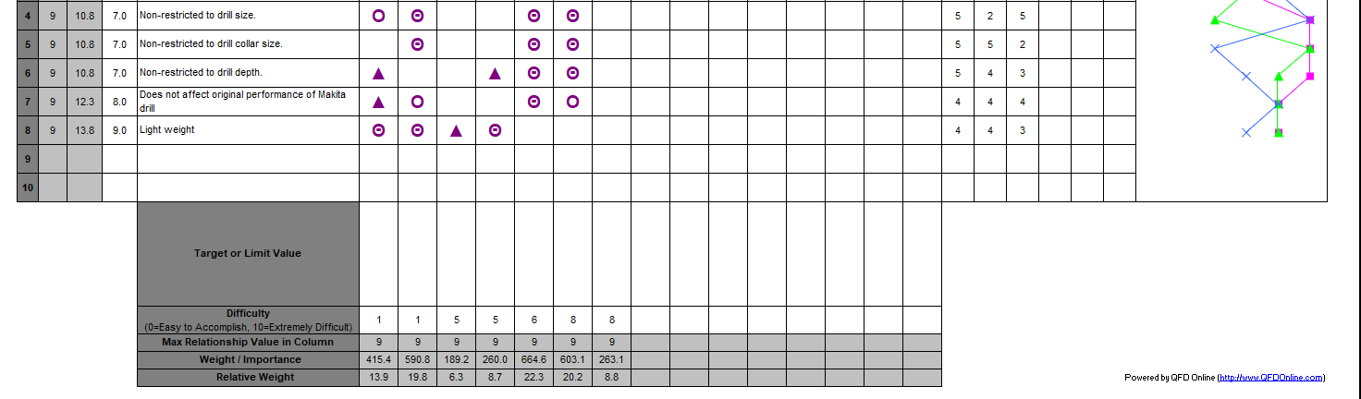
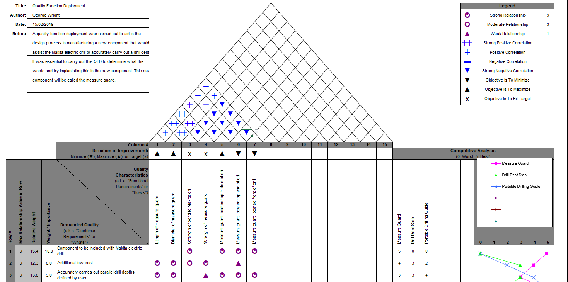

Figure 3: Measure guard QFD (QFD 2019).

The QFD was successful in obtaining several demanded qualities by the customer which were ranked by importance and cross-referenced with the component’s quality characteristics to see if there were relevant relationships. In doing this the QFD generated weight importance of each quality characteristics that highlighted which areas to focus on to meet the customers’ demands when generating alternative ideas. With weight importance of 664.6 it was noted that the measure guard would be best suited top middle (viewing from the side) instead of 603.1 from the end. Important to focus on with a score of 415.4 and 590.8 were the measure guard’s length and diameter. Even though the weight importance of the strength bond was low at 189.2 it was essential that this was targeted.

Additionally, more information regarding the competing products drill depth stops and portable drill guides were researched to analyse further details of the demanded qualities from the QFD. Figures 3 and 4 show the two competing products:

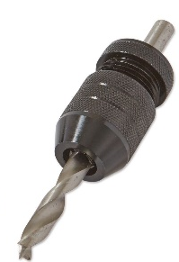

Figure 4: Drill depth stop kit – Set of 2 (Amazon 2019).
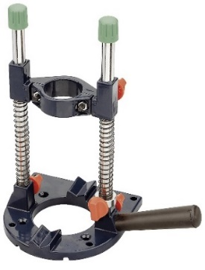
Figure 5: KWB Drill Stand/Guide 778400 - for Drills and Cordless Drill, 43 mm Euro Collar (Amazon 2019).

Both products were selected from Amazon and even though there are a variety of both types from different manufacturers, they all have similar features. Table 1 below shows the unit price, pros and cons of each product:
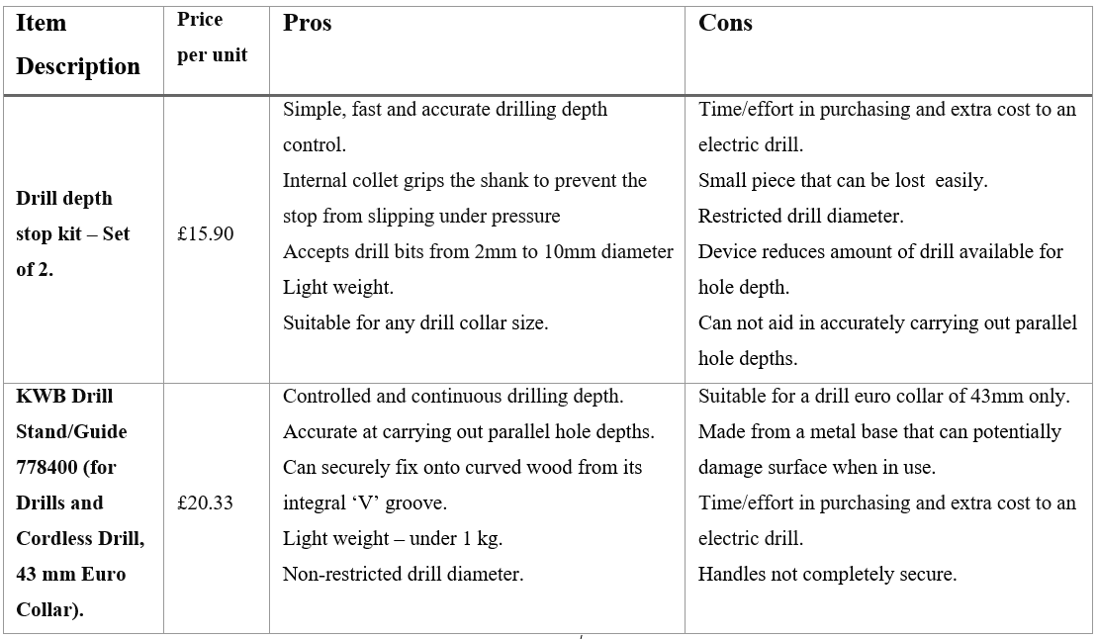Table 1: Competing products price, pros and cons.

It was key to analysis the two product’s to see if it was possible to have the measure guard include some or all strengths from both products. Table 1 also makes it possible to incorporate features of the measure guard that would be improvements to the weaknesses of the other two products. As a result, it was essential that the measure guard match both products strengths in accurately drilling a defined depth with control, must be light and mustn’t restrict drill diameter. As an advantage, the measure guard would be designed to suit all drill collar sizes and most importantly be included in the package of the electric drill when purchased. From this it was essential to keep the cost of the measure guard low and preferably lower than the competing products. The QFD was amended with this research with a competitive analysis completed and what we can expect our component to rank against them.

Developing Alternatives
The next stage was to start developing alternative ideas to the existing products mentioned previously which would aid the Makita drill to accurately drill a hole depth and to bond the component with the drill during manufacture. During this process it was important to sketch a variety of ideas and keep an open mind. The PDS was used here in developing the alternative ideas and are shown below in three sketches:
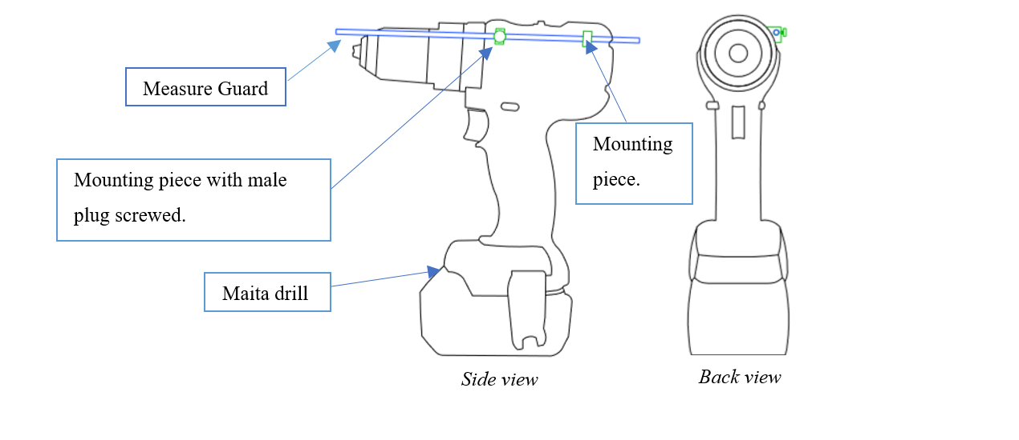
Figure 6: Sketch 1 – Measure guard attached by two bonded mounting pieces.

Sketch 1 shows two mounting pieces bonded to the Makita drill; viewing from the side, one is placed top centre with a female thread (on the side) and the other on the back of the drill as per QFD analysis. Both are designed to have a hole bored out to allow the metal measure guard to slide through. The measure guard would be the main component in allowing the user to define a drill depth. This bar would be fastened onto the electric drill by screwing a male threaded plug on the mounting piece that has been female threaded.

For the user to define a drill depth the measure guard would first be placed horizontally levelled with the tip of the electric drill piece used. Next the measure guard would be placed away from the surface that is to be drilled by the defined depth distance. After fastening the measure guard, the user can commence drilling until the measure guard has contacted the surface being drilled. At this point the defined measured depth would be completed hence meeting with the PDS and QFD. Sketch 2 below was another alternative idea:
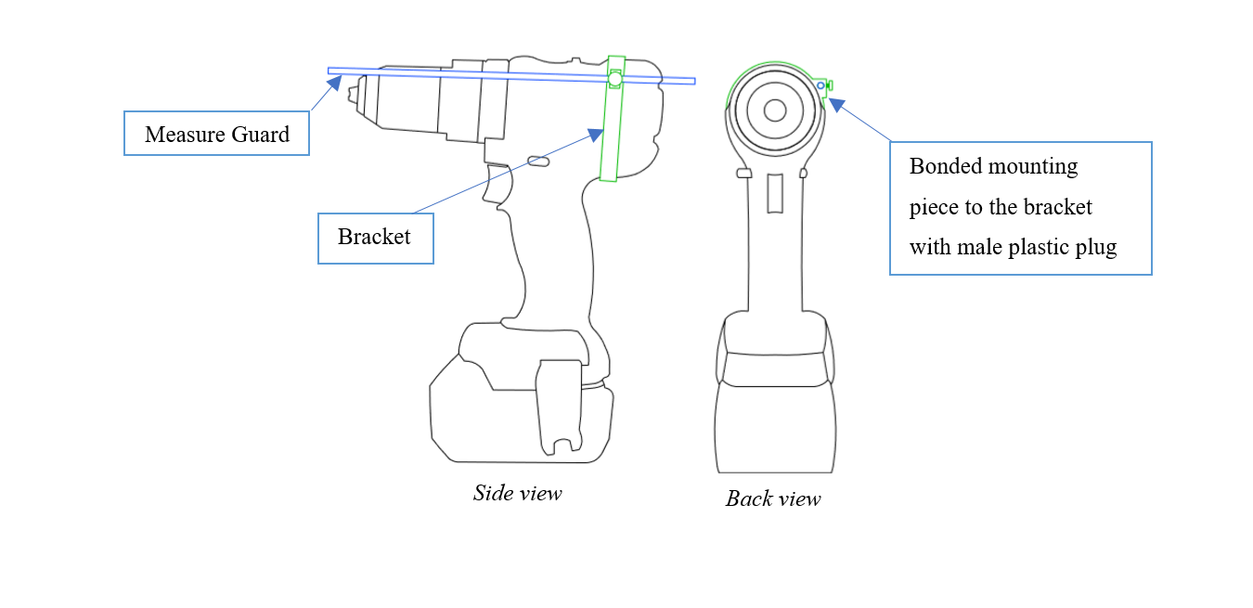
Figure 7: Sketch 2 – Measure guard attached by a bracket.

Sketch 2 uses the same ideas as sketch 1 in how the user defines a drill depth with the measure guard and how it is fastened onto the bracket. The difference here is the measure guard is attached to the drill by a bracket that goes around the circumference of the Makita at the back. Lastly, sketch 3 was developed as another idea:
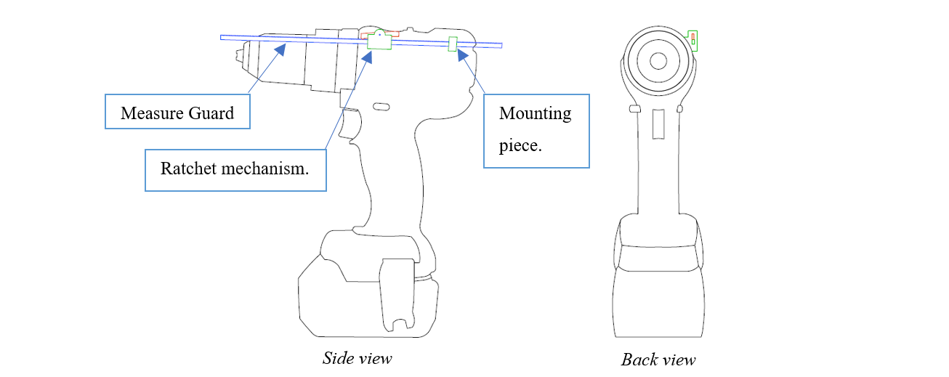
Figure 8: Sketch 3 – Measure guard attached by ratchet mechanism.

Sketch 3 shows a ratchet bonded to the Makita drill with the measure guard attached similarly to sketches 1 and 2. The idea here is the ratchet will allow the measure guard to be pulled in one direction by the user to define a drill depth. The reset button allows the rachet to place the measure guard to its original position when another desired drill depth is wanted.

After developing several alternative ideas, the next task was to analyse each sketch by their pros and cons which would aid in selecting the chosen solution.

Choosing Alternatives
To analyse each sketch table 2 was generated to check if several criteria were met by each alternative idea. The criteria were selected based on the strengths and weaknesses on the competing products in addition to the documents PDS and QFD. Table 2 can be seen below:
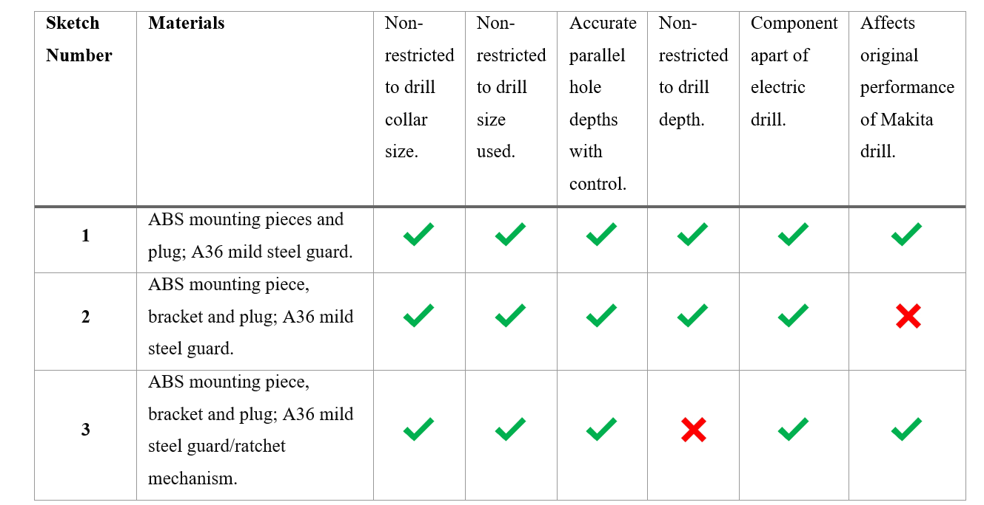
Table 2: Sketches 1, 2 & 3 criteria performance.
ABS was used for all components other than the measure guard as it is suitable for machining, easy to glue, very hard, sturdy, has a long lifespan and relatively cheap. It has its disadvantages in that is created from oil and so potentially can affect the environment (Flynt 2019). A36 mild steel was used in the design process as it is easy to machine, ductile, relatively cheap and tough. This also has its disadvantages as it can rust easily and therefore it is recommended that a zinc coating is applied upon manufacture to prevent corrosion (Haji 2019).

Sketch 1 met all the criteria set out from the PDS and QFD predicting it would accurately carry out parallel hole depths with control, be non-restricted to the drill collar size or drill sizes or drill depth defined and was to be included as a component of the electric drill. Sketch 2 met all these requirements as well however it was predicted that its design could potentially affect the performance of the Makita drill. The bracket designed in sketch 2 was bonded around the areas where the Makita drills ventilation were located and so may be partially or completely blocked by the bracket design leading to overheating of the product. The outcome of this could lead the Makita drill to be damaged and therefore there would be an extra cost to replace it for both the customer and manufacture. Both sketches 1 and 3 in advantage were predicted not to influence the performance of the electric drill.

Sketch 3 also met many of the criteria set out however its design restricted a drill depth. This would be a disadvantage as both sketches 1 and 2 were non-restricted to a drill depth as well as the competing products. It was decided that sketch 1 would be the selected alternative solution as it met all the criteria set out and poses advantages over the competing products in that it becomes a component of the electric drill and isn’t collar restricted.

Models
Using SolidWorks, sketch 1 was designed and created to produce an assembly model of the Makita drill with the measure guard. Firstly, this was done by designing and creating individual components of the measure guard which were then saved by parts i.e. the mounting pieces, the measure guard itself and the male threaded plug. Materials were also specified in this design as per table 2 for all parts. The next step was to bring all these parts together into an assembly. The Makita drill was imported from GRABCAD into SolidWorks and each part was imported on top of this and mated onto the planes created on the electric drill to reflect sketch 1 (Van Balen 2019). The assembly is shown below:

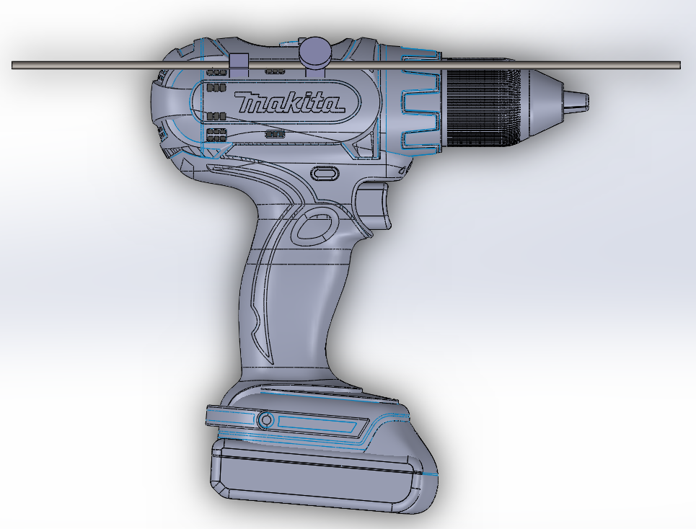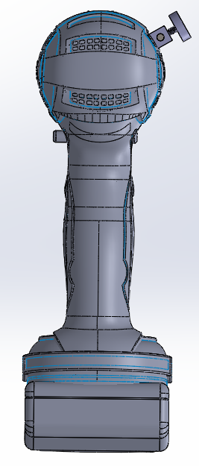
Figure 9: Makita drill assembly with the measure guard.

From this design model of the drill a dimension drawing of the new assembly was created and shown in figure 10 below:
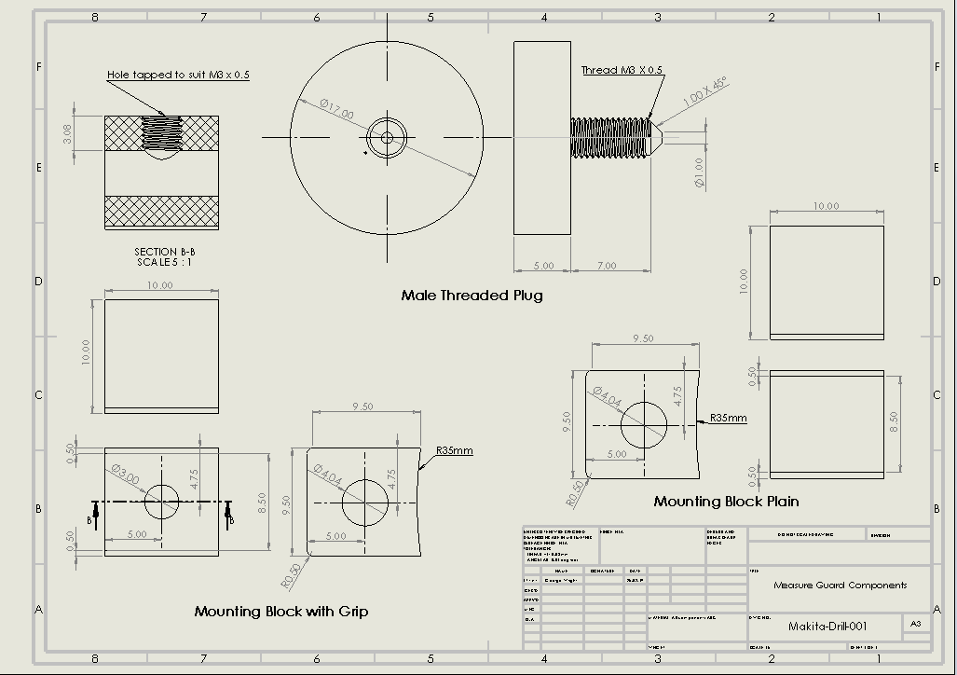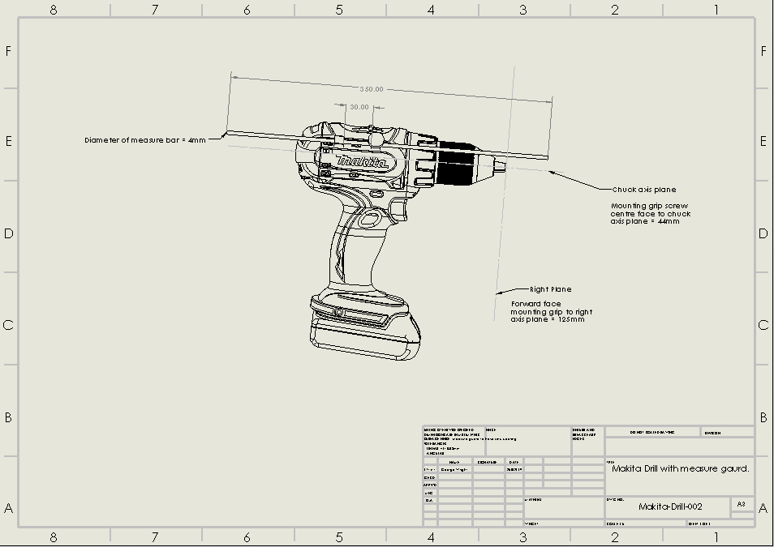
Figure 10: Makita drill assembly with dimensions.

A protype can now be created using the model shown in figure 9 and dimensions given in figure 10 however will not be carried out as a part of this assignment.

Testing and Evaluating
It’s recommended the testing of this model should be carried out to fully evaluate this new design with a prototype to confirm whether the criteria set out by the PDS and QFD are met prior to manufacturing such as accurately drilling a parallel surface depth. In addition, a prototype would be required to determine manufacture cost and weight to see if it within the specification in the PDS.

FMEA was used on the model produced and is shown in appendix 5.2. FMEA has its advantages in effectively identifying, evaluating and prioritizing potential failures of a product or procedure in this case the measure guard (Najafpour et al 2017). Prioritising was ranked with a value called the ‘risk priority number’ (RPN) which equals:

$$RPN=Severity×occurrence ×detection-Equation 1$$

Therefore, the higher the RPN value the higher the requirement there is to eliminate or reduce that risk of failure. However, this can be deceiving as we can have a high severity failure with low occurrence and detection values giving a lower RPN. This doesn’t mean that this failure is neglected and prioritised lower than others, because it can potentially have severe consequences and must be addressed (Carlson 2009). The model RPN values analysed in descending order showed risk of the user cutting themselves was 336, damage to the surface from the component was 252 and non-parallel depth holes was 150.

Using this FMEA evaluation it was recommended in priority order that the measure guard should be re-designed to have all components rounded off with no sharp edges, then to include an extra component that would prevent any damage of the guard upon impact with the wall.

Conclusions
A methodology was successfully applied in re-designing the Makita drill which changed the manufacture in that a measure guard was created and bonded to the drill in the model produced. The re-design also changed the serviceability where the user can now drill through a surface to a specific depth, hence making an improvement. The PDS was re-written to include recommendations for future re-designing with the possibility of manufacture.

References
Amazon (2019). [online] Amazon.co.uk. Available at: https://www.amazon.co.uk/Drill-778400-Drills-Cordless-Collar/dp/B0043VUCGO/ref=sr_1_2?ie=UTF8&qid=1550397331&sr=8-2&keywords=portable+drilling+guide [Accessed 17 Feb. 2019].
Amazon (2019). [online] Amazon.co.uk. Available at: https://www.amazon.co.uk/Drill-Bit-Depth-Stop-Kit/dp/B076F4LZSP/ref=sr_1_7?ie=UTF8&qid=1550319936&sr=8-7&keywords=drill+depth+stop [Accessed 16 Feb. 2019].
Carlson, C. (2009). Preventing Problems. Appliance Design, 57(5), pp.26-29.
Childs P (2014). Mechanical design engineering handbook. Elsevier LTD, pp.25-49.
Engineering Design Process (2019). [image] Available at: https://www.teachengineering.org/k12engineering/designprocess [Accessed 15 Feb. 2019].
Flynt J (2019). PLA vs. ABS Plastic – The Pros and Cons. [online] 3D Insider. Available at: https://3dinsider.com/pla-vs-abs-plastic-pros-cons/ [Accessed 20 Feb. 2019].
Haji E (2019). Mild Steel ( MS ) Flanges - E S Haji • Flange Manufacturer • Chennai - E S Haji • Flange Manufacturer • Custom Flanges • Chennai. [online] Eshaji.in. Available at: http://eshaji.in/technical-info/ms-flanges/ [Accessed 26 Feb. 2019].
Hill-Cunningham P, Mott M and Hunt A (2018). Facilitating an Elementary Engineering Design Process Module. School Science and Mathematics, 118(1-2), pp.53-60.
Hollers B (2017). Documenting the engineering design process. Technology and Engineering Teacher, 77(2), pp.35-39.
HSE (2019). UK law on the design and supply of products - Work equipment and machinery. [online] Hse.gov.uk. Available at: http://www.hse.gov.uk/work-equipment-machinery/uk-law-design-supply-products.htm [Accessed 16 Feb. 2019].
Hughes P and Ferrett E (2011). Introduction to health and safety at work. 5th ed. Oxford: Elsevier Butterworth Hein, pp.458-459.
ITEA (2007). Standards for technological literacy: Content for the Study of Technology. 3rd ed. Reston, Va.: International Technology Education Association, p.91.
Jiang H, Kwong C, Liu Y and Ip W (2014). A methodology of integrating affective design with defining engineering specifications for product design. International Journal of Production Research, 53(8), pp.2472-2488.
Kay N (2019). How can I drill to an exact depth with a hand drill? [online] Home Improvement Stack Exchange. Available at: https://diy.stackexchange.com/questions/31705/how-can-i-drill-to-an-exact-depth-with-a-hand-drill [Accessed 15 Feb. 2019].
Legislation (2019). Patents Act 1977. [online] Legislation.gov.uk. Available at: https://www.legislation.gov.uk/ukpga/1977/37 [Accessed 24 Feb. 2019].
Makita (2019). [image] Available at: https://www.screwfix.com/p/makita-dhp459sfe-18v-3-0ah-li-ion-lxt-brushless-cordless-combi-drill/6407p#product_additional_details_container [Accessed 15 Feb. 2019].
Morgan R (2019). [presentation] Design Process Fundamentals.
Najafpour Z, Hasoumi M, Behzadi F, Mohamadi E, Jafary M and Saeedi M (2017). Preventing blood transfusion failures: FMEA, an effective assessment method. BMC Health Services Research, 17(1).
Reed P (2019). Don't just cover the engineering design process, patent it. Technology and Engineering Teacher, 73(2), p.1.
QFD (2019). QFD Online. [online] Qfdonline.com. Available at: http://qfdonline.com/ [Accessed 15 Feb. 2019].
Van Balen B (2019). Makita Cordless Drill. [online] GRABCAD community. Available at: https://grabcad.com/library/makita-cordless-drill [Accessed 19 Feb. 2019].
Wolniak R (2018). The use of QFD method advantages and limitation. Production Engineering Archives, 18, pp.14-17.

Appendix

Product Design Specification Document

Product Title: Measure Guard on a Makita cordless combi drill
A. Product design & performance issues
- Expected product size and weight: 35cm in length and weight < 100g.

- Expected product performance requirements: Must accurately indicate a specified drill depth when drilling into a surface defined by the user. Must be light and mustn’t be restricted to drill diameter. Furthermore, must suit all drill collar sizes and importantly be included in the package of the electric drill when purchased

- Loadings likely encountered: Own load only.

- Expected product service environment: Drill vibrations and dust.

- Subject to shock loading: Possible if drill encounters a void before correct depth reached

- Product be exposed to dirt or other contaminants: Potential dirt.

- Anomalies in power/fuel available for this product: No.

- Product impact on environment: None provided its metal and/or plastic component parts are re-cycled at end of life

- Expected product safety requirements: Ensure component is fastened onto electric drill and adequate protection when in contact with surface. Ensure no sharp edges.

- Potential sources of product liability litigation: Ensure to include safety information with the package regarding potential sources of product liability litigation i.e. for the measure guard. This is making the user aware of risks such as sharp edges and getting fingers trapped. It is important to monitor any safety issues with the component and rectifying any new problems.

- Potential operator hazards: Sharp edges. Fingers trapped.

- Potential manufacturing and assembly hazards: Fingers trapped upon assembly.

- Potential for misuse/abuse: Potential for user to extend measure guard beyond its use and cause damage. Furthermore, user applying unnecessary load on measure guard causing damage.

- Expected product reliability standards and requirements: Measure guard must match the reliability standards to that of the electric drill.

- Expected product ergonomic requirements: Ensure measure guard is designed so that the user can adjust in a suitable ergonomic stance. It is important to ensure in this case how it is fitted onto the electric drill and how it is dismantled.

- Desirable user/operator features in this product: To provide accurate surface depth measurements, easily to use and low cost.

- Expected product aesthetics: Ensure features match to that of the electric drill.

- Expected product maintenance requirements: Maintenance must be taken by the design company only if the component is damaged. As for the electric drill the component will be under one-year guarantee. If not damaged, component will be maintenance free.

- Material requirements: Materials used for the measure guard must keep its structural integrity, shape and have a low weight. Adding weight to this will add the overall weight of the electric drill which will be handled by the user thus potentially be difficult to lift.

- Expected product recycling potential and expected disposal: The material used for the measure guard is anticipated to be a plastic and therefore can be a hazard to the environment if disposed of incorrectly. It is important that this component, if disposed of, is recycled accordingly.

- Manufacturing process requirements and limitations: To be checked upon manufacture.

- Product packaging requirements: This component will come in the packaging to the existing product; in a plastic carrying case.

- Applicable codes and standards to be checked: Must comply to the Health and Safety Work act 1974 section 6 and the supply of machinery regulations 2008.

- Patents to be checked: To be checked prior to manufacture.

- Processes to research/benchmark: Checked existing or familiar products that carry out the same function as the measure guard.

- Product part and prototype testing requirements: To be carried out and checked against PDS.

B. Market Issues
- Potential customer base: Homeowners who carry out DIY and companies / self-employed people who carry out maintenance and installation works.

- Market constraints and competition: Cordless combi drills have a sound place in the existing market. There are existing products that allow the user to carry out defined surface drill depths with an existing cordless combi drill i.e. drill stops and portable drilling guides. However, these require the user to go out and buy separately to the cordless combi drill. This is the advantage of including the measure guard to the cordless combi drill into one package when bought.

- Target product price: £149.99 (current value on Screw Fit). Furthermore, information required on extra material costs.

- Target production volume and market share: The new design incorporates several strengths from existing products i.e. accurately drilling a defined depth with control, must be light and mustn’t be restricted to drill diameter. As an advantage, the measure guard would be designed to suit all drill collar sizes and importantly be included in the package of the electric drill when purchased. There is a continuous market for electric drills and with the addition of a component that accurately drills a defined depth is invaluable.

- Expected product distribution environment: To be checked prior to manufacture.

C. Capability issues

- Company constraints on product design, manufacture, and distribution: To be checked prior to manufacture.

- Schedule requirements: To be checked prior to manufacture.

FMEA on Measure Guard

