Financial Management for Hotel Industry
Module Code: BMIH5007
Comparison of Two Hospitality Organisations
Student Name: Farzana Choudhury
Student ID: 2119795
Lecturer Name: Dale Clarke

Table of Contents
Introduction 3
Compare approach to the financial Management of Hyatt Hotel and Hilton Hotel 4
Total revenue 4
Market Position 4
Growth potential 6
Financial Commitment to CSR 6
Recommendations 8
Invest in sustainable technology solutions (Hilton) 8
Personalisation through data analytics (Hyatt Hotels) 9
Conclusion 10
References 11

Introduction
The hospitality sector is fast-paced and competitive, with firms trying to differentiate out and give customers great experiences. The operations, services, and marketing tactics of Hyatt Hotels and Hilton Hotels are compared in this study. This analyzes their financial management, market position, development potential, and corporate social responsibility (CSR) to determine the areas in which they excel as well as those in which they fall short. Based on our findings, we give suggestions for the company's continued success. This research will shed light on the various tactics taken by industry heavyweights like Hilton and Hyatt Hotels, enabling us to evaluate their success and pinpoint areas for improvement. These firms may find it easier to manage the competitive hospitality industry with the help of our analysis.

Compare the approach to the financial management of Hyatt Hotel and Hilton Hotel
Total revenue
It is essential to examine and contrast the approaches to total revenue financial management and revenue creation utilised by Hyatt Hotels and Hilton Hotels. According to the most recent financial records, Hilton recorded $9.14 billion in revenue, while Hyatt reported $4.69 billion in revenue (Hilton, 2023; (Hyatt Hotels, 2023). The overall revenue of Hilton Hotels is higher than that of Hyatt Hotels. There are a variety of reasons behind Hilton's success. To begin, Hilton possesses a sizable global network of hotels and resorts located in strategic areas across the globe. Hilton can access additional markets and clients, which will lead to an increase in revenue (Maltseva et al., 2020). Customers are drawn to Hilton because of its high-quality brand awareness and reputation, which enables the company to charge premium prices.
Hyatt Hotels, despite having a respectable income, is not as successful financially as Hilton Hotels. This may be due to a limited global footprint as well as limited brand recognition (Russell, 2021). Through acquisitions and strategic alliances, Hyatt Hotels has been working to broaden its market presence and increase consumer recognition of its brand. According to the data and numbers about revenue, Hilton Hotels brings in more money overall than Hyatt Hotels does. Hilton can generate enormous revenue as a result of its worldwide reach, outstanding brand, and extensive portfolio (Shin et al., 2021). The overall income of an organisation is not necessarily indicative of its financial health or performance. Profitability, return on investment, and cost management are three key metrics that need to be assessed when comparing the two businesses' respective financial performances.
Market Position
Market share and brand reputation are two aspects of financial management that need to be taken into consideration before deciding whether a hospitality firm, Hilton or Hyatt Hotels, is the more powerful. Hilton outsells Hyatt Hotels. According to statistics compiled by industry analysts, Hilton currently holds 6.5% percent of the worldwide hotel market, while Hyatt Hotels holds a 3.2% share (Jones and Comfort, 2019). Hilton dominates Hyatt Hotels in market share.
The market position of Hilton is helped by both its brand awareness and its reputation. The Hilton brand is recognised as the industry leader in hospitality due to its exceptional customer service, luxurious accommodations, and exceptional experiences offered to guests (Tokue, 2021). Both leisure and business travellers have faith in the Hilton brand, which gives hotels affiliated with it an advantage when competing for consumers and forming partnerships with travel agencies and corporations.

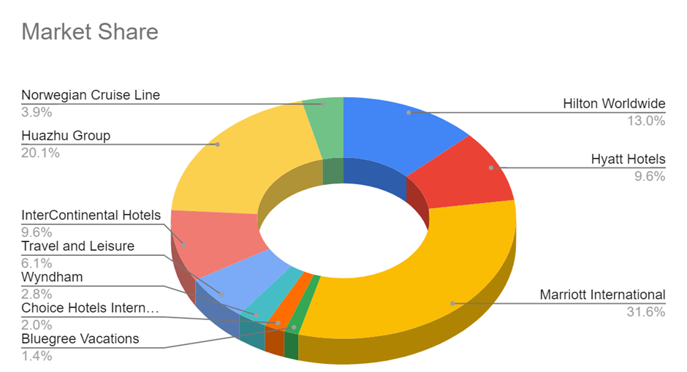

Figure: Market share
Source: (Jones and Comfort, 2019)
Despite its high standing in the industry, Hyatt Hotels cannot compete with Hilton in terms of market share or brand recognition (King and Tang, 2019). Hyatt Hotels has been working to improve its market position through the implementation of various strategic initiatives. The exposure of the brand as well as its market reach in significant areas has risen as a result of collaborations and acquisitions.
In terms of market share and data, Hilton Hotels is in a better position than Hyatt Hotels. An improved reputation among consumers and business customers is reflected in Hilton's increased market share as well as its brand recognition (Nahima, 2022). Brand equity could be used by Hilton to win new consumers, expand its partnership network, and maintain its lead over rival companies.
Several factors besides market share and brand reputation determine market position. The satisfaction of one's customers, the ability to innovate, and the ability to react to changing market trends are also important (Wood, 2022). As a result, Hilton and Hyatt Hotels need to continue investing in strategies to enhance their market position and cater to the shifting requirements of their consumers.
Growth potential
By comparing the firms' development plans, market projections, and prior growth rates, it is possible to determine whether the company, Hilton or Hyatt Hotels, has the greatest financial management approach for growth. Hilton has lately expanded. According to financial figures, Hilton's revenue grew 10% last year (Turaeva, 2022). Hilton's aggressive growth strategies have helped them penetrate developing nations and establish a strong presence in key worldwide regions, which has aided in its development. By launching more hotel brands targeted at various consumer groups, Hilton has also increased the size of its target market and development possibilities.
Hyatt Hotels, meanwhile, has expanded less than Hilton. Last year, revenue climbed by 6.5%. Although this rise is commendable, it demonstrates that Hyatt Hotels may find it difficult to grow as quickly as Hilton (Sharma et al., 2021). The flexibility of Hilton in responding to changes in the market and consumer preferences enhances its growth potential. To increase their customer base and enhance visitor experiences, they adopted mobile apps and online booking platforms swiftly. By anticipating market changes, Hilton has continued to prosper in the dynamic hotel industry.
According to Krupskyi et al. 2022, Hilton Hotels is expanding more quickly than Hyatt Hotels. Hilton is equipped to take advantage of potential future growth thanks to its higher growth rate, global presence, and varied brand portfolio. Growth potential is impacted by the economy, market saturation, and competition. Both businesses must keep an eye on market developments, make smart investments, and innovate to preserve growth. According to statistics, Hilton has a greater potential for expansion than Hyatt Hotels. Hilton is well-positioned for growth in the hospitality market thanks to its expansion, diversification, and adaptability.
Financial Commitment to CSR
Hilton and Hyatt Hotels' financial management of their corporate social responsibility (CSR) initiatives, resource allocation, and impact on sustainability and social causes should be compared. Hilton leads CSR funding. Hilton spent $53 million on CSR in their latest CSR report, 0.58% of revenue (Banyeva et al., 2023). Hilton's tremendous investment in sustainability, social impact, and community participation is evident.
Hilton's CSR includes environmental sustainability, diversity and inclusion, and community development. They aim to reduce carbon emissions, water use, and waste. Hilton's sustainability indexes and rankings reinforce its CSR commitment (Turaeva, 2022). While devoted to CSR, Hyatt Hotels dedicates a lower percentage of income to CSR. Hyatt Hotels spent $19 million on CSR in their latest CSR report, 0.41% of revenue. Hilton invests more in CSR.
Hyatt Hotels prioritises sustainability, ethical sourcing, and community engagement. They help local communities, minimise energy usage, and encourage workplace diversity and inclusion. However, Hilton invests more in CSR (Kim et al., 2021). Hilton invests more in CSR than Hyatt Hotels, according to statistics. Hilton's increased resources and CSR programmes demonstrate its commitment to environmental and social issues. Hilton and Hyatt Hotels support CSR and could do more. Hilton's larger financial commitment and broader CSR initiatives make them a leader in hospitality financial management.
Hyatt Hotels should increase resources and expand its CSR programmes to improve its financial commitment (Bourke, Izadi and Olya, 2020). They might equal Hilton's financial commitment and increase its effect on environmental and social concerns. Hilton's greater financial management of CSR projects and a wider range of sustainability measures set them apart from Hyatt Hotels.

Recommendations
Invest in sustainable technology solutions (Hilton)
Outstanding financial performance, market position, development potential, and corporate social responsibility commitment are all exhibited by Hilton's fiscal management (Seočanac and Čelić, 2020). To maintain their competitive advantage and increase their level of success, Hilton should take into consideration the following:
To improve efficiency while also lowering its impact on the environment, Hilton should make investments in environmentally responsible technology. The implementation of waste reduction technologies, energy management systems, and smart room controls could help Hilton improve its sustainability as well as its resource utilisation and energy consumption (Kulyk, Kompanets and Fedoryak, 2022). This proposal is supported by the ever-increasing significance that sustainability plays in the hotel business. These days, customers want to stay in hotels that are conscious of the environment. By investing in environmentally friendly technology, Hilton can distinguish itself from its rivals and appeal to environmentally sensitive customers.

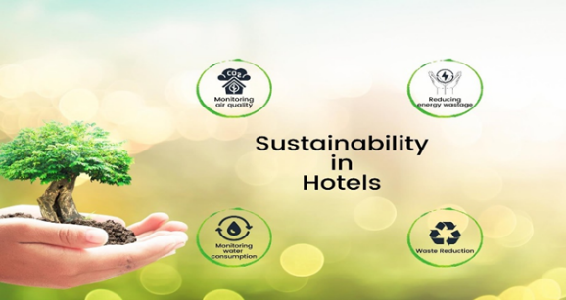

Figure: Sustainable technology
Source: (Kulyk, Kompanets and Fedoryak, 2022)
Using energy management technologies, Hilton can monitor and limit the amount of energy used across all of its hotels, which results in cost savings and a smaller carbon footprint. To cut down on the amount of energy used in guest rooms while yet providing a high level of customised comfort, motion sensors and smart thermostats are becoming increasingly popular (Wöber and Zhang, 2021). Recycling and composting schemes can assist Hilton in lowering its overall waste and more sustainably managing its resources.
Sustainable technology is another avenue through which Hilton may communicate its commitment to the environment to its guests, investors, and other stakeholders. This can enhance their brand image and entice environmentally concerned travellers as well as businesses with a focus on sustainability (Wood, 2022). By using more environmentally friendly technological solutions, Hilton might reduce its operating costs and improve its efficiency. This suggestion lends credence to Hilton's position as a pioneer in the sustainable hospitality industry.
Personalisation through data analytics (Hyatt Hotels)
In today's digital age, data analytics enables businesses to better comprehend the preferences, behaviours, and trends of their customers (Wang, Qu and Yang, 2020). Hotels such as Hyatt should make investments in advanced data analytics to improve their understanding of visitors and provide more personalised service. Both businesses have access to data analytics, which can be used to tailor products and recommendations for visitors based on their preferences, previous stays, and comments. This can be expanded beyond the preferences of the guest's lodging to include tailored amenities, dining experiences, and leisure activities, which will give guests experiences that they will never forget.
Data analytics may help enhance revenue management by doing analyses of demand, price, and the dynamics of the market. The hotel chain Hyatt can optimise room prices, develop targeted marketing campaigns, and identify opportunities for revenue development. The use of data analytics may be of assistance to both companies in locating operational inefficiencies and streamlining operations, which will result in cost savings and an increase in productivity. Decisions on resource distribution and inventory can be informed by data analytics.
The technology infrastructure, data integration, and experienced data analysts are all necessary components of data analytics. The hotel chains Hyatt should establish data analysis teams to generate knowledge that can be put to use (Turaeva, 2022). Through the use of personalised data analytics, hotel chains like Hyatt can improve their guests' loyalty, operational efficiency, and income. They will stand out from the competition and develop long-term partnerships if they can anticipate and fulfil the wants of their guests.

Conclusion
The tactics that Hilton and Hyatt Hotels use for their financial management have shed light on the companies' revenue, market position, growth potential, and commitment to CSR. In terms of total income, market position, and financial commitment to CSR, Hilton Hotels has outpaced its competitor Hyatt Hotels. The Hilton should make investments in environmentally friendly technology to improve their efficiency and lower their impact on the environment. Using data analytics, hotels like Hilton and Hyatt can improve their efficiency and customise their guests' experiences. If both businesses consider these recommendations, they may be able to boost their competitiveness, increase the number of clients they attract, and further solidify their leadership position in the highly competitive hotel industry.

References
Banyeva, I., Lebedieva, N., Nehrey, M., Velychko, O., Petrova, O. and Peresichna, S. (2023) Digital Tools of Marketing Strategies in Hotel Branding. Journal of Information Technology Management, [online] 15(1), pp.62–88. doi:https://doi.org/10.22059/jitm.2023.90726.
Bourke, J.G., Izadi, J. and Olya, H.GT. (2020) Failure of play on asset disposals and share buybacks: Application of game theory in the international hotel market. Tourism Management, 77, p.103984. doi:https://doi.org/10.1016/j.tourman.2019.103984.
Hilton (2023) Annual Reports. [online] Hilton.com. Available at: https://ir.hilton.com/financial-reporting/annual-reports.
Hyatt Hotels (2023) Hyatt Hotels Corporation - Investor Relations - Financial Reporting - Annual Reports. [online] Hyatt.com. Available at: https://investors.hyatt.com/investor-relations/financial-reporting/annual-reports/default.aspx.
Jones, P. and Comfort, D. (2019) Sustainable Development Goals and the World’s Leading Hotel Groups. ATHENS JOURNAL OF TOURISM, [online] 6(1), pp.1–14. doi:https://doi.org/10.30958/ajt.6-1-1.
Kim, C., Kang, H.J., Chung, K. and Choi, K. (2021) COVID-19 and Hotel Productivity Changes: An Empirical Analysis Using Malmquist Productivity Index. Service Science, 13(4), pp.243–257. doi:https://doi.org/10.1287/serv.2021.0283.
King, B. and Tang, C.M.F. (2019) Training Hotels in Asia: An Exploration of Alternative Models. Journal of Hospitality & Tourism Education, 32(1), pp.43–54. doi:https://doi.org/10.1080/10963758.2019.1654883.
Krupskyi, O., Dzhusov, O., Meshko, N., Britchenko, I., Prytykin, A. and Honchar, O. (2022) Original scientifi c paper Key sources when formulating competitive advantages for hotel chains. [online] Available at: https://hrcak.srce.hr/file/318807.
Kulyk, M., Kompanets, K. and Fedoryak, R. (2022) Behavioral mechanism of consumers of hotel and restaurant services during martial law. Commodities·and·markets, [online] 44(4), pp.101–112. doi:https://doi.org/10.31617/2.2022(44)08.
Maltseva, M.V., Tsunaeva, Y.O., Arakelian, A.M. and Galazova, S.S. (2020) Information and Networking Technologies in the System of Promotion of Hotel Services. ‘Smart Technologies’ for Society, State and Economy, pp.1440–1450. doi:https://doi.org/10.1007/978-3-030-59126-7_158.
Nahima, P. (2022) PROTECTING THE INTERESTS OF AFFORDABLE HOUSING PROPERTY MANAGERS AND OWNERS 2021 NAHMA Meeting Site Search and Hotel Proposals. [online] Available at: https://www.nahma.org/wp-content/uploads/2019/02/2021-NAHMA-Meeting-Site-Search.pdf [Accessed 16 May 2023]..
Russell, M. (2021) Four Battered Hotel Chains Still Make Fortune’s Best Companies to Work For List. vtechworks.lib.vt.edu. [online] Available at: https://vtechworks.lib.vt.edu/handle/10919/103805 [Accessed 16 May 2023]..
Seočanac, M. and Čelić, I. (2020) INVESTIGATING EXPERIENCE OF CHINESE TOURISTS WITH BRANDED HOTELS IN SERBIA: A CASE STUDY OF BOOKING.COM. Tourism International Scientific Conference Vrnjačka Banja - TISC, [online] 5(1), pp.434–451. Available at: http://www.tisc.rs/proceedings/index.php/hitmc/article/view/351.
Sharma, A., Shin, H., Santa-María, M.J. and Nicolau, J.L. (2021) Hotels’ COVID-19 innovation and performance. Annals of Tourism Research, 88, p.103180. doi:https://doi.org/10.1016/j.annals.2021.103180.
Shin, H., Sharma, A., Nicolau, J.L. and Kang, J. (2021) The impact of hotel CSR for strategic philanthropy on booking behavior and hotel performance during the COVID-19 pandemic. Tourism Management, [online] 85, p.104322. doi:https://doi.org/10.1016/j.tourman.2021.104322.
Tokue, J. (2021) A New Hospitality Marketing Perspective on the Emergence of ‘Lifestyle Hotels’. JAPANESE SOCIETY AND CULTURE. doi: https://doi.org/10.52882/2434-1738-0305.
Turaeva, E. (2022) TO UNDERSTAND THE ROLE OF ICT AND INDUSTRY 4.0 IN HOTEL INDUSTRY OF UZBEKISTAN. Инновационные исследования в современном мире: теория и практика, [online] 1(22), pp.85–92. Available at: https://in-academy.uz/index.php/zdit/article/view/3762 [Accessed 16 May 2023]..
Wang, Y.-C., Qu, H. and Yang, J. (2020) Love spillover from a hotel sub-brand to its corporate brand: An associative network theory perspective. Journal of Hospitality and Tourism Management, 44, pp.263–271. doi:https://doi.org/10.1016/j.jhtm.2020.07.006.
Wöber, K. and Zhang, B. (2021) The change of customer behavior and its impact on hotel sustainability management Bachelor Thesis for Obtaining the Degree Bachelor of Business Administration in Tourism, Hotel Management & Operations. [online] Available at: https://www.modul.ac.at/uploads/files/Theses/Bachelor/Undergrad_2022/BBA_2022/1811084_ZHANG_Boya_BBA_Thesis.pdf [Accessed 21 Mar. 2023].
Wood, D. (2022) Hotel Companies Shutting Down Development, Closing Offices in Russia. vtechworks.lib.vt.edu. [online] Available at: https://vtechworks.lib.vt.edu/handle/10919/109369 [Accessed 16 May 2023]..

