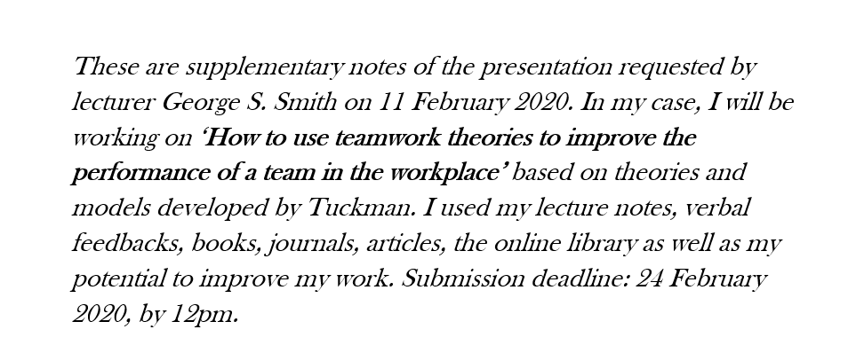

In 1965, Tuckman came up with "Tuckman's stages of group development" which are: Forming, Storming, Norming and Performing. This theory is still being applied by most teams, despite all the critiques.
Forming: Team members learn to know each other and make friendships. They’re excited about the task ahead. Newstrom and Scannell (1998) state that it’s when ‘team members get to develop a personal profile’ in dependency and inclusion. For example, when I started work at Escentual, I knew all my teammates’ names within a week, and we could have fun together.
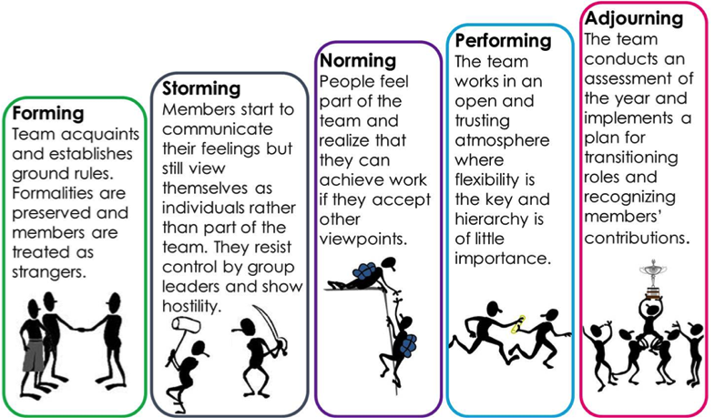
Storming: The manager’s authority is challenged, as team members fight for position. This is the stage when many teams fail. MindTools Team (2019) stipulate that team members may experience stress for lack of ‘a strong relationship with their colleagues.’ It’s a stage of instability characterized by counter-dependency.
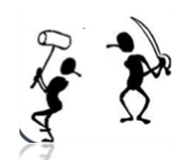
Norming: Hierarchy is established, co-operation develops, team’s “norms” are developed. Team members commit to team goal, and there’s progress. As per CMI (2013), it’s when team members are committed to their organisation’s goals and values, motivated to contribute to organisational success. It’s a stage of trust and structure.
Performing: Team members work mutually to achieve a common goal. Manager develops team/group members’ ability. It’s when roles are fully supported, and solutions are implemented to reach excellence in standards of working.
Thus, a manager must identify every stage and follow step-by-step the performance of their team. Hall (2003) defines this as a ‘systematic approach to increase overall organisational effectiveness.’
DIFFERENCE BETWEEN TEAMS & GROUPS:
The word ‘team’ can be defined in different ways, depending on different situations. Slater (2010) is defining a team as people working together in a committed way to achieve a common goal/mission.
To Morgan (2017), teams and groups are nearly the same, as both consist of ‘individuals working together to accomplish a common goal.’ The only difference is that in groups, people are put together, and, in teams, they’re chosen to be together. In fact, it’s all about individuals working as one to achieve a common goal to which they are all mutually committed. For example, I am a stock controller at Primark. My role is to control items we have in stock, but this doesn’t stop me from helping others to achieve a goal in displaying new items. I’m accountable to good achievement.

GROUP DYNAMICS is a description of the effects of roles and behaviours on group members. It’s about how a group is structured and how it functions. Drummond (2012) warns that bringing people together, giving them objectives and building them to work like a team regardless of body chemistry may not bring out the best in them. A well-sized group will develop clear communication and understanding. The study conducted on a group of Geese shows the importance of increasing visibility, flying in a V motion. They trust and support each other with an encouraging honking. They’re interdependent, standing by each other during trials/difficulties. Group members use to influence one another, and ‘some influences represent a group’s non-negotiable givens, some its dynamics and others its results’ (Barber, 2012).
Factors such as size, roles, norms and cohesiveness may affect a group behaviour, So, a group with a big number can likely face a challenge on visibility and clear communication, because ‘Communication is a key to understanding’ (Fakhoury, 2019). A clear communication is a very important factor to group/team development. So, a reflective manager needs management communication skills to be able to lead the group/team to higher performance. This helps them to collect, analyse and evaluate feedbacks. The correct use of tone, language and formality is a key to group/team development as shown in the lesson on the Geese. Using jargons in the workplace may be a barrier to good communication and a break to group/team development.
Moreover, Drummond (2012)observes that without a measure of harmony and cohesion, a group is likely to splinter apart.
To sum it up, an article writes, Bruce Tuckman’s model of the developmental sequence in small groups has rightly been adopted as a helpful starting point about possible stages or phases within different small groups.

Wellington, P. (2017) Effective people management, pp.170-172. Koran Page, London.
Newstrom, J. and Scannell, E. (1998) Team building games, p.3. McGraw-Hill Publishing Company, Glasgow.
Available at https://www.mindtools.com/pages/article/newLDR_86.htm (Accessed: 19 February 2020)
Chartered Management Institute (2013) Managing others: the organisational essentials, p.160. Profile Books Ltd, London.
Hall, A. (2003) Managing people, p.84. Open University Press, Berkshire.
Slater, R. (2010) Team management secrets, p.12. Happer Collins Publishers, London.
Morgan, P. (2017) The business student’s guide to study and employability, pp.203-204. Sage Publications Ltd, London.
Drummond, H. (2012) Guide to decision making: Getting it right than wrong, pp.68. Profile Books Ltd, London.
Barber, P. (2012) Facilitating change in groups and teams, p.135. Libri Publishing, Faringdon.
Fakhoury, M. (2019) The must have skill of the 21st century. Available at https://www.youtube.com/watch?v=RWvllvRbgr8&t=473s (Accessed: 12 February 2020).
Drummond, H. (2012) Guide to decision making: Getting it right than wrong, p.69. Profile Books Ltd, London.
Smith, M. (2019) Bruce W. Tuckman – forming, storming, norming and performing in groups. Available at http://infed.org/mobi/bruce-w-tuckman-forming-storming-norming-and-performing-in-groups/ (Accessed: 21 February 2020).

