Kinetic Energy Recovery

Kiera Ryman
2404390


University of Wales Trinity Saint David
Engineering Academic Discipline
Beng Motorsport Engineering

ACHA5010
Alternative Propulsion Systems

30/11/2025

Word Count: 1508

Contents
1 Introduction 3
2 Dynamic Characteristics 4
2.1 Test Mass 4
2.2 Frontal Area 4
2.3 Rolling Resistance Coefficient 4
2.4 Coefficient of Aerodynamic Drag 4
3 WLTP Test Procedure 5
4 WLTP Spreadsheets 6
5 KERS Power Input and Energy Storage Requirements 8
5.1 Natural Coast Down 8
5.2 Calculating the Maximum Energy Available for Recovery 8
5.3 Largest Power Inputs 9
6 Suitable KERS System 10
6.1 Pros and Cons of each system 10
6.2 Calculating values to determine KERS 11
6.3 Selected KERS 11
7 Kinetic Energy Recovered 12
8 System Operations 14
8.1 Operations 14
8.2 Driver Sensations 14
9 Conclusion 15
10 References 16

Introduction
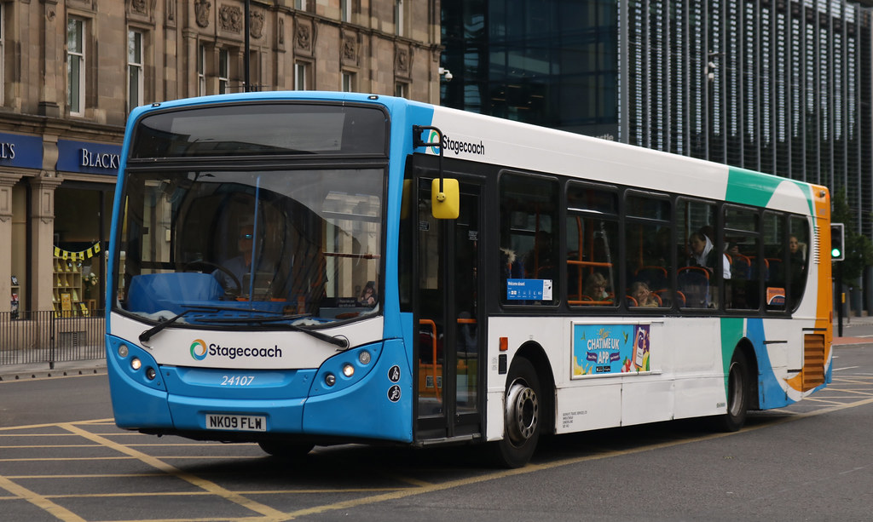
This report analyses the effects of introducing a Kinetic Energy Recovery System to an ENVIRO 300 single decker bus to reduce vehicle fuel consumption. This includes researching the dynamic characteristics of the bus, selecting the appropriate WLTP for the bus, specifying a suitable KERS system and plotting the kinetic energy recovered that is returned to the wheel road contact.
Figure 1 - ENVIRO 300 Single Decker Bus (flickriver, 2023)

Dynamic Characteristics

Test Mass
According to GOV.UK (2025) the running weight of an ENVIRO 300 is 11125kg based on an assumed passenger weight of 65kg, a length of 12m, a total passenger number 70 people and a kerb weight of 8850kg.

Frontal Area
The frontal area of the bus can be determined using the width (2.5m) and the height (3m) (Academic, 2010).
$A=W×H$ (Equation 1)
$A=2.5×3=7.5m^{2}$ (Equation 2)
Equation 2 shows that the frontal area of the bus on 7.5m².

Rolling Resistance Coefficient
While there is no specific data that exists on the rolling resistance coefficient of an ENVIRO 300, the tolling resistance coefficient of a heavy vehicle like a truck or bus is 0.006-0.01 (The Engineering Toolbox, 2008). From this, the rolling resistance coefficient can be determined to be 0.008.

Coefficient of Aerodynamic Drag
According to Bayindirli and Celik (2018), the aerodynamic drag coefficient of a bus in 0.633. This value was found during testing in a wind tunnel.

WLTP Test Procedure
To determine the correct WLTP cycle the ENVIRO 300 falls into, it is necessary to know the maximum velocity of the vehicle which is 62mph (Regional Transport, 2025) and the rated power which is 263kW (Volvo, 2025).
$Class Ratio=\frac{Ratio of rated power }{Kerb mass (kg)}$ (Equation 3)
$Class 1:Class Ratio≤22$ (Equation 4)
$Class 2: Class Ratio >22 but ≤34$ (Equation 5)
$Class 3: Class Ratio >34$ (Equation 6)
$Class Ratio=\frac{263000 }{11125}=23.64$ (Equation 7)
Looking at equations 3 and 7, the vehicle falls into WLTP class 2 (equation 5), meaning that this procedure will be used when analysing the vehicle.
Figure 2 - WLTP Class 2 Cycle Graph
Figure 2 shows the WLTP Class 2 graph which is created from the provided speed and time data from WLTP regulations.
Highlighted in red are some of the areas where the bus would be decelerating during the test procedure. Identifying these areas of braking is important to see where regenerative braking could be taking place.

WLTP Spreadsheets
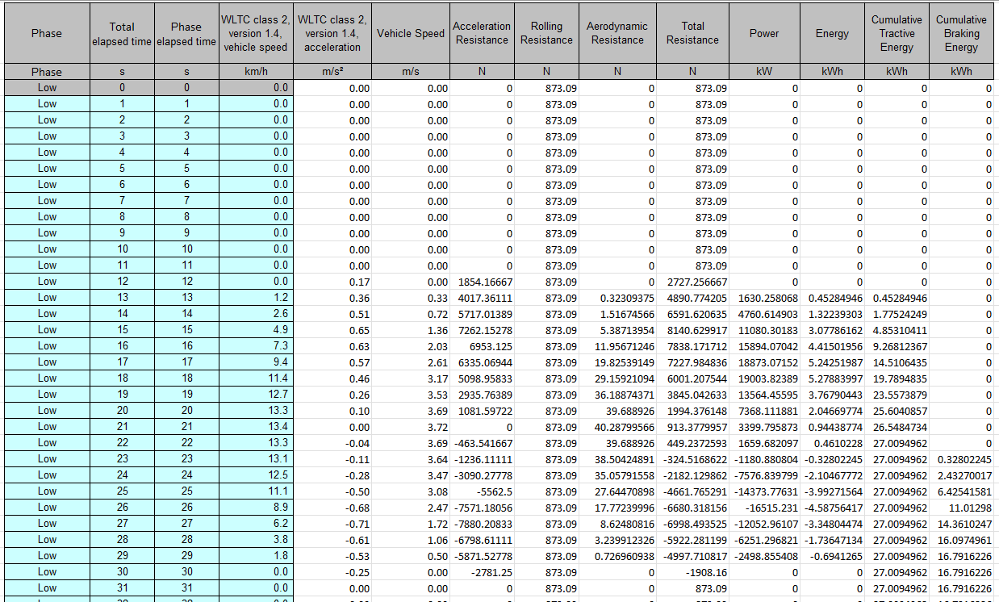
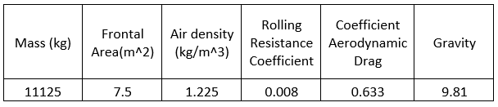
Using the data on the provided WLTP spreadsheet, as well as the researched values in Table 1 (The Engineering Toolbox, 2003), it was possible to create a graph shown in figure 3 showing the cumulative tractive and braking energy.
Figure 3 - Snapshot of data calculated to create graphs
Table 1 - Researched Values for WLTP
Figure 3 shows some of the data that was calculated to determine the cumulative tractive and braking energy. The values are calculated for every second across the entire cycle, allowing for any subsequent graphs that are made to showcase information about the entire cycle.

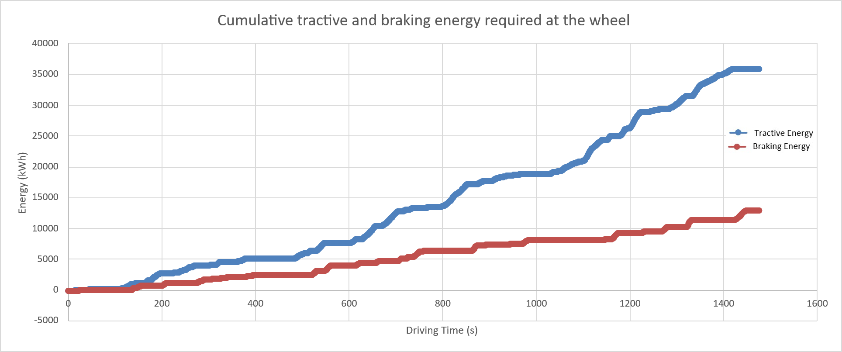
Figure 4 shows the cumulative and braking energy required at the wheel over the WLTP cycle. The braking energy has been changed from the initial negative values to positive values to fit the graph. This data is useful to look at when designing a regenerative braking system (Ehsani et al., 2018, p. 378). The energy dissipated in the low-speed range (before 150s) can be considered at insignificant as the energy lost can be left without compromising the energy recovered significantly. This is because the difference between the two lines shows the losses incurred during the cycle, and the space in between them here is so small.
Figure 4 - Cumulative tractive and braking energy required at the wheel over WLTP cycle

KERS Power Input and Energy Storage Requirements
Figure 5 - WLTP Cycle with callouts at beginning and end of braking sections
Figure 5 shows the entire WLTP Class 2 cycle, highlighting the largest areas of braking. These areas, highlighted in yellow, are the only largest areas where kinetic energy can be recovered as it is only possible when the bus is decreasing in speed.

Natural Coast Down
When looking at these areas where kinetic energy can be recovered, it is important to consider natural coast down. While the bus is driving, it can be assumed that the driver will not use the brake every single time the bus decelerates and that natural coast down will have an effect.
Natural coast down is where the driver will drive in a naturalistic manner and the car will decelerate when the brake pedal is not pressed, and the acceleration pedal has been released (Li et al., 2020).

Calculating the Maximum Energy Available for Recovery
From the largest areas of braking, it is possible to calculate the maximum kinetic energy that can be recovered using equation 8 (Sang, 2007, p.1) and equation 9. This data can then be used in the process of deciding what KERS system to implement.
${KE=\frac{1}{2}×m×V}^{2}$ (Equation 8)
$J=KE1-KE2$ (Equation 9)
Using equations 8 and 9, they can be combined to find the maximum kinetic energy that can be recovered can be calculated for all the braking areas highlighted in yellow:
$$J=\left(\frac{1}{2}×11125×{\left(\frac{67.2×1000}{60×60}\right)}^{2}\right)-\left(\frac{1}{2}×11125×{\left(\frac{0×1000}{60×60}\right)}^{2}\right)=1938.22kJ$$
$$J=\left(\frac{1}{2}×11125×{\left(\frac{67.1×1000}{60×60}\right)}^{2}\right)-\left(\frac{1}{2}×11125×{\left(\frac{34.2×1000}{60×60}\right)}^{2}\right)=1430.44kJ$$
$$J=\left(\frac{1}{2}×11125×{\left(\frac{75.5×1000}{60×60}\right)}^{2}\right)-\left(\frac{1}{2}×11125×{\left(\frac{46.3×1000}{60×60}\right)}^{2}\right)=1526.49kJ$$
$$J=\left(\frac{1}{2}×11125×{\left(\frac{40.9×1000}{60×60}\right)}^{2}\right)-\left(\frac{1}{2}×11125×{\left(\frac{0×1000}{60×60}\right)}^{2}\right)=717.98kJ$$
$$J=\left(\frac{1}{2}×11125×{\left(\frac{55.5×1000}{60×60}\right)}^{2}\right)-\left(\frac{1}{2}×11125×{\left(\frac{14.4×1000}{60×60}\right)}^{2}\right)=1233.06kJ$$
$$J=\left(\frac{1}{2}×11125×{\left(\frac{51.4×1000}{60×60}\right)}^{2}\right)-\left(\frac{1}{2}×11125×{\left(\frac{0×1000}{60×60}\right)}^{2}\right)=1133.94kJ$$
$$J=\left(\frac{1}{2}×11125×{\left(\frac{47.2×1000}{60×60}\right)}^{2}\right)-\left(\frac{1}{2}×11125×{\left(\frac{13.7×1000}{60×60}\right)}^{2}\right)=875.64kJ$$
Looking at these values, it is possible to calculate an average value for the energy that can be recovered across the KERS cycle. To do this, the two highest values can be ignored as these happen when the bus would be braking harshly from a relatively high speed to a low speed. This kind of driving is unlikely to happen with the stop/start city driving that the bus will be doing. Bearing this is mind, the average can be found to be 1078.21kW.

Largest Power Inputs
Looking at the power data calculated in figure 3, it is possible to find the largest value to determine the maximum power input. This can be seen to be 168.28kW, or around 170kW.

Suitable KERS System

Pros and Cons of each system
When determining a suitable KERS system to implement, it is important to consider all the pros and cons of each system:
Table 2 - Supercapacitor Pros and Cons
PROS | CONS
Have a very large storage capacity, as well as a high energy density (Yang, Luo & Li, 2017). | Doesn’t suit driving conditions that involve lot of lower speeds or harsh braking (Birch, 2025)
They are ideal for handling short, high-current pulses, ideal for stop-start driving (Qoitech, 2025). | They can add lots of extra weight to the vehicle (Sharma et al., 2019).
They have a long-life cycle and are low maintenance (Eureka, 2025). | May require sophisticated thermal management systems in case of high-power flows (Eureka, 2025).

Table 3 - Flywheel Pros and Cons
PROS | CONS
They can recharge quickly; this is ideal for when there is lots of harsh braking (Amiryar & Pullen, 2017). | Can be mechanically complex due to high-speed bearing and vacuum enclosures being required (Eureka, 2025).
An asynchronous flywheel is 93.4% efficient (Amiryar & Pullen, 2017). | Cannot store energy long-term for applications (NenPower, 2025).
Can be made less complex by using modular designs (Eureka, 2025). | They can experience catastrophic failure due to fatigue (Lu et al, 2023).
They have a long-life cycle (Eureka, 2025). | Might not be as effective at steady high speeds (Olabi et al., 2021).
They don’t suffer from chemical degradation or require disposal of chemical batteries (Budhlani et al., 2022). | They can’t store as much energy as other KER systems can (Burns, 2014)

Table 4 - Hydraulic KERS Pros and Cons
PROS | CONS
They have extremely high-power density (Eureka, 2025). | Some systems can increase vehicle weight significantly (Rensselar, 2012).
Useful in heavy-duty applications as they are robust (Eureka, 2025). | Vehicle must have enough space to accommodate the KERS (Rensselar, 2012).
They are around 74% efficient (Yoon et al., 2015). | Hydraulic KERS can be quite noisy (Dindorf, Takosoglu and Wos, 2023).
They are ideal in stop/start driving conditions due to the highly efficient regen system (EPA, 2016).

Calculating values to determine KERS
To select the correct KERS, it is important to first calculate what the system should be capable of storing and delivering.
The energy required to be stored has previously been calculated to be 1078.21kJ, along with the maximum power input of 170kW. This can be used to determine the time needed to deliver the energy:
$$\frac{1078.21kJ}{3600}=0.2995kWh$$
$$\frac{1078.21kJ}{170kW}=6s$$
Overall, the KERS selected needs 6s at 170kW to fill the energy storage with a capacity of 0.2995kWh.

Selected KERS
For the ENVIRO 300 bus, it makes sense to implement a supercapacitor KER system. This is for multiple different reasons:
- They have a long-life cycle and are low maintenance, making them ideal for buses which will be used for a long time.
- They are ideal for a stop/start driving style of a bus in a city.
- Although it might add lots of extra weight, it doesn’t matter as a bus isn’t designed for performance and already has a high overall mass.
- The motor selected for the system is very efficient at around 90% (Renault Group, 2021). The motor controller can also be up to 95% efficient (Lovati, 2023). Also, in vehicles, supercapacitors are around 98% efficient (Eaton, 2022). All these values together create a total efficiency of 70* (0.95×0.95×0.9×0.9×0.98×0.98).

Kinetic Energy Recovered
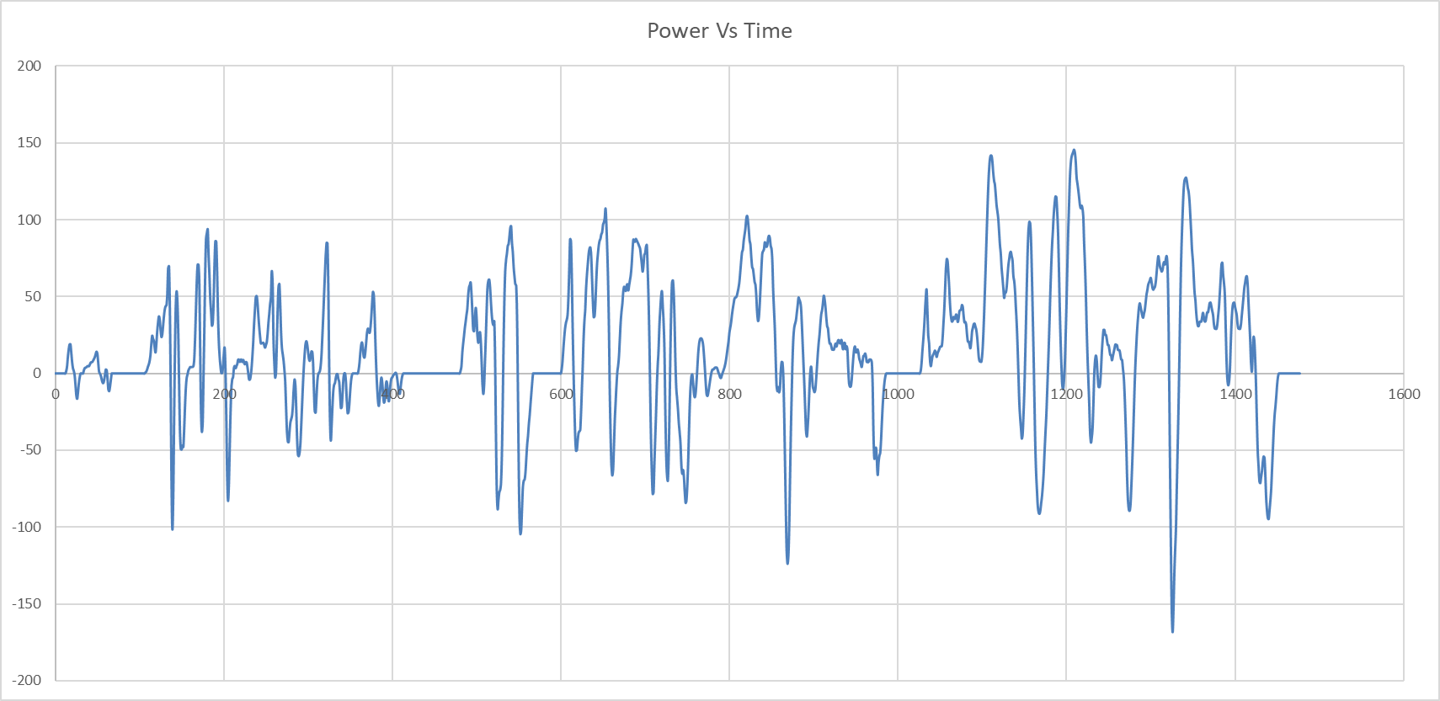
To determine the amount of kinetic energy that is recovered and returned, it is necessary to look at the braking energy vs time (figure 6):
Figure 6 - Power/Braking Energy Vs Time
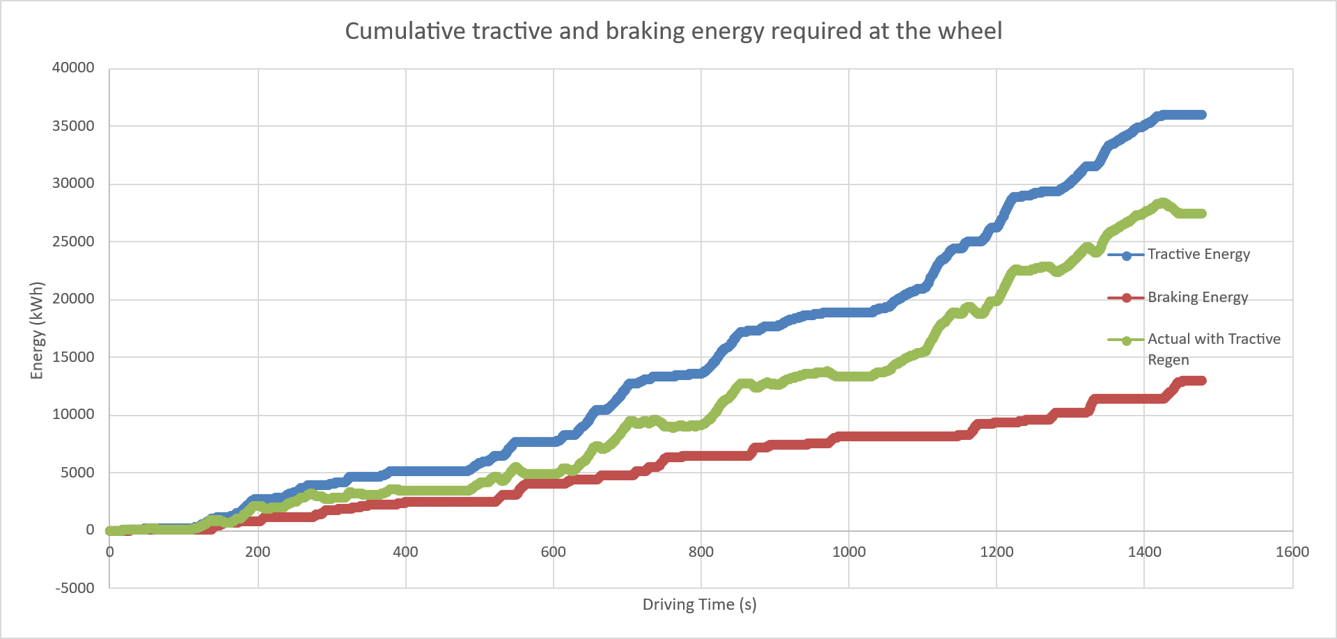
Looking at this, it is possible to determine what value to size the capacitor at. There are areas where the braking energy frequently reaches values around 80kW. Therefore, an 80kJ capacitor has been selected. Although there are areas where spikes go above this, the capacitor system will be fine as they aren’t very frequent and don’t last for a long time.
Figure 7 - Actual Tractive Regen at the Wheel
Using the value that the capacitor is set to be, along with the efficiency, it is possible to work out the actual tractive regeneration (figure 7), with the values calculated in figure 8.
Overall System Efficiency | Braking Energy capped at 80kW power | Cumulative energy available for recovery | Actual Recovered Energy | tractive -regen actual
0.70207641 | kJ | kJ | kJ | kJ

Figure 8 – Values required to calculate actual tractive regen

These values made it possible to plot actual tractive regeneration (figure 7). The graph shows the braking energy against the tractive energy, with the difference between them being the energy that would be lost without a KERS. However, with the designed KERS implemented, it is possible see the tractive regen, which shows the energy that is being regenerated.
Seeing the green tractive regeneration allows the KERS to be seen to be working. The amount of energy being regenerated is above the braking energy which means that the system is working. It is also below the cumulative tractive energy, which shows that the system is not unrealistic by regenerating more energy than is possible, but while still be fairly efficient.

System Operations

Operations
The designed supercapacitor KERS system operates by converting the kinetic energy that is present under braking into electrical energy that is then stored in a supercapacitor. This energy is then able to be used to provide a boost in acceleration (Energy Education, 2018). The conversion of this energy is done by a motor generator unit (Batalha, 2025). In this system, it was found to be 90% efficient.
When the stored energy in the supercapacitor is going to be used, it is redeployed and sent back through the motor generator unit (Energy Education, 2018). This allows the bus to get a boost of power when it is accelerating.

Driver Sensations
Implementing the KERS can cause some drivers to feel unfamiliar with their braking system (Eureka, 2025). The bus’ handling characteristics can be affected due to the varying levels of regen braking, along with the sudden boosts of power during acceleration.
Overall, the driver of the bus should feel that there is an efficiency gain. This is useful as the bus is doing lots of city driving frequently, causing the city council running the bus to be more sustainable.

Conclusion
In conclusion, implementing a KERS allows the ENVIRO 300 single decker bus to recover kinetic energy that would otherwise be lost under braking. This increases the efficiency of the bus by allowing the kinetic energy to be stored in the supercapacitor KERS and then using it to provide a boost in acceleration.
Ultimately, implementing a KERS system allows the bus to regenerate kinetic energy and be more efficient.

References
Academic (2010) Optare Tempo. Available at: https://en-academic.com/dic.nsf/enwiki/2418891 (Accessed: 20 October 2025).
Amiryar, M. E. & Pullen, K. R. (2017). A Review of Flywheel Energy Storage System Technologies and Their Applications. Applied Sciences, 7(3), 286. doi: 10.3390/app7030286. Available at: https://openaccess.city.ac.uk/id/eprint/17719/1/AmiryarandPullenA%20Review%20of%20Flywheel%20Energy%20Storage%20System_applsci-07-00286.pdf
Batalha, J. (2025) ‘Kinetic Energy Recovery Systems’, Automotive Electronics, unknown date. Available at: https://cecas.clemson.edu/cvel/auto/AuE835_Projects_2009/batalha_project.html
Bayindirli, C. and Celik, M. (2018) ‘The experimentally and numerically determination of the drag coefficient of a bus model’, International Journal of Automotive Engineering and Technologies, 7(3), pp. 117-123. Available at: https://dergipark.org.tr/tr/download/article-file/579107
Birch, R. (2025) ‘Regenerative braking: how does EV and hybrid car brake energy regeneration work?’ Auto Express, 15 July 2025. Available at: https://www.autoexpress.co.uk/tips-advice/353643/regenerative-braking-what-it-and-how-does-it-work
Budhlani, J., Bhutada, M., Chhabria, S., Bhutan, H., Peddi, V. and Chougule, S. (2022). ‘Design and Analysis of Flywheel based Kinetic Energy Recovery System’, International Journal of Automotive Engineering and Technologies, 9(1), e-ISSN: 2395-0056. Available at: https://www.irjet.net/archives/V9/i1/IRJET-V9I172.pdf
Burns, C. (2014) ‘Can flywheel technology drive out the battery from car hybrids?’, The Guardian, 27 January. Available at: https://www.theguardian.com/science/blog/2014/jan/27/flywheel-hybrid-flybrid#:~:text=So%20despite%20the%20fact%20that,flywheel%20for%20the%20short%20stuff.
Dindorf, R., Takosoglu, J. and Wos, P. (2023) ‘Review of Hydro-Pneumatic Accumulator Models for the Study of the Energy Efficiency of Hydraulic Systems’. Energies, 16(18), 6472. Available at: https://www.mdpi.com/1996-1073/16/18/6472
Eaton (2022) The major differences between supercapacitors and batteries (White Paper ELX1150). Available at: https://eepower.com/uploads/articles/eaton-supercapacitor-vs-batteries-white-paper-elx1150-en.pdf (Accessed: 27 November 2025).
Ehsani, M., Gao, Y., Longo, S. and Ebrahimi. K. (2018) Modern Electric, Hybrid Electric, and Fuel Cell Vehicles. Third Edition. Boca Raton: CRC Press
Energy Education (2018) Kinetic energy recovery system. Available at: https://energyeducation.ca/encyclopedia/Kinetic_energy_recovery_system (Accessed: 29 November 2025).
EPA (2017) Hydraulic Hybrid Research. Available at: https://archive.epa.gov/otaq/technology/web/html/research-hhvs.html (Accessed: 26 November 2025).
Eureka (2025) Mechanical complexity reduction through advanced KERS. Available at: https://eureka.patsnap.com/report-research-on-mechanical-complexity-reduction-through-advanced-kers-kinetic-energy-recovery-system (Accessed: 26 November 2025).
Flickriver (2023) Stagecoach: 24107 NK09FLW MAN 18.240/Alexander Dennis Enviro 300. Available at: https://www.flickriver.com/photos/emdjt42/52962770318/ (Accessed: 29 October 2025).
GOV.UK (2025) Bus Specifications. Available at: https://view.officeapps.live.com/op/view.aspx?src=https%3A%2F%2Fassets.publishing.service.gov.uk%2Fmedia%2F5a78bbd940f0b63247699be5%2Fbuslength.xls&wdOrigin=BROWSELINK (Accessed: 29 October 2025).
Li, S., Li, P., Yao, Y., Han, X., Xu, Y., and Chen, L. (2020) ‘Analysis of drivers’ deceleration behavior based on naturalistic driving data’, Traffic Injury Prevention, 21(1), 42-47. Available at: https://www-tandfonline-com.ezproxy.uwtsd.ac.uk/doi/epdf/10.1080/15389588.2019.1707194?needAccess=true
Lovati, S. (2023) ‘Overview of Motor Control in Electric Vehicles’, Power Elecronic News, 20 April. Available at: https://www.powerelectronicsnews.com/overview-of-motor-control-in-electric-vehicles/
Lu, J., Zheg, H., Haider, M.H., Feng, Y., Zhi, P., Cheng, J. and Wang, Z. (2023) ‘Fracture failure analysis of flywheel hub served in heavy-fuel aviation piston engine’, Engineering Failure Analysis, 151(2023), 107363. Available at: https://www.sciencedirect.com/science/article/pii/S1350630723003175
NenPower (2025) What are the disadvantages of flywheel energy storage? Available at: https://nenpower.com/blog/what-are-the-disadvantages-of-flywheel-energy-storage/
Olabi, A. G., Wilberforce, T., Abdelkareem, M. A. and Ramadan, M. (2021) ‘Critical Review of Flywheel Energy Storage System’, Energies, 14(8), 2159. Available at: https://www.mdpi.com/1996-1073/14/8/2159
Qoitech (2025) Did you know? Supercapacitor. Available at: https://forum.qoitech.com/t/did-you-know-supercapacitor/559
Regional Transport (2025) Regional Transport Frequently asked questions. Available at: https://regionaltransport.co.uk/rt_005.htm (Accessed: 30 October 2025).
Renault Group (2021) The energy efficiency of an electric car motor. Available at: https://www.renaultgroup.com/en/magazine/energy-and-motorization/the-energy-efficiency-of-an-electric-car-motor/
Rensselar, J. V. (2012) ‘Power to spare: Hydraulic Hybrids’ Society of Tribologists and Lubrication Engineers, TLT Cover Story January 2012. Available at: https://www.stle.org/files/TLTArchives/2012/02_February/Cover_Story.aspx
Sang, D. (2007) Physics 2. 7th edn. Cambridge: Cambridge University Press.
Sharma, S., Narayan, Singh, A.N., Yadav, R. Jha, A., Vanshaj, K and Fahim, M. (2019) ‘Regenerative Braking System’ International Journal of Trend in Scientific Research and Development, 3(4), e-ISSN: 2456 – 6470. Available at: https://www.ijtsrd.com/papers/ijtsrd23546.pdf
The Engineering Toolbox (2003) Air Density, Specific Weight, and Thermal Expansion Coefficients at Varying Temperatures and Pressures. Available at: https://www.engineeringtoolbox.com/air-density-specific-weight-d_600.html (Accessed: 20 November 2025).
The Engineering Toolbox (2008) Rolling Resistance. Available at: https://www.engineeringtoolbox.com/rolling-friction-resistance-d_1303.html (Accessed: 29 October 2025).
Volvo (2025) Volvo B8R 4X2 Technical Specification. Available at: https://www.volvobuses.com/content/dam/volvo-buses/markets/australia/brochures/volvo-b8r-brochure/specifications/Data-sheet-B8R-4x2-Euro-6.pdf (Accessed: 3 November 2025).
Yang, Y., Luo, C. and Li, P. (2017) ‘Regenerative Braking Control Strategy of Electric-Hydraulic Hybrid (EHH) Vehicle’, Energies, article 1038. Available at: https://www.researchgate.net/publication/381279444_Regenerative_Braking_Control_Strategy_of_Electric-Hydraulic_Hybrid_EHH_Vehicle
Yoon, H., Kim, E., Kim, M., Lee, J., Lee, G. and Ahn, S. (2015) ‘Towards greener machine tools – A review on energy saving strategies and technologies’ 48(August), pp. 870-891. Available at: https://www.sciencedirect.com/science/article/pii/S1364032115002609

