The 1960 Spartacus Film based off of the book by Howard Fast is a serious look on the tale of Spartacus, showing his journey around Italy during the third servile war. It is the origin of the popularly quoted phrase “I am Spartacus!” The film had some heavy censorship, not being able to show much violence apart from one fight scene towards the end and the crucifixions. Furthermore, it had some Hollywood glamour to it, including a relationship with a woman that Fast fabricated for the sake of plot. Something which is alluded to in Plutarch’s work but apart from that, there is no real mention of a woman being in Spartacus’ life. The movie itself focuses on various issues such as slavery, corrupted leaders, ignorance of those in power all whilst presenting it in this classical background. The Book by Fast was made in 1951. The world was still recovering from the second world war during this time and there was still slavery in the world at this point.
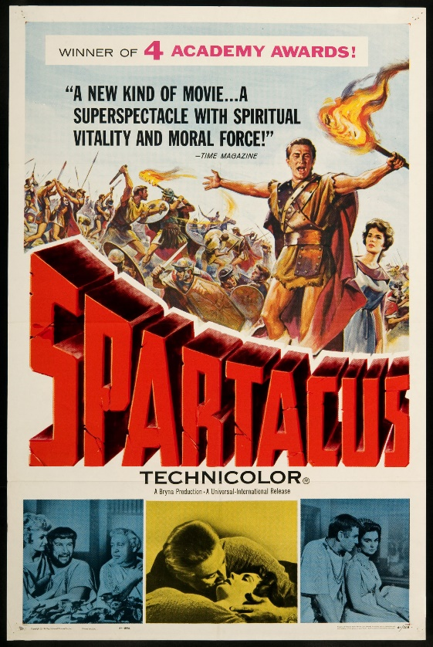

The 1913 film, whilst silent due to the time that it was produced in, offered a rather more brutal and war focused account of the war and focuses more on Crassus than the 1960 version does. The film paints the slaves as the evil in the film. This account focus’ more on what our ancient sources were focused on; Crassus. There is a more serious note within this film, reflecting the serious nature of the world during this period in time.
Generally, any published novels depicting Spartacus are done from a historical standpoint and seek to show what Spartacus and Italy were going through at the time of the war. For example, Fast’s ‘Spartacus’ book, which was the basis for Stanley Kubrick’s movie in 1960, does not seek to do much else than tell an account of the third servile war with the added romance in. Fast highlights the effects of oppression on people and how such a system will eventually lead to uprising against the system by the oppressed. ‘The Gladiators’ by Arthur Koestler shows how the war effected the Roman Republic and what that meant for politics; he was influenced by the political issues in Europe at the time due to the rise of communism in 1939.
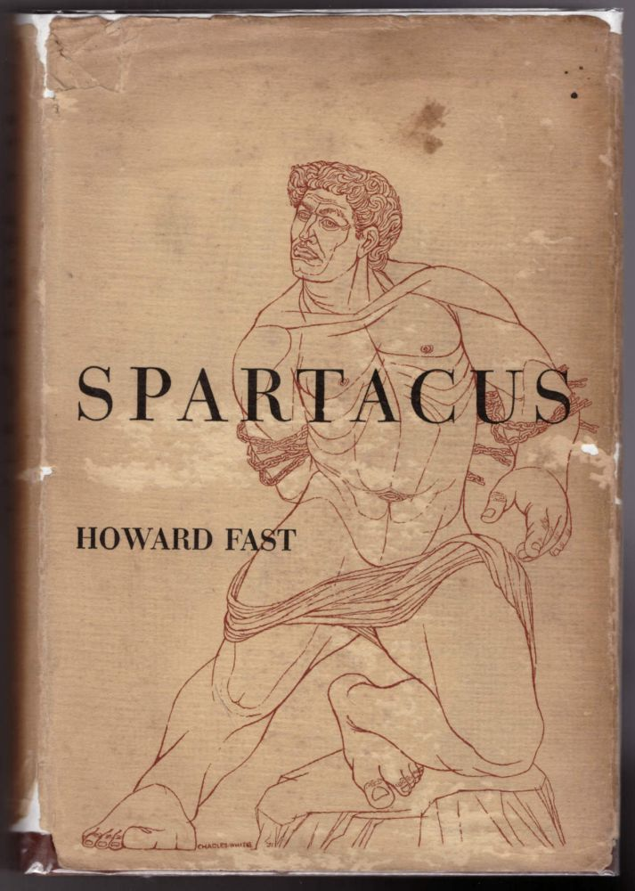
As the tale of Spartacus spreads to a multi-media medium, it begins to get more and more dramatized; such as in the program ‘Heroes and Villains’ which was produced by the BBC. The episode on Spartacus (2008) shows Spartacus’ story in a very simplified manner due to the time limits. Furthermore, there is the inclusion of the wife. Adding a love interest into Spartacus’ life seems to be something which was popularised by the Kubrick movie and book by Fast. There is not any conclusive evidence of Spartacus having a love interest during his time as a gladiator and as a slave. In ancient sources, Plutarch is the only one who really mentions a wife and his account of such is inconclusive due to the sheer problematic fact that it would be unlikely that a wife Spartacus had in Thrace would be sold with him and remain by him at the gladiator school. Apart from this fact, the episode for Spartacus does appear to be trying to show an account close to truth. Unfortunately, it is remarked by reviewers that the historical inaccuracies of the episode mean that it should be taken as little more than a BBC fictionisation of an event. It is described as a drama so it is only to be expected that the tale is bent to cater to a wider audience. This account is not made to reflect current political or moral struggles that are going on in the world, as many of the literature pieces are, which furthers the lack of need to have anything more than a vague story behind the episode.
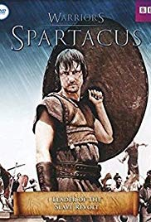
The 2010 adaptation of the story of Spartacus is ‘Spartacus: Blood and Sand’ is similarly presented in this dramatized way. It was the first of four seasons in production by Steven S. DeKnight and had various other media associated with it, including games (both digital and table top) and comics. J.M Clements also based a novel off of the first season and then a second book was made by Mark Morris. This adaptation was given mediocre scores by critics. Much like many modern made dramas which have to capture an audience, they used violence and sex to keep the plot interesting to some views. Others found this crass and vulgar, commenting that if a show is truly good, it should not have to rely on sex to keep its viewers interested. Unlike with the Kubrick movie in 1960, the censorship laws have been relaxed considerably, meaning that these things were allowed to be shown more on screen. Much like with the BBC production, this piece is not influenced by external factors like political struggle. It is a show which uses a part of history which is greatly popular in order to make money. However, it does seem to try to rationalise several issues that historians and scholars have with Spartacus. Firstly, the origin of his name; it was not common for a slave to carry a personal name from their former life, the show makes a point of naming the character of Spartacus and doing so after the name of the powerful Thracian kings. There are also insights into how people became slaves (such as a need to pay debts or war prisoners). And yet again, we have this need to include a love interest in Spartacus’ life, one which has come up a considerable amount of times in the modern adaptations of the tale of this Thracian leader. The story of Spartacus and the three servile wars is gone into a great mount of depth, the entire story spanning over the four seasons. It could be remarked that modern adaptations are more focused on making something which an audience will find captivating than displaying just historical accuracies.

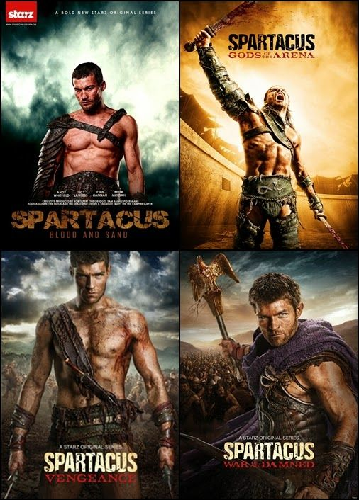
Word Count: 1113

Bibliography
Clements, J.M. (2012) Spartacus: Swords and Ashes. Titan Books.
Fast, H. (1951). Spartacus. Blue Heron Press.
Koestler, A. (1939). The Gladiator.
Morris, M. (2012). Spartacus: Morituri (Spartacus 1). Titan Books.
Spartacus. (1913). Vidali, Enrico. [Film]. Italy.
Spartacus. (1960). Kubrick, Stanley. [Film]. United States: Universal International.
‘Spartacus’ (2008). Heroes and Villains. Series 1 Episode 3. BBC One Television. 13 February.
Spartacus: Blood and Sand (2010). Starz. 22 January

Ancient Sources:
Plutarch. Crassus. 8

Spartacus. 1960.
Fast. 1951
Spartacus. 1960
Plutarch. Crassus. 8
Fast. 1951
Spartacus. 1960
Spartacus. 1913
Spartacus. 1960
Fast. 1951.
Spartacus. 1960
Fast. 1951
Koestler. 1939
Fast. 1951
Spartacus. 2008
Spartacus. 1960
Fast. 1951
Plutarch. Crassus. 8
Spartacus. 2008
Spartacus: Blood and Sand. 2010
Clements. 2012
Morris. 2012
Spartacus. 1960
Spartacus. 2008
Spartacus: Blood and Sand. 2010. Spartacus: Gods of the Arena. 2012 Spartacus: Vengeance. 2012 Spartacus: War of the Damned. 2013
Spartacus: Blood and Sand. 2010. Spartacus: Gods of the Arena. 2012 Spartacus: Vengeance. 2012 Spartacus: War of the Damned. 2013

