Analyse the Networks and Discuss its Security Postures
Declan Shipley
2303938
Analyse the Networks and Discuss its Security Postures
Network and Cyber Security Essentials

Contents
Purpose of the Report 2
The Role of the NIST Cybersecurity Framework 3
Tools Used in the Reconnaissance Stage of a Cyber Attack 5
Mitigation Strategies for Malware 6
Phishing Attacks and How to Mitigate Them 7
Creation of a Secure Network Design 8
Implementation in Packet Tracer 9
Software and Hardware Improvements 9
Certificates of Completion 10
Introduction to Packet Tracer 10
Palo Alto Network Security Fundamentals 11
Palo Alto Cybersecurity Foundation 11
References 12

Purpose of the Report
Within this report, the role and purposes of various network systems/framework will be documented and explained, and how they are used in order to both attack and defend a network system, both of which are critically important, as discussed here [1]. Topics included are:
- NIST Cybersecurity Framework & it’s importance,
- Nmap & Wireshark and their uses in cyber-attacks,
- Mitigation Strategies
- Phishing Attacks
- Creation of a secure network design
- Possible improvements of the network security
- Proof of Certificates.

The Role of the NIST Cybersecurity Framework
One of the most important tools for safeguarding digital assets and personal information is the NIST Cybersecurity Framework. The National Institute of Standards and Technology (NIST) created this framework to help organisations manage cybersecurity risk in an organised manner in response to the growing frequency and sophistication of cyber threats [2]. Fundamentally, the NIST Cybersecurity Framework provides standards, best practices, and guidance to assist organisations in recognising, identifying, defending against, responding to, and recovering from cybersecurity incidents. Organisations can and should create strong cybersecurity programmes that are customised to their unique requirements and risk profiles by adhering to these recommendations, the importance of which is discussed in this [3] article.
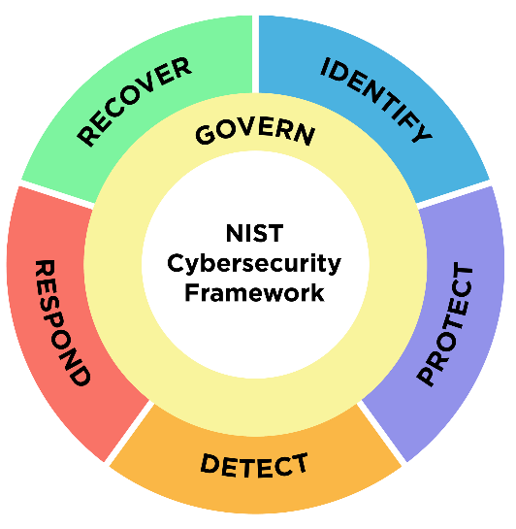
Figure 1: The NIST Cybersecurity Framework
The NIST Cybersecurity Framework's emphasis on risk management is one of the main ways it protects digital assets and personal data [4]. Through comprehensive risk assessments, entities can detect possible weaknesses and dangers to their data and systems. This makes it possible for them to put in place the proper safeguards and controls to successfully reduce these risks.
In addition, the framework fosters ongoing monitoring and development, which supports a proactive approach to cybersecurity. Organisations are encouraged to continually evaluate their security posture, adjust to changing threats, and adopt updates and enhancements as needed [5], instead of seeing cybersecurity as a one-time activity. This continuous procedure lowers the possibility of successful cyberattacks by assisting organisations in staying ahead of developing threats and vulnerabilities. The NIST Cybersecurity Framework's emphasis on cooperation and communication is another important feature. By giving organisations, a standard vocabulary and set of guidelines, the framework facilitates effective internal and external stakeholder communication regarding cybersecurity risks and strategies. This promotes a collaborative approach to cybersecurity, which is crucial in today's linked digital ecosystem [6]. It also makes it easier for departments within an organisation to collaborate with one another as well as other organisations in the same industry or supply chain.

Furthermore, for regulatory compliance, the NIST Cybersecurity Framework is an invaluable tool. It is now simpler for organisations to prove compliance with legal and regulatory requirements as a result of the adoption of the framework as the foundation for cybersecurity legislation and standards by numerous industries and jurisdictions. This practice not only mitigates financial penalties and fines for organisations but also fosters more trust and confidence among stakeholders, partners, and customers.
In conclusion, the NIST Cybersecurity Framework is essential for protecting digital assets and sensitive personal information because it gives businesses a methodical way to manage cybersecurity risk, as well as encourages proactive teamwork in the field, and makes regulatory compliance easier. Organisations can improve their cybersecurity posture and better defend themselves against cyber threats in the increasingly digital environment by adhering to the framework's standards.

Tools Used in the Reconnaissance Stage of a Cyber Attack
During the reconnaissance stage of a cyberattack, which is when the attackers gather important information on the target, the tools “Nmap” and “Wireshark” are essential tools that help attackers obtain important data about target networks.
A programme for scanning networks called Nmap makes reconnaissance easier by identifying hosts, services, and open ports. An attacker may use Nmap, for example, to perform a ping scan and find the hosts that are currently active on a network. Furthermore, by using Nmap's port scanning features, an attacker can find possible points of entry into the network, like open TCP ports that can be found by doing a TCP SYN scan, however it can be used in order to troubleshoot and improve security, as detailed in this book [7].
A packet sniffing programme called Wireshark records and examines network traffic to help with reconnaissance [8]. With Wireshark, an attacker can listen in on network conversations and see device configurations and network topology. Wireshark can also record traffic in order to find services or protocols that are susceptible. Attackers, for instance, can identify service versions and configurations by capturing and analysing traffic, which helps identify vulnerabilities that can be exploited.
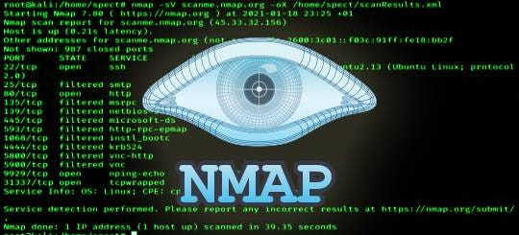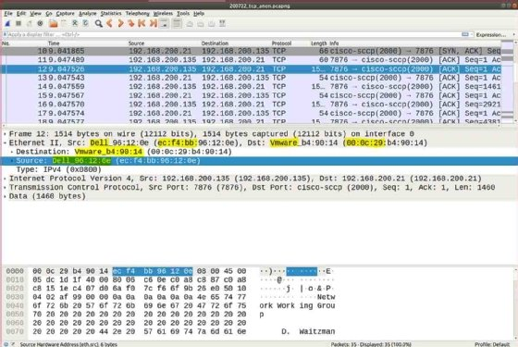
Figure 2: Wireshark
Figure 3: Nmap
To sum up, Nmap and Wireshark are essential tools for network reconnaissance since they help find hosts, open ports, and security holes in target systems. Nmap can scan a network to find open ports and active hosts, and Wireshark can capture network traffic to find network topology and vulnerable services. Attackers can obtain important information by successfully utilising these technologies, which helps them plan and carry out successful cyberattacks.

Mitigation Strategies for Malware
Though they function in different ways, the well-known malware programmes "WannaCry" and "TeleRAT" both seriously jeopardise cybersecurity, the extent of which is discussed in this [9] book.
"WannaCry" is a ransomware program that spreads through a vulnerability in Windows operating systems, particularly targeting unpatched systems. On compromised PCs, it encrypts files and requests a Bitcoin ransom to unlock them. The malware takes advantage of the EternalBlue vulnerability, which the NSA created first and the hacker collective Shadow Brokers later disclosed. WannaCry quickly spreads over networks once a system is compromised, encrypting files, and interfering with normal operations.
There are, however, some mitigation strategies [10] for this programme, these include:
- To fix known vulnerabilities, update and patch operating systems and software on a regular basis.
- Divide networks into segments to stop malware from spreading. Limit access to vital information and systems in order to lessen the impact of infections.
- Inform consumers about the prevalence of WannaCry infection vectors, such as phishing scams and dubious email attachments. Staff members should be reminded to use caution when opening emails or clicking on links from unidentified sources.
The remote access trojan (RAT) known as "TeleRAT," on the other hand, enables attackers to access compromised devices without authorization. It disguises itself, frequently via malicious links or attachments, by seeming to be trustworthy programmes or files [11]. Once installed, TeleRAT lets attackers to remotely manipulate the infected device, steal important information, and conduct surveillance activities without the user's awareness.
Again, there are simple but effective mitigation methods we can use, which are:
- Use intrusion detection systems and antivirus software as endpoint protection measures to find and stop malware infections. Update security software to maintain optimal performance.
- Use application whitelisting to prevent the execution of files and programmes that are not authorised. Organisations can stop the installation and operation of malicious software by limiting the programmes that are allowed to operate.
- Keep an eye on outgoing connections to known TeleRAT command-and-control servers as well as any unusual activity occurring on the network.
In conclusion, even if WannaCry and TeleRAT function in distinct ways, cybersecurity is nonetheless seriously threatened by both. Organisations can protect themselves against these malware threats and lessen the impact they have on operations and data security by putting proactive mitigation strategies into place, such as patch management, network segmentation, and more, detailed in this [12] book.

Phishing Attacks and How to Mitigate Them
Phishing attacks, which can be sophisticated and include variations like "Whaling" and "Pharming," take use of both technological and human flaws to infiltrate systems or steal confidential data [13].
Phishing attacks of the "whaling" variety target prominent figures in an organisation, including executives or senior management. Perpetrators compose individualised and persuasive emails with the intention of tricking recipients into divulging private information, including bank account numbers or login credentials. Attackers raise their chances of success by posing as reliable sources or using information that is readily available to the public. Listed below are some effective mitigation strategies:
- Train and Educate staff members about the dangers of phishing scams and how to spot dubious communications [14].
- Use Multi-Factor-Authentication programmes to bolster security measures beyond passwords. Make it necessary for prominent people to authenticate with two or more factors.
- Implement email filtering systems that make use of sophisticated threat detection methods to recognise and stop them. Increase the precision of email filtering by utilising machine learning techniques, whitelists, and blacklists.
Another type of phishing assault called "pharming" entails secretly diverting website traffic to phoney websites [15]. In order to drive users to malicious websites intended to steal sensitive information, such as login credentials or financial details, attackers hack DNS servers or alter hosts files on compromised devices. Some mitigation strategies include:
- To verify DNS responses and stop DNS spoofing attacks, use DNS security mechanisms. Keep an eye out for irregularities and indications of interference in DNS traffic.
- To encrypt data in transit and defend against man-in-the-middle attacks, promote the usage of HTTPS for website connections. Make sure that trustworthy certificate authorities provide SSL/TLS certificates to genuine websites, and that these websites use HTTPS.
- Protect hosts and endpoints from Pharming attacks by installing endpoint protection software that identifies and stops malicious activity, configuring firewalls and intrusion detection/prevention systems, and updating operating systems and applications on a regular basis.

Creation of a Secure Network Design
In order to create a secure and efficient network, the use of a “Mesh” topology will be implemented. A mesh topology allows for high-speed data-transfer, as well as a high level of resilience of node failure, as each node has multiple paths of communication, which eliminates single points of failure, increasing availability [16]. It’s also easy to identify network faults, making it easy to keep secure as faults can be more easily identified. Below is a diagram that details the topology.
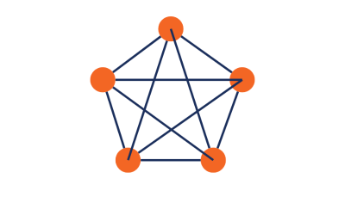
Figure 4: Mesh Topology

Implementation in Packet Tracer
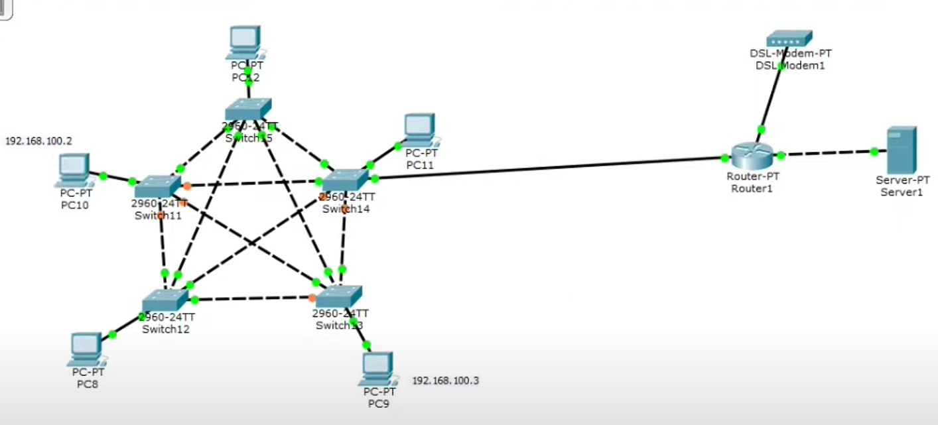
Figure 5: Mesh Topology in Packet Tracer

Software and Hardware Improvements
Some further improvements can be made using specific pieces of software and hardware, in order to make it more secure and reliable whilst in operation. These include:
- Mesh Networking Software: Utilize mesh networking software that supports robust encryption protocols (such as WPA2 or WPA3) to secure communications between nodes. This ensures that data transmitted within the mesh network is protected from eavesdropping and interception.
- Mesh Networking Software: Utilize mesh networking software that supports robust encryption protocols (such as WPA2 or WPA3) to secure communications between nodes. This ensures that data transmitted within the mesh network is protected from eavesdropping and interception.
- Mesh Networking Software: Utilize mesh networking software that supports robust encryption protocols (such as WPA2 or WPA3) to secure communications between nodes. This ensures that data transmitted within the mesh network is protected from eavesdropping and interception.
By implementing these software and hardware components, organizations can strengthen security measures within a mesh network topology, protecting against various cyber threats and ensuring the confidentiality, integrity, and availability of network resources and data.

Certificates of Completion

Introduction to Packet Tracer
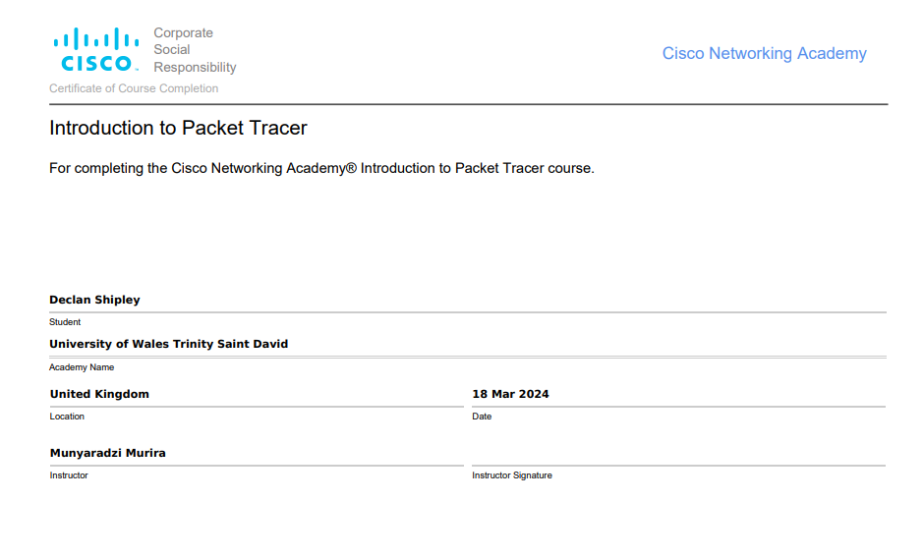
Figure 6: Introduction to Packet Tracer

Palo Alto Network Security Fundamentals
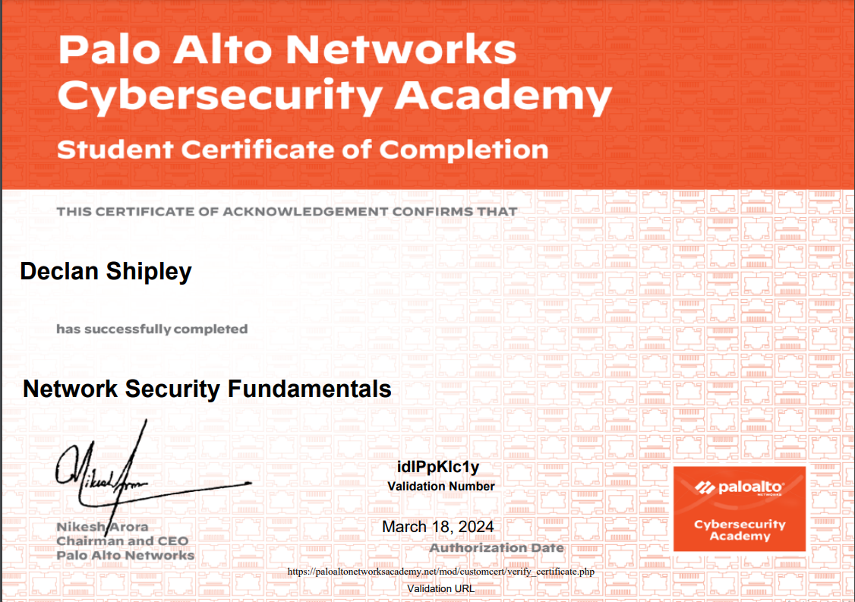
Figure 7: Network Security Fundamentals

Palo Alto Cybersecurity Foundation
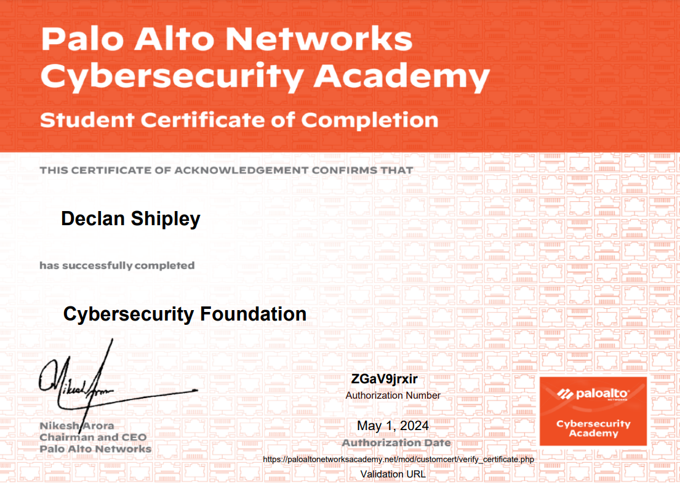
Figure 8: Cybersecurity Foundation Certificate

References

[1] | P. Dowd and J. McHenry, “Network security: it's time to take it seriously,” Computer, vol. 31, no. 9, pp. 24-28, 1998.
[2] | K. Barbara, E. W. Bernroider and W. Roman, “Evaluation of Cybersecurity Management Controls and Metrics of Critical Infrastructures: A Literature Review Considering the NIST Cybersecurity Framework,” Secure IT Systems, vol. 11252, pp. 369-384, 2018.
[3] | A. Alison, L. Dennis and K. Lam-For, “Security modelling for organisations,” Computer and Communications Security, pp. 241-250, 1994.
[4] | G. B. White and S. Natalie, Research Anthology on Business Aspects of Cybersecurity, IGI Global, 2022.
[5] | Security Metrics, “6 Ways to Make Data Security Consistent in Your Business,” Security Metrics, [Online]. Available: https://www.securitymetrics.com/blog/6-ways-make-data-security-consistent-your-business.
[6] | U. Prof. Ms. Tejaswini, “Importance of Cyber Security in Digital Era,” International Journal for Research in Applied Science and Engineering Technology, vol. 9, no. 8, pp. 963-966, 2021.
[7] | O. Angela and P. Becky, Nmap in the Enterprise: Your Guide to Network Scanning, Elsevier, 2011.
[8] | B. Usha, V. Ashutosh and S. Makul, “Evaluation of the Capabilities of WireShark as a tool for,” International Journal of Computer Applications, vol. 6, no. 7, pp. 1-5, 2010.
[9] | S. Ed and Z. Lenny, Malware: Fighting Malicious Code, Prentice Hall Professional, 2004.
[10] | N. Kolokotronis and S. Stavros, Cyber-Security Threats, Actors, and Dynamic Mitigation, CRC Press, 2021.
[11] | TitanFile, “7 Types of Computer Malware and How to Prevent Them,” TitanFile, 14 May 2021. [Online]. Available: https://www.titanfile.com/blog/types-of-computer-malware/.
[12] | N. Conteh, Ethical Hacking Techniques and Countermeasures for Cybercrime Prevention, IGI Global, 2021.
[13] | J. Lance, Phishing Exposed, Elsevier, 2005.
[14] | S. Tomasz, “Training in shaping employee information security awareness,” Entrepreneurship and Sustainability Issues, vol. 7, no. 3, pp. 1832-1846, 2020.
[15] | Fortinet, “What Is Pharming and How To Protect Against Attacks,” Fortinet, 2024. [Online]. Available: https://www.fortinet.com/resources/cyberglossary/pharming#:~:text=Pharming%20is%20online%20fraud%20that.
[16] | BBC Bitesize, “networks,” BBC Bitesize, [Online]. Available: https://www.bbc.co.uk/bitesize/guides/zvspfcw/revision/9#:~:text=Having%20nodes%20arranged%20in%20a,no%20node%20should%20be%20isolated.

Figure 1: The NIST Cybersecurity Framework 3
Figure 2: Wireshark 5
Figure 3: Nmap 5
Figure 4: Mesh Topology 8
Figure 5: Mesh Topology in Packet Tracer 9
Figure 6: Introduction to Packet Tracer 10
Figure 7: Network Security Fundamentals 11
Figure 8: Cybersecurity Foundation Certificate 11

