Blog Link - https://sway.office.com/nC0hjo86teyHqm0a?ref=Link

The ever-evolving Education system, are theorists still having an impact on learning environments today??
Did Dewey make a difference?
It is no secret that learning environments can be a challenging, especially with the greater need for a more inclusive system and higher demands on the pastoral side of the job. Theorists have impacted and contributed to a wealth of change in education over many decades. One theorist said to be pivotal in the movement of education is John Dewey. One of the most influential parts of his theory was placing a child at the centre of education experiences (Sikandar 2016). Who was Dewey and what lead to his theory?
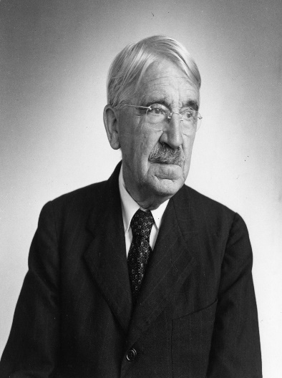
Dewey was born in 1859 and became a philosopher who also taught in several universities. Dewey is said to have written over 1000 pieces of work over his lifetime (Biography.com Editors 2014). Dewey based his theories on pragmatism. Pragmatism is the opposite to an idealist education. Idealist education is being taught information that is not relevant to you or your life. Pragmatism is learning information that is relevant and interests you. Involving learners in the environment around them.
Dewey’s theory involved pragmatism, but he also progressive education. What’s progressive education? Progressive Education is what Dewey considered as fundamental in a child’s education, he believed that children learn best through doing. Ask yourself how do you learn best? Personally, I have always learnt best by doing, feeling, and experiencing.
(Biography.com Editors 2014)
Alan Pritchard describes ‘for Dewey each child is unique, formed through a combination of genetics and experience’ (Pritchard 2017a, p.119). Pritchard leads onto establish that Dewey believed education was not just about factual knowledge being departed into learners but about it being a whole experience (Pritchard 2017b, p.119).
Dewey had four principles of learning related to his theory.
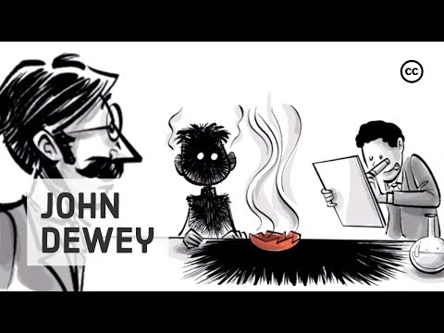
Click on the link for a video on Dewey’s four principles of learning.

(Sprouts Schools 2021b)
The video outlined the following core principles,
- Experiential learning – Children learn best when doing. When learners are engaged, they absorb information. Learners learn from making mistakes.
- Discussion – Dewey believed learners should have open and honest discussions about the world and environment around them. Learning to adapt thoughts and perceptions relating to the real world.
- Interactive – Learner’s environments should be interactive making the subject more engaging.
- Interdisciplinary – Continuity to allow learners to build on a depth of knowledge that they already hold. Using skills that are transferable to different subjects. (Sprouts Schools 2021c).
Experimental learning is a term used that also means learning by doing. Dewey was passionate about children being unique and learning by actively doing things rather than just being spoken at. Dewey proclaimed that teachers had the key to awakening a child’s learning. In 1987 Dewey stated that,
‘The teacher is not in the school to impose certain ideas or to form certain habits in the child but is there as a member of the community to select the influences which shall affect the child and to assist him in properly responding to these influences’ (Dewey 1897a).
Dewey emphasised that the more experience a child has the more growth they can obtain which in turns allows for more learning. Dewey’s theory was ahead of it’s time. But Dewey didn’t stop here when it came to his theories!! John Dewey advanced his theory on experimental learning by integrating curriculum design. Curriculum design was a term used by Dewey, he thought that education should promote the growth of a learner. He believed that learners should be at the heart of decision making when it came to their education and he denoted to this as flexible curriculum (Bates 2019a, p.276).
Here are some of the core principles of a flexible curriculum:
- The discovery of learning through interaction and doing.
- Use tools and resources that interest a learner.
- Find out what interests the learner.
- Allow learners to communicate their feeling and thoughts within the school environment.
- Allow learners to make mistakes and learn and improve from them.
- Encourage a learner to find what they are passionate about.
Dewey said, ‘I believe that education, therefore is a process of living and not a preparation for future living’ (Dewey 1897b). What do you think? Did Dewey have lasting impact on our current education system? Was he a pioneer in education? Take a look at the new ALN reform and see what is at the heart of it!!
Was Froebel instrumental?
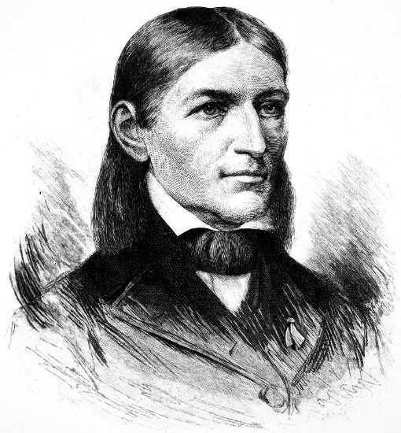
Now let’s look at another theorist who is said to have had a lasting effect on our education system. Fredreich Froebel, a German man born in 1782 and died in 1852. What was it that he did to be classed as a pioneer in educational theorists? Well Froebel was the innovator in what we know as kindergartens or preschools. Froebel saw the importance of children learning from a young age, he recognised that they are like little sponges in their early years, able to absorb and retain information. Froebel believed that children should learn through natural environments and informal surroundings.
Although I have called this a theory Froebel saw his ideas as an approach. An approach to help early childhood development and strategies in a natural environment, developed through play.
Unlike many educational theorists Froebel was not a lecturer or philosopher, he had many jobs before joining a school of Frankfurt where he observed the ideas of Pestalozzi. Although Pestalozzi influenced Froebel, Froebel had strong ideas on what he wanted his approach to be (Tovey 2017b, p.9).
(Fine Art America 2012)
Froebel opened his first school in 1837. The Froebel approach was an idea that he saw the setting as,
‘a community where children could grow and learn at their own pace, with adults who understood their development and cultivated their learning, just as good gardeners tend to young plants’ (Tovey 2017b, p.10).
What are the principles in the Froebel approach?
- Freedom with guidance – allow a child to learn by themselves with guidance from educators
- Unity, Connectedness and Community – Creating strong links and relationships between learners, their environment and home life. Creating unity in a learner’s life.
- Engaging with nature – Using nature as much as possible to fulfil educational experiences.
- Learning through self-activity and reflection – Allowing learners to do things by themselves, not always holding their hands or being ready to catch them when they fall
- The central importance of play – A learner having fun and enjoying what they do is at the forefront of the approach.
- Creativity and the power of symbols – allowing learners to be their true creative selves, not standing in their way.
- Knowledgeable and nurturing educators – Educators need to build good relationships, nurture, and observe and get to know learners to develop their playing experiences to challenge a child (Tovey 2017a).
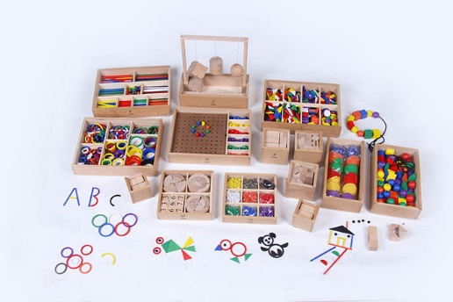
What was Froebel’s main aim? Froebel wanted children to take risks, fail in order to overcome obstacles and play in an environment that was natural. Learners using the environment around them to learn and develop their social skills (Bruce 2012, p.xiii). Being in the great outdoors. I mean what isn’t to love about that as an approach.

In this picture you will see what Froebel labelled as gifts and occupations. Gifts were things that would remain as their natural form once they had been used and occupations would take on their new form after being used. This was part of Frobel’s approach.
Let’s look at Froebel’s intention behind the use of gifts and occupations.
(Froebel complete set [no date])
Froebel saw these instruments as a way for children to learn. The materials were objects that couldn’t be manipulated but could be used to build, explore different shapes and structures (Bates 2019b, p.208). Learners would need to learn from mistakes made and use problem solving skills to succeed in play. Take the building of a tower in an early year setting, learning the skill to place the blocks on top of each other, balancing the blocks and ascertaining which blocks fit on which shapes. Seldom does this go right the first time. But what does happen every time the tower falls is the child learns to have a go in a different way or keep persevering. Skills they will undoubtedly use in later life.
Occupations can be seen as more creative. The materials can be manipulated, cut, stuck or drawn. These allow learners to express themselves and problem solve. Frobel saw the occupations as equally as important as gifts. Both
So, was Froebel instrumental in our education system? Ask yourself this, do we use gifts, occupations, and outdoor learning as part of our curriculum in the early years today?
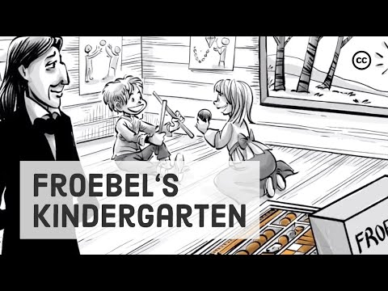
Before we move on look at the sprouts clip on Froebel. It sums up his work in a clear and concise way.

(Sprouts Schools 2021a)

Do Dewey and Froebel fall into one of theoretical approaches to learning?
Both Dewey and Froebel have different approaches to learning. But fundamentally they both see the learner as being instrumental in the decisions being made to their education.
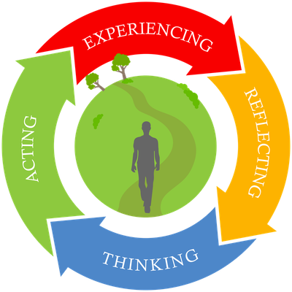
Let’s look at where Dewey falls in terms of theoretical approaches. Dewey is said to be a pragmatist. A pragmatist can be defined as ‘Pragmatists believe that reality must be experienced’ (Jordan 2014). Dewey believed in a hands-on approach where learners take part in activities. Under this approach Dewey developed experimental learning.
What does an experimental learning classroom look like? Unlike traditional ideologies of a classroom Dewey wanted the environment to be interactive and engaging. Group work, student collaboration, discussions, and interaction to expand knowledge and develop growth were all part of his ideas.
A chance for learners to experience new things and build on prior knowledge. ‘In Dewey's view, children should be allowed to explore their environments.’ (Jordan 2014b).
(Experienced Based Learning Systems [no date])

Part of Dewey’s approach is interdisciplinary – a term used by him that meant a cross over of subjects. What you learn in one class doesn’t dictate that you cannot broaden on that subject matter in another class. He wanted children to build strong foundations of knowledge by learning subjects in more than one environment (Ralston 2011). I will discuss his matter further on in the blog as I have seen first-hand the benefits of this in my educational setting.
Although Dewey has been labelled a pragmatist you could also argue that his approach comes under social constructivism and even constructivism.
Do we think that Dewey’s approach is the only way for children to learn?
Froebel was classed as a constructivist. The term ‘constructivism is about learning being active, contextualised process of constructing knowledge rather than acquiring it’ (Reis 2014).
But the term is broad, and a number of educational theorists come under constructivism with largely different approaches.
Froebel had his own plan. Froebel saw the importance of early education but not in a pedagogy way. Froebel wanted children to build on early experiences by learning through play. A natural environment that was created to allow children to be creative and free. A kindergarten was formed.
Froebel’s approach was to educate young children by allowing them to learn from making mistakes, build on previous knowledge. Froebel’s approach incorporated rewards of gifts and occupations. Simple but effective materials that children could use to play with. Take a look at some of them in the blog above. How many of us have sat and built towers from wooden blocks, created structures out of sticks and made models out of modelling clay. Children still use these materials daily not just at home but in the early years’ environment. All these gifts and occupations awaken children’s visual, kinaesthetic, and auditory senses of learning.
Bates suggests that critics of Froebel think that not enough emphasis in early years settings is on academia and subjects such as reading, writing and numeracy (Bates 2019c, p.209). What do you think? I think in current early years settings they encompass all of these into the play that children take part in.
It’s a testament to Froebel today to see that early year’s centres, kindergartens, preschools what ever they may now be known, are seen to be paramount in the development of young children. How many of us have seen children thrive in these environments?
When you read the above blogs on Froebel and Dewey did you see similarities? Dewey and Froebel believed that children were both at the forefront of learning, they both wanted children to build on experiences around them. They also both had the ideologies that classrooms should be of an andragogy environment and not pedagogy.
Dewey and Froebel mention the importance of the professional in both of its approaches. Vygotsky another educational theorist who was another contributor of constructivism names this person as the more knowledgeable other (MKO). Although theorists have been labelled and put into boxes with regards to their theoretical approaches, do you think they can fall into more than one category? Do you see the cross over? I think in both the approaches of Dewey and Froebel you can see connections.
What resources and strategies are used in my educational setting?
With Dewey and Froebel both singing from the same hymn sheet when it came to person centred approach, I think its key to note that the setting I currently work in is currently under the new Additional Learning Needs reform. An act by parliament with the main aim of placing children at the heart of all decisions being made. Learners with ALN will have a voice in what happens in their entire education experience. Within the guidance the Welsh Government state ‘The Act requires that the views of children, their parents and young people should always be considered as part of the planning process’ (Welsh Government 2018).
The new ALN reform also pushes for unity between communities, education settings and home environments. An approach that Dewey had even back in the 1800’s.
My education setting also follows what Dewey named a ‘flexible curriculum’. Learners within the secondary school I work in learn about a topic in more than one subject area.
Take history, geography, and religious studies. In one subject the topic has been based on Chernobyl, another nuclear weapons, and another the nuclear bombing of Hirashima. All topics are relatable and require the building of prior knowledge which relates back to both Dewey and Froebel approaches. It also creates greater engagement from learners as they understand the topics in each subject better.
This is also part of the vision of the new curriculum for Wales which is currently being rolled out across the country. The aim is for a much more flexible curriculum that encompasses cross curricular skills.

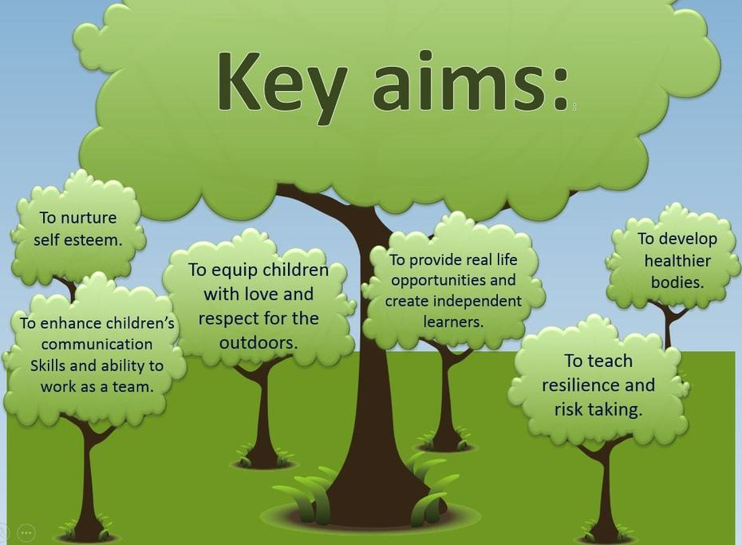
A strategy that my secondary setting also uses is forest schools. When you look at what defines a forest school it just resonates with Froebel. Forest school is a person-centred approach with the idea that children go out into nature and be themselves. Forest schools were derived to allow learners to develop intellectually, physically, emotionally, and socially. They want learners to take risks and learn from what they do, use problem solving skills to adapt to situations in an ever-changing environment, and feel a sense of accomplishment when they do (Forest School Association [no date]). All of these can be put into Froebel’s principles outlined in the blog above.
(Colebrook Junior School 2021)
I have the privilege of seeing the children arrive back from forest school, soaking wet, covered in mud all telling tales about the experiences they have had.
Although the strategies and resources outlined above do take place in my secondary setting and can be related back to both Dewey and Froebel. I do feel like in my setting these resources and strategies are only available if you fall into a certain category. Dewey and Froebel wanted their approaches to reach everyone. I hope more learners get the chance to enjoy these strategies especially forest school!! I hope I get to experience it soon as well.

Reference list
Bates, B. 2019a. Learning theories simplified: ...and how to apply them to teaching: 130+ theories and models from great thinkers. London: Sage Publications., p. 276.
Bates, B. 2019b. Learning theories simplified: ...and how to apply them to teaching: 130+ theories and models from great thinkers. London: Sage Publications., p. 208.
Bates, B. 2019c. Learning theories simplified: ...and how to apply them to teaching: 130+ theories and models from great thinkers. London: Sage Publications., p. 209.
Berkeley Graduate Division 2019. Overview of Learning Theories | GSI Teaching & Resource Center. Available at: https://gsi.berkeley.edu/gsi-guide-contents/learning-theory-research/learning-overview/ [Accessed: 29 October 2021].
Biography.com Editors 2014. John Dewey. Available at: https://www.biography.com/scholar/john-dewey [Accessed: 27 October 2021].
Bruce, T. 2012. Early childhood practice: Froebel today. Los Angeles: Sage., p. xiii.
Colebrook Junior School 2021. Forest School Key aims. Available at: https://www.colebrook-jun.swindon.sch.uk/curriculum/forest-school [Accessed: 29 October 2021].
Dewey, J. 1897a. My Pedagogic Creed. School Journal 54, p. pp. 77-80.
Dewey, J. 1897b. My Pedagogic Creed. School Journal 54, p. pp. 77-80.
Experienced Based Learning Systems [no date]. Video 8 things to know about the experiential learning cycle | Experience Based Learning Systems, LLC (EBLS). Available at: https://learningfromexperience.com/themes/experiential-learning-theory-videos/ [Accessed: 29 October 2021].
Fine Art America 2012. Fredreich Froebel. Available at: https://fineartamerica.com/featured/friedrich-froebel-1782-1852-granger.html [Accessed: 28 October 2021].
Forest School Association [no date]. What is Forest School? | Forest School Association. Available at: https://forestschoolassociation.org/what-is-forest-school/ [Accessed: 29 October 2021].
Froebel complete set [no date]. Available at: https://www.handmadecharlotte.com/wp-content/uploads/2014/07/Froebel-Complete-Set2.jpg [Accessed: 29 October 2021].
Jordan, A. 2014a. John Dewey on Education: Impact & Theory - Video & Lesson Transcript | Study.com. Available at: https://study.com/academy/lesson/john-dewey-on-education-impact-theory.html [Accessed: 29 October 2021].
Jordan, A. 2014b. John Dewey on Education: Impact & Theory - Video & Lesson Transcript | Study.com. Available at: https://study.com/academy/lesson/john-dewey-on-education-impact-theory.html [Accessed: 29 October 2021].
Pritchard, A. 2017a. Ways of learning: learning theories for the classroom. London; New York: Routledge, Taylor & Francis Group., p. 119.
Pritchard, A. 2017b. Ways of learning: learning theories for the classroom. London; New York: Routledge, Taylor & Francis Group., p. 119.
Ralston, S.J. 2011. Interdisciplinarity: Some Lessons from John Dewey. SSRN Electronic Journal 1(2). doi: 10.2139/ssrn.1711255.
Reis, R. 2014. Teaching and Learning Theories | Tomorrow’s Professor Postings. Available at: https://tomprof.stanford.edu/posting/1505 [Accessed: 29 October 2021].
Sikandar, A. 2016. John Dewey and His Philosophy of Education. Journal of Education and Educational Development 2(2), p. 191. doi: 10.22555/joeed.v2i2.446.
Sprouts Schools 2021a. Froebel’s Kindergarten: The Origins of Early Childhood Education – Sprouts — Free Videos for Schools and Learning. Available at: https://sproutsschools.com/froebels-kindergarten-the-origins-of-early-childhood-education/ [Accessed: 28 October 2021].
Sprouts Schools 2021b. John Dewey’s 4 Principles of Education. Available at: https://youtu.be/y3fm6wNzK70 [Accessed: 27 October 2021].
Sprouts Schools 2021c. John Dewey’s 4 Principles of Education. Available at: https://youtu.be/y3fm6wNzK70 [Accessed: 27 October 2021].
Tovey, H. 2017a. A FROEBELIAN APPROACH. Froebel Trust. Available at: https://www.froebel.org.uk/uploads/documents/FT-Froebels-principles-and-practice-today.pdf [Accessed: 28 October 2021].
Tovey, H. 2017b. Bringing the Froebel approach to your early years practice. London; New York: Routledge, Taylor & Francis Group., p. 9.
Tovey, H. 2017c. Bringing the Froebel approach to your early years practice. London; New York: Routledge, Taylor & Francis Group., p. 10.
Welsh Government 2018. ADDITIONAL LEARNING NEEDS AND EDUCATION TRIBUNAL (WALES) ACT., p. 7. Available at: https://gov.wales/sites/default/files/publications/2018-04/additional-learning-needs-and-education-tribunal-wales-act-2018-explanatory-memorandum.pdf [Accessed : 29 October 2021].

