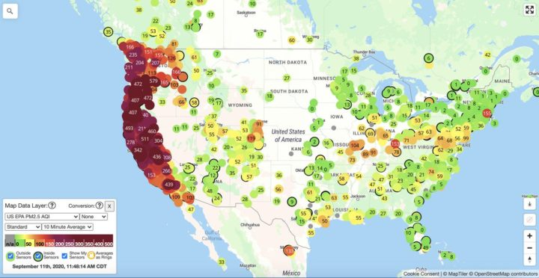
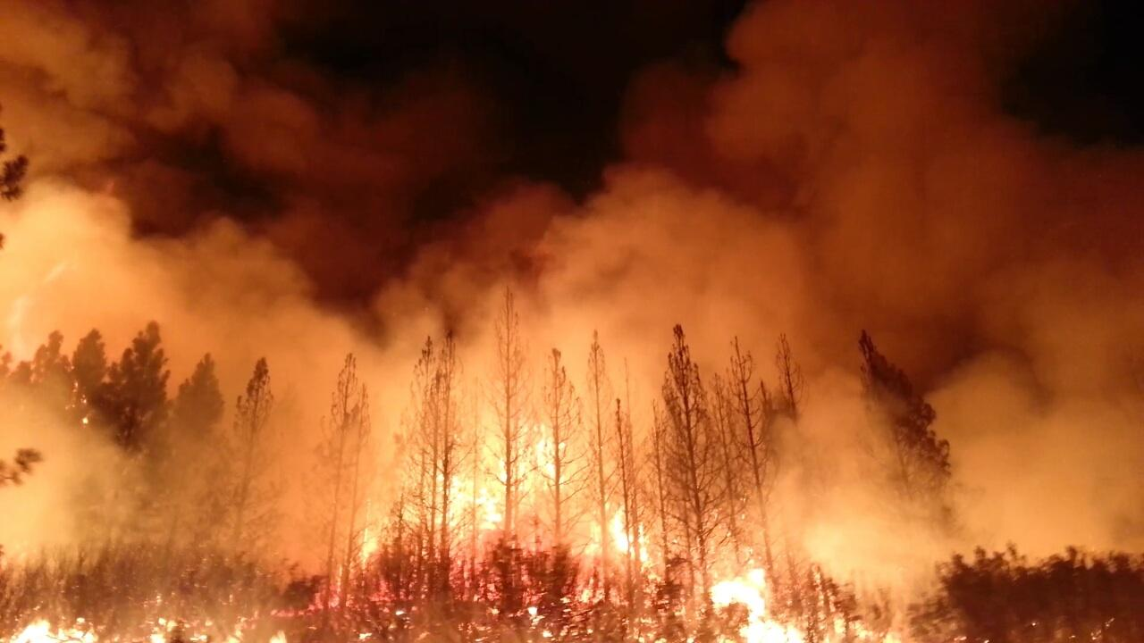
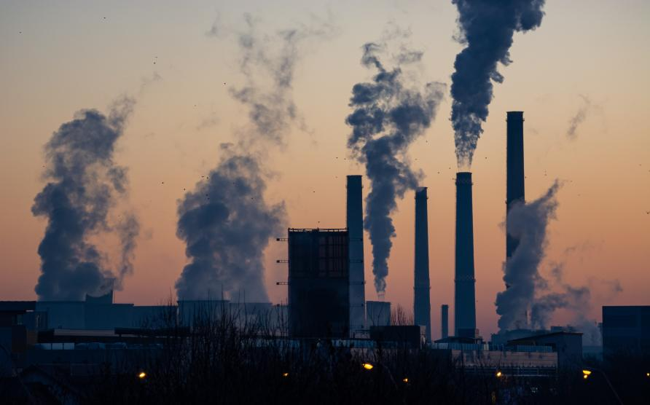
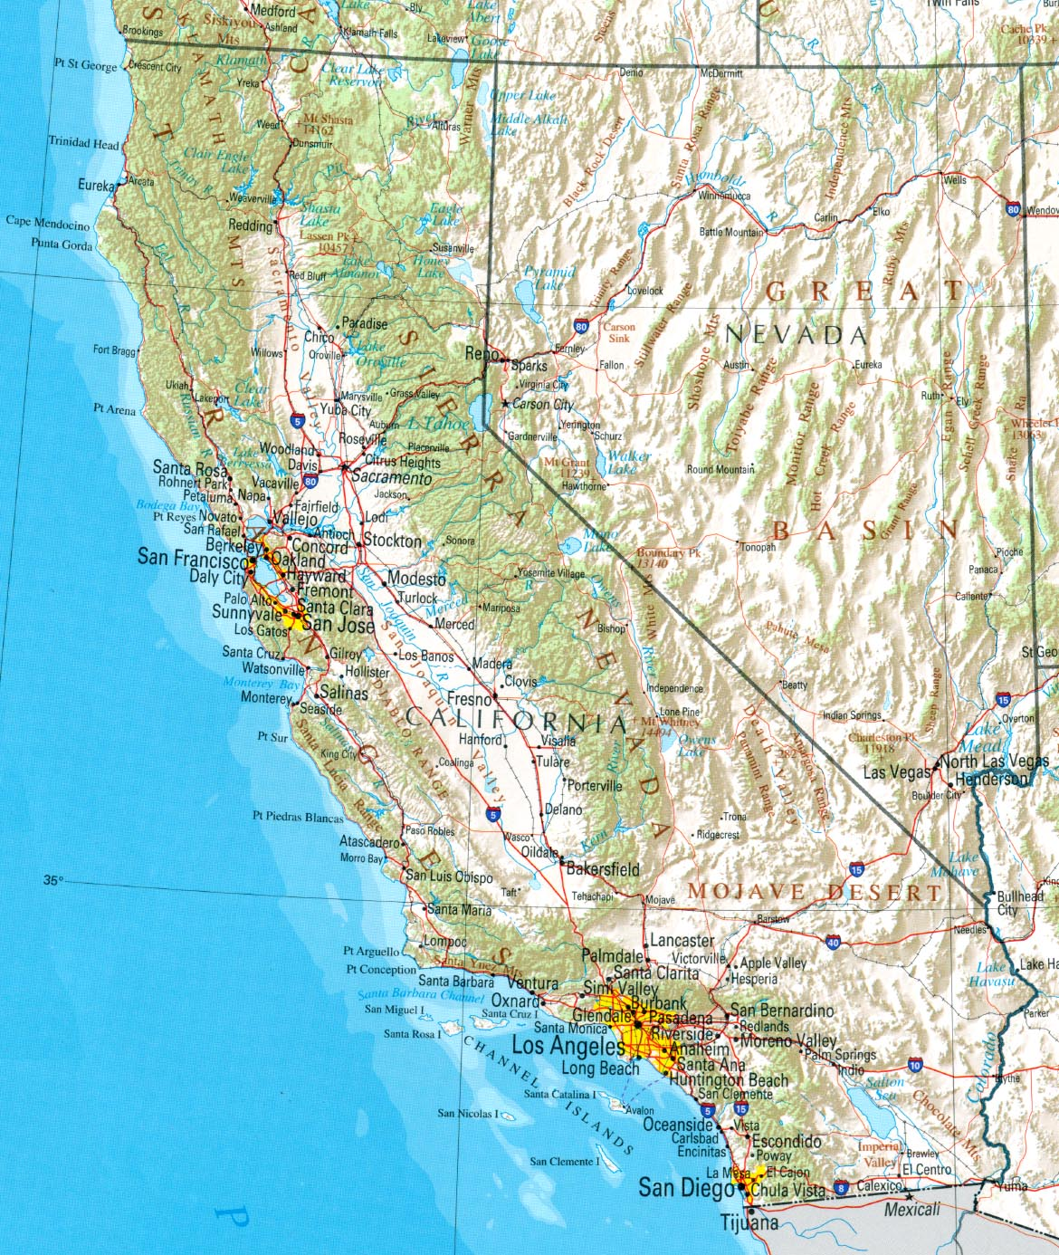
Why was California so affected by COVID 19?
This Photo – California pollution map
This Photo – California forest fires
This Photo – California pollution
This Photo – California Map

California and COVID-19
  - Charlotte Morgan
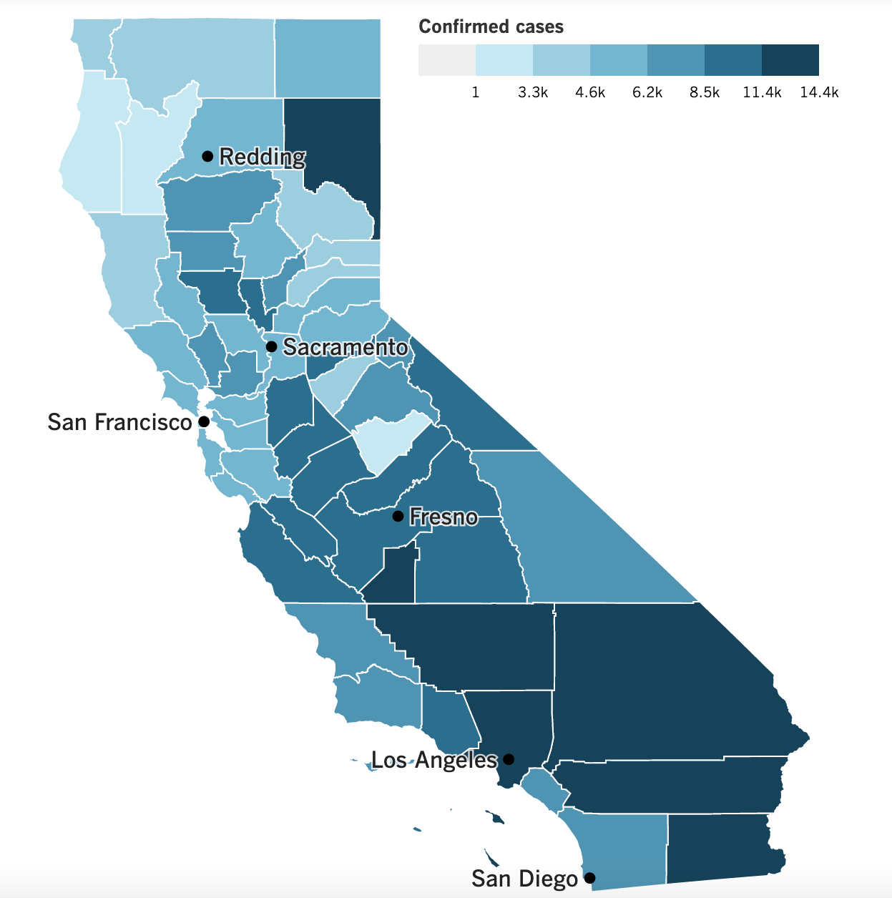
- 1 out of every 11 people in the state has tested positive (LA Times, 2020).
Figure 1: Map of COVID cases per county
- The state has averaged 8,000 new cases and 374.7 new deaths per day (LA Times, 2020).
- Southern counties seem to be more affected (LA Times, 2020) – why is this?
- California named one of the most affected states in the US (Bashir et al., 2020).
- One of the primary reasons for such a high infection rate is low air quality, greenhouse gas emissions and environmental pollutants (Bashir et al., 2020).
- Research has shown that long term exposure to pollutants such as fine particulate matter (PM2.5), nitrogen dioxide (NO₂) and sulphur dioxide (SO₂) can reduce lung function and cause respiratory illness (Cole et al., 2020).

How did the pandemic affect air quality in California?
Implementation of lockdown restrictions in the US, and subsequently California, has resulted in activities such as industrial projects, construction projects and transportations becoming stagnant (Greenstone and Nigam, 2020). These restrictions will have negative implications for the economy, however, are likely to have some positive implications on the environment. One notable positive impact is that on air pollution in California. As the state observes social distancing and quarantine orders, the natural environment has been given ‘healing time’ (Bashir et al., 2020). In particular, air quality has been impacted and there have been reports that smog has given way to blue skies (Bashir et al., 2020).

However, some warn that the initial impacts of lockdowns on the environment might not have been as impactful as first hoped. Satellite monitoring and roadway data show that nitrogen oxides linked to automobiles were down worldwide after lockdowns began, sometimes by as much as 50% in certain locations (Plautz, 2020). Although this is a large reduction in emissions, this reduction could have little impact on the total concentrations of pollutants that have accumulated in the atmosphere for decades (Zambrano-Monserrate et al., 2020).

References

Bashir, M. F. et al. (2020) ‘Correlation between environmental pollution indicators and COVID-19 pandemic: A brief study in Californian context’, Environmental Research, 187, p. 109652. doi: 10.1016/j.envres.2020.109652.
Cole, M., Ozgen, C. and Strobl, E. (2020) Air Pollution Exposure Linked To Higher COVID-19 Cases And Deaths - Air Quality News, Air Quality News. Available at: https://airqualitynews.com/2020/07/21/air-pollution-exposure-linked-to-higher-covid-19-cases-and-deaths/ (Accessed: 16 February 2021).

Greenstone, M. and Nigam, V. (no date) ‘Does Social Distancing Matter?’, SSRN Journal, pp. 2020–26. doi: 10.2139/ssrn.3561244.
Los Angeles Times Staff (2020) California Coronavirus Cases: Tracking The Outbreak, Los Angeles Times. Available at: https://www.latimes.com/projects/california-coronavirus-cases-tracking-outbreak/ (Accessed: 16 February 2021).
Plautz, J. (2020) Did Covid Lockdowns Really Clear the Air?, Bloomberg. Available at: https://www.bloomberg.com/news/articles/2020-12-21/what-covid-lockdowns-did-for-urban-air-pollution (Accessed: 16 February 2021).
Zambrano-Monserrate, M. A., Ruano, M. A., & Sanchez-Alcalde, L. (2020). Indirect effects of COVID-19 on the environment. Science of The Total Environment, 728, 138813. https://doi.org/10.1016/j.scitotenv.2020.138813

